Table S1. Percentage* of genomes carrying genes with significant similarity to B. cereus ATCC 14579 genome locus-tag (AE016877.1 genbank accession) listed in column 1, for each major phylogenetic group/species associated to B. cereus sensu lato
NCBI  Refseq_genome  Database | B. wiedmannii (taxid:1890302)  (316 genomes) | B. mobilis (taxid:2026190) B. paramobilis taxid:2817477  (165 genomes) | B. anthracis (taxid:1392)  (1015 genomes) | B. cereus** anthracis-like sub-group  (20 genomes) | B. paranthracis (taxid:2026186), B. pacificus (taxid:2026187), and B. tropicus (taxid:2026188)  (911 genomes) | B. cereus (taxid:1396)  B. thuringiensis (taxid:1428)  (5239 genomes) | B. toyonensis (taxid:155322)  (440 genomes) | B. mycoides/ weihenstepha-nensis  (taxid: 1405)  (301 genomes) | B. proteolyticus (taxid:2026192) and B. (nitratireducens )taxid:2026193  (40 genomes) | B. pseudomycoides (taxid:64104)  (153 genomes) | B. cytotoxicus (taxid:580165)  (103 genomes)
Phylo group*** | II-1 | II-2 | III-8a | III-8b** | III-5, III-9 and III-12 | IV | V | VI | VI-like M | I | VII
Locus_tag
BC_1204 | 0 | 0 | 2,7 | 45 | 0 | 100 | 0 | 100 | 0 | 0 | 0
BC_1206 | 100 | 55 | 7 | 100 | 100 | 100 | 100 | 100 | 57 | 0 | 0
BC_1943 | 100 | 100 | 100 | 100 | 100 | 100 | 100 | 0 | 0 | 4 | 0
BC_1944 | 100 | 0 | 100 | 100 | 100 | 100 | 0 | 0 | 0 | 4 | 0
BC_3427 | 100 | 5 | 100 | 74 | 100 | 100 | 100 | 19 | 95 | 3 | 0
BC_3514 | 16 | 2 | 0 | 0 | 5 | 100 | 0 | 6 | 0 | 100 | 0
BC_4863 | 100 | 100 | 100 | 100 | 100 | 100 | 100 | 100 | 85 | 100 | 0
BC_4867 | 100 | 100 | 100 | 100 | 100 | 100 | 100 | 100 | 85 | 100 | 100
* this value was determined by the optimized Highly Similar Sequences BLASTN algorithm (megablast program) (https://blast.ncbi.nlm.nih.gov/), and by selecting the refseq_genomes database and each appropriate known taxid associated to B. cereus sensu lato ; hits with identity % > 80% and Query-cover>95% were considered as positive; values are rounded values.
**here the sequences were blasted vs 20 genomes representative of all the genomic diversity in group III-8b.
***according to (42)
The light-yellow boxes indicate a low percentage (< 20%) of genomes carrying genes with significant similarity to B. cereus ATCC 14579 genome locus-tag

Fig S1
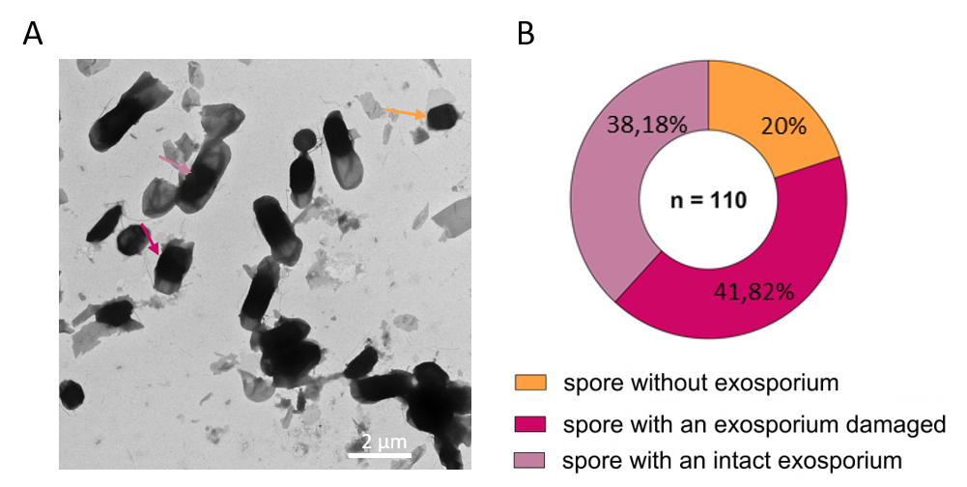

Fig S2
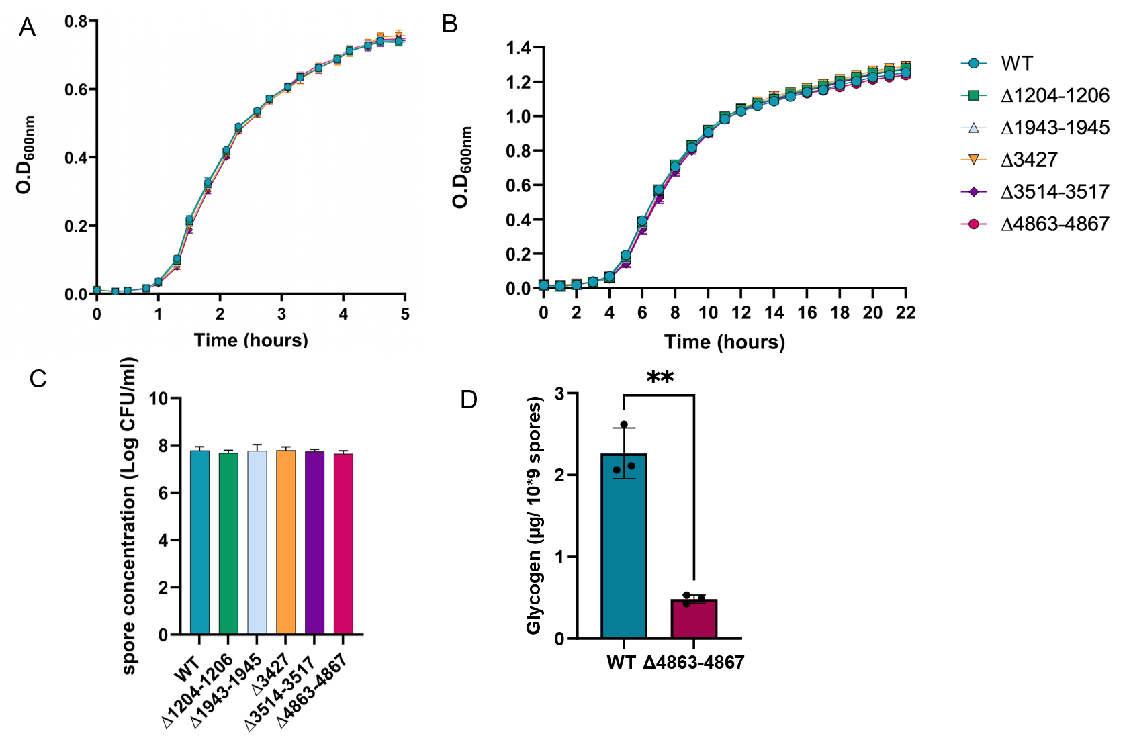
Fig S3
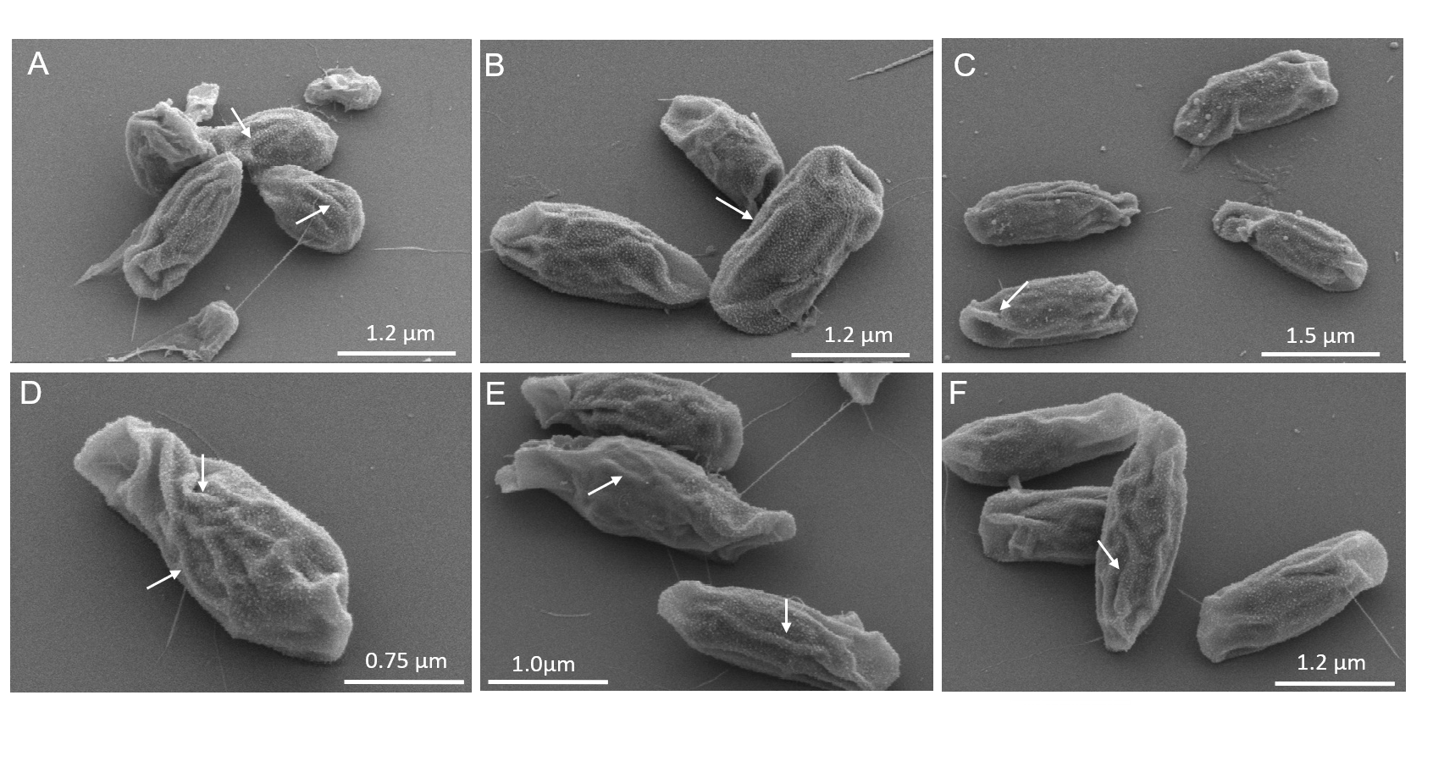

Fig S4
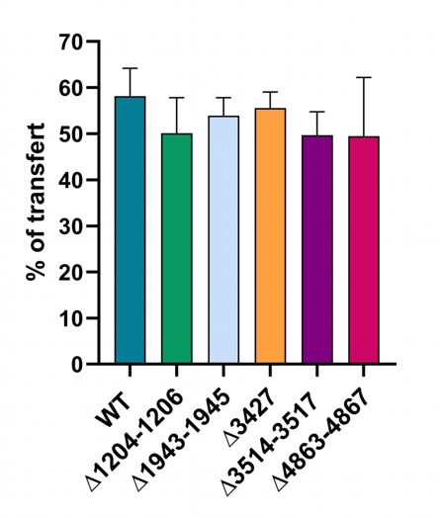

Fig S5
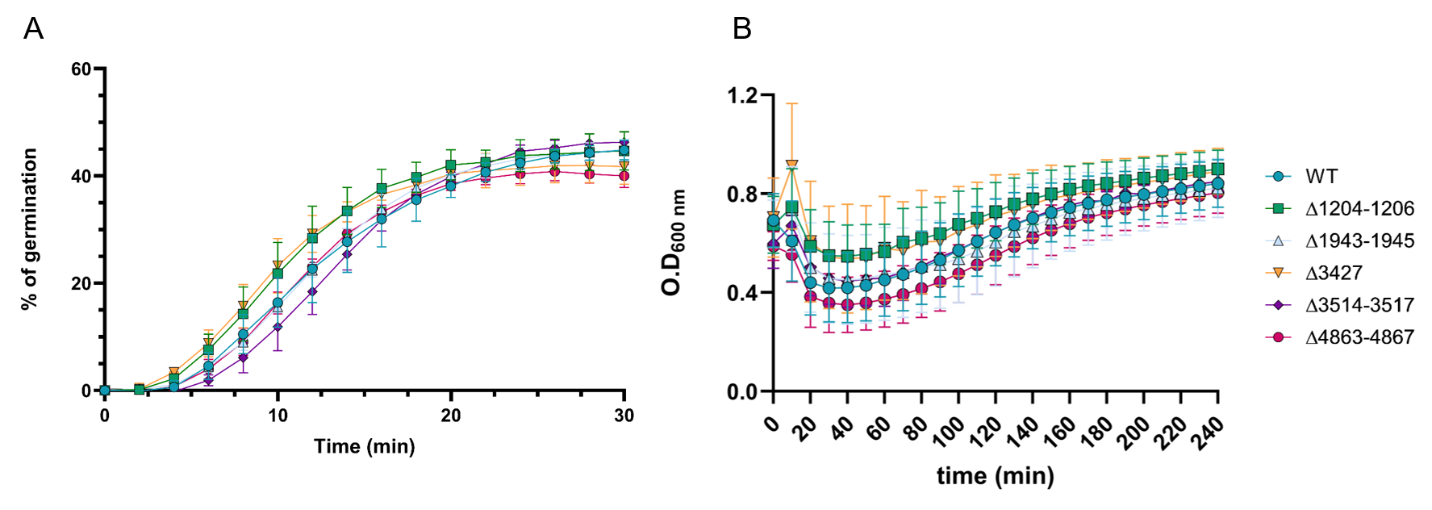

Fig S6
