Supporting Information

Role of Cu-O-Ce Interface on Low-Temperature CO Oxidation over CuO/CeO₂
Fuka Takahashi, Takeshi Ohtsu, Atsushi Satsuma*
Department of Materials Chemistry, Graduate School of Engineering, Nagoya University, Furo-cho, Chikusa-ku, Nagoya 464-8603, Japan
*Correspondence should be addressed: satsuma@chembio.nagoya-u.ac.jp

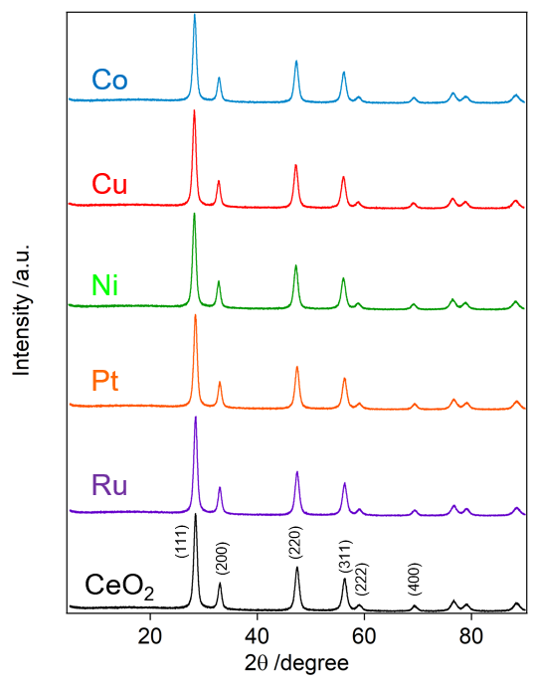

Fig. S1 XRD patterns of 0.5wt% M/CeO₂ (M = Ru, Cu, Pt, Co, and Ni).

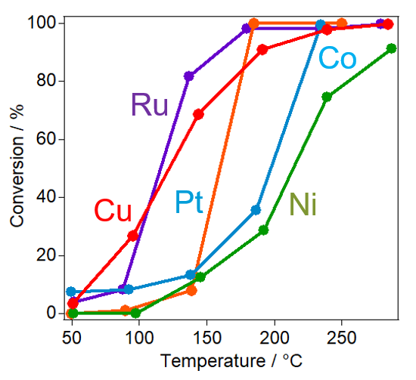

Fig. S2 CO conversion on 0.5wt% M/CeO₂ (M = Ru, Cu, Pt, Co, and Ni) as a function of reaction temperature. Reaction conditions: 0.3%CO, 10%O₂, N₂ balance, catalyst 25 mg, total flow rate 100 mL/min.

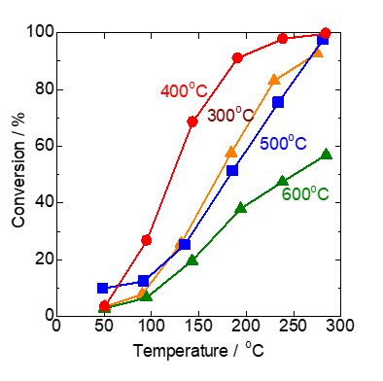

Fig. S3 Effect of calcination temperature of CeO₂ support on CO conversion of 0.5wt% Cu/CeO₂. Reaction conditions: 0.3% CO, 10% O₂, N₂ balance; catalyst 25 mg; total flow rate 100 mL/min.

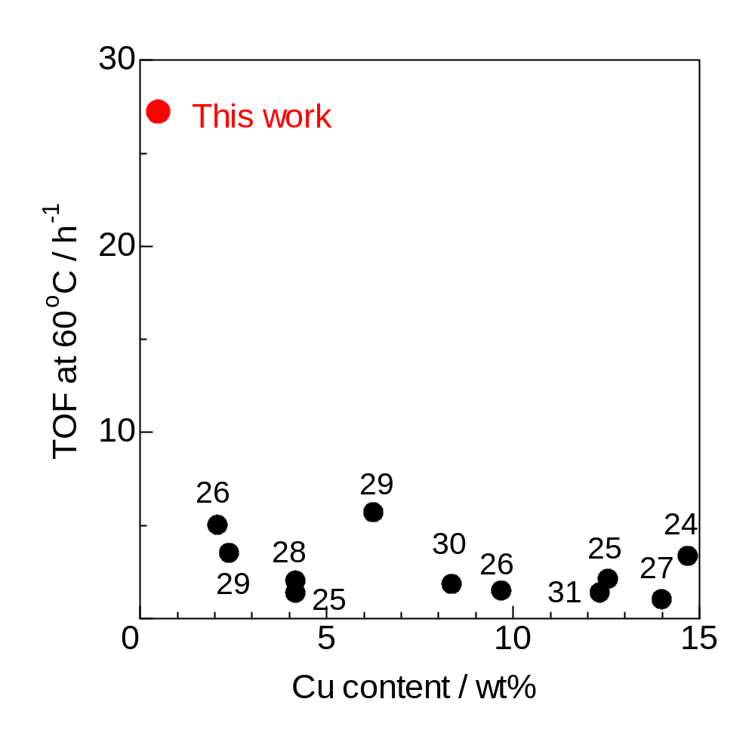

Fig. S4 Comparison of TOF of CO oxidation over Cu/CeO₂ catalysts as a function of Cu content. The numbers indicate the reference number.

Table S1 Cu content, reaction conditions, and catalytic activity of CO oxidation at 60 ºC over Cu/CeO₂ catalysts.
Catalyst | Cu  (wt%) | SV  (mL/g_{cat}·h) | CO conc.  (%) | CO conv.*  (%) | TOF*  h⁻¹ | Ref.
Cu/CeO₂ | 0.5 | 240,000 | 0.3 | 8.20 | 27.2 | This study
CuO-CeO₂ nanosheet | 14.7 | 54,000 | 0.4 | 39.0 | 3.33 | 24
Cu_{0.3}Ce_{0.7}-T | 12.56 | 54,000 | 1 | 21.0 | 2.10 | 25
Cu_{0.1}Ce_{0.9}-T | 4.18 | 54,000 | 1 | 4.5 | 1.35 | 25
CuO/CeO₂ 20-CC | 9.7 | 18,000 | 1 | 34.0 | 1.47 | 26
CuO/CeO₂ 5-CC | 2.4 | 18,000 | 1 | 20.0 | 3.49 | 26
CuO-CeO₂ | 14 | 60,000 | 1 | 10.0 | 1.00 | 27
Cu_{0.1}Ce_{0.9}O₂ | 4.18 | 30,000 | 1 | 12.0 | 2.00 | 28
0.15Cu/CeO₂ nanorod | 6.27 | 30,000 | 3 | 17.0 | 5.67 | 29
0.05Cu/CeO₂ nanorod | 2.09 | 30,000 | 3 | 5.0 | 5.00 | 29
CuO-CeO₂ 450-CC | 8.37 | 18,000 | 1 | 36.5 | 1.82 | 30
Cu/CeO₂ nanorod | 12.34 | 7,200 | 1 | 100.0 | 1.36 | 31
* at 60 ºC

Table S2 Comparison of TOF at 70 ºC with after treated CuCe catalysts reported by Tian et al. [33].
Catalyst | Cu  (wt%) | Treatment | TOF  (10⁻² s⁻¹) | Ref.
0.5 wt% Cu/CeO₂ | 0.5 | 10%O₂/N₂ at 300 °C | 1.0 | This study
CuCe-Red | 5.0 | 1% CO/Ar at 200 °C | 40 | 33
CuCe-Rex | 5.0 | %CO/20%O₂/Ar at 200 °C | 1.9 | 33
CuCe-Ox | 5.0 | 20%O₂/Ar at 200 °C | 1.5 | 33
Reaction conditions
This study: 0.3%CO/10%O₂/N₂, SV = 240,000 mL/g_{cat}·h
Reference 34: 1%CO/20%O₂/Ar, SV = 60,000 mL/g_{cat}·h

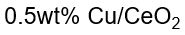
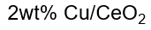
Fig. S5 Distribution of particle size of Cu species on 0.5wt% Cu/CeO₂ and 2wt% Cu/CeO₂.

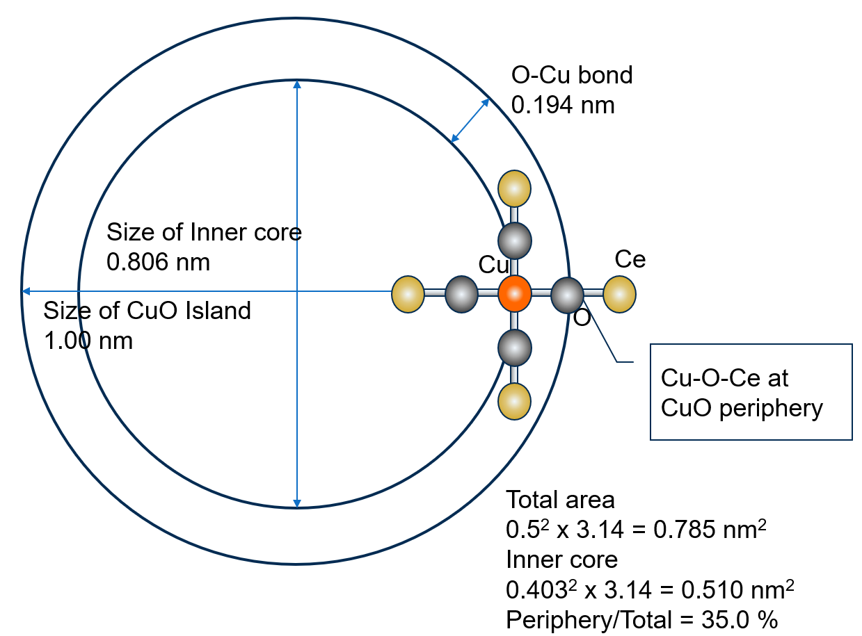

Fig. S6 Schematic model of periphery in CuO monolayer island

