Online Supplemental Information

Comparison of InvisalignⓇ Aligners versus Fixed Appliance Treatment in pain perception: a systematic review and meta-analysis

Dinis Pereira MSc ^{1,2}* 0000-0001-7529-9025, Vanessa Machado, MSc^{1,2}* 0000-0003-2503-260X, João Botelho, MSc^{1,2} 0000-0002-1019-8263, José João Mendes, PhD ² 0000-0003-0167-4077, Ana Delgado, PhD^{1,2} 0000-0003-1851-2752

*Equally first author

¹Orthodontics Department, Clinical Research Unit (CRU), Centro de Investigação Interdisciplinar Egas Moniz (CiiEM), Egas Moniz - Cooperativa de Ensino Superior, C.R.L., Monte de Caparica, Almada, Portugal
²Clinical Research Unit (CRU), Centro de Investigação Interdisciplinar Egas Moniz (CiiEM), Egas Moniz - Cooperativa de Ensino Superior, C.R.L., Monte de Caparica, Almada, Portugal

Author responsible for correspondence – Vanessa Machado
Address: Campus Universitário, Quinta da Granja, Monte de Caparica.
Telephone number: + 351 964 805 122
E-mail address: vmachado@egasmoniz.edu.pt

Authors’ contribution: All authors’ have equally contributed for the study design, data analysis and manuscript draft.
Legends
Table S1. PRISMA 2009 Checklist.
Table S2. List of potentially relevant studies not included in the systematic review, along with the reasons for exclusion.
Table S3. Cohort studies bias assessment using the Newcastle-Ottawa Scale (NOS) for Cohort studies.

Table S1. PRISMA 2009 Checklist
Section/topic | # | Checklist item | Reported on page #
TITLE
Title | 1 | Identify the report as a systematic review, meta-analysis, or both. | 1
ABSTRACT
Structured summary | 2 | Provide a structured summary including, as applicable: background; objectives; data sources; study eligibility criteria, participants, and interventions; study appraisal and synthesis methods; results; limitations; conclusions and implications of key findings; systematic review registration number. | 1
INTRODUCTION
Rationale | 3 | Describe the rationale for the review in the context of what is already known. | 2
Objectives | 4 | Provide an explicit statement of questions being addressed with reference to participants, interventions, comparisons, outcomes, and study design (PICOS). | 2
METHODS
Protocol and registration | 5 | Indicate if a review protocol exists, if and where it can be accessed (e.g., Web address), and, if available, provide registration information including registration number. | 3
Eligibility criteria | 6 | Specify study characteristics (e.g., PICOS, length of follow-up) and report characteristics (e.g., years considered, language, publication status) used as criteria for eligibility, giving rationale. | 3
Information sources | 7 | Describe all information sources (e.g., databases with dates of coverage, contact with study authors to identify additional studies) in the search and date last searched. | 3
Search | 8 | Present full electronic search strategy for at least one database, including any limits used, such that it could be repeated. | 3
Study selection | 9 | State the process for selecting studies (i.e., screening, eligibility, included in systematic review, and, if applicable, included in the meta-analysis). | 3
Data collection process | 10 | Describe method of data extraction from reports (e.g., piloted forms, independently, in duplicate) and any processes for obtaining and confirming data from investigators. | 3-4
Data items | 11 | List and define all variables for which data were sought (e.g., PICOS, funding sources) and any assumptions and simplifications made. | 4
Risk of bias in individual studies | 12 | Describe methods used for assessing risk of bias of individual studies (including specification of whether this was done at the study or outcome level), and how this information is to be used in any data synthesis. | 4
Summary measures | 13 | State the principal summary measures (e.g., risk ratio, difference in means). | 4
Synthesis of results | 14 | Describe the methods of handling data and combining results of studies, if done, including measures of consistency (e.g., I²) for each meta-analysis. | 4

Section/topic | # | Checklist item | Reported on page #
Risk of bias across studies | 15 | Specify any assessment of risk of bias that may affect the cumulative evidence (e.g., publication bias, selective reporting within studies). | NA
Additional analyses | 16 | Describe methods of additional analyses (e.g., sensitivity or subgroup analyses, meta-regression), if done, indicating which were pre-specified. | 4
RESULTS
Study selection | 17 | Give numbers of studies screened, assessed for eligibility, and included in the review, with reasons for exclusions at each stage, ideally with a flow diagram. | 4
Study characteristics | 18 | For each study, present characteristics for which data were extracted (e.g., study size, PICOS, follow-up period) and provide the citations. | 5
Risk of bias within studies | 19 | Present data on risk of bias of each study and, if available, any outcome level assessment (see item 12). | 5
Results of individual studies | 20 | For all outcomes considered (benefits or harms), present, for each study: (a) simple summary data for each intervention group (b) effect estimates and confidence intervals, ideally with a forest plot. | NA
Synthesis of results | 21 | Present results of each meta-analysis done, including confidence intervals and measures of consistency. | 5
Risk of bias across studies | 22 | Present results of any assessment of risk of bias across studies (see Item 15). | NA
Additional analysis | 23 | Give results of additional analyses, if done (e.g., sensitivity or subgroup analyses, meta-regression [see Item 16]). | 5
DISCUSSION
Summary of evidence | 24 | Summarize the main findings including the strength of evidence for each main outcome; consider their relevance to key groups (e.g., healthcare providers, users, and policy makers). | 5-6
Limitations | 25 | Discuss limitations at study and outcome level (e.g., risk of bias), and at review-level (e.g., incomplete retrieval of identified research, reporting bias). | 6
Conclusions | 26 | Provide a general interpretation of the results in the context of other evidence, and implications for future research. | 7
FUNDING
Funding | 27 | Describe sources of funding for the systematic review and other support (e.g., supply of data); role of funders for the systematic review. | 7
NA – Not applicable
From: Moher D, Liberati A, Tetzlaff J, Altman DG, The PRISMA Group (2009). Preferred Reporting Items for Systematic Reviews and Meta-Analyses: The PRISMA Statement. PLoS Med 6(7): e1000097. doi:10.1371/journal.pmed1000097
For more information, visit: www.prisma-statement.org.

Table S2. List of potentially relevant studies not included in the systematic review, along with the reasons for exclusion.

Title | Exclusion reason
Long-term Comparison of Treatment Impacts Between Invisalign and fixed appliance therapy | Thesis
A prospective longitudinal controlled assessment of pain experience and oral health‐related quality of life in adolescents undergoing fixed appliance treatment | Abstract
A prospective, longitudinal, study of initial discomfort associated with fixed and Invisalign treatment | Thesis
Periodontal health during clear aligners treatment: a systematic review | Systematic review
A comparison of pain experienced by patients treated with labial and lingual orthodontic appliances | No Invisalign treatment
A randomized controlled trial of self-perceived pain, discomfort, and impairment of jaw function in children undergoing orthodontic treatment with fixed or removable appliances | No Invisalign treatment
Comparison of oral impacts experienced by patients treated with labial or customized lingual fixed orthodontic appliances | No Invisalign treatment
Invisalign update: A review of articles. | Review
Orthodontic pain: from causes to management—a review | Review
Effect of reducing the incremental distance of tooth movement per aligner while maintaining overall rate of movement on self-reported discomfort in Invisalign patients | Thesis
A survey study comparing adult orthodontic patient quality of life between Invisalign and fixed appliances. | Thesis
Patient perceptions of speech, discomfort, and salivary flow while wearing Invisalign® aligners | Only Invisalign treatment
Severe obstructive sleep apnea treatment with oral appliance: The impact on obstructive, central and mixed events | Unrelated to the review objective
Effect of Chewing Gum on Pain in Fixed Orthodontic Treatment | No Invisalign treatment
The Effect of Chewing Gum on the Pain Associated With Initial Placement of Fixed Orthodontic Appliances | No Invisalign treatment
The effect of chewing gum on the impact, pain and breakages associated with fixed orthodontic appliances: a randomized clinical trial | No Invisalign treatment
Clear Aligners in Orthodontics | Review
Satisfaction with orthodontic treatment outcome | Absence of VAS score analysis
Evaluation of preemptive valdecoxib therapy on initial archwire placement discomfort in adults | Unrelated to the review objective
Pain experience in adults undergoing treatment: A longitudinal evaluation | No Invisalign treatment
Changes of substance P in the crevicular fluid in relation to orthodontic movement preliminary investigation | Unrelated to the review objective
Lingual vs. labial fixed orthodontic appliances: systematic review and meta‐analysis of treatment effects | Systematic review and meta-analysis
Effect of single-dose low-level helium-neon laser irradiation on orthodontic pain: a split-mouth single-blind placebo-controlled randomized clinical trial | Unrelated to the review objective
Pain and orthodontic patient compliance: A clinical perspective | Review
A comparison between customized clear and removable orthodontic appliances manufactured using RP and CNC techniques | No Invisalign treatment
A longitudinal evaluation of pulpal pain during orthodontic tooth movement | No Invisalign treatment
Perio/Restorative Interface | Unrelated to the review objective
Orthodontic anchoring techniques and its influence on pain, discomfort, and jaw function—a randomized controlled trial | No Invisalign treatment
Effects of vibrational devices on orthodontic tooth movement: A systematic review | Systematic review
The effects of brief daily vibration on clear aligner orthodontic treatment | No Invisalign treatment
Adult patients' adjustability to orthodontic appliances. Part I: a comparison between Labial, Lingual, and Invisalign™ | Health-Related Quality of Life questionnaire
Relevant research from orthodontic journals: focus on rate of tooth movement | Absence of VAS score analysis
Percepcija bola, socijalna i funkcionalna nelagodnost tokom ortodontske terapije | Not in English
Effects of Anxiety and Daytime Clenching on Orthodontic Pain Perception | Unrelated to the review objective
Comparison of oral health-related quality of life of patients treated by palatal expanders with patients treated by fixed orthodontic appliances | Absence of VAS score analysis
2016 AAO Annual Session Charley Schultz Resident Scholar Award | Congress
Relationships between facial features in the perception of profile attractiveness | Unrelated to the review objective
Comparaison de la perception de la douleur entre le traitement orthodontique avec Invisalign® et le traitement avec fils et boîtiers fixes | Thesis
Interdisciplinary Treatment | Unrelated to the review objective
Pain Perception in Orthodontic Patients Treated by Fixed Orthodontic Appliances and It's Effect on Their Quality of Life | Absence of VAS score analysis
Contemporary treatment of Class II maxillary deficiency malocclusion in growing patients | Abstract
Orthodontics-e-book: current principles and techniques | Book
2nd Internation Congress of Croatian Society of Orthodontics "Excellence in Orthodontics", Zagreb, September 24th-27th | Congress
Skaidrių tiesinimo kapų ir fiksuotų ortodontinių aparatų palyginimas. Šaknų rezorbcija, periodonto būklė, patiriamas skausmas ir poreikis vaistams | Not in English
Lasers in orthodontics | Unrelated to the review objective
XVI Съезд ортодонтов России | Not in English
Sistemas y tipos de retención | Review
Thermal Properties of Commonly Used Clear Aligner Systems As-Received and After Clinical Use | Thesis
Magnetic forces in orthodontics | Unrelated to the review objective
Low pneumoperitoneum pressure reduces pain after mini-laparoscopic hysterectomy: Results from two independent randomized controlled trails | Unrelated to the review objective
Questionnaire to measure patients' expectations of orthodontic treatment in the University at Buffalo orthodontic clinic | Book
Potential risks of orthodontic therapy: a critical review and conceptual framework | Review
Effects os nasal obstruction on development of motor representation within the facial primay motor cortex in growing rats | Not in humans
Percepción del dolor durante alineación y nivelación de ortodoncia en los pacientes que acuden a la clínica de posgrado de la Facultad de Odontología | Not in English
Orthodontic treatment with and without removable aligner systems by general dentists | Book
Arch expansion predictability with Invisalign | Unrelated to the review objective
Patient Experiences and Emergency Appointments Associated with Orthodontic Appliance Treatment | Unrelated to the review objective

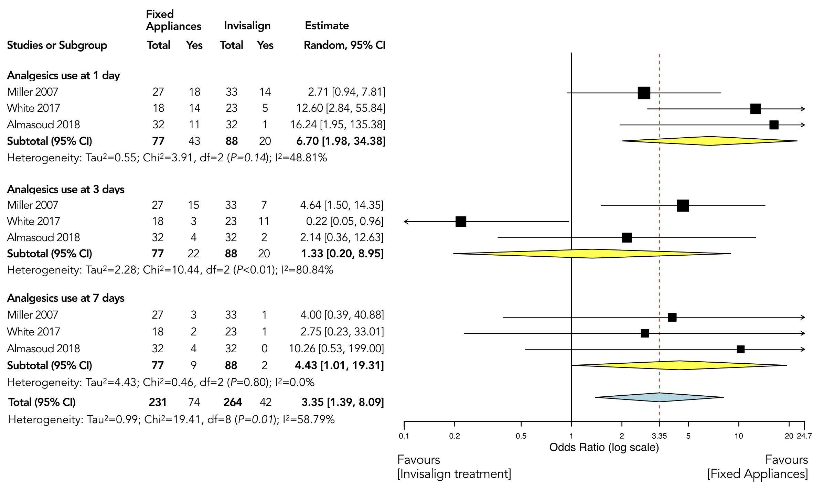
Figure S3: Forest plot diagram showing analgesic consumption at day 1, 3 and 7 of Invisalign treatment versus Fixed appliances. Mean effect size estimates have been calculated with 95% confidence intervals and are shown in the figure. Area of squares represents sample size, continuous horizontal lines and diamonds width represents 95% confidence interval. Blue diamond center and the vertical red dotted line represent the overall pooled estimate.

