Supplementary Information: Additional Figures

Purpose and scope
This supplementary section presents additional figures supporting the BMEntropy v1.0 exploratory workflow. The figures summarize the analytical procedure and reported entropy relationships; the main text remains the authoritative source for methods, results, and limitations.

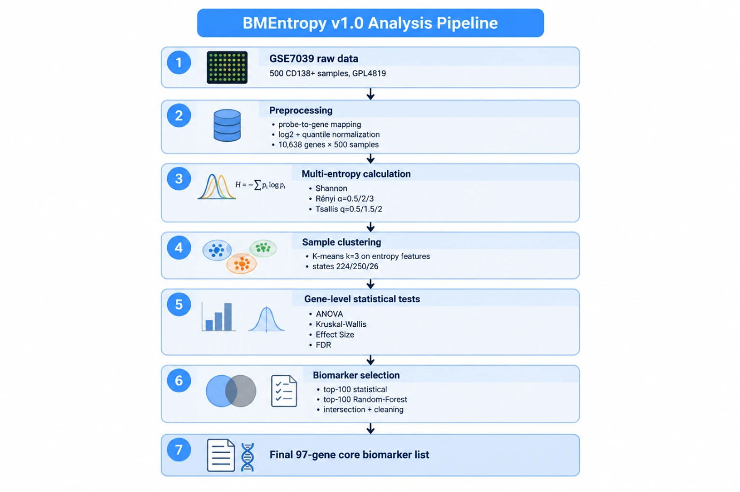
Figure 1. BMEntropy analysis workflow
Figure 1. Overview of the BMEntropy v1.0 analysis pipeline, from expression-data preprocessing through entropy calculation, unsupervised grouping, and exploratory candidate-gene selection. The schematic summarizes the workflow described in the Methods section.
The candidate-gene procedure is exploratory and does not constitute a validated diagnostic or biomarker-selection procedure.

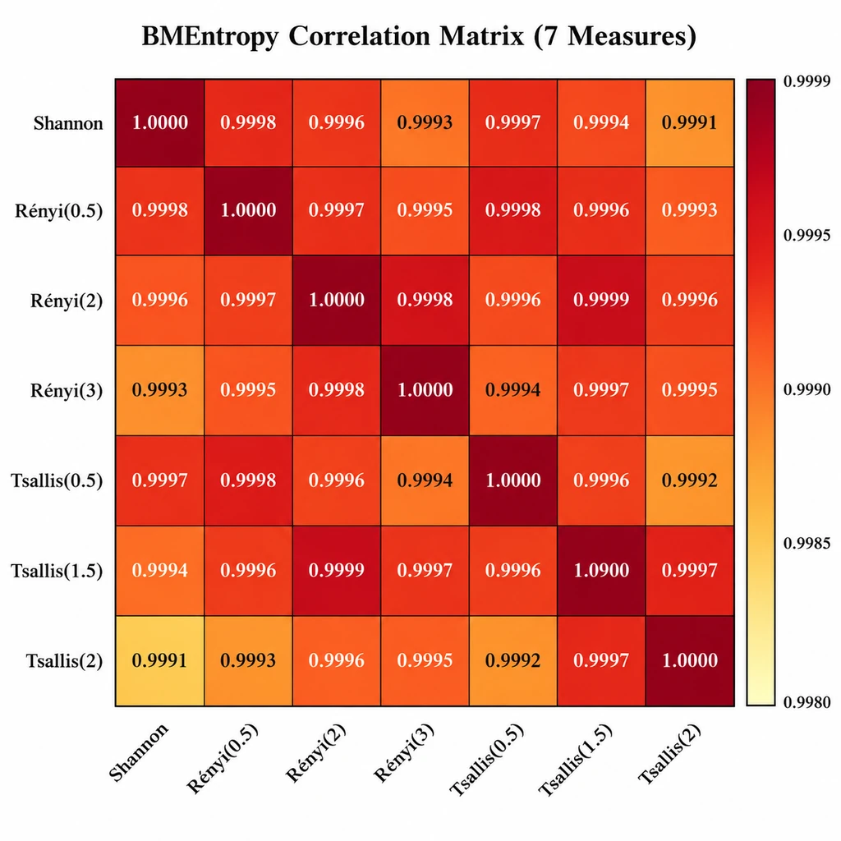
Figure 2. Pairwise associations among entropy measures
Figure 2. Pairwise associations among the seven entropy summaries: Shannon entropy, Rényi entropy (α = 0.5, 2, and 3), and Tsallis entropy (q = 0.5, 1.5, and 2). The heatmap provides a visual summary of the correlations described in the Results section.

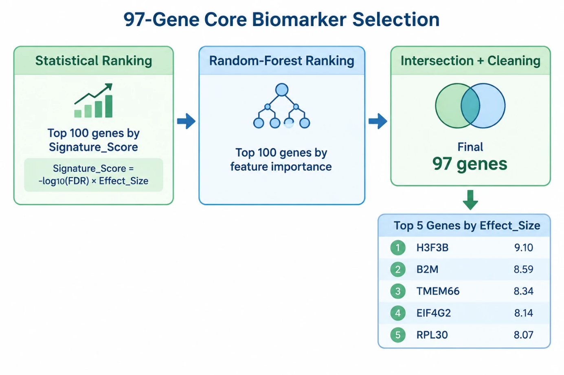

Figure 3. Exploratory selection of the 97-gene candidate set
Figure 3. Exploratory construction of the 97-gene candidate set by intersecting ranked statistical and Random Forest feature lists followed by gene-name cleaning. The candidate set is hypothesis-generating and is not a clinically validated biomarker panel.

