Supporting Information

Platelet Membrane–Camouflaged PB-MnO₂ Nanobiomimetic for Enhanced Photothermal Tumor Ablation

Anahita Barooj Kiakalaiy, Laleh Salarilak, Shayesteh Bochani, Ali Kalantari-Hesari, Abdolreza Esmaeilzadeh, Sophia Taheri, Kiana Nazari Nasi, Faezeh Almasi, Mitra Khalili, Fatemeh Hakimi*, Aziz Maleki*

(c)
(a)
(b)

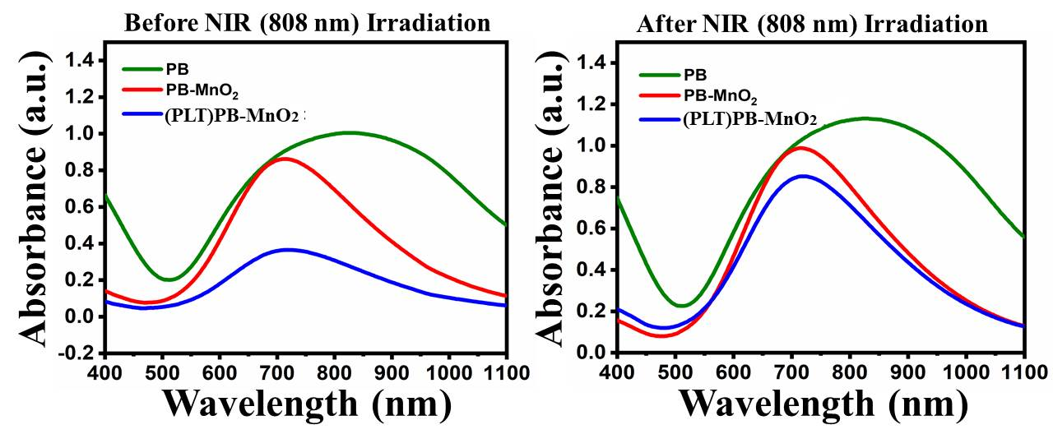
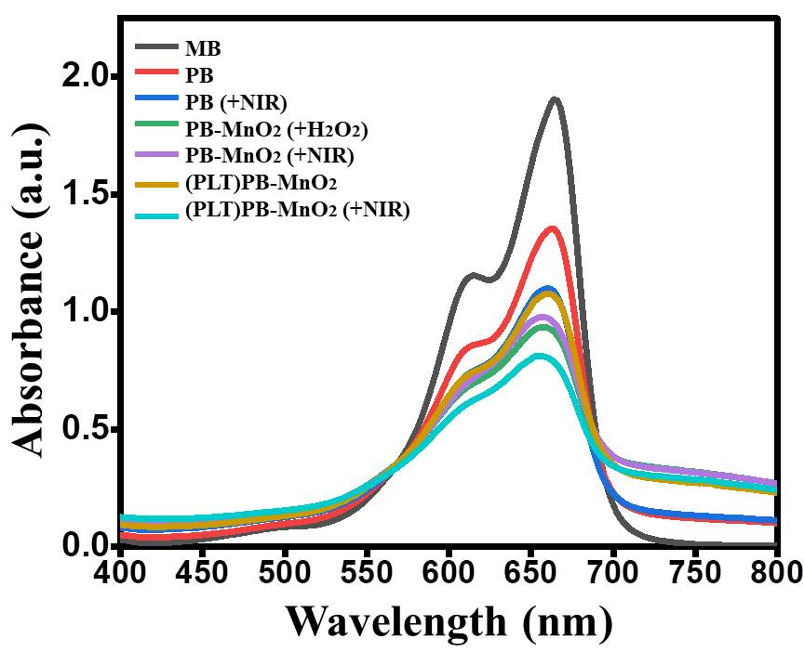
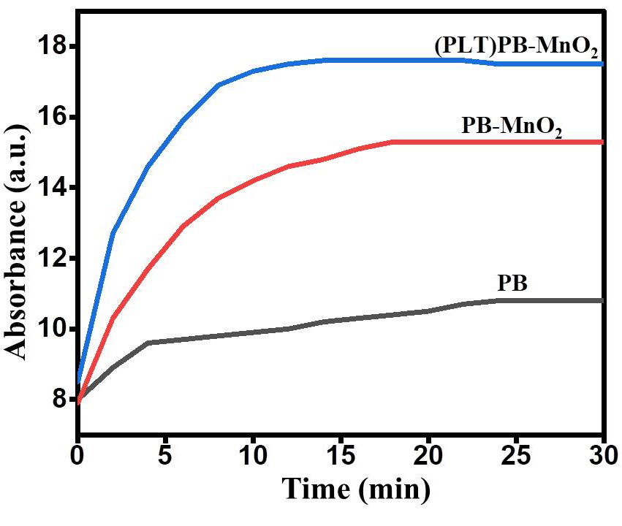

Figure S1. Additional absorption characterization of the PB-MnO₂ nanobiomimetic . (a) UV–Vis absorption spectra of the PB, PB-MnO₂, and (PLT)PB-MnO₂ before and after 808 nm laser irradiation. (b) Time-dependent absorption profiles of the different formulations. (c) Comparison of the absorption of different formulations compared with methylene blue under irradiation and non-irradiation conditions.

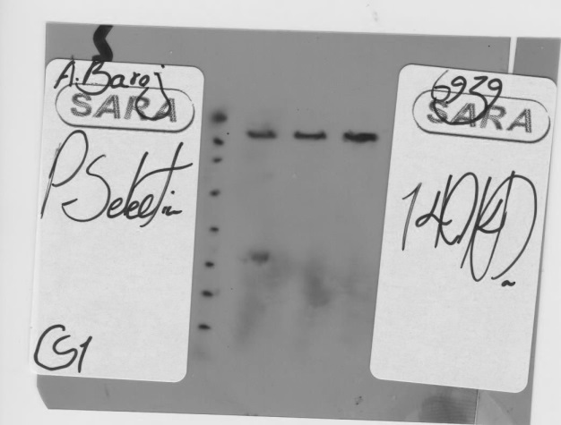
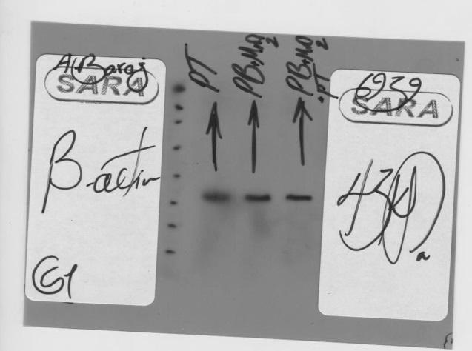

Figure S2. Full-length, uncropped Western blot images corresponding to the cropped blots presented in Figure 3 of the main manuscript.

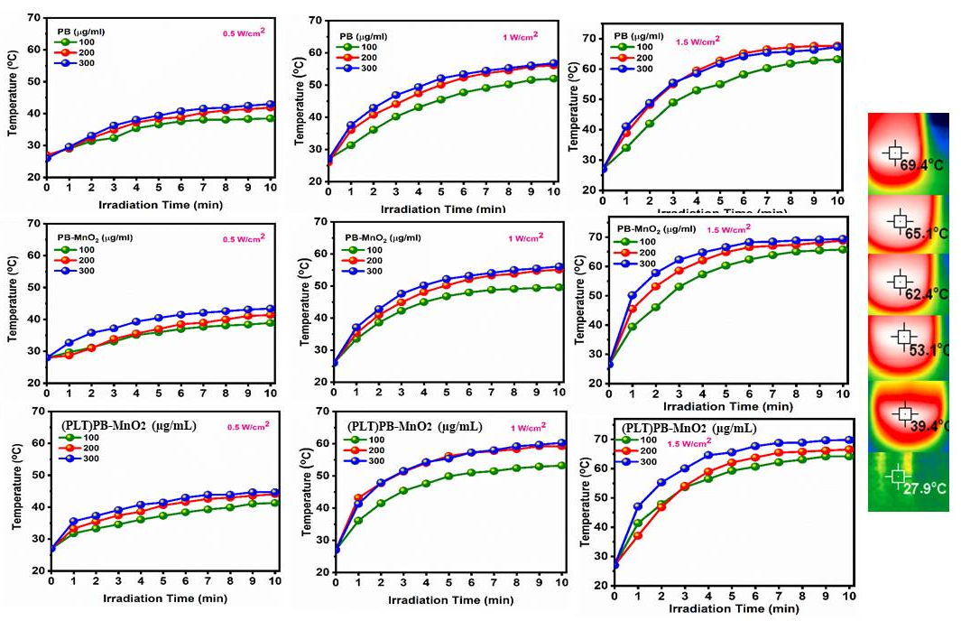
(a)
(b)

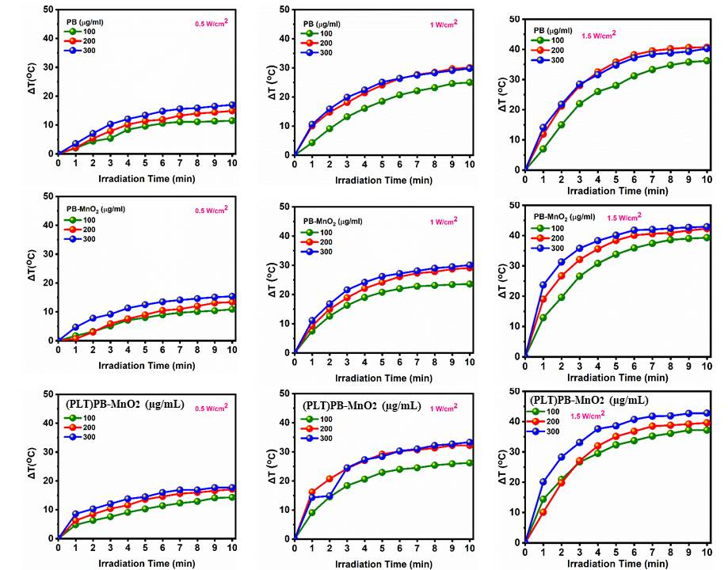
Figure S3. Photothermal characterization of the formulations at different concentrations and laser powers. (a) Temperature changes as a function of irradiation time. (b) Corresponding temperature changes (ΔT) as a function of irradiation time at different formulation concentrations and laser powers.

