Supplemental Figure 1. Kaplan–Meier survival curve restricted to participants diagnosed with LC death defined based on the underlying cause of death or were lost to follow-up. Survival time was calculated from the time of diagnosis of LC to the date of death due to LC. The underlying cause of death definition was used to be consistent with the SEER mortality data used for comparison. (End-of-follow-up survival probability: 0.17)
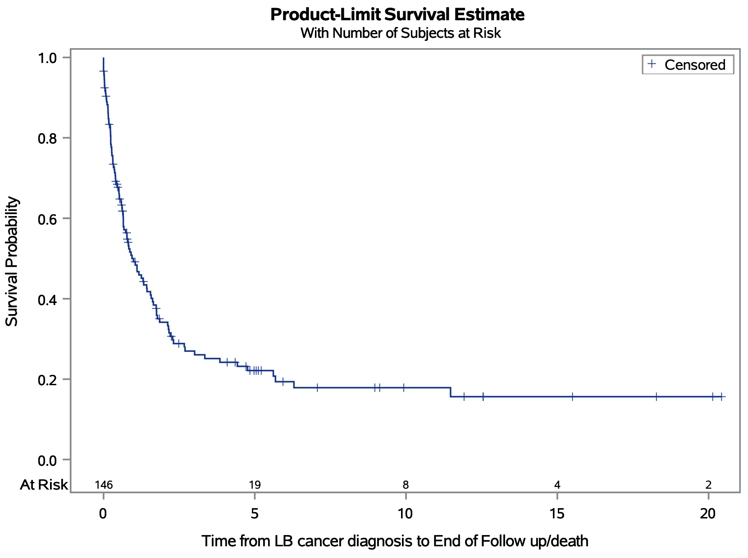

Supplemental Figure 2. Kaplan–Meier survival curves for LC cases restricted to cases with stage at diagnosis information (including our reclassifications) and participants with LC as an underlying cause of death. Survival time was calculated from the time of diagnosis of LC to the date of death due to LC or loss to follow-up. The underlying cause of death definition was used to be consistent with the SEER mortality data used for comparison. (Log-rank p < 0.0001; Wilcoxon < 0.0001)(End-of-follow-up survival probability: Localized, 0.44; Regional, 0.24; Distant, 0.06)
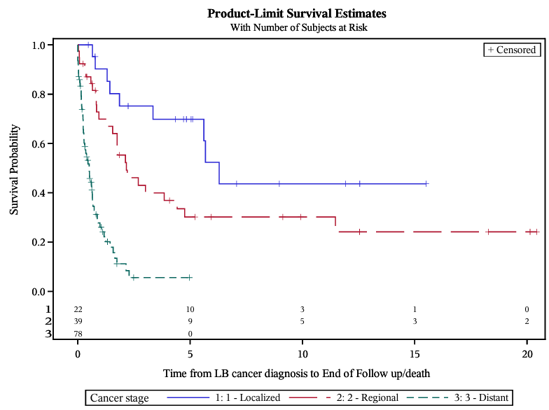

Supplemental figure 3. Kaplan–Meier survival curve restricted to participants diagnosed with LC who died of any causes or were lost to follow-up. Survival time was calculated from the time of diagnosis of LC to the date of death. (End-of-follow-up survival probability: 0.00)
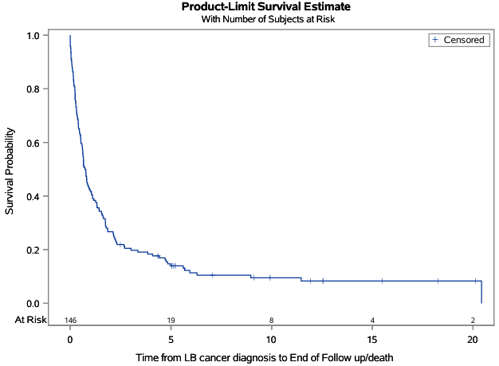

Supplemental figure 4. Kaplan–Meier survival curves for LC cases restricted to cases with stage at diagnosis information (including our reclassifications). Survival time was calculated from the time of diagnosis of LC to death from any cause or loss to follow-up. (Log-rank p < 0.0001; Wilcoxon p < 0.0001) (End-of-follow-up survival probability: Localized, 0.23; Regional, 0.00ª; Distant, 0.00)
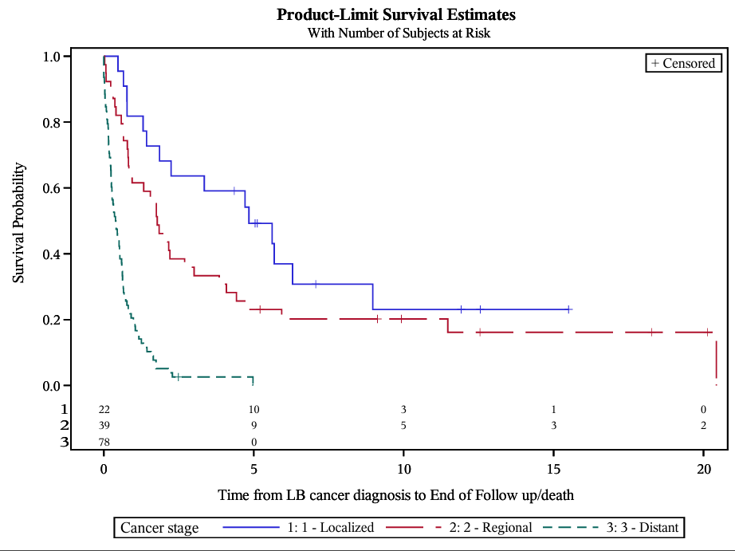
ª In the regional group, two participants remained alive at 20 years but died shortly thereafter.

