Opposing NF-κB–associated transcriptional changes accompany high CAR density and signaling rest in CAR-T cells

Qian Wang^{1,2,†}, Zhoulin Chen^{1,†}, Haohan Yang¹, Youcheng Yang^{1,§}, Shubing Wang^{1,§}

Affiliations
¹Department of Bioengineering, University of California, Los Angeles, Los Angeles, CA 90095, USA
²Biomedical Imaging Research Institute, Cedars-Sinai Medical Center, Los Angeles, California, USA
§Corresponding author Email: youcheng@ucla.edu (Y.Y.), brianbrian@g.ucla.edu (S.W.)
†These authors contributed equally: Qian Wang, Zhoulin Chen

Correspondence and requests for materials
Youcheng Yang
Department of Bioengineering
University of California, Los Angeles
Los Angeles, CA 90095, USA
Phone: 617-650-7327, Email: youcheng@ucla.edu

Shubing Wang
Department of Bioengineering
University of California, Los Angeles
Los Angeles, CA 90095, USA
Phone: 310-963-4840, Email: brianbrian@g.ucla.edu

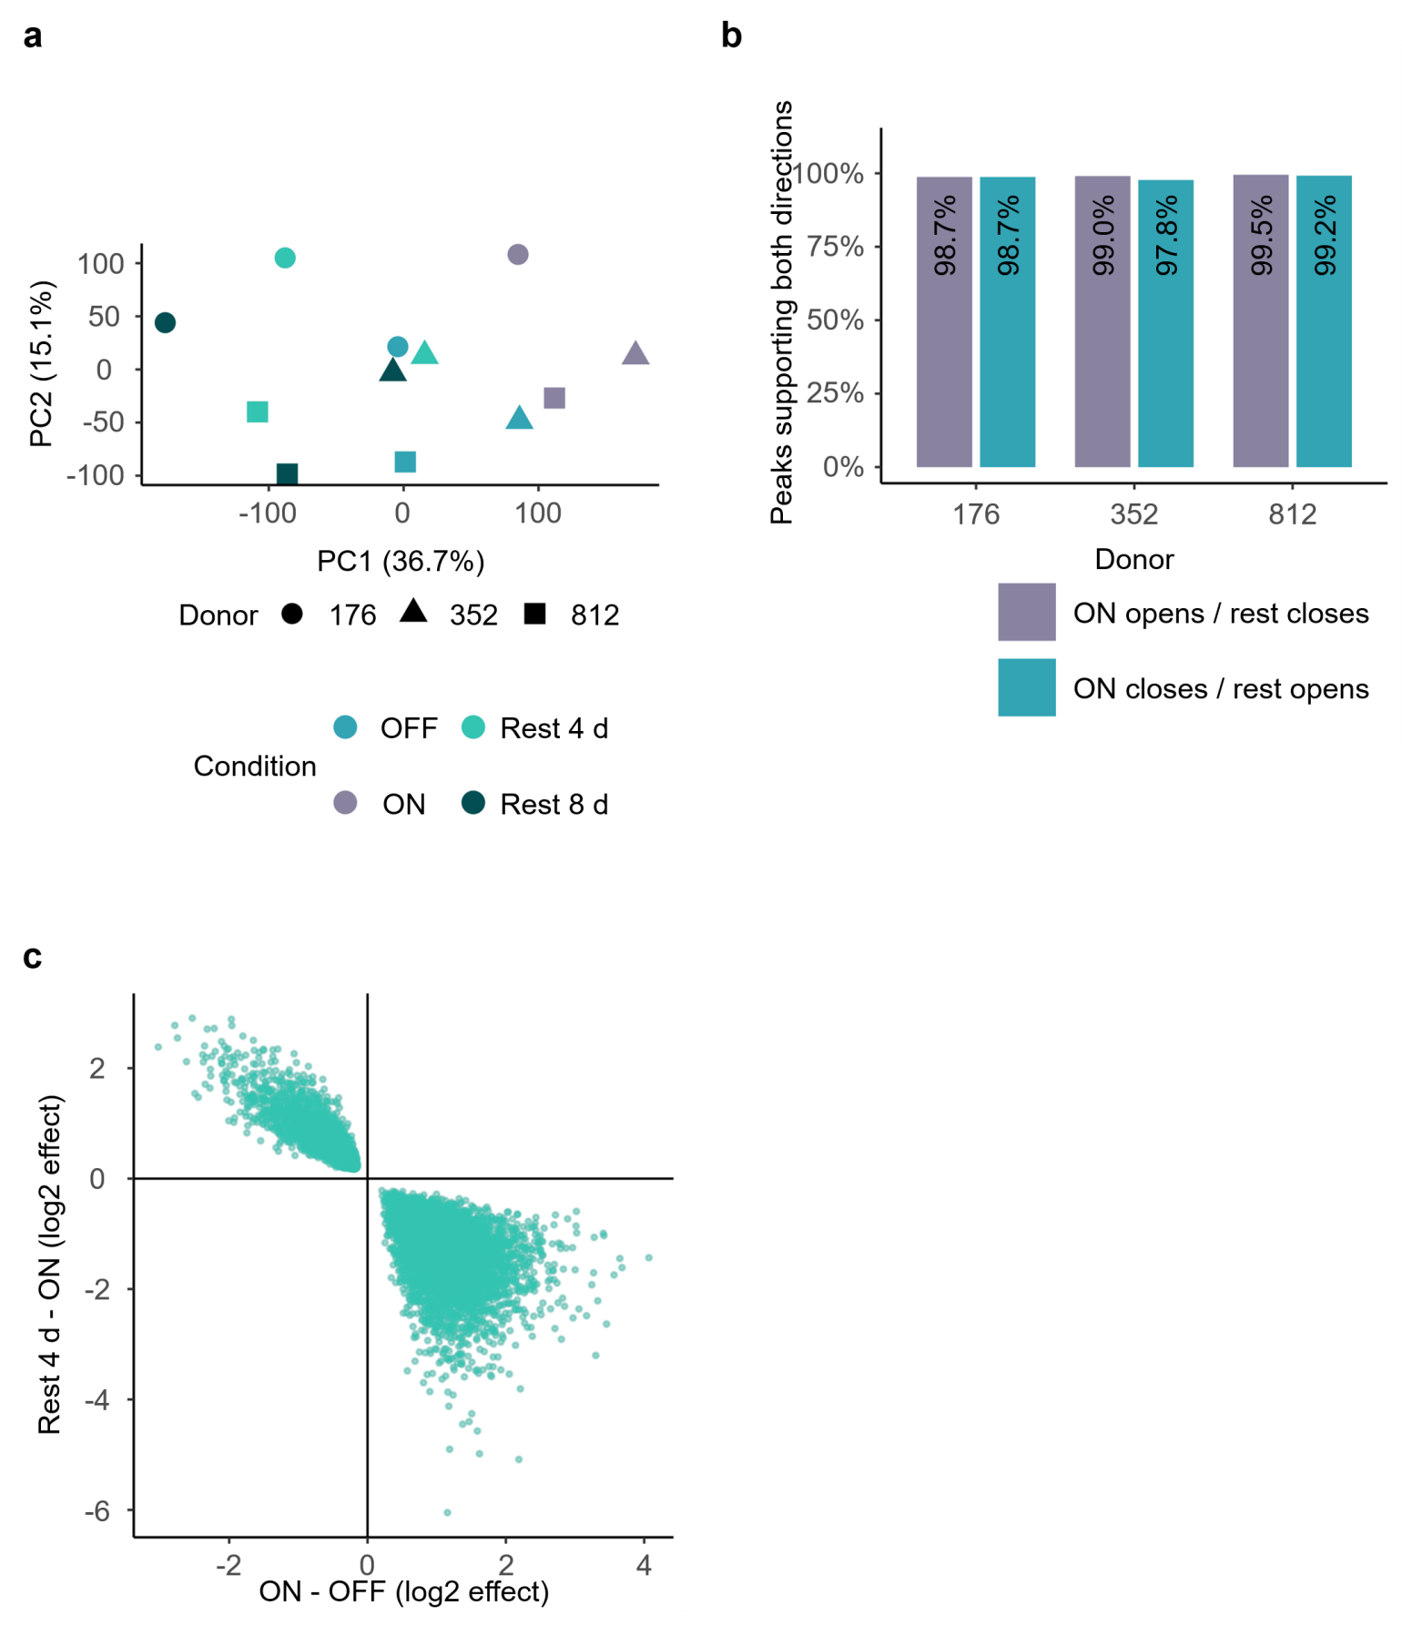
Supplementary Fig.1 | Quality checks of rest-associated chromatin accessibility.
a, Principal component analysis of ATAC-seq profiles from three donors under OFF, ON, four-day rest (Rest4) and eight-day rest (Rest8) conditions. b, Donor-level directional consistency of the 9,254 four-day return peaks, showing the fraction of peaks that changed with signaling and reversed direction after Rest4 in each donor. c, Comparison of ON−OFF and Rest4−ON accessibility effects across the return-peak set, illustrating the opposing changes used to define signaling-responsive chromatin regions.

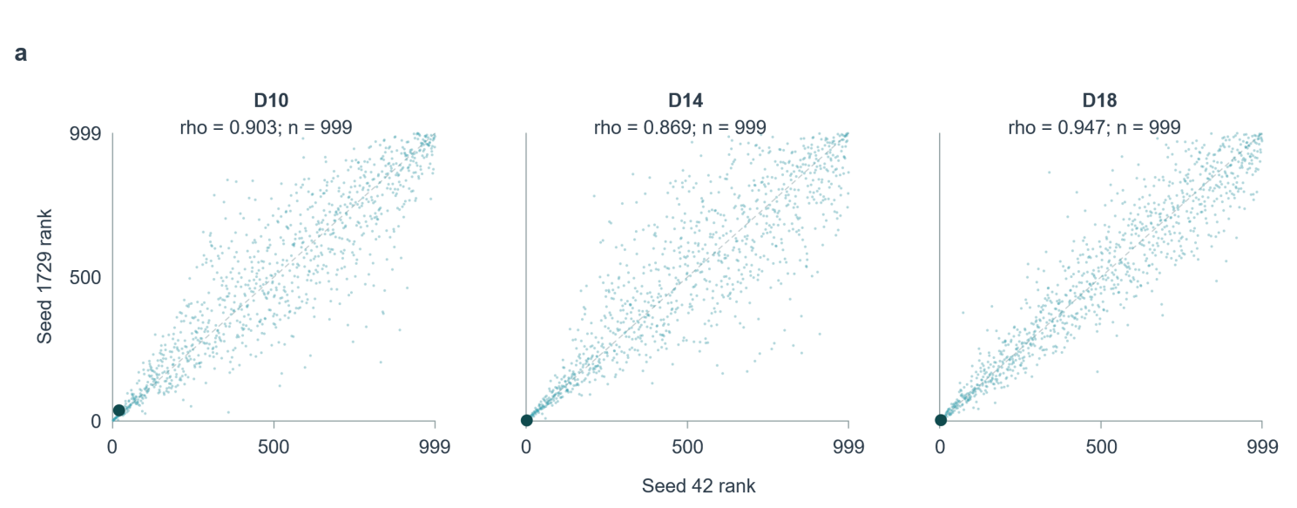
Supplementary Fig.2 | Subsampling reproducibility of virtual NFKBIA knockout.
a, Concordance of gene-level perturbation ranks across two independent subsampling runs for each donor. TCF7 is highlighted, and Spearman correlation coefficients indicate the reproducibility of the inferred network responses.

