Supplementary Information
Near-reference carbon stocks with distinct carbon pool composition following restoration of northern China's largest seagrass bed
Chao Liu^{1,2}, Shihao Niu³, Shaochun Xu⁴, Yanping Li¹, Xin Zhao⁵, Ping Li⁶, Zhiwei Zhang^{1*}, Huohuo Wang³, Liming Zuo^{3*}, Chunjuan Wang¹, Wanglai Cui^{7*}, Bojun, Gu⁷
¹ Research Center for Coastal Zone Science and Marine Development Strategy, First Institute of Oceanography, Ministry of Natural Resources, Qingdao 266100, P. R. China
² School of Engineering, Cardiff University, Cardiff CF24 3AA, United Kingdom
³ Hebei Provincial Water Exploration Institute (Hebei Provincial Remote Sensing Center), Shijiazhuang 050021, P. R. China
⁴ Laboratory of Marine Ecology and Environmental Sciences, Institute of Oceanology, Chinese Academy of Sciences, Qingdao 266100, P. R. China
⁵ School of Geographic Science, East China Normal University, Shanghai 200062, China.
⁶ Institute of Marine Development, Ocean University of China, Qingdao, 266100, China College of Management, Ocean University of China, Qingdao 266100, P. R. China
⁷ College of Economics and Management, Zhejiang Ocean University, Zhoushan 316022, P. R. China
*Corresponding anthors:
Zhiwei Zhang (zhangzhiwei@fio.org.cn), Liming Zuo(zuoliming@163.com), and Wanglai Cui (cuiwanglai@zjou.edu.cn)

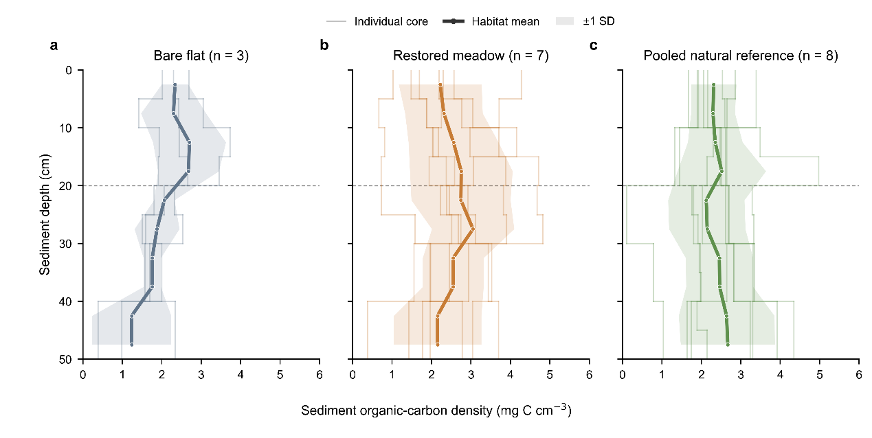
Supplementary Figure S1 | Sediment organic-carbon density profiles across the three habitat groups. Depth-resolved sediment organic-carbon density in a, the bare flat (n = 3 cores), b, the restored meadow (n = 7 cores), and c, the pooled natural reference (n = 8 cores). Thin coloured step lines show individual core profiles at their original sampling intervals. Thick lines and shaded envelopes show the habitat mean and ±1 standard deviation, respectively, evaluated at 5-cm depth midpoints. Where an original measurement spanned 10 cm, its measured value was retained across the corresponding two display positions; this visualization does not add analytical depth resolution. The horizontal dashed line marks the 20-cm boundary used to partition the 0–20-cm surface layer from the 20–50-cm rooting-zone interval. Natural-reference cores collected in 2021 and 2024 were pooled for the habitat-level analysis; sampling year and original core identifiers are retained in the accompanying Source Data and are not treated as comparison factors in this figure.
Supplementary Figure S2 | Measured sediment organic-carbon stocks and profile-depth coverage across habitat groups. Core-level sediment organic-carbon stocks within a, 0–20 cm, b, 20–50 cm, and c, the common measured 0–50-cm interval in the bare flat (n = 3), restored meadow (n = 7), and pooled natural reference (n = 8). Coloured points represent independent sediment cores; black points and error bars denote the mean ±1 standard deviation. Stocks were calculated as the sum of measured interval-specific carbon density multiplied by interval thickness and were not extrapolated below 50 cm. d, deepest depth for which sediment carbon concentration was tabulated for each core. Coloured bars denote measured profile coverage, pale-grey extensions denote the remaining depth to 100 cm without tabulated carbon-concentration data, and the dashed vertical line marks the common 50-cm analytical depth used in a–c. Natural-reference cores from both surveys are combined into one habitat group; sampling year remains available in the Source Data and sample identifiers but is not used as a graphical or statistical comparison factor.
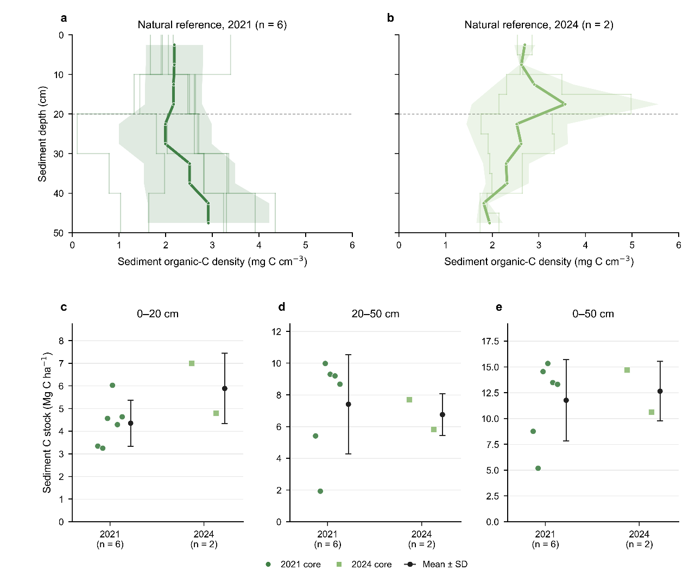
Supplementary Figure S3 | Sampling-year provenance of natural-reference sediment measurements. Year-stratified visualization of the natural-reference observations used to construct the pooled habitat baseline. Sediment organic-carbon density profiles are shown for a, the spatially distributed 2021 survey (n = 6 cores), and b, the targeted 2024 survey (n = 2 cores). Thin step lines show individual core measurements at their original depth intervals; thick lines and shaded envelopes denote the survey mean and ±1 standard deviation, respectively, evaluated at 5-cm depth midpoints. The horizontal dashed line marks the 20-cm depth boundary. Core-level sediment organic-carbon stocks are shown for the c, 0–20-cm, d, 20–50-cm and e, 0–50-cm intervals. Coloured symbols represent individual cores and black points and error bars show the mean ±1 standard deviation. This figure documents sampling provenance and within-survey distributions; it is descriptive and does not treat year as an inferential factor in the primary habitat comparison.

Supplementary Figure S4 | Sensitivity of standardized 0–100 cm sediment organic-carbon stocks to deep-profile extrapolation. Large symbols and error bars show habitat means ± SE, and small symbols show independent sediment cores for bare flats (n = 3), the restored meadow (n = 7) and the pooled natural reference (n = 8). The shaded column identifies the author-defined primary treatment, in which the thickness-weighted mean organic-carbon concentration measured below 50 cm was extended to 100 cm. Alternative treatments carried forward the terminal measured concentration, applied the thickness-weighted mean below 40 cm, or used the minimum and maximum concentrations observed at or below 40 cm as deterministic bounds. Profiles measured to 100 cm were unchanged across treatments. Source data are provided as a Source Data file.

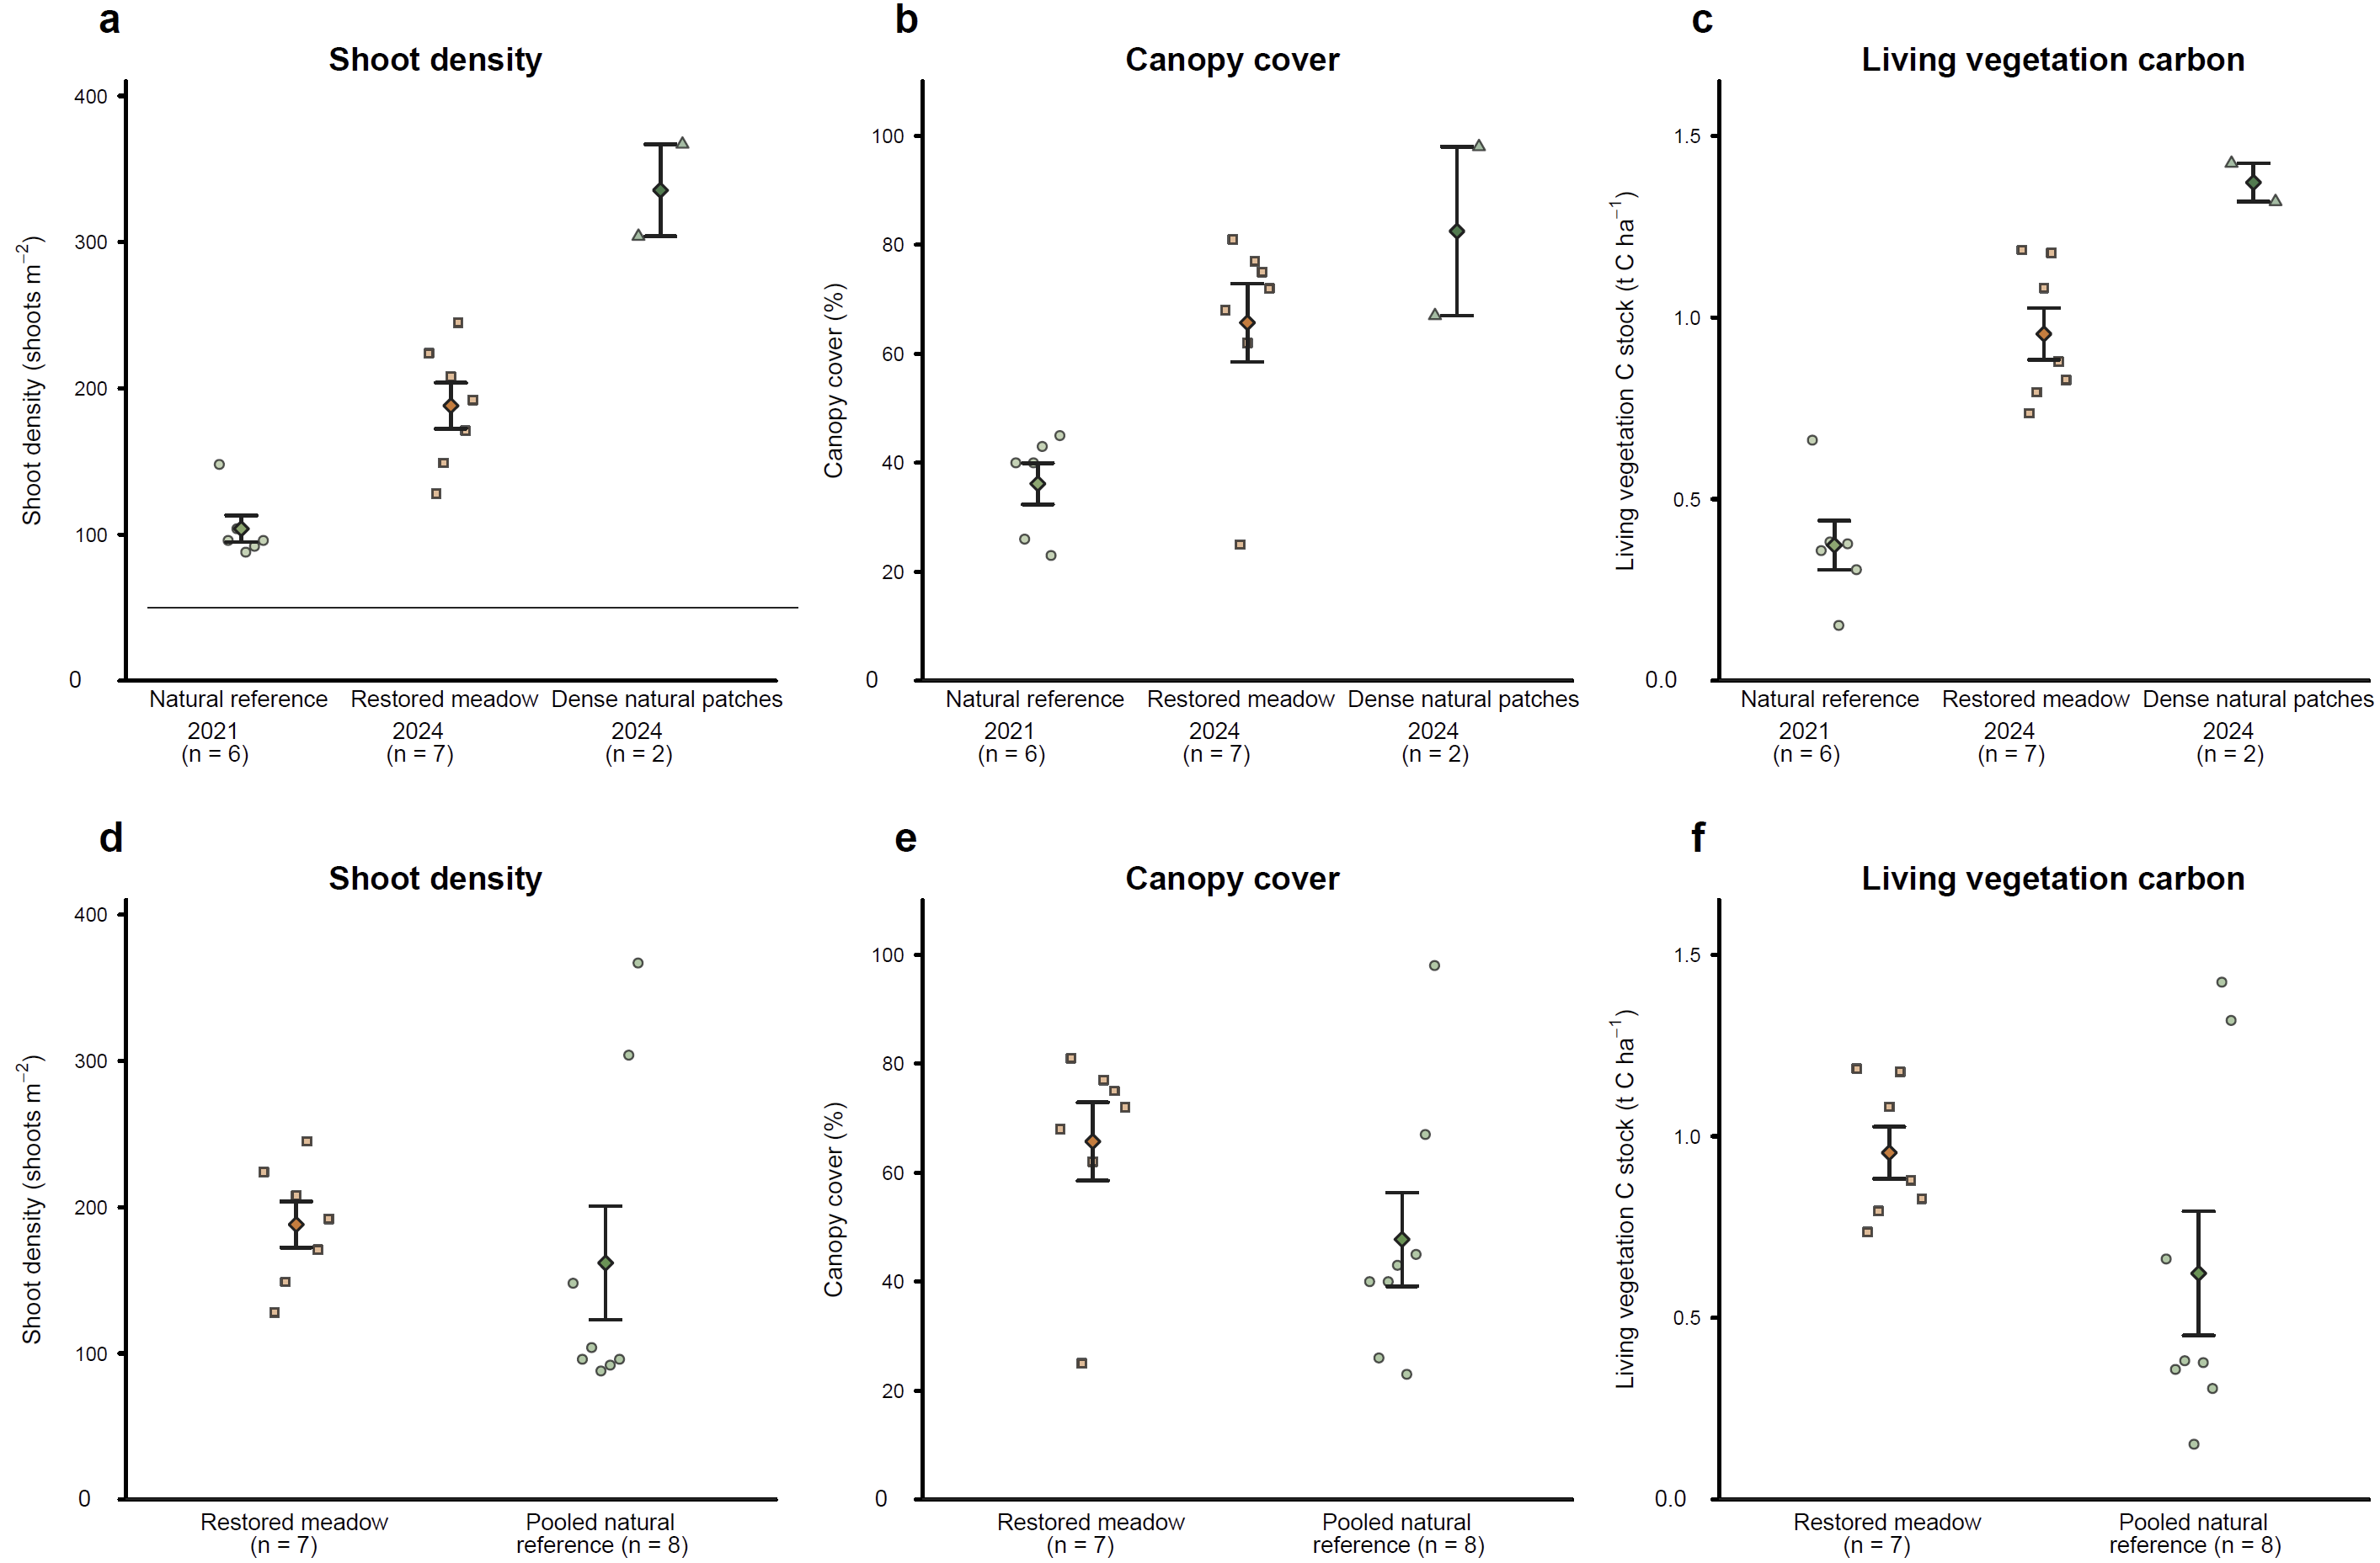
Supplementary Figure S5 | Station-level vegetation structure and living-vegetation carbon stocks in the restored meadow and natural reference. a–c, Year-resolved distributions of shoot density, canopy cover and total living-vegetation carbon stock, respectively, for the spatially distributed natural-reference survey conducted in 2021 (n=6), the restored meadow sampled in 2024 (n=7), and the targeted dense natural-reference patches sampled in 2024 (n=2). d–f, Corresponding comparisons between the restored meadow and the pooled natural reference, in which observations from the two natural-meadow surveys were combined (n=8) according to the primary analytical design. Small symbols denote independent sampling stations; diamonds and error bars show means ± SE. Total living-vegetation carbon represents the sum of above- and belowground biomass carbon stocks. The year-resolved panels are presented to characterize the spatial vegetation context of the natural reference and are not interpreted as tests of temporal change.

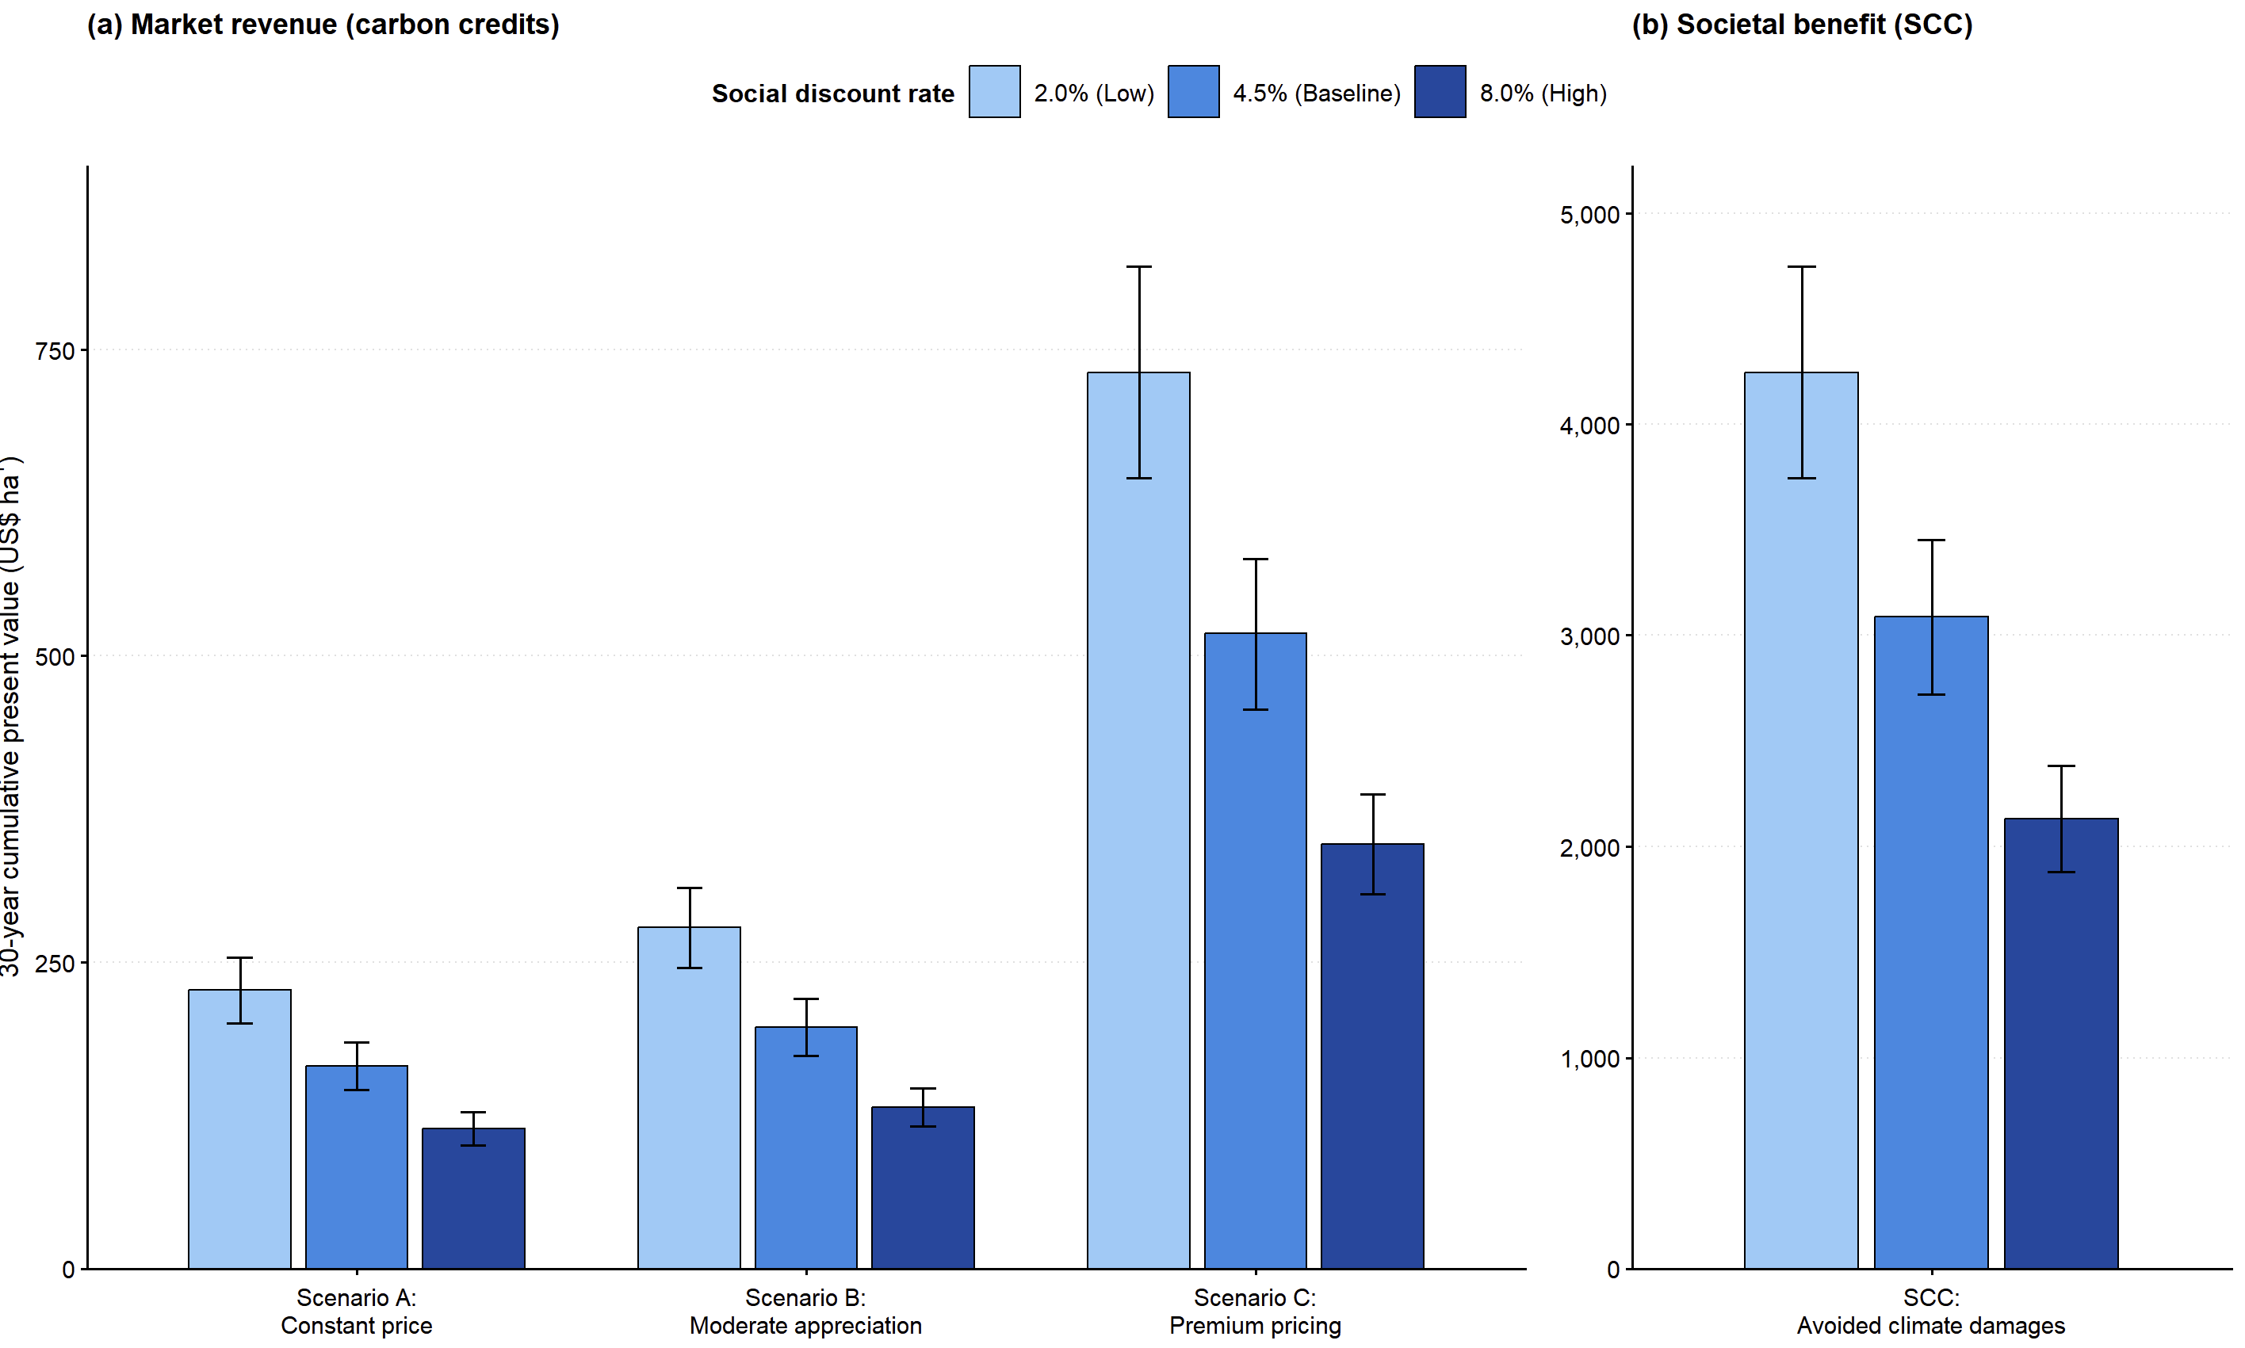
Supplementary Figure S6 | Sensitivity of the 30-year valuation of sedimentary carbon accumulation to the social discount rate. Cumulative present values of potential carbon-credit revenue under constant-price, moderate-appreciation and premium-pricing scenarios (a), and the societal climate benefit valued using the social cost of carbon (b), were calculated using annual discount rates of 2.0%, 4.5% and 8.0%. The 4.5% rate represents the baseline model. Bars show central estimates and error bars indicate ±1 propagated SE arising from the CFCS regression slope and the station-level mean sediment organic-carbon density.

Supplementary Table S1 | Scenario assumptions and 30-year present values of sedimentary carbon burial in restored seagrass meadows.
Valuation scenario | Valuation basis | Price assumptions | 30-year present value (2020 USD ha⁻¹) | Interpretation
A: Constant market price | Potential carbon-credit revenue | USD 9.91 tCO₂e⁻¹, zero real price growth over 30 years. | 165.4 ± 19.5 | Baseline evaluation using static voluntary market prices.
B: Moderate price appreciation | Potential carbon-credit revenue | Initial price of USD 9.91 tCO₂e⁻¹, applying a systemic 1.5% yr⁻¹ real appreciation from year 2. | 197.3 ± 23.3 | Valuation tracking macro-market tightening using the BCCT default.
C: Premium blue-carbon price | Potential carbon-credit revenue | Initial premium price of USD 26.03 tCO₂e⁻¹, applying the same systemic 1.5% yr⁻¹ real appreciation. | 518.1 ± 61.2 | Realistic projection of high-quality blue carbon asset value.
SCC-based valuation | Avoided global climate damages | USD 185 tCO₂e⁻¹, baseline held constant over 30 years. | 3,088.5 ± 364.7 | Monetization of avoided global climate damages.
Notes: All monetary inputs were expressed in constant 2020 USD. The analysis assumed an annual sedimentary carbon removal of 1.025 ± 0.121 CO₂e ha⁻¹ yr⁻¹ over 30 years. Present values were calculated using a baseline annual discount rate of 4.5%, with 2.0% and 8.0% evaluated in the sensitivity analysis. The 1.5% annual price-appreciation rate represents the expert-informed default used by the Blue Carbon Cost Tool (BCCT). Price trajectories, the SCC and discount rates were treated as deterministic scenario parameters. Reported uncertainties represent propagated SE associated with the estimated carbon-burial rate.

Supplementary Table S2 | Sensitivity of standardized 0–100 cm sediment organic-carbon stocks to deep-profile extrapolation
Deep-layer treatment | Bare flat,  n = 3 | Restored meadow, n = 7 | Natural reference,  n = 8 | Welch F  (df₁, df₂) | P
Lower observed-deep bound | 14.53 ± 2.58 | 19.71 ± 1.27 | 24.70 ± 3.53 | 2.62 (2, 5.70) | 0.156
deep mean  (This study) | 14.59 ± 2.54 | 20.66 ± 1.64 | 24.70 ± 3.53 | 2.90 (2, 6.51) | 0.126
Terminal layer | 14.70 ± 2.46 | 20.03 ± 1.13 | 24.70 ± 3.53 | 2.76 (2, 5.52) | 0.148
40+ cm weighted mean | 15.14 ± 2.59 | 21.43 ± 1.71 | 25.01 ± 3.49 | 2.82 (2, 6.56) | 0.130
Upper observed-deep bound | 15.76 ± 2.52 | 22.33 ± 1.71 | 25.10 ± 3.48 | 2.88 (2, 6.69) | 0.125
Notes: Deep mean: the submitted thickness-weighted mean concentration observed below 50 cm was applied across 50–100 cm. This is the primary author-defined extrapolation; Terminal layer: the concentration of the deepest recovered interval was carried forward to 100 cm; Lower observed-deep bound: the minimum concentration observed at or below 40 cm was applied across 50–100 cm; Upper observed-deep bound: the corresponding maximum was applied across 50–100 cm. The lower and upper are deterministic sensitivity bounds, not confidence intervals. The assumed concentration in each scheme was combined with the corresponding core-specific 50–100 cm dry bulk density. Values are mean ± SE in t C ha⁻¹. Sediment cores are the independent units. Welch’s one-way ANOVA compares the three habitats within each scenario.

