Supplementary Information
Lysine-functionalized layered double hydroxides for the antibiotics’ efficient removal: Controllable fabrication via BBD model and removing mechanism
Yuying Huª, Susu Liuª, Min Qiuª, Xiaohuan Zhengª, Xiaoming Peng ª, Hongling Daiª, Fengping Hu^{a,}, Li Xu^{b}, Gaoping Xu^{b}
ª School of Civil Engineering and Architecture, East China Jiaotong University, Nanchang 330013, Jiangxi Province, China
^{b} Jiangxi Province Key Laboratory of Drinking Water Safety, Nanchang, 330013, Jiangxi Province, China
The EDS elemental mapping
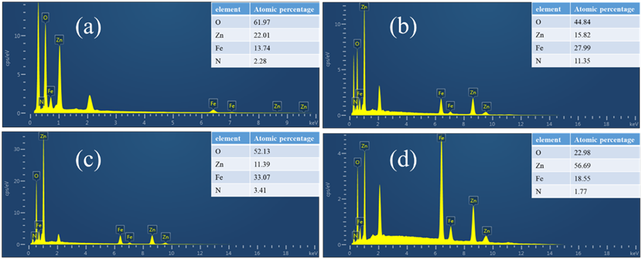
Fig. S1 EDS elemental mapping images of Ly @ FeZn (a), Ly @ FeZn-CIP (b), Ly @ FeZn-NOR (c) and Ly @ FeZn-OFL (d).
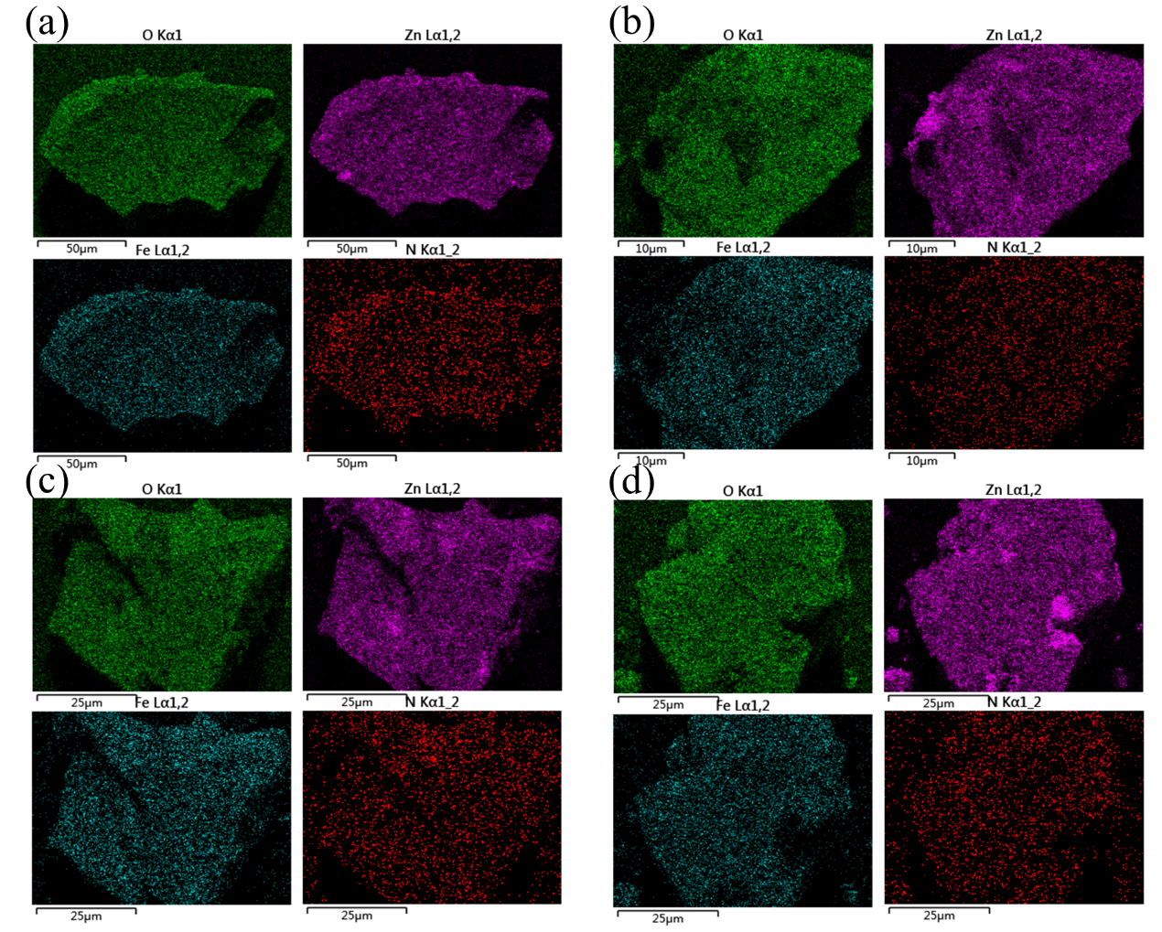
The elemental distribution mapping
Fig. S2 Elemental distribution mapping of Ly @ FeZn (a), Ly @ FeZn-CIP (b), Ly @ FeZn-NOR (c) and Ly @ FeZn-OFL (d)

The adsorption thermodynamics of Ly @ FeZn for CIP, NOR and OFL
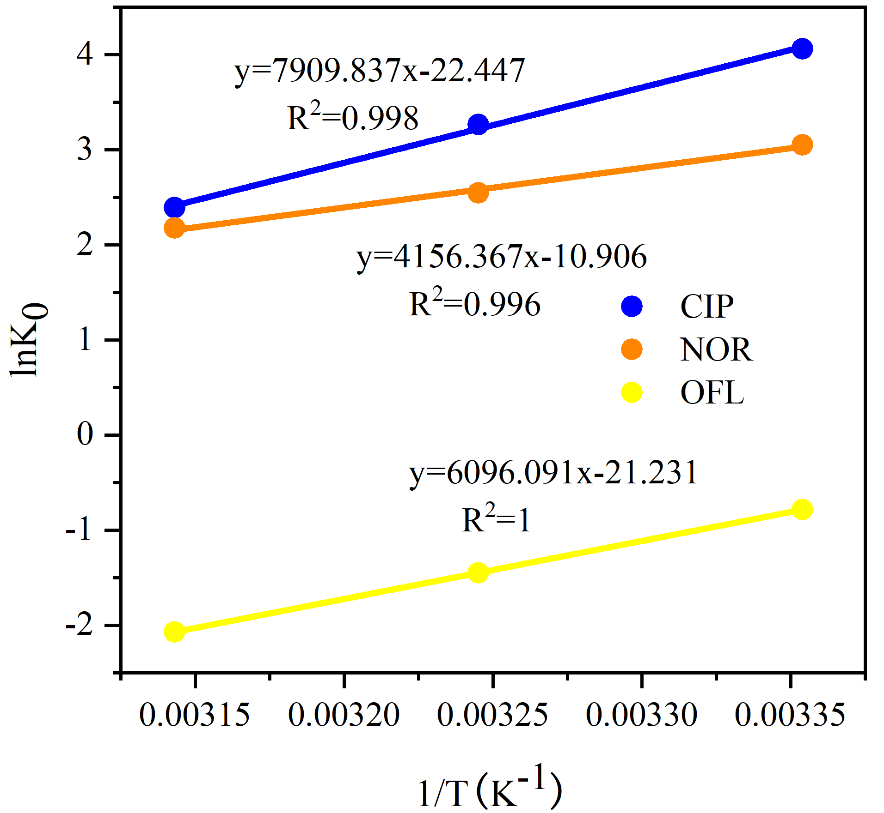
Fig. S3. Of Ink₀ vs 1/T for CIP, NOR and OFL adsorption on Ly @ FeZn at 298K, 308K and 318 K.

The regeneration experiments of Ly @ FeZn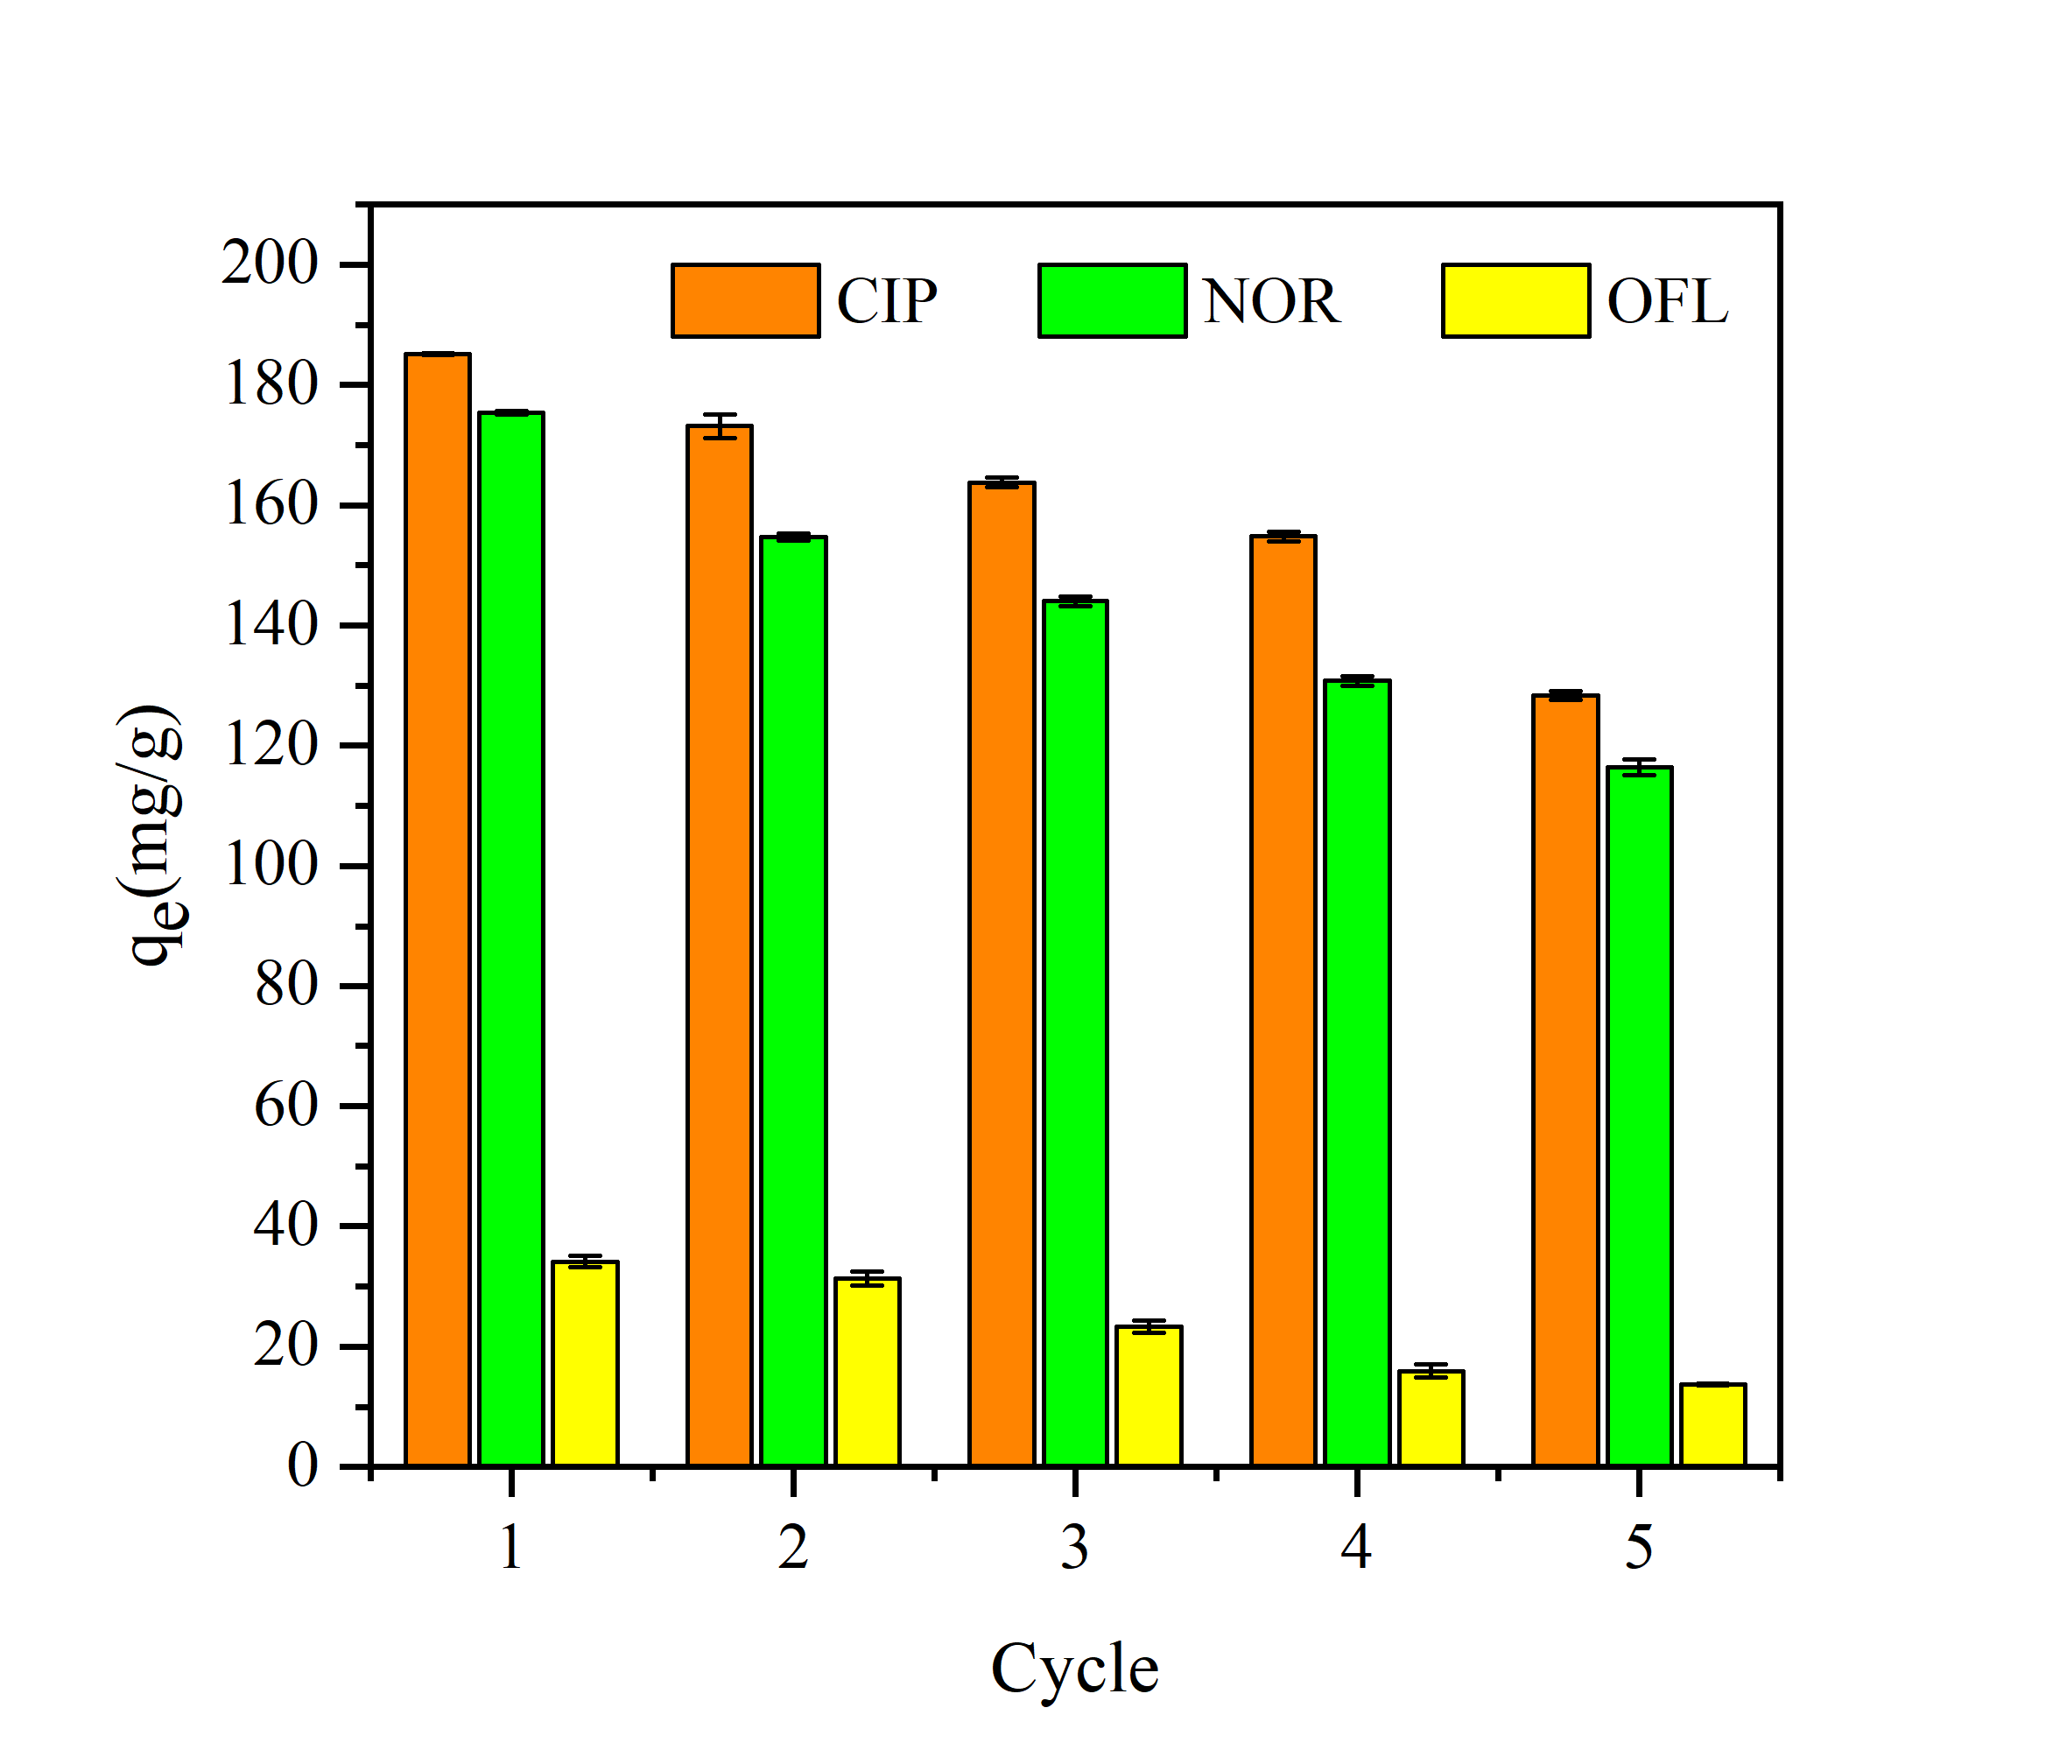
Fig. S4. Recycling experiments for removal of Ly @ FeZn for CIP, NOR and OFL.

Corresponding author. E-mail address: hufengping22@126.com (F. Hu).

