Supplement - Internal solitary waves as a global ocean hazard observed continuously by automated Sentinel-1 classification

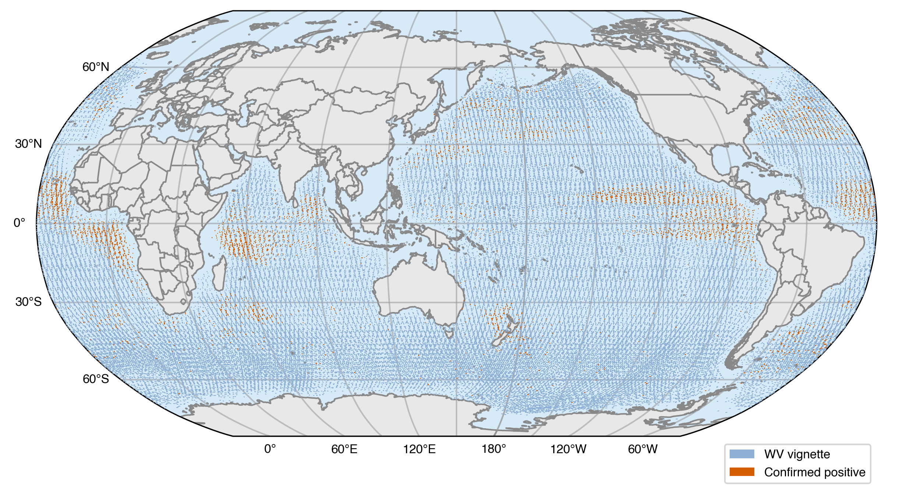

Supplementary Fig. 1 | Ocean area imaged by the Sentinel-1 WV archive, with confirmed detections. Every analysed WV vignette (4,064,170) drawn as its nominal 20-km footprint in light blue, with the human-confirmed-positive subset (19,167) overlaid in vermillion, on a single Robinson projection. The light-blue union is the ocean area physically imaged; its size is reported in Methods. This figure is the visual basis for the imaged-area statistic; observational reach and detection density appear in Fig. 1b and Fig. 2 respectively.

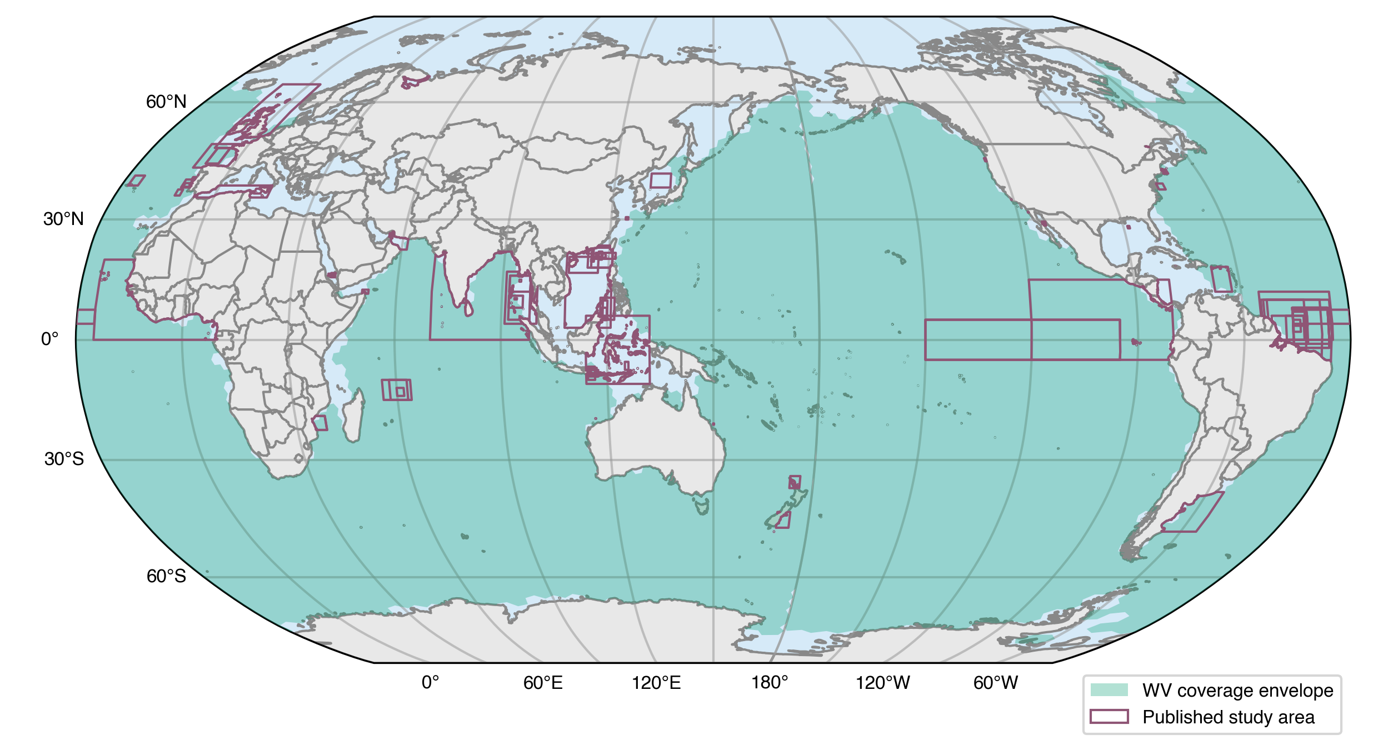

Supplementary Fig. 2 | The WV acquisition envelope and the prior study regions within it. The envelope is the dissolved union of H3 resolution-2 cells the analysed archive’s footprints occupy, clipped to ocean; prior study regions are drawn over it, filled where they intersect the envelope and outlined where they do not. Regions lying wholly outside it are those WV does not image — predominantly marginal seas, straits and shelf sites. Of the 105 study regions, 38 lie wholly outside the envelope. Within the envelope the prior record had examined about 10% of it (387 of 3,765 cells), against about 12% of the open ocean as a whole, so the contrast does not depend on which extent is used. The envelope grows as the harvest completes, so it is a lower bound on the ocean WV reaches, and the share above is therefore an upper estimate.
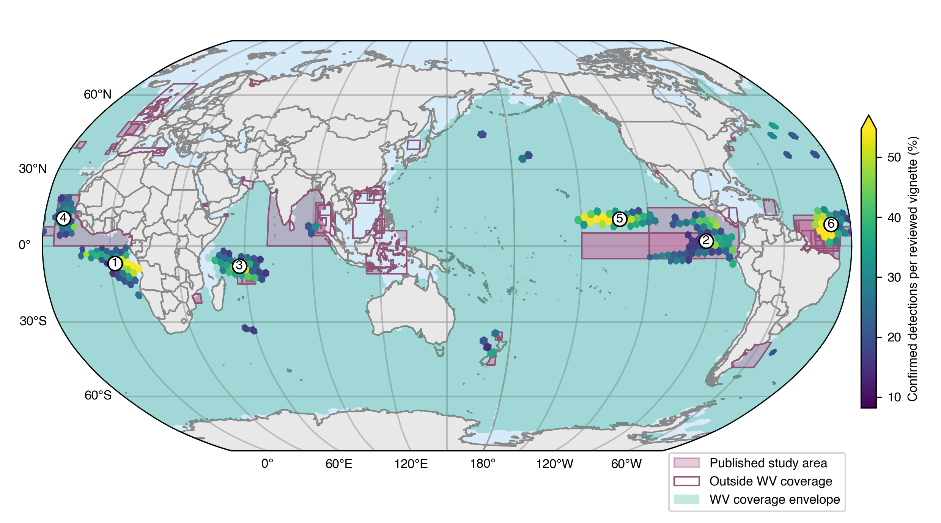

Supplementary Fig. 3 | Statistically elevated cells and the centres they form. Cells of the H3 geospatial grid (resolution 2) whose confirmed-detection rate exceeds the global reviewed-set rate at a Benjamini–Hochberg false-discovery rate of q ≤ 0.05, tested cell by cell with an exact binomial against 8.20% of reviewed vignettes. Colour gives confirmed detections per reviewed vignette on a viridis scale running from that global rate to 54.7%, the 95th percentile of the elevated cells and not their maximum, which is 100%; eleven cells exceed that bound and take the end colour. The denominator is expert-reviewed vignettes rather than all vignettes, because review coverage varies between cells by more than an order of magnitude. 208 cells are elevated, holding 14,784 confirmed detections, and they resolve into 19 connected centres. Numbered white circles mark the six largest, which together hold 74.5% of all confirmed detections: 1, eastern tropical Atlantic; 2, Pacific cold tongue; 3, Mascarene Ridge of the Indian Ocean; 4, off Guinea shelf and Cape Verde; 5, 10°N tropical Pacific; 6, off the Amazon shelf. Of the six, only centre 1 intersects no published study region. Prior study regions are drawn as reddish-purple boxes, clipped to the pale bluish-green WV acquisition envelope; boxes outlined but unfilled lie outside it. A cell that does not clear the test is not evidence of absence: a cell the classifier never fired in was never reviewed, and SAR detection of internal solitary waves is wind-limited throughout, so the occurrence field is a lower bound.
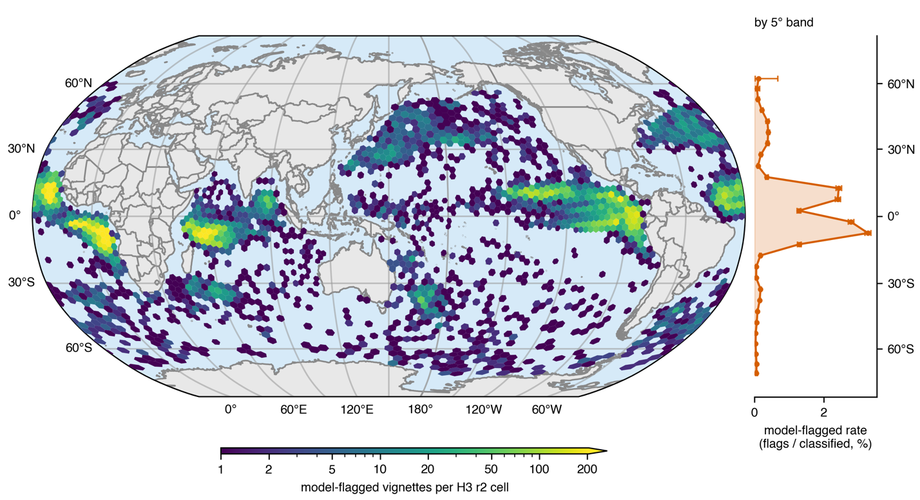
Supplementary Fig. 4 | Model-detected internal solitary waves, the unconfirmed tier. The classifier applied uniformly to every vignette of the Sentinel-1 WV archive at a fixed decision threshold of 0.935, without expert review. Density of model-flagged vignettes (25,440 of 4,064,170 classified) aggregated to equal-area cells of the H3 geospatial grid (resolution 2), colour giving flags per cell on a logarithmic viridis scale, drawn with the same binning, projection and colour scale as Fig. 2a. The profile along the right-hand edge shares the map's latitude axis and gives the model-flagged rate by 5° latitude band, flags divided by classified vignettes in that band: vermillion markers, line and horizontal whiskers giving 95% Wilson score intervals, with a pale vermillion fill to the axis. The two denominators differ and the profiles are not comparable in level: Fig. 2 reports confirmed detections per expert-reviewed vignette, this panel reports flags per classified vignette. What is comparable is shape. Both profiles peak in the tropics and both show a mid-latitude secondary rise that is stronger in the northern hemisphere; because the model is applied uniformly, the model-detected profile carries no term for where expert review has reached. This tier is reported for that comparison only. It is unconfirmed, its precision varies strongly with latitude, and it contributes no detection count reported elsewhere in this work.

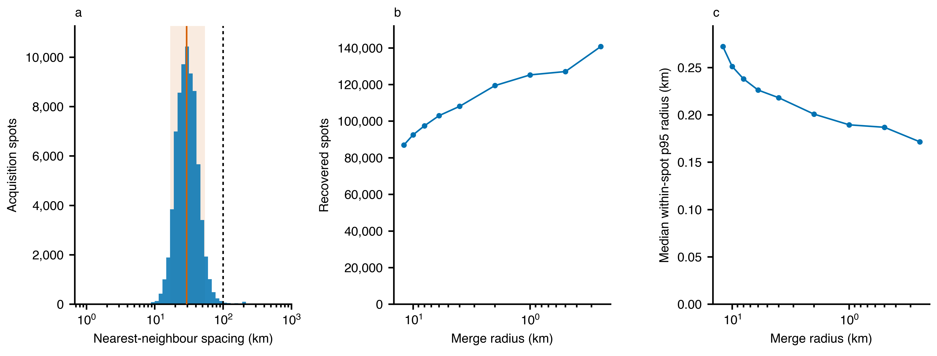

Supplementary Fig. 5 | Spatial structure of the Sentinel-1 WV acquisition field. a, Distribution of nearest-neighbour great-circle spacing between recovered acquisition spots (blue bars; n = 74,379 spots, recovered from 4,064,170 ocean vignettes). Spots are recovered by snapping vignette centroids to a 0.1° grid and merging eight-connected occupied cells, so separations closer than that aggregation are not resolved in this panel. The vermillion line marks the median spacing, 29.30 km; the pale vermillion band spans the 5th to 95th percentiles, 16.8 to 54.1 km; the black dashed line marks the mission’s nominal 100 km along-orbit spacing for a single track⁷⁵. Of all spots, 92.8% lie within 50 km of another. b, Number of recovered spots against the radius at which nearby acquisition positions are merged, radius decreasing to the right on a logarithmic axis. The count rises without settling at any radius, so no merge scale recovers a unique set of positions. Positions here are grouped by single-linkage clustering at each radius rather than by the grid-snap used in a, so the two counts are not directly comparable. c, Median 95th-percentile radius of repeat acquisitions about their own spot centre, over the same merge radii. It remains sub-kilometre at every radius tested, from 12 down to 0.25 km, so the positional repeatability reported in Methods, 0.33 km, is a property of the acquisition plan rather than of the grouping choice. Together the three panels show a dense field with no characteristic spacing, which is why imaged area and observational reach are quantified on an imposed equal-area grid rather than on the acquisition positions themselves.

