Supplemental Materials
Table S1. Statistical results for correlations between oscillatory activity and mood
Participant ID | P1 | P2
Fig 3A-B Kendall Tau
L-HPC | 0.26 (p<0.001) | n/a
R-HPC | 0.27 (p<0.001) | -0.16 (p=0.02)
Fz | 0.17 (p=0.002) | 0.16 (p=0.03)
Cz | 0.10 (p=0.09) | -0.26 (p<0.001)
Pz | 0.16 (p=0.0051) | -0.22 (p<0.001)
Fig 3C-D Kendall Tau
L-HPC | 0.31 (p<0.001) | n/a
R-HPC | 0.17 (p=0.0016) | -0.01 (p=0.84)
Fz | 0.22 (p<0.001) | nan
Cz | 0.15 (p=0.010) | -0.37 (p<0.001)
Pz | 0.15 (p=0.006) | 0.29 (p<0.001)
Fig S1B-C Kendall Tau
L-HPC | 0.14 (p=0.01) | n/a
R-HPC | 0.39 (p<0.001) | -0.17 (p=0.013)
Fz | -0.06 (p=0.32) | -0.44 (p<0.001)
Cz | -0.08 (p=0.13) | -0.23 (p<0.001)
Pz | 0.14 (p=0.01) | -0.39 (p<0.001)
Fig S2A-B Kendall Tau
L-HPC | 0.32 (p<0.001) | n/a
R-HPC | 0.25 (p<0.001) | 0.12 (p=0.07)
Fz | 0.19 (p=0.001) | 0.07 (p=0.35)
Cz | 0.09 (p=0.14) | -0.25 (p=0.001)
Pz | 0.16 (p=0.004) | -0.008 (p=0.91)
Fig S2C-D Kendall Tau
L-HPC | 0.31 (p<0.001) | n/a
R-HPC | 0.25 (p<0.001) | -0.26 (p<0.001)
Fz | 0.15 (p=0.007) | 0.07 (p=0.35)
Cz | 0.01 (p=0.86) | -0.21 (p=0.005)
Pz | 0.13 (p=0.03) | -0.03 (p=0.69)
Fig S2E-F Kendall Tau
L-HPC | 0.15 (p=0.007) | n/a
R-HPC | 0.34 (p<0.001) | 0.01 (p=0.92)
Fz | -0.02 (p=0.68) | nan
Cz | 0.04 (p=0.51) | -0.08 (p=0.28)
Pz | 0.12 (p=0.03) | -0.04 (p=0.56)

Table S2. Statistical results for hippocampal–cortical connectivity analyses
Participant ID | P1  L-HPC | P1  R-HPC | P2  R-HPC
Fig 4A Kendall tau
Fz | 0.13 (p=0.2) | -0.20 (p=0.03) | -0.26 (p=0.02)
Cz | 0.16 (p=0.08) | -0.24 (p=0.01) * | -0.24 (p=0.04)
Pz | -0.15 (p=0.1) | -0.37 (p<0.01) ** | -0.10 (p=0.4)
Fig 4B Cliff Delta
Fz | -0.23 | -0.46 ^ | -0.20
Cz | -0.28 | -0.19 | -0.30
Pz | 0.46 ^ | -0.14 | -0.22
Fig 5A Kendall tau
Fz | 0.17 (p=0.2) | 0.10 (p=0.3) | -0.20 (p=0.3)
Cz | 0.06 (p=0.6) | 0.11 (p=0.2) | -0.52 (p<0.01) **
Pz | -0.02 (p=0.9) | -0.02 (p=0.8) | -0.42 (p<0.01) **
Fig 5B Cliff Delta
Fz | 0.05 | -0.17 | -0.26
Cz | -0.38 ^ | -0.35 ^ | -1.0 ^^
Pz | 0.01 | -0.24 | -0.44 ^

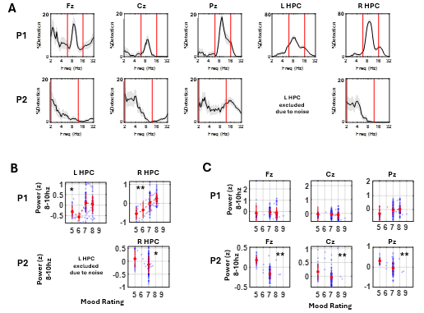
Figure S1. Oscillatory activity across recording structures. (A) Oscillatory detection rate across frequency 2-32hz. (B) Oscillatory activity quantified as band power (z-scored across the recording duration) and its correlation with mood ratings. HPC = hippocampus. Black asterisks indicate statistical significance after FDR correction. * indicates p < 0.05; ** indicates p < 0.01.

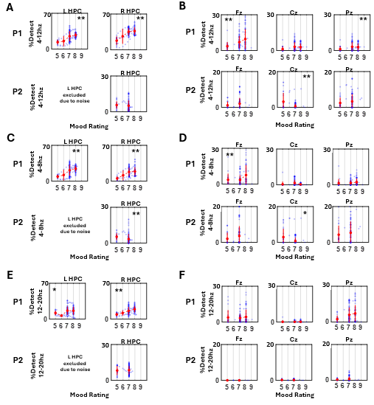
Figure S2. Oscillatory activity and mood across frequency bands. Theta–alpha (A, B), theta (C, D), and beta (E, F) bands are shown for the hippocampus and scalp EEG. HPC = hippocampus. Black asterisks indicate statistical significance after FDR correction; gray asterisks indicate uncorrected significance. * indicates p < 0.05; ** indicates p < 0.01.

