Supporting Information

Selective Hydrogenolysis of Glycerol to 1,2-Propanediol over a NaBH₄-Reduced Cu–Pd/TiO₂ Catalyst

Ado Ibrahim Yargaya, Shamsudeen Mikail, Suleiman Yusif Sule, Abbas Abdurrahman Yusuf, Manniru Abdullahi Ali, Ahmad Muhammad Sani, and Kittichai Chaiseeda*

Organic Synthesis, Electrochemistry and Natural Product Research Unit (OSEN), Department of Chemistry, Faculty of Science, King Mongkut’s University of Technology Thonburi, Bangkok 10140, Thailand

* Corresponding author. E-mail: kittichai.cha@kmutt.ac.th

- Chromatograms
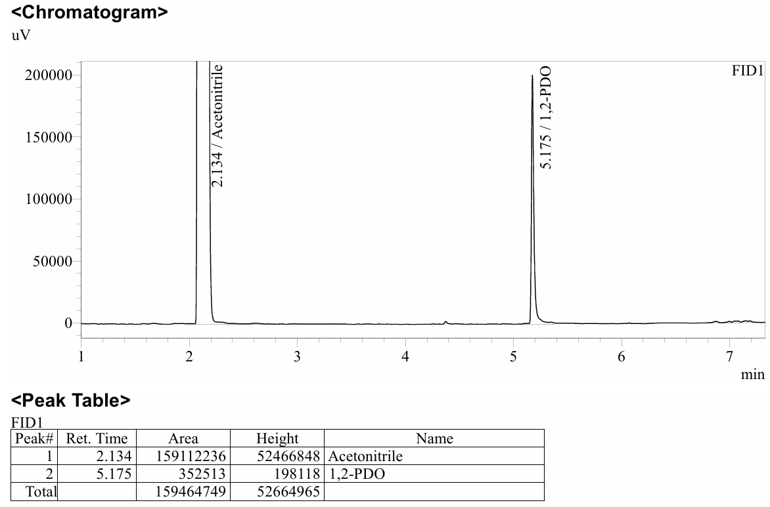
Fig. S1 GC chromatogram of the solketal standard used for peak identification and calibration.

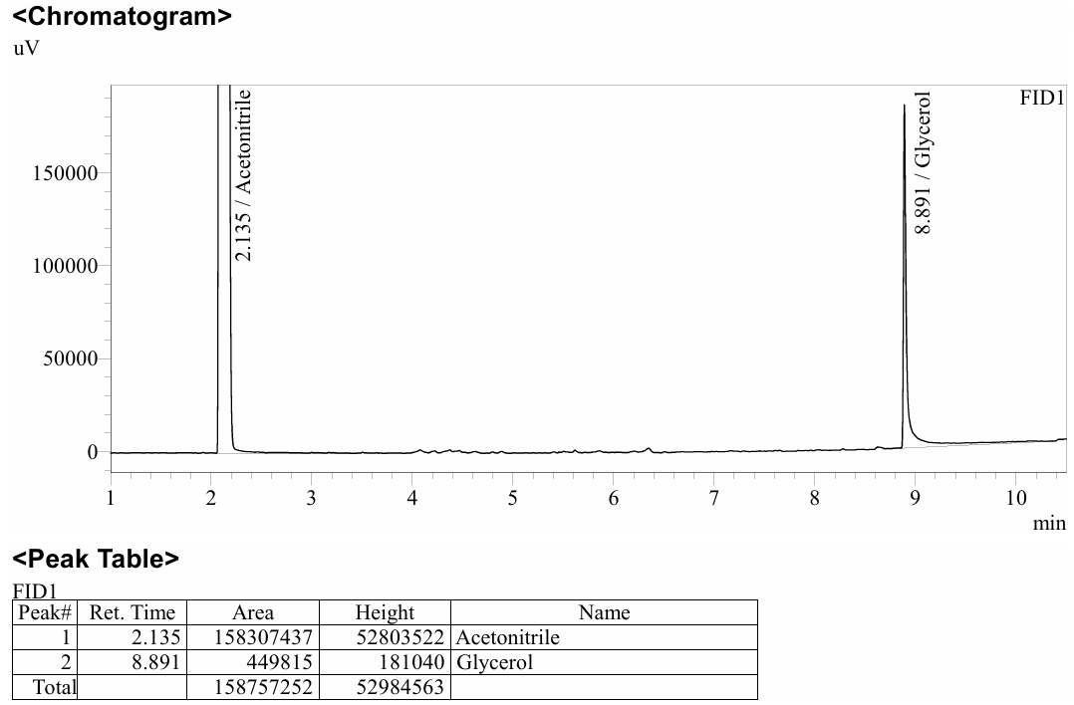
Fig. S2 GC chromatogram of the glycerol standard used for peak identification and calibration.

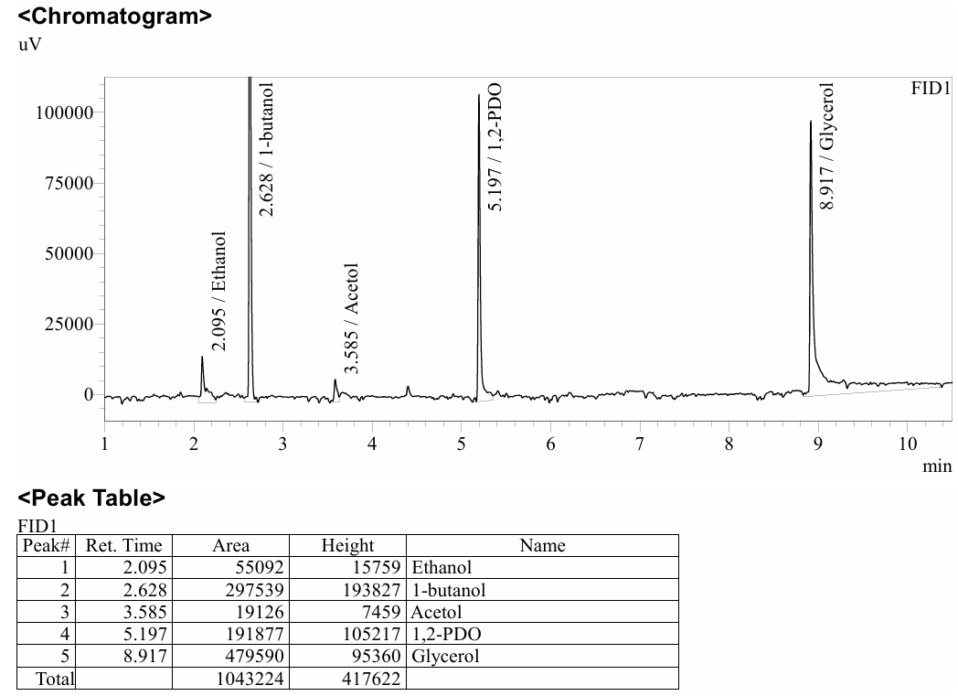
Fig. S3 GC chromatogram showing the effect of glycerol amount on glycerol conversion and product distribution.

- Table S1 GC Information
GC brand | Shimadzu
GC model | GC-2030
Autosampler model | AOC-30i
Detector type | FID
Column Brand | GC capillary column
Column model | VF-WAXms
Column coating material | Polyethylene glycol
Column Length (m) | 30.0
Column Diameter (mm) | 0.25
Column Film Thickness (μm) | 0.25
Injection Volume (μL) | 1.0
Carrier gas | He
Carrier Gas Flow Rate (mL/min) | N₂ (24 mL/min), H₂ (40 mL/min), Air (300 mL/min)
Injector temperature (°C) | 60
Detector temperature (°C) | 250
Equilibration Time (min) | 1.0
Oven temperature program | 60 °C (0 min hold), ramped at 20 °C/min to 250 °C (1 min hold), with a total run time of 10.5 minutes

