SUPPLEMENTARY INFORMATION

Screening Protein Conformational Responses by Molecular Friction Sensing

Pablo Porragas Paseiro^{1,2,3} , Lukas Aufinger¹, Alfred Kick², Tereza Jahodová^{1,4}, Veronica Hamer¹, Ulrich Rant^{1,2,5}*, Wouter Engelen¹*

¹ Bruker Dynamic Biosensors, Bruker Daltonics GmbH & Co. KG, Perchtinger Str. 8/10, 81379, Munich, Germany
² Kurt-Schwabe-Institut für Mess- und Sensortechnik Meinsberg e.V., Waldheim, 04736, Germany
³ Technical University Darmstadt Karolinenplatz 5, 64289 Darmstadt, Germany
⁴ Ludwig-Maximilians-Universität München, Butenandtstr. 5–13, 81377 Munich, Germany
⁵ Technical University Dresden, 01609 Dresden, Germany

* e-mail:
wouter.engelen@bruker.com
ulrich.rant@tu-dresden.de

Content:
- Note S1: Symbolic regression, protein-DNA conjugation, sample preparation and assay setup.
- Figure S1: Nonlinear least squares optimization of upwards trajectories fit.
- Table S1: Proteins used for covalent attachment to DNA origami nanolevers.
- Table S2: Analytes used in binding-induced conformational change experiments.
- Table S3: Protein-analyte specific switchSENSE conformational change assay parameters.
- Note S2: Hydrodynamic radius calculation from atomic coordinates.
- Figure S2: Leave-one-out (LOO) cross-validation of v_{diff} – R_{h} correlation.
- Figure S3: Accuracy of hydrodynamic radius measurement at varying fluorescence values.
- Figure S4: RMSD of R_{h} measurement at varying Fup values.
- Figure S5: Leave-one-out (LOO) cross-validation of vdiff – MW correlation.
- Note S3: Langevin dynamics Simulations.
- Figure S6: oxDNA simulations of the DNA origami nanolever.
- Figure S7: Langevin dynamics simulations of the surface tethered DNA origami nanolever.
- Figure S8: Langevin dynamics simulations of bare nanolever at varying temperature and glycerol concentration.
- Figure S9: Effect of protein net charge on error of molecular friction sensing derived Rh.
- Table S4: Reference calibration proteins and their respective net charges.
- Table S5: Hydrodynamic radius (Rh) of proteins measured by DLS.
- Note S4: Minimally detectable difference (MDD)
- Table S6: MDD for Calmodulin, Myokinase and LgBiT conformational change.
- Note S5: SPR Analysis
- Figure S10: Single concentration SPR hit screening sensorgrams
- Table S7: %Rmax values from a single-concentration binding screen at 10 µM analyte.
- Table S8: Kinetic rates of identified hits binding to carbonic anhydrase.
- Table S9: Chemical structures of compounds identified as binders in SPR screen and characterized with molecular friction sensing.
- Figure S11: SPR Titration Cycle Kinetic (TCK) sensorgrams of small molecules binding tightly to carbonic anhydrase.
- Figure S12: SPR Multi Injection Cycle Kinetic (MICK) sensorgrams of small molecules binding to carbonic anhydrase.
- FIgure S13: Molecular friction sensing characterization of the 22 confirmed carbonic anhydrase binders.
- Figure S14 to S287: proFIRE chromatograms.

Supplementary Note 1

Symbolic regression
To derive a quasi velocity v from the recorded upward fluorescence trajectories f(t), a single empirical closed-form function is fitted to each trace. The velocity (v) is defined as the analytical time derivative of the fitted function, evaluated at the half-maximum fluorescence time point. Because trajectory shapes vary with protein size, we sought a single functional form that generalizes well across a broad range of protein sizes. For this purpose, we employed Symbolic Regression using the PySR framework, which uses evolutionary search to identify compact closed-form expressions to reproduce the measured data while penalizing unnecessary complexity [1].
The symbolic regression was trained on the upward trajectories from the panel of 12 proteins shown in Figure 2. The operator set and limits were:

binary_operators=["+", "*", "^"]
unary_operators=["square", "cube", "exp", "sqrt"]
niterations=10000,maxsize=10, maxdepth=5

The selected expression was:
 | $$f\left(t\right)=a*b^{c^{\sqrt{t}}}$$ | Eq.1

Equation 1 was then fitted to each individual trace by nonlinear least squares to obtain (a,b,c) as shown in Figure S1.
After fitting each individual trace, the velocity (v) was obtained by computing the derivative at half-maximum fluorescence (Eq. 2).

 | $$v=f^{'}\left(t_{0.5}\right)=\frac{a*b^{c^{\sqrt{t_{0.5}}}}*ln\left(b\right)*c^{\sqrt{t_{0.5}}}*ln(c)}{2\sqrt{t_{0.5}}}$$ | where $f\left(t_{0.5}\right)=0.5$ | Eq.2

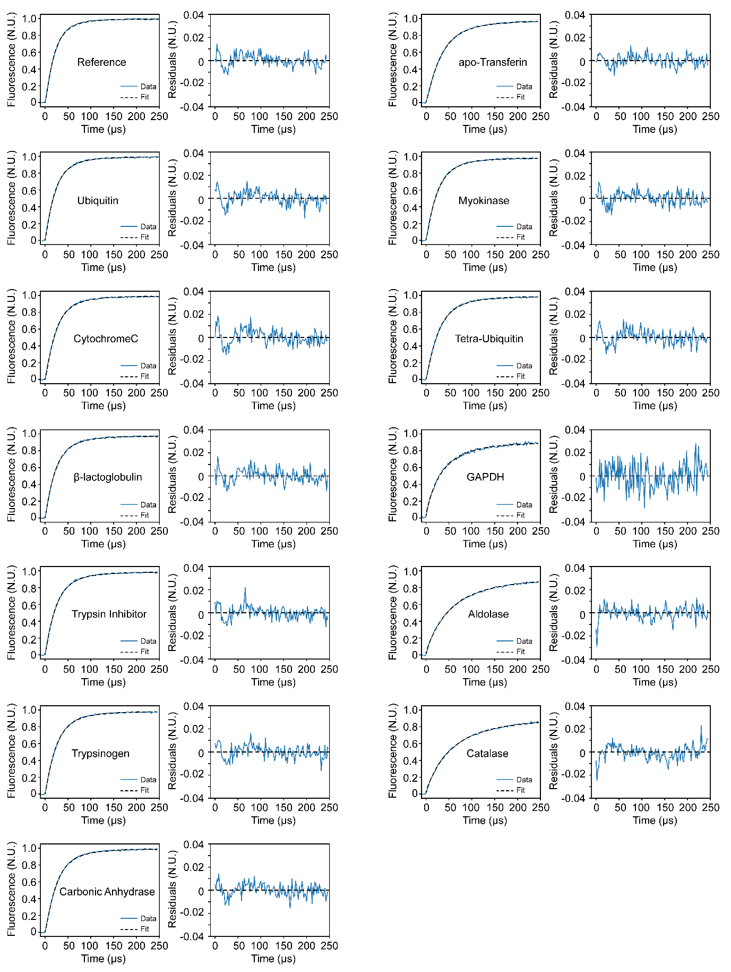
Figure S1: Nonlinear least squares optimization of Eq.1 to the upwards trajectories of the protein panel in Figure 2. For each protein, the upwards trajectory, the resulting fitted trace, and the residuals computed by subtracting the fitted curve from the raw data are shown.

Preparation of Protein-DNA Conjugates
Protein-DNA conjugates were prepared using standard amine coupling to conjugate the proprietary Dynamic Biosensors ‘Ligand Strand NHS’ to the proteins of interest. Conjugation reactions were carried out according to HK-NHS-1 kit (Dynamic Biosensors GmbH) instructions. Proteins of interest were prepared to a final concentration of 1 mg/mL in the corresponding buffers listed in Table S1 to be compatible with the conjugation reaction. Note: for LgBiT conjugation, purification spin columns were equilibrated to Buffer M (50 mM MES, 150 mM NaCl, pH 6.5).

ProFIRE Purification
The Protein-DNA conjugates were purified from non-conjugated oligonucleotide and free protein according to the proFIRE® ion-exchange chromatography workflow (Dynamic Biosensors GmbH) with a gradient of Buffer B (50 mM Na₂HPO₄/NaH₂PO₄, 1 M NaCl, pH 7.2) in Buffer A (50 mM Na₂HPO₄/NaH₂PO₄, 150 mM NaCl, pH 7.2) according to the manufacturer instructions (Dynamic Biosensors GmbH, User Manual_proFIRE®_v20221108). The proFIRE® Data Viewer software was used to determine which conjugate peaks were suitable for collection. The selected fractions were pooled and buffer exchanged to TE40 buffer (10 mM Tris, 40 mM NaCl, 50 µM EDTA, 50 µM EGTA, 0.05% Tween®20) and concentrated with 10 kDa MWCO tubes according to kit HK-NHS-1 (Dynamic Biosensors GmbH) instructions. The final concentration of the Protein-DNA conjugate was determined by measuring the absorbance at 260 nm. Concentration was adjusted to 1 µM in TE40 buffer and the purified conjugates were aliquoted, flash frozen in liquid nitrogen and stored at -80 °C until further use.

Hybridization of DNA Origami Nanolevers to Proteins of Interest
Proteins of interest were hybridized to DNA origami nanolevers according to kit instruction (HK-ORM-1, Dynamic Biosensors GmbH). In short, Ligand Strand-protein conjugates or Ligand-free strand were diluted to 250 nM in Origami Buffer. Origami Nanolever 1 - Ra (20 nM) was mixed with Ligand Strand-protein conjugate (250 nM) at 1:1 ratio (v/v) while Origami Nanolever 2 - Ra (20 nM) was mixed with Ligand-free strand (250 nM) at 1:1 ratio (v/v). Origami nanolever 1 and Origami nanolever 2 solutions were incubated separately at room temperature at 600 rpm for 2 hours. Finally, the nanolever solutions were mixed at a 1:1 ratio (v/v).

Table S1: Proteins used for covalent attachment to DNA origami nanolevers
Protein | manufacturer | Cas # | Catalog # | Accession # | Buffer exchange | Direct Resuspension
Ubiquitin | R&D systems | 79586‑22‑4 | U-100H | P0CG47.1 | - | Buffer C
Cytochrome C | Sigma-Aldrich | 9007-43-6 | C3131 | P62894 | - | Buffer C
β-Lactoglobulin | Sigma-Aldrich | 50863-92-8 | L7880 | P02754 | - | Buffer C
Trypsin Inhibitor | Sigma-Aldrich | 9035-81-8 | T9003 | - | - | Buffer C
Trypsinogen | Sigma-Aldrich | 9002-08-8 | T1143 | Q29463 | - | Buffer C
Carbonic Anhydrase | Sigma-Aldrich | 9001-03-0 | C2273 | - | - | Buffer C
Myokinase | Sigma-Aldrich | 9013-02-9 | M3003 | - | Yes, Buffer C | -
Tetra-Ubiquitin | Enzo | - | BML-UW0785 | Q96C32 | Yes, Buffer C | -
apoTransferrin | Sigma-Aldrich | 11096-37-0 | T1147 | - | - | Buffer C
GAPDH | Supelco | 9001-50-7 | G5262 | - | - | Buffer C
Aldolase | Sigma-Aldrich | 9024-52-6 | A2714 | - | - | Buffer C
Catalase | Sigma-Aldrich | 9001-05-2 | C40 | P00432 | - | Buffer C
Calmodulin | Sigma-Aldrich | - | C4874 | P62157 | - | Buffer C
LgBiT | Promega | - | N401C | - | Yes, Buffer M | -
MalE | NKMAXBio | - | MBP0801 | P0AEX9 | Yes, Buffer C | -

Table S2: Analytes used in binding-induced conformational change experiments
Protein of Interest | Analyte | Abbr. | Concentration (M) | Cas # | Distributor | Manufacturer
Carbonic Anhydrase | 4,5-Dichlorothiophene-2-sulfonamide | DCS | 5.63 E-08 | 256353-34-1 | Santa Cruz Biotechnology | Santa Cruz Biotechnology
Carbonic Anhydrase | EMAC10101d | EMAC | 2.52 E-07 | 2561476-24-0 | Biozol | Targetmol
Carbonic Anhydrase | U-104 | WWZ | 8.82 E-06 | 178606-66-1 | Biozol | Targetmol
Carbonic Anhydrase | Dorzolamide | ETS | 8.38 E-09 | 130693-82-2 | Biozol | Targetmol
Carbonic Anhydrase | 4-Sulfamoylbenzoic acid | 4SO | 3.41 E-05 | 138-41-0 | Biozol | Abmole Bioscience
Carbonic Anhydrase | Cyclothiazide | CYZ | 1.83 E-05 | 2259-96-3 | Biozol | Targetmol
Carbonic Anhydrase | Hydrochlorothiazide | HCZ | 4.68 E-05 | 58-93-5 | Biozol | Targetmol
Carbonic Anhydrase | AEG 3482 | AEG | 5.16 E-09 | 63735-71-7 | Biozol | Targetmol
Carbonic Anhydrase | Methazolamide | MZM | 1.22 E-06 | 554-57-4 | Biozol | Targetmol
Carbonic Anhydrase | Pifithrin-mu | PIF | 1.93 E-07 | 64984-31-2 | Biozol | Targetmol
Carbonic Anhydrase | Brinzolamide | BZ1 | 4.07 E-09 | 138890-62-7 | Biozol | Targetmol
Carbonic Anhydrase | 3,5-difluorobenzenesulfonamide | FBU | 1.37 E-07 | 140480-89-3 | Merck | Fluorochem
Carbonic Anhydrase | Dansylamide | MNS | 6.39 E-05 | 1431-39-6 | Biozol | Targetmol
Carbonic Anhydrase | Acetazolamide | AZM | 5.48 E-07 | 59-66-5 | Biozol | Targetmol
Carbonic Anhydrase | Celecoxib | CEL | 4.79 E-05 | 169590-42-5 | Biozol | Targetmol
Carbonic Anhydrase | 4-fluorobenzenesulfonamide | FBS | 3.47 E-05 | 402-46-0 | Merck | Fluorochem
Carbonic Anhydrase | 4-Bromo-3-methylbenzenesulfonamide | BMB | 7.27 E-06 | 879487-75-9 | Merck | Fluorochem
Carbonic Anhydrase | 2-Methyl-5-nitrobenzenesulfonamide | MNB | 2.03 E-05 | 6269-91-6 | Biozol | Toronto Research Chemicals
Carbonic Anhydrase | Sulfanilamide | SAN | 1.38 E-04 | 63-74-1 | Merck | Sigma-Aldrich
Carbonic Anhydrase | Irosustat (667-coumate) | 667 | 4.63 E-07 | 288628-05-7 | Biozol | Taregtmol
Carbonic Anhydrase | Furosemide | FUN | 1.13 E-06 | 54-31-9 | Merck | Sigma-Aldrich
Carbonic Anhydrase | Trichlormethiazide | TRU | 5.01 E-05 | 133-67-5 | Biozol | Taregtmol
Maltodextrin Binding Protein | Maltose | - | 50 E-06 | 6363-53-7 | Merck | Sigma-Aldrich
Maltodextrin Binding Protein | Maltotriose | - | 50 E-06 | 207511-08-8 | Merck | Sigma-Aldrich
Maltodextrin Binding Protein | Maltotetraose | - | 50 E-06 | 34612-38-9 | Merck | Sigma-Aldrich
Maltodextrin Binding Protein | Lactose | - | 50 E-06 | 64044-51-5 | Merck | Sigma-Aldrich
Maltodextrin Binding Protein | Maltotriitol | - | 50 E-06 | 32860-62-1 | Synthose | Synthose
Maltodextrin Binding Protein | Maltotetraitol | - | 50 E-06 | 66767-99-5 | Synthose | Synthose
Calmodulin | Calmodulin Inhibitory Peptide | CIP | 10 E-09 | - | Merck | Calbiochem
Myokinase | P¹,P⁵-Di(adenosine-5′) pentaphosphate pentasodium salt | AP₅A | 10 E-06 | 4097-04-5 | Merck | Sigma-Aldrich
LgBiT | HiBiT | - | 7 E-09 | 1628912-54-8 | GenScript Biotech | GenScript Biotech

Table S3: Protein-analyte specific switchSENSE conformational change assay parameters.
Protein Conjugate | # switching cycle repeats | Acquisition time (s) | LED Power (%) | Running Buffer
Carbonic Anhydrase | 5 | 60 | AUTO | P140 + 2.5% DMSO
Maltodextrin Binding Protein | 5 | 180 | 2.5 | TE100
Calmodulin | 3 | 180 | 2.5 | TE140 + 2 mM CaCl₂
Myokinase | 3 | 180 | 2.5 | TE50 + 1 mM MgCl₂
LgBiT | 4 | 180 | 2.5 | TE140

Conformational change experiments were performed on the heliX⁺ biosensor (Dynamic Biosensors GmbH). Unless stated otherwise, assay temperature was set to 20 °C. Analytes were diluted in their assay specific running buffer. Association time was set to 300 s and association flow rate to 40 µL/min. Ligand and analyte specific assay conditions are listed in Table S3.
Carbonic anhydrase binders were freshly dissolved in DMSO to concentrations corresponding to 400x K_{d}, obtained from SPR characterization and aliquoted in well plates. Well plates were then stored at -80 °C. Directly before use, a well plate was equilibrated to room temperature and analytes were diluted to a concentration corresponding to 10x K_{d} by diluting the DMSO stocks 40-fold in P140 (10 mM Na₂HPO₄/NaH₂PO₄, 140 mM NaCl and 0.05 % Tween®20; 0.2 µm sterile filtered), yielding a final DMSO content of 2.5 %.

Supplementary Note 2
Hydrodynamic radius calculation from atomic coordinates
To estimate the hydrodynamic radius of the proteins analysed in this study, atomic coordinates were obtained from the Protein Data Bank (PDB) whenever experimentally determined crystal structures were available. Each PDB file was manually curated to remove oligomeric states arising from crystal packing. Additionally, all water molecules, non-essential ligands, and ions not occupying their physiological binding sites were removed. Non-native terminal residues protruding from the native protein structure (e.g., 6xHis tags) were also manually deleted.
Hydrodynamic properties were computed using HYDROPRO (version 10) [2, 3]. An initial run was performed to estimate the minimum and maximum bead radii (SIGMIN and SIGMAX) using the following parameters:

INDMODE: 1
AER: 2.9
NSIG: -1
T: 20
ETA: 0.01

After determining optimal SIGMIN and SIGMAX, a second run was executed with the number of minibead radii set to 10 (NSIG: 10). From the translational diffusion coefficients (D) computed by HYDROPRO, the hydrodynamic radius was derived using the Stokes-Einstein relation:

 | $$R_{h}= \frac{k_{B}T}{6πμD}$$ | Eq.3
Where:
μ = 1.0 cP
T = 293.15 K

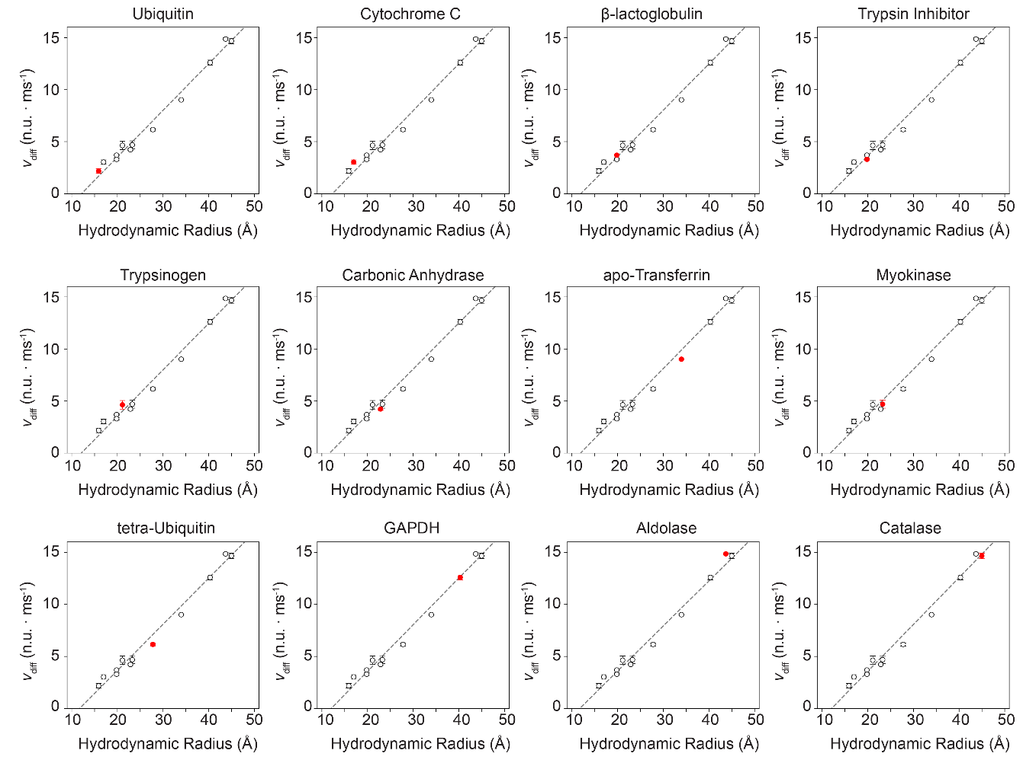
Figure S2: Leave-one-out (LOO) cross-validation of v_{diff} vs. R_{h} correlation.

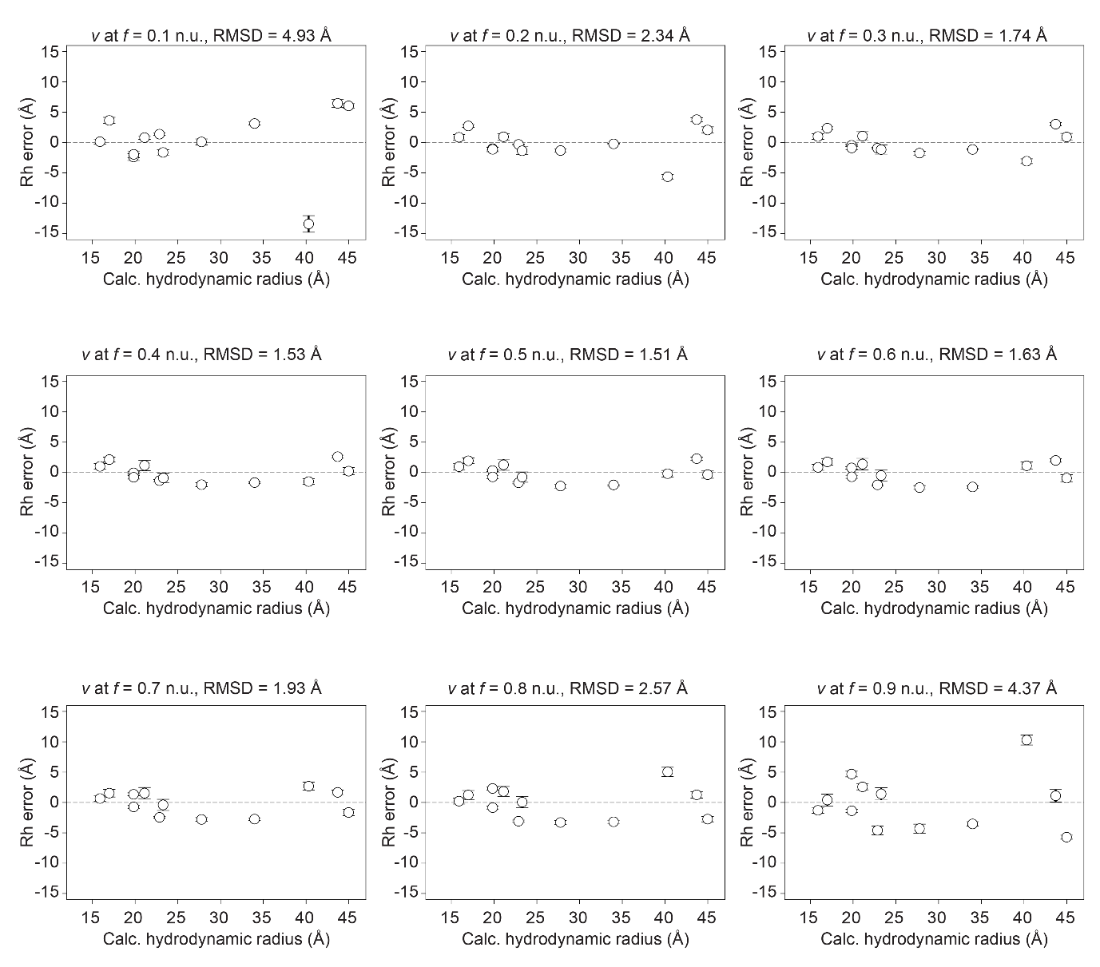
Figure S3: Accuracy of hydrodynamic radius measurement at varying fluorescence values. The differential velocity (v_{diff}) was determined for all proteins at different fluorescence values ranging from 0.1 to 0.9 n.u. by calculating the derivative of the upwards trajectories at the respective fluorescence values. Following LOO cross-validation the difference (R_{h} error) between calculated theoretical hydrodynamic radius and measured hydrodynamic radius is calculated. The root mean square deviation from the true hydrodynamic radius indicates the overall accuracy of hydrodynamic radius measurements at the respective fluorescence value.
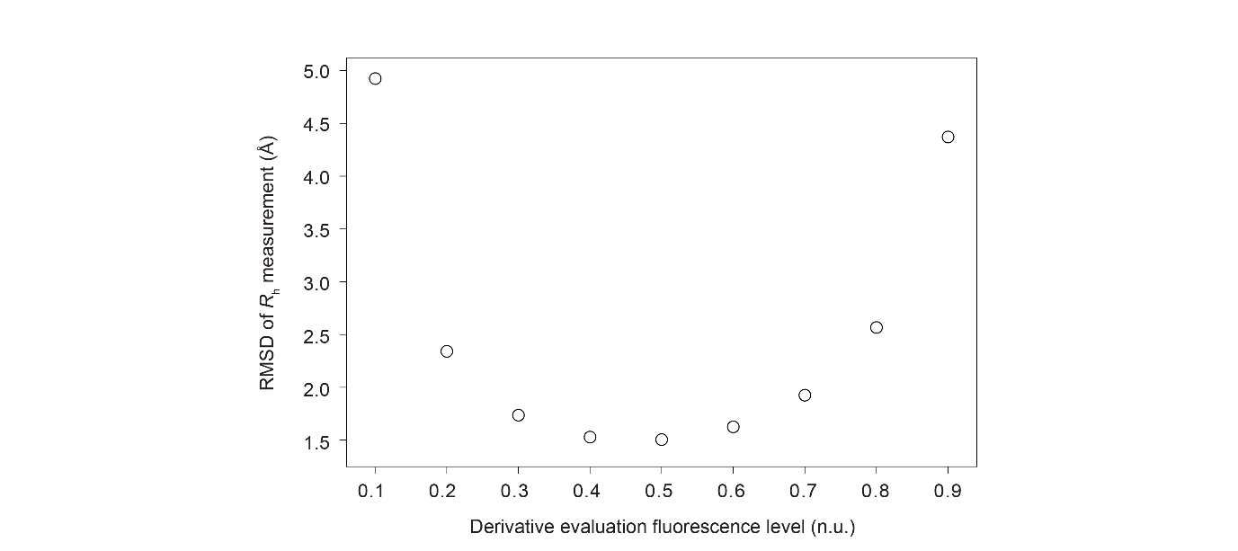
Figure S4: RMSD of hydrodynamic radius measurement at varying fluorescence values. Smallest RMSD of hydrodynamic radius measurement is obtained by deriving the velocity at f = 0.5 n.u.

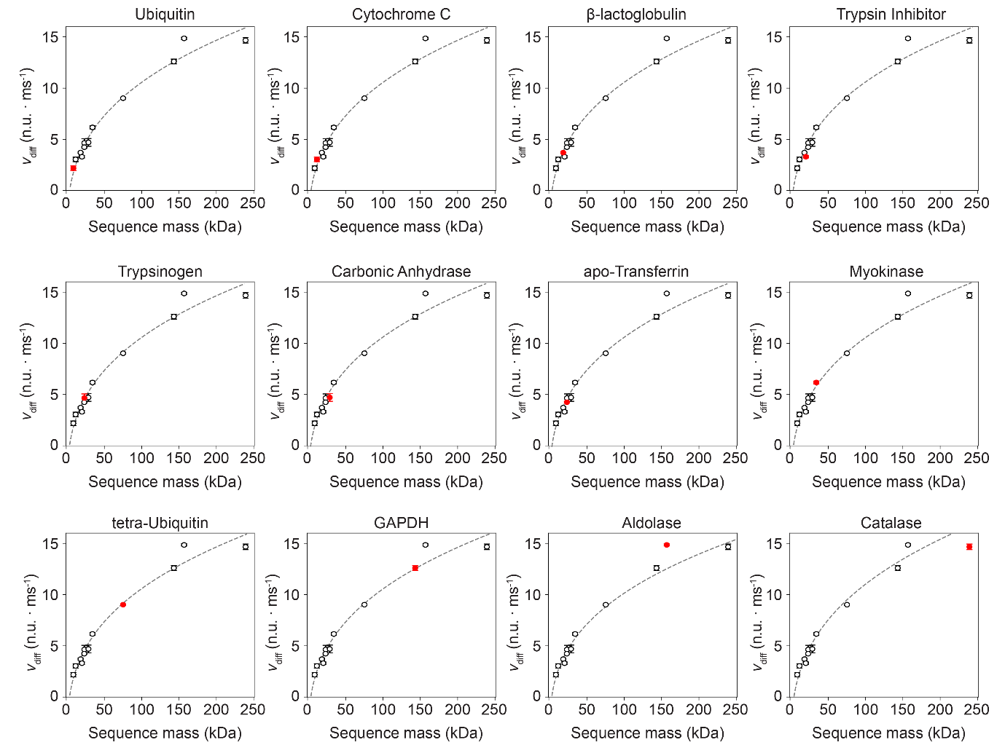
Figure S5: Leave-one-out (LOO) cross-validation of v_{diff} vs. MW correlation.

Supplementary Note 3
Langevin dynamics Simulations
Assumptions:
- Electric field for the majority of the nanolever is negligible at physiological ionic strength: Debye length λ_{D} << L.
- The DNA origami nanolever is significantly larger than the attached protein: L >> R.
- There are no noncovalent interactions between the protein and nanolever.

To simulate the upward trajectory of a protein-functionalized DNA origami nanolever, we approximate the nanolever as a rigid, end-tethered rod rotating in a 1-dimensional energy landscape. The overdamped Langevin equation for the angular coordinate θ (angle between the longitudinal axis of the nanolever and the surface plane) is:
 | $$dθ=\sqrt{2D_{rot}}dW+D_{rot}\frac{δ\ln{p(θ)}}{δθ}dt$$ | Eq.4

where,
D_{rot} = k_{b}T / ζ is the rotational diffusion coefficient, with ζ the rotational friction coefficient.
dW is a Wiener increment drawn from the normal distribution N(0, dt).
p(θ) is the equilibrium probability distribution. [4]

For a freely rotating end-tethered rod in the absence of external fields:

 | $$p\left(θ\right)∝cos⁡(θ)$$ | Eq.5

Substituting Eq. 5 into the drift term of Eq. 4:
 | $$D_{rot}\frac{δ\ln{p(θ)}}{δθ}=D_{rot}\frac{δ\ln{cos(θ)}}{δθ}=-D_{rot}tan(θ)$$ | Eq.6

Thus Eq. 4 becomes:
 | $$dθ=\sqrt{2D_{rot}}dW-D_{rot}\tan{(θ)}dt$$ | Eq.7

Rotational friction for a uniform rod
The rotational friction coefficient ζ_{rod} of a rigid, slender rod tethered at one end to an immobile surface is:
 | $$ζ_{rod}=\frac{4πη}{3(ln(p)+C_{r})}L^{3}$$ | Eq.8

where:
p = L / d is the aspect ratio of the nanolever.
C_{r} is the finite-aspect-ratio correction for rotational friction of an end-tethered rod.

Rotational friction for a segmented rod
For a rod composed of multiple segments with varying diameter:
 | $$ζ_{rod}=\int_{0}^{L}{λx^{2}dx}$$ | Eq.9

where λ is the local friction per unit length:
 | $$λ=\frac{4πη}{ln(p)+C_{i}}$$ | Eq.10

Thus, for a rod of N segments:
 | $$ζ_{rod,seg}=\frac{4πη}{3}\sum_{i=1}^{N}{\frac{{x_{i,end}}^{3}-{x_{i,start}}^{3}}{\ln\left(p_{i}\right)+C_{i}}}$$ | Eq.11

where:
x_{i,start} and x_{i,end} are the segment boundaries along the rod.
p_{i} = L / d_{i}
C_{i} is the per segment finite-aspect-ratio correction to the perpendicular translational drag coefficient [5].

 | $$C_{i}=0.84+\frac{0.185}{p_{i}}+\frac{0.233}{{p_{i}}^{2}}$$ | Eq.12

Geometric analysis of DNA origami nanolever

The DNA origami nanolever was simulated using oxDNA at a salt concentration of 140 mM NaCl [6, 7, 8, 9, 10]. The mean structure obtained from the simulation was manually segmented into three domains based on their distinct cross-section geometry (Anchor, 4-helix bundle, Ligand). Each segment was analyzed independently to characterize its geometric properties as follows.
First, the particle coordinates were centered at the centroid of the segment. Next, a Principal Component Analysis (PCA) was performed on the covariance matrix of all atom coordinates, yielding three orthogonal eigenvectors that correspond to the three principal axes of the fragment. For each axis, its length was calculated as the difference between the maximum and minimum projections of the coordinates along the respective eigenvector, with the major axis defining L_{i}. To approximate the effective cross-section size of each fragment, an equivalent diameter d_{i} was calculated as the square root of the product of the extends along the two minor axes.

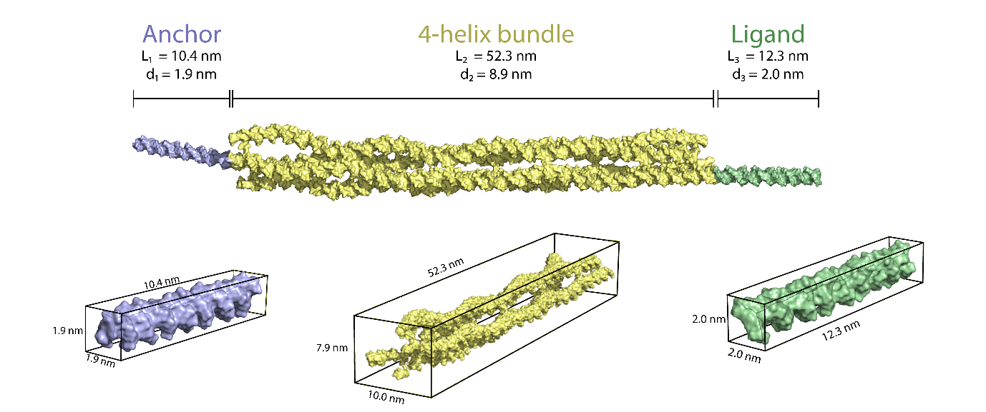
Figure S6: oxDNA simulations of the DNA origami nanolever. The resulting mean structure obtained from oxDNA simulation was segmented into three domains which were individually characterized to derive geometric properties.

Protein contribution to rotational friction

The rotational friction coefficient ζ_{prot} of a spherical protein with hydrodynamic radius R that rotates about an axis at distance L + R is dominated by the translational friction along the circular arc traced by the protein (assuming L >> R). Therefore, we can approximate ζ_{prot} as:

 | $$ζ_{prot}= 6πηR{(L+R)}^{2}$$ | Eq.13

Derivation of Eq. 13:
If a force, in this case the drag force F_{drag}, acts perpendicular to the nanolever of length L, the torque is:

 | $$τ=F_{drag}∙\left(L+R\right)$$ | Eq.14

Drag force on a sphere:
 | $F_{drag}=6πηR∙v$ | Eq.15

where v is the tangential velocity of the sphere:

 | $$v= ω(L+R)$$ | Eq.16

and ω the angular velocity.

Substituting Eq.16 in Eq.15 yields:
 | $$F_{drag}=6πηR∙ω(L+R)$$ | Eq.17

Substituting Eq.17 in Eq.14 yields:
 | $$τ=6πηR∙ ω\left(L+R\right)∙\left(L+R\right)=6πηR{\left(L+R\right)}^{2}ω$$ | Eq.18

Thus,
 | $$ζ_{prot}= 6πηR{(L+R)}^{2}$$ | Eq.19
Giving the total rotational friction coefficient as:

 | $$ζ_{tot}= ζ_{rod}+ζ_{prot}$$ | Eq.20

Integrating the Langevin differential equation using Euler-Maruyama for different values of R, yield the angle progression over time (Figure S7a). Please note that all nanolevers diffuse towards the same equilibrium angle of 32.7°, which agrees with Eq. 21.

 | $$〈θ〉=\int_{0}^{\frac{π}{2}}{θ}\cos{(θ)}dθ=32.7°$$ | Eq.21

Next, simulated angular trajectories over time were converted into normalized fluorescence using a previously established correlation (Figure S7b) [11]:
 | $$f\left(θ\right)=0.45{\left[1-e^{-0.042 L \sin{(θ)}}\right]}^{3.1}$$ | Eq.22
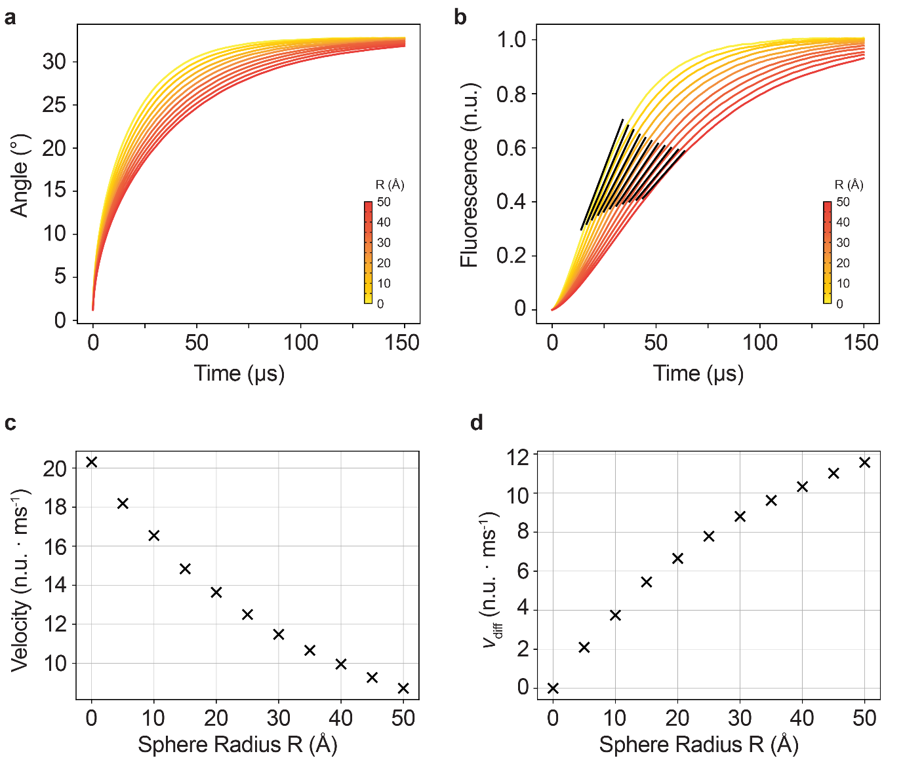
Figure S7: Langevin dynamics simulations. Langevin dynamics simulations of the surface tethered DNA origami nanolever with spheres of varying radius attached. a. Angular progression over time of simulated upwards trajectories of nanolevers with spheres of varying radius attached. b. Normalized fluorescence over time derived from the traces in panel a, according to eq. 22. c. Nanolever velocity derived from the fluorescence time traces of panel b. d. Differential velocity (v_{diff}) as a function of attached sphere radius.

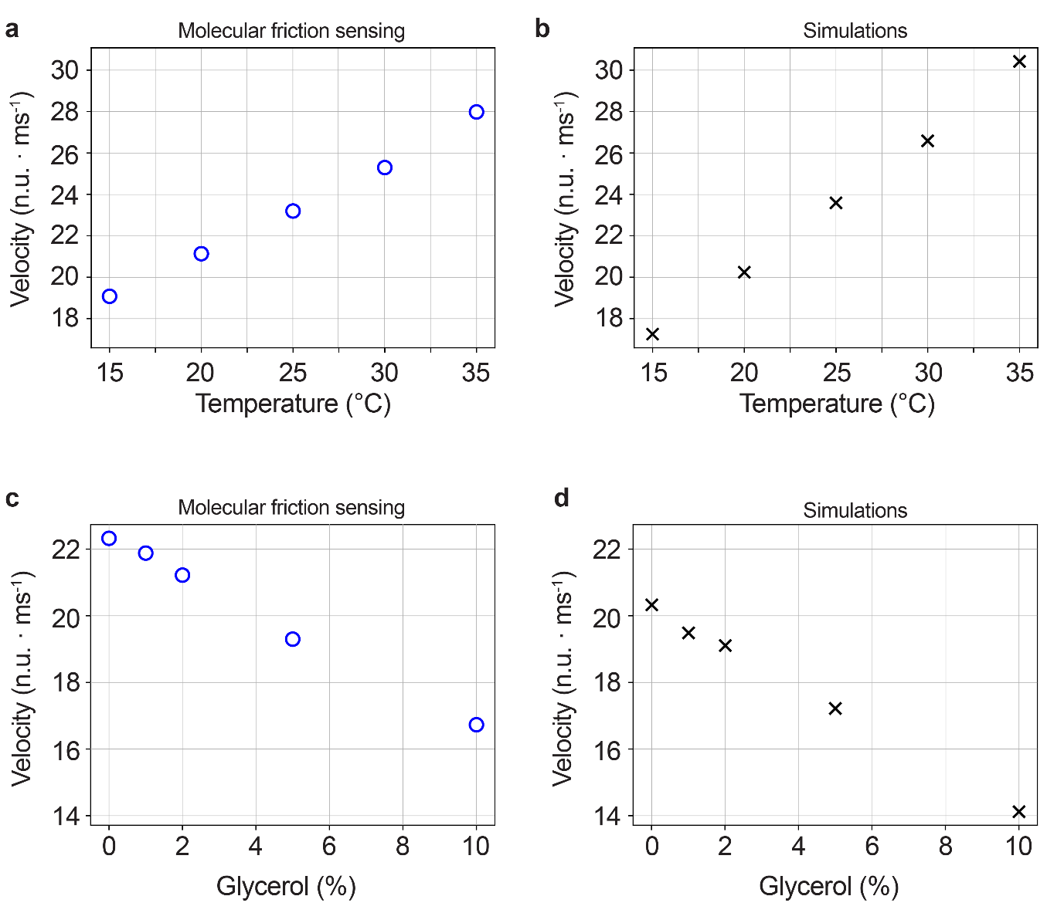
Figure S8: Langevin dynamics simulations of bare nanolever at varying temperature and glycerol concentration. a. Experimental nanolever velocity at increasing temperatures measured with molecular friction sensing. b. Langevin dynamics simulations of nanolever velocity at increasing temperatures. Simulation parameters were set to 15 °C (T = 288.15 K / η = 1.1375 cP), 20 °C (T = 293.15K / η = 1.005 cP), 25 °C (T = 298.15K / η = 0.890 cP), 30 °C (T = 303.15K / η = 0.7972 cP), 35 °C (T = 208.15K / η = 0.7191 cP).[12] c. Experimental nanolever velocity at increasing glycerol concentrations measured with molecular friction sensing d. Langevin dynamics simulations of nanolever velocity at increasing glycerol concentrations (vol%). Viscosities at the respective glycerol concentrations were obtained by first converting vol% to wt%, followed by viscosity approximation according to [13]. Simulation parameters were set to 0 % (η = 1.005 cP), 1 % (η = 1.0358 cP), 2 % (η = 1.068 cP), 5 % (η = 1.1734 cP), 10 % (η = 1.3832 cP).

Table S4: Reference calibration proteins and their respective net charges.
Protein | Identifier | Z (e)ª
Ubiquitin | 1UBI | -0.9
Cytochrome C | 2B4Z | 7.5
β-Lactoglobulin | 1QG5 | -9
Trypsin Inhibitor | 1BA7 | -11.7
Trypsinogen | 1TGN | 4.2
Carbonic Anhydrase | 1V9E | -3.4
Myokinase | 4AKE | -0.6
Tetra-Ubiquitin^{b} | Q96C32-F1-v4 | -0.6
apoTransferrin | 2HAU | -7.3
GAPDH | 1J0X | 8.8
Aldolase | 1ADO | 9.4
Catalase | 4BLC | -11.6
ª Protein net charge were calculated with Prot pi Protein Tool.
^{b} Crystal structure obtained from AlphaFold Protein Structure Database

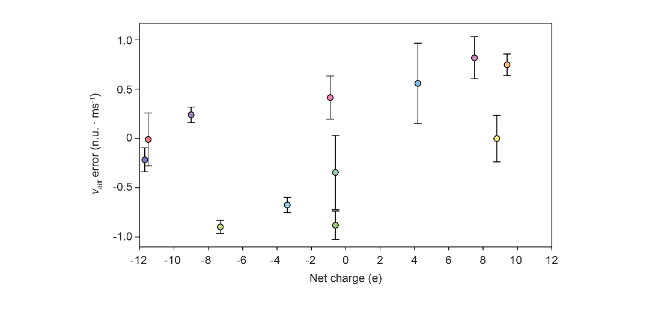
Figure S9: Effect of protein net charge on error of molecular friction sensing derived R_{h}. Spearman’s rank correlation coefficient was calculated for all reference calibration proteins (r_{s} = 0.497, p = 0.100), indicating no significant influence of protein net charge on velocity and resulting hydrodynamic radius measurements. Protein net charges were calculated with Prot pi Protein Tool.

Dynamic light scattering (DLS)
Deionized water was used for buffer preparation (MicroPure UV with a 0.2 µm filter). Samples were prepared in TE140 buffer containing 140 mM NaCl, 10 mM Tris, 50 µM EDTA, 50 µM EGTA. The pH was adjusted to 7.4 by adding 1 M HCl and measuring with a Mettler Toledo Seven Exellence pH meter equipped with an Inlabo Expert Pro-ISM electrode. The final buffer was filtered through a 0.1 µm nylon filter prior to use.
The proteins were dissolved in the TE140 buffer to a concentration of 1 g/L. If required, 50 µL of the samples were additionally filtered through ultrafiltration units (Nanosep, orange, Omega-Membrane, 300 kD) by centrifugation (10 krcf, 2 min). Prior to sample filtration, the filters were wetted by centrifugation of 500 µL TE140 buffer (10 krcf, 2 min) in the ultrafiltration units.
DLS measurements were performed using a Zetasizer Ultra instrument (Malvern Panalytical GmbH). Measurements were conducted at 25 °C using 5 µL sample volumes in glass capillaries (ZSU0003) mounted in a low-volume disposable cell (ZSU1002). The wavelength of the scattered laser light was 632.8 nm. The scattering angle was 90° (side-scatter configuration).
Hydrodynamic diameters were determined using the software ZS XPLORER applying the "Multiple Narrow Modes" algorithm assuming water as the dispersant model with a refractive index of 1.33 and a viscosity of 0.872 mPas. The hydrodynamic radius values in Table S5 are mean and standard deviations from 3 repetitive measurements.

Table S5: Hydrodynamic radius (R_{h}) of proteins measured by DLS.
Protein | R_{h.} (Å)
Ubiquitin | 15.7 ± 1.2
Cytochrome C | 19.1 ± 0.7
Trypsin Inhibitor | 36.9 ± 2.4
Trypsinogen | 23.3 ± 0.6
apoTransferrin | 41.8 ± 0.4
Aldolase | 60.5 ± 1.3
Catalase | 57.0 ± 2.0

Supplementary Note 4
Minimally detectable difference (MDD)

The minimally detectable differences for the binding induced conformational changes described in Figure 3a-c were calculated as follows:
 | $$MDD=(z_{1-α}{+z}_{1-b})\sqrt{{σ_{v_{diff,blank}}}^{2}+{σ_{v_{diff,ligand}}}^{2}}\left|\frac{∆R_{h}}{∆v_{diff}}\right|$$ | Eq.23
Where:
z_{1-α} and z_{1-β} are the critical z value for the significance level and quantile for the selected power, here set to 2.326 (α = 0.01, one-sided) and 0.84 (power = 80%) respectively.

Table S6: MDD for Calmodulin, Myokinase and LgBiT conformational change.
 | Calmodulin | Myokinase | LgBiT
v_{diff,blank} | 7.85 | 6.07 | 4.00
 | 8.40 | 5.87 | 3.81
 | 8.22 | 6.11 | 4.09
 | - | - | 3.87
$$μ_{v_{diff,blank}}$$ | 8.16 | 6.02 | 3.94
$$σ_{v_{diff,blank}}$$ | 0.16 | 0.07 | 0.06
v_{diff,ligand} | 6.14 | 4.74 | 4.98
 | 5.52 | 4.65 | 4.86
 | 5.54 | 4.82 | 4.67
 | - | - | 5.44
$$μ_{v_{diff,ligand}}$$ | 5.73 | 4.74 | 4.99
$$σ_{v_{diff,ligand}}$$ | 0.24 | 0.05 | 0.16
Δv_{diff} | -2.42 | -1.28 | 1.05
$$\sqrt{{σ_{v_{diff,blank}}}^{2}+{σ_{v_{diff,ligand}}}^{2}}$$ | 0.26 | 0.09 | 0.17
ΔR_{h} | -1.72 | -1.52 | 0.15
MDD (α = 0.01, P = 80%) | 0.58 | 0.34 | 0.08

Supplementary Note 5
SPR analysis
SPR measurements were conducted on a Triceratops SPR #64 (Bruker) in PE140 buffer (10 mM Na₂HPO₄/NaH₂PO₄, pH 7.4, 140 mM NaCl, 50 mM EDTA, 50 mM EGTA, 0.05 % Tween-20) with 2.5 % DMSO. Carbonic anhydrase (Sigma Aldrich, CAS No: 9001-03-0) was covalently immobilized on a polycarboxylate HCA sensor (Bruker, Part No: 1900422) via amine coupling chemistry using the Amine Coupling Kit (Bruker, Part No: 1862634). Initially, CA was dissolved in ddH₂O to a concentration of 10 mg/mL and subsequently diluted to 50 µg/mL in Sodium Acetate Buffer, pH 5 (Part No:1862640) immediately prior to the coupling process. The sensor surface was activated in the horizontal direction with a 1:1 mixture of 400 mM EDC and 50 mM NHS (360 s at 10 µL/min), followed by vertical injection of CA (360 s at 10 µL/min). The surface was then deactivated horizontally with 1M Ethanolamine-HCl (240 s at 10 µL/min). Immobilization yielded a final response of approximately 6,000-8,000 response units (RU). The surface was stabilized for a minimum of 5 hours with a series of buffer injections following immobilization.
Solvent correction was performed before each kinetic experiment with DMSO concentrations of 2.0 %, 2.25 %, 2.5 %, 2.75 % and 3.0 %. The measured values were used to construct a calibration curve to determine a correction factor for every individual injection in an automated step in the Bruker SPR Analyzer 4 software.
All small molecules were dissolved in DMSO to a concentration of 400 µM and further diluted in PE140 buffer to a concentration of 10 µM (final DMSO concentration 2.5 %). For initial hit screening, all molecules were screened at a single concentration of 10 µM. For the initial single concentration hit screen, response values of 10 µM analyte binding were extracted at 100 s and %R_{max} was calculated as in equation 24, assuming 1:1 binding stoichiometry.

 | $${\%R}_{max}=\frac{R_{analyte}}{R_{CA}\left(\frac{{MW}_{analyte}}{{MW}_{CA}}\right)}*100$$ | Eq.24

Where R_{analyte} is the observed binding signal of the analyte (in RU), R_{CA} is the immobilization level of CA (in RU), and MW_{analyte} and MW_{CA} are the molecular weights of the analyte and carbonic anhydrase, respectively.

Selected hits with a %R_{max} > 10 % were subsequently subjected to a full kinetic analysis with 6 concentrations of analyte in a 5-fold dilution series (120 s association, 600 s dissociation time at 25 µL/min for both experiments). Full kinetic analysis was performed in the Multi Injection Cycle Kinetic (MICK) assay format. Analytes for which the dissociation time was insufficient (tight binders with slow dissociation) were remeasured using a Titration Cycle Kinetic (TCK) assay using an optimized concentration range (120 s association, 900 s dissociation time at 25 µL/min). All experiments were performed with a minimum of three repeats.
Analysis of kinetic values was performed in the Bruker SPR Analyzer 4 software. Sensorgrams were double referenced (horizontal interspot reference surface and blank) and solvent corrected. To extract kinetic values, curves from the full experiment were fitted with a 1:1 Langmuir Model (MICK) and Kinetic Titration Model (TCK) applying a local R_{bulk} parameter. Depending on the binding affinities, highest or lowest concentrations were excluded from the analysis when not contributing to the fitting.

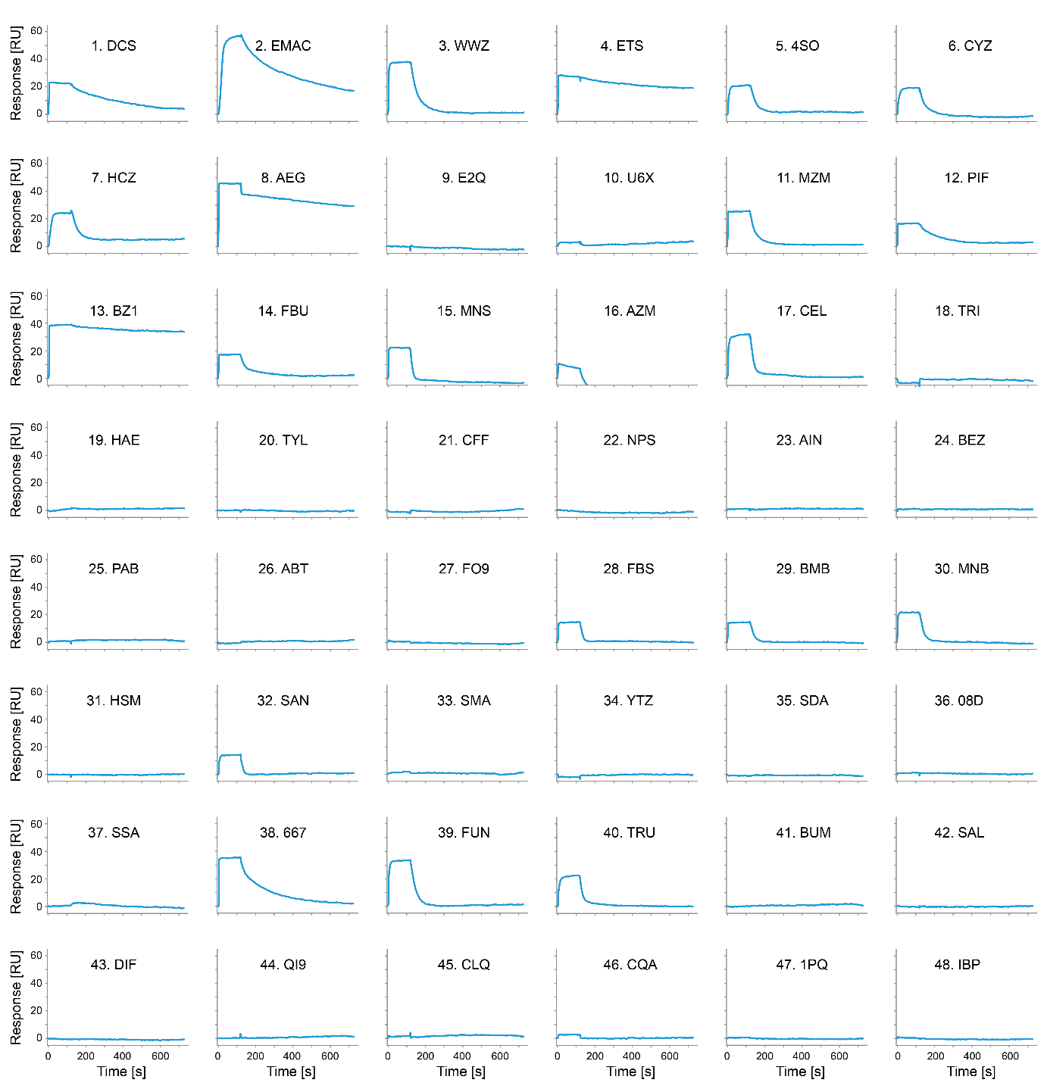
Figure S10: Single concentration (10 µM) SPR hit screening of small molecules binding to carbonic anhydrase. The maximum response values of analyte binding were extracted at 100 seconds, %R_{max} values (Table S7) were calculated for each compound as in equation 24.

Table S7: %R_{max} values from a single-concentration binding screen at 10 µM analyte.
# | Compound | Abbr. | %R_{max} (%) | # | Compound | Abbr. | %R_{max} (%)
1 | 4,5-Dichlorothiophene-2-sulfonamide | DCS | 41.0 | 25 | 4-Aminobenzoic acid | PAB | 0.76
2 | EMAC10101d | EMAC | 53.8 | 26 | 1-aminobenzotriazole | ABT | -3.34
3 | U-104 | WWZ | 56.1 | 27 | Famotidine | FO9 | 1.57
4 | Dorzolamide | ETS | 38.3 | 28 | 4-fluorobenzenesulfonamide | FBS | 34.7
5 | 4-Sulfamoylbenzoic acid | 4SO | 42.7 | 29 | 4-Bromo-3-methylbenzenesulfonamide | BMB | 23.5
6 | Cyclothiazide | CYZ | 25.6 | 30 | 2-Methyl-5-nitrobenzenesulfonamide | MNB | 38.2
7 | Hydrochlorothiazide | HCZ | 33.2 | 31 | Histamine | HSM | 1.38
8 | AEG 3482 | AEG | 65.7 | 32 | Sulfanilamide | SAN | 30.3
9 | NBQX disodium | E2Q | 0.83 | 33 | Sulfamethazine | SMA | 2.57
10 | (±)-Sulpiride | U6X | 2.43 | 34 | Sulfathiazole | YTZ | -0.92
11 | Methazolamide | MZM | 53.1 | 35 | Sulfadiazine | SDA | -2.56
12 | Pifithrin-mu | PIF | 36.4 | 36 | Sulfamethoxazole | 08D | 2.75
13 | Brinzolamide | BZ1 | 40.7 | 37 | Sulfisoxazole | SSA | 0.23
14 | 3,5-difluorobenzenesulfonamide | FBU | 29.6 | 38 | Irosustat (667-coumate) | 667 | 44.9
15 | Dansylamide | MNS | 39.8 | 39 | Furosemide | FUN | 40.6
16 | Acetazolamide | AZM | 12.6 | 40 | Trichlormethiazide | TRU | 26.8
17 | Celecoxib | CEL | 35.4 | 41 | Brumetadine | BUM | 0.98
18 | 1,2,4-triazole | TRI | -16.6 | 42 | Salicylic Acid | SAL | -1.00
19 | Acetohydroxamate | HAE | -1.46 | 43 | Diclofenac sodium salt | DIF | 0.03
20 | Paracetamol | TYL | -0.17 | 44 | Quinine | QI9 | 0.20
21 | Caffeine | CFF | -2.01 | 45 | Chloroquine | CLQ | 2.71
22 | Naproxen | NPS | 1.47 | 46 | Amodiaquine | CQA | 1.51
23 | Acetylsalicylic acid | AIN | 2.28 | 47 | Primaquine | 1PQ | 0.79
24 | Benzoic acid | BEZ | 5.33 | 48 | Ibuprofen | IBP | 0.13

Table S8: Kinetic rates of identified hits binding to carbonic anhydrase. Mean and standard deviations are shown of k_{on}, k_{off} and K_{d}, calculated from at least 3 repeats.
# | Compound | Abbr. | k_{on} (M⁻¹s⁻¹) | k_{off} (s⁻¹) | K_{d} (M)
1 | 4,5-Dichlorothiophene-2-sulfonamide | DCS | 7.30 ± 3.91 E+05 | 3.45 ± 1.81 E-03 | 5.63 ± 2.73 E-09
2 | EMAC10101d | EMAC | 8.52 ± 0.74 E+04 | 2.14 ± 0.17 E-04 | 2.52 ± 0.17 E-08
3 | U-104 | WWZ | 3.88 ± 1.27 E+04 | 2.92 ± 0.55 E-03 | 8.82 ± 4.25 E-07
4 | Dorzolamide | ETS | 6.78 ± 2.15 E+05 | 5.00 ± 1.81 E-04 | 8.38 ± 4.49 E-10
5 | 4-Sulfamoylbenzoic acid | 4SO | 1.24 ± 0.46 E+04 | 3.53 ± 0.57 E-02 | 3.41 ± 1.68 E-06
6 | Cyclothiazide | CYZ | 8.41 ± 0.55 E+03 | 1.51 ± 0.53 E-03 | 1.83 ± 0.73 E-06
7 | Hydrochlorothiazide | HCZ | 5.74 ± 1.08 E+03 | 2.63 ± 0.43 E-02 | 4.68 ± 0.88 E-06
8 | AEG 3482 | AEG | 8.52 ± 0.73 E+04 | 4.46 ± 1.26 E-04 | 5.16 ± 1.01 E-10
11 | Methazolamide | MZM | 4.12 ± 1.97 E+05 | 2.98 ± 0.56 E-02 | 1.22 ± 0.64 E-07
12 | Pifithrin-mu | PIF | 5.18 ± 0.94 E+05 | 1.01 ± 0.33 E-03 | 1.93 ± 0.48 E-08
13 | Brinzolamide | BZ1 | 9.07 ± 3.08 E+05 | 3.17 ± 0.50 E-04 | 4.07 ± 1.85 E-10
14 | 3,5-difluorobenzenesulfonamide | FBU | 3.39 ± 1.79 E+05 | 3.58 ± 0.60 E-02 | 1.37 ± 0.61 E-08
15 | Dansylamide | MNS | 1.78 ± 0.47 E+04 | 1.01 ± 0.20 E-01 | 6.39 ± 2.84 E-06
16 | Acetazolamide | AZM | 3.08 ± 0.51 E+05 | 1.63 ± 0.33 E-02 | 5.48 ± 0.92 E-08
17 | Celecoxib | CEL | 1.15 ± 0.14 E+04 | 5.42 ± 0.54 E-02 | 4.79 ± 0.82 E-06
28 | 4-fluorobenzenesulfonamide | FBS | 2.63 ± 1.09 E+04 | 7.89 ± 1.11 E-02 | 3.47 ± 1.20 E-06
29 | 4-Bromo-3-methylbenzenesulfonamide | BMB | 7.81 ± 3.82 E+04 | 4.37± 0.82 E-02 | 7.27 ± 3.73 E-07
30 | 2-Methyl-5-nitrobenzenesulfonamide | MNB | 3.02 ± 1.22 E+04 | 4.91 ± 1.23 E-02 | 2.03 ± 1.03 E-06
32 | Sulfanilamide | SAN | 1.09 ± 0.56 E+04 | 1.18 ± 0.28 E-01 | 1.38 ± 0.76 E-05
38 | Irosustat (667-coumate) | 667 | 2.18 ± 0.70 E+05 | 9.27 ± 1.27 E-03 | 4.63 ± 1.19 E-08
39 | Furosemide | FUN | 2.44 ± 0.24 E+04 | 2.72 ± 0.54 E-03 | 1.13 ± 0.14 E-07
40 | Trichlormethiazide | TRU | 6.92 ± 0.54 E+03 | 3.48 ± 0.45 E-03 | 5.01 ± 0.25 E-06

Table S9: Chemical structures of compounds identified as binders in SPR screen and characterized with molecular friction sensing.
Compound | Abbr. | Structure | Compound | Abbr. | Structure
Celecoxib | CEL | 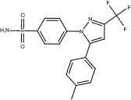 | 2-Methyl-5-nitrobenzenesulfonamide | MNB | 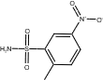
EMAC10101d | EMAC | 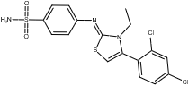 | 4,5-Dichlorothiophene-2-sulfonamide | DCS | 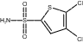
AEG 3482 | AEG | 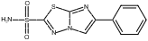 | 4-Bromo-3-methylbenzenesulfonamide | BMB | 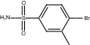
U-104 | WWZ | 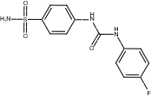 | Cyclothiazide | CYZ | 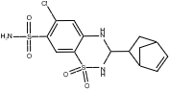
Irosustat (667-coumate) | 667 | 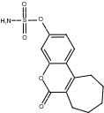 | Pifithrin-mu | PIF | 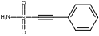
4-fluorobenzenesulfonamide | FBS | 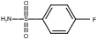 | Sulfanilamide | SAN | 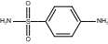
Table S9 (Continued):
Compound | Abbr. | Structure | Compound | Abbr. | Structure
Methazolamide | MZM | 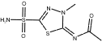 | Dansylamide | MNS | 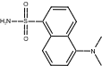
Acetazolamide | AZM | 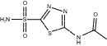 | Furosemide | FUN | 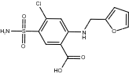
Trichlormethiazide | TRU | 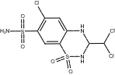 | Dorzolamide | ETS | 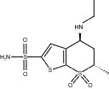
3,5-difluorobenzenesulfonamide | FBU | 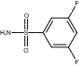 | 4-Sulfamoylbenzoic acid | 4SO | 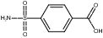
Hydrochlorothiazide | HCZ | 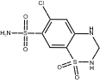 | Brinzolamide | BZ1 | 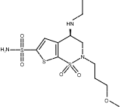

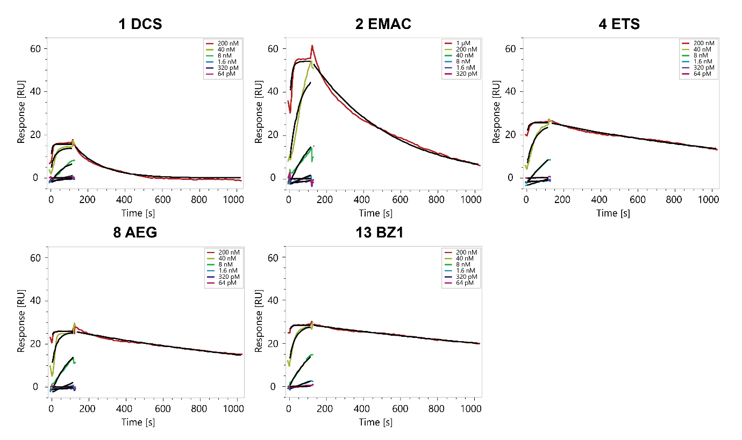
Figure S11: SPR Titration Cycle Kinetic (TCK) sensorgrams of small molecules binding tightly to carbonic anhydrase.
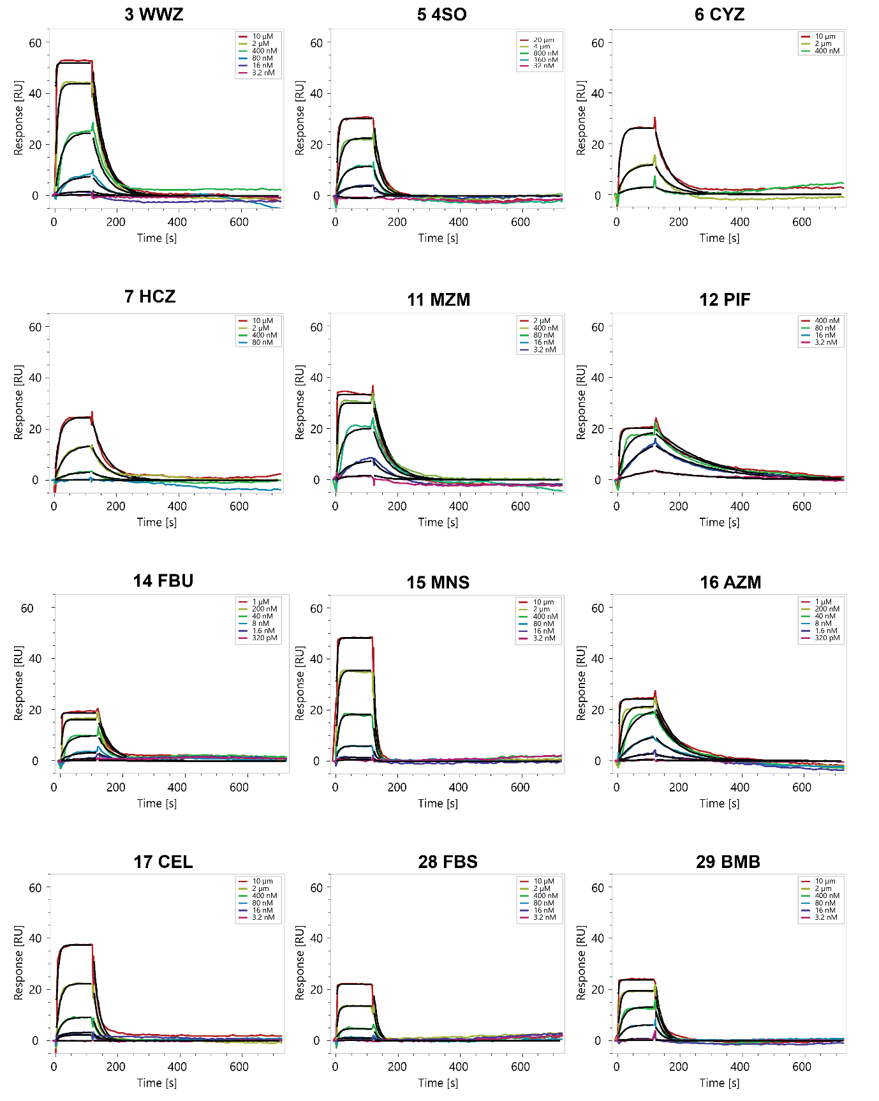
Figure S12: SPR Multi Injection Cycle Kinetic (MICK) sensorgrams of small molecules binding to carbonic anhydrase.

Figure S12 (continued).
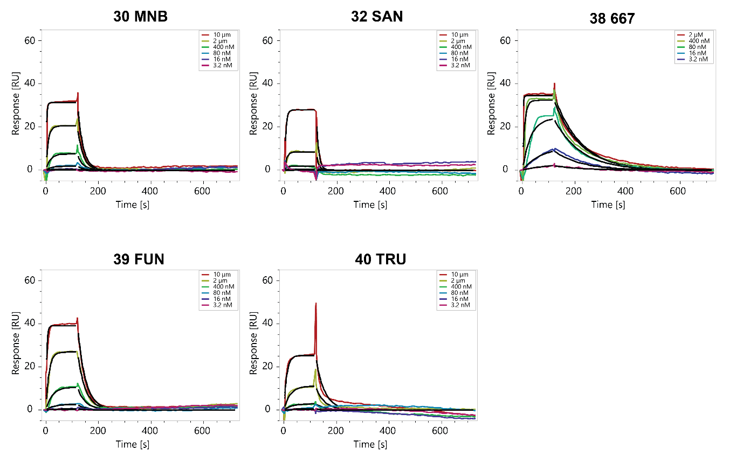
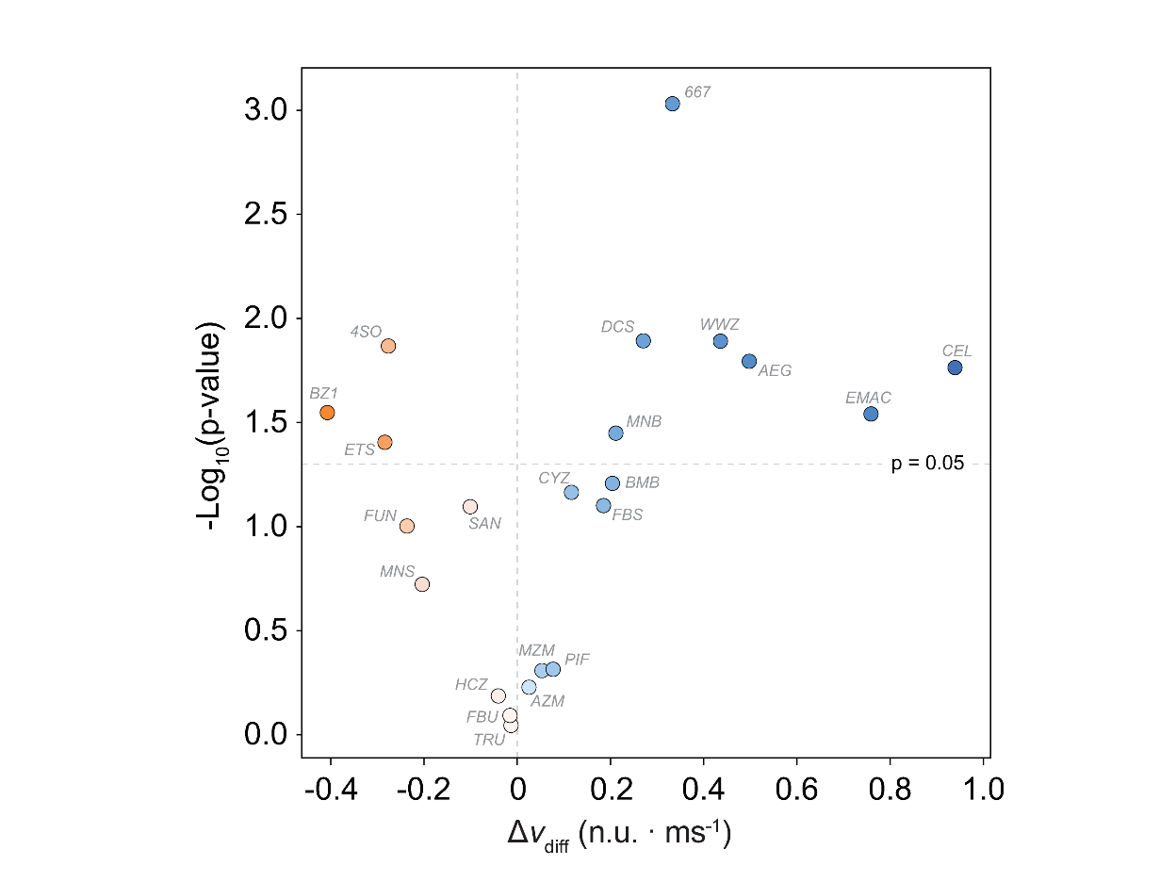
Figure S13. Molecular friction sensing characterization of the 22 confirmed carbonic anhydrase binders. The volcano plot reports the statistical significance (-log₁₀(p-value)) versus the corresponding differential velocity change (Δv_{diff}). Statistical significance was evaluated by a two-sided t-test against a null hypothesis of Δv_{diff} = 0, with five independent replicates.

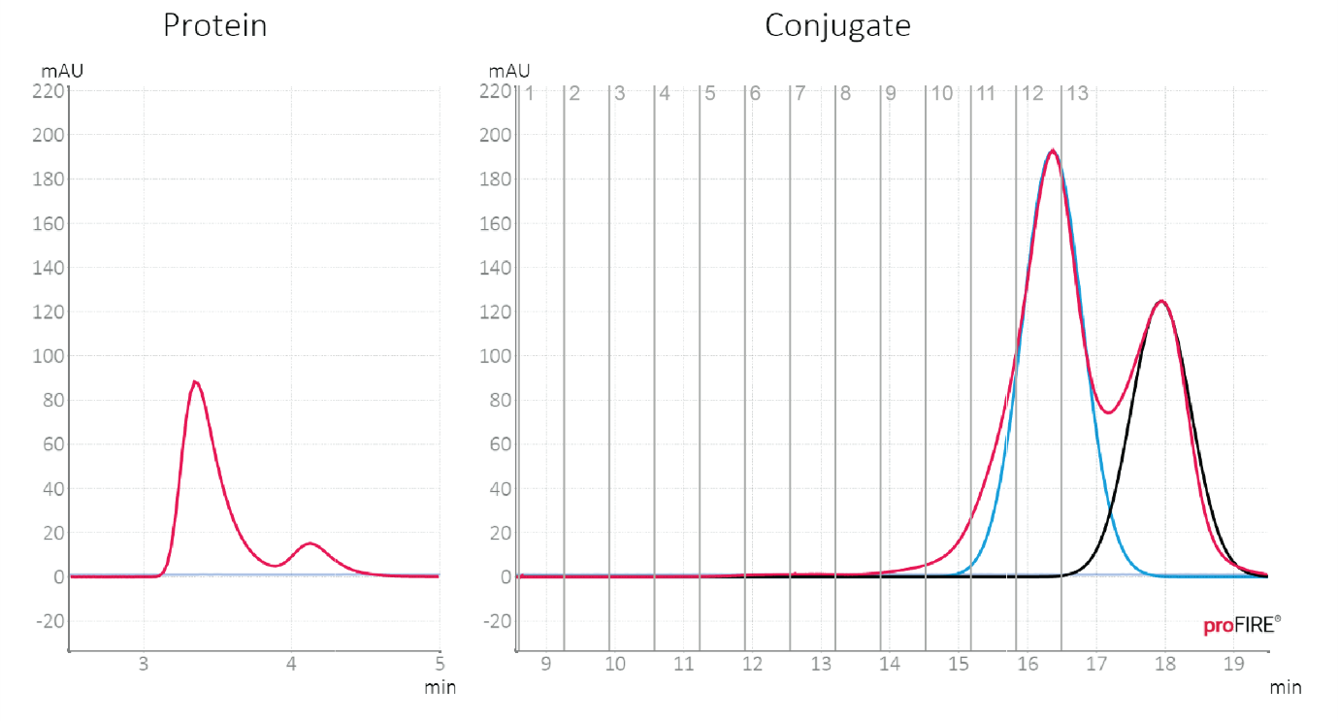
Figure S14. proFIRE chromatogram: Purification chromatogram of Ubiquitin conjugated to a 48-nt. ligand strand. Conjugate fraction 12 (yield 9.6 µM – 70 µL) was collected and used for further measurements.

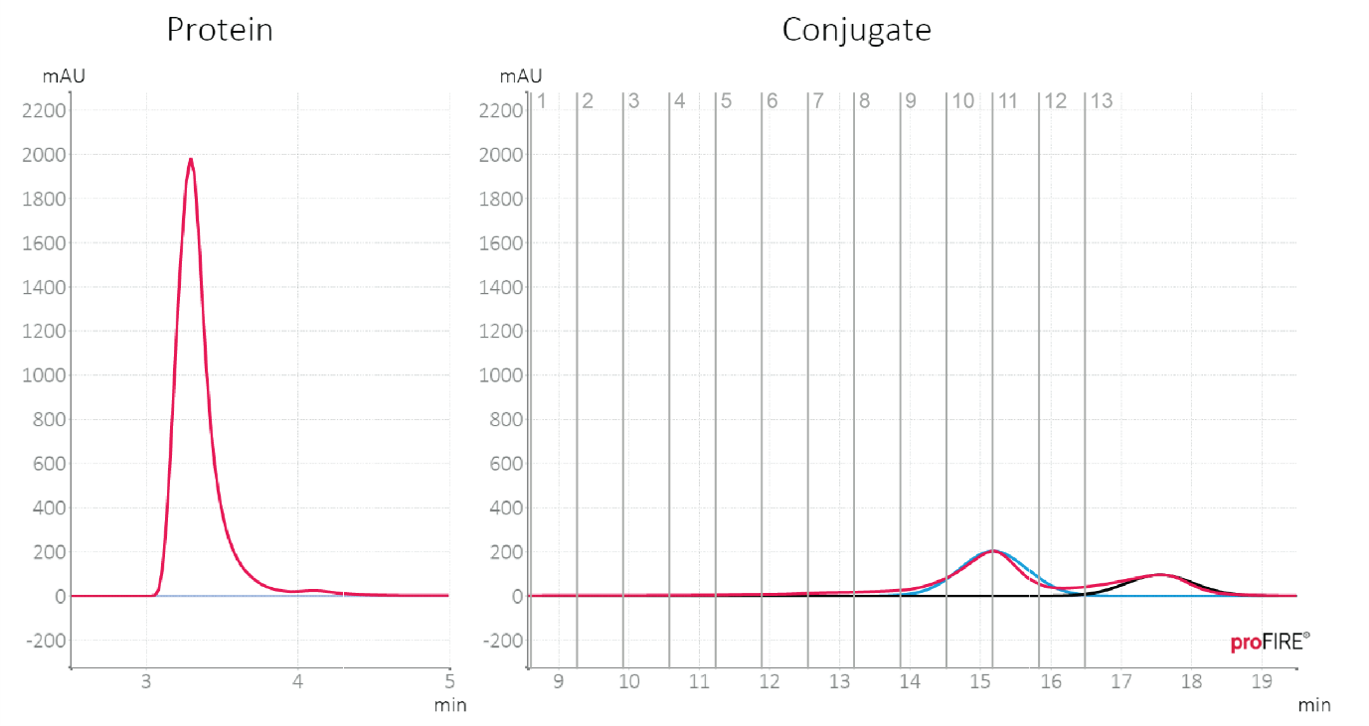
Figure S15. proFIRE chromatogram: Purification chromatogram of cytochrome C conjugated to a 48mer oligonucleotide. Conjugate fractions 10-11 (yield 14.77 µM – 66 µL) were collected, pooled, and used for further measurements.
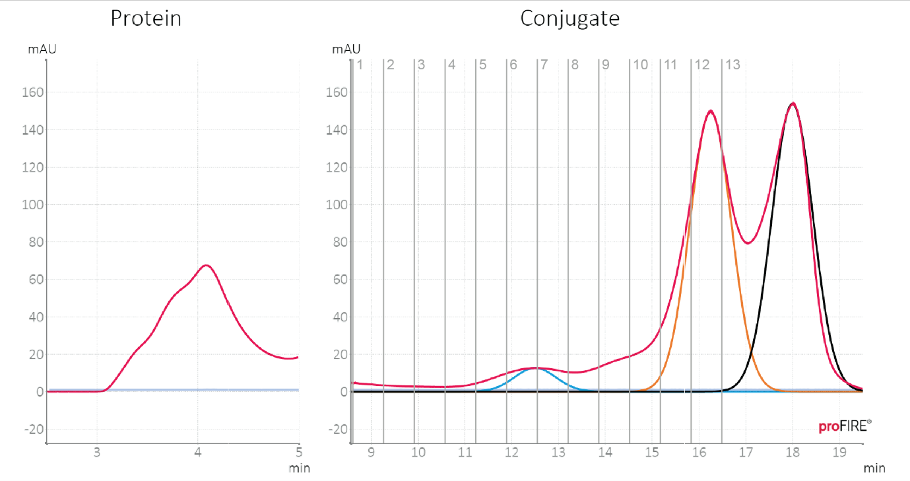
Figure S16. proFIRE chromatogram: Purification chromatogram of trypsin inhibitor conjugated to a 48mer oligonucleotide. Conjugate fractions 11-12 (yield 9.77 µM – 85 µL) were collected, pooled, and used for further measurements.

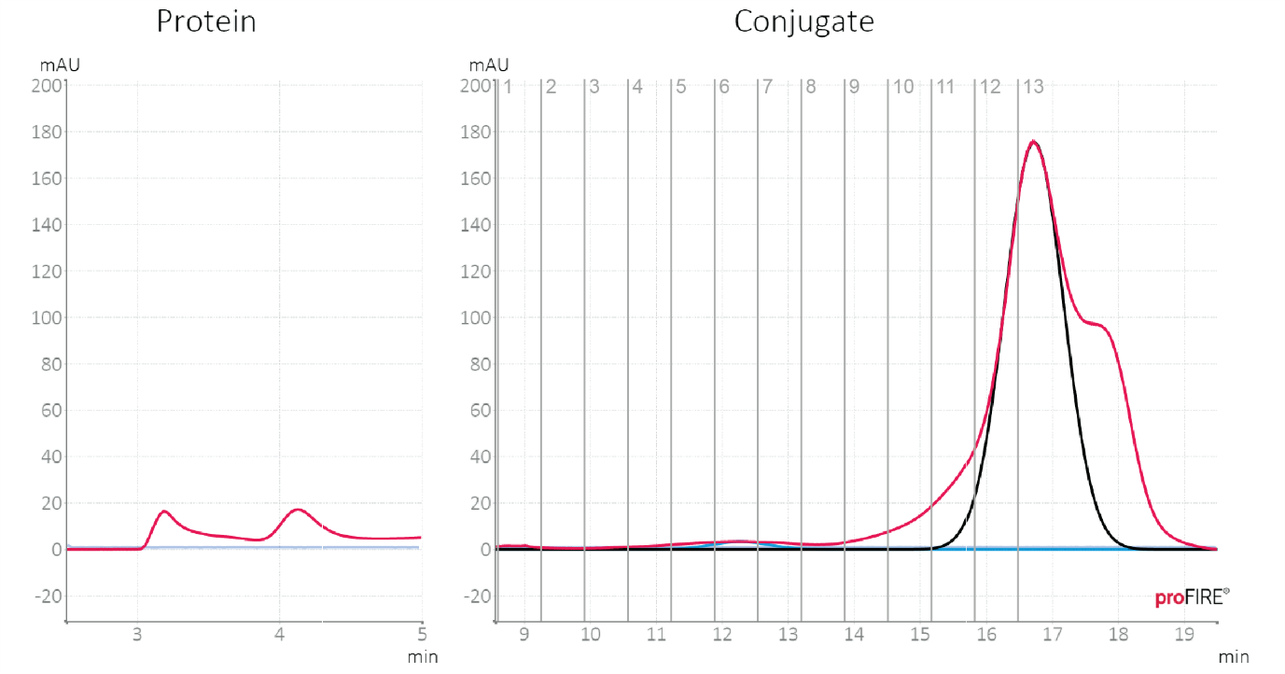
Figure S17. proFIRE chromatogram: Purification chromatogram of Beta-Lactoglobulin conjugated to a 48mer oligonucleotide. Conjugate fractions 11-12 (yield 8.55 µM – 63 µL) were collected, pooled, and used for further measurements.
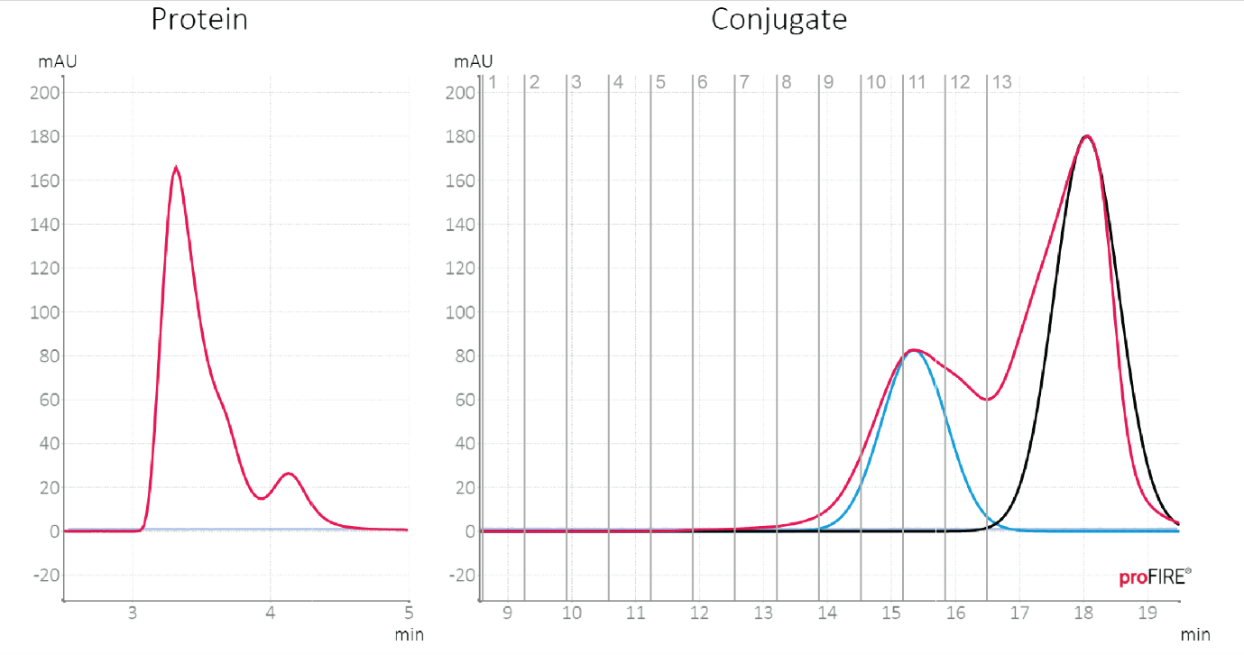
Figure S18. proFIRE chromatogram: Purification chromatogram of Trypsinogen conjugated to a 48mer oligonucleotide. Conjugate fractions 10-11 (yield 11.6 µM – 50 µL) were collected, pooled, and used for further measurements.

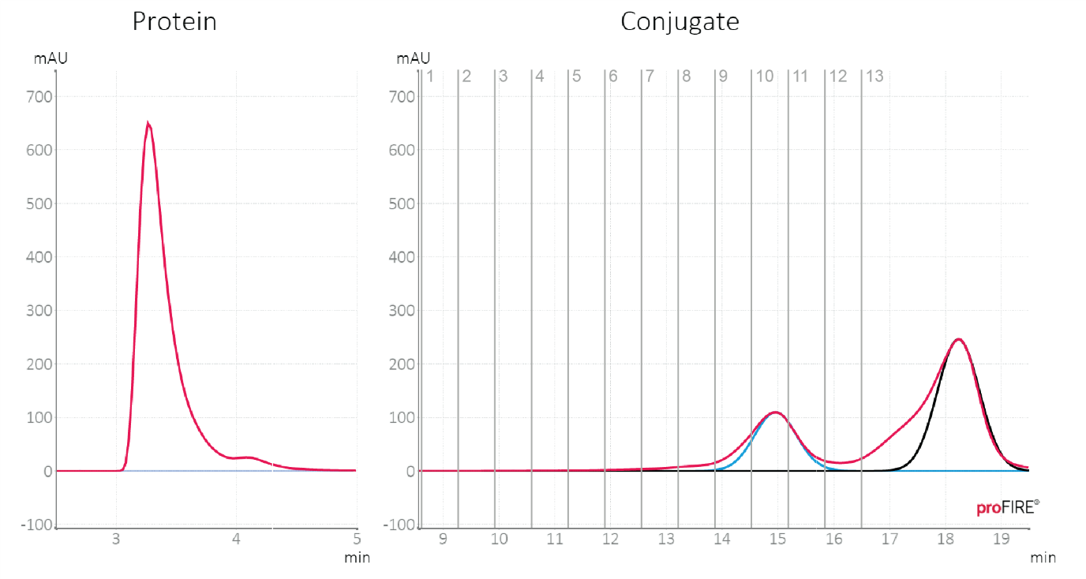
Figure S19. proFIRE chromatogram: Purification chromatogram of Carbonic Anhydrase conjugated to a 48mer oligonucleotide. Conjugate fractions 9-11 (yield 7.2 µM – 70 µL) were collected, pooled, and used for further measurements.
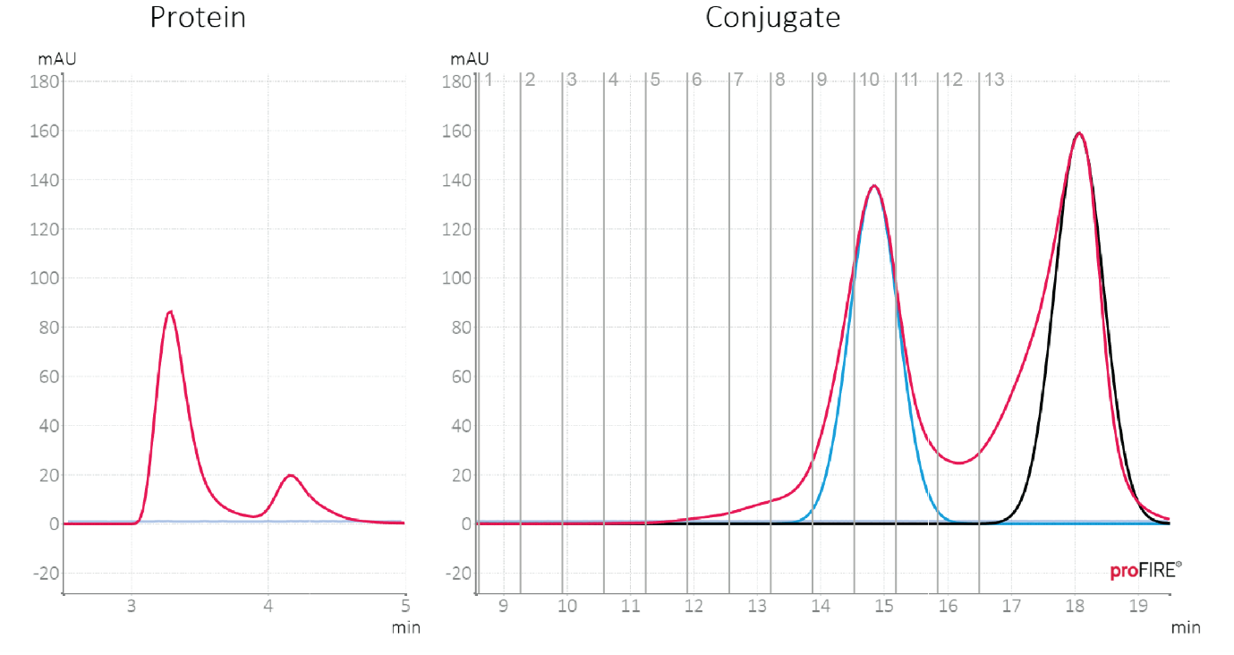
Figure S20. proFIRE chromatogram: Purification chromatogram of Myokinase conjugated to a 48mer oligonucleotide. Conjugate fractions 9-10 (yield 10.5 µM – 75 µL) were collected, pooled, and used for further measurements.

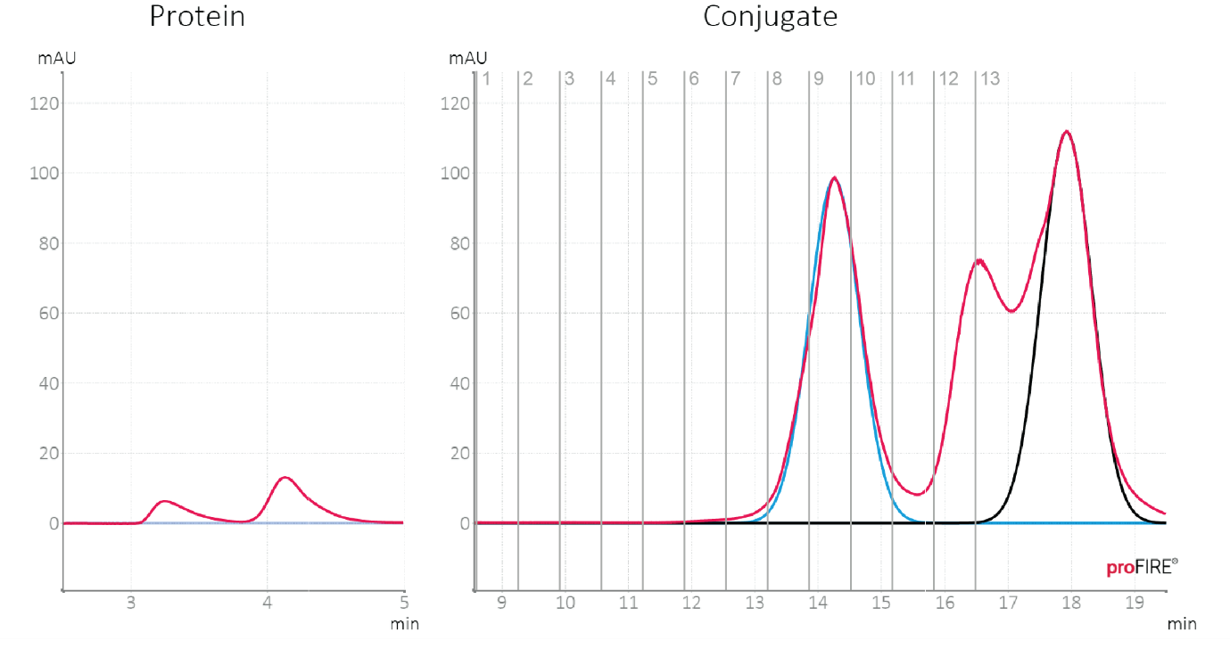
Figure S21. proFIRE chromatogram: Purification chromatogram of Tetraubiquitin conjugated to a 48mer oligonucleotide. Conjugate fraction 9 (yield 4.49 µM – 75 µL) was collected, pooled, and used for measurements.
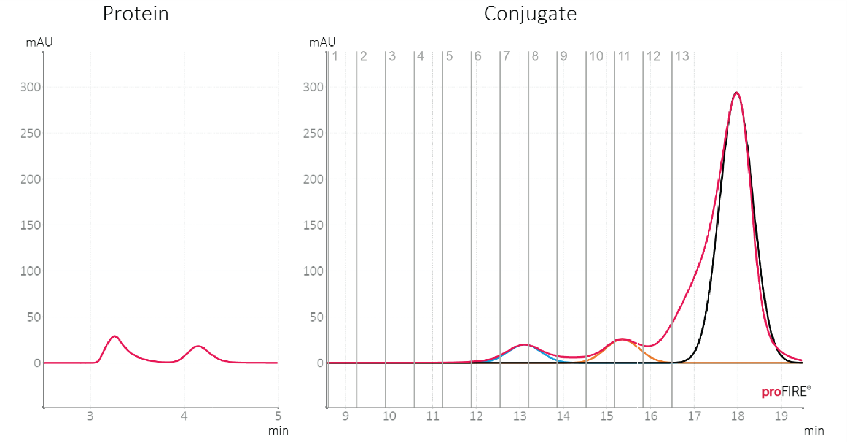
Figure S22. proFIRE chromatogram: Purification chromatogram of apo-Transferrin conjugated to a 48mer oligonucleotide. Conjugate fractions 7-8 (yield 7.7 µM – 70 µL) were collected, pooled, and used for further measurements.

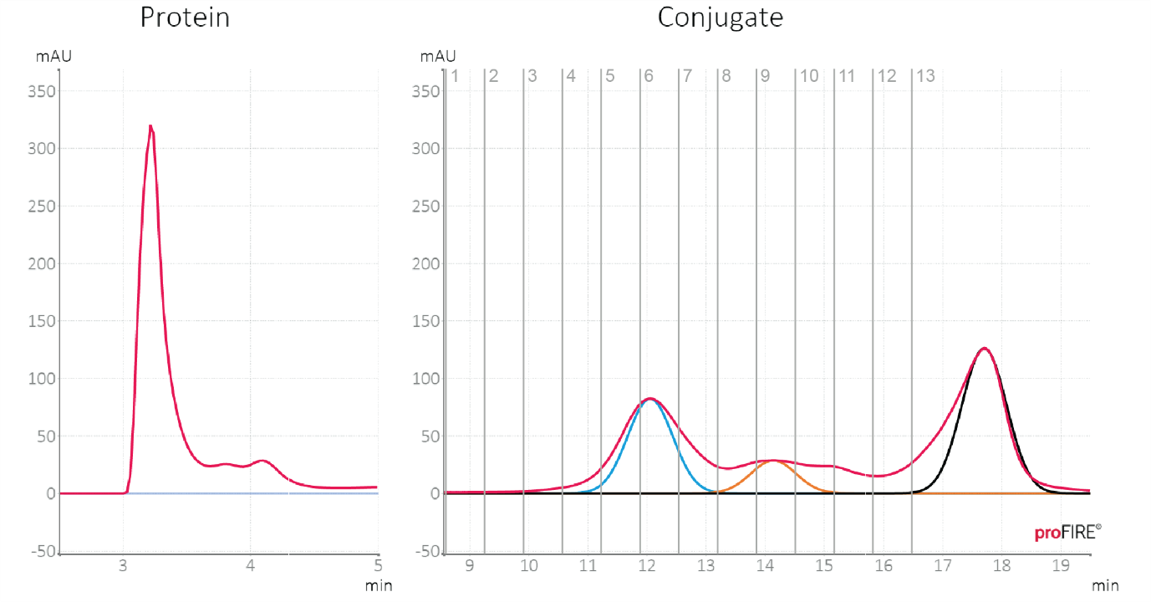
Figure S23. proFIRE chromatogram: Purification chromatogram of GAPDH conjugated to a 48mer oligonucleotide. Conjugate fractions 5-6 (yield 6.5 µM – 80 µL) were collected, pooled, and used for further measurements.
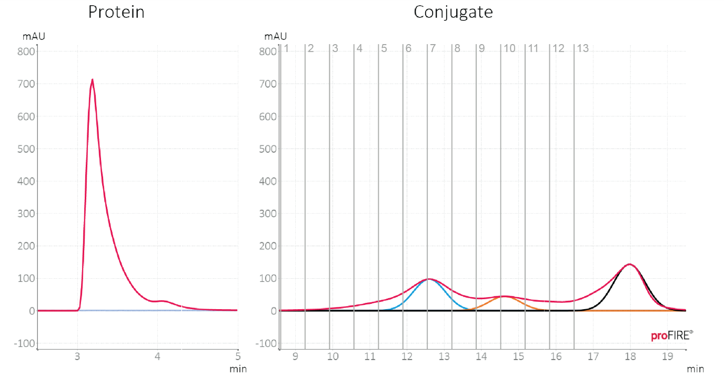
Figure S24. proFIRE chromatogram: Purification chromatogram of Aldolase conjugated to a 48mer oligonucleotide. Conjugate fractions 6-7 (yield 10.3 µM – 70 µL) were collected, pooled, and used for further measurements.

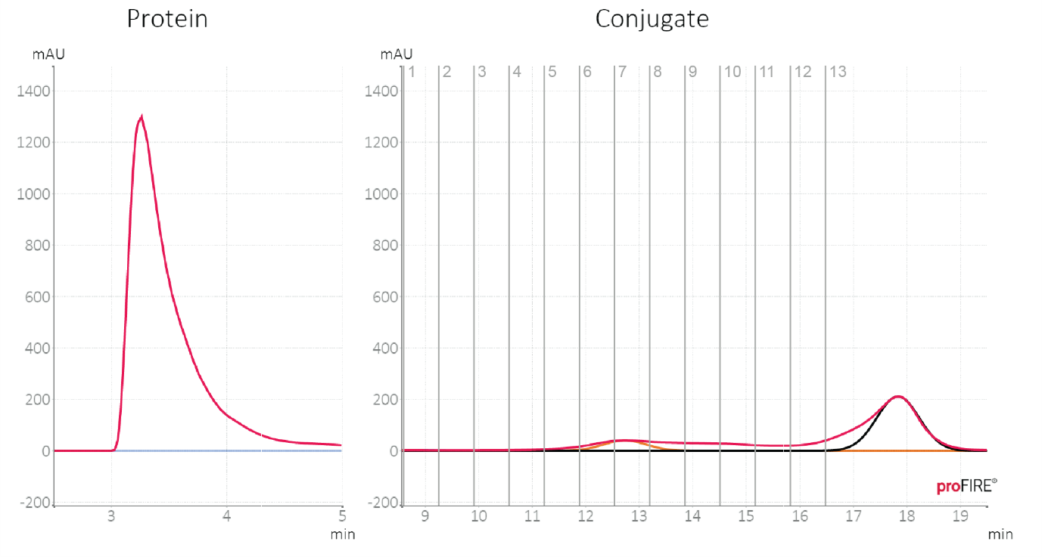
Figure S25. proFIRE chromatogram: Purification chromatogram of Catalase conjugated to a 48mer oligonucleotide. Conjugate fractions 6-7 (yield 2.67 µM – 75 µL) were collected, pooled, and used for further measurements.
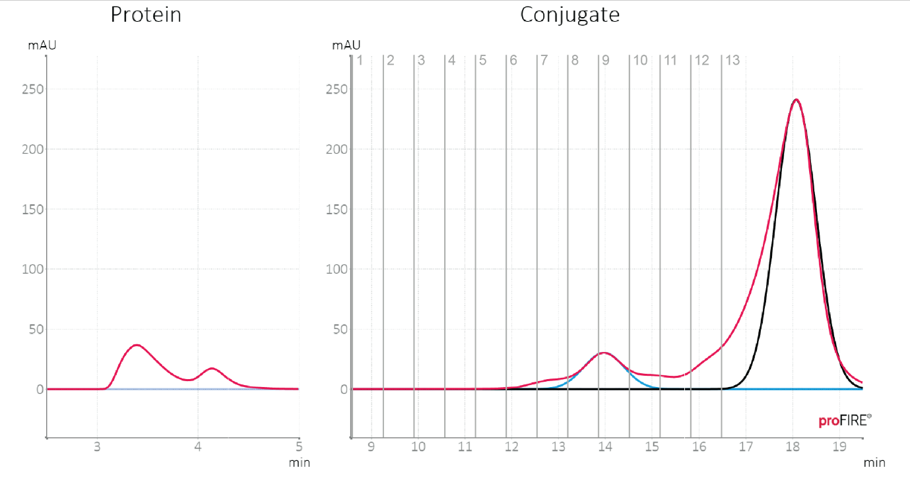
Figure S26. proFIRE chromatogram: Purification chromatogram of Maltodextrin-binding protein conjugated to a 48mer oligonucleotide. Conjugate fractions 7-9 (yield 6.5 µM – 70 µL) were collected, pooled, and used for further measurements.

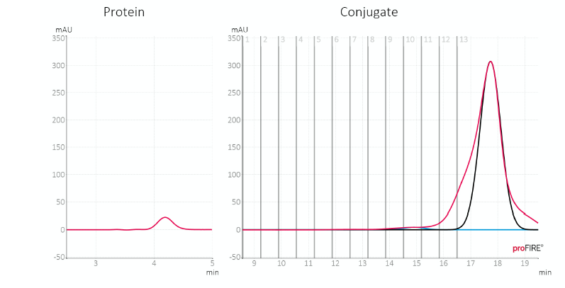
Figure S27. proFIRE chromatogram: Purification chromatogram of LgBiT conjugated to a 48mer oligonucleotide. Conjugate fractions 9-10 (yield 1.98 µM – 50 µL) were collected, pooled, and used for further measurements.

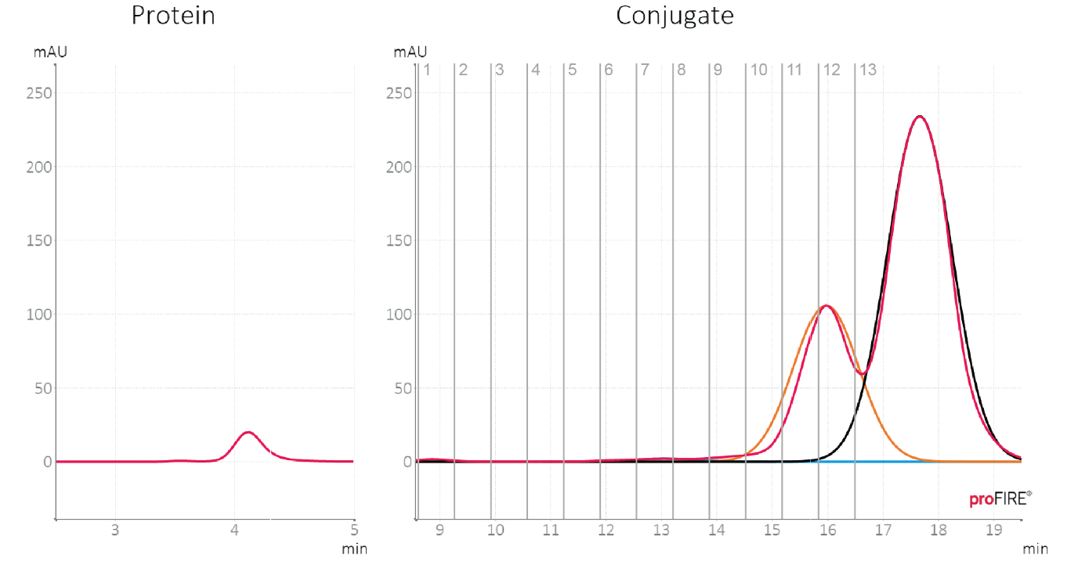
Figure S28. proFIRE chromatogram: Purification chromatogram of Calmodulin conjugated to a 48mer oligonucleotide. Conjugate fractions 10-12 (yield 7.35 µM – 90 µL) were collected, pooled, and used for further measurements.

Supplementary References
- Cranmer, M. (2023). Interpretable Machine Learning for Science with PySR and SymbolicRegression.jl. http://arxiv.org/abs/2305.01582
- García de la Torre, J., Huertas, M. L., & Carrasco, B. (2000). Calculation of Hydrodynamic Properties of Globular Proteins from Their Atomic-Level Structure. Biophysical Journal, 78(2), 719–730. https://doi.org/10.1016/S0006-3495(00)76630-6
- Ortega, A., Amorós, D., & García de la Torre, J. (2011). Prediction of Hydrodynamic and Other Solution Properties of Rigid Proteins from Atomic- and Residue-Level Models. Biophysical Journal, 101(4), 892–898. https://doi.org/10.1016/j.bpj.2011.06.046
- Langer, A., Kaiser, W., Svejda, M., Schwertler, P., & Rant, U. (2014). Molecular Dynamics of DNA–Protein Conjugates on Electrified Surfaces: Solutions to the Drift-Diffusion Equation. The Journal of Physical Chemistry B, 118(2), 597–607. https://doi.org/10.1021/jp410640z
- Tirado, M. M., & de la Torre, J. G. (1979). Translational friction coefficients of rigid, symmetric top macromolecules. Application to circular cylinders. The Journal of Chemical Physics, 71(6), 2581–2587. https://doi.org/10.1063/1.438613
- Ouldridge, T. E., Louis, A. A., & Doye, J. P. K. (2011). Structural, mechanical, and thermodynamic properties of a coarse-grained DNA model. The Journal of Chemical Physics, 134(8). https://doi.org/10.1063/1.3552946
- Rovigatti, L., Šulc, P., Reguly, I. Z., & Romano, F. (2015). A comparison between parallelization approaches in molecular dynamics simulations on GPUs. Journal of Computational Chemistry, 36(1), 1–8. https://doi.org/10.1002/jcc.23763
- Šulc, P., Romano, F., Ouldridge, T. E., Rovigatti, L., Doye, J. P. K., & Louis, A. A. (2012). Sequence-dependent thermodynamics of a coarse-grained DNA model. The Journal of Chemical Physics, 137(13). https://doi.org/10.1063/1.4754132
- Snodin, B. E. K., Randisi, F., Mosayebi, M., Šulc, P., Schreck, J. S., Romano, F., Ouldridge, T. E., Tsukanov, R., Nir, E., Louis, A. A., & Doye, J. P. K. (2015). Introducing improved structural properties and salt dependence into a coarse-grained model of DNA. The Journal of Chemical Physics, 142(23). https://doi.org/10.1063/1.4921957
- Poppleton, E., Romero, R., Mallya, A., Rovigatti, L., & Šulc, P. (2021). OxDNA.org: A public webserver for coarse-grained simulations of DNA and RNA nanostructures. Nucleic Acids Research, 49(W1), W491–W498. https://doi.org/10.1093/nar/gkab324
- Kaiser, W., & Rant, U. (2010). Conformations of End-Tethered DNA Molecules on Gold Surfaces: Influences of Applied Electric Potential, Electrolyte Screening, and Temperature. Journal of the American Chemical Society, 132(23), 7935–7945. https://doi.org/10.1021/ja908727d
- Pátek, J., Hrubý, J., Klomfar, J., Součková, M., & Harvey, A. H. (2009). Reference Correlations for Thermophysical Properties of Liquid Water at 0.1MPa. Journal of Physical and Chemical Reference Data, 38(1), 21–29. https://doi.org/10.1063/1.3043575
- Cheng, N.-S. (2008). Formula for the Viscosity of a Glycerol−Water Mixture. Industrial & Engineering Chemistry Research, 47(9), 3285–3288. https://doi.org/10.1021/ie071349z

