Table of Contents

Section 1. Characterization of C-LCP-1-3 crystals.................................. 13
Section 2. Characterization of C-LCP-4-5 crystals.................................. 20
Section 3. Characterization of P-LCP-1-2 crystals.................................. 30
Section 4. Single-crystal device of C-LCP-1 and P-LCP-1...................... 41

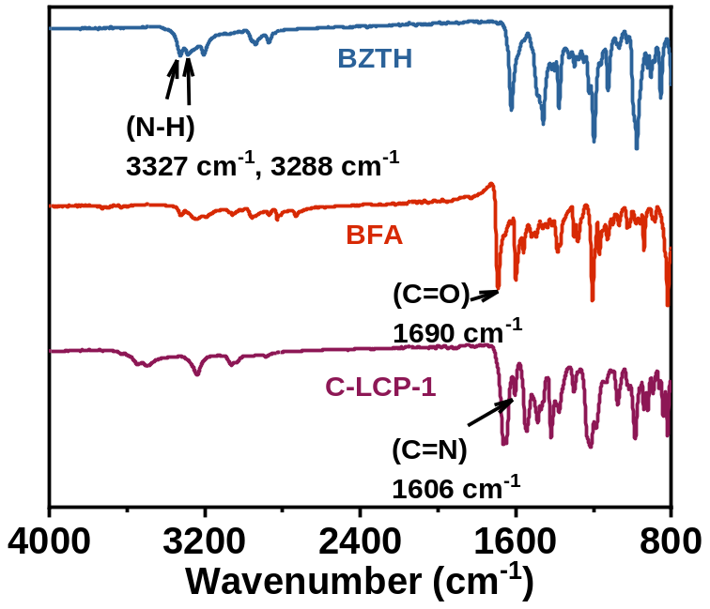
Supplementary Fig. S1 The FT‑IR spectrum of C‑LCP‑1 was compared with those of the starting monomers, BFA and BZTH.

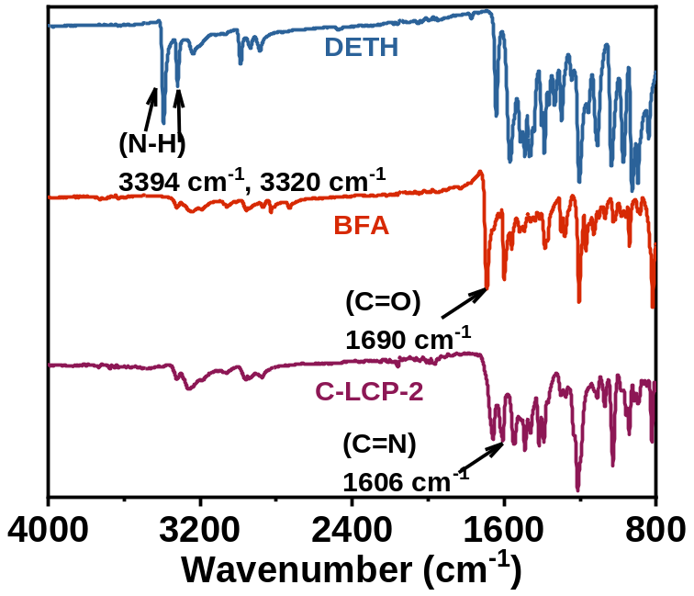
Supplementary Fig. S2 The FT‑IR spectrum of C‑LCP‑2 was compared with those of the starting monomers, BFA and DETH.
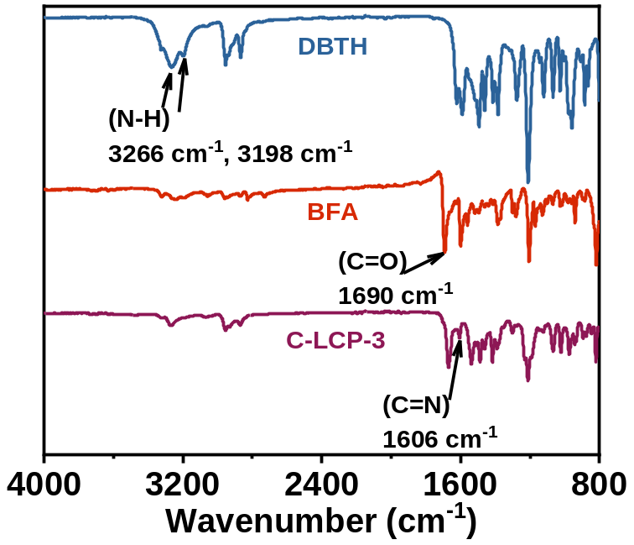
Supplementary Fig. S3 The FT‑IR spectrum of C‑LCP‑3 was compared with those of the starting monomers, BFA and DBTH.

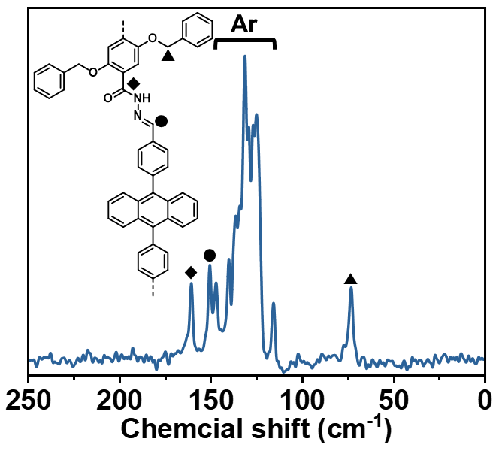
Supplementary Fig. S4 Solid-state ¹³C NMR spectra of C-LCP-1.

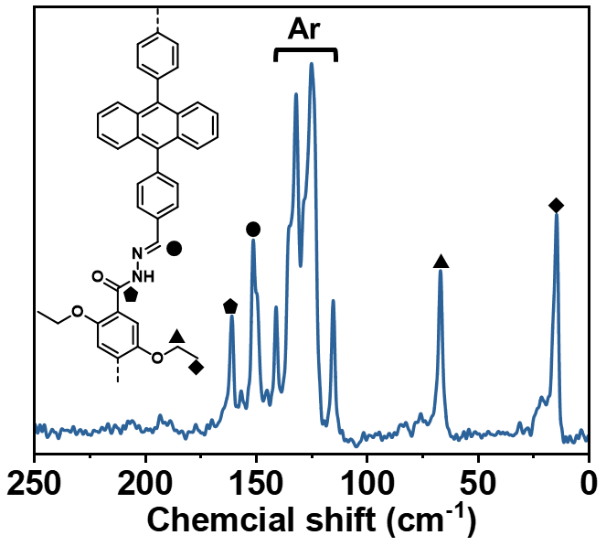
Supplementary Fig. S5 Solid-state ¹³C NMR spectra of C-LCP-2.

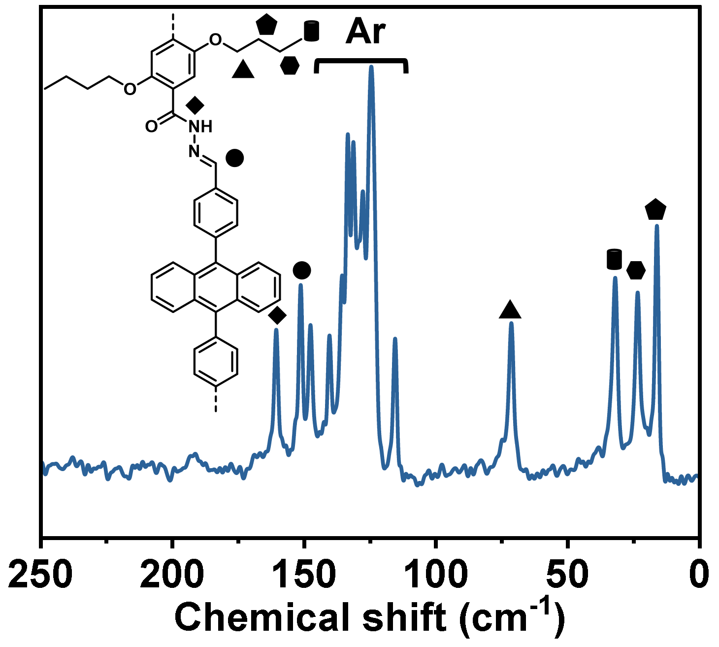
Supplementary Fig. S6 Solid-state ¹³C NMR spectra of C-LCP-3.
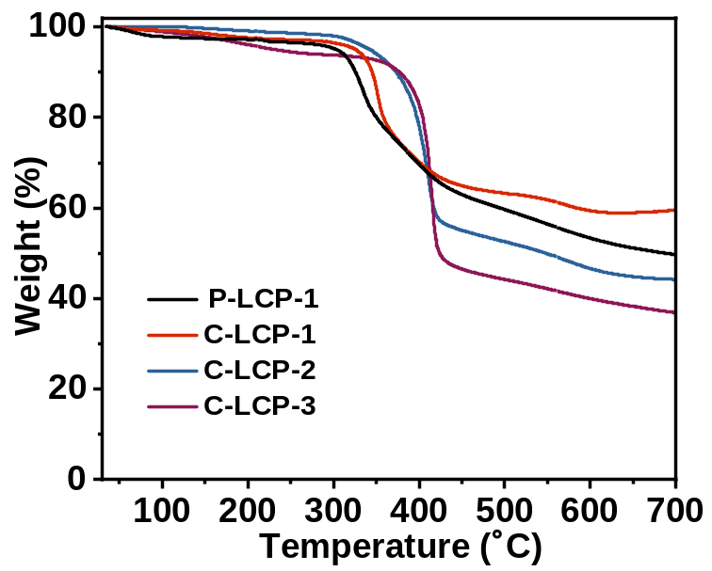
Supplementary Fig. S7 TGA data of C-LCP-1-3 and P-LCP-1 under N₂ atmosphere.

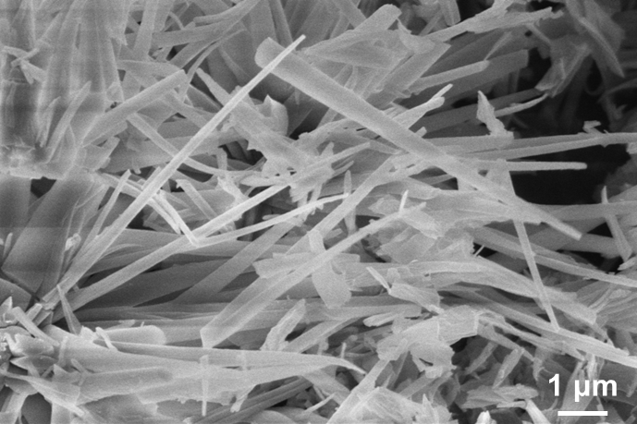
Supplementary Fig. S8 SEM image of C-LCP-2.

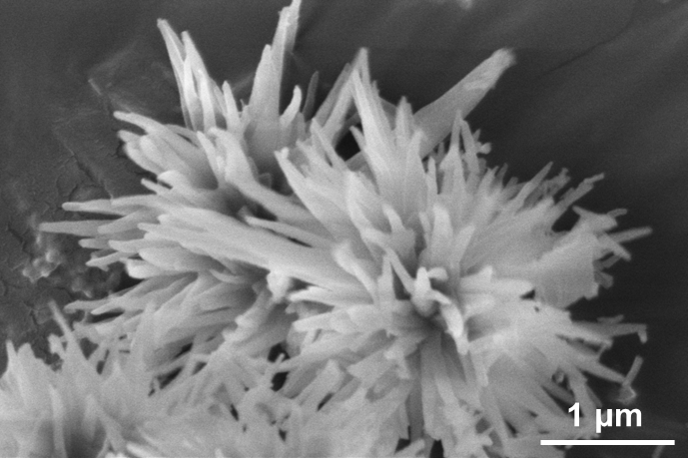
Supplementary Fig. S9 SEM image of C-LCP-3.

Supplementary Table 1 Crystal data and structure refinement parameters for C-LCP-1.
Empirical formula | C₂₅N₂O₂H₁₇
Formula weight | 377.42
Crystal system | monoclinic
Space group | C2/c
a/Å | 46.7(7)
b/Å | 9.8(2)
c/Å | 8.3(4)
α/° | 90
β/° | 94.2(4)
γ/° | 90
Volume/Å³ | 3788(206)
Z | 8
ρ_{calc}g/cm³ | 1.323
μ/mm⁻¹ | 0.000
F(000) | 641.0
Radiation | transmission electron microscope (λ = 0.0251)
2θ range for data collection/° | 0.15 to 1.41
Index ranges | -34 ≤ h ≤ 34, -9 ≤ k ≤ 9, -8 ≤ l ≤ 8
Reflections collected | 3529
Independent reflections | 1092 [R_{int} = 0.1405, R_{sigma} = 0.1983]
Data/restraints/parameters | 1092/26/84
Goodness-of-fit on F² | 1.110
Final R indexes [I>=2σ (I)] | R₁ = 0.2407, wR₂ = 0.5920
Final R indexes [all data] | R₁ = 0.3070, wR₂ = 0.6523
Largest diff. peak/hole / e Å⁻³ | 0.16/-0.16

Supplementary Table 2 Crystal data and structure refinement parameters for C-LCP-2.
Empirical formula | C₂₀N₂O₂H₁₅
Formula weight | 315.35
Crystal system | monoclinic
Space group | I2/a
a/Å | 8.3(4)
b/Å | 9.1(5)
c/Å | 43.9(8)
α/° | 90
β/° | 91.7(2)
γ/° | 90
Volume/Å³ | 3345(256)
Z | 8
ρ_{calc}g/cm³ | 1.253
μ/mm⁻¹ | 0.000
F(000) | 532.0
Radiation | transmission electron microscope (λ = 0.0251)
2θ range for data collection/° | 0.066 to 1.424
Index ranges | -8 ≤ h ≤ 8, -9 ≤ k ≤ 9, -43 ≤ l ≤ 43
Reflections collected | 4111
Independent reflections | 1670 [R_{int} = 0.1917, R_{sigma} = 0.2350]
Data/restraints/parameters | 1670/65/72
Goodness-of-fit on F² | 1.254
Final R indexes [I>=2σ (I)] | R₁ = 0.4178, wR₂ = 0.7227
Final R indexes [all data] | R₁ = 0.5061, wR₂ = 0.7916
Largest diff. peak/hole / e Å⁻³ | 0.43/-0.44

Supplementary Table 3 Crystal data and structure refinement parameters for C-LCP-3.
Empirical formula | C₂₂N₂O₂H₁₉
Formula weight | 343.41
Crystal system | monoclinic
Space group | I2/a
a/Å | 8.1(2)
b/Å | 9.52(17)
c/Å | 45.1(3)
α/° | 90
β/° | 91.39(10)
γ/° | 90
Volume/Å³ | 3470(118)
Z | 8
ρ_{calc}g/cm³ | 1.315
μ/mm⁻¹ | 0.000
F(000) | 589.0
Radiation | transmission electron microscope (λ = 0.0251)
2θ range for data collection/° | 0.154 to 1.53
Index ranges | -8 ≤ h ≤ 8, -10 ≤ k ≤ 10, -46 ≤ l ≤ 47
Reflections collected | 5118
Independent reflections | 1819 [R_{int} = 0.1550, R_{sigma} = 0.1573]
Data/restraints/parameters | 1819/35/78
Goodness-of-fit on F² | 1.232
Final R indexes [I>=2σ (I)] | R₁ = 0.2115, wR₂ = 0.5385
Final R indexes [all data] | R₁ = 0.3055, wR₂ = 0.6136
Largest diff. peak/hole / e Å⁻³ | 0.25/-0.29

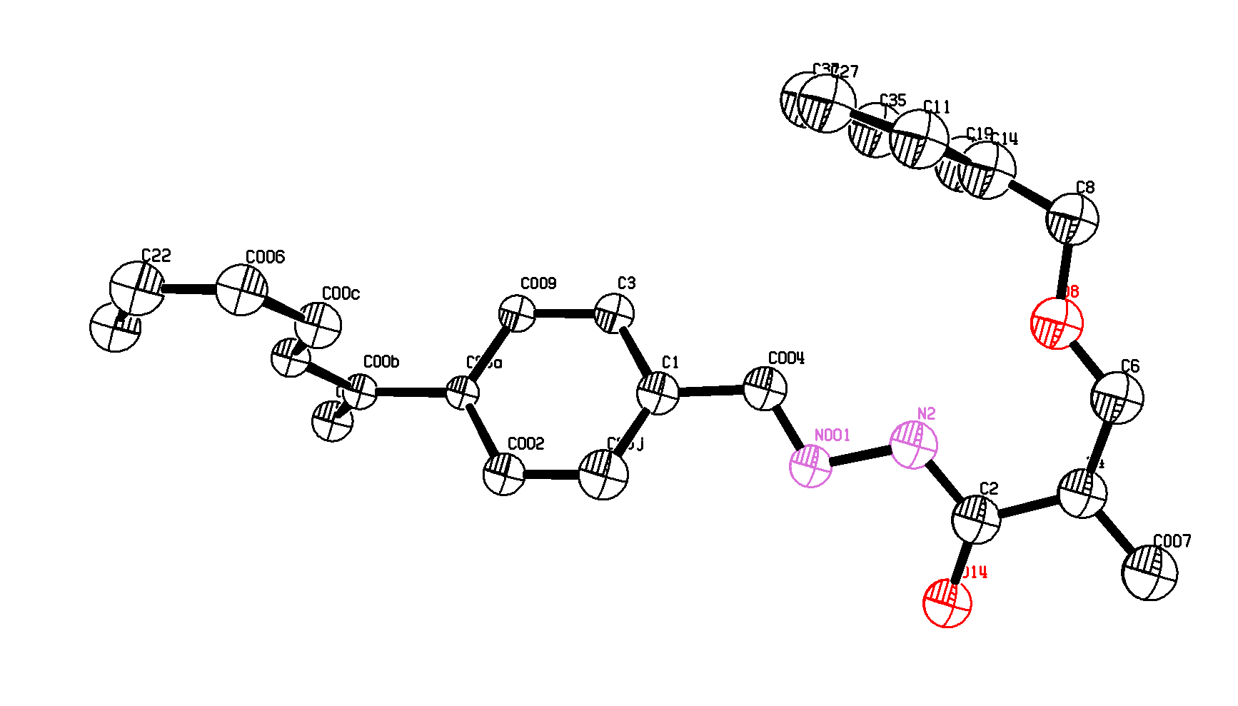
Supplementary Fig. S10 The asymmetric unit in the single-crystal structure of C-LCP-1. Thermal ellipsoids are drawn with 30% probability.

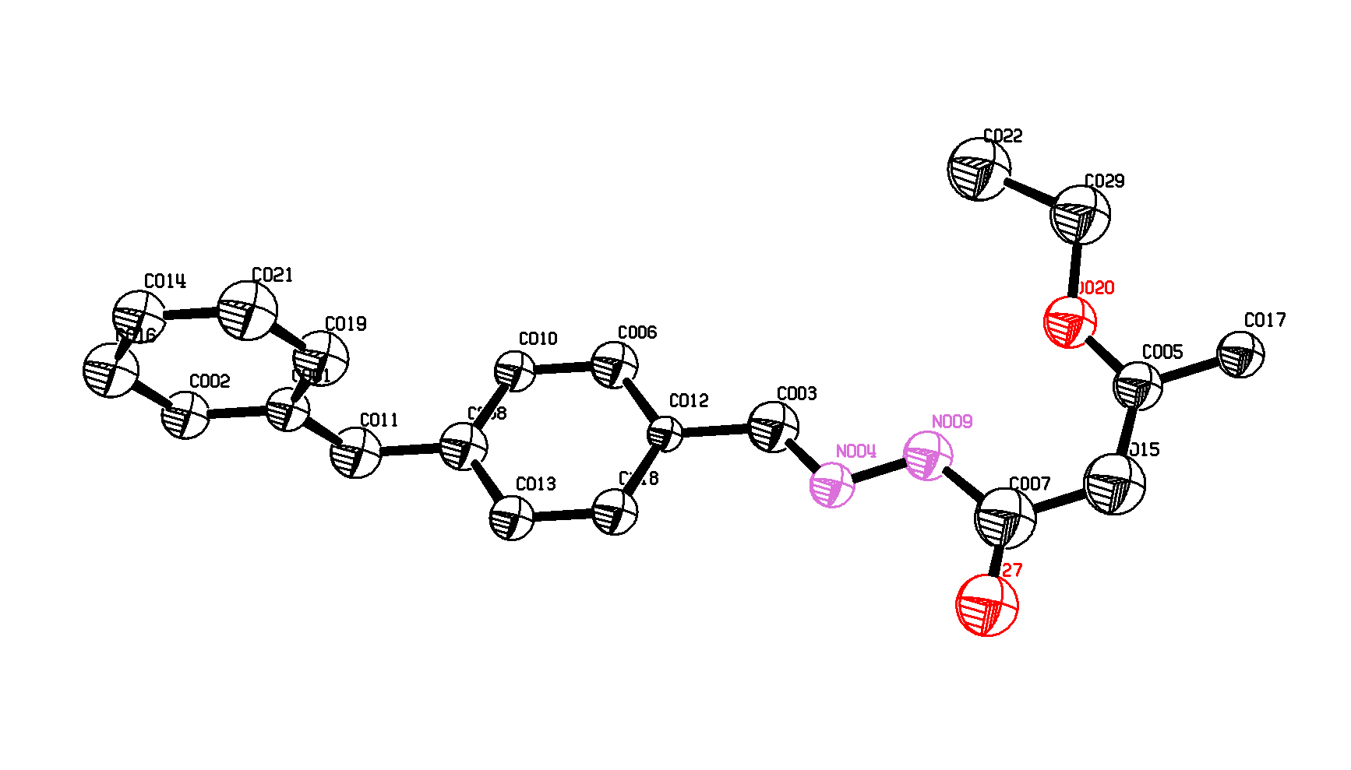
Supplementary Fig. S11 The asymmetric unit in the single-crystal structure of C-LCP-2. Thermal ellipsoids are drawn with 30% probability.
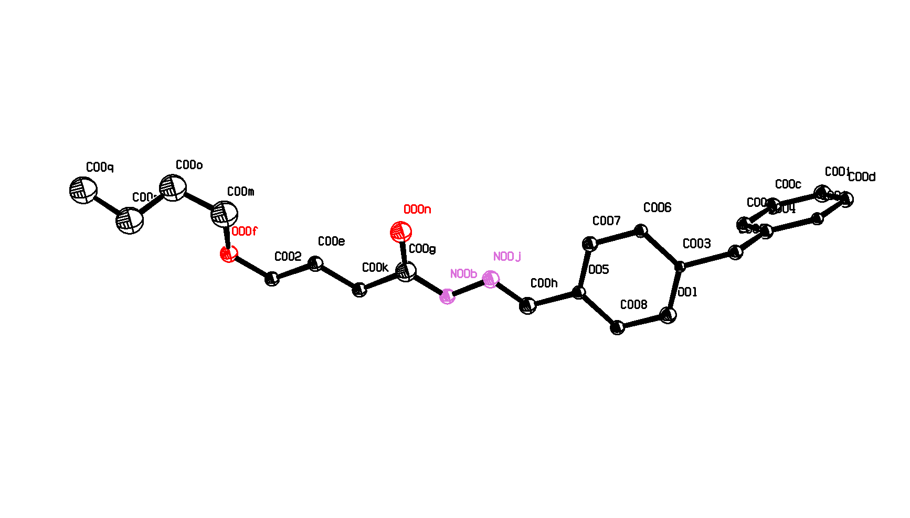
Supplementary Fig. S12 The asymmetric unit in the single-crystal structure of C-LCP-3. Thermal ellipsoids are drawn with 30% probability.

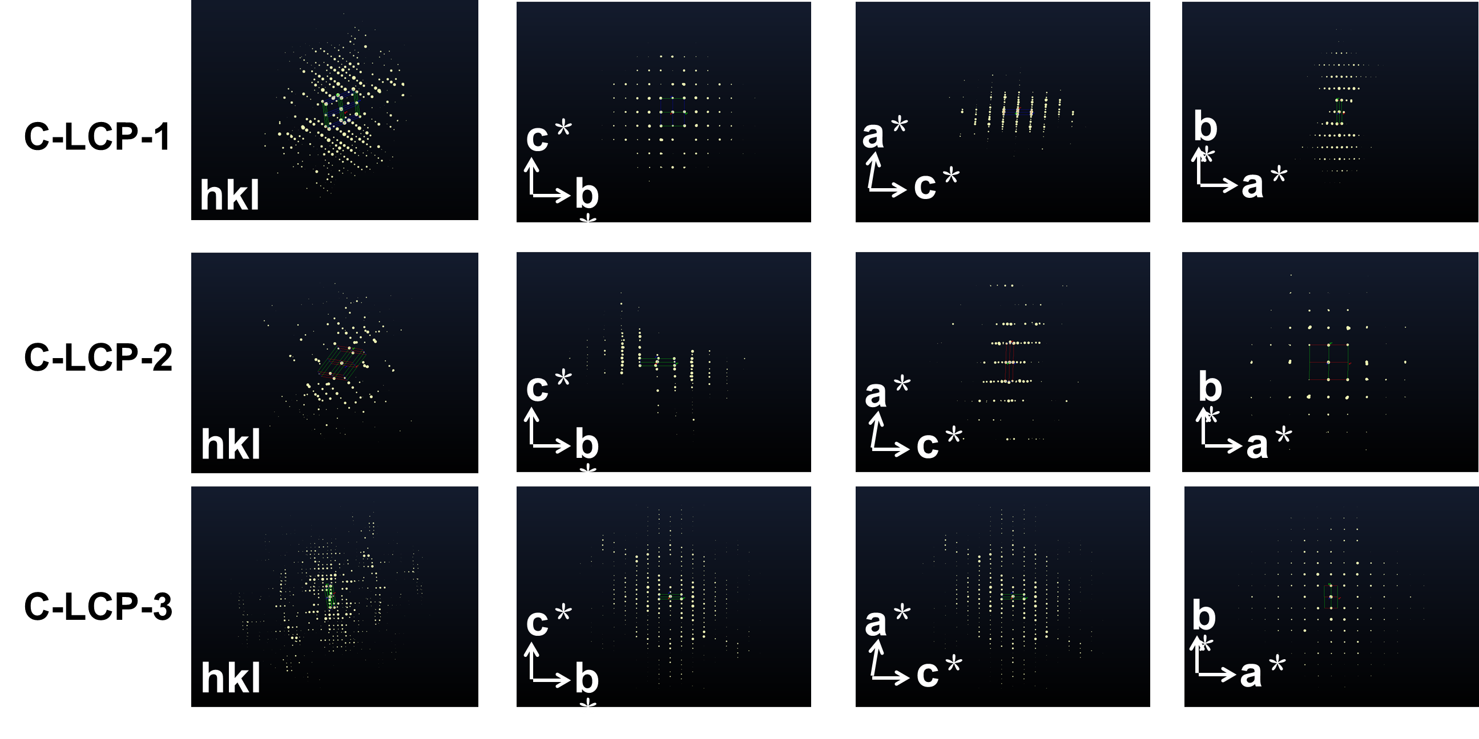
Supplementary Fig. S13 The three-dimensional reciprocal lattice of C-LCP-1-3.

Supplementary Table 4 The unit‑cell parameters of C-LCP-1-3.

 | a | b | c | α | β | γ
C-LCP-1 | 46.9 Å | 9.8 Å | 8.3 Å | 90° | 94.2° | 90°
C-LCP-2 | 8.3 Å | 9.1 Å | 43.9 Å | 90° | 91.7° | 90°
C-LCP-3 | 8.1 Å | 9.52 Å | 45.1 Å | 90° | 90.39° | 90°

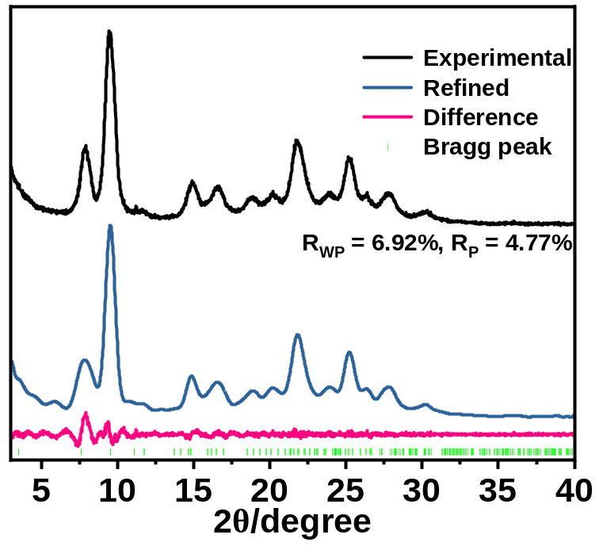
Supplementary Fig. S14 The PXRD patterns of C-LCP-2.

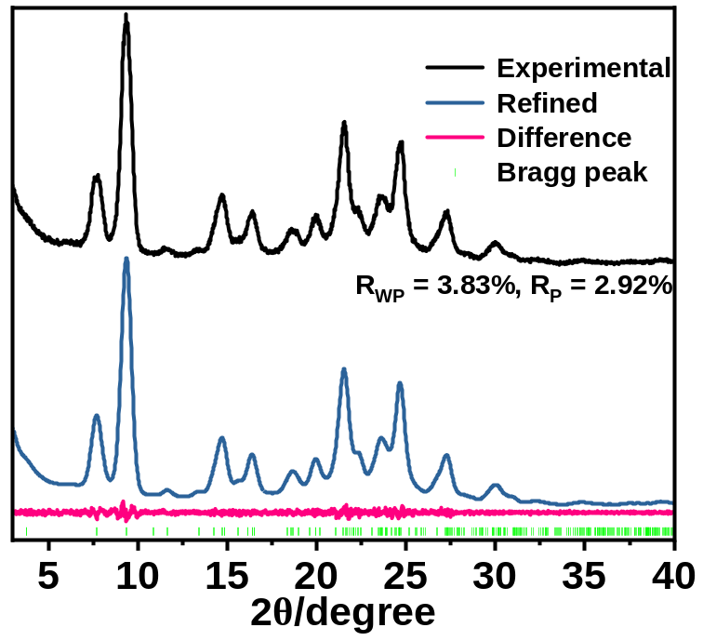
Supplementary Fig. S15 The PXRD patterns of C-LCP-3.

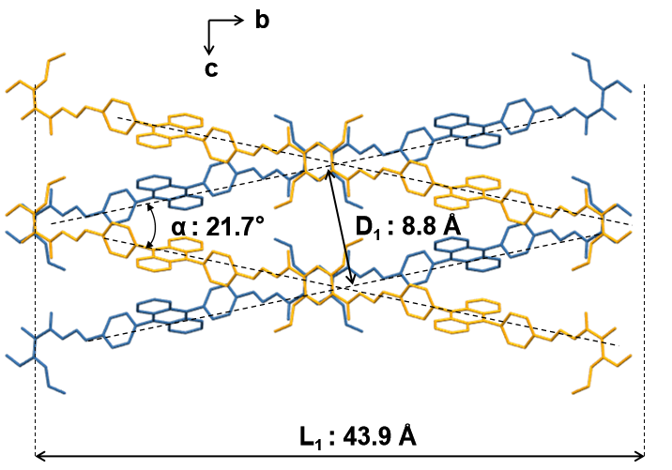
Supplementary Fig. S16 The packing structure of C-LCP-2.

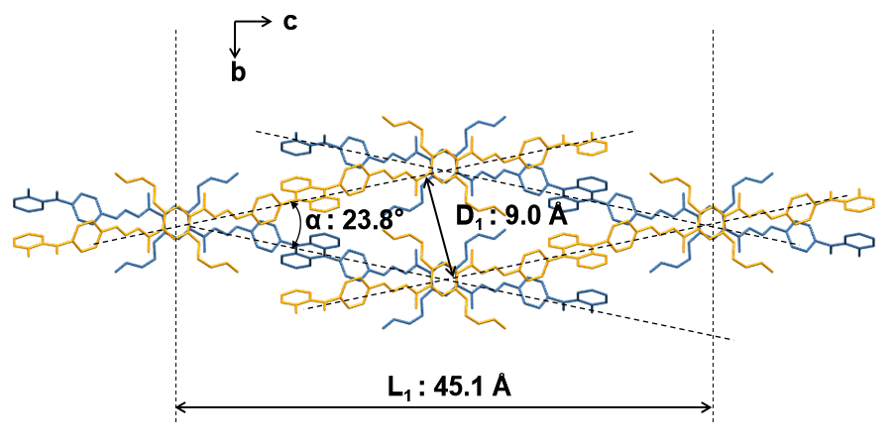
Supplementary Fig. S17 The packing structure of C-LCP-3.
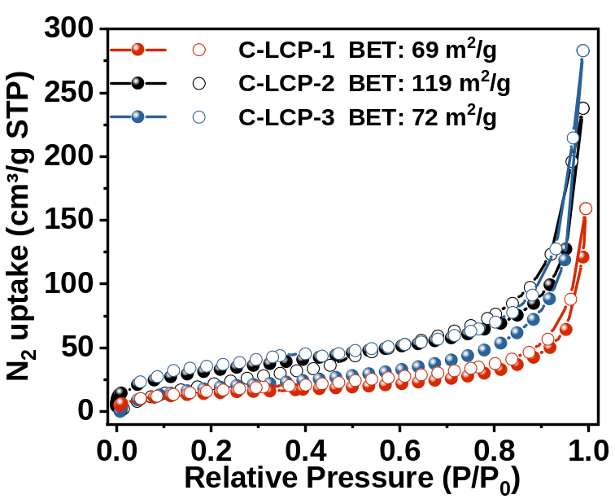
Supplementary Fig. S18 N₂ adsorption of C-LCP-1-3.

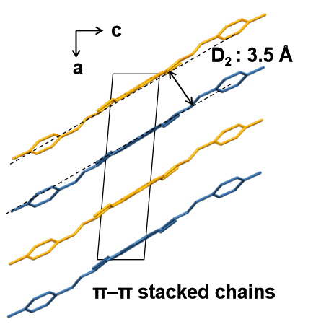
Supplementary Fig. S19 The interlayer distance and π–π stacked chains of C-LCP-2.

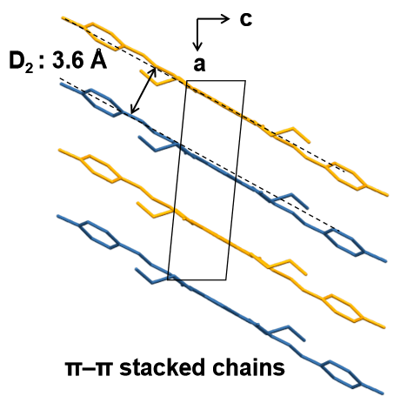
Supplementary Fig. S20 The interlayer distance and π–π stacked chains of C-LCP-3.

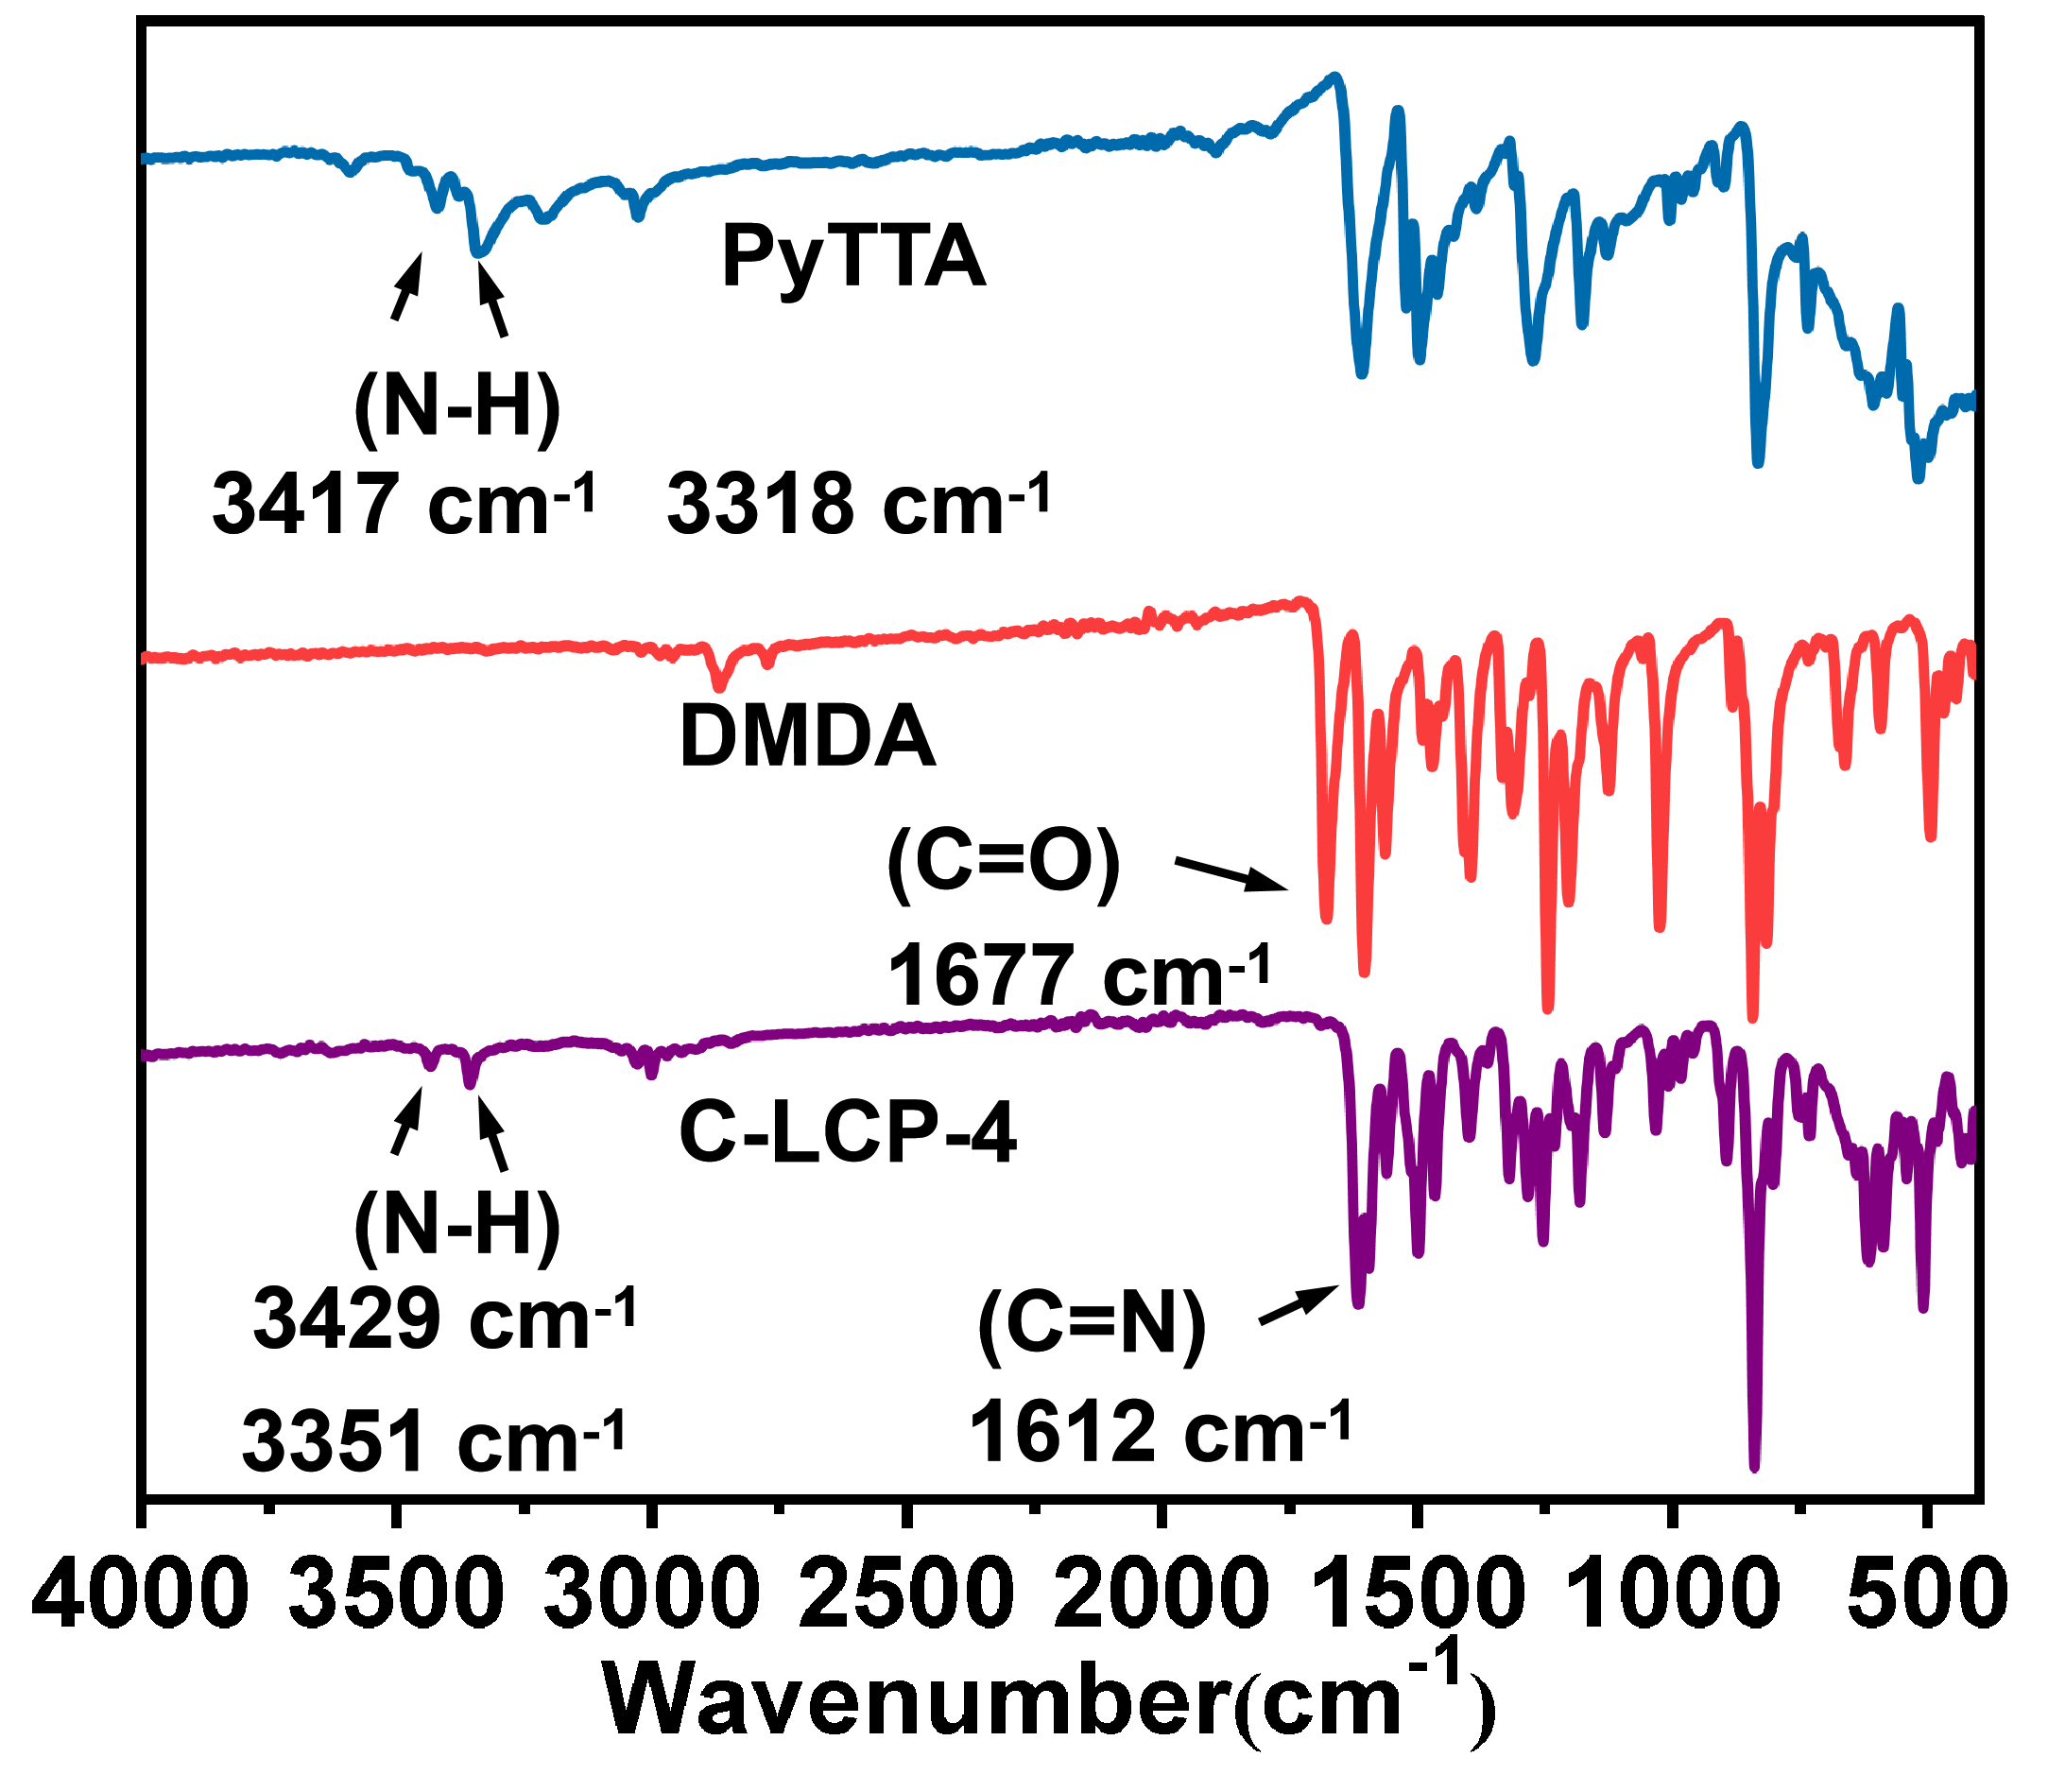
Supplementary Fig. 21 The FT‑IR spectrum of C‑LCP‑4 was compared with those of the starting monomers, PyTTA and DMDA.
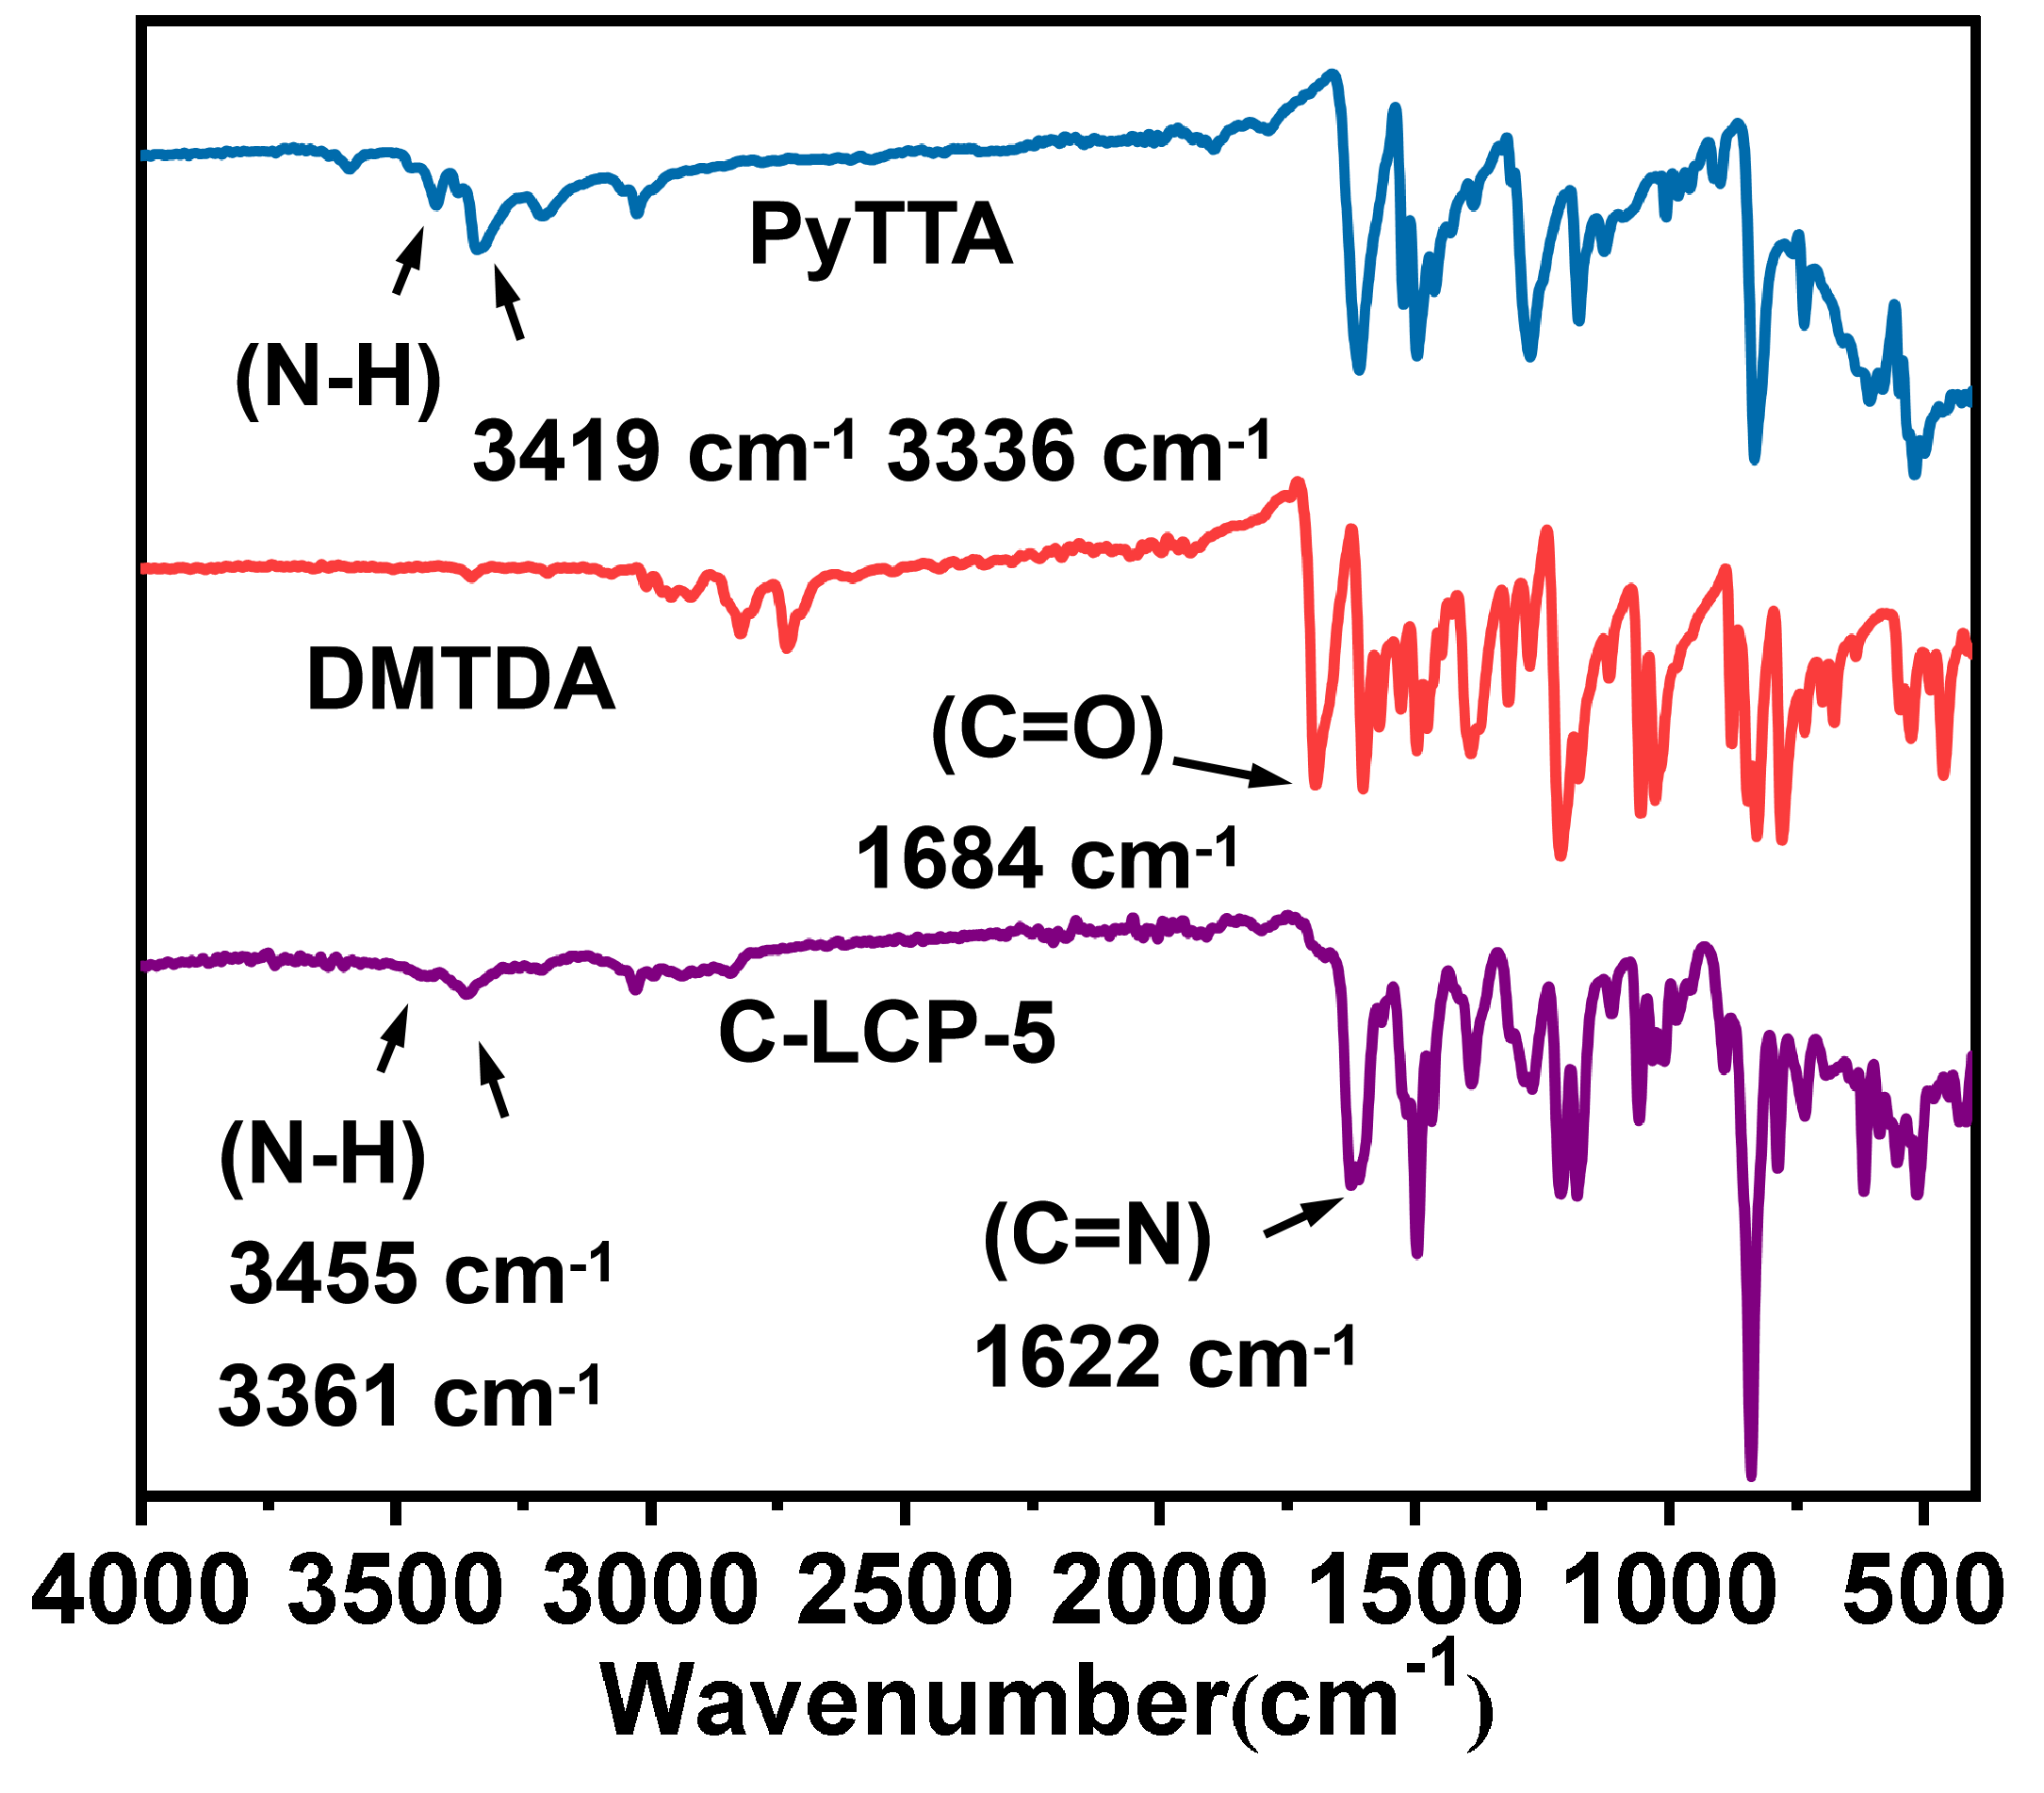
Supplementary Fig. 22 The FT‑IR spectrum of C‑LCP‑5 was compared with those of the starting monomers, PyTTA and DMDA.

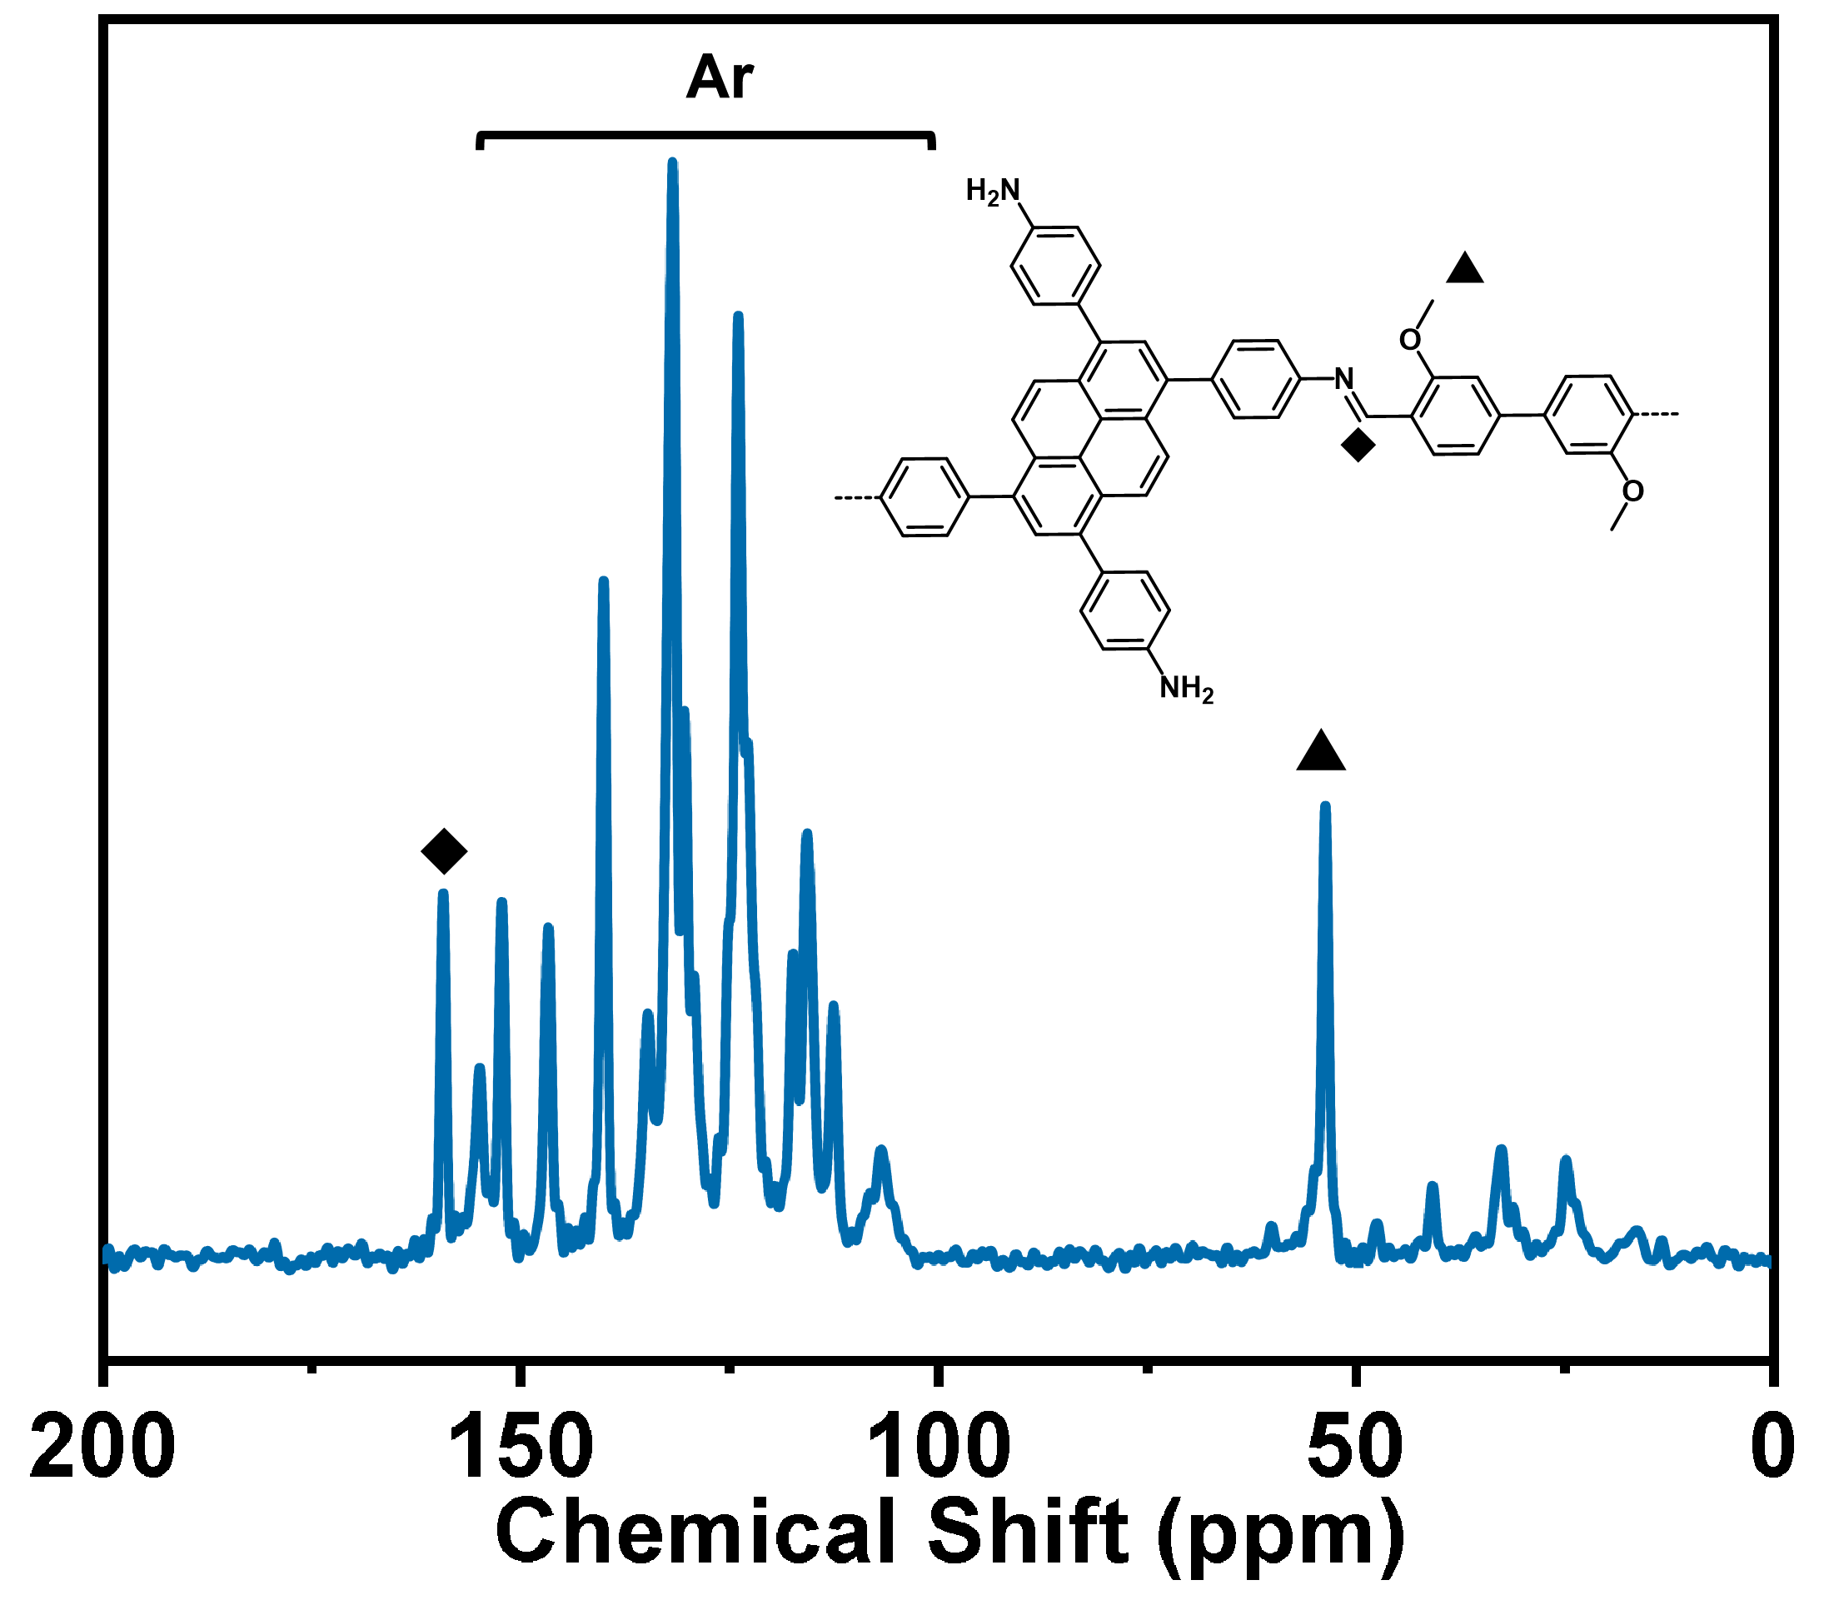
Supplementary Fig. S23 Solid-state ¹³C NMR spectra of C-LCP-4.
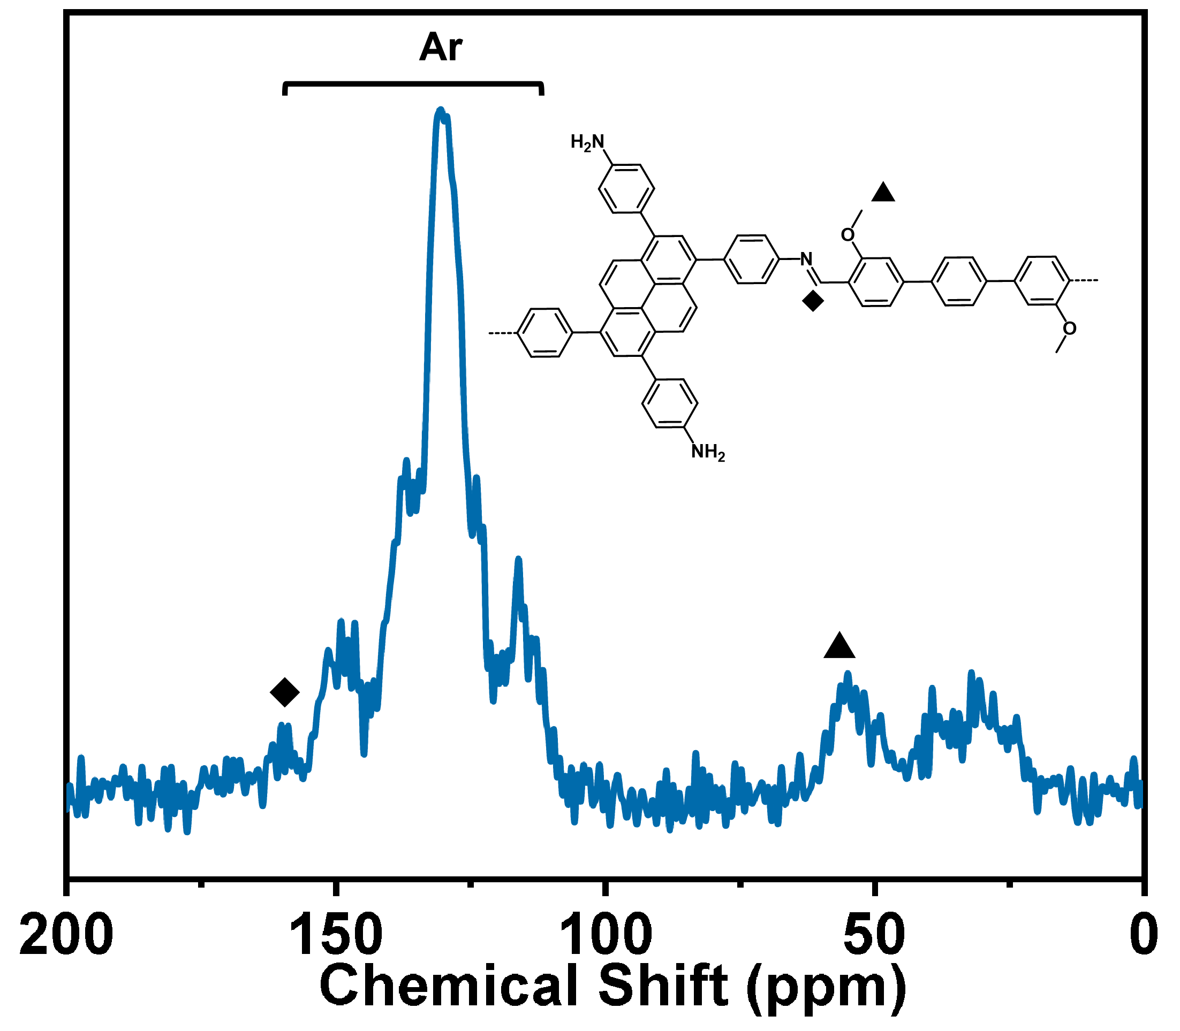
Supplementary Fig. S24 Solid-state ¹³C NMR spectra of C-LCP-5.

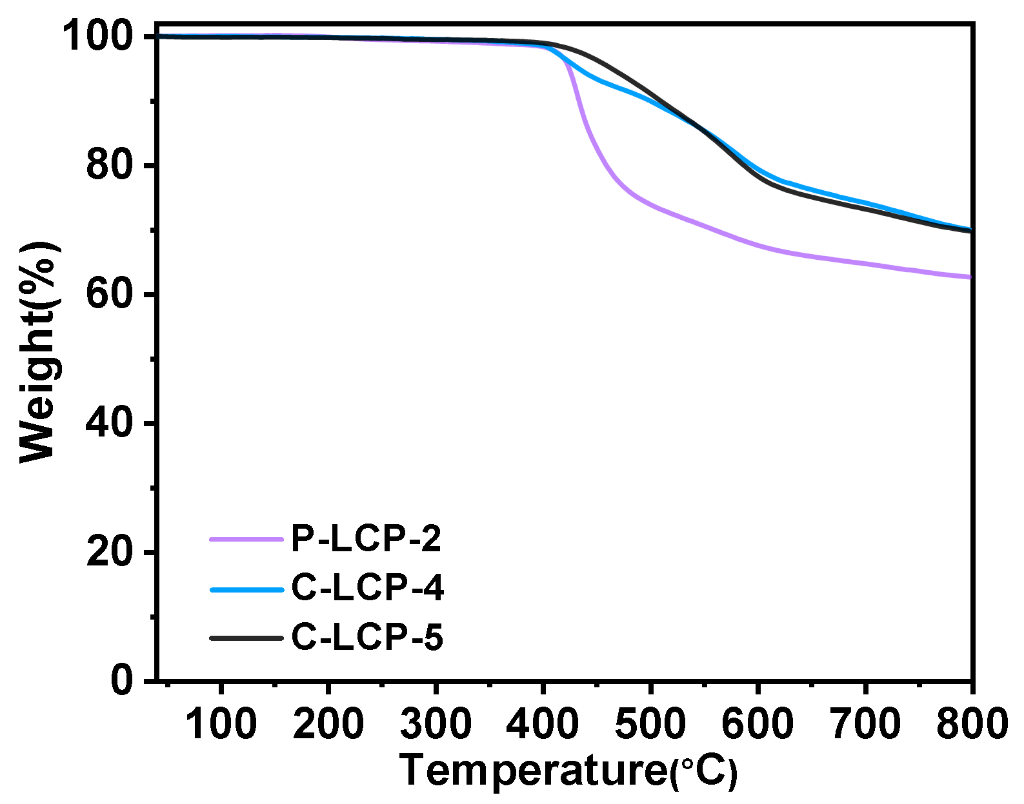
Supplementary Fig. S25 TGA data of C-LCP-4-5 and P-LCP-2 under N₂ atmosphere.

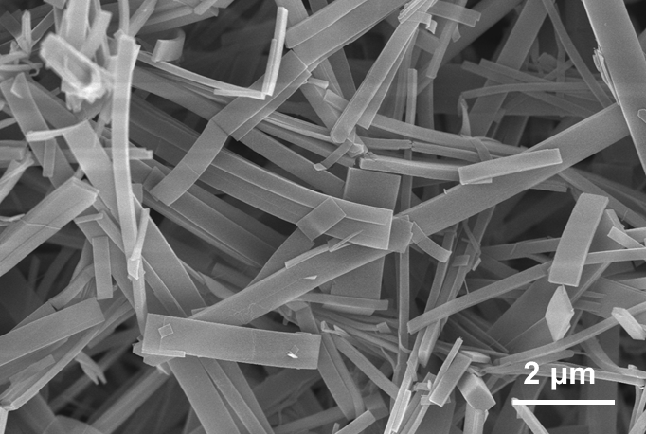
Supplementary Fig. S26 SEM image of C-LCP-5.

Supplementary Table 5 Crystal data and structure refinement parameters for C-LCP-4.
Empirical formula | C₃₆H₂₈N₂O
Formula weight | 504.63
Crystal system | orthorhombic
Space group | Pccm
a/Å | 24.618(7)
b/Å | 14.9679(12)
c/Å | 7.3420(11)
α/° | 90
β/° | 90
γ/° | 90
Volume/Å³ | 2705.4(9)
Z | 4
ρ_{calc}g/cm³ | 1.239
μ/mm⁻¹ | 0.000
F(000) | 446.0
Radiation | transmission electron microscope (λ = 0.0251)
2θ range for data collection/° | 0.096 to 1.796
Index ranges | -27 ≤ h ≤ 26, -18 ≤ k ≤ 18, -9 ≤ l ≤ 9
Reflections collected | 9391
Independent reflections | 2494 [R_{int} = 0.0874, R_{sigma} = 0.1023]
Data/restraints/parameters | 2494/35/104
Goodness-of-fit on F² | 0.892
Final R indexes [I>=2σ (I)] | R₁ = 0.2322, wR₂ = 0.5022
Final R indexes [all data] | R₁ = 0.2815, wR₂ = 0.5747
Largest diff. peak/hole / e Å⁻³ | 0.75/-0.46

Supplementary Table 6 Crystal data and structure refinement parameters for C-LCP-5.
Empirical formula | C₃₉N₂O
Formula weight | 512.44
Crystal system | orthorhombic
Space group | Pccm
a/Å | 29.330(14)
b/Å | 14.8291(17)
c/Å | 7.5004(14)
α/° | 90
β/° | 90
γ/° | 90
Volume/Å³ | 3262.2(17)
Z | 4
ρ_{calc}g/cm³ | 1.035
μ/mm⁻¹ | 0.000
F(000) | 413.0
Radiation | transmission electron microscope (λ = 0.0251)
2θ range for data collection/° | 0.096 to 1.58
Index ranges | -25 ≤ h ≤ 25, -15 ≤ k ≤ 15, -8 ≤ l ≤ 8
Reflections collected | 9174
Independent reflections | 1655 [R_{int} = 0.1063, R_{sigma} = 0.0861]
Data/restraints/parameters | 1655/88/78
Goodness-of-fit on F² | 0.990
Final R indexes [I>=2σ (I)] | R₁ = 0.3125, wR₂ = 0.6462
Final R indexes [all data] | R₁ = 0.3520, wR₂ = 0.6996
Largest diff. peak/hole / e Å⁻³ | 0.64/-0.38

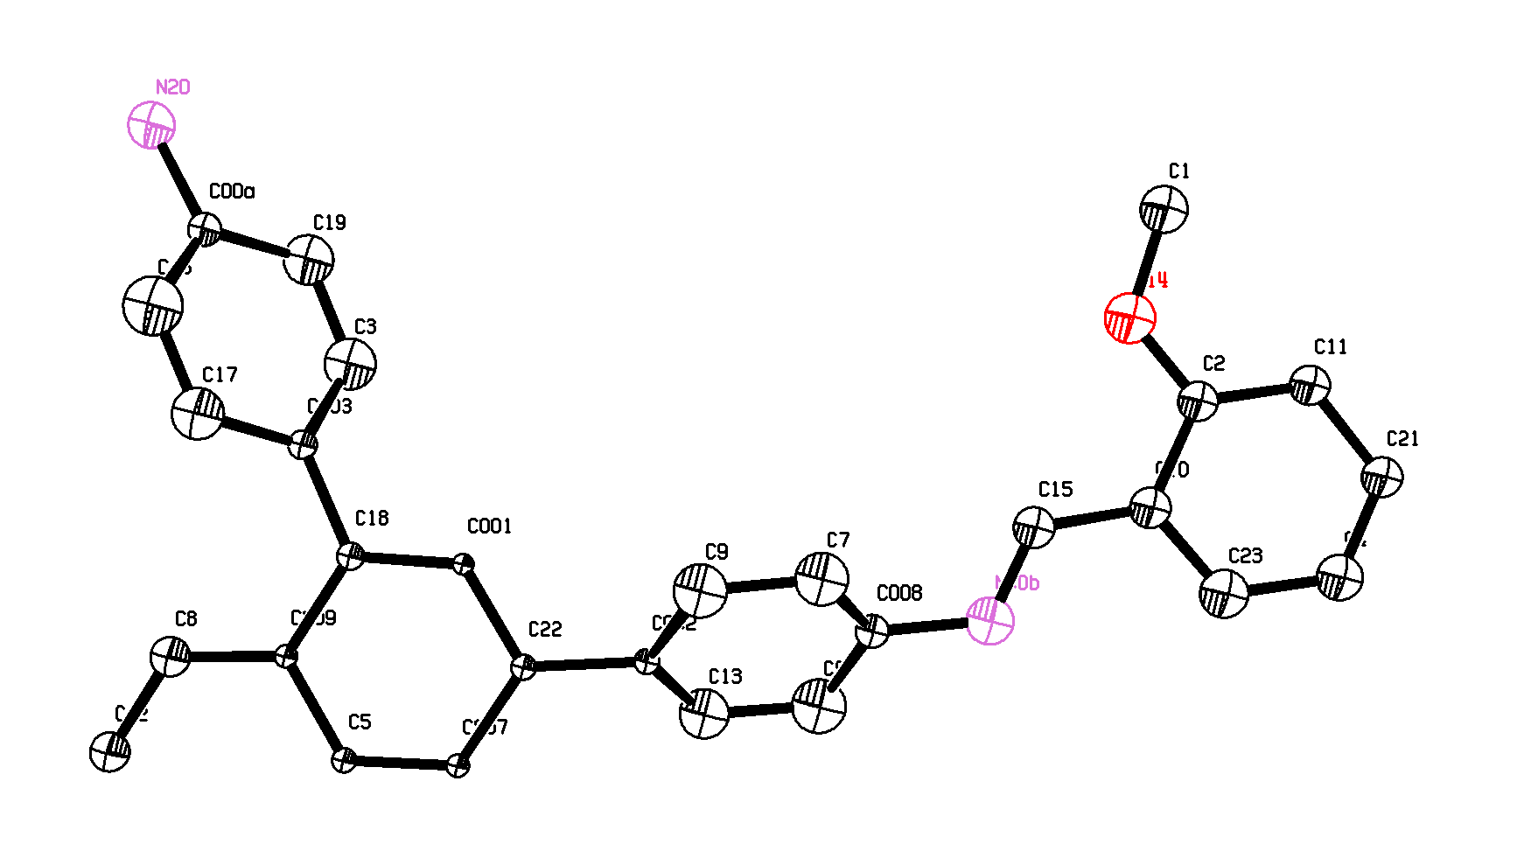
Supplementary Fig. S27 The asymmetric unit in the single-crystal structure of C-LCP-4. Thermal ellipsoids are drawn with 30% probability.
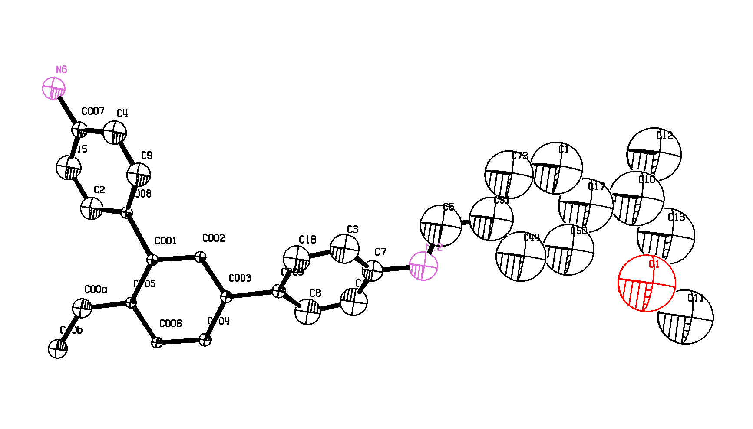
Supplementary Fig. S28 The asymmetric unit in the single-crystal structure of C-LCP-5. Thermal ellipsoids are drawn with 30% probability.
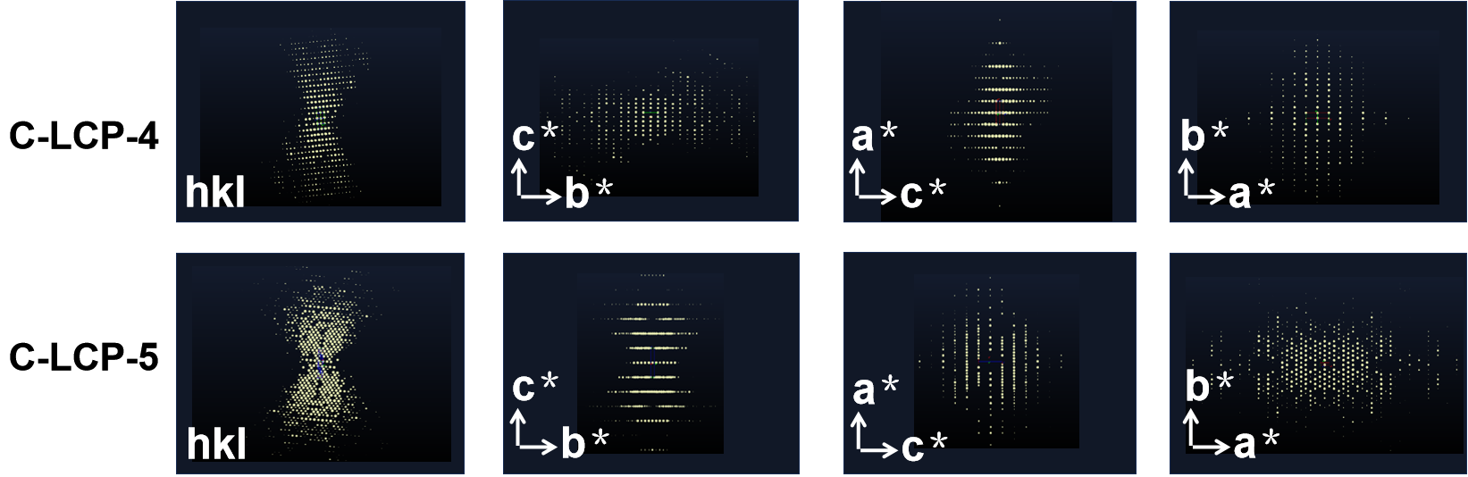
Supplementary Fig. S29 The three-dimensional reciprocal lattice of C-LCP-4-5.

Supplementary Table 7 The unit‑cell parameters of C-LCP-4-5.

 | a | b | c | α | β | γ
C-LCP-4 | 24.6 Å | 15.0 Å | 7.3 Å | 90° | 90° | 90°
C-LCP-5 | 29.3 Å | 14.8 Å | 7.5 Å | 90° | 91.7° | 90°

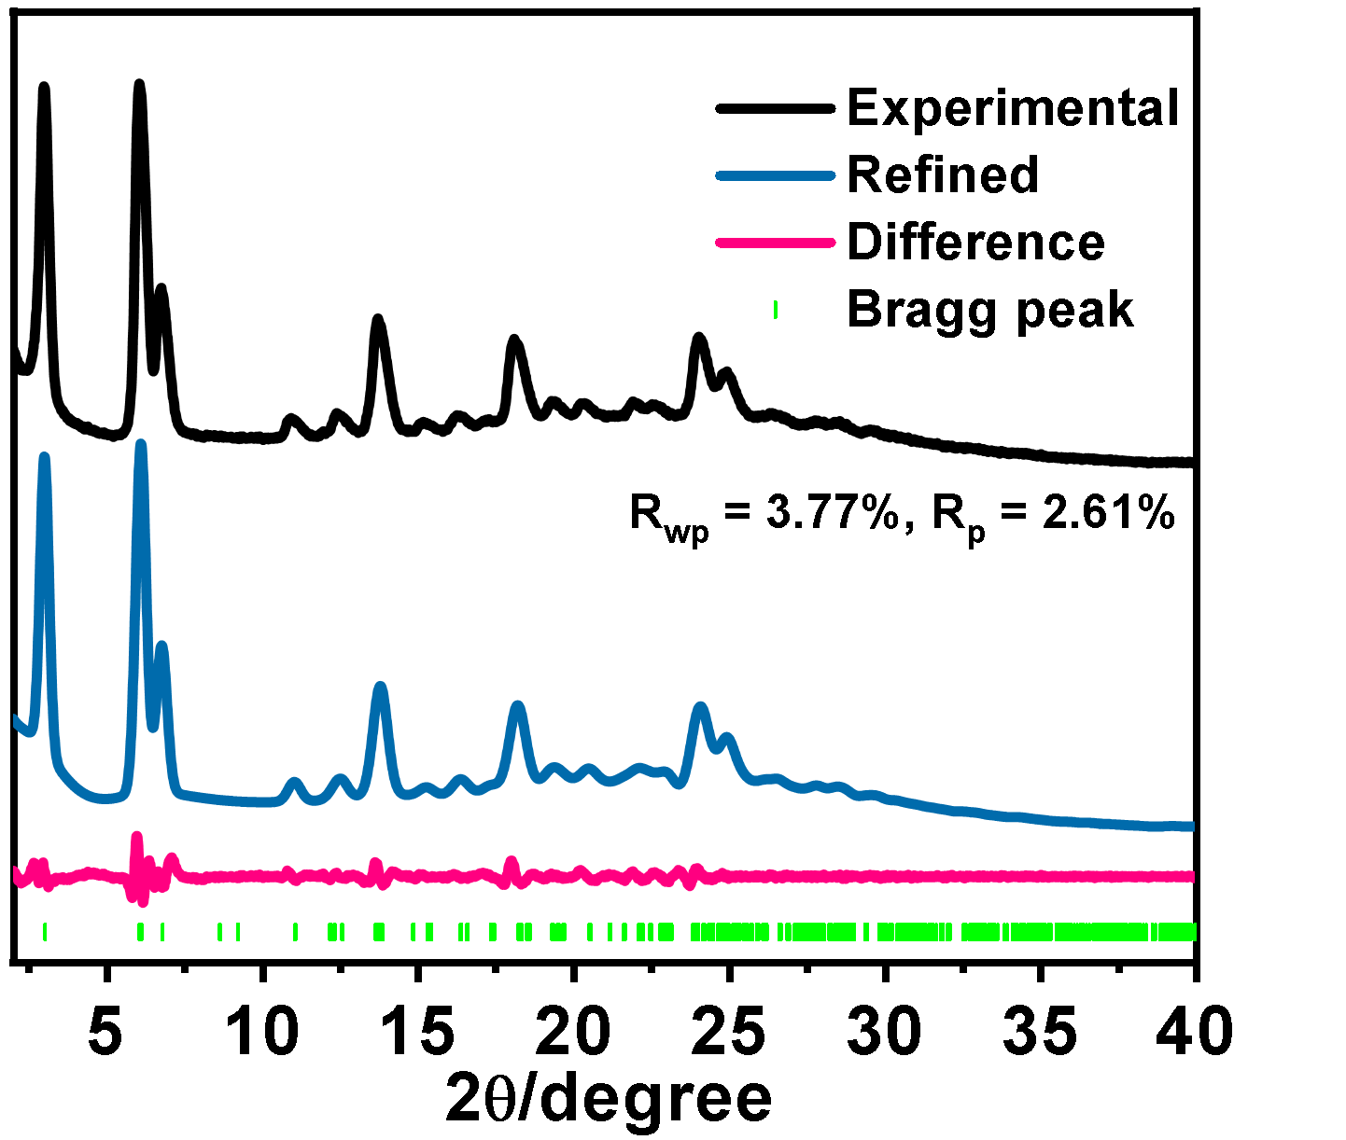
Supplementary Fig. S30 The PXRD patterns of C-LCP-5.

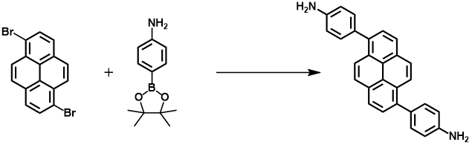
Synthesis of 1,6-bis(4-aminophenyl)pyrene (PyDA).
A suspension of 1,6-dibromopyrene (262 mg, 0.727 mmol, 1 equiv), 4-aminophenylboronic acid pinacol ester (326 mg, 1.48 mmol, 2.05 equiv) and Na₂CO₃ (154 mg, 1.45 mmol, 2 equiv) in DMF/H₂O (3:1, 32 mL) was degassed with argon for 15 minutes. Pd(PPh₃)₄ (80 mg, 0.069 mmol, 0.10 equiv) was added and the mixture was heated at 110 °C for 24 h under argon. The hot suspension was filtered and the filtrate was diluted with water and extracted with dichloromethane (3 × 60 mL). The combined organic layers were washed with water (4 × 100 mL) and brine, dried over MgSO₄ and the solvent was evaporated. The solid was washed with cold diethyl ether to give 216 mg (77 %) of 1,6bis(4-aminophenyl)pyrene as a pale yellow powder. ¹H NMR (400 MHz, CDCl₃) δ 8.18 (dd, J = 30.3, 8.5 Hz, 1H), 8.05-7.83 (m, 1H), 7.44 (d, J = 7.1 Hz, 1H), 6.92 (t, J = 22.1 Hz, 1H), 3.82 (s, 1H). ¹³C NMR (101 MHz, CDCl₃) δ 145.66, 137.85, 131.56, 130.13, 128.88, 127.66, 127.09, 125.45, 125.15, 124.21, 115.06.
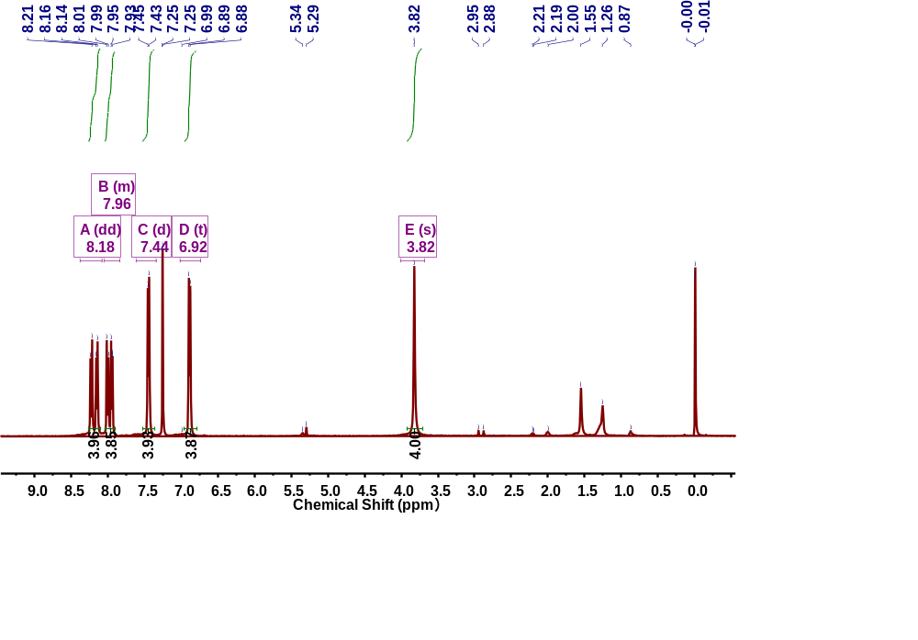
Supplementary Fig. S31 ¹H NMR spectrum of PyDA.

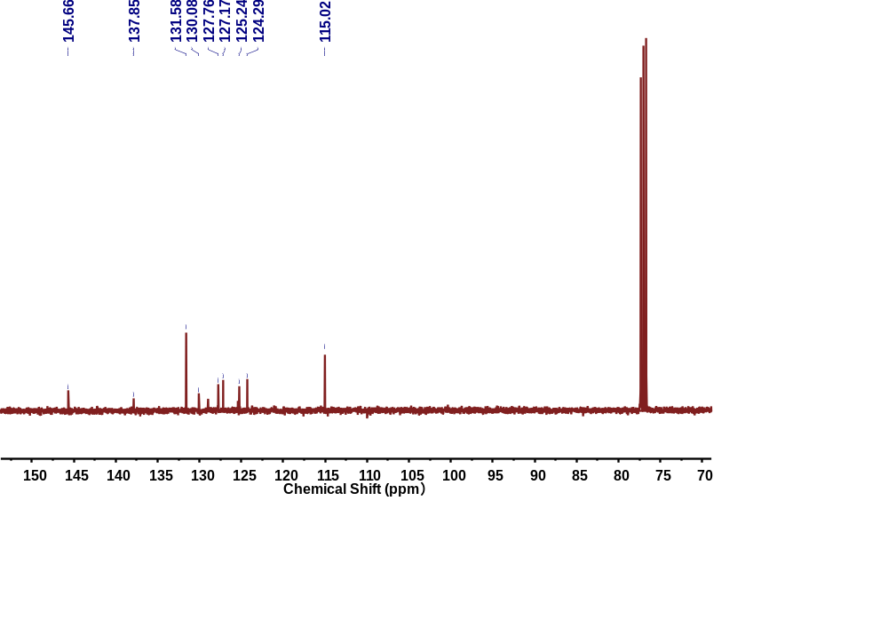
Supplementary Fig. S32 ¹³C NMR spectrum of PyDA.

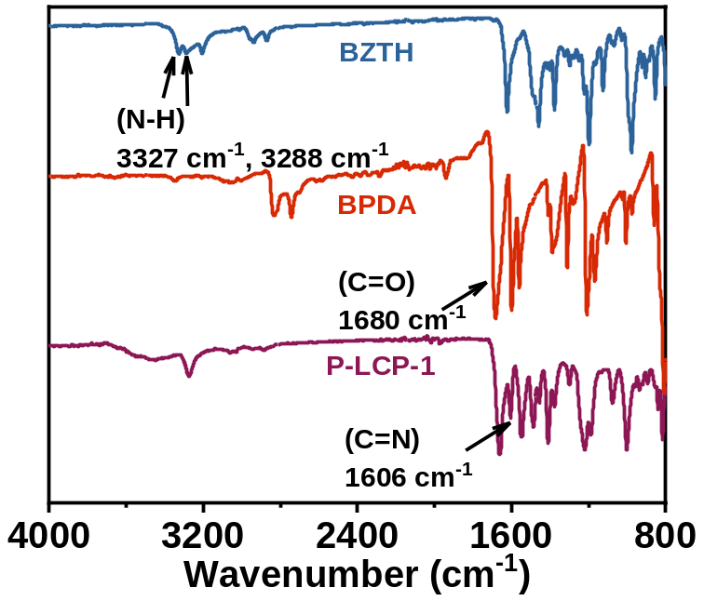
Supplementary Fig. S33 The FT‑IR spectrum of P‑LCP‑1 was compared with those of the starting monomers, BFA and DBTH.
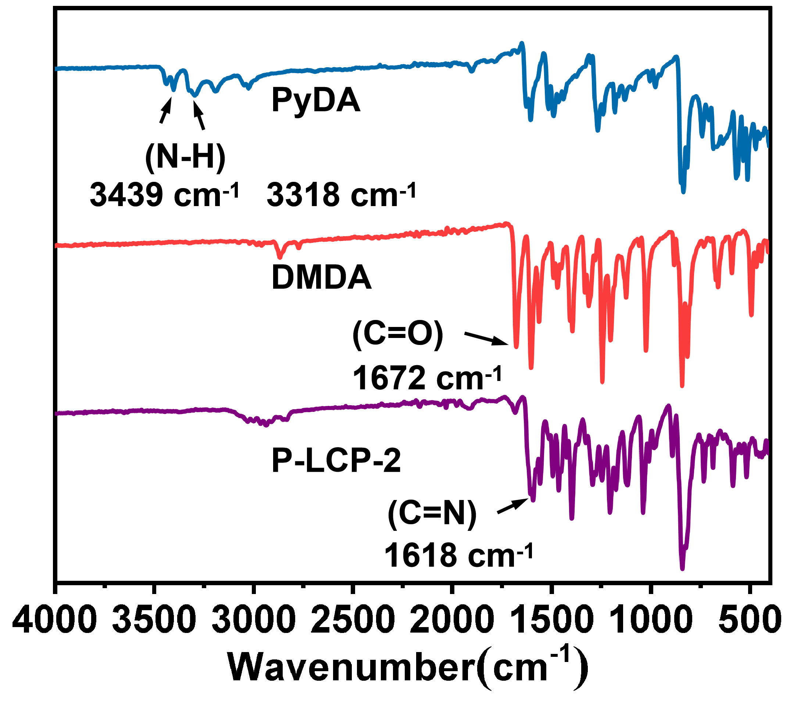
Supplementary Fig. S34 The FT‑IR spectrum of P‑LCP‑2 was compared with those of the starting monomers, PyDA and DMDA.

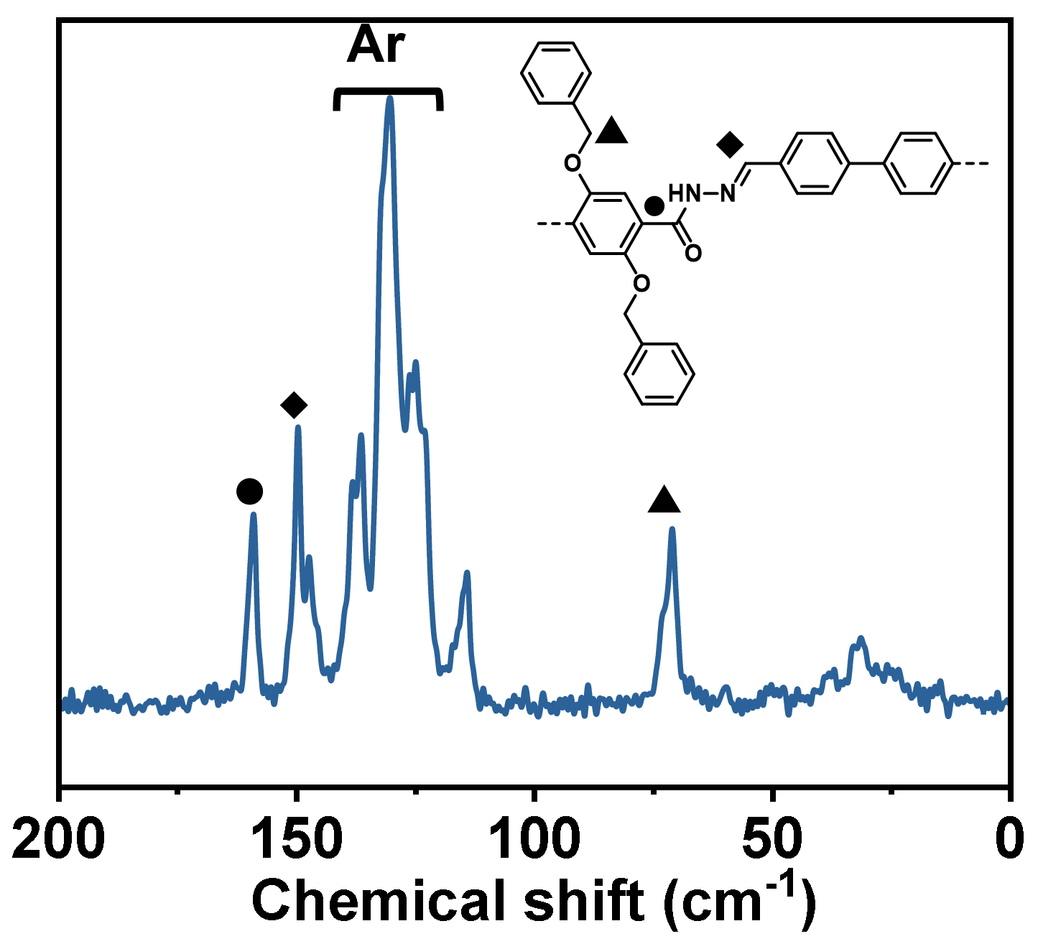
Supplementary Fig. S35 Solid-state ¹³C NMR spectra of P-LCP-1.
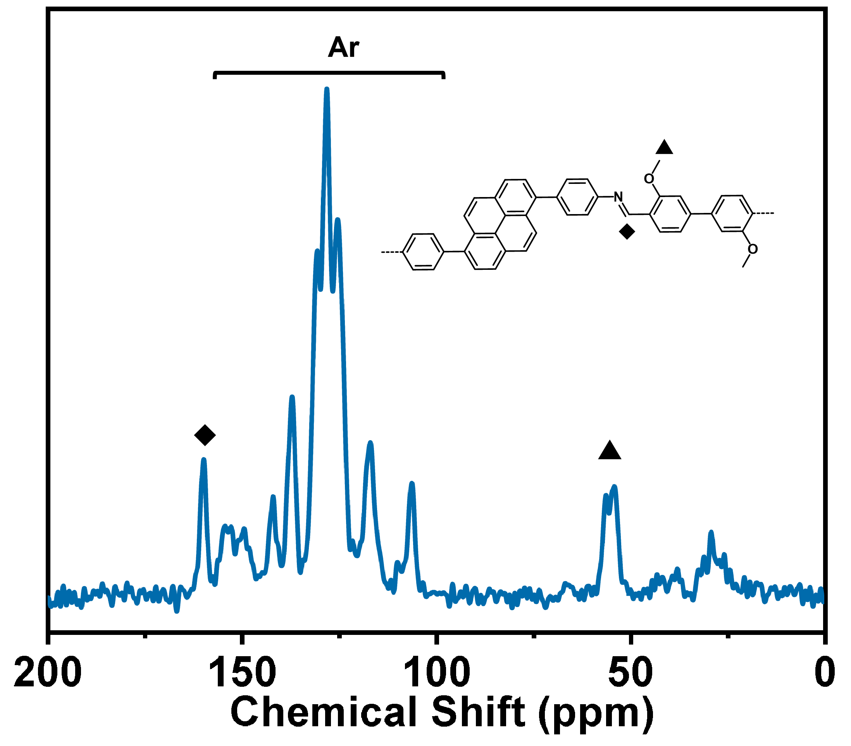
Supplementary Fig. S36 Solid-state ¹³C NMR spectra of P-LCP-2.

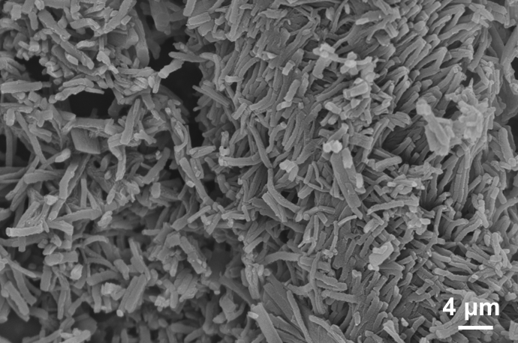
Supplementary Fig. S37 SEM image of P-LCP-1.

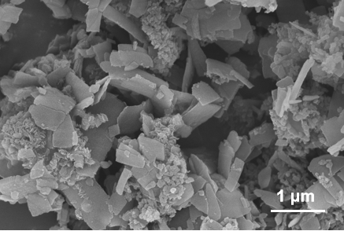
Supplementary Fig. S38 SEM image of P-LCP-2.

Supplementary Table 8 Crystal data and structure refinement parameters for P-LCP-1.
Empirical formula | C₁₈N₂O₂H₁₄
Formula weight | 290.32
Crystal system | monoclinic
Space group | C2/c
a/Å | 8.6(4)
b/Å | 19.9(3)
c/Å | 17.9(3)
α/° | 90
β/° | 99.2(12)
γ/° | 90
Volume/Å³ | 3014(174)
Z | 8
ρ_{calc}g/cm³ | 1.280
μ/mm⁻¹ | 0.000
F(000) | 488.0
Radiation | transmission electron microscope (λ = 0.0251)
2θ range for data collection/° | 0.144 to 1.424
Index ranges | -7 ≤ h ≤ 7, -19 ≤ k ≤ 19, -17 ≤ l ≤ 17
Reflections collected | 3629
Independent reflections | 1169 [R_{int} = 0.1808, R_{sigma} = 0.1949]
Data/restraints/parameters | 1169/14/59
Goodness-of-fit on F² | 1.474
Final R indexes [I>=2σ (I)] | R₁ = 0.2269, wR₂ = 0.4900
Final R indexes [all data] | R₁ = 0.3711, wR₂ = 0.5806
Largest diff. peak/hole / e Å⁻³ | 0.23/-0.28

Supplementary Table 9 Crystal data and structure refinement parameters for P-LCP-2.
Empirical formula | C₄₄H₃₂N₂O₂
Formula weight | 620.75
Crystal system | triclinic
Space group | P-1
a/Å | 12.093(2)
b/Å | 12.5740(18)
c/Å | 12.654(3)
α/° | 108.911(16)
β/° | 114.21(2)
γ/° | 94.951(13)
Volume/Å³ | 1605.7(6)
Z | 2
ρ_{calc}g/cm³ | 1.284
μ/mm⁻¹ | 0.000
F(000) | 271.0
Radiation | transmission electron microscope (λ = 0.0251)
2θ range for data collection/° | 0.124 to 1.598
Index ranges | -13 ≤ h ≤ 13, -13 ≤ k ≤ 13, -13 ≤ l ≤ 13
Reflections collected | 5717
Independent reflections | 2905 [R_{int} = 0.0557, R_{sigma} = 0.1334]
Data/restraints/parameters | 2905/124/132
Goodness-of-fit on F² | 1.069
Final R indexes [I>=2σ (I)] | R₁ = 0.3282, wR₂ = 0.7048
Final R indexes [all data] | R₁ = 0.3797, wR₂ = 0.7582
Largest diff. peak/hole / e Å⁻³ | 0.41/-0.28

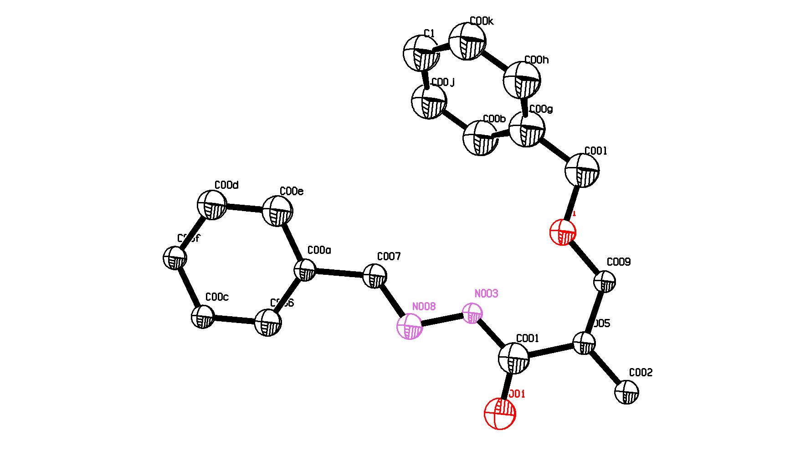
Supplementary Fig. S39 The asymmetric unit in the single-crystal structure of P-LCP-1. Thermal ellipsoids are drawn with 30% probability.
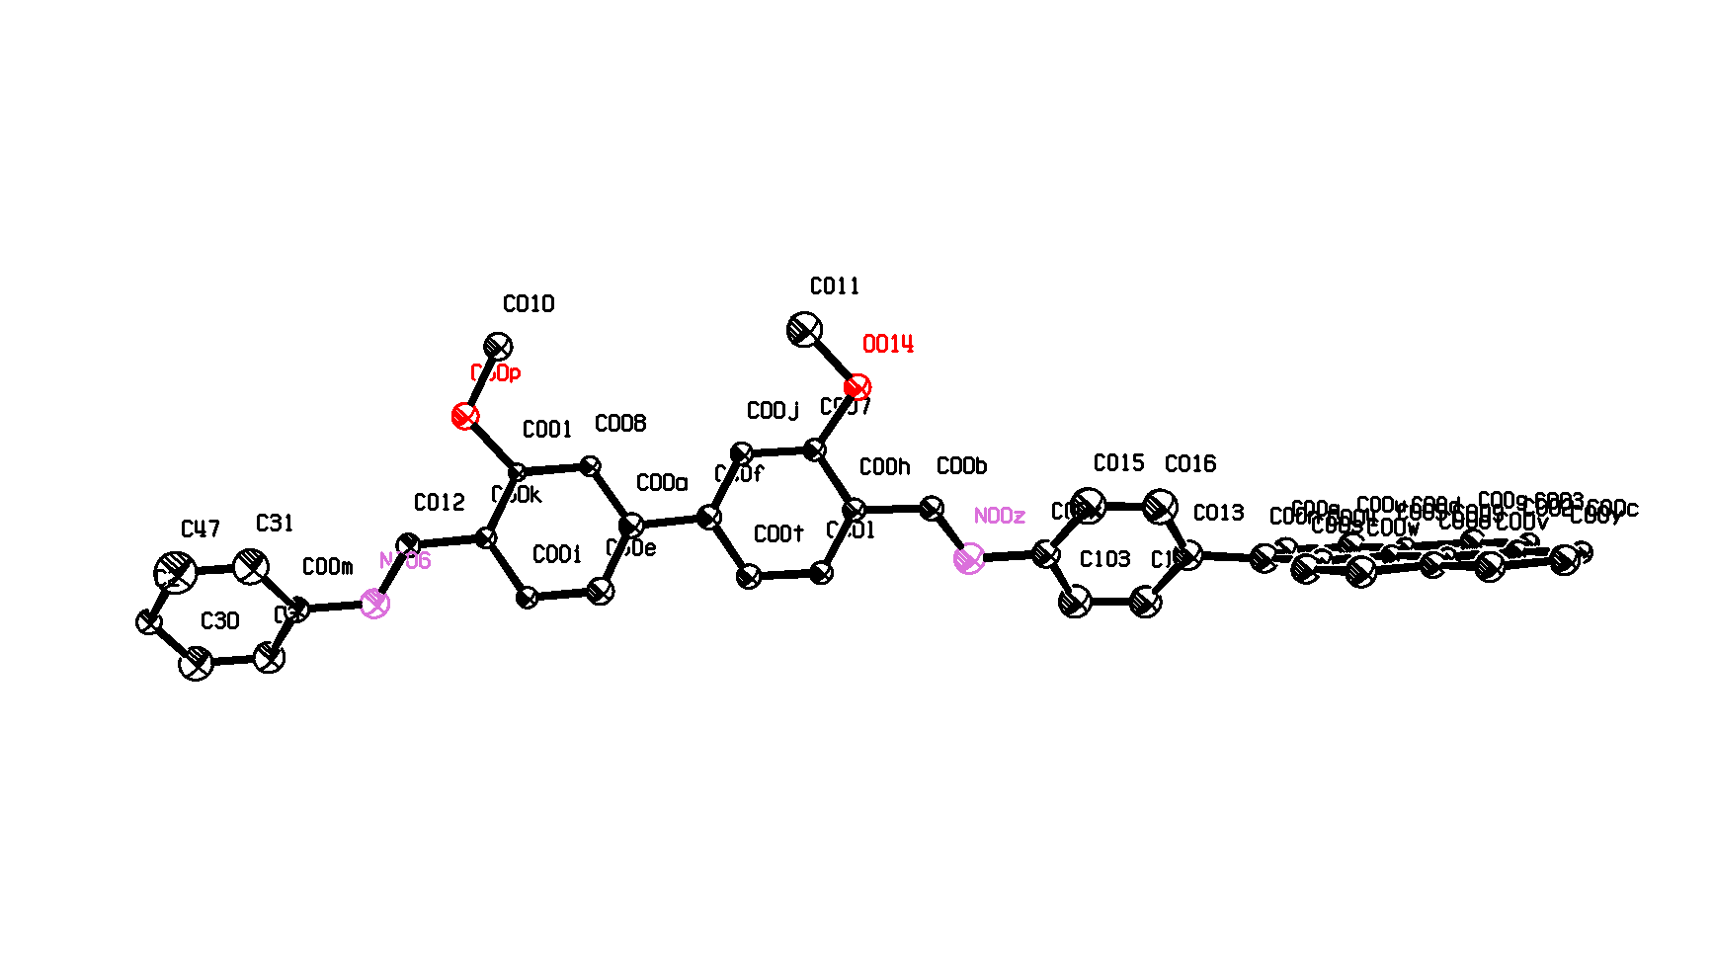
Supplementary Fig. S40 The asymmetric unit in the single-crystal structure of P-LCP-2. Thermal ellipsoids are drawn with 30% probability.

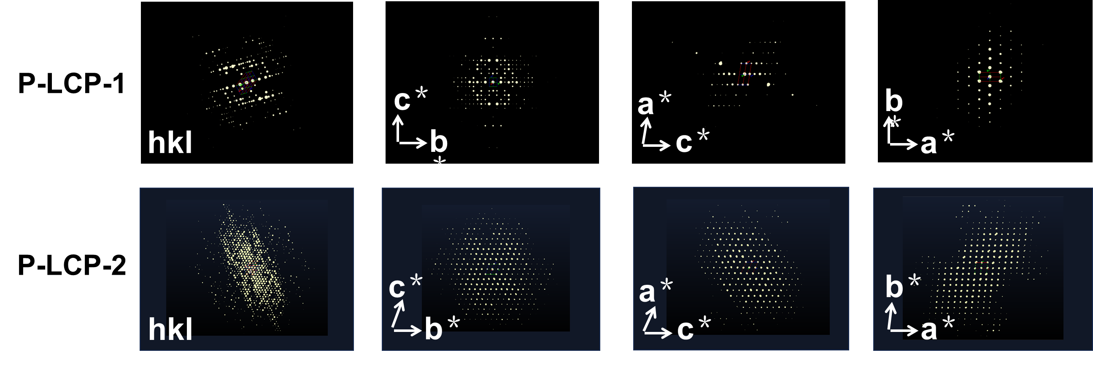
Supplementary Fig. S41 The three-dimensional reciprocal lattice of P-LCP-1 and P-LCP-2.
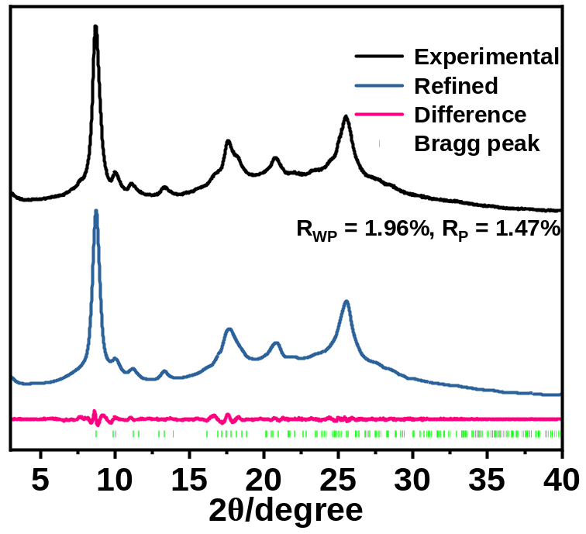
Supplementary Fig. S42 The PXRD patterns of P-LCP-1.

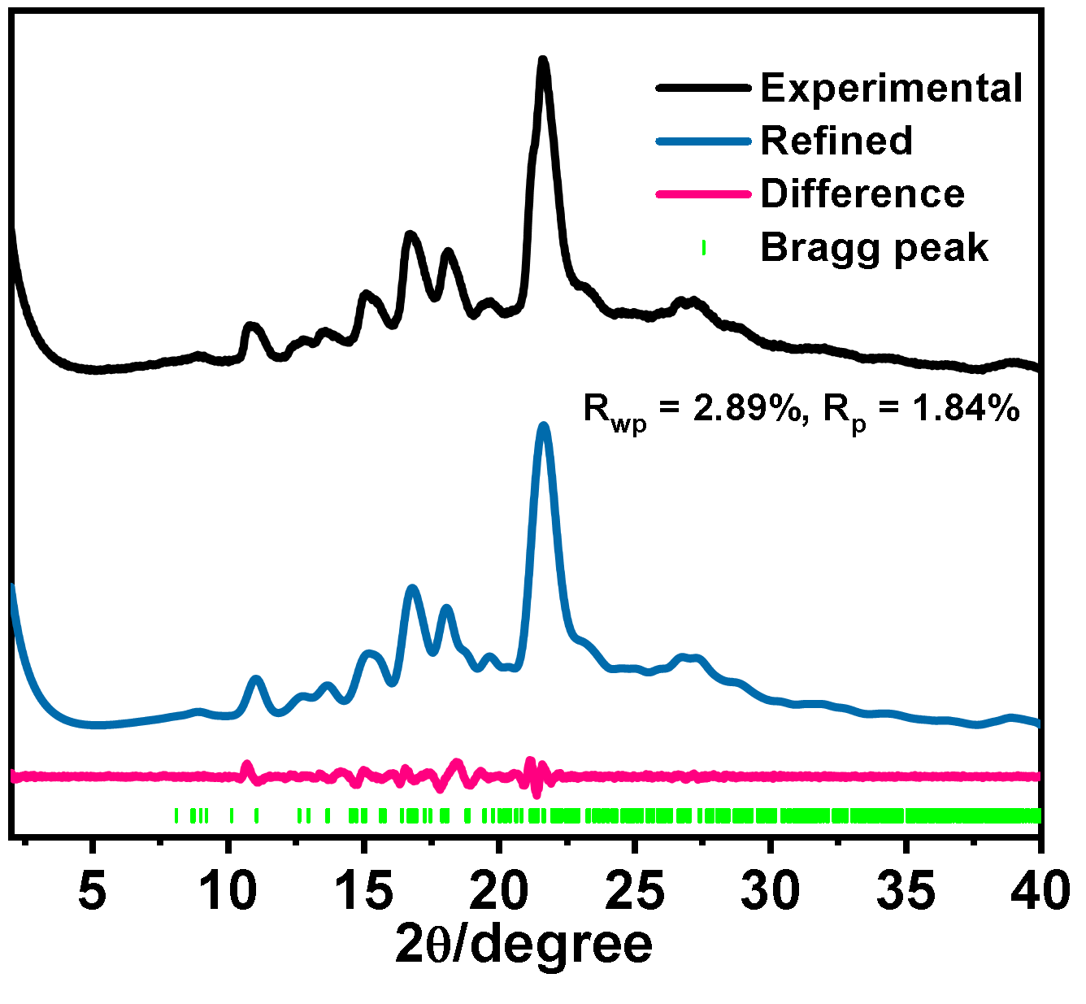
Supplementary Fig. S43 The PXRD patterns of P-LCP-2.

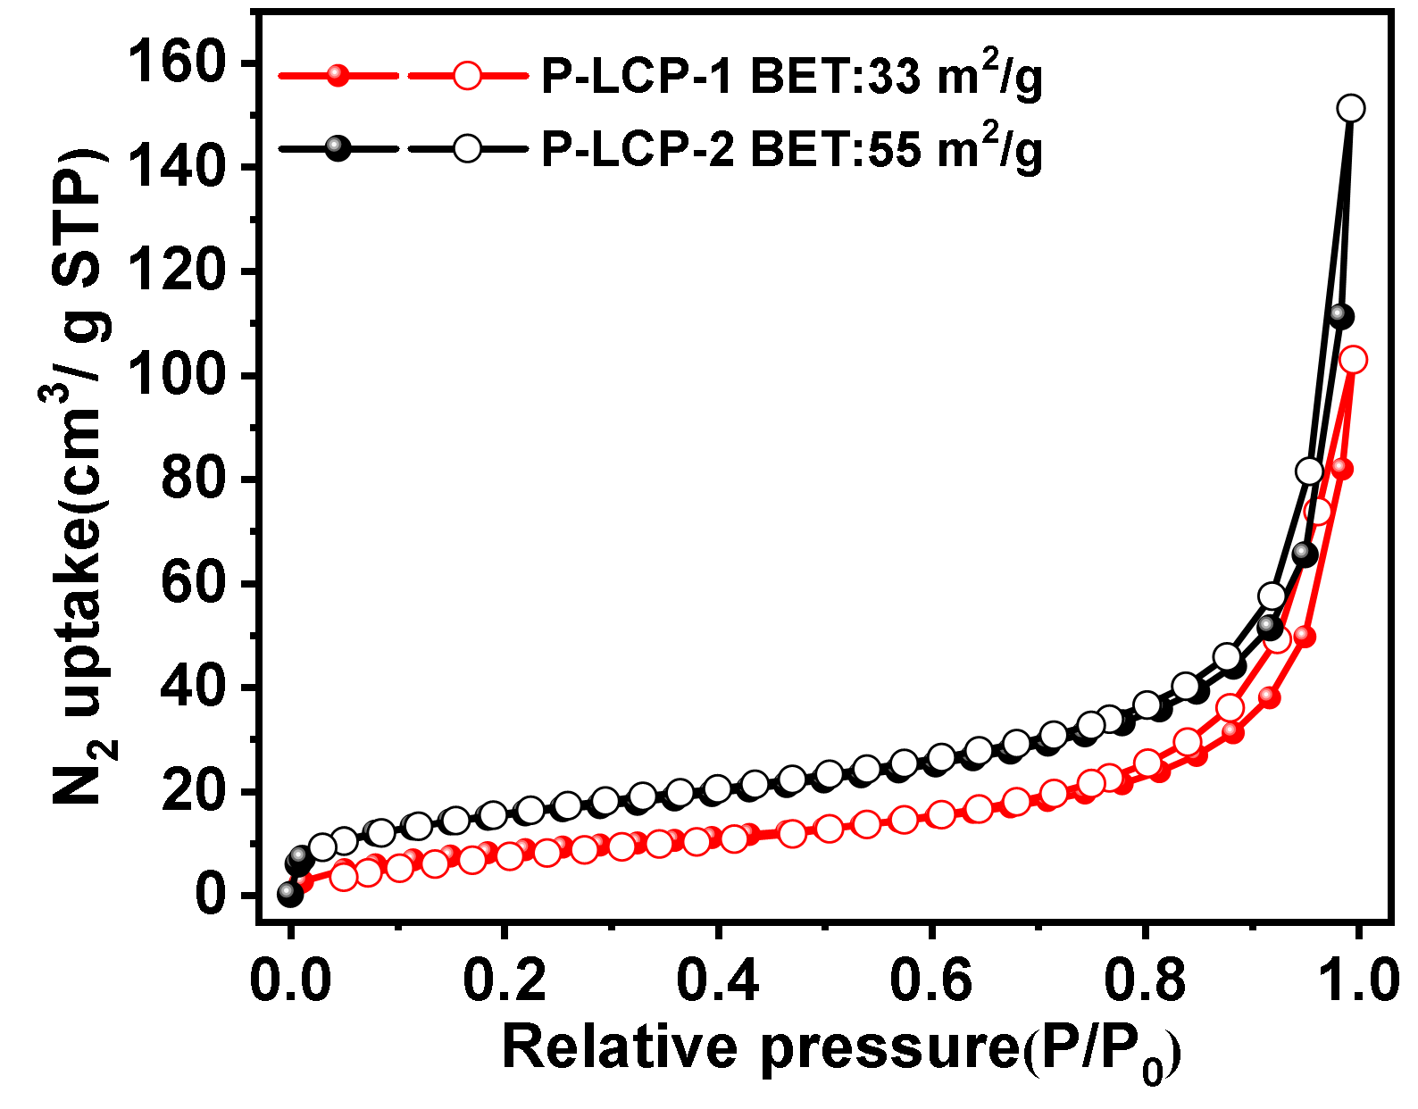
Supplementary Fig. S44 N₂ adsorption of P-LCP-1-2.
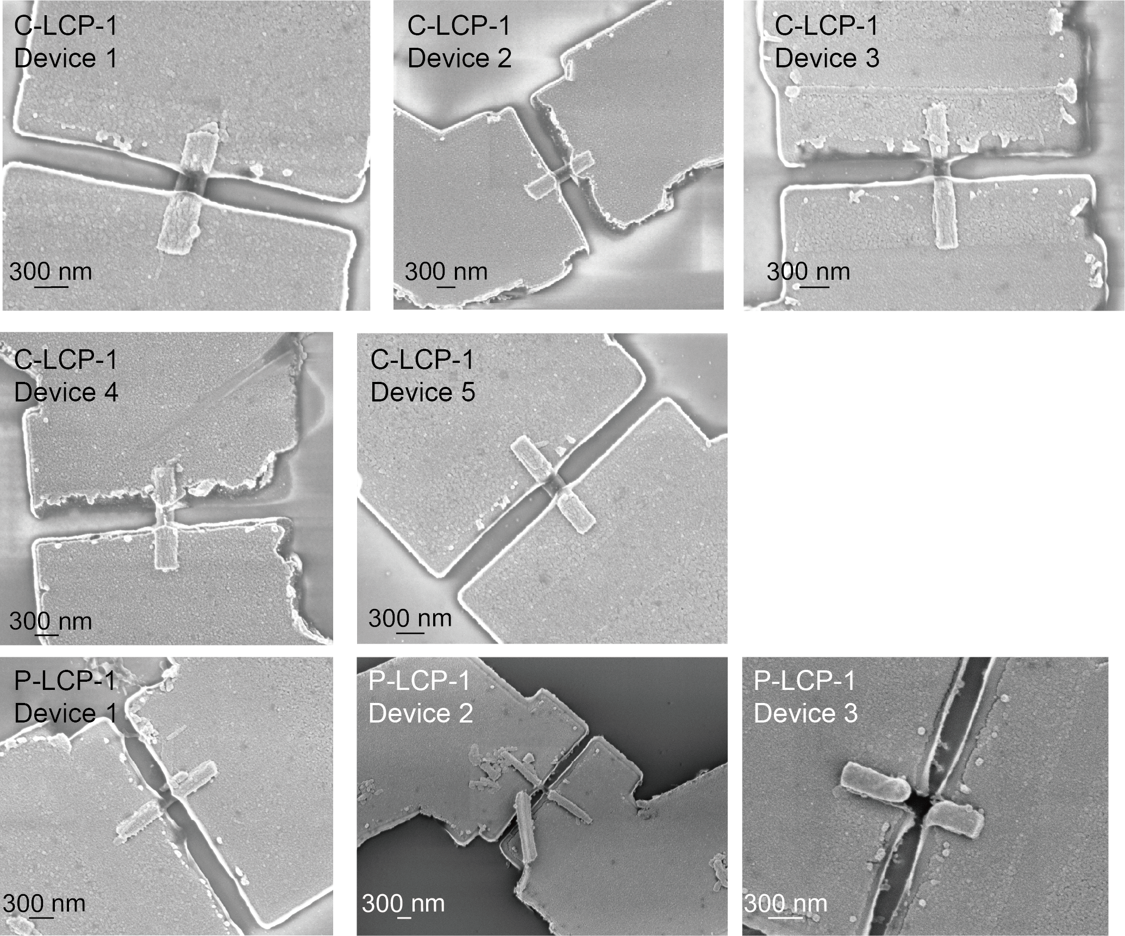
Supplementary Fig. S45 SEM characterization of individual polymer single-crystal devices. Representative SEM images of five C-LCP-1 devices (top and middle rows) and three P-LCP-1 devices (bottom row), showing the alignment of paired electrodes across crystals with different dimensions, orientations, and positions.
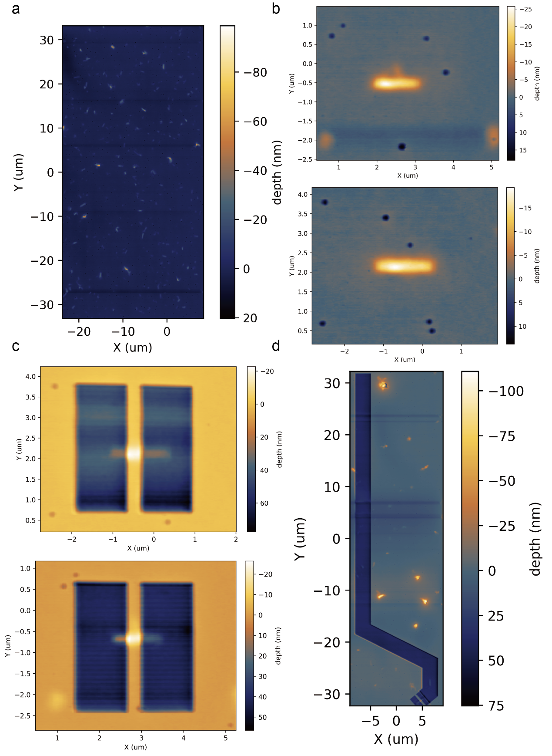
Supplementary Fig. S46 NanoFrazor feedback images showing (a) crystal localization, (b) scanning of an individual crystal, (c) electrode fabrication, and (d) connection of the electrodes to the prefabricated electrodes.
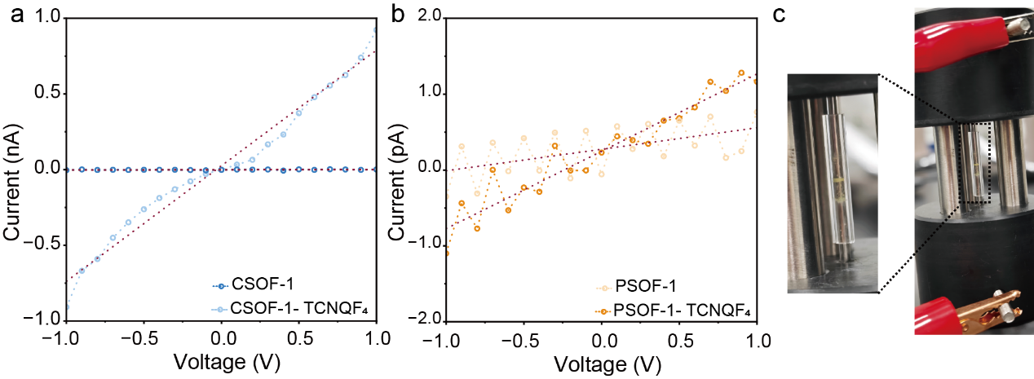
Supplementary Fig. S47 Electrical characterization of pressed C-LCP-1 and P-LCP-1 pellets. a,b Two-terminal current–voltage characteristics of pristine and TCNQF₄-treated C-LCP-1 and P-LCP-1 pellets. The current of the pristine pellet approaches the detection limit, whereas the treated pellet exhibits an increased but strongly nonlinear response, consistent with Schottky-type barriers at the electrode–pellet interface and transport limited by interparticle junctions. c, Photograph of the two-terminal pellet-measurement setup; the inset shows an enlarged view of the sample-contact region.

Supplementary Table 10 Geometrical parameters and electrical conductivity values by pressed-pellet of C-LCP-1 and P-LCP-1 devices before and after TCNQF₄ treatment.

Sample | Resistance (Ω) | Pellet Thickness (mm) | Cross-sectional Area  （mm²） | Electrical Conductivity (S/cm)
C-LCP-1  pellets | 8.79×10¹¹ | 0.88 | 2.93 | 3.42×10⁻¹²
C-LCP-1  pellets TCNQF₄ | 1.31×10⁹ | 0.64 | 2.89 | 1.69×10⁻⁹
P-LCP-1  pellets | 3.53×10¹¹ | 1.75 | 3.04 | 1.63×10⁻¹¹
P-LCP-1  pellets TCNQF₄ | 9.81×10¹¹ | 0.75 | 3.04 | 2.52×10⁻¹²

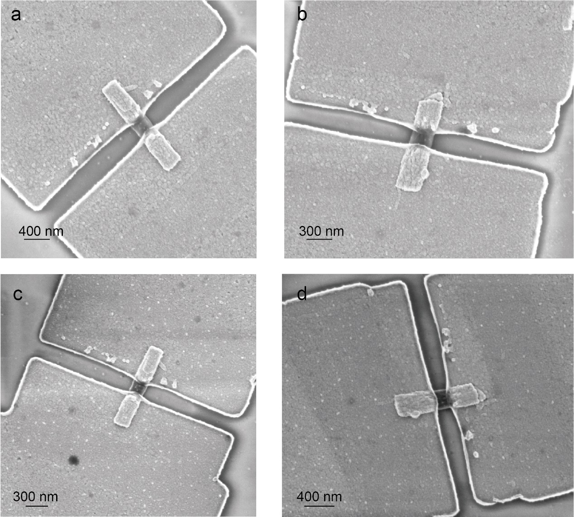
Supplementary Fig. S48 Morphological stability of the single-crystal devices during TCNQF₄ treatment. a,b, SEM images of two devices before TCNQF₄ treatment. c,d, Corresponding SEM images of the same devices after treatment, showing that the crystals and electrode structures remain intact. Scale bars are indicated in each panel.

Supplementary Table 11 Geometrical parameters and two-probe electrical conductivity values of individual C-LCP-1 and P-LCP-1 devices before and after TCNQF₄ treatment.
Device | Initial Resistance  (Ω) | Resistance After TCNQF₄  (Ω) | Conduction Length (nm) | Cross-sectional Width (nm) | Cross-sectional Thickness (nm) | Initial Conductivity  (S/cm) | Conductivity After TCNQF₄ Treatment  (S·cm⁻¹)
C-LCP-1  Device 1 | 1.97 × 10¹⁴ | 3.12 × 10¹³ | 138.2 | 255.9 | 41 | 6.7 ×10⁻¹⁰ | 4.2 × 10⁻⁹
C-LCP-1  Device 2 | 5.47 × 10¹⁴ | 2.31 × 10¹³ | 302.6 | 236.8 | 37 | 6.3 × 10⁻¹⁰ | 1.5 × 10⁻⁸
C-LCP-1  Device 3 | 2.35 × 10¹⁴ | 4.25 × 10¹³ | 129.7 | 170.3 | 45 | 7.2 × 10⁻¹⁰ | 4.0 × 10⁻⁹
C-LCP-1  Device 4 | 5.08 × 10¹⁴ | 5.04 × 10¹³ | 235.3 | 216.5 | 29 | 7.4 × 10⁻¹⁰ | 7.4 × 10⁻⁹
C-LCP-1  Device 5 | 3.98 × 10¹⁴ | 3.83 × 10¹³ | 151.8 | 233.3 | 32 | 5.1 × 10⁻¹⁰ | 5.3 × 10⁻⁹
P-LCP-1  Device 1 | 4.30 × 10¹⁴ | 1.00 × 10¹⁴ | 131.5 | 147.9 | 31 | 6.7 × 10⁻¹⁰ | 2.9 × 10⁻⁹
P-LCP-1  Device 2 | 1.64 × 10¹⁴ | 9.78 × 10¹³ | 120.4 | 122.6 | 41 | 1.5 × 10⁻⁹ | 2.6 × 10⁻⁹
P-LCP-1  Device 3 | 1.58 × 10¹⁴ | 1.07 × 10¹⁴ | 112.1 | 194.5 | 48 | 7.6 × 10⁻¹⁰ | 1.1 × 10⁻⁹

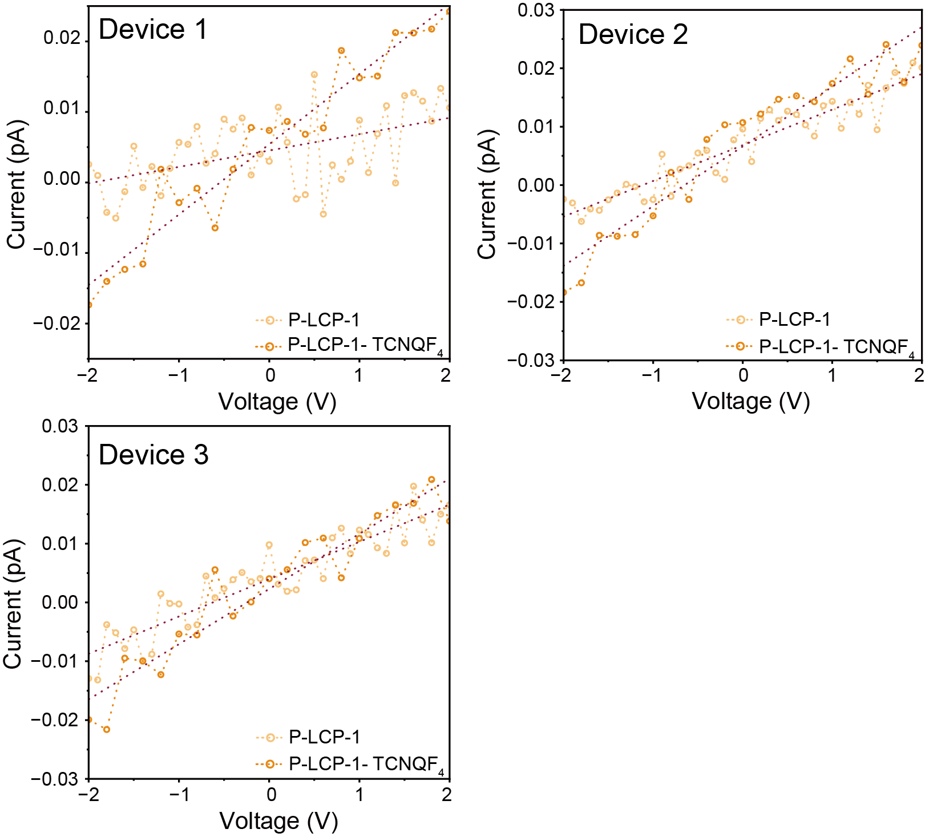
Supplementary Fig. S49 Electrical response of P-LCP-1 single-crystal devices to TCNQF₄ treatment. Current–voltage characteristics of three independent P-LCP-1 devices before and after TCNQF₄ treatment. Dashed lines denote linear fits used to determine the two-terminal resistance.

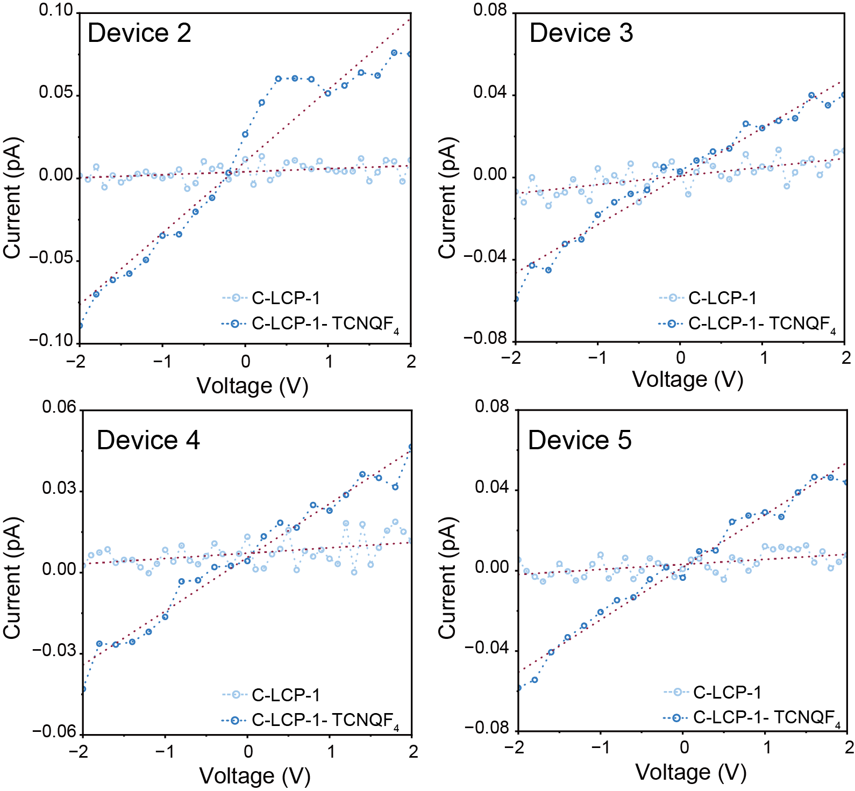
Supplementary Fig. S50 Reproducibility of the electrical response of C-LCP-1 single-crystal devices. Current–voltage characteristics of four additional C-LCP-1 devices (Devices 2–5) before and after TCNQF₄ treatment. TCNQF₄ treatment increased the current response in every device. Dashed lines denote linear fits used to determine the two-terminal resistance.

