Article

Agricultural storage is a hidden demand driver and an overlooked temporal buffer in global agrifood system futures

Supplementary Information

Author list:
Xin Zhao¹, Pralit L. Patel¹, Stephanie T. Morris¹, Ellie N. Lochner¹, Matthew T. Binsted¹, Katherine V. Calvin¹, Thomas B. Wild¹, James A. Edmonds¹, Marshall A. Wise¹

Affiliations
¹ Joint Global Change Research Institute, Pacific Northwest National Laboratory, 5825 University Research Ct, College Park, MD 20740, USA

Corresponding Author: Xin Zhao | xin.zhao@pnnl.gov

Contents

Supplementary Section 1. Supplementary background and motivation 3
Supplementary Section 2. Supplementary description of the methodology 7
Supplementary Section 2.1. Structural role and measurement of storage in the agrifood system 7
Supplementary Section 2.2. Recent GCAM agricultural and food-system developments 19
Supplementary Section 3. Supplementary results 22
Supplementary Section 3.1. Long-term impacts and sensitivity analyses 22
Supplementary Section 3.2. Transmission of biophysical yield shocks 30
Supplementary references 43

List of Supplementary Tables and Figures

Supplementary Table 1 | Key global agricultural modeling and shock-transmission studies. 5
Supplementary Table 2 | Comparison of agricultural storage representations relevant to global economic modeling. 6
Supplementary Table 3 | Agricultural commodity mapping between GCAM commodities and FAO primary items. 10
Supplementary Table 4 | Mapping between GCAM (v9.1) regions and IPCC R10 regions. 11
Supplementary Table 5 | Commodity balance and storage indicators for cereal grains in the GCAM base year (2021). 18
Supplementary Table 6 | Summary of storage cost estimates. 20
Supplementary Table 7 | Yield-shock transmission elasticities under alternative storage representations. 39
Supplementary Table 8 | Pairwise tests of period-to-period transmission elasticities across storage representations. 41
Supplementary Table 9 | Fixed-effect robustness of period-to-period transmission elasticities. 42

Supplementary Fig. 1 | Structural representation of storage-related elements in agricultural supply utilization accounts. 12
Supplementary Fig. 2 | Global traceable food balance sheets, 2010 – 2022. 13
Supplementary Fig. 3 | Storage variation by GCAM storable commodity and region, 2010 – 2022. 14
Supplementary Fig. 4 | Stock-to-gross-supply and stock-to-gross-use ratios by commodity group and region. 15
Supplementary Fig. 5 | Storage loss indicators by commodity group and region. 16
Supplementary Fig. 6 | Regional and global patterns of biophysical yield shocks used in model simulations. 21
Supplementary Fig. 7 | Global and regional crop stocks in per capita dietary-energy terms. 23
Supplementary Fig. 8 | Agroeconomic and environmental projections under dynamic storage. 24
Supplementary Fig. 9 | Agroeconomic and environmental projections under hidden storage. 25
Supplementary Fig. 10 | Impact of dynamic storage representation (Dynamic vs. Hidden) on agroeconomic and environmental projections. 26
Supplementary Fig. 11 | Agricultural storage dynamics and multisectoral impacts under biophysical yield shocks. 27
Supplementary Fig. 12 | Agricultural storage dynamics and multisectoral impacts under fixed-ratio storage. 28
Supplementary Fig. 13 | Agricultural storage dynamics and multisectoral impacts under dynamic storage without cross-period carryover adjustment. 29
Supplementary Fig. 14 | Cumulative agroeconomic responses to biophysical yield shocks under Dynamic Storage. 32
Supplementary Fig. 15 | Transmission of cumulative biophysical yield shocks to agroeconomic outcomes in 2050. 33
Supplementary Fig. 16 | Cumulative transmission of biophysical yield shocks to agroeconomic outcomes in 2100. 34
Supplementary Fig. 17 | Period-to-period agroeconomic responses to biophysical yield shocks under Dynamic Storage, by model period. 35
Supplementary Fig. 18 | Period-to-period agroeconomic responses to biophysical yield shocks under Dynamic Storage, by region. 36
Supplementary Fig. 19 | Period-to-period transmission of biophysical yield shocks to agroeconomic outcomes. 37

Supplementary Section 1. Supplementary background and motivation
As a central adjustment mechanism in agricultural markets, storage and the associated behavioral responses represent an increasingly important gap in global economic and multisector dynamic modeling that warrants explicit treatment^{1–5}. This gap is particularly relevant to two closely related streams of research. The first uses global economic and multisector models to assess long-term agrifood futures and their implications for production, trade, land, water, emissions, and food security^{6–10}. The second examines how biophysical and economic shocks propagate through agricultural markets and supply chains, and how market adjustments contribute to resilience^{11–14}. Across both streams, storage has received substantially less systematic attention than other adjustment mechanisms, such as international trade. A separate literature has developed explicit models of stockholding and intertemporal commodity allocation, often with detailed representations of expectations, costs, risk, and inventory constraints, but these applications are generally more theoretical and specialized in commodity, geographic, or system coverage. The resulting gap is therefore one of integration, i.e., connecting explicit intertemporal storage dynamics with the broad system scope required for global agrifood and environmental assessment.
Global economic and multisector models have become central tools for evaluating long-term agricultural transformation and its multisectoral interactions. Model intercomparison exercises illustrate both the breadth of these frameworks and the importance of the market-mediated responses they represent. Nelson et al. (2014)¹⁵, for example, compared global economic models subjected to harmonized biophysical crop-yield shocks and evaluated endogenous responses through yields, harvested area, production, consumption, international trade, and prices. More recently, Sundiang et al. (2025)⁶ used an ensemble of ten global economic models to evaluate food-system transformation pathways through changes in agricultural production, demand, prices, land use, water and nutrient use, and greenhouse-gas emissions, while related multisector studies have begun to examine the consequences of previously underrepresented structural mechanisms, such as agricultural labor market evolution^{16,17}. Across these applications, however, storage has generally not been isolated or harmonized as a distinct endogenous intertemporal adjustment margin. Long-run adjustment is therefore primarily captured through the mechanisms represented explicitly in each model, leaving the roles of stock accumulation and drawdown, carryover, and storage-associated losses in agroeconomic and environmental pathways largely unresolved.
The second stream concerns the transmission of biophysical shocks and the mechanisms that buffer their market impacts. International trade reallocates supply across space, whereas storage reallocates it across time; yet global assessments have paid considerably more attention to the former. Diffenbaugh et al. (2012)¹¹, for example, quantified the transmission of interannual maize-yield variability into commodity prices and explicitly identified omitted stockholding as an important limitation requiring a dynamic treatment. Subsequent global studies have examined responses to interannual biophysical variability through production, land allocation, consumption, and trade without endogenous inventory adjustment ^{13,14} (Zhao et al., 2021; Haqiqi, 2024). Other analyses recognize reserves as a potential resilience mechanism without incorporating storage decisions within the economic model itself. Hasegawa et al. (2021)¹⁸, for instance, estimated consumption shortfalls under extreme yield events using AIM/Hub and compared the resulting food requirements ex post with observed cereal reserves. These studies demonstrate the importance of market-mediated adaptation while leaving the temporal allocation of commodities largely exogenous or unresolved (see a summary of key selected studies in Supplementary Table 1).
Storage is not entirely absent from agricultural economic modeling. Empirical and structural-estimation studies demonstrate systematic relationships among inventories, prices, and market scarcity^{19,20}. Such evidence, however, has generally been developed for individual commodities or specific markets, while explicit storage representations in broader global models remain comparatively limited. The modeling structures most relevant to the present study are summarized in Supplementary Table 2. The Aglink-Cosimo model provides an important global precedent, linking beginning and ending stocks across annual periods through reduced-form equations responsive to supply, consumption, and current prices relative to recent prices. Hertel et al. (2005) instead incorporated price-responsive stock variation into a global general-equilibrium model, demonstrating the importance of storage for short-run commodity-market adjustment while representing bounded changes in stocks rather than explicit inventory paths. More specialized models resolve intertemporal behavior in greater detail. Gouel (2013) employs rational expectations, storage costs, and non-negative inventories; Mitra and Boussard (2012) represent adaptive expectations, risk aversion, storage costs, and capacity constraints; and Schewe et al. (2017) maintain stock-flow-consistent annual inventories within a global wheat supply–demand model. These approaches reveal a general scope–structure trade-off: broader global models tend to adopt parsimonious stock relationships, whereas richer representations of expectations, risk, and inventory constraints are typically applied to individual commodities or specialized markets. Storage-specific physical losses are also generally absent from the core stockholding equations of these comparators.
The present study addresses this gap through complementary data and modeling advances. Building on recent developments in traceable global supply utilization accounting²¹, we construct model-ready storage accounts and integrate them with an endogenous representation of interperiod stockholding in a global multisector framework. This enables storage to operate as a distinct temporal adjustment margin alongside trade while retaining connections to broader agroeconomic and environmental outcomes. Rather than replacing more behaviorally detailed storage models, our contribution is to bring globally consistent inventory data and key storage dynamics into the class of models used for long-term assessment and biophysical-shock analysis. Earlier estimates without explicit storage are therefore conditional on how intertemporal adjustment was omitted, fixed, or represented implicitly; our analysis evaluates when relaxing that condition materially changes market and resource use responses.

Supplementary Table 1 | Key global agricultural modeling and shock-transmission studies.
Studies are representative rather than exhaustive and were selected because storage was omitted, externally prescribed, or not evaluated as an endogenous adjustment margin in the focal application. Previous versions of GCAM were used in Nelson et al. (2014), Zhao et al. (2021), and Sundiang et al. (2025).
Study | Model / approach | Scale / horizon | Primary focus | Main market-mediated responses examined
Diffenbaugh et al. (2012)¹¹ | GTAP-BIO-AEZ | Global economy;  comparative static; annual variability | Transmission of interannual maize-yield variability to commodity markets | Prices, trade, biofuel demand
Nelson et al. (2014)¹⁵ | Nine global economic models (AgMIP) | Global; to 2050 | Economic responses to harmonized biophysical crop-yield shocks | Endogenous yield, harvested area, production, consumption, trade, prices
Puma et al. (2015)²² | Global food-trade network analysis | Global; wheat and rice; historical networks and disruption experiments | Vulnerability of global food trade to large supply disruptions | Trade connectivity, import dependence, export restrictions
Janssens et al. (2020)²³ | GLOBIOM | Global; to 2050 | International trade as adaptation to heterogeneous biophysical yield impacts | Production, management/intensification, land allocation, consumption, trade, prices
Zhao et al. (2021)¹⁴ | GCAM | Global; multi-crop; interannual;  2010–2050 | Transmission of interannual biophysical yield variability through agricultural markets | Production, land allocation, consumption, trade, prices
Hasegawa et al. (2021)¹⁸ | AIM/Hub (AIM/CGE) + crop-model ensemble | Global; extreme events evaluated for 2020–2050 | Food-security consequences of extreme biophysical yield events | Production, land, prices, consumption, trade, hunger risk
Haqiqi (2024)¹³ | Statistical yield-risk and market-integration framework | Global maize; future production variability | Irrigation and market integration as buffers against biophysical production risk | Irrigation, spatial market integration, regional and global supply risk
Sundiang et al. (2025)⁶ | Ten global economic models | Global; 2020–2050 | Economic and environmental consequences of food-system transformation | Production, demand, prices, trade, land, water, nutrient use, emissions

Supplementary Table 2 | Comparison of agricultural storage representations relevant to global economic modeling.
Study / model | Scope | Inventory structure | Behavior /  expectations | System coupling
Hertel et al. (2005)⁴ | Global AGE; staple grains | Bounded stock variation; no explicit inventory path or physical loss | Price-responsive stock changes; opportunity cost | Economy-wide production, consumption, trade and prices
Aglink-Cosimo²⁴ | Global agricultural PE; multi-commodity; annual | Beginning and ending stocks linked across years; no storage-specific physical loss | Reduced-form response to supply, consumption, trend, and relative prices | Agricultural production, consumption, trade and prices
Mitra & Boussard (2012)²⁵ | Single commodity; seasonal and interannual | Explicit inventories; non-negativity and capacity; no physical loss | Adaptive expectations, risk aversion, storage cost and interest | Prices, production and stocks
Gouel (2013)²⁶ | Single cereal market; annual | Explicit non-negative inventories; capacity in policy cases; no physical loss | Rational expectations and arbitrage; storage and financing costs | Prices, production, welfare and storage policy
Schewe et al. (2017)²⁷ | Global wheat; annual | Explicit inventories and carryover; no explicit physical loss | Price-responsive storage dynamics | Wheat production, consumption, stocks and prices
Present study  GCAM v9.1 | Global multisector; 32 regions; 13 storable crop sectors | Opening and closing stocks, carryover and physical storage loss | Intertemporal allocation based on expected future value, storage cost and discounting | Production, consumption, trade, land, water and emissions

Supplementary Section 2. Supplementary description of the methodology

Supplementary Section 2.1. Structural role and measurement of storage in the agrifood system
Storage-related elements play a key structural role in commodity balances (Supplementary Fig. 1). Supplementary Fig. 2 presents the recompiled traceable Food Balance Sheets (T-FBS) for GCAM commodities at the global level. The mapping from FAO primary commodities to GCAM commodities is provided in Supplementary Table 3; for subsequent regional analyses, GCAM regions are aggregated to the IPCC R10 regions according to
Supplementary Table 4.
A key advantage of the traceable food balance framework is that it extends agricultural storage measurement beyond primary commodities while separating storage-related elements. By converting processed products to Primary Commodity equivalents (PCe), inventories of products such as flour, milled rice, vegetable oils and refined sugar can be combined consistently with stocks of the corresponding primary commodities while preserving their underlying physical requirements (Main Fig. 1C & Fig. 2). This broader accounting boundary is quantitatively important, e.g., in 2022, approximately 30% of global cereal-grain stocks were held as processed products (Main Fig. 1D). Capturing these downstream inventories provides a more comprehensive measure of commodities carried across time and improves their representation in global economic models, in which processing chains are typically represented at coarser sectoral resolution. Such inventories can contribute both to recurring demand for primary commodities and to the capacity of the agrifood system to shift available supply across periods.
Beyond expanding the measurement boundary, the reconstructed accounts reveal substantial heterogeneity in storage dynamics across commodities, regions, and years (Supplementary Fig. 3). Annual stock changes alternate between accumulation and drawdown, with markedly different magnitudes across regional commodity markets (Main Fig. 1C & Fig. 2). At the same time, storage intensity at the global level is comparatively persistent over 2010–2022 for most storable commodity groups (Supplementary Fig. 4). Grains are a notable exception, i.e., their global stock-to-gross-use ratio increased substantially after the 2011 food-price crisis through approximately 2018 before stabilizing, with much of this increase concentrated in a few major stockholding regions rather than occurring uniformly worldwide. More broadly, stock levels tend to scale with the size of domestic commodity use despite considerable regional variation in accumulation and drawdown. This combination of persistence and heterogeneity is consistent with inventories serving partly as working capital that supports commodity use across time, while also indicating that historical stock ratios should not be treated as fixed.
Measures of storage intensity are also sensitive to the accounting boundary used to define the denominator. Supplementary Fig. 4 and Supplementary Table 5 compare closing stocks relative to gross domestic use with opening stocks relative to gross domestic supply, illustrating that alternative but reasonable definitions can yield substantially different ratios, particularly in highly traded regions. In our preferred stock-to-gross-use measure, net closing stocks are compared with current domestic utilization, closing stocks, and inferred storage-associated losses; exports are excluded because they are not part of the domestic intertemporal allocation represented in the storage model. Likewise, the stock-to-gross-supply indicator excludes imports and relates opening stocks to domestic production and opening inventories. Including exports as part of use would, for example, mechanically lower measured storage intensity in major exporting regions, while including imports in gross supply would have an analogous effect in import-dependent regions. Treatment of storage loss also matters because closing stocks are observed net of loss, whereas the commodities lost during storage nevertheless required contemporaneous supply. These definitional differences highlight uncertainty in comparing storage ratios across regions and in the economic decision the model represents.
The use-side measure is also more consistent across regions than the corresponding supply-side measure, supporting its use in the storage representation. For cereal grains in the 2021 base year, the closing stock-to-gross-use ratio ranges from 18% to 44% across IPCC R10 regions, compared with a wider range of 15% to 59% for the opening stock-to-gross-supply ratio (Supplementary Fig. 4; Supplementary Table 5). Based on the regional values in Supplementary Table 5, the corresponding cross-regional standard deviations are approximately 8 and 14 percentage points, respectively. The same qualitative pattern is generally evident for the other storable crop groups, although its magnitude varies across commodities. Differences are particularly pronounced where domestic production is poorly aligned with domestic use because of trade. For example, the Middle East has an opening stock-to-gross-supply ratio of 59% but a closing stock-to-gross-use ratio of 30%, whereas the corresponding ratios for Reforming Economies are 16% and 32%, respectively. More generally, the greater regularity of stocks relative to domestic use is consistent with inventories functioning as working capital that supports commodity flows through time, rather than being determined primarily by the location of production.
Storage-associated losses introduce an additional measurement challenge because reported post-harvest losses do not distinguish losses occurring during storage from those arising during handling, transport, processing, or other supply-chain activities. We therefore infer storage loss rates conservatively from the lower of loss relative to production and loss relative to current domestic utilization, as described in the Main Methods. The resulting estimates are comparatively stable at the global level over 2010–2022, with average rates of approximately 5% for grains and higher values for several other storable crop groups, but show greater variation across regions and commodities (Supplementary Fig. 5). Some regional year-to-year spikes are likely to reflect uncertainty or outliers in the underlying reported loss data as well as genuine differences in storage conditions and supply-chain performance, and should therefore be interpreted cautiously. The alternative loss-to-supply and loss-to-demand indicators further illustrate how trade and the choice of accounting boundary can affect inferred regional rates. Explicitly separating storage-associated loss remains important because, unlike net stock accumulation, these losses generate recurring replacement demand. Together, these reconstructed stock and loss measures provide the empirical basis for calibrating storage and representing it as an explicit intertemporal component of agricultural markets in GCAM.

Supplementary Table 3 | Agricultural commodity mapping between GCAM commodities and FAO primary items.
Source: GCAM Core Model Proposal (CMP)-382²⁸. GCAM commodities are further aggregated into broader commodity groups for analysis and reporting.
Sector  (Agg.) | GCAM commodity | FAO primary item (240)
Grains | Wheat | Wheat
Grains | Rice | Rice, paddy
Grains | Corn | Maize
Grains | OtherGrain | Barley; Buckwheat; Canary seed; Cereals nes; Fonio; Grain, mixed; Oats; Quinoa; Rye; Triticale; Millet; Sorghum
Oil crops | Soybean | Soybeans
Oil crops | OilPalm (Tree) | Oil palm fruit
Oil crops | OilCrop | Castor oil seed; Hempseed; Jojoba seed; Linseed; Melonseed; Mustard seed; Oilseeds nes; Poppy seed; Rapeseed; Safflower seed; Sesame seed; Sunflower seed
Oil crops | OilCrop (Tree) | Coconuts; Kapok fruit; Karite nuts (sheanuts); Olives; Tallowtree seed; Tung nuts
Sugar crops | SugarCrop | Sugar cane; Sugar beet; Sugar crops nes
Other crops | RootTuber | Cassava; Potatoes; Roots and tubers nes; Sweet potatoes; Taro (cocoyam); Yams; Yautia (cocoyam);
Other crops | FiberCrop | Fibre crops nes; Flax fibre and tow; Hemp tow waste; Jute; Manila fibre (abaca); Ramie; Seed cotton; Sisal
Other crops | NutsSeeds | Groundnuts, with shell
Other crops | NutsSeeds (Tree) | Almonds, with shell; Areca nuts; Brazil nuts, with shell; Cashew nuts, with shell; Chestnut; Hazelnuts, with shell; Kola nuts; Nuts nes; Pistachios; Walnuts, with shell
Other crops | Legumes | Bambara beans; Beans, dry; Broad beans, horse beans, dry; Chick peas; Cow peas, dry; Lentils; Lupins; Peas, dry; Pigeon peas; Pulses nes; Vetches
Non-storable  crops | Vegetables | Artichokes; Asparagus; Beans, green; Cabbages and other brassicas; Carobs; Carrots and turnips; Cassava leaves; Cauliflowers and broccoli; Chicory roots; Chillies and peppers, dry; Chillies and peppers, green; Cucumbers and gherkins; Eggplants (aubergines); Garlic; Leeks, other alliaceous vegetables; Lettuce and chicory; Maize, green; Melons, other (inc.cantaloupes); Mushrooms and truffles; Okra; Onions, dry; Onions, shallots, green; Peas, green; Pumpkins, squash and gourds; Spinach; String beans; Tomatoes; Vegetables, fresh nes; Vegetables, leguminous nes; Watermelons
Non-storable  crops | Fruits | Berries nes; Blueberries; Cranberries; Currants; Gooseberries; Grapes; Pineapples; Raspberries; Strawberries
Non-storable  crops | Fruits (Tree) | Apples; Apricots; Avocados; Bananas; Cashewapple; Cherries; Cherries, sour; Dates; Figs; Fruit, citrus nes; Fruit, fresh nes; Fruit, pome nes; Fruit, stone nes; Fruit, tropical fresh nes; Grapefruit (inc. pomelos); Kiwi fruit; Lemons and limes; Mangoes, mangosteens, guavas; Oranges; Papayas; Peaches and nectarines; Pears; Persimmons; Plantains and others; Plums and sloes; Quinces; Tangerines, mandarins, clementines, satsumas
Other crops | MiscCrop | Anise, badian, fennel, coriander; Ginger; Hops; Pepper (piper spp.); Peppermint; Pyrethrum, dried; Spices nes; Tea; Tobacco, unmanufactured; Vanilla
Other crops | MiscCrop (Tree) | Cinnamon (cannella); Cloves; Cocoa, beans; Coffee, green; Mate; Nutmeg, mace and cardamoms; Rubber, natural;
Other crops | FodderGrass | forage Products; Grasses Nes for forage; Grasses Nes for forage; Rye grass for forage & silage
Other crops | FodderHerb | Alfalfa for forage and silage; Beets for Fodder; Cabbage for Fodder; Carrots for Fodder; Clover for forage and silage; Green Oilseeds for Silage; Leguminous for Silage; Swedes for Fodder; Turnips for Fodder; Vegetables Roots Fodder; Maize for forage and silage; Sorghum for forage and silage
Livestock | Beef | Meat, cattle; Meat, buffalo
Livestock | Dairy | Milk, whole fresh cow; Milk, whole fresh camel; Milk, whole fresh buffalo; Milk, whole fresh goat; Milk, whole fresh sheep
Livestock | Pork | Meat, pig
Livestock | Poultry | Meat, duck; Meat, goose and guinea fowl; Meat, turkey; Meat, chicken; Meat, chicken; Eggs, other bird, in shell; Eggs, hen, in shell;
Livestock | SheepGoat | Meat, sheep; Meat, goat
Livestock | OtherMeat  &Fish | Freshwater Fish; Fish, Body Oil; Fish, Liver Oil; Demersal Fish; Pelagic Fish; Marine Fish, Other; Crustaceans; Cephalopods; Molluscs, Other; Aquatic Animals, Others; Aquatic Plants; Meat, Aquatic Mammals; Meat, rabbit; Meat, camel; Meat, other camelids; Meat, horse; Meat, ass; Meat, mule; Meat, other rodents; Meat, bird nes; Meat, game; Meat nes; Offals, edible, cattle; Offals, edible, buffaloes; Offals, pigs, edible; Offals, sheep,edible; Offals, edible, goats; Offals, horses; Offals, edible, camels; Offals, liver chicken; Offals, liver geese; Offals, liver duck; Offals, liver turkeys; Offals nes; Liver prep.; Fat, cattle; Fat, buffaloes; Fat, sheep; Fat, goats; Fat, pigs; Fat, camels; Fat, other camelids; Oils, fats of animal nes; Degras; Grease incl. lanolin wool; Fat nes, prepared; Honey, natural; Snails, not sea

Supplementary Table 4 | Mapping between GCAM (v9.1) regions and IPCC R10 regions.
Note that Ukraine has been treated as an independent GCAM region since GCAM v8.1. The mapping of countries to GCAM 32 regions is available at https://jgcri.github.io/gcam-doc/common_assumptions.html.
GCAM region | IPCC R10 region | IPCC R10 region definition
Africa_Eastern | Africa | Countries of Sub-Saharan Africa (AFRICA)
Africa_Northern | Africa | Countries of Sub-Saharan Africa (AFRICA)
Africa_Southern | Africa | Countries of Sub-Saharan Africa (AFRICA)
Africa_Western | Africa | Countries of Sub-Saharan Africa (AFRICA)
South Africa | Africa | Countries of Sub-Saharan Africa (AFRICA)
China | China | Countries of centrally-planned Asia;  primarily China (CHINA+)
Taiwan | China
EU-12 | Europe | Eastern and Western Europe (i.e., the EU28) (EUROPE)
EU-15 | Europe | Eastern and Western Europe (i.e., the EU28) (EUROPE)
Europe_Non_EU | Europe | Eastern and Western Europe (i.e., the EU28) (EUROPE)
European Free Trade Association | Europe | Eastern and Western Europe (i.e., the EU28) (EUROPE)
India | South Asia
South Asia | South Asia | Countries of South Asia; primarily India (INDIA+)
Pakistan | South Asia
Argentina | Latin America | Countries of Latin America and the Caribbean  (LATIN_AM)
Brazil | Latin America | Countries of Latin America and the Caribbean  (LATIN_AM)
Central America and Caribbean | Latin America | Countries of Latin America and the Caribbean  (LATIN_AM)
Colombia | Latin America | Countries of Latin America and the Caribbean  (LATIN_AM)
Mexico | Latin America | Countries of Latin America and the Caribbean  (LATIN_AM)
South America_Northern | Latin America | Countries of Latin America and the Caribbean  (LATIN_AM)
South America_Southern | Latin America | Countries of Latin America and the Caribbean  (LATIN_AM)
Middle East | Middle Ease | Countries of the Middle East;  Iran, Iraq, Israel, Saudi Arabia, Qatar, etc. (MIDDLE_EAST)
Canada | North America | North America;  primarily the United States of America and Canada (NORTH_AM)
USA | North America
Australia_NZ | Pacific OECD | Pacific OECD (PAC_OECD)
Japan | Pacific OECD | Pacific OECD (PAC_OECD)
South Korea | Pacific OECD | Pacific OECD (PAC_OECD)
Central Asia | Reforming | Reforming Economies of Eastern Europe and  the Former Soviet Union; primarily Russia (REF_ECON)
Ukraine | Reforming
Russia | Reforming
Indonesia | Rest of Asia | Other countries of Asia (REST_ASIA)
Southeast Asia | Rest of Asia | Other countries of Asia (REST_ASIA)

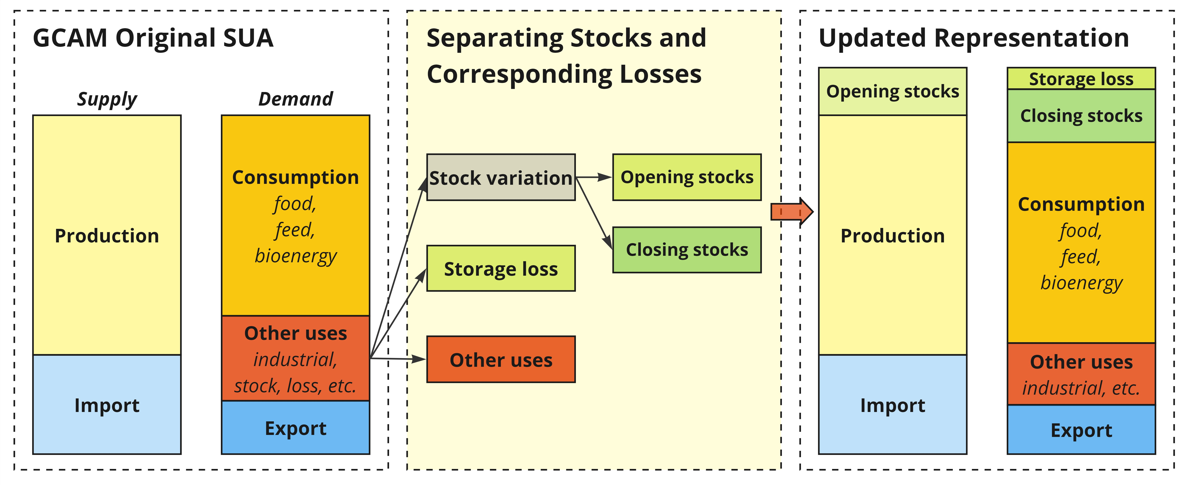
Supplementary Fig. 1 | Structural representation of storage-related elements in agricultural supply utilization accounts.
Schematic illustrating the restructuring of GCAM agricultural supply utilization accounts (SUA) to represent storage explicitly. In the original representation (left), stock variation and post-harvest losses are embedded within aggregate “other uses.” The reconstructed accounts (center) separate opening and closing stocks and infer the portion of reported post-harvest loss associated with storage. In the updated representation (right), opening stocks enter regional supply alongside production and imports, whereas closing stocks and storage-associated losses are represented explicitly on the use side alongside current consumption, other uses and exports. The restructuring preserves the underlying commodity balance while establishing the intertemporal linkage between closing stocks in one period and opening stocks in the next.

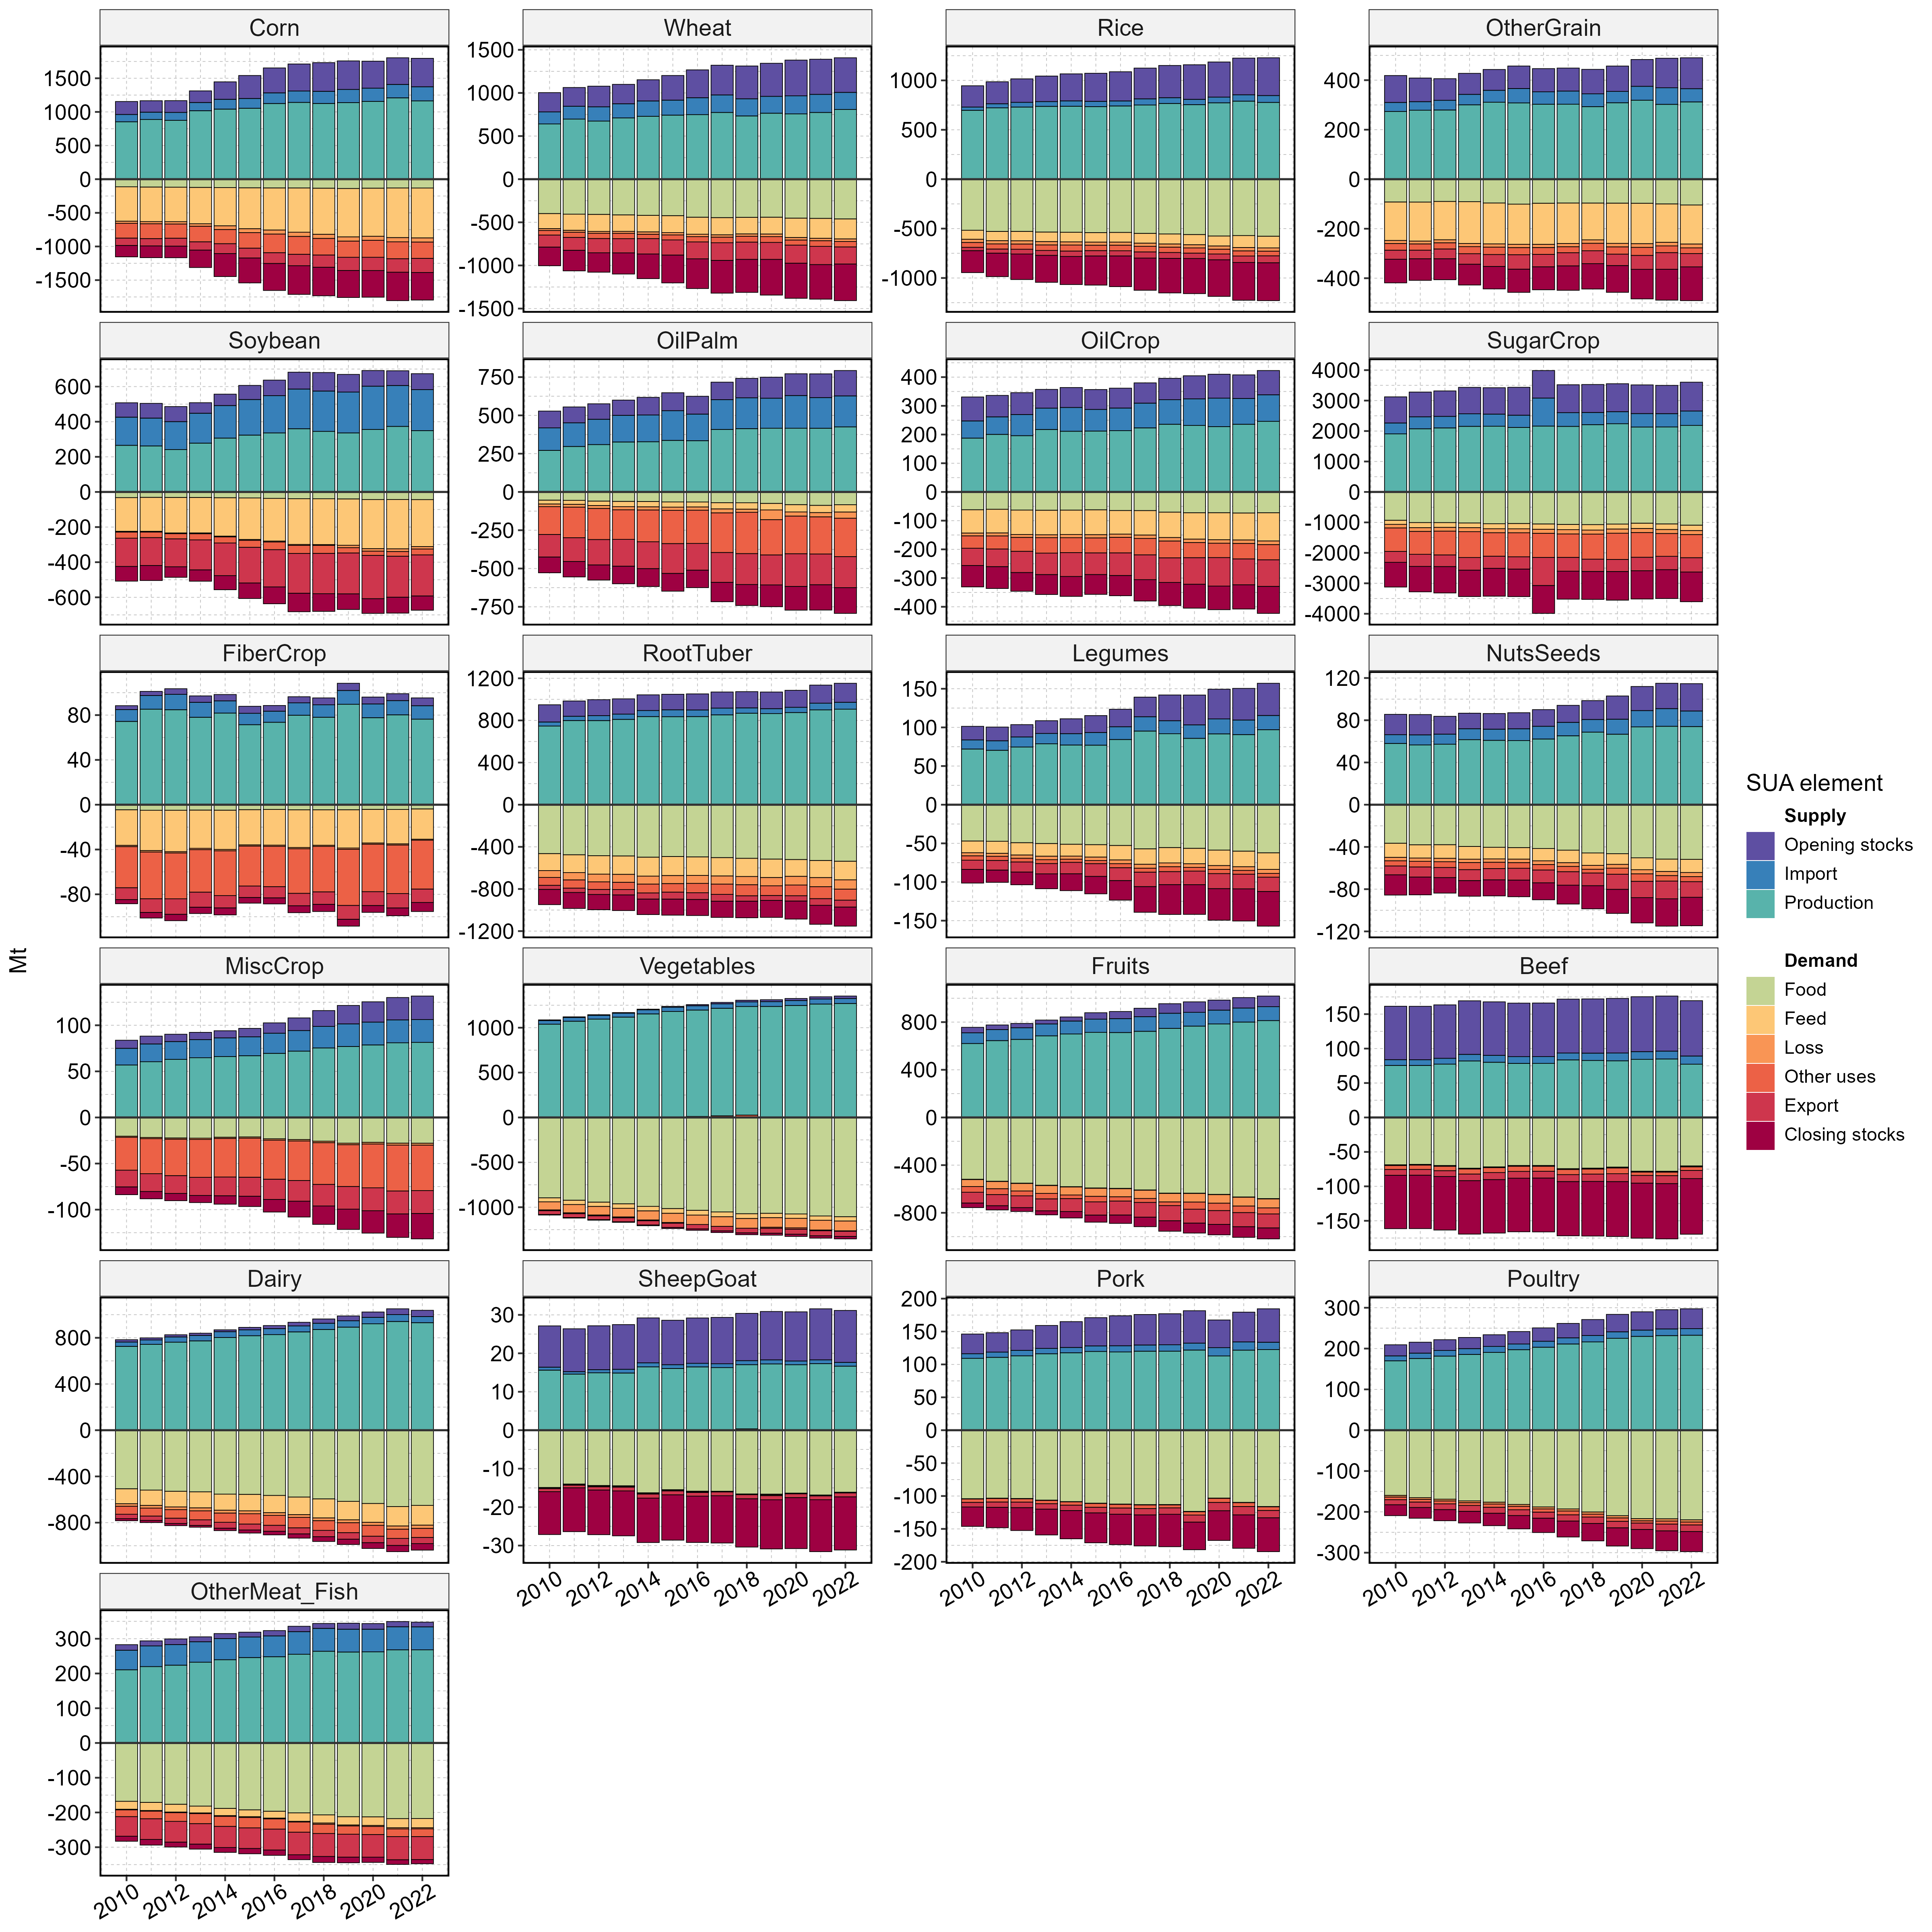
Supplementary Fig. 2 | Global traceable food balance sheets, 2010 – 2022.
Global supply (positive values) and demand (negative values) are shown for 21 aggregated GCAM commodities from 2010 to 2022 in Primary Commodity equivalents (PCe), expressed in million tonnes (Mt). Stacked bars distinguish individual supply and utilization elements; commodity mappings are provided in Supplementary Table 3. “Loss” denotes total post-harvest loss, including storage-associated losses. Gross imports and exports are aggregated across 32 GCAM regions (
Supplementary Table 4) and balance annually at the global level. Data sources: FAOSTAT and gcamfaostat.

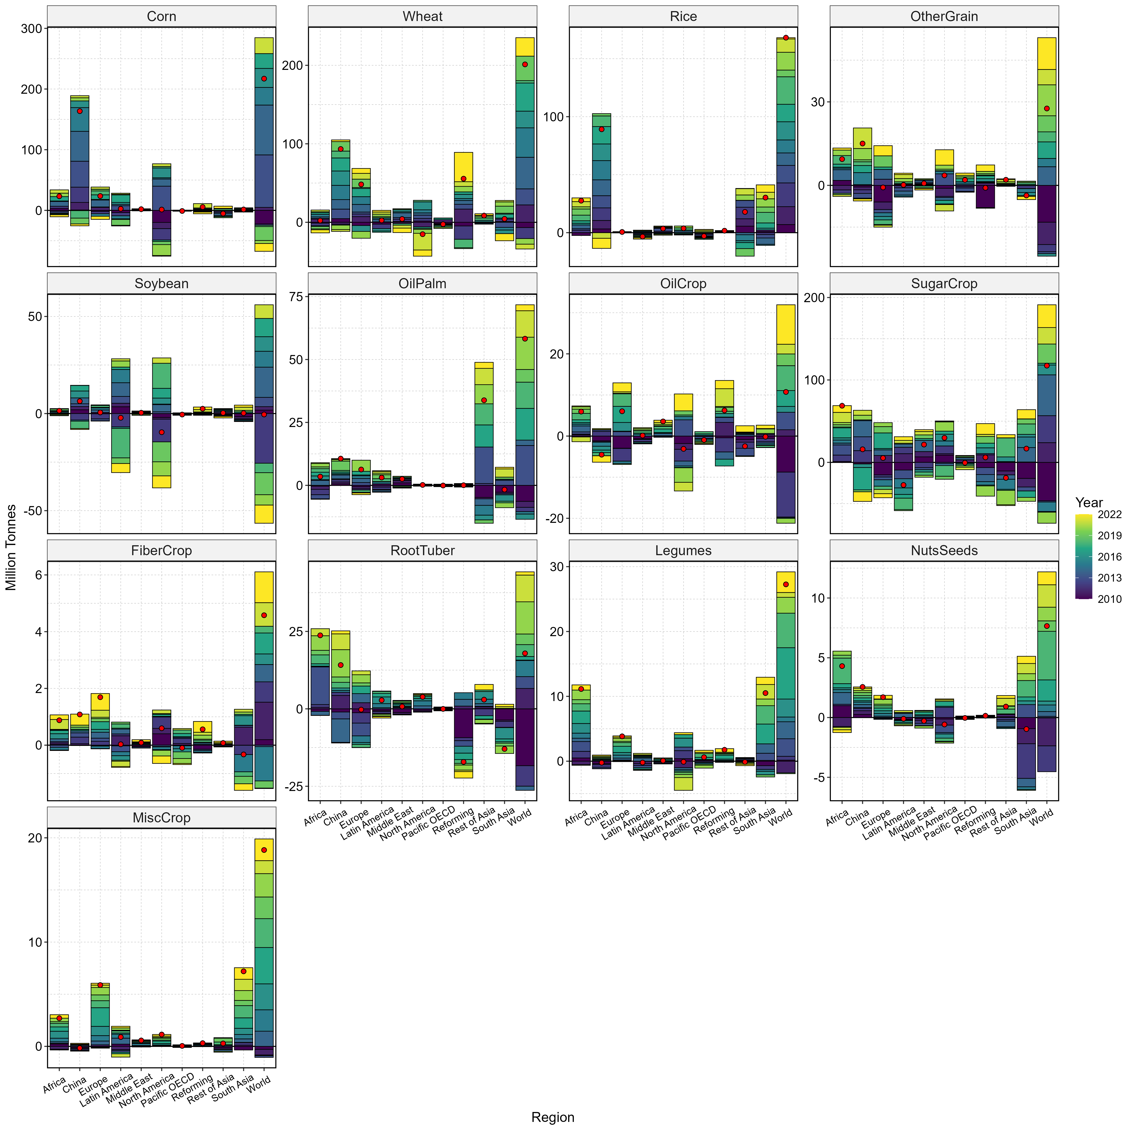
Supplementary Fig. 3 | Storage variation by GCAM storable commodity and region, 2010 – 2022.
Annual storage variation from 2010 to 2022 is shown for 13 GCAM storable crop commodities across IPCC R10 regions and the world. Within each commodity–region bar, colored segments represent year-specific stock changes, with positive values indicating stock accumulation and negative values indicating stock drawdown; red dots indicate the net cumulative change over 2010–2022. Storage variation is defined as the difference between closing and opening stocks and is reported in million tonnes (Mt). This disaggregated view underlies the global and regional storage summaries presented in Main Fig. 2. Data sources: FAOSTAT and gcamfaostat.

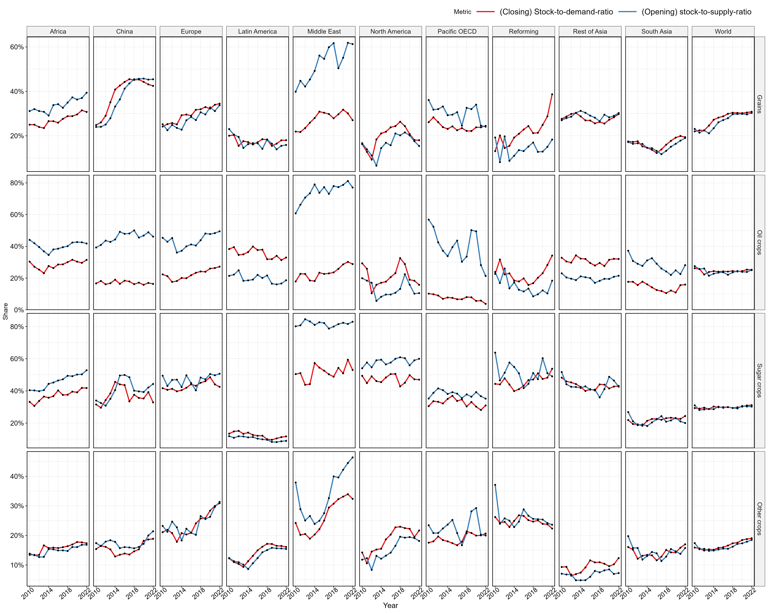
Supplementary Fig. 4 | Stock-to-gross-supply and stock-to-gross-use ratios by commodity group and region.
Historical storage indicators are shown for four storable crop groups—grains, oil crops, sugar crops, and other crops—across IPCC R10 regions and the world from 2010 to 2022. Blue lines show the opening stock-to-gross-supply ratio, where gross supply is defined as production plus opening stocks; red lines show the closing stock-to-gross-use ratio, where gross use comprises domestic utilization plus gross closing stocks (including the storage associated losses). Imports and exports are excluded from both measures. Ratios are expressed as shares and characterize the relative importance of inventories within domestic commodity supply and use. Data sources: FAOSTAT and gcamfaostat.

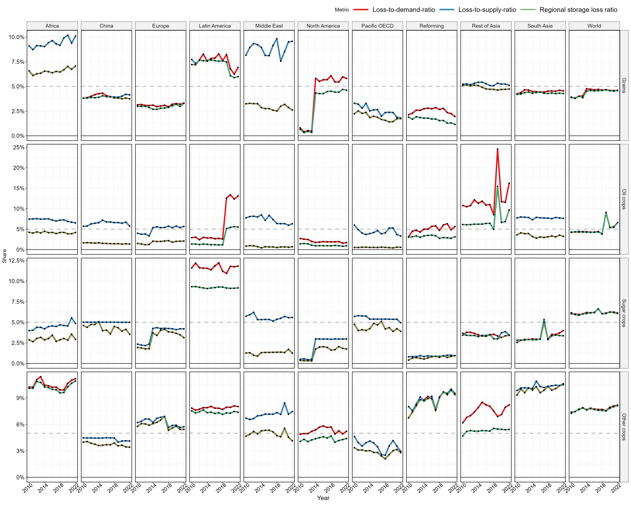
Supplementary Fig. 5 | Storage loss indicators by commodity group and region.
Historical loss indicators are shown for four storable crop groups—grains, oil crops, sugar crops, and other crops—across IPCC R10 regions and the world from 2010 to 2022. Lines show post-harvest losses relative to total demand (red) and total supply (blue), together with the regional storage loss ratio used to represent storage-associated losses in the model (green). All indicators are expressed as shares. Grey dashed lines indicate a 5% reference level. Commodity and regional aggregations follow those used throughout the analysis. Data sources: FAOSTAT and gcamfaostat.

Supplementary Table 5 | Commodity balance and storage indicators for cereal grains in the GCAM base year (2021).
Values represent three-year averages for 2020–2022 and are aggregated to IPCC R10 regions and the world. Commodity-balance quantities are reported in million tonnes (Mt), primary commodity equivalent. Closing stocks are reported net of inferred storage-associated losses. The closing stock-to-gross-use ratio is defined as closing stocks divided by the sum of current domestic utilization, closing stocks and storage loss, whereas the opening stock-to-gross-supply ratio is defined as opening stocks divided by the sum of production and opening stocks. Imports and exports are shown as components of the full commodity balance but are excluded from the denominators of both storage indicators. Data sources: FAOSTAT and gcamfaostat.
Region | Opening  stocks | Production | Import | Export | Domestic  consumption (current) | Closing  stocks | Stock  loss | Closing-  stock-to-  gross-  use | Opening-stock-  to-  gross-  supply
Africa | 131 | 218 | 106 | 10 | 299 | 137 | 9 | 31% | 38%
China | 525 | 629 | 64 | 14 | 661 | 524 | 19 | 44% | 45%
Europe | 178 | 368 | 93 | 100 | 353 | 180 | 6 | 33% | 33%
Latin America | 52 | 290 | 78 | 104 | 259 | 55 | 2 | 18% | 15%
Middle East | 39 | 27 | 56 | 1 | 84 | 36 | 1 | 30% | 59%
North America | 106 | 491 | 20 | 133 | 388 | 92 | 4 | 19% | 18%
Pacific OECD | 23 | 63 | 46 | 32 | 75 | 24 | 0 | 24% | 27%
Reforming | 44 | 237 | 7 | 89 | 134 | 63 | 1 | 32% | 16%
Rest of Asia | 99 | 240 | 50 | 21 | 258 | 106 | 5 | 29% | 29%
South Asia | 104 | 482 | 27 | 43 | 456 | 110 | 4 | 19% | 18%
World | 1301 | 3045 | 546 | 546 | 2969 | 1326 | 52 | 31% | 30%

Supplementary Section 2.2. Recent GCAM agricultural and food-system developments
GCAM has been widely applied to agricultural, land-use and food-system questions, including global model-intercomparison activities such as AgMIP and recent multi-model assessments of food-system transformation^{6,7,29}. These applications have used different generations of GCAM, which is relevant because the model has evolved continuously as new data, methods and sectoral representations have been incorporated. For example, Sheng et al. used an enhanced GCAM v7.0 with an explicit agricultural labor-market representation¹⁶, whereas the recent EAT–Lancet multimodel analysis employed GCAM v7.1 with study-specific modifications³⁰. The more recent ScenarioMIP work builds on the subsequent v8 generation of GCAM³¹.
Over the past several model generations, substantial effort has focused on improving the consistency and traceability of GCAM’s agricultural and food-system data. GCAM v7.0 introduced a revised agricultural data-processing framework, including harmonized FAOSTAT supply–utilization data and primary-commodity-equivalent accounting³². Related open-source tools, including gcamfaostat³³, and subsequent traceable food-balance datasets extended this framework and improved the ability to follow agricultural commodities through processing and utilization. Building on these advances, GCAM v7.1 had introduced an explicit representation of agricultural storage into GCAM, allowing inventories and associated losses to be distinguished from residual commodity uses²⁸. These developments established the data and modeling foundation used in the present analysis.
Subsequent GCAM releases further updated the broader socioeconomic and economic context in which agricultural storage operates. Recent developments include updated SSP socioeconomic drivers, a shift of the final calibration year from 2015 to 2021, and continued development of GCAM-Macro, including the KLEAM extension linking capital, labor, energy, agriculture, and materials more explicitly within the macroeconomic framework³⁴. The present study uses GCAM v9.1, publicly released in June 2026, and therefore evaluates storage within this more recent model configuration. Although the core storage capability was introduced in an earlier GCAM release²⁸, we further refine its implementation and design scenarios to distinguish the long-term structural effects of explicit stock accounting from the role of endogenous inventories in shock transmission.

Supplementary Table 6 | Summary of storage cost estimates.
Given this range of estimates across regions and technologies, we adopt a conservative uniform interannual storage cost of 3% of producer prices in the baseline specification.
Region | Description of interannual storage cost share | Source
USA (& developed regions) | In the USA and other developed regions, advanced storage technologies (e.g., grain bins with drying systems), either on-farm or commercially rented, are commonly employed. Several extension studies have outlined the calculation of the levelized cost for grain storage using grain bins. Based on the values provided by Edwards et al. (2014), the one-year storage cost for corn ranges from $0.8 to $1.1 per bushel, constituting approximately 11% to 13% of the producer prices (as of 2015). Assuming that approximately half of annual storage reflects interannual carryover, the implied interannual cost share is 3%–7%. The storage cost for soybeans is slightly lower than that for corn, with a comparable “interannual” cost share of 3% to 5%. | (Duncan et al., 2022; Edwards, 2014)^{35,36}
Arab Countries /Middle East | The marginal storage cost in 2009 ranged from $1.69 (Jordan) to $3.47 (Tunisia) per ton per month for grains. Converted to 2015 USD and annualized, and assuming half of the storage duration reflects interannual carryover, the implied cost share is 2%–4.5% of producer prices. | (David, 2012; Larson et al., 2014)^{37,38}
African countries | In Africa and other lower-income regions, crop storage practices tend to be less efficient, leading to relatively higher losses. Recently, Purdue Improved Crop Storage (PICS) bags were developed to enhance grain storage, reducing losses in African regions at a lower capital cost. The cost is approximately $12.5 per ton per year, whereas standard bags cost $1.7 per ton per year. Even with a 100% overhead cost assumption, storage costs using standard bags would be about 1.2% of producer prices. Hermetic storage technologies imply higher cost shares (5%–8%), though with lower loss rates. If we assume 50% of the cost to be “interannual”, the overall cost would be in the range of 1% to 4%. | (Baributsa et al., 2015; Dijkink et al., 2022; Kotu et al., 2019; Manandhar et al., 2018; Ndegwa et al., 2016; Sudini et al., 2015)^{39–44}

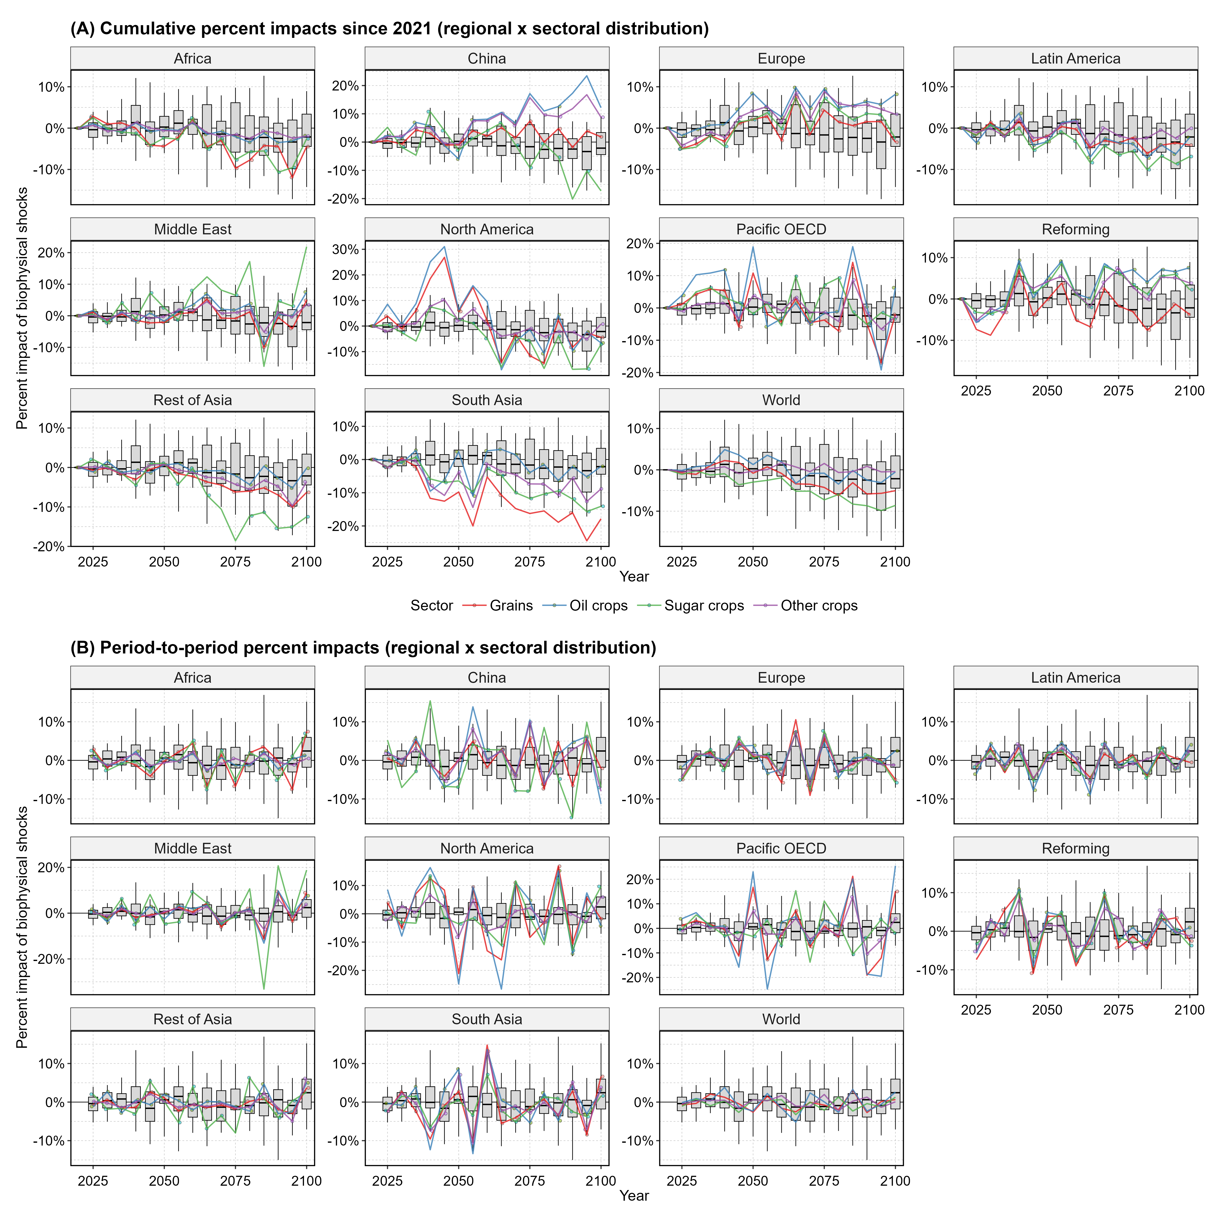
Supplementary Fig. 6 | Regional and global patterns of biophysical yield shocks used in model simulations.
Panel A shows cumulative percentage deviations from the Smooth yield trajectory since 2021, and Panel B shows the corresponding period-to-period deviations in yield growth between successive GCAM model periods. In each panel, gray boxplots show the global distribution across 10 IPCC R10 regions and four crop groups (Grains, Oil crops, Sugar crops, and Other crops), yielding up to 40 region–crop observations per model period. Boxes indicate the interquartile range, center lines the median, and whiskers the 5th–95th percentile range. Colored lines show crop-group-specific shocks for the indicated region; lines in the World panel show the corresponding global aggregate shocks. Biophysical yield shocks are derived from ISIMIP2b simulations using the GEPIC global gridded crop model driven by HadGEM2-ES under RCP6.0, and are aggregated to GCAM production regions, crop groups, and model periods as described in Methods. Data source: ISIMIP2b⁴⁵ and osiris⁴⁶.

Supplementary Section 3. Supplementary results

Supplementary Section 3.1. Long-term impacts and sensitivity analyses
The supplementary analyses extend the long-term results in the main text by providing additional regional and sectoral detail and by testing the sensitivity of the principal findings to alternative yield and storage assumptions. Supplementary Fig. 7 reports the regional and sectoral composition of projected stocks in per-capita dietary-energy terms. Supplementary Fig. 8 and Supplementary Fig. 9 provide the full agroeconomic and environmental trajectories under Dynamic and Hidden Storage, respectively, including regional supply–utilization balances, land use, agricultural labor and capital inputs, irrigation water, fertilizer use, prices and cumulative emissions. Supplementary Fig. 10 reports the corresponding Dynamic–Hidden differences. Supplementary Fig. 11–Supplementary Fig. 13 then repeat the long-term comparison under biophysical yield shocks, Fixed-Ratio Storage and an alternative treatment of cross-period stock carryover, respectively.
Projected changes in storage are heterogeneous across regions and commodities. Per-capita stocks increase across all IPCC R10 regions over the century, although the magnitude and commodity composition of the increase differ substantially (Supplementary Fig. 7). The full regional balances under Dynamic Storage further show how opening stocks contribute to supply while closing stocks and storage-associated losses constitute distinct demand components (Supplementary Fig. 8). Under Hidden Storage, these flows remain embedded within other uses rather than evolving as explicit inventory accounts (Supplementary Fig. 9). The resulting differences propagate beyond commodity balances: Dynamic Storage generally lowers long-run agricultural production and associated resource requirements relative to Hidden Storage, while regional and sectoral responses can differ in magnitude and occasionally direction as production and trade are reallocated across markets (Supplementary Fig. 10).
The long-term conclusions are qualitatively robust across the alternative model configurations examined. When the Dynamic–Hidden comparison is repeated under spatially and temporally varying biophysical yield shocks, stocks and net stock variation become less smooth, but explicit storage continues to produce lower long-run production, irrigation-water requirements and cumulative emissions than Hidden Storage (Supplementary Fig. 11). Fixed-Ratio Storage produces broadly similar long-run effects despite disabling price-responsive stock reallocation (Supplementary Fig. 12). This indicates that the structural long-run effects arise primarily from explicitly separating stock accumulation and storage-associated losses from other commodity demand, whereas endogenous stockholding behavior is more consequential for shorter-period shock transmission. Removing the default cross-period carryover adjustment changes the magnitude of several long-run impacts but does not reverse their principal direction (Supplementary Fig. 13), indicating that the treatment of carryover between five-year model periods represents an important quantitative uncertainty but does not drive the basic structural result.
These sensitivity analyses isolate several modeling choices that are particularly relevant to storage, but they are not intended to characterize the full uncertainty in future agrifood pathways. The shock sensitivity uses one internally consistent Earth system–crop-model realization, while storage costs, region–commodity loss rates and other behavioral parameters remain fixed within the corresponding experiments. The results should therefore be interpreted as evidence that the main structural conclusions persist across the storage and yield configurations examined, rather than as probabilistic bounds on future storage or its system-wide impacts.

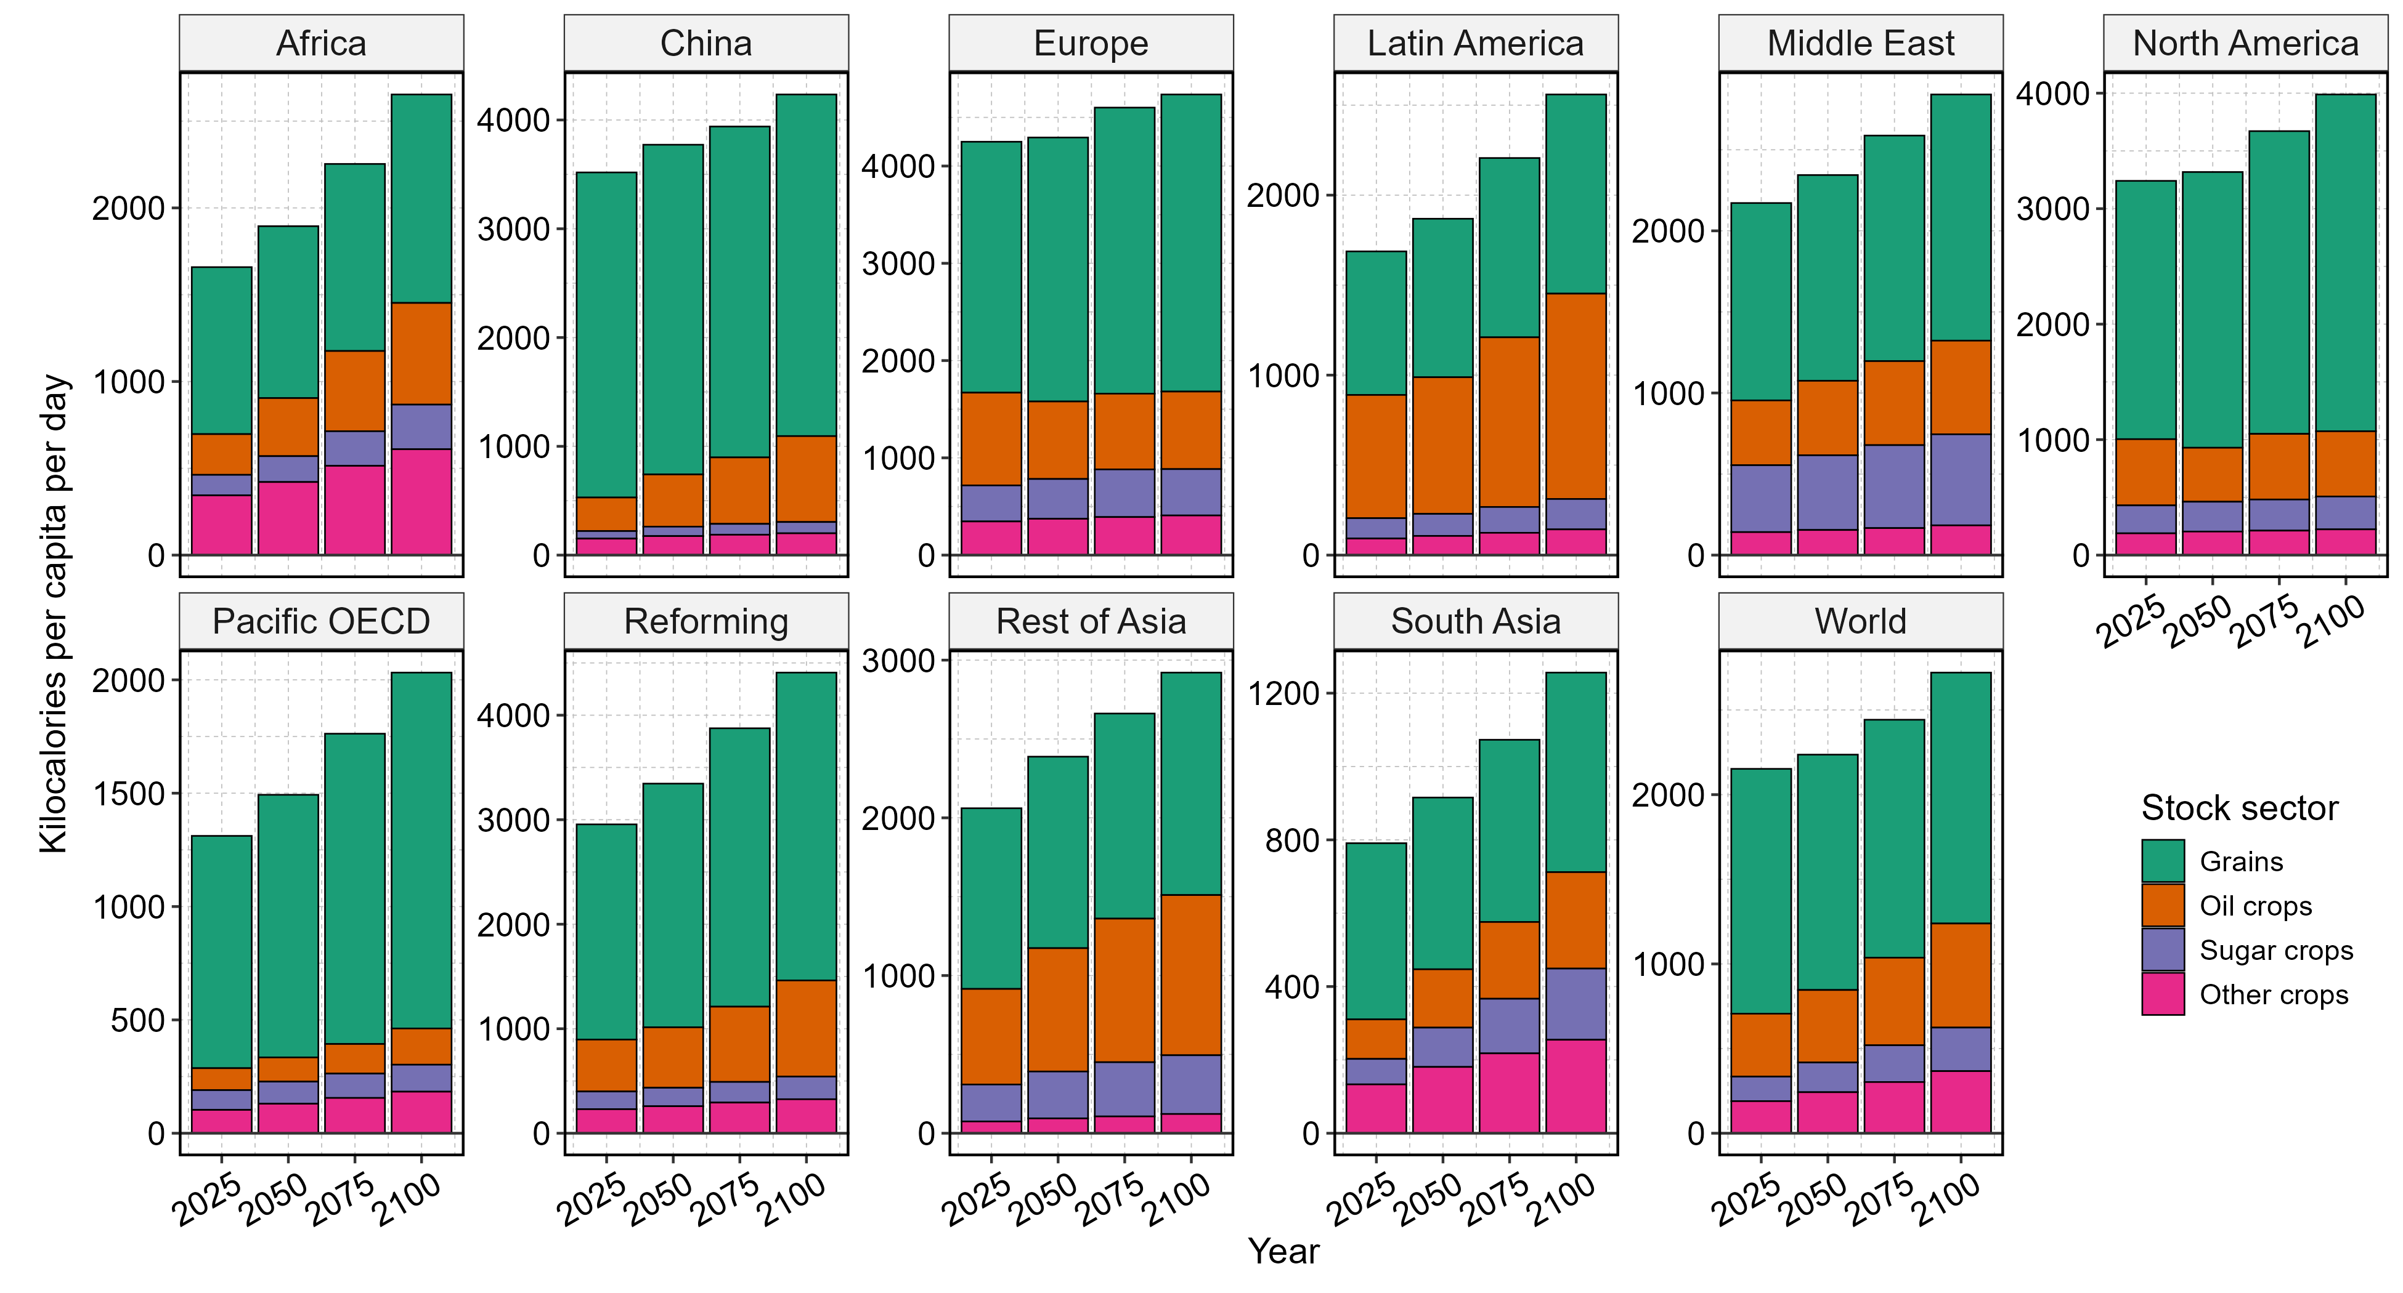
Supplementary Fig. 7 | Global and regional crop stocks in per capita dietary-energy terms.
Stacked bars show closing stock levels by crop sector, converted to kilocalories per capita per day. This figure supplements Main Fig.4B. Results are reported for IPCC R10 regions and the world. Data source: GCAM simulation results.

Supplementary Fig. 8 | Agroeconomic and environmental projections under dynamic storage.
GCAM v9.1 projections from the Dynamic Storage scenario (S1). Panels A–C show regional supply–utilization accounts for cereal grains, oil crops and sugar crops, respectively, expressed in primary-commodity-equivalent (PCe) mass units. Supply elements are plotted above zero and demand elements below zero; opening stocks enter regional supply, whereas closing stocks and storage-associated losses enter demand. Panel D shows land cover and use by category (rock, ice, desert, tundra, and urban not included). Panels E–H show agricultural labor input, capital input, irrigation-water withdrawals, and nitrogen fertilizer use, respectively. Panel I shows producer-price indices for the four storable crop groups relative to 2021. Panel J shows cumulative agricultural CH₄ and N₂O emissions, converted to CO₂-equivalent using 100-year global warming potentials (GWP100), together with CO₂ emissions from land use, land-use change and forestry (LULUCF), accumulated from 2021 through each indicated year. Data source: GCAM simulation results.
Supplementary Fig. 9 | Agroeconomic and environmental projections under hidden storage.
GCAM v9.1 projections from the Hidden Storage scenario (S2). See Supplementary Fig. 8 for detailed captions.
Supplementary Fig. 10 | Impact of dynamic storage representation (Dynamic vs. Hidden) on agroeconomic and environmental projections.
Panels A–C show differences in balanced supply–utilization accounts between dynamic and hidden storage (S1−S2). Supply-side changes are plotted as S1−S2, whereas demand-side changes are sign-reversed; positive values therefore indicate higher supply or lower demand under dynamic storage, and negative values indicate the reverse. Black points show explicit net stock variation (closing minus opening stocks), which enters the balance as a demand item and uses the same sign convention. In the hidden-storage scenario, this flow is not separately represented but remains embedded within “other uses”. Including net stock variation, total positive and total negative contributions offset in each region and model year. See Supplementary Fig. 8 and Supplementary Fig. 9 for additional details.
Supplementary Fig. 11 | Agricultural storage dynamics and multisectoral impacts under biophysical yield shocks.
Panels A–D show projected closing stocks, their regional and sectoral composition, net stock variation, and storage-associated losses under dynamic storage with HadGEM2-ES–GEPIC yield shocks (S3). Panels E–J show differences between dynamic and hidden storage under the same yield shocks (S3 vs. S4) in production, irrigation-water withdrawals, land use, and cumulative agricultural and LULUCF emissions. Panels I–J show impacts accumulated from 2021 to 2100. Panel definitions, sign conventions, and units follow Main Fig. 4. Data source: GCAM simulation results.
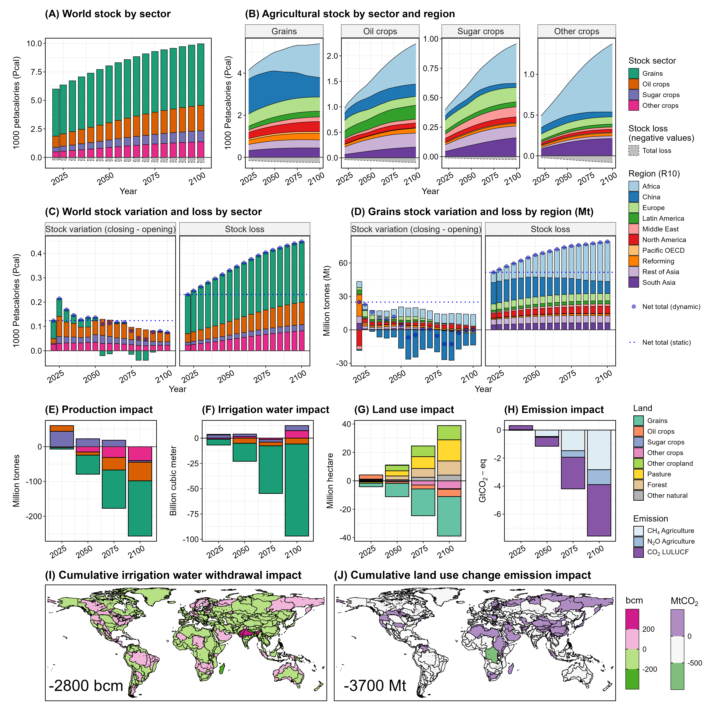
Supplementary Fig. 12 | Agricultural storage dynamics and multisectoral impacts under fixed-ratio storage.
Panels A–D show projected closing stocks, their regional and sectoral composition, net stock variation, and storage-associated losses in the fixed-ratio scenario with smooth yields (S5), in which initial stock-to-gross-use ratios are held fixed and price-responsive stock reallocation is disabled. Panels E–J show differences between fixed-ratio and hidden storage under smooth yields (S5−S2) in production, irrigation-water withdrawals, land use, and cumulative agricultural and LULUCF emissions. Panels I–J show impacts accumulated from 2021 to 2100. Panel definitions, sign conventions, and units follow Main Fig. 4. Data source: GCAM simulation results.

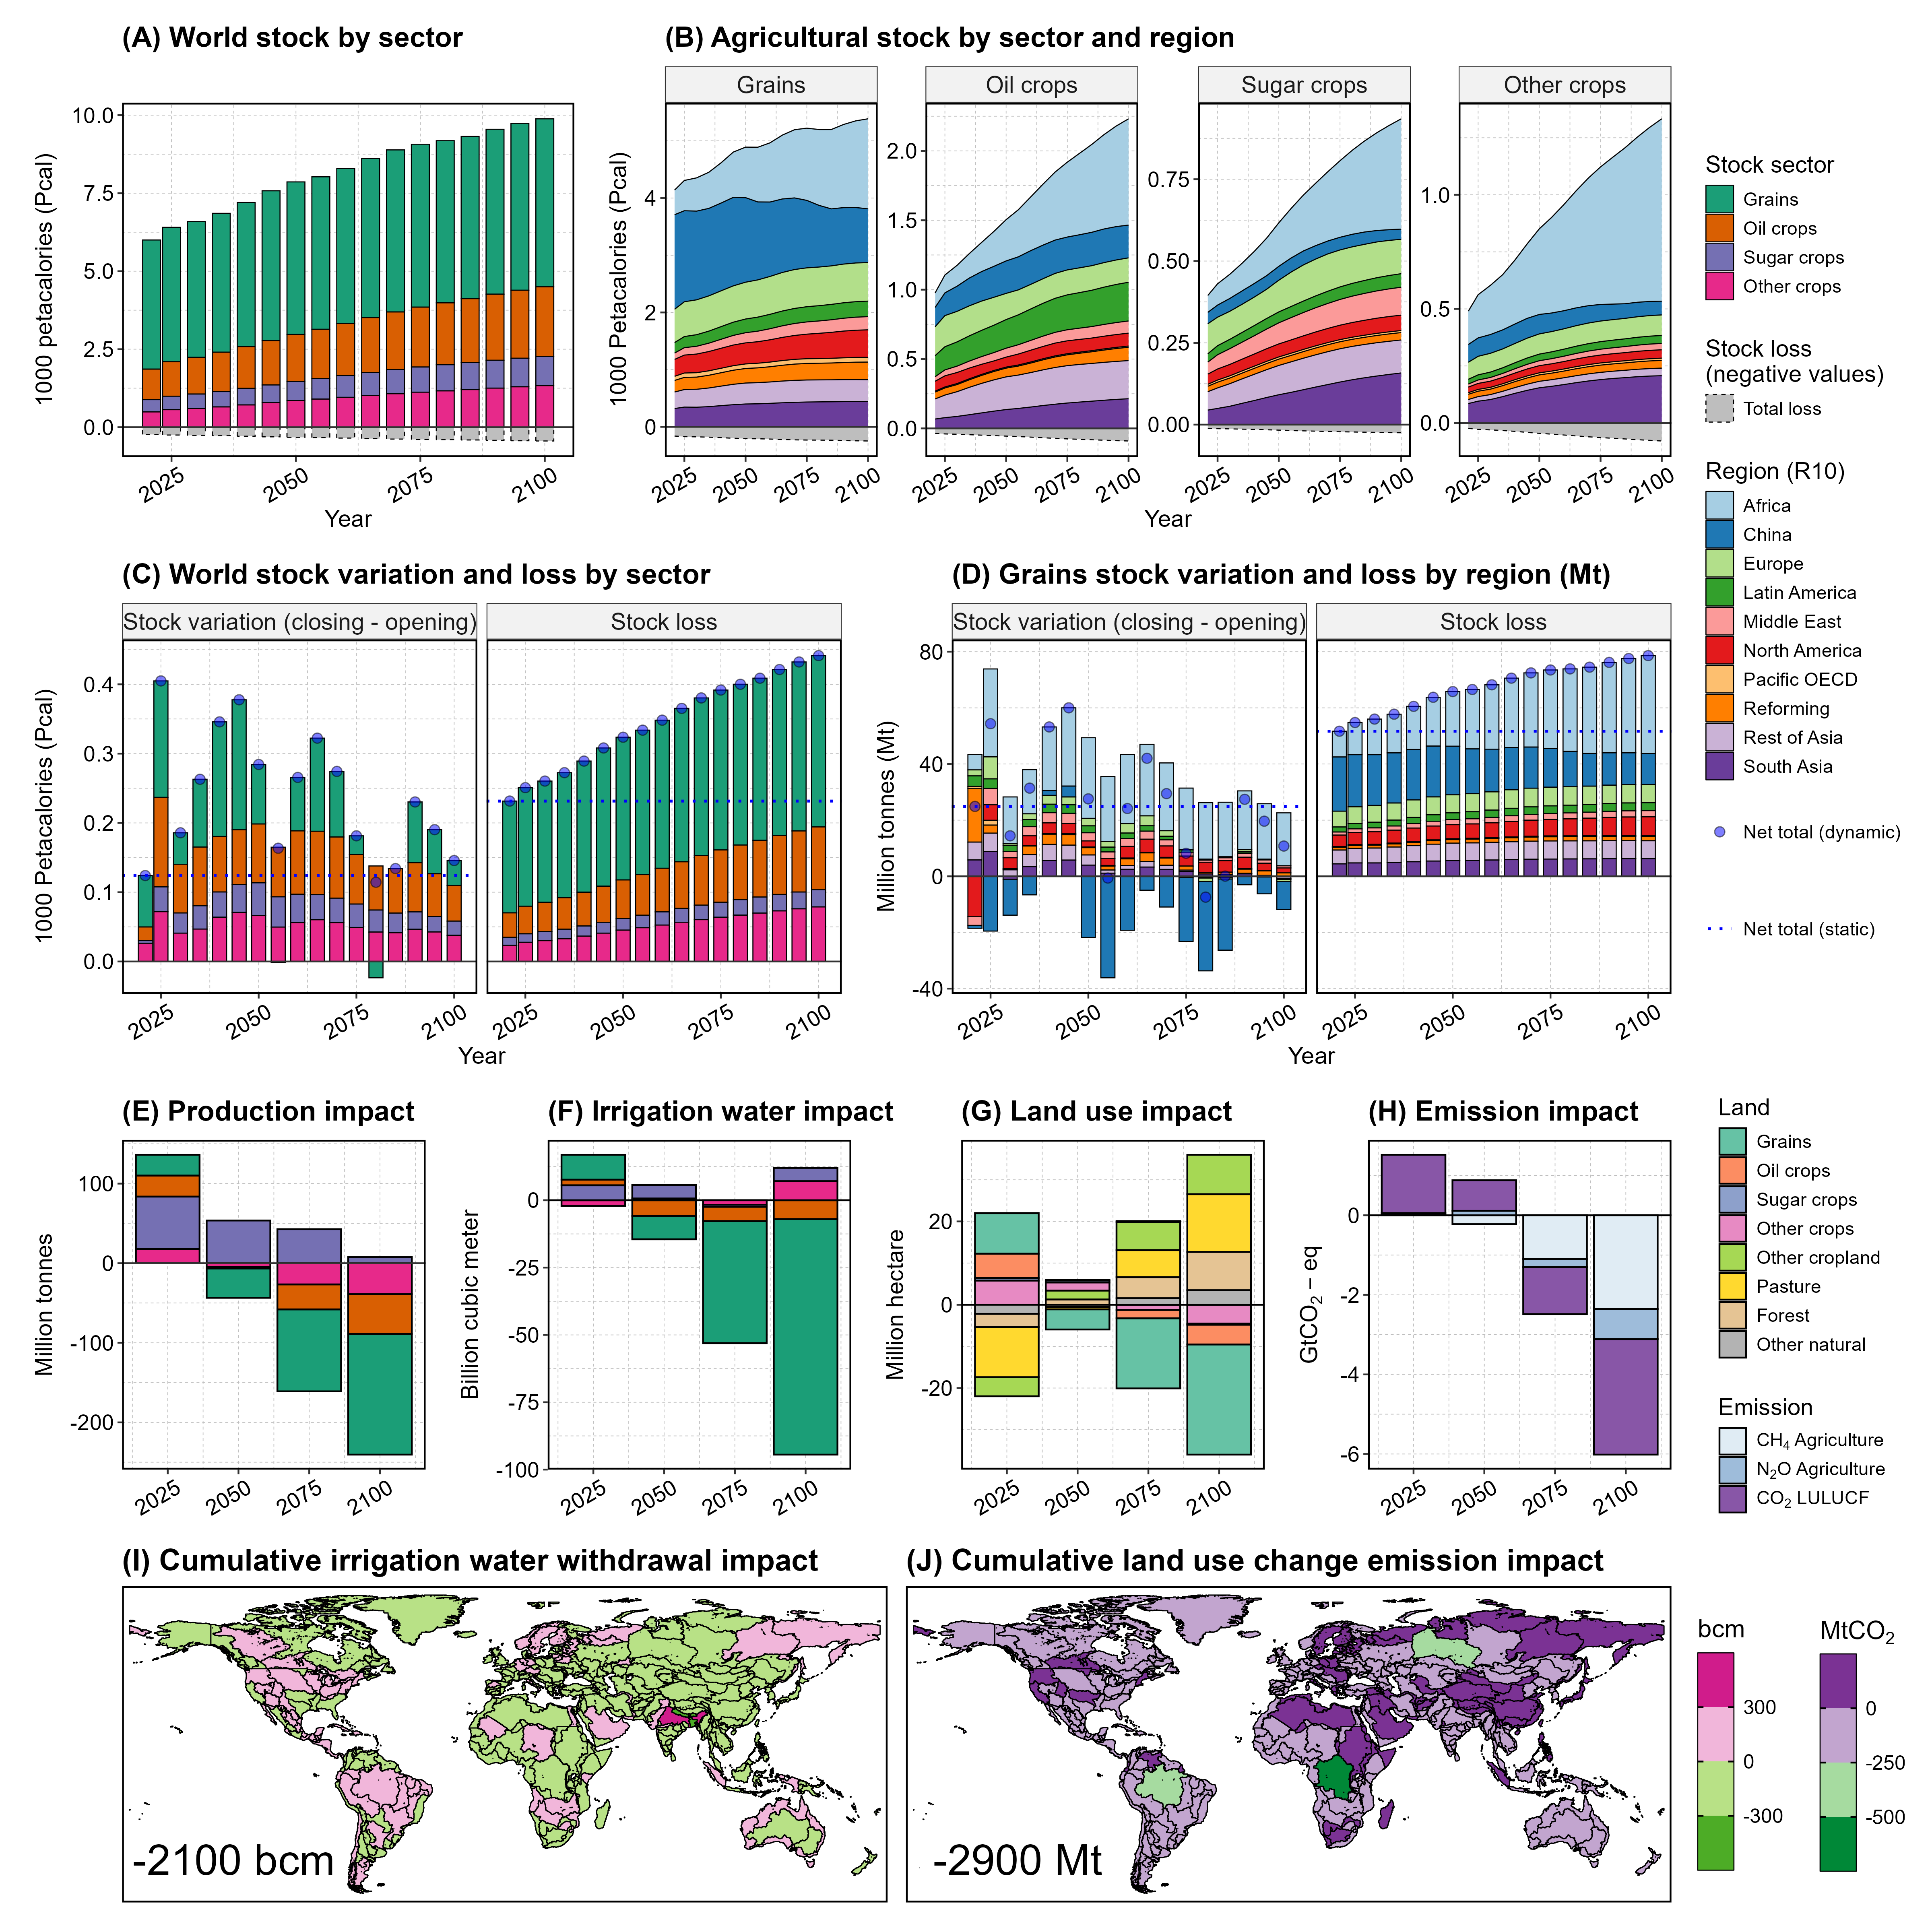
Supplementary Fig. 13 | Agricultural storage dynamics and multisectoral impacts under dynamic storage without cross-period carryover adjustment.

Panels A–D show projected closing stocks, their regional and sectoral composition, net stock variation, and storage-associated losses in a Dynamic Storage sensitivity scenario in which the cross-period carryover adjustment factor is set to unity ($δ=1$). Closing stocks in one model period therefore become opening stocks in the next without cross-period adjustments (e.g., population-linked carryover adjustment applied in the default dynamic storage scenario), while price-responsive stockholding remains active at model years. Panels E–J show differences between this sensitivity scenario and hidden storage under smooth yields in agricultural production, irrigation-water withdrawals, land use, and cumulative agricultural and LULUCF emissions. Panels I–J show impacts accumulated from 2021 to 2100. Panel definitions, units, and sign conventions follow Main Fig. 4. Data source: GCAM simulation results.

Supplementary Section 3.2. Transmission of biophysical yield shocks
The supplementary analyses provide a more complete characterization of how biophysical yield shocks propagate through agricultural markets than is shown in the main text. Supplementary Fig. 14 traces cumulative responses under Dynamic Storage throughout the projection period, while Supplementary Fig. 15 and Supplementary Fig. 16 compare cumulative transmission across Dynamic, Hidden, and Fixed-Ratio Storage at the 2050 and 2100 horizons. Supplementary Fig. 17 and Supplementary Fig. 18 resolve the Dynamic Storage responses between successive model periods and across regions, respectively, and Supplementary Fig. 19 extends the period-to-period comparison across all three storage representations. Together, these figures distinguish cumulative endpoint responses from shorter-period adjustments and show the substantial temporal, regional, and crop-specific heterogeneity underlying the pooled relationships reported in Main Fig. 5. Supplementary Table 7–Supplementary Table 9 provide the corresponding transmission coefficients, cross-market distributions, pairwise tests across storage representations, and fixed-effect robustness specifications.
Under Dynamic Storage, cumulative responses evolve considerably over time and vary across regions and crop groups (Supplementary Fig. 14). Realized yield closely follows the imposed biophysical perturbation, while adjustments in harvested area, production, trade, consumption, and prices redistribute its effects through the agricultural system. Inventory responses are particularly variable because stockbuilding in one period may subsequently be offset by drawdown, so cumulative changes can remain modest even when inventories are actively adjusting along the pathway. The absolute-response panels complement the percentage responses by showing changes in net stock variation and net exports directly in physical quantities. These panels show that both inventory adjustment and international trade remain active response margins in level terms, rather than being features arising only from the logarithmic formulation of the transmission metrics. Supplementary Fig. 14 presents this evolution across model years, while the corresponding absolute-response panels in Supplementary Fig. 15 and Supplementary Fig. 16 show the same stock and trade margins at the 2050 and 2100 cumulative horizons.
The horizon comparisons further illustrate why cumulative measures alone provide an incomplete view of storage. At 2050, the cumulative closing-stock relationship under Dynamic Storage is weak relative to the responses in production and trade, whereas by 2100 a clearer positive stock response is evident (Supplementary Fig. 15 and Supplementary Fig. 16; Supplementary Table 7). This difference is consistent with inventories serving as an intertemporal adjustment margin: accumulation and drawdown occurring at intermediate dates can offset when only the change between the base year and a single future endpoint is considered. The absolute stock-variation panels provide a complementary view of this process, while the net-export panels show that trade also responds materially to the imposed yield perturbations. Hidden Storage does not provide a separately identifiable inventory response because stocks are not represented explicitly.
Resolving responses between successive model periods makes these temporal adjustments more apparent. Supplementary Fig. 17 shows that the direction and magnitude of period-to-period responses vary substantially across transitions, including alternating stock accumulation and drawdown as the sign and magnitude of yield perturbations change. Its absolute-response panels similarly show sizeable positive and negative movements in net stock variation and net exports across periods. Supplementary Fig. 18 reorganizes the same responses by region and reveals substantial geographic and crop-specific heterogeneity in the use of inventories, trade and other adjustment margins. Thus, the pooled relationships in the main analysis summarize a broad distribution of responses rather than a uniform adjustment across markets.
Supplementary Fig. 19 compares these period-to-period relationships directly across storage representations. Dynamic Storage exhibits a substantially stronger positive relationship between yield perturbations and closing stocks than Fixed-Ratio Storage, reflecting endogenous stockbuilding following favorable yield changes and drawdown following adverse changes. The absolute-response panel shows the same distinction in physical stock variation and also demonstrates a clear response of net exports, reinforcing the role of both inventories and trade as adjustment margins. Differences across storage representations are also evident for harvested area, production, exports, and producer prices, whereas realized yield and consumption are much less sensitive to the representation of storage. Hidden Storage has no explicit closing-stock outcome and therefore cannot provide a separately identifiable inventory-transmission response.
The complete coefficient estimates support these transmission patterns (Supplementary Table 7). Cumulative inventory transmission is sensitive to the endpoint considered, whereas the period-to-period estimates reveal a substantially stronger inventory response under Dynamic Storage; the distribution of market-specific slopes additionally confirms considerable heterogeneity across region–crop markets. Pairwise Wald tests show that the representation of storage significantly alters several transmission margins, including harvested area, production, exports, and producer prices, while differences for some other outcomes are comparatively small (Supplementary Table 8). The difference in the closing-stock response between Dynamic and Fixed-Ratio Storage is particularly pronounced. Re-estimating the period-to-period relationships with region and region–crop-market fixed effects produces closely similar transmission patterns, including the inventory response, supporting robustness to the fixed-effect specifications examined (Supplementary Table 9).

Supplementary Fig. 14 | Cumulative agroeconomic responses to biophysical yield shocks under Dynamic Storage.
Panel A shows cumulative percentage responses since 2021, calculated as the difference between cumulative log changes in the Dynamic Storage shock and Smooth scenarios (S3 relative to S1) from the common 2021 base year to each model year. Panel B shows corresponding responses in absolute differences for net stock variation and net exports, calculated as differences in level changes from the 2021 base. Because the paired scenarios share the same base-year calibration, these measures are equivalent to the S3−S1 deviation at each model year. Both mass (Mt) and dietary-energy (Pcal) measures are included for stock-related variables. For each model year, boxplots summarize the distribution across 10 IPCC R10 regions and four crop groups, yielding up to 40 region–crop observations. Boxes indicate the interquartile range, center lines the median, and whiskers the 5th–95th percentile range. Colored points show individual region–crop observations, and colored lines show world-level responses by crop group. Data source: GCAM simulation results.
Supplementary Fig. 15 | Transmission of cumulative biophysical yield shocks to agroeconomic outcomes in 2050.
Panel A shows cumulative percentage responses from 2021 to 2050 under Dynamic, Hidden, and Fixed-Ratio Storage. Responses are calculated as differences in cumulative log changes between the corresponding biophysical-shock and Smooth scenarios: S3 relative to S1 for Dynamic Storage, S4 relative to S2 for Hidden Storage, and S6 relative to S5 for Fixed-Ratio Storage. The horizontal axis shows the cumulative biophysical yield deviation, and the vertical axis shows the corresponding cumulative response in each outcome. Panel B shows responses (absolute differences) for net stock variation and net exports. Each point represents one IPCC R10 region–crop-group observation, yielding up to 40 observations per storage representation. Colors distinguish storage representations. Lines show scenario-specific ordinary least-squares fit with an intercept, and shaded bands show 95% confidence intervals for the fitted mean relationship. Grey diagonal lines in Panel A indicate a one-to-one response. Hidden Storage does not report explicit closing stocks or storage-associated losses. Stock-related variables are reported using both mass (Mt) and dietary-energy (Pcal) measures. Data source: GCAM simulation results.
Supplementary Fig. 16 | Cumulative transmission of biophysical yield shocks to agroeconomic outcomes in 2100.
Scenario pairings, calculations, panel definitions, units, statistical fits, and other conventions follow Supplementary Fig. 15. Data source: GCAM simulation results. The fitted slopes are interpreted as cumulative yield-shock transmission elasticities at 2100.
Supplementary Fig. 17 | Period-to-period agroeconomic responses to biophysical yield shocks under Dynamic Storage, by model period.

Panel A shows shock-induced percentage responses for each transition between successive GCAM model periods, calculated as the difference in log growth between the Dynamic Storage shock and Smooth scenarios (S3 relative to S1). Panel B shows corresponding responses in absolute differences for net stock variation and net exports, for which logarithmic responses are not defined consistently. Both mass (Mt) and dietary-energy (Pcal) measures are included for stock-related variables. For each model-period transition, boxplots summarize the distribution across 10 IPCC R10 regions and four crop groups, yielding up to 40 region–crop observations. Boxes indicate the interquartile range, center lines the median, and whiskers the 5th–95th percentile range. Colored points show individual region–crop observations, and colored lines show world-level responses by crop group. Data source: GCAM simulation results.
Supplementary Fig. 18 | Period-to-period agroeconomic responses to biophysical yield shocks under Dynamic Storage, by region.
This figure presents the same period-to-period responses as Supplementary Fig. 17, regrouped by IPCC R10 region. Panel A shows percentage responses, and Panel B shows responses in absolute differences for net stock variation and net exports. Within each region, boxplots summarize the distribution across 16 model-period transitions and four crop groups, yielding up to 64 period–crop observations. Boxes indicate the interquartile range, center lines the median, and whiskers the 5th–95th percentile range; colored points distinguish crop groups. The World category shows corresponding globally aggregated responses across model periods and crop groups. Data source: GCAM simulation results.

Supplementary Fig. 19 | Period-to-period transmission of biophysical yield shocks to agroeconomic outcomes.
Panel A shows percentage responses for each transition between successive GCAM model periods under Dynamic, Hidden, and Fixed-Ratio Storage. Period-to-period shocks and responses are calculated as differences in log growth between the corresponding biophysical-shock and Smooth scenarios: S3 relative to S1, S4 relative to S2, and S6 relative to S5, respectively. Panel B shows responses in absolute difference for net stock variation and net exports, for which percentage changes are not consistently defined. Each point represents one IPCC R10 region–crop-group–period observation across 16 model-period transitions, yielding up to 640 observations per storage representation. Colors distinguish storage representations. Lines show scenario-specific pooled ordinary least-squares fits with an intercept, and shaded bands show 95% confidence intervals for the fitted mean relationship. The Panel A slopes are interpreted as period-to-period yield-shock transmission elasticities. Grey diagonal lines indicate a one-to-one response. Hidden Storage does not report explicit closing stocks or storage-associated losses. Stock-related variables are reported using both mass (Mt) and dietary-energy (Pcal) measures. This figure supplements Main Fig.5. Data source: GCAM simulation results.

Supplementary Table 7 | Yield-shock transmission elasticities under alternative storage representations.
Panels A and B report cumulative transmission in 2050 and 2100, respectively; panel C reports pooled period-to-period transmission over 2021–2100. Entries in panels A–C are slope coefficients (β), with standard errors (SEs) in parentheses and P values for tests against zero. Cumulative regressions contain 40 region–crop observations per storage representation; period-to-period regressions contain 640 observations from 40 region–crop markets and 16 transitions. Panel D reports the median and interquartile range of 40 market-specific period-to-period slopes per representation; these ranges describe cross-market heterogeneity, not confidence intervals. Responses are calculated from the paired yield-shock and smooth-yield scenarios: S3 relative to S1 (Dynamic Storage), S4 relative to S2 (Hidden Storage), and S6 relative to S5 (Fixed-Ratio Storage). Data source: GCAM simulation analysis. Note that closing stocks denote net inventories after storage-associated losses and use the mass-based series. Consumption denotes current domestic consumption, excluding closing stocks and storage-associated losses. Hidden Storage does not explicitly represent inventories. P values below 0.001 are displayed as <0.001. Pairwise coefficient-equality tests are reported in Supplementary Table 8; fixed-effect robustness is reported in Supplementary Table 9.
A | Cumulative transmission in 2050 (n = 40 region–crop observations per storage representation)
Outcome | Dynamic Storage |  | Hidden Storage |  | Fixed-Ratio Storage
Outcome | β (SE) | P | β (SE) | P | β (SE) | P
Realized yield | 1.006 (0.049) | <0.001 | 1.054 (0.036) | <0.001 | 1.051 (0.037) | <0.001
Area harvested | -0.504 (0.054) | <0.001 | -0.533 (0.040) | <0.001 | -0.521 (0.048) | <0.001
Production | 0.502 (0.055) | <0.001 | 0.520 (0.045) | <0.001 | 0.529 (0.050) | <0.001
Exports | 0.978 (0.132) | <0.001 | 0.979 (0.113) | <0.001 | 0.961 (0.111) | <0.001
Closing stocks | -0.029 (0.037) | 0.440 | — | — | 0.045 (0.013) | <0.001
Imports | -0.208 (0.055) | <0.001 | -0.156 (0.050) | 0.003 | -0.188 (0.051) | <0.001
Consumption | 0.038 (0.015) | 0.015 | 0.038 (0.014) | 0.011 | 0.040 (0.014) | 0.006
Producer price | -0.255 (0.026) | <0.001 | -0.266 (0.019) | <0.001 | -0.245 (0.020) | <0.001

B | Cumulative transmission in 2100 (n = 40 region–crop observations per storage representation)
Outcome | Dynamic Storage |  | Hidden Storage |  | Fixed-Ratio Storage
Outcome | β (SE) | P | β (SE) | P | β (SE) | P
Realized yield | 1.082 (0.063) | <0.001 | 1.111 (0.067) | <0.001 | 1.078 (0.063) | <0.001
Area harvested | -0.478 (0.096) | <0.001 | -0.572 (0.074) | <0.001 | -0.490 (0.095) | <0.001
Production | 0.604 (0.105) | <0.001 | 0.539 (0.075) | <0.001 | 0.589 (0.106) | <0.001
Exports | 1.114 (0.168) | <0.001 | 1.165 (0.158) | <0.001 | 1.048 (0.157) | <0.001
Closing stocks | 0.075 (0.024) | 0.004 | — | — | 0.075 (0.018) | <0.001
Imports | -0.166 (0.055) | 0.004 | -0.034 (0.065) | 0.610 | -0.156 (0.052) | 0.005
Consumption | 0.087 (0.018) | <0.001 | 0.090 (0.022) | <0.001 | 0.085 (0.018) | <0.001
Producer price | -0.256 (0.033) | <0.001 | -0.255 (0.031) | <0.001 | -0.246 (0.030) | <0.001

C | Period-to-period transmission, 2021–2100 (n = 640 region–crop observations per storage representation)
Outcome | Dynamic Storage |  | Hidden Storage |  | Fixed-Ratio Storage
Outcome | β (SE) | P | β (SE) | P | β (SE) | P
Realized yield | 0.994 (0.010) | <0.001 | 1.006 (0.010) | <0.001 | 0.994 (0.010) | <0.001
Area harvested | -0.365 (0.017) | <0.001 | -0.468 (0.015) | <0.001 | -0.399 (0.016) | <0.001
Production | 0.629 (0.017) | <0.001 | 0.538 (0.013) | <0.001 | 0.596 (0.016) | <0.001
Exports | 0.891 (0.032) | <0.001 | 1.065 (0.040) | <0.001 | 0.981 (0.036) | <0.001
Closing stocks | 0.184 (0.011) | <0.001 | — | — | 0.039 (0.003) | <0.001
Imports | -0.096 (0.011) | <0.001 | -0.118 (0.012) | <0.001 | -0.129 (0.012) | <0.001
Consumption | 0.031 (0.004) | <0.001 | 0.034 (0.005) | <0.001 | 0.038 (0.004) | <0.001
Producer price | -0.212 (0.006) | <0.001 | -0.267 (0.008) | <0.001 | -0.235 (0.007) | <0.001

D | Cross-market heterogeneity in period-to-period transmission (n = 16 transitions per region–crop per storage representation); median and interquartile range are shown.
Outcome | Dynamic Storage | Hidden Storage | Fixed-Ratio Storage
Realized yield | 0.897 [0.789, 1.043] | 0.903 [0.804, 1.058] | 0.910 [0.792, 1.048]
Area harvested | -0.442 [-0.577, -0.150] | -0.514 [-0.667, -0.389] | -0.462 [-0.643, -0.266]
Production | 0.546 [0.301, 0.666] | 0.387 [0.271, 0.555] | 0.433 [0.288, 0.604]
Exports | 0.667 [0.466, 1.101] | 0.865 [0.567, 1.157] | 0.762 [0.509, 1.102]
Closing stocks | 0.185 [0.112, 0.390] | — | 0.041 [0.014, 0.103]
Imports | -0.060 [-0.185, 0.034] | -0.113 [-0.234, -0.024] | -0.094 [-0.246, -0.011]
Consumption | 0.033 [0.003, 0.099] | 0.035 [0.002, 0.135] | 0.038 [0.007, 0.128]
Producer price | -0.165 [-0.332, -0.106] | -0.191 [-0.382, -0.133] | -0.178 [-0.393, -0.148]

Supplementary Table 8 | Pairwise tests of period-to-period transmission elasticities across storage representations.
The table reports differences in slope coefficients (Δβ) and Wald F statistics, with P values in parentheses from interacted pooled period-to-period regressions. Δβ is the coefficient under the first representation minus that under the second; the null hypothesis is equality of the two coefficients. The underlying period-to-period series contains 640 region–crop–transition observations per storage representation over 2021–2100. Each pairwise test has one numerator degree of freedom. Only Dynamic versus Fixed-Ratio is available for closing stocks because Hidden Storage does not explicitly represent inventories. These tests support the comparisons in Main Fig. 5C. Data source: GCAM simulation analysis.
Outcome | Dynamic − Hidden |  | Dynamic − Fixed-Ratio |  | Hidden − Fixed-Ratio
Outcome | Δβ | F (P) | Δβ | F (P) | Δβ | F (P)
Realized yield | -0.012 | 0.661 (0.416) | -0.0004 | 0.001 (0.975) | 0.011 | 0.609 (0.435)
Area harvested | 0.103 | 20.251 (<0.001) | 0.034 | 2.261 (0.133) | -0.069 | 9.039 (0.003)
Production | 0.091 | 17.235 (<0.001) | 0.034 | 2.385 (0.123) | -0.058 | 6.855 (0.009)
Exports | -0.174 | 11.503 (<0.001) | -0.090 | 3.119 (0.077) | 0.084 | 2.691 (0.101)
Closing stocks | — | — | 0.145 | 169.852 (<0.001) | — | —
Imports | 0.022 | 1.689 (0.194) | 0.032 | 3.933 (0.048) | 0.011 | 0.439 (0.508)
Consumption | -0.004 | 0.369 (0.543) | -0.007 | 1.350 (0.245) | -0.003 | 0.293 (0.588)
Producer price | 0.055 | 32.541 (<0.001) | 0.023 | 5.888 (0.015) | -0.032 | 10.867 (<0.001)

Supplementary Table 9 | Fixed-effect robustness of period-to-period transmission elasticities.
Panels A and B report the region fixed-effect and region–crop-market fixed-effect specifications, respectively. Entries in the first three numerical columns are slope coefficients (β), with standard errors (SEs) in parentheses. Each scenario-specific regression contains 640 observations from 40 region–crop markets and 16 transitions over 2021–2100. The final three columns report pairwise Wald F statistics with P values in parentheses for equality of coefficients between storage representations within each specification; each pairwise test has one numerator degree of freedom. All available individual-slope tests against zero have P < 0.001. All elasticities are dimensionless. Data source: GCAM simulation analysis.
A | Region fixed effects
Outcome | Transmission elasticity, β (SE) |  |  | Pairwise Wald F (P)
Outcome | Dynamic | Hidden | Fixed-Ratio | Dynamic vs  Hidden | Dynamic vs  Fixed-Ratio | Hidden vs  Fixed-Ratio
Realized yield | 0.994 (0.010) | 1.005 (0.010) | 0.994 (0.010) | 0.659 (0.417) | 0.001 (0.975) | 0.608 (0.436)
Area harvested | -0.365 (0.017) | -0.468 (0.015) | -0.399 (0.016) | 20.181 (<0.001) | 2.253 (0.133) | 9.007 (0.003)
Production | 0.629 (0.017) | 0.538 (0.014) | 0.595 (0.016) | 17.208 (<0.001) | 2.382 (0.123) | 6.843 (0.009)
Exports | 0.889 (0.032) | 1.063 (0.040) | 0.979 (0.037) | 11.494 (<0.001) | 3.116 (0.078) | 2.689 (0.101)
Closing stocks | 0.184 (0.011) | — | 0.039 (0.003) | — | 168.755 (<0.001) | —
Imports | -0.096 (0.012) | -0.117 (0.012) | -0.128 (0.012) | 1.683 (0.195) | 3.922 (0.048) | 0.438 (0.508)
Consumption | 0.031 (0.004) | 0.034 (0.005) | 0.038 (0.004) | 0.367 (0.545) | 1.346 (0.246) | 0.293 (0.588)
Producer price | -0.211 (0.006) | -0.266 (0.008) | -0.234 (0.007) | 32.483 (<0.001) | 5.877 (0.015) | 10.849 (0.001)

B | Region-Crop (2-way) fixed effects
Outcome | Transmission elasticity, β (SE) |  |  | Pairwise Wald F (P)
Outcome | Dynamic | Hidden | Fixed-Ratio | Dynamic vs  Hidden | Dynamic vs  Fixed-Ratio | Hidden vs  Fixed-Ratio
Realized yield | 0.993 (0.010) | 1.005 (0.010) | 0.994 (0.010) | 0.656 (0.418) | 0.001 (0.975) | 0.605 (0.437)
Area harvested | -0.364 (0.018) | -0.467 (0.016) | -0.398 (0.016) | 20.050 (<0.001) | 2.237 (0.135) | 8.952 (0.003)
Production | 0.629 (0.018) | 0.538 (0.014) | 0.596 (0.016) | 17.112 (<0.001) | 2.366 (0.124) | 6.808 (0.009)
Exports | 0.890 (0.033) | 1.064 (0.041) | 0.980 (0.038) | 11.345 (<0.001) | 3.077 (0.080) | 2.653 (0.104)
Closing stocks | 0.184 (0.011) | — | 0.038 (0.004) | — | 165.060 (<0.001) | —
Imports | -0.096 (0.012) | -0.118 (0.012) | -0.129 (0.012) | 1.670 (0.196) | 3.885 (0.049) | 0.433 (0.511)
Consumption | 0.031 (0.004) | 0.034 (0.005) | 0.037 (0.004) | 0.362 (0.548) | 1.333 (0.248) | 0.292 (0.589)
Producer price | -0.211 (0.006) | -0.267 (0.008) | -0.235 (0.007) | 32.100 (<0.001) | 5.810 (0.016) | 10.718 (0.001)

Supplementary references
1. Assefa, T. T., Meuwissen, M. P. M. & Oude Lansink, A. G. J. M. Price Volatility Transmission in Food Supply Chains: A Literature Review. Agribusiness 31, 3–13 (2015).
2. Zou, T., Dawodu, A., Mangi, E. & Cheshmehzangi, A. General limitations of the current approach in developing sustainable food system frameworks. Glob. Food Secur. 33, 100624 (2022).
3. Huss, M., Brander, M., Kassie, M., Ehlert, U. & Bernauer, T. Improved storage mitigates vulnerability to food-supply shocks in smallholder agriculture during the COVID-19 pandemic. Glob. Food Secur. 28, 100468 (2021).
4. Hertel, T. W., Reimer, J. J. & Valenzuela, E. Incorporating commodity stockholding into a general equilibrium model of the global economy. Econ. Model. 22, 646–664 (2005).
5. Gouel, C. Food Price Volatility and Domestic Stabilization Policies in Developing Countries. in The Economics of Food Price Volatility 261–306 (University of Chicago Press, 2014).
6. Sundiang, M. et al. Bundling measures for food systems transformation: a global, multimodel assessment. Lancet Planet. Health 9, (2025).
7. Gibson, M. et al. Food systems transformation would reshape global agriculture. Nature 1–8 (2026) doi:10.1038/s41586-026-10775-2.
8. Riahi, K. et al. The Shared Socioeconomic Pathways and their energy, land use, and greenhouse gas emissions implications: An overview. Glob. Environ. Change 42, 153–168 (2017).
9. Nelson, G. C. et al. Agriculture and climate change in global scenarios: why don’t the models agree. Agric. Econ. 45, 85–101 (2014).
10. Hasegawa, T. et al. Risk of increased food insecurity under stringent global climate change mitigation policy. Nat. Clim. Change 8, 699–703 (2018).
11. Diffenbaugh, N. S., Hertel, T. W., Scherer, M. & Verma, M. Response of corn markets to climate volatility under alternative energy futures. Nat. Clim. Change 2, 514–518 (2012).
12. Davis, K. F., Downs, S. & Gephart, J. A. Towards food supply chain resilience to environmental shocks. Nat. Food 2, 54–65 (2021).
13. Haqiqi, I. Trade can buffer climate-induced risks and volatilities in crop supply. Environ. Res. Food Syst. 1, 021004 (2024).
14. Zhao, X. et al. Global agricultural responses to interannual climate and biophysical variability. Environ. Res. Lett. 16, 104037 (2021).
15. Nelson, G. C. et al. Climate change effects on agriculture: Economic responses to biophysical shocks. Proc. Natl. Acad. Sci. 111, 3274–3279 (2014).
16. Sheng, D. et al. Labour market evolution is a key determinant of global agroeconomic and environmental futures. Nat. Food 1–12 (2025) doi:10.1038/s43016-024-01088-6.
17. Vittis, Y., Obersteiner, M., Godfray, H. C. J. & Springmann, M. Labour requirements for healthy and sustainable diets at global, regional, and national levels: a modelling study. Lancet Planet. Health 9, (2025).
18. Hasegawa, T. et al. Extreme climate events increase risk of global food insecurity and adaptation needs. Nat. Food 2, 587–595 (2021).
19. Bobenrieth, E., Wright, B. & Zeng, D. Stocks-to-use ratios and prices as indicators of vulnerability to spikes in global cereal markets. Agric. Econ. 44, 43–52 (2013).
20. Cafiero, C., Bobenrieth H., E. S. A., Bobenrieth H., J. R. A. & Wright, B. D. The empirical relevance of the competitive storage model. J. Econom. 162, 44–54 (2011).
21. Zhao, X. et al. Traceable and Scalable Food Balance Sheets from Agricultural Commodity Supply and Utilization Accounts (2010–2022). Sci. Data 12, 834 (2025).
22. Puma, M. J., Bose, S., Chon, S. Y. & Cook, B. I. Assessing the evolving fragility of the global food system. Environ. Res. Lett. 10, 024007 (2015).
23. Janssens, C. et al. Global hunger and climate change adaptation through international trade. Nat. Clim. Change 10, 829–835 (2020).
24. OECD-FAO. THE AGLINK-COSIMO MODEL A PARTIAL EQUILIBRIUM MODEL OF WORLD AGRICULTURAL MARKETS. https://www.agri-outlook.org/about/ (2026).
25. Mitra, S. & Boussard, J.-M. A simple model of endogenous agricultural commodity price fluctuations with storage. Agric. Econ. 43, 1–15 (2012).
26. Gouel, C. Rules versus Discretion in Food Storage Policies. Am. J. Agric. Econ. 95, 1029–1044 (2013).
27. Schewe, J., Otto, C. & Frieler, K. The role of storage dynamics in annual wheat prices. Environ. Res. Lett. 12, 054005 (2017).
28. Zhao, X., Patel, P., Ellie, L. & Binsted, M. Core Model Proposal #382: Representing Agricultural and Food Storage. https://github.com/JGCRI/gcam-doc/blob/gh-pages/cmp/382-AgFoodStorage.pdf (2024) doi:10.2172/3024073.
29. Xia, S. et al. Ozone pollution reduction partially offsets the negative impact of climate change mitigation efforts on global hunger. Nat. Food 1–13 (2026) doi:10.1038/s43016-026-01322-3.
30. Rockström, J. et al. The EAT–Lancet Commission on healthy, sustainable, and just food systems. The Lancet 406, 1625–1700 (2025).
31. Van Vuuren, D. P. et al. The Scenario Model Intercomparison Project for CMIP7 (ScenarioMIP-CMIP7). Geosci. Model Dev. 19, 2627–2656 (2026).
32. Zhao, X. & Wise, M. Core Model Proposal #360: GCAM Agriculture and Land Use (AgLU) Data and Method Updates: Connecting Land Hectares to Food Calories. https://github.com/JGCRI/gcam-doc/blob/gh-pages/cmp/360_AgLU_data_and_methods.pdf (2023) doi:10.13140/RG.2.2.34673.29282.
33. Zhao, X. et al. gcamfaostat: An R package to prepare, process, and synthesize FAOSTAT data for global agroeconomic and multisector dynamic modeling. J. Open Source Softw. 9, 6388 (2024).
34. Zhao, X. et al. Core Model Proposal #411: GCAM Macro-Economic Module KLEAM and Related Agriculture Sector Updates. https://jgcri.github.io/gcam-doc/cmp/411-GCAM_Macro_KLEAM.pdf (2026).
35. Duncan, W. H., Smith, S. A., Narayanan, C. R. & Martinez, C. C. Estimating Costs for Grain Storage: Bags and Bins. https://extension.tennessee.edu/publications/Documents/W1060.pdf (2022).
36. Edwards, W. Cost of Storing Grain. Ag Decis. Mak. https://www.extension.iastate.edu/agdm/wholefarm/html/c2-24.html (2014).
37. David, B., Michelle L. ,Erekat,Dana Mohamed,Lampietti,Julian A. ,De Hartog,Arnold H. ,Michaels,Sean. The Grain Chain : Food Security and Managing Wheat Imports in Arab Countries. https://documents.worldbank.org/en/publication/documents-reports/documentdetail/172941468299064537/The-grain-chain-food-security-and-managing-wheat-imports-in-Arab-countries (2012).
38. Larson, D. F., Lampietti, J., Gouel, C., Cafiero, C. & Roberts, J. Food Security and Storage in the Middle East and North Africa. World Bank Econ. Rev. 28, 48–73 (2014).
39. Baributsa, D., Baoua, I., Djibo, K. & Murdock, L. Using and Recycling Purdue Improved Crop Storage (PICS) Bags. (2015).
40. Dijkink, B., Broeze, J. & Vollebregt, M. Hermetic Bags for the Storage of Maize: Perspectives on Economics, Food Security and Greenhouse Gas Emissions in Different Sub-Saharan African Countries. Front. Sustain. Food Syst. 6, (2022).
41. Kotu, B. H., Abass, A. B., Hoeschle-Zeledon, I., Mbwambo, H. & Bekunda, M. Exploring the profitability of improved storage technologies and their potential impacts on food security and income of smallholder farm households in Tanzania. J. Stored Prod. Res. 82, 98–109 (2019).
42. Manandhar, A., Milindi, P. & Shah, A. An Overview of the Post-Harvest Grain Storage Practices of Smallholder Farmers in Developing Countries. Agriculture 8, 57 (2018).
43. Ndegwa, M. K., De Groote, H., Gitonga, Z. M. & Bruce, A. Y. Effectiveness and economics of hermetic bags for maize storage: Results of a randomized controlled trial in Kenya. Crop Prot. 90, 17–26 (2016).
44. Sudini, H. et al. Purdue Improved Crop Storage (PICS) bags for safe storage of groundnuts. J. Stored Prod. Res. 64, 133–138 (2015).
45. Frieler, K. et al. Assessing the impacts of 1.5 °C global warming – simulation protocol of the Inter-Sectoral Impact Model Intercomparison Project (ISIMIP2b). Geosci. Model Dev. 10, 4321–4345 (2017).
46. Ahsan, H., Khan, Z., Snyder, A., Kyle, P. & Vernon, C. osiris: An R package to process climate impacts on agricultural yields for the Global Change Analysis Model. J. Open Source Softw. 8, 5226 (2023).

See https://github.com/JGCRI/gcam-doc/tree/gh-pages/cmp for released technical documentations.

