Additional file
Supplementary tables and figures for “Three-dimensional visualisation combined with intraoperative ultrasound in laparoscopic hepatectomy for complex hepatolithiasis: a propensity score-matched retrospective cohort study”.
Submission ID:17b0f3f1-4a95-4e92-bca3-d6813aade625

Tables

Table S 1. Stone distribution before and after PSM

 | Before PSM |  |  |  | After PSM
Stone distribution (n, %) | Study group (n=84) | Control group (n=96) | SMD | P value | Study group (n=66) | Control group (n=66) | SMD | P value
Left lobe stones | 42 (50.0) | 43 (44.8) | 0.104 | 0.682 | 32 (48.5) | 33 (50.0) | 0.030 | 0.991
Right lobe stones | 26 (31.0) | 30 (31.3) | 0.006 | 0.485 | 22 (33.3) | 21 (31.8) | 0.032 | 0.860
Bilateral/diffuse stones | 8 (9.5) | 10 (10.4) | 0.030 | 1.000 | 6 (9.1) | 6 (9.1) | 0.000 | 1.000
Concomitant common bile duct stones | 8 (9.5) | 13 (13.5) | 0.126 | 0.846 | 6 (9.1) | 6 (9.1) | 0.000 | 1.000

Table S 2. Comparison of intraoperative indicators after PSM
Variable | Study group | Control group | Statistical value | P value
Operative time (min) | 206.59±55.93 | 238.48±73.55 | 2.516 | 0.012
Intraoperative blood loss (mL) | 262.95±183.99 | 390.61±299.06 | 2.429 | 0.015
Conversion to open surgery | 6/66 | 16/66 | 5.450 | 0.019
Intraoperative transfusion rate | 26/66 | 34/66 | 4.400 | 0.036

Table S 3. Comparison of early postoperative liver function indicators
Variable | Study group | Control group | Statistical value | P value
Postoperative day 1
ALT (U/L) | 223.62±218.12 | 424.26±649.53 | 4.319 | <0.001
AST (U/L) | 199.41±201.94 | 290.90±241.92 | 2.847 | 0.004
TBIL (μmol/L) | 24.91±19.60 | 34.06±24.90 | 2.337 | 0.019
Postoperative day 3
ALT (U/L) | 102.29±146.24 | 128.14±132.32 | 1.893 | 0.058
AST (U/L) | 51.23±61.68 | 84.73±94.26 | 1.937 | 0.053
TBIL (μmol/L) | 19.32±16.65 | 29.34±67.11 | 1.447 | 0.148
Note: ALT, alanine aminotransferase; AST, aspartate aminotransferase; TBIL, total bilirubin.

Table S 5. Multivariable logistic regression analysis of postoperative complications
Variable | Regression coefficient | OR | 95% CI | P value
Three-dimensional visualisation + ultrasound | −1.162 | 0.313 | 0.107–0.915 | 0.034
Previous abdominal surgery | 1.850 | 6.361 | 1.200–33.700 | 0.028

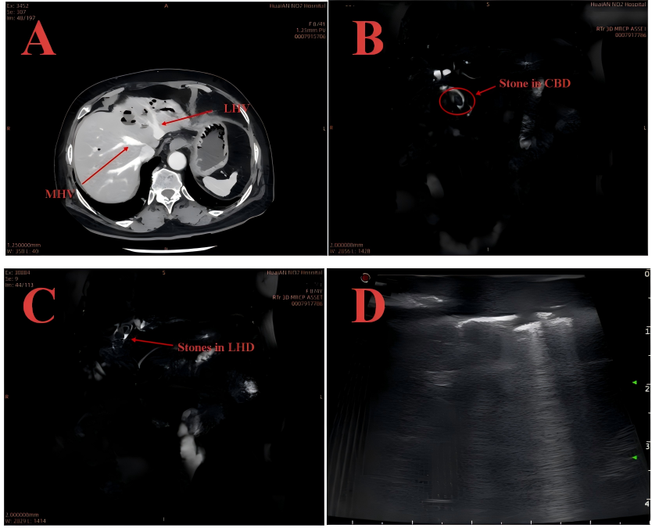
Figure S1 A. CT image showing atrophy of the left hepatic lobe. The left hepatic duct stones are poorly visualised within the atrophic parenchyma.
Figure S1 B. MRCP shows stone within the CBD.
Figure S1 C. MRCP shows stones within the LHD.
Figure S1 D. Real-time IOUS guidance for determining the transection plane.
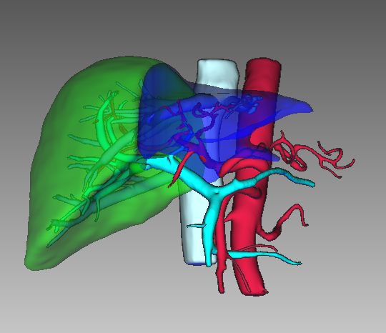
Figure S 2 . Preoperative imaging-based 3D visualisation for planned laparoscopic left hemihepatectomy.
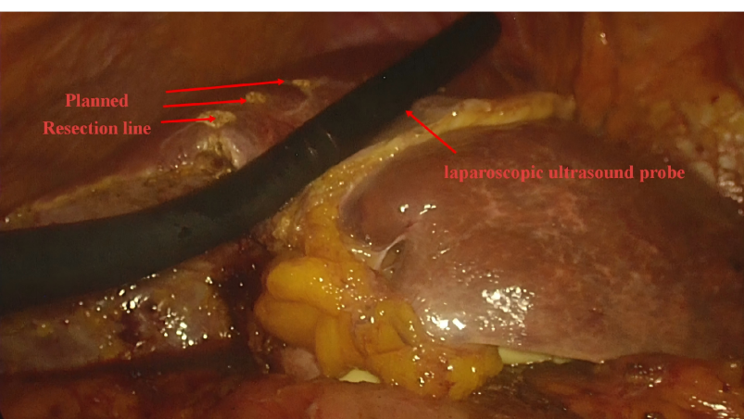
Figure S 3 . After dissecting the ligamentum teres, the transection plane was corrected under IOUS guidance.

