Supplementary Section

Effect of glucose and gentamicin on regulation of swarming motility and biofilm formation of Pseudomonas aeruginosa HRW.1-S3
Saurav Kumar Saha, Kritika Prasad and Tapas K Sengupta*
Department of Biological Sciences
Indian Institute of Science Education and Research Kolkata
Mohanpur, Nadia-741246, West Bengal, India
*Correspondence email: senguptk@iiserkol.ac.in; ORCID ID- 0000-0001-6482-914X

S1. Determination of Sub-Minimum Inhibitory Concentration of gentamicin against HRW.1-S3
To prepare seed cultures of Pseudomonas aeruginosa (PA) strains, bacterial cells were inoculated in BH medium and incubated at 37°C for 10–12 hours. After incubation, the cultures were adjusted to ensure a final concentration of 3 × 10⁶ CFU/mL in BH medium. Next, different concentrations of gentamicin were added to the culture in a tube. The tubes were incubated at 37°C with shaking at 150 rpm for 18 hours. The following day, bacterial growth was assessed by measuring the optical density (OD) at 600 nm using a Shimadzu spectrophotometer.
Figure S1

Fig. S1: Minimum inhibitory concentration of gentamicin against HRW.1-S3. Data are expressed as mean ± SEM from three independent experiments. Statistical significance is denoted as follows: * (P ≤ 0.05), ** (P ≤ 0.01), *** (P ≤ 0.001), and **** (P ≤ 0.0001), while 'ns' indicates non-significance
Result: Bacterial growth was found to be decreasing with the increasing concentration of gentamicin. The minimum inhibitory concentration of gentamicin against HRW.1-S3 was determined to be 3 µg/ml, as no visible growth was observed in this condition. For further studies of biofilm and swarming, two sub-MIC gentamicin concentrations, 0.75 µg/ml (MIC/4) and 1.5 µg/ml (MIC/2), were chosen.
S2. Biofilm load assay
The biofilm load assay was performed on a polystyrene-coated NUNC multi-dish 24-well plate (Thermo Scientific) by following the method described previously [1]. 3*10⁶CFU/mL of HRW.1-S were grown in the plates in the presence of differential glucose and gentamicin and incubated for 24 hours at 37 °C at 150 rpm. After discarding the planktonic cells, staining was done with 0.1% CV. The residual stain was removed, followed by a PBS wash. The plates were dried, and 1 mL of 30% (v/v) acetic acid was added to the wells to solubilize the stain. The absorbance was measured at 600 nm using Gene5 software on a plate reader (Biotek, Agilent, USA).
S3. EPS quantification
HRW.1-S3 swarming and biofilms were grown in BH with 0.25% and 0.5% glucose agar and media, respectively, in the presence and absence of gentamicin. For swarming, cells were scraped after day 7, resuspended in the PBS, and centrifuged at 11180g for 10 minutes. For biofilm, a PBS wash was given to remove planktonic cells. 1 mL of PBS was added, and the biofilms were scraped and centrifuged at 11,180g for 10 minutes. The supernatant from both conditions was then filtered through a 0.22 µm filter to remove any bacterial cells. Exoprotein was estimated using Bradford reagent, and absorbance was measured at 595 nm. The exopolysaccharide was measured using Anthrone reagent, and the absorbance was recorded at 625 nm. Extracellular lipid was measured using Nile Red, with excitation at 530 nm and emission at 580 nm. eDNA was measured using EtBr (1 µg/ml) with excitation at 254 nm and emission at 616 nm [1] .
S4. Reverse transcription-quantitative real-time polymerase chain reaction (RT-qPCR)
Real-time PCR was performed using a TB Green Premix ExTaq (Tli RNaseH Plus) kit (Takara, Japan). Briefly, 25ng of cDNA was added to a mix of 0.2 µl of both forward and reverse primers (concentration 10 µM) and 5 µl of 2X TB Green Premix ExTaq (RNase H Plus). The prepared mix was subjected to PCR reaction in a CFX96 Touch Real-time PCR Detection System (Bio-Rad Laboratories, Hercules, CA, USA). Primers for 16S rRNA, lasI, rhlB, fliA were used for gene expression study (Supplementary Table S1). All values were normalized to 16S rRNA. Data were analysed using the 2-ΔΔCt method to plot the graphs.
S5. Plasmid and strain construction
DNA manipulations were performed according to the protocol described by Hmelo et al [2]. Genomic DNA and plasmid DNA were isolated using the HiPurA Bacterial Genomic DNA and Plasmid DNA Miniprep Purification kit (Himedia, India), respectively. Briefly, 500 bp upstream and downstream regions of the lasI gene were amplified from the genomic DNA of Pseudomonas aeruginosa HRW.1-S3. Firstly, the upstream region (lasI_UP) was ligated into the EcoR1-Kpn1 site of the pEX18Tc vector, resulting in the formation of pEX18Tc:lasI_UP plasmid. The chloramphenicol cassette (cat) was amplified from the pbP-ORF using forward and reverse primers with KpnI and BamHI sites, respectively. The product was then ligated into the pEX18Tc:lasI_UP plasmid, resulting in the pEX18Tc:lasI_UP:cat plasmid. Lastly, the downstream region (lasI_DN) having BamH1 and HindIII restriction sites was finally ligated into the pEX18Tc:lasI_UP:cat plasmid, resulting in the formation of a tripartite complex pEX18Tc:lasI_UP:cat:lasI_DN having the upstream and downstream regions with chloramphenicol cassettes in between them. All the ligation reactions were performed using T4 DNA ligase (Takara, Japan) according to the manufacturer’s protocol. The vector was then mobilized from E. coli SM10λ (received as a kind gift from Prof. Partha Pratim Datta, Department of Biological Sciences, IISER Kolkata) into Pseudomonas aeruginosa through conjugational mating. The single-crossover colonies were obtained by plating them on LB+100 µg/mL Tetracycline. Double recombinants were further obtained by streaking them on LB+ sucrose plates. The mutant was grown by streaking on plates containing 20 µg/mL Chloramphenicol. The details of the primers and plasmids used are provided in Supplementary Tables S2 & S3, respectively.

Figure S2
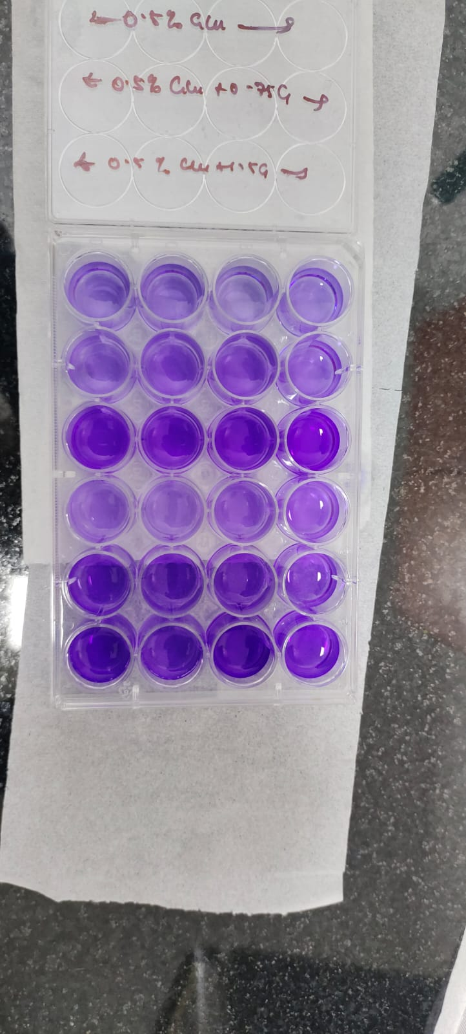
0.5% Glucose
0.5% Glucose +
0.75 µg/ml
Gentamicin
0.5%
Glucose +
1.5 µg/ml Gentamicin
0.25%
Glucose
0.25% Glucose +
0.75 µg/ml
Gentamicin
0.25% Glucose + 1.5 µg/ml Gentamicin

Fig. S2. Representative 24 well plate image of biofilm formation of HRW.1-S3 in presence of differential glucose and gentamicin

Figure S3
Fig. S3. Topological features of biofilm formed by HRW.1-S3 in the presence of glucose and gentamicin (a) Thickness, (b) Skewness, (c) Kurtosis; Data are expressed as mean ± SEM from three independent experiments. Statistical significance is denoted as follows: * (P ≤ 0.05), ** (P ≤ 0.01), *** (P ≤ 0.001), and **** (P ≤ 0.0001), while 'ns' indicates non-significance

Figure S4
Fig. S4. Representative AFM images of swarming cells of HRW.1-S3. N=3

S6. Rhamnolipid detection using the CTAB plate method
Rhamnolipid secretion under varying glucose (0.25% and 0.5%) and gentamicin (0.75 µg/ml and 1.5 µg/mL) was checked using the CTAB assay. CTAB agar was prepared by mixing CTAB (Himedia, India) and methylene blue (Himedia, India) at final concentrations of 0.2 mg/mL and 0.05mg/mL, respectively. After pouring the plates, holes were made in the solidified agar, and 100 µL of supernatant from different swarming conditions was loaded into them. The plates were incubated for 24-48 hours, and the presence of dark blue zones indicated the presence of rhamnolipids.
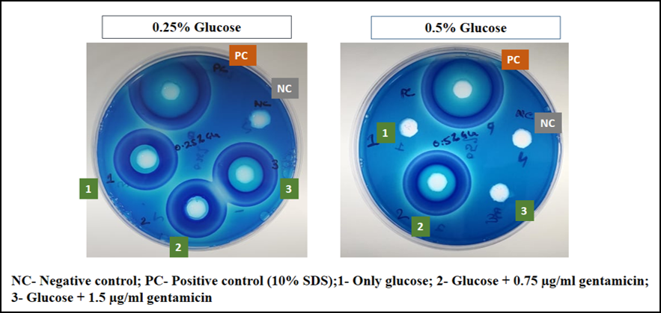
Figure S5

Fig. S5 Rhamnolipid detection of HRW.1-S3 swarming cells in the presence of differential glucose and gentamicin
Result:
The supernatant from the swarming cells was collected after day 7 and was used to check the presence of biosurfactant across different experimental conditions. It was observed that under swarming conditions, clear halo regions around the wells were evident, confirming the presence of rhamnolipids. The non- swarming conditions had no distinct halo regions present, suggesting the absence of rhamnolipids. The presence of rhamnolipids confirms their active role in the swarming of HRW.1-S3 across different experimental conditions.

Table S1. List of primers used for RT-qPCR study
Target gene | Primer sequences
16S | Forward Primer: 5’- ACACTGAGGTGCGAAAGCGTGG -3’  Reverse Primer: 5’- TCCCCAGGCGGTCGACTTATCG -3’
lasI | Forward Primer: 5’- TGGGCGAGATGCACAAGTTGC-3’  Reverse Primer: 5’- TCGCCAGCAACCGAAAACCTG -3’
fliA | Forward Primer: 5’- GCGCGACGCTAAAGATCACGAA -3’  Reverse Primer: 5’-CCGTGGATCGGTTCGTTGTGAC -3’
rhlB | Forward Primer: 5’-TGAGCGACGAACTGACCTACCG -3’  Reverse Primer: 5’-CGTACTTCTCGTGAGCGATGCG-3’

Table S2. Primer sequences used in PCR amplification for cloning.
Name | Forward Primer (5´-3´) | Reverse Primer (5´-3´)
lasI_UP | TACAGAATTCGGGAGATATCGGT | TCAGGTACCCTTCACTTCCTCC
lasI_DN | TTGGGATCCCGGGGACCTGT | ATAAAGCTTTCCGCAGGAGG
Cat | TAAGCAGGATCCCAAGCGAGCTCGATATCAAA | TGCTTAGGTACCTCAGGAGCTAAGGAAGCTAAAATG
pEX18Tc MCS | CGCCAGGGTTTTTCCCAGTCACGAC | AGCGGATAACAATTTCACACAGGA

Table S3. Plasmids used in this study
Name | Characteristics | Source
pEX18Tc | Suicide vector carrying sacB and tetracycline resistance | Novopro
pBP-ORF | Chloramphenicol cassette | Kind gift from Prof. Supratim Datta, IISER Kolkata

References
1. Kumar A, Saha SK, Banerjee P, et al (2023) Antibiotic-Induced Biofilm Formations in Pseudomonas aeruginosa Strains KPW.1-S1 and HRW.1-S3 are Associated with Increased Production of eDNA and Exoproteins, Increased ROS Generation, and Increased Cell Surface Hydrophobicity. Current Microbiology 2023 81:1 81:11-. https://doi.org/10.1007/S00284-023-03495-7
2. Hmelo LR, Borlee BR, Almblad H, et al (2015) Precision-engineering the Pseudomonas aeruginosa genome with two-step allelic exchange. Nat Protoc 10:1820–1841. https://doi.org/10.1038/NPROT.2015.115

