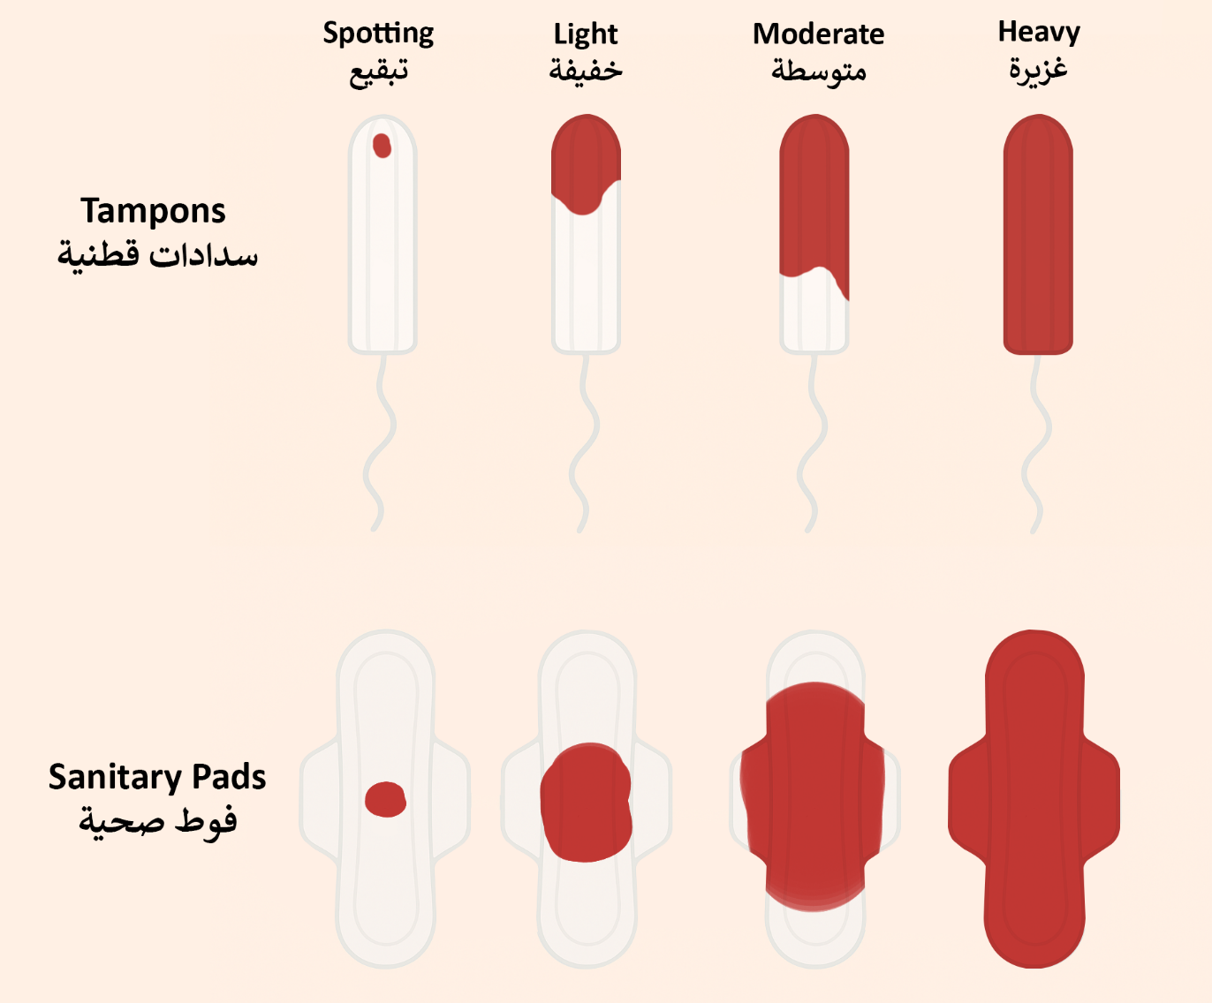
Supplementary Figure 1 – Diagram of Menstrual Flow Heaviness Categories

Supplementary Table 1 – Bivariate Analysis of Knowledge, Attitude, and Practice by Sociodemographics
 | Knowledge  Median (IQR) | p | Attitude  Median (IQR) | p | Practice  Median (IQR) | p
Age ¹ | -0.136 | 0.006 | -0.072 | 0.144 | -0.001 | 0.989
BMI ¹ | -0.066 | 0.177 | 0.009 | 0.860 | -0.026 | 0.596
Lebanese citizen
No | 0.00 (50.00) | 0.136 | 75.00 (20.00) | 0.284 | 46.88 (37.50) | 0.016
Yes | 25.00 (58.33) |  | 80.00 (20.00) |  | 53.12 (28.12)
Married
No | 33.33 (66.67) | <0.001 | 80.00 (25.00) | 0.116 | 53.12 (28.12) | 0.402
Yes | 8.33 (41.67) |  | 75.00 (25.00) |  | 53.12 (31.25)
Healthcare worker / student
No | 8.33 (41.67) | <0.001 | 75.00 (25.00) | <0.001 | 50.00 (31.25) | 0.001
Yes | 58.33 (50.00) |  | 85.00 (25.00) |  | 59.38 (25.00)
Governorate
Akkar | 4.17 (16.67) | 0.107 | 82.50 (45.00) | 0.570 | 43.75 (40.62) | 0.617
Beirut | 16.67 (50.00) |  | 80.00 (25.00) |  | 56.25 (28.12)
Beqaa | 33.33 (41.67) |  | 75.00 (20.00) |  | 56.25 (40.62)
Mount Lebanon | 33.33 (66.67) |  | 75.00 (25.00) |  | 53.12 (31.25)
Nabatiyeh | 33.33 (54.17) |  | 82.50 (17.50) |  | 46.88 (26.56)
North Lebanon | 33.33 (66.67) |  | 85.00 (25.00) |  | 59.38 (28.12)
South Lebanon | 8.33 (50.00) |  | 80.00 (30.00) |  | 50.00 (25.00)
I do not currently live in Lebanon | 8.33 (37.50) |  | 80.00 (25.00) |  | 51.56 (29.69)
Average monthly income
Less than 100$ | 16.67 (41.67) | 0.004 | 70.00 (37.50) | 0.275 | 57.81 (42.19) | 0.615
Between 100$ - 299$ | 0.00 (41.67) |  | 75.00 (20.00) |  | 50.00 (31.25)
Between 300$ - 599$ | 0.00 (50.00) |  | 75.00 (30.00) |  | 50.00 (28.12)
Between 600$ - 899$ | 33.33 (58.33) |  | 80.00 (20.00) |  | 56.25 (25.00)
Greater than 900$ | 33.33 (66.67) |  | 80.00 (25.00) |  | 53.12 (25.00)
Educational level
Primary education (elementary) | 0.00 (0.00) | 0.018 | 40.00 (0.00) | 0.111 | 75.00 (0.00) | 0.024
Secondary education (middle/high school) | 20.83 (58.33) |  | 75.00 (35.00) |  | 50.00 (31.25)
Higher vocational school (non-university degree) | 8.33 (41.67) |  | 75.00 (22.50) |  | 53.12 (31.25)
Bachelors or Master’s degree | 25.00 (58.33) |  | 80.00 (20.00) |  | 53.12 (28.12)
Post-graduate education | 50.00 (41.67) |  | 75.00 (20.00) |  | 65.62 (28.12)
IQR: Interquartile Range; ¹ spearman correlation coefficient

Supplementary Table 2 – Bivariate Analysis of Knowledge, Attitude, and Practice by Reproductive Characteristics
 | Knowledge  Median (IQR) | p | Attitude  Median (IQR) | p | Practice  Median (IQR) | p
Age at Menarche ¹ | -0.047 | 0.396 | 0.034 | 0.546 | 0.123 | 0.027
Average Menses Length (days) ¹ | 0.009 | 0.870 | 0.062 | 0.261 | -0.052 | 0.349
Average Cycle Length (days) ¹ | 0.107 | 0.053 | 0.114 | 0.040 | 0.072 | 0.193
Average menstrual pain severity ¹ | 0.132 | 0.017 | 0.083 | 0.134 | 0.022 | 0.697
Gravidity ¹ | -0.198 | <0.001 | -0.078 | 0.157 | -0.023 | 0.682
Parity ¹ | -0.177 | 0.001 | -0.044 | 0.424 | 0.004 | 0.946
Had an abortion
No | 25.00 (58.33) | 0.020 | 80.00 (25.00) | 0.016 | 53.12 (25.00) | 0.401
Yes | 8.33 (45.83) |  | 75.00 (32.50) |  | 50.00 (34.38)
Regular cycle
No | 16.67 (58.33) | 0.248 | 75.00 (30.00) | 0.250 | 53.12 (34.38) | 0.632
Yes | 25.00 (58.33) |  | 80.00 (20.00) |  | 53.12 (25.00)
Diagnosed with adenomyosis
No | 25.00 (58.33) | 0.075 | 75.00 (20.00) | 0.069 | 53.12 (28.12) | 0.001
Yes | 50.00 (33.33) |  | 90.00 (10.00) |  | 78.12 (18.75)
No one I personally know has been diagnosed with uterine adenomyosis
No | 50.00 (33.33) | <0.001 | 80.00 (25.00) | 0.260 | 62.50 (28.12) | 0.004
Yes | 16.67 (58.33) |  | 75.00 (20.00) |  | 53.12 (28.12)
Immediate family
No | 25.00 (58.33) | 0.012 | 75.00 (20.00) | 0.038 | 53.12 (28.12) | 0.001
Yes | 58.33 (41.67) |  | 90.00 (20.00) |  | 70.31 (25.00)
Extended family
No | 25.00 (58.33) | 0.058 | 75.00 (20.00) | 0.229 | 53.12 (31.25) | 0.164
Yes | 62.50 (37.50) |  | 87.50 (20.00) |  | 60.94 (28.12)
Friends
No | 25.00 (58.33) | 0.034 | 80.00 (20.00) | 0.789 | 53.12 (28.12) | 0.057
Yes | 41.67 (33.33) |  | 75.00 (20.00) |  | 59.38 (21.88)
I have not been diagnosed with any other gynaecological diseases
No | 25.00 (58.33) | 0.995 | 80.00 (20.00) | 0.665 | 56.25 (28.12) | 0.152
Yes | 25.00 (58.33) |  | 75.00 (25.00) |  | 53.12 (28.12)
Polycystic ovarian syndrome
No | 25.00 (58.33) | 0.837 | 80.00 (25.00) | 0.309 | 53.12 (28.12) | 0.456
Yes | 25.00 (58.33) |  | 75.00 (20.00) |  | 53.12 (28.12)
Endometriosis
No | 25.00 (58.33) | 0.097 | 75.00 (20.00) | 0.631 | 53.12 (28.12) | 0.003
Yes | 41.67 (37.50) |  | 85.00 (12.50) |  | 76.56 (21.88)
Leiomyomas (uterine fibroids)
No | 25.00 (58.33) | 0.667 | 80.00 (20.00) | 0.196 | 53.12 (31.25) | 0.707
Yes | 8.33 (50.00) |  | 75.00 (20.00) |  | 53.12 (28.12)
Malignant cancers (uterine, ovarian, endometrial, cervical, other…)
No | 25.00 (58.33) | 0.938 | 75.00 (20.00) | 0.038 | 53.12 (31.25) | 0.862
Yes | 33.33 (66.67) |  | 100.00 (0.00) |  | 54.69 (53.12)
Used oral contraceptive pills
No | 25.00 (54.17) | 0.193 | 80.00 (25.00) | 0.218 | 51.56 (28.12) | 0.133
Yes | 29.17 (58.33) |  | 75.00 (25.00) |  | 56.25 (25.00)
Dysmenorrhea
No | 16.67 (50.00) | 0.023 | 80.00 (25.00) | 0.268 | 50.00 (28.12) | 0.150
Yes | 33.33 (58.33) |  | 75.00 (25.00) |  | 56.25 (28.12)
Dyspareunia
No | 25.00 (58.33) | 0.730 | 75.00 (20.00) | 0.771 | 53.12 (28.12) | 0.073
Yes | 16.67 (66.67) |  | 80.00 (30.00) |  | 62.50 (31.25)
Dyschezia
No | 25.00 (58.33) | 0.235 | 75.00 (20.00) | 0.966 | 53.12 (28.12) | 0.065
Yes | 33.33 (66.67) |  | 80.00 (20.00) |  | 59.38 (28.12)
Pelvic heaviness
No | 25.00 (58.33) | 0.191 | 75.00 (20.00) | 0.091 | 50.00 (31.25) | 0.081
Yes | 33.33 (66.67) |  | 85.00 (20.00) |  | 56.25 (21.88)
Bleeding between periods
No | 25.00 (58.33) | 0.029 | 75.00 (20.00) | 0.661 | 53.12 (28.12) | 0.001
Yes | 45.83 (33.33) |  | 80.00 (15.00) |  | 71.88 (28.12)
Uterine tenderness
No | 25.00 (58.33) | 0.302 | 75.00 (20.00) | 0.115 | 53.12 (28.12) | 0.204
Yes | 33.33 (58.33) |  | 85.00 (15.00) |  | 59.38 (40.62)
Infertility
No | 25.00 (58.33) | 0.402 | 75.00 (20.00) | 0.653 | 53.12 (31.25) | 0.523
Yes | 54.17 (37.50) |  | 82.50 (15.00) |  | 57.81 (26.56)
Lightest menstrual flow
Spotting | 16.67 (58.33) | 0.352 | 80.00 (20.00) | 0.346 | 46.88 (29.69) | 0.038
Light | 25.00 (58.33) |  | 80.00 (25.00) |  | 53.12 (28.12)
Moderate | 33.33 (58.33) |  | 75.00 (30.00) |  | 53.12 (26.56)
Heavy | 50.00 (50.00) |  | 82.50 (12.50) |  | 76.56 (29.69)
Heaviest menstrual flow
Light | 29.17 (62.50) | 0.982 | 75.00 (30.00) | 0.309 | 62.50 (23.44) | 0.194
Moderate | 25.00 (58.33) |  | 75.00 (25.00) |  | 50.00 (31.25)
Heavy | 25.00 (58.33) |  | 80.00 (25.00) |  | 53.12 (28.12)
Subjective knowledge of gynaecological topics
Almost no knowledge | 0.00 (16.67) | <0.001 | 75.00 (30.00) | 0.001 | 46.88 (34.38) | <0.001
Very little knowledge | 8.33 (33.33) |  | 75.00 (20.00) |  | 46.88 (28.13)
Basic knowledge | 41.67 (58.33) |  | 80.00 (25.00) |  | 59.38 (28.13)
Well-versed in gynaecological topics | 58.33 (25.00) |  | 85.00 (20.00) |  | 62.50 (18.75)
IQR: Interquartile Range; ¹ spearman correlation coefficient

Supplementary Table 3 – Multinominal Categorical Regression for Confidently Giving Correct or False Answers Compared to “I Don’t Know”
Outcome | Coef. | St.Err. | t-value | p-value | [95% Conf  Interval]
Incorrect Answer (Reference: “I don’t know”)
Age | .995 | .022 | -0.24 | .812 | .953 | 1.038
Body mass index (kg/m2) | 1.015 | .021 | 0.73 | .468 | .975 | 1.056
Lebanese citizen : base no | 1 | . | . | . | . | .
Yes | 1.229 | .423 | 0.60 | .549 | .626 | 2.412
Married : base no | 1 | . | . | . | . | .
Yes | .646 | .229 | -1.23 | .219 | .323 | 1.295
Average monthly income : base Less than 100$ | 1 | . | . | . | . | .
Between 100$ - 299$ | 1.264 | .724 | 0.41 | .683 | .411 | 3.884
Between 300$ - 599$ | .954 | .498 | -0.09 | .929 | .343 | 2.652
Between 600$ - 899$ | 2.144 | 1.064 | 1.54 | .124 | .811 | 5.67
Greater than 900$ | 1.758 | .843 | 1.18 | .24 | .686 | 4.502
Educational level : base High school or lower | 1 | . | . | . | . | .
Higher vocational school (non-university degree) | .519 | .209 | -1.63 | .104 | .235 | 1.144
Bachelor's or Master's degree | .921 | .254 | -0.30 | .766 | .536 | 1.583
Post-graduate education | .665 | .309 | -0.88 | .381 | .267 | 1.656
Healthcare Worker : base no | 1 | . | . | . | . | .
Yes | 1.803* | .427 | 2.49 | .013 | 1.133 | 2.869
Average menstrual pain severity | 1.018 | .041 | 0.44 | .662 | .94 | 1.102
Diagnosed with adenomyosis : base no | 1 | . | . | . | . | .
Yes | 1.749 | .919 | 1.06 | .287 | .625 | 4.897
No one I personally know has been diagnosed with uterine adenomyosis : base no | 1 | . | . | . | . | .
Yes | .384** | .124 | -2.96 | .003 | .204 | .724
Gravidity | 1.127 | .156 | 0.86 | .389 | .859 | 1.477
Had an abortion : base no | 1 | . | . | . | . | .
Yes | .557 | .205 | -1.59 | .112 | .271 | 1.146
Used oral contraceptive pills : base no | 1 | . | . | . | . | .
Yes | 1.083 | .232 | 0.37 | .711 | .711 | 1.648
Pelvic heaviness : base no | 1 | . | . | . | . | .
Yes | .787 | .205 | -0.92 | .356 | .473 | 1.309
Bleeding between periods : base no | 1 | . | . | . | . | .
Yes | 1.576 | .646 | 1.11 | .267 | .706 | 3.518
Subjective knowledge : base almost no knowledge | 1 | . | . | . | . | .
Very little knowledge | 2.749* | 1.132 | 2.45 | .014 | 1.226 | 6.161
Basic knowledge | 5.878*** | 2.444 | 4.26 | 0 | 2.601 | 13.28
Well versed | 10.503*** | 5.082 | 4.86 | 0 | 4.069 | 27.115
Dysmenorrhea : base no | 1 | . | . | . | . | .
Yes | .864 | .188 | -0.67 | .501 | .563 | 1.324
Constant | .045*** | .042 | -3.34 | .001 | .007 | .278
Correct Answer (Reference: “I don’t know”)
Age | .996 | .02 | -0.18 | .857 | .959 | 1.036
Body mass index (kg/m2) | 1.003 | .019 | 0.15 | .878 | .966 | 1.041
Lebanese citizen : base no | 1 | . | . | . | . | .
Yes | 1.551 | .49 | 1.39 | .165 | .835 | 2.883
Married : base no | 1 | . | . | . | . | .
Yes | .737 | .221 | -1.02 | .309 | .41 | 1.327
Average monthly income : base Less than 100$ | 1 | . | . | . | . | .
Between 100$ - 299$ | .855 | .488 | -0.27 | .784 | .279 | 2.618
Between 300$ - 599$ | .909 | .468 | -0.19 | .853 | .332 | 2.491
Between 600$ - 899$ | 1.596 | .794 | 0.94 | .347 | .602 | 4.233
Greater than 900$ | 1.585 | .774 | 0.94 | .346 | .608 | 4.13
Educational level : base High school or lower | 1 | . | . | . | . | .
Higher vocational school (non-university degree) | .628 | .231 | -1.26 | .207 | .305 | 1.293
Bachelor's or Master's degree | .846 | .212 | -0.67 | .505 | .518 | 1.383
Post-graduate education | .762 | .334 | -0.62 | .535 | .322 | 1.801
Healthcare Worker : base no | 1 | . | . | . | . | .
Yes | 1.926** | .428 | 2.95 | .003 | 1.247 | 2.976
Average menstrual pain severity | 1.037 | .037 | 1.02 | .309 | .967 | 1.113
Diagnosed with adenomyosis : base no | 1 | . | . | . | . | .
Yes | 1.305 | .611 | 0.57 | .57 | .521 | 3.265
No one I personally know has been diagnosed with uterine adenomyosis : base no | 1 | . | . | . | . | .
Yes | .436** | .125 | -2.90 | .004 | .249 | .763
Gravidity | .987 | .118 | -0.11 | .911 | .781 | 1.247
Had an abortion : base no | 1 | . | . | . | . | .
Yes | 1.076 | .355 | 0.22 | .825 | .563 | 2.055
Used oral contraceptive pills : base no | 1 | . | . | . | . | .
Yes | 1.138 | .228 | 0.65 | .518 | .769 | 1.685
Pelvic heaviness : base no | 1 | . | . | . | . | .
Yes | .766 | .188 | -1.09 | .276 | .474 | 1.238
Bleeding between periods : base no | 1 | . | . | . | . | .
Yes | 1.106 | .376 | 0.30 | .767 | .568 | 2.155
Subjective knowledge : base almost no knowledge | 1 | . | . | . | . | .
Very little knowledge | 1.587 | .509 | 1.44 | .15 | .846 | 2.978
Basic knowledge | 3.917*** | 1.296 | 4.13 | 0 | 2.047 | 7.492
Well versed | 7.713*** | 3.156 | 4.99 | 0 | 3.458 | 17.2
Dysmenorrhea : base no | 1 | . | . | . | . | .
Yes | 1.067 | .205 | 0.34 | .737 | .732 | 1.556
Constant | .184 | .16 | -1.95 | .051 | .034 | 1.006
*** p < .001; ** p < .01, * p < 0.05

