Supplementary information

Integrated phytochemical profiling and computational analysis identify anabsinthin as a promising sesquiterpene lactone targeting coronavirus main protease (Mpro/3CLpro)

Salma Loukman ¹, Salaheddine El Hadad ¹, Fatim Ezahra Mesrar ¹, Aicha Talha ¹, Hamza Tachallait ¹, Reda Benmrid ², Najat Bouchmaa², Rachid Daoud ¹, Rachid El Fatimy ², Rachid Benhida * ^{1,3}

¹ College of Chemical Sciences and Engineering (CCSE), Department of Chemical and Biochemical Sciences - Green Process Engineering (CBS-GPE), Mohammed VI Polytechnic University (UM6P), Ben Guerir 43150, Morocco.
² Faculty of Medical Sciences, UM6P Hospitals, Mohammed VI Polytechnic University, Benguerir. 43150, Morocco.
³ Nice Institute of Chemistry. University Côte d’Azur, Nice, France.
* Corresponding authors.
E-mail addresses: Rachid.BENHIDA@um6p.ma

- Supplementary experimental procedures

S1.1. General information and apparatus
All solvents used for extraction, cleanup, and chromatographic purification were of analytical or HPLC grade and were used without further purification unless otherwise stated. Dried extracts and purified fractions were protected from light and stored in closed glass vials until analysis. Solvent removal was carried out under reduced pressure using a rotary evaporator at temperatures not exceeding 40 °C to minimize thermal degradation of thermolabile phytochemicals.
Ultrasound-assisted extraction was performed using a probe-type ultrasonic processor Vibra-Cell™ (Sonics & Materials, USA), equipped with a titanium sonotrode and placed inside an acoustic enclosure. The system operated at a fixed ultrasonic frequency of 20 kHz and a nominal power of 400 W. During extraction, the ultrasonic probe was directly immersed into the plant material–solvent suspension and maintained below the liquid surface without touching the vessel walls or bottom, allowing efficient acoustic cavitation and mass transfer enhancement.

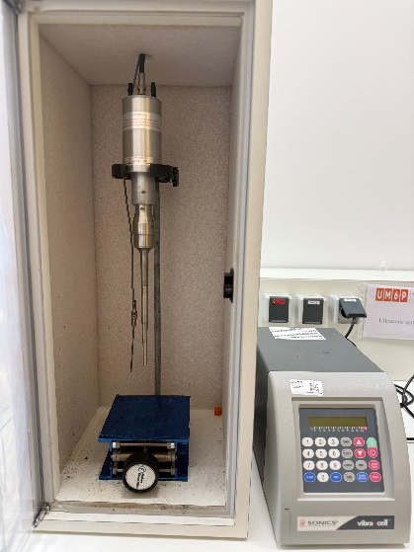
Figure S1. Probe-type ultrasonic processor used for ultrasound-assisted extraction.

S1.2. Detailed ultrasound-assisted extraction procedure and work-up
For each experimental run, the required amount of dried and powdered aerial parts of Artemisia absinthium L. was introduced into a glass extraction vessel. Ethanol or hexane was then added according to the solid-to-liquid ratio defined in the experimental design. The solvent volume was adjusted using the following equation:
V = m / R
where V is the solvent volume in mL, m is the mass of dried plant powder in g, and R is the solid-to-liquid ratio in g/mL
Most experiments were performed using 500 mg of plant powder, while the low solid-to-liquid ratio axial experiments were carried out using 250 mg of plant powder to keep a suitable extraction volume. The suspension was manually homogenized before sonication. Ultrasound-assisted extraction was then performed at room temperature according to the sonication time specified in the response surface design. After sonication, the suspension was transferred into centrifuge tubes and centrifuged at 3000 rpm and 10 °C for 10 min. The supernatant was collected, and the remaining plant residue was subjected to a second centrifugation under the same conditions. The combined supernatants were filtered and concentrated under reduced pressure at 40 °C to afford the corresponding dried extracts.
The extraction yield was calculated according to the following equation:
Extraction yield (%) = (mass of dried extract / initial mass of dried plant powder) × 100
All dried extracts were stored in closed amber glass vials protected from light until further GC-MS, LC-MS, and purification analyses.
- Ultrasound-assisted extraction optimization of Artemisia absinthium

The ultrasound-assisted extraction of Artemisia absinthium L. was optimized using response surface methodology. Three variables were investigated: sonication time, solid-to-liquid ratio, and solvent type. Sonication time and solid-to-liquid ratio were considered as numerical factors, whereas solvent type was considered as a categorical factor. The experimental design consisted of 28 runs organized in two blocks. The extraction yield was used as the response variable.
The complete experimental matrix and the corresponding extraction yields are presented in Table S1.

Table S1. Box–Behnken design matrix and experimental results for ultrasound-assisted extraction optimization of Artemisia absinthium L

Run | A: Time (min) | B: Solid-to-liquid ratio (g/mL) | C: Solvent | Yield (%)
1 | 2.6 | 0.02 | EtOH | 10.1
2 | 2.6 | 0.04 | EtOH | 14.26
3 | 7.8 | 0.03 | EtOH | 15.01
4 | 13.0 | 0.04 | EtOH | 17.4
5 | 7.8 | 0.03 | EtOH | 16.6
6 | 7.8 | 0.03 | EtOH | 17.82
7 | 2.6 | 0.04 | Hexane | 1.5
8 | 13.0 | 0.04 | Hexane | 3.36
9 | 13.0 | 0.02 | EtOH | 13.0
10 | 13.0 | 0.02 | Hexane | 5.6
11 | 7.8 | 0.03 | Hexane | 3.44
12 | 7.8 | 0.03 | Hexane | 2.5
13 | 7.8 | 0.03 | Hexane | 2.3
14 | 2.6 | 0.02 | Hexane | 2.26
15 | 7.8 | 0.0158579 | EtOH | 9.4
16 | 7.8 | 0.03 | EtOH | 16.16
17 | 7.8 | 0.0441421 | EtOH | 18.34
18 | 7.8 | 0.03 | Hexane | 4.84
19 | 7.8 | 0.0441421 | Hexane | 7.06
20 | 15.1539 | 0.03 | Hexane | 5.1
21 | 7.8 | 0.03 | Hexane | 8.44
22 | 0.446089 | 0.03 | Hexane | 8.96
23 | 0.446089 | 0.03 | EtOH | 16.64
24 | 7.8 | 0.0158579 | Hexane | 1.36
25 | 7.8 | 0.03 | EtOH | 19.44
26 | 7.8 | 0.03 | Hexane | 7.22
27 | 7.8 | 0.03 | EtOH | 18.68
28 | 15.1539 | 0.03 | EtOH | 16.89

S2.1. Statistical analysis of the extraction yield
The experimental extraction yields were fitted using a quadratic response surface model. The significance of the model and of the individual terms was evaluated by analysis of variance. The ANOVA results are summarized in Table S2.

Table S2. ANOVA for the quadratic response surface model of extraction yield

Source | Sum of Squares | df | Mean Square | F-value | p-value
Block | 39.79 | 1 | 39.79 | – | –
Model | 965.19 | 8 | 120.65 | 31.25 | < 0.0001
A: Time | 2.35 | 1 | 2.35 | 0.6093 | 0.4452
B: Solid-liquid ratio | 43.11 | 1 | 43.11 | 11.17 | 0.0036
C: Solvent | 866.92 | 1 | 866.92 | 224.56 | < 0.0001
AB | 0.1922 | 1 | 0.1922 | 0.0498 | 0.8259
AC | 2.77 | 1 | 2.77 | 0.7165 | 0.4084
BC | 16.29 | 1 | 16.29 | 4.22 | 0.0548
A² | 0.0909 | 1 | 0.0909 | 0.0235 | 0.8798
B² | 33.55 | 1 | 33.55 | 8.69 | 0.0086
Residual | 69.49 | 18 | 3.86 | – | –
Lack of Fit | 52.18 | 10 | 5.22 | 2.41 | 0.1126
Pure Error | 17.31 | 8 | 2.16 | – | –
Cor Total | 1074.48 | 27 | – | – | –
R² | 0.9328
Adjusted R² | 0.9030
Predicted R² | 0.7962

The model showed a significant fit to the experimental data, with an R² value of 0.9328, an adjusted R² of 0.9030, and a predicted R² of 0.7962. The lack of fit was not significant, indicating that the model adequately described the experimental response within the investigated domain.

S2.2. Model equations
The fitted model equations used for extraction yield prediction are given in Table S3.

Table S3. Model equations for extraction yield prediction.

Equation Type | Form
Coded | Yield = 11.04 + 0.3834A + 1.64B + 5.56C – 0.1550AB + 0.4158AC + 1.01BC – 0.0784A² – 1.51B²
Actual (Hexane) | Yield = –10.81480 + 0.128453×Time + 990.82522×Ratio – 2.98077×Time×Ratio – 0.002901×Time² – 15071.875×Ratio²
Actual (EtOH) | Yield = –6.98683 + 0.288367×Time + 1192.60087×Ratio – 2.98077×Time×Ratio – 0.002901×Time² – 15071.875×Ratio²

Where A = sonication time (coded), B = solid-liquid ratio (coded), C = solvent type (coded: –1 for hexane, +1 for ethanol).

- GC-MS Profiling

GC-MS analyses were carried out on the ethanolic and hexane extracts obtained from Artemisia absinthium L. to compare their volatile and semi-volatile phytochemical profiles. Representative GC-MS chromatograms of the ethanolic and hexane extracts are shown in Figures S1 and S2, respectively. The complete GC-MS compound reports, including peak lists, retention times, mass spectra, and library matching results, are provided as separate supplementary spectral files: Supplementary File S1A (chromatogram of the ethanolic extract of Artemisia absinthium L.) and Supplementary File S1B (chromatogram of the hexane extract of Artemisia absinthium L.)

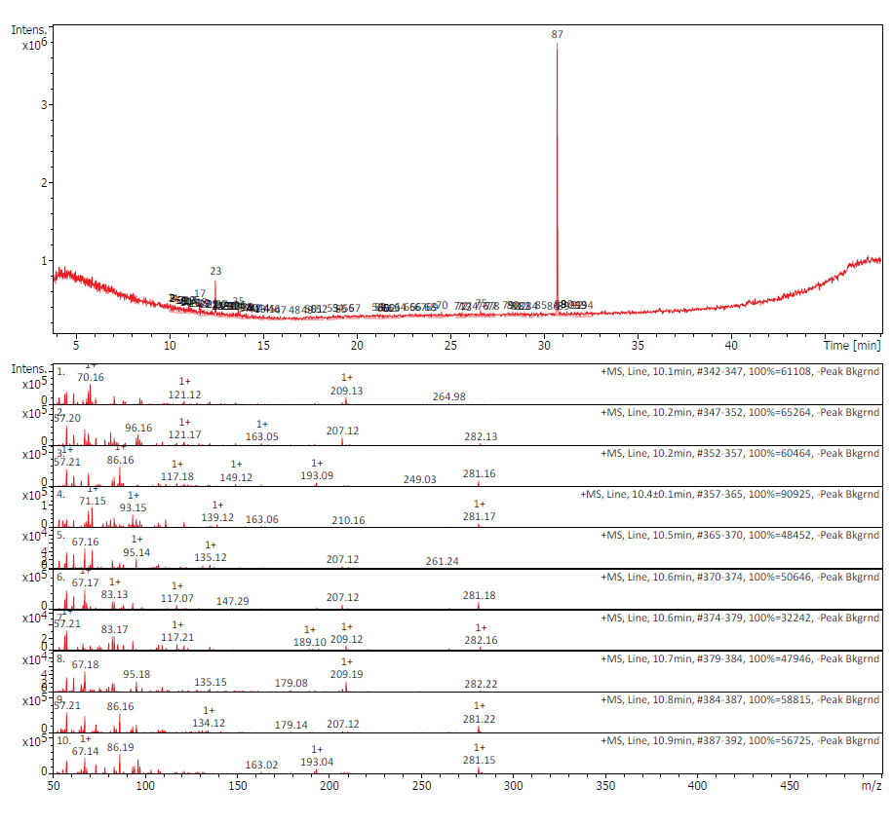
Figure S1. GC-MS chromatogram of the ethanolic extract of Artemisia absinthium L

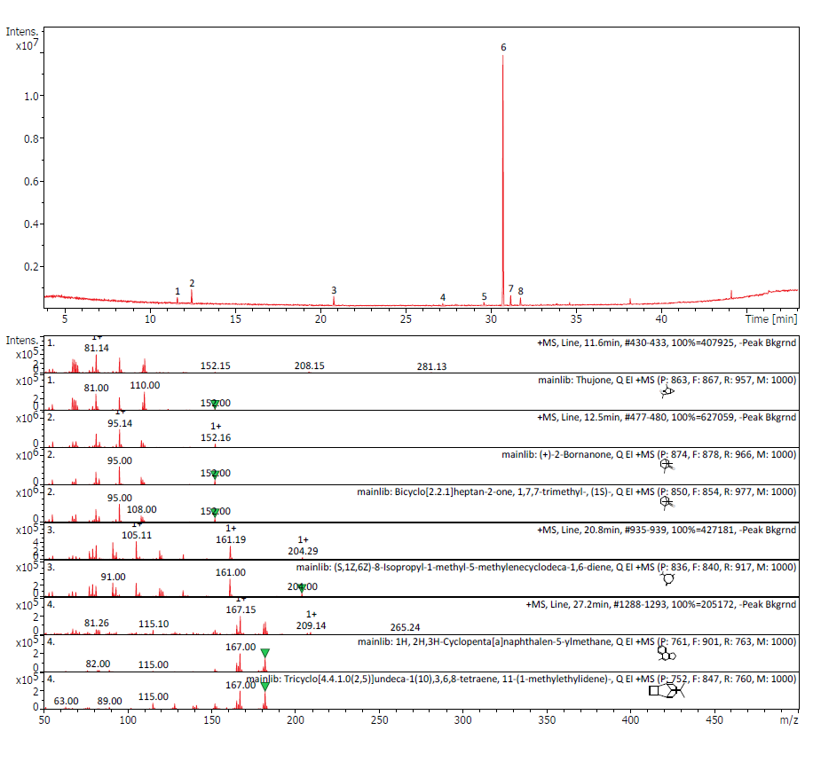
Figure S2. GC-MS chromatogram of the hexane extract of Artemisia absinthium L

4. LC-MS profiling

LC-MS profiling was performed on the ethanolic and hexane extracts of Artemisia absinthium L. to support the dereplication of major non-volatile metabolites. Data were acquired in both positive and negative ionization modes. Tentative metabolite assignments were based on retention behaviour, MS signals, and comparison with literature data and peer-reviewed phytochemical databases. The complete LC-MS compound reports, including retention times, detected ions, mass spectra, and tentative metabolite annotations, are provided as separate supplementary spectral files: Supplementary File S2A (report of the ethanolic extract of Artemisia absinthium L) and Supplementary File S2B (report of the hexane extract of Artemisia absinthium L).

5. Cleanup, preparative purification, and LC-MS-based identification of absinthin and anabsinthin
S5.1. Cleanup of the optimized ethanolic extract
The ethanolic extract obtained under the optimized ultrasound-assisted extraction conditions was selected for targeted purification. After solvent evaporation under reduced pressure at 40 °C, the crude residue was dissolved in ethyl acetate and washed twice with brine to remove highly polar impurities. The organic phase was recovered and subjected to a QuEChERS-based dispersive solid-phase extraction cleanup.
Anhydrous MgSO₄ and a silica-based sorbent mixture composed of PSA/C18 were added to the organic phase. The mixture was vortexed for 1 min and centrifuged at 3000 rpm and 10 °C for 10 min. The clarified supernatant was collected, filtered, and concentrated under reduced pressure at 40 °C to afford the cleaned extract used for preparative HPLC fractionation.

S5.2. Preparative HPLC fractionation
Preparative fractionation of the cleaned ethanolic extract was performed using a BÜCHI Pure system operated in preparative HPLC mode and equipped with a C18 column. The mobile phase consisted of water and acetonitrile, both containing 0.1% formic acid. Elution was performed using a water/acetonitrile gradient. Fractions were monitored by UV and ELSD detection, and major peaks were automatically collected.
Collected fractions were concentrated under reduced pressure, dried, and analysed by LC-MS. Fractions showing LC-MS features consistent with absinthin- and anabsinthin-related sesquiterpene lactones were selected for further dereplication and characterization.
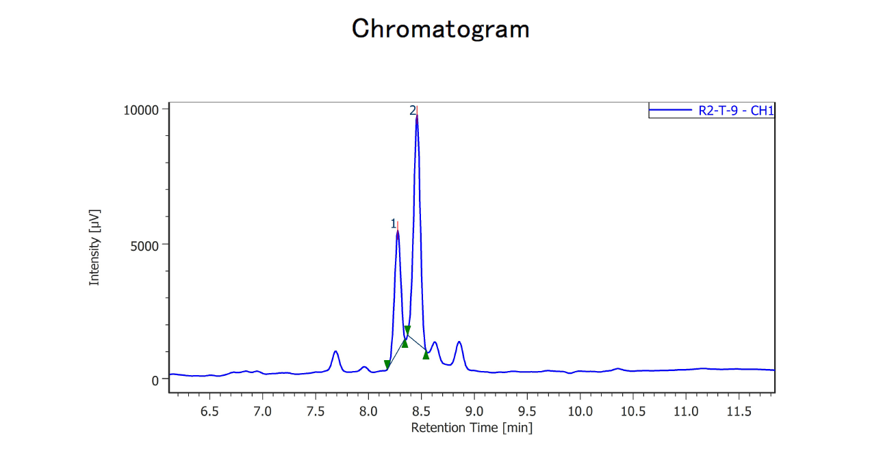
Figure S5. Chromatogram of the cleaned ethanolic extract of Artemisia absinthium L
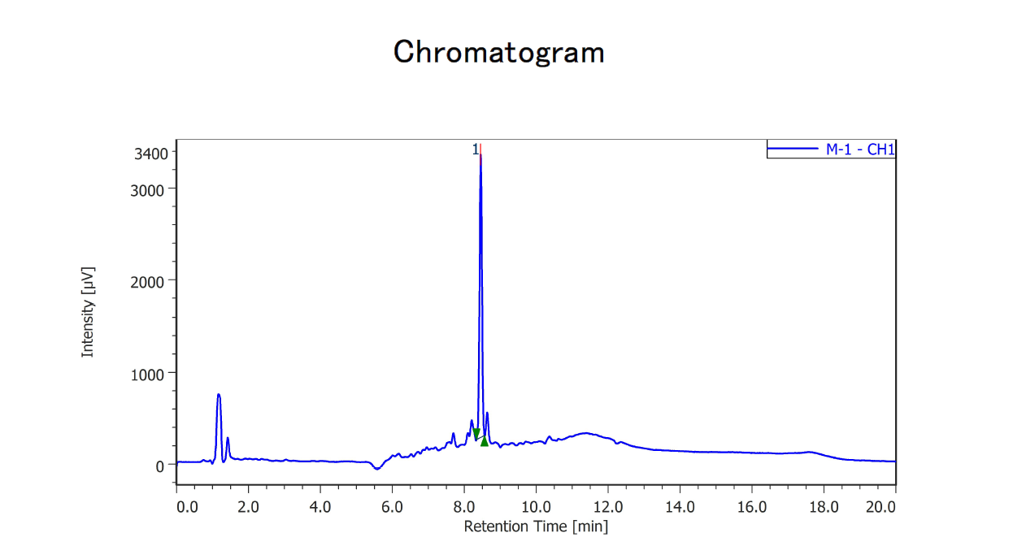
Figure S6. Chromatogram of the purified fraction obtained from the cleaned ethanolic extract of Artemisia absinthium L

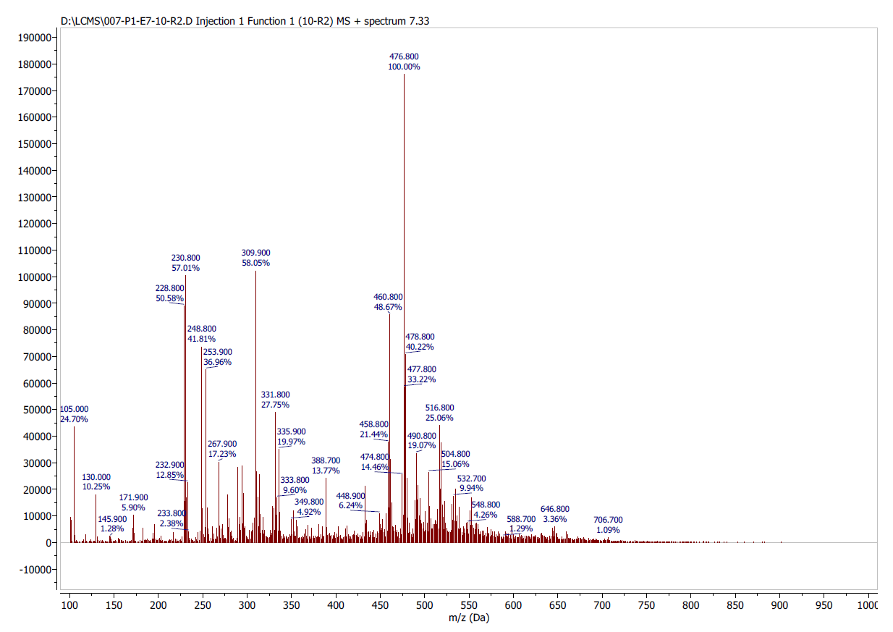
Figure S7. LC-MS report of the purified fraction obtained after the second purification round

