Eichhornia crassipes management in a eutrophic reservoir: Cover reduction, rapid recolonization, and cyanobacterial dynamics

Supplementary Material

S1. Random Forest model performance
The Random Forest models were built for ecological attribution rather than prediction, following the interpretable machine-learning framework common in water-quality studies (Hasani et al., 2024; Park et al., 2022). To characterize their explanatory capacity, we report out-of-bag (OOB) R², root-mean-square error (RMSE) and mean absolute error (MAE) for each response and station (Table S1). Out-of-bag prediction uses, for each observation, only the trees that did not include it during training, providing an internal generalization estimate without a separate hold-out set.
Explanatory capacity varied systematically with the response variable rather than with the station. Cyanobacterial density was the only response modelled with positive skill at all three stations (R²_OOB = 0.45, 0.05 and 0.27 at BP075, BP081 and BP085), whereas chlorophyll-a was captured at the upstream stations (0.28 and 0.27) but not downstream (0.06), and RCCa showed low or negative R²_OOB throughout (−0.25 to 0.13). This ordering is consistent with the station signatures in the descriptive data (Figure 1b): the upstream stations are defined by strong, structured gradients in nutrients and organic load, which the chlorophyll-a models could exploit, whereas at the reservoir outlet the cyanobacterial fraction — the response most strongly associated with macrophyte cover — carried the clearest signal. The failure of the RCCa models may reflects its construction: as a ratio of cyanobacterial density to chlorophyll-a, inflating its variance and preventing reliable generalization (Shi et al., 2015).
The SHAP summaries for chlorophyll-a and RCCa are provided to document the internal association structure of those models, not to support predictive claims.
Table S1. Out-of-bag performance of the station specific Random Forest models. RMSE and MAE are expressed in the units of each response. Cyanobacterial density was log₁₀ transformed; chlorophyll-a and RCCa were untransformed.
Response | Station | n | R²(OOB) | RMSE | MAE | Units
Cyanobacteria | BP075 | 71 | 0.45 | 0.94 | 0.71 | log₁₀ cells mL⁻¹
Cyanobacteria | BP081 | 69 | 0.05 | 1.02 | 0.75 | log₁₀ cells mL⁻¹
Cyanobacteria | BP085 | 69 | 0.27 | 0.78 | 0.62 | log₁₀ cells mL⁻¹
Chlorophyll-a | BP075 | 80 | 0.28 | 49.4 | 33.0 | µg L⁻¹
Chlorophyll-a | BP081 | 80 | 0.27 | 9.75 | 4.56 | µg L⁻¹
Chlorophyll-a | BP085 | 73 | 0.06 | 18.8 | 11.6 | µg L⁻¹
RCCa | BP075 | 78 | −0.02 | 2355 | 1234 | dimensionless
RCCa | BP081 | 78 | −0.25 | 31430 | 9675 | dimensionless
RCCa | BP085 | 73 | 0.13 | 6219 | 3392 | dimensionless

S2. Station wise Spearman correlations
Before the multivariate analysis, Spearman rank correlations were computed between each water quality predictor and the three phytoplankton responses at each station (Figure S1). Upstream, phytoplankton metrics were associated mainly with nutrient, organic load and physical descriptors, and all cyanobacterial associations were weak (|ρ| ≤ 0.34). At BP081, the station with the strongest sewage signature, both cyanobacterial density and chlorophyll-a correlated positively with total phosphorus and ammoniacal nitrogen, consistent with the well established role of nitrogen and phosphorus supply in Eichhornia crassipes dominated, eutrophic systems (Reddy et al., 1989, 1990); chlorophyll-a additionally followed a coherent organic load signal (chemical and biochemical oxygen demand). At BP075 the associations were fewer and less structured. The weak absolute strength of the cyanobacterial correlations is itself consistent with the multi factor control of bloom formation, in which no single variable dominates (Izydorczyk et al., 2009).
Downstream, at BP085, macrophyte cover became the distinguishing correlate, negatively associated with cyanobacterial density (ρ = −0.45) and with cyanobacterial dominance (RCCa, ρ = −0.53) but not with chlorophyll-a. This selective association, with the cyanobacterial fraction rather than with total phytoplankton biomass, is consistent with evidence that dense macrophyte stands restructure phytoplankton communities through shading, nutrient competition and allelopathy rather than uniformly reducing biomass (Cui et al., 2025; Körner & Nicklisch, 2002; Mowe et al., 2019). True color was the strongest single correlate of both cyanobacterial density (ρ = −0.55) and RCCa (ρ = −0.59), and was itself positively correlated with macrophyte cover (ρ = +0.53, p < 0.001). The two are therefore not independent predictors but likely index a common pathway, whereby colored dissolved organic matter released by dense and senescing floating mats links mat dynamics to the optical and chemical state of the water column (Kröger et al., 2007).
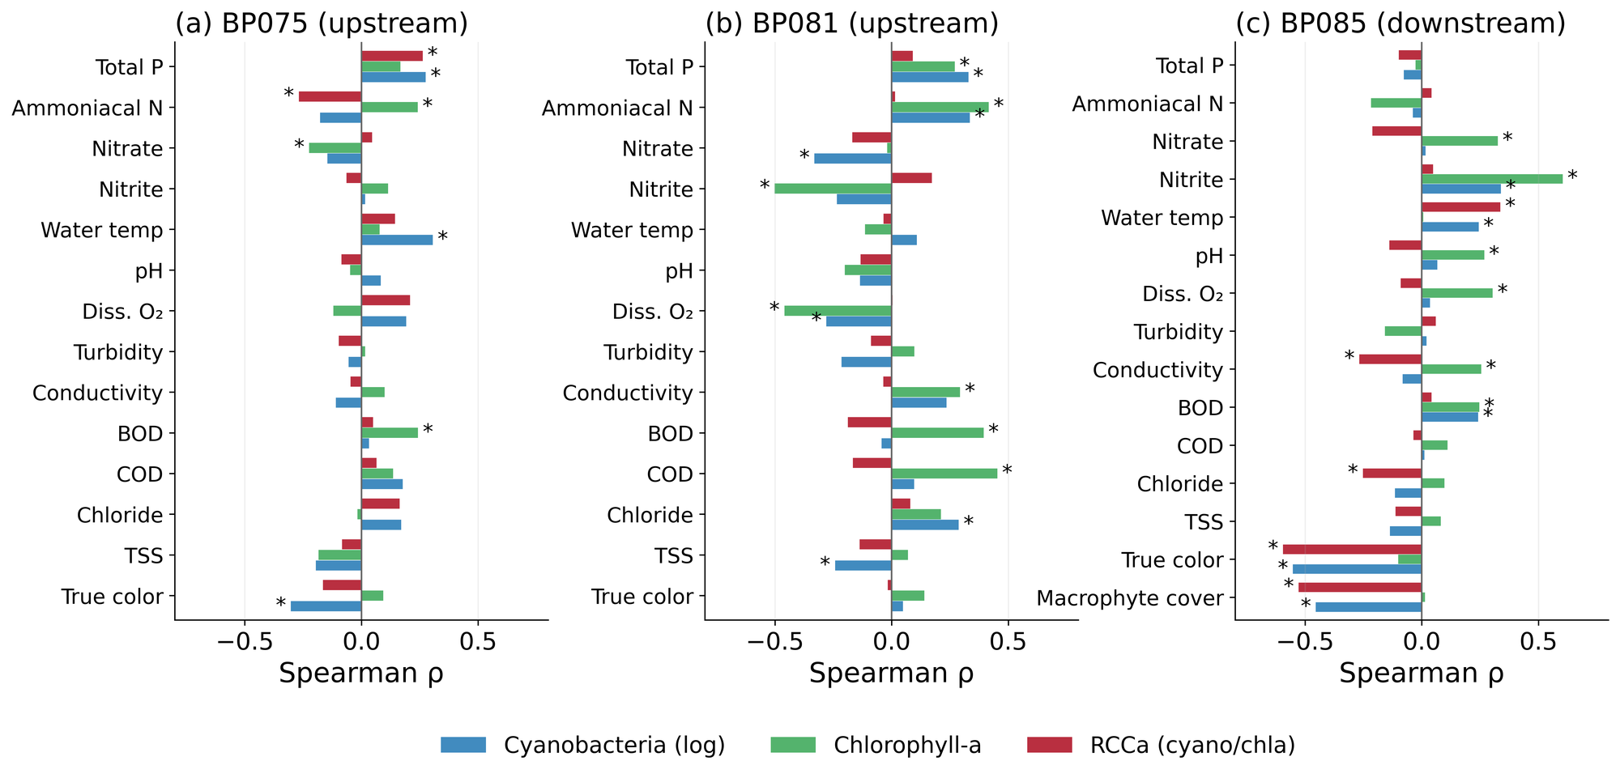
Figure S1. Spearman rank correlations between water-quality predictors and cyanobacterial density (log₁₀), chlorophyll-a and the RCCa index, per station. Macrophyte cover was included only at BP085, where floating mats occur within the reservoir. Asterisks indicate statistically significant correlations (p < 0.05).

References
Cui, Z., Yang, C., Ma, L., Gu, X., Shen, X., Wan, B., Tao, Y., Sang, Y., & Huang, Q. (2025). Floating-leaved and submerged macrophytes suppress filamentous cyanobacteria blooms and 2-MIB episodes in eutrophic shallow lakes. Journal of Hazardous Materials, 492(January), 138163. https://doi.org/10.1016/j.jhazmat.2025.138163
Hasani, S., Arias, M. E., Nguyen, H. Q., Tarabih, O. M., Welch, Z., & Zhang, Q. (2024). Leveraging explainable machine learning for enhanced management of lake water quality. Journal of Environmental Management, 370(September), 122890. https://doi.org/10.1016/j.jenvman.2024.122890
Izydorczyk, K., Carpentier, C., Mrówczyński, J., Wagenvoort, A., Jurczak, T., & Tarczyńska, M. (2009). Establishment of an Alert Level Framework for cyanobacteria in drinking water resources by using the Algae Online Analyser for monitoring cyanobacterial chlorophyll a. Water Research, 43(4), 989–996. https://doi.org/10.1016/j.watres.2008.11.048
Körner, S., & Nicklisch, A. (2002). Allelopathic Growth Inhibition of Selected Phytoplankton Species by Submerged Macrophytes. Journal of Phycology, 38(5)(June), 862–871. https://doi.org/10.1046/j.1529-8817.2002.t01-1-02001.x
Kröger, R., Holland, M. M., Moore, M. T., & Cooper, C. M. (2007). Plant senescence: A mechanism for nutrient release in temperate agricultural wetlands. Environmental Pollution, 146(1), 114–119. https://doi.org/10.1016/j.envpol.2006.06.005
Mowe, M. A. D., Song, Y., Sim, D. Z. H., Lu, J., Mitrovic, S. M., Tan, H. T. W., & Yeo, D. C. J. (2019). Comparative study of six emergent macrophyte species for controlling cyanobacterial blooms in a tropical reservoir. Ecological Engineering, 129(January), 11–21. https://doi.org/10.1016/j.ecoleng.2018.12.026
Park, J., Lee, W. H., Kim, K. T., Park, C. Y., Lee, S., & Heo, T. Y. (2022). Interpretation of ensemble learning to predict water quality using explainable artificial intelligence. Science of the Total Environment, 832(January), 155070. https://doi.org/10.1016/j.scitotenv.2022.155070
Reddy, K. R., Agami, M., & Tucker, J. C. (1989). Influence of nitrogen supply rates on growth and nutrient storage by water hyacinth (Eichhornia crassipes) plants. Aquatic Botany, 36(1), 33–43. https://doi.org/10.1016/0304-3770(89)90089-2
Reddy, K. R., Agami, M., & Tucker, J. C. (1990). Influence of phosphorus on growth and nutrient storage by water hyacinth (Eichhornia crassipes (Mart.) Solms) plants. Aquatic Botany, 37(4), 355–365. https://doi.org/10.1016/0304-3770(90)90021-C
Shi, K., Zhang, Y., Li, Y., Li, L., Lv, H., & Liu, X. (2015). Remote estimation of cyanobacteria-dominance ininland waters. Water Research, 68, 217–226. https://doi.org/10.1016/j.watres.2014.10.019

