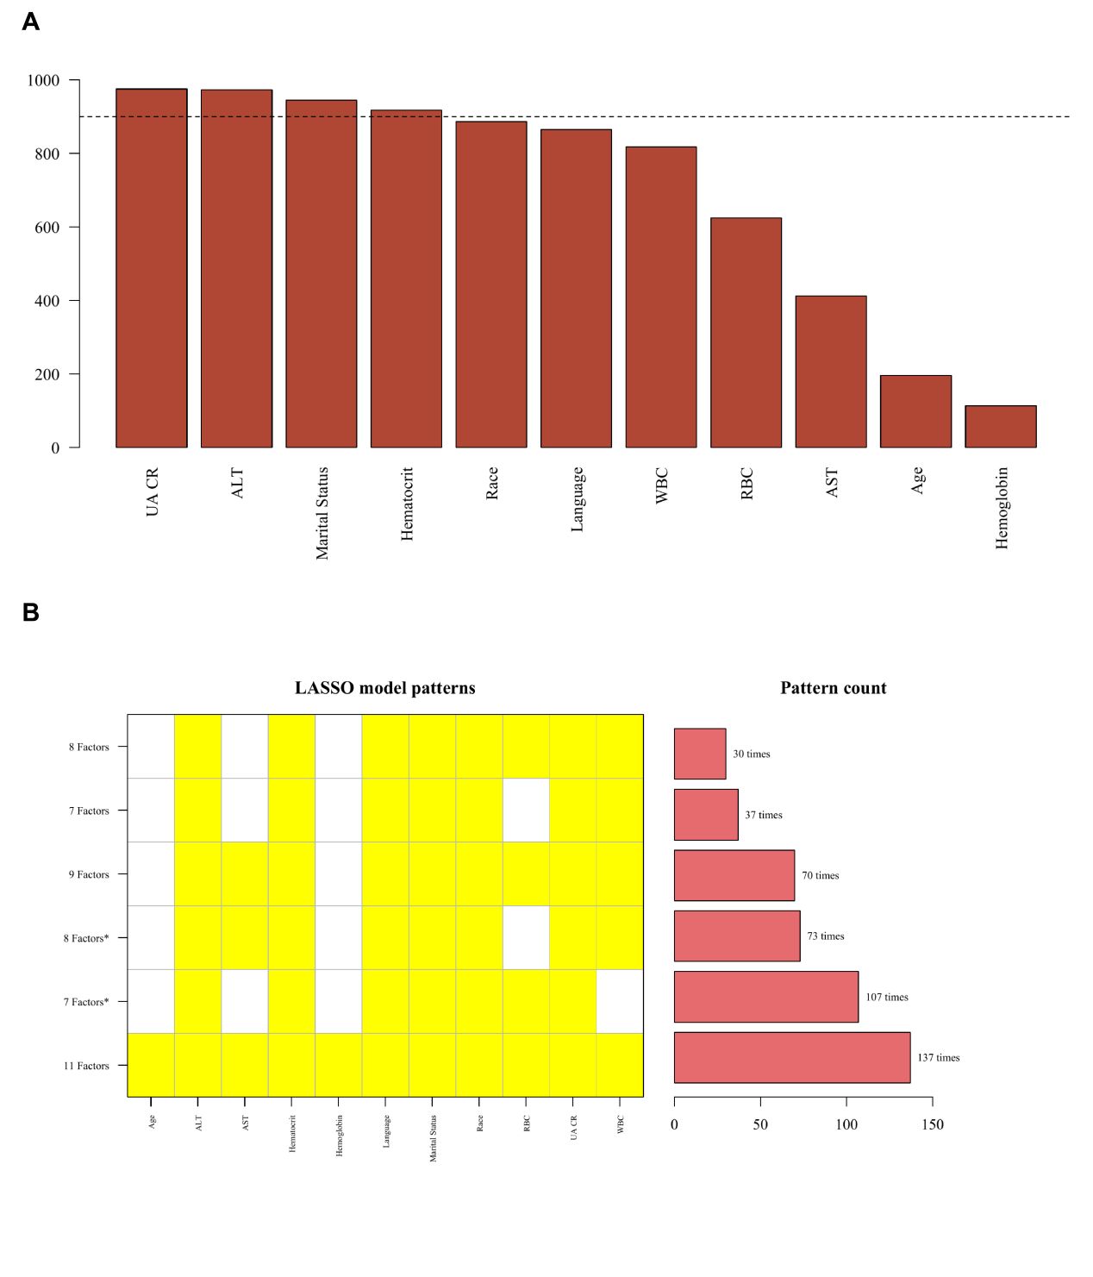
Figure S1. LASSO feature selection

