SUPPLEMENTARY INFORMATION

Carbon Support–Alkali Interplay Controls CO₂ Slip in Dual-Functional Materials for Direct Air Capture and Methanation

Victor Bordejéª, José María Conesa^{b}, María V. Morales^{c}, Antonio Guerrero-Ruiz^{c,d}, Inmaculada Rodríguez-Ramos^{b,d} , Enrique García-Bordejéª
ª Instituto de Carboquímica (ICB-CSIC), Miguel Luesma Castán 4, E-50018 Zaragoza, Spain,
^{b} Instituto de Catálisis y Petroleoquímica (CSIC), 28049, Madrid, Spain
^{c} Departamento de Química Inorgánica y Química Técnica, UNED, 28040, Madrid, Spain
^{d} Grupo de Diseño y Aplicación de Catalizadores Heterogéneos, Unidad Asociada UNED-CSIC (ICP), Spain

Textural characterisation

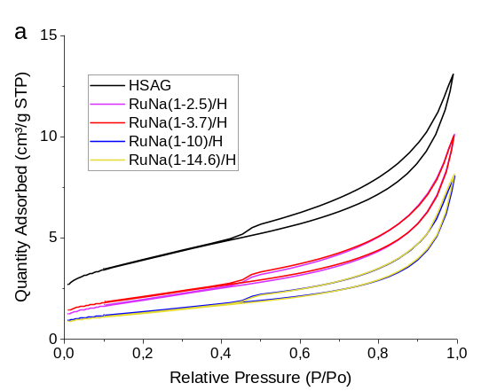 | 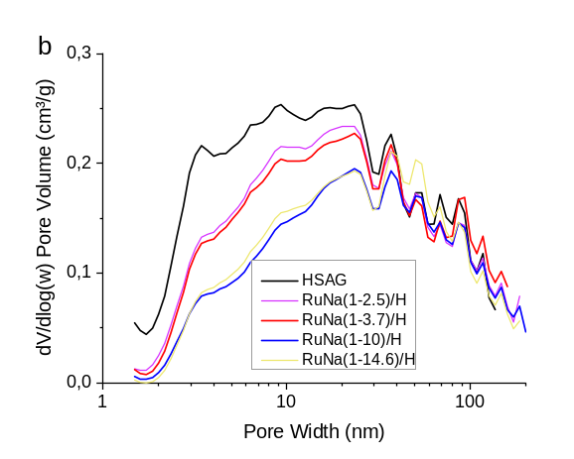
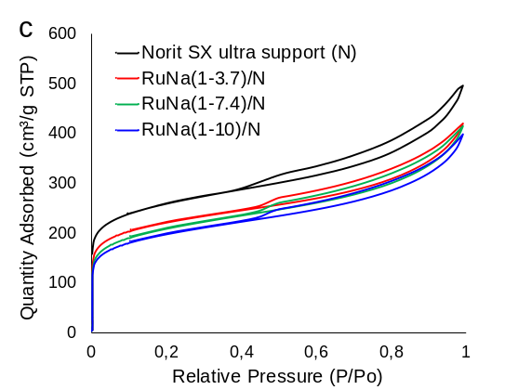 | 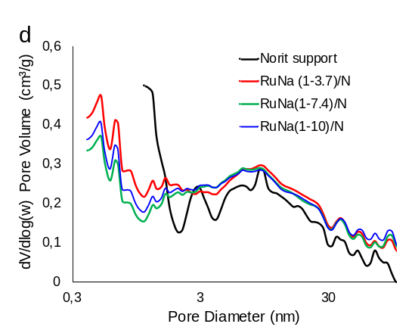
Figure S1. N₂ adsorption-desorption isotherms (left panels, a and c) and pore-size distributions (right panels, b and d) for RuNa DFMs with different Na loadings: (a,b) HSAG-supported samples and bare HSAG; (c,d) AC Norit-supported samples and bare Norit AC.

Table S1. Textural properties of RuNa DFMs supported on HSAG and Norit AC, normalised to the support mass.
Sample | Surface area | Pore Volume | Micropore Surface Area* (S_{mic}) | Micr. Pore vol. * | Mesop Surface Area (S_{mes}) | Meso Pore vol. | Percentage of support weight
 | m²g⁻¹ | cm³ g⁻¹ | m² g⁻¹ | cm³g⁻¹ | m²g⁻¹ | cm³g⁻¹ | %
HSAG | 298 | 0,41 | n.d. | n.d. | 227 | 0,376 | 100
RuNa(1:2.5)/H | 163 | 0,37 | n.d. | n.d. | 157,8 | 0,368 | 95,5
RuNa(1:3.7)/H | 174 | 0.37 | n.d. | n.d. | 151 | 0,359 | 94,8
RuNa(1:7.4)/H | 154 | 0.35 | n.d. | n.d. | 138 | 0,343 | 92,5
RuNa(1:10)/H | 117 | 0.30 | n.d. | n.d. | 103 | 0,294 | 91
RuNa(1:14.6)/H | 116 | 0.31 | n.d. | n.d. | 107 | 0,306 | 88,5
Norit AC support | 935 | 0.77 | 615 | 0.24 | 320 | 0.53 | 100
RuNa(1:3.7)/N | 826 | 0.68 | 528 | 0.21 | 298 | 0.47 | 94.8
RuNa(1:7.4)/N | 800 | 0.69 | 446 | 0.17 | 354 | 0.52 | 92.5
RuNa(1:10)/N | 776 | 0.67 | 466 | 0.18 | 310 | 0.49 | 91.0
* calculated from the N₂ adsorption isotherm using the t-plot method
n.d.: not reliably determined by the t-plot method because is below determination error

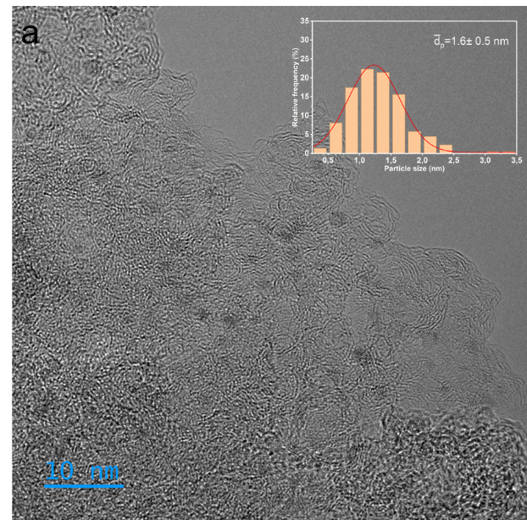 | 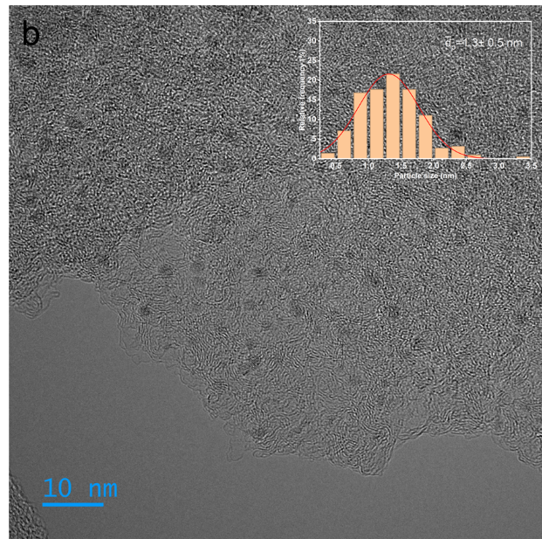
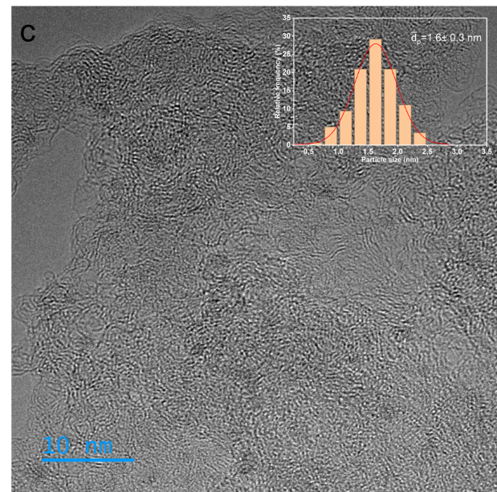 | 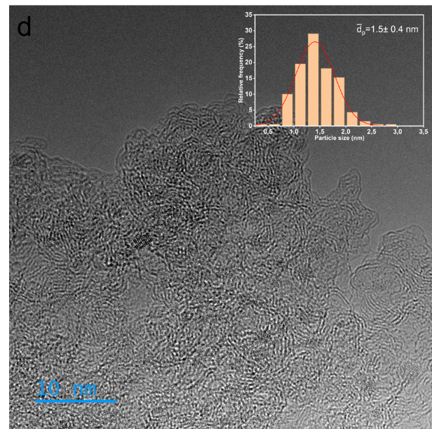

Figure S2. Representative HRTEM images and corresponding Ru particle-size distributions for (a) RuNa(1:3.7)/N, (b) RuNa(1:10)/N, (c) RuK(1:3.7)/N and (d) RuK(1:10)/N.

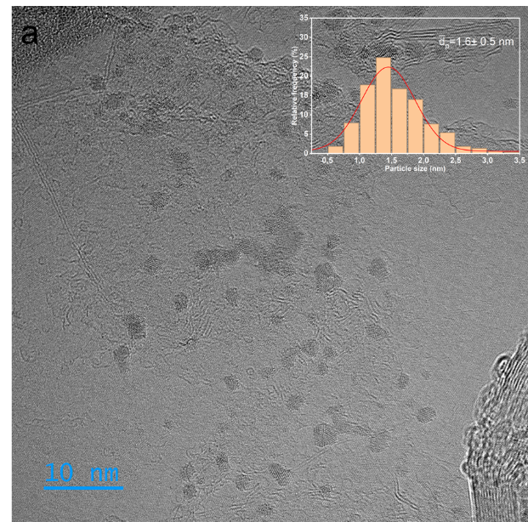 | 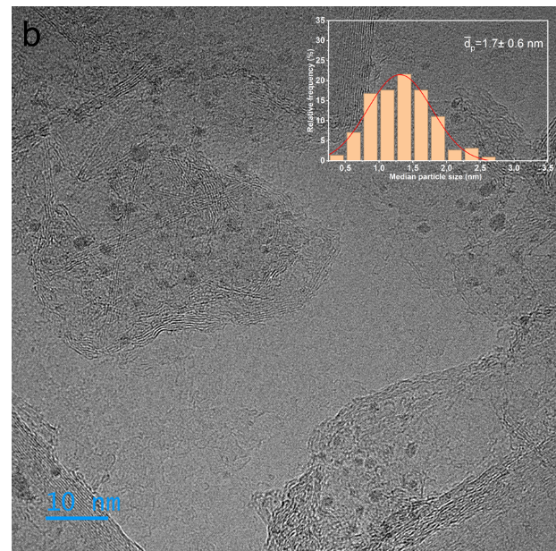
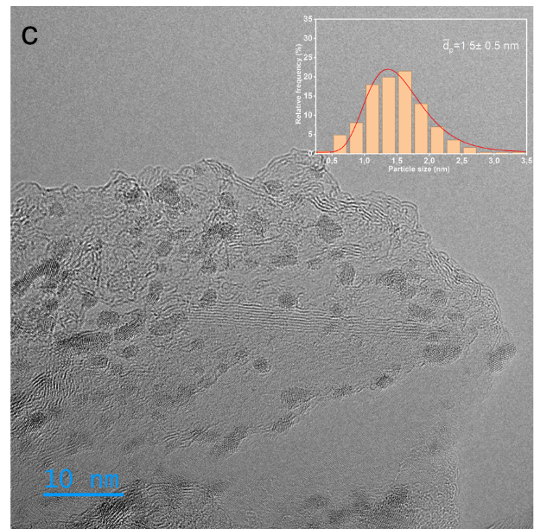 | 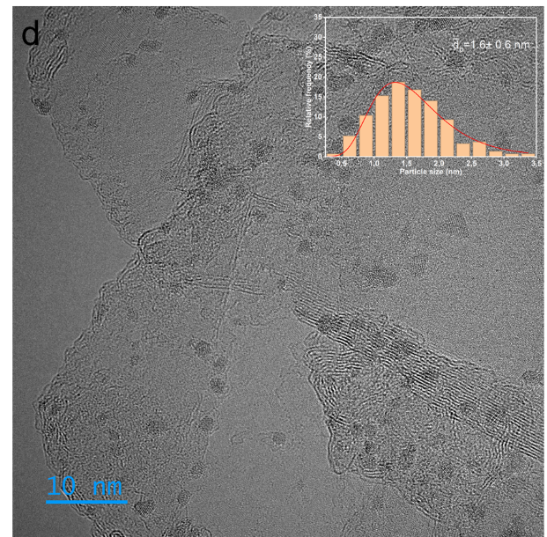
Figure S3. Representative HRTEM images and corresponding Ru particle-size distributions for (a) RuNa(1:3.7)/H, (b) RuNa(1:10)/H, (c) RuK(1:3.7)/H and (d) RuK(1:10)/H.

a | 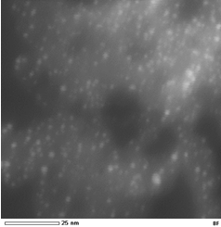 | 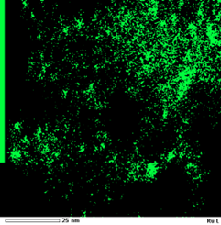 | 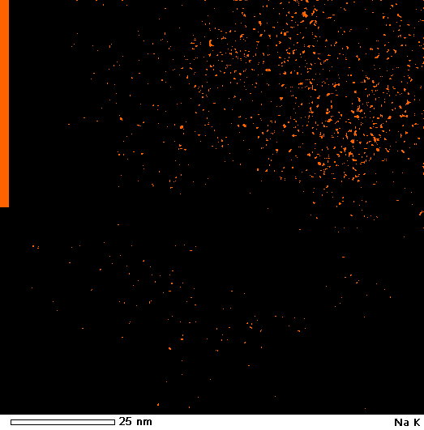
b | 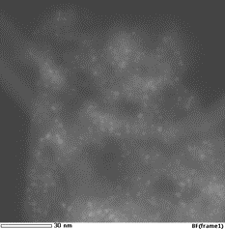 | 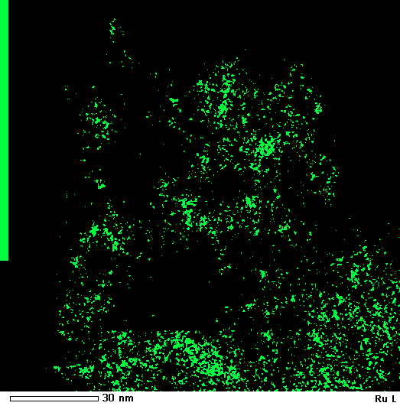 | 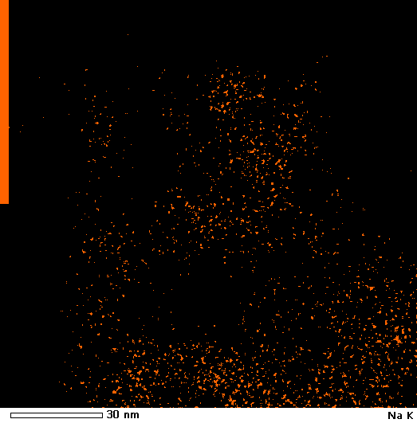
c | 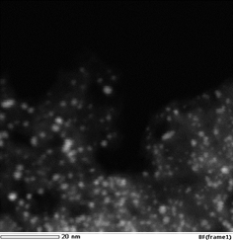 | 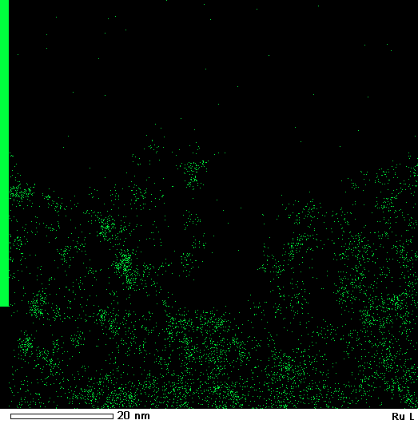 | 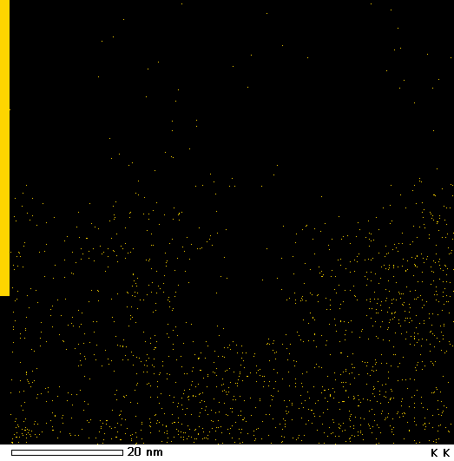
d | 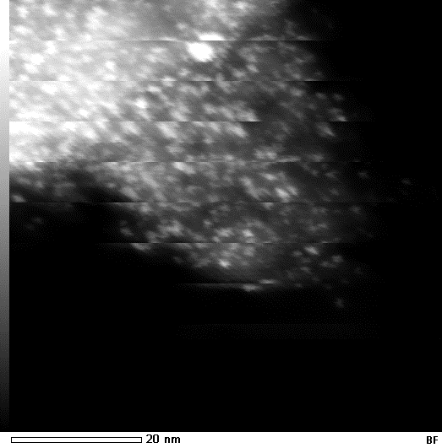 | 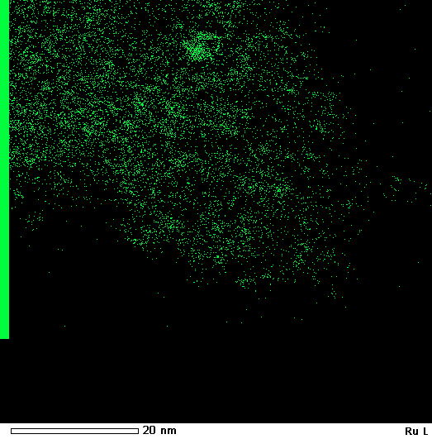 | 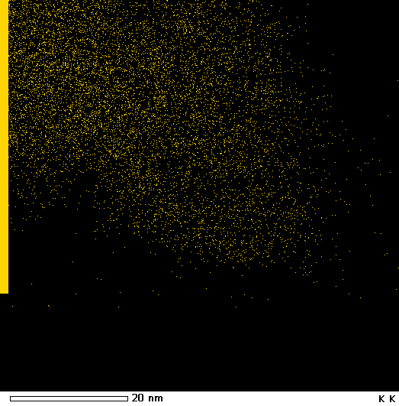
Figure S4. STEM images and EDS maps for (a) RuNa(1:3.7)/N, (b) RuNa(1:10)/N, (c) RuK(1:3.7)/N and (d) RuK(1:10)/N. Ru, Na and K are shown in green, orange and yellow, respectively
a | 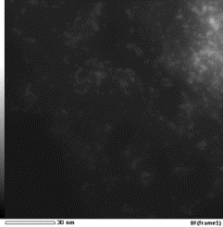 | 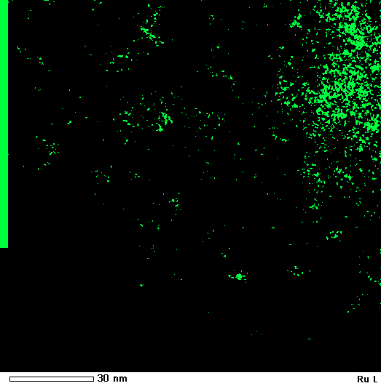 | 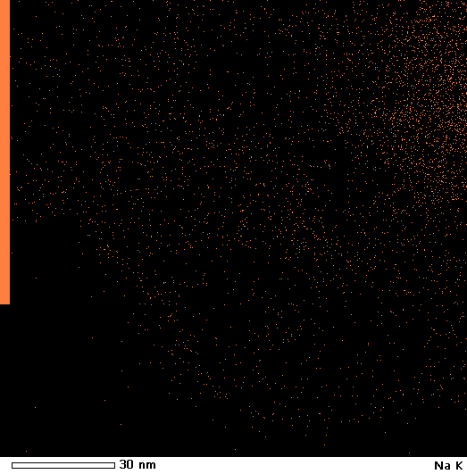
b | 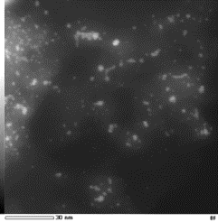 | 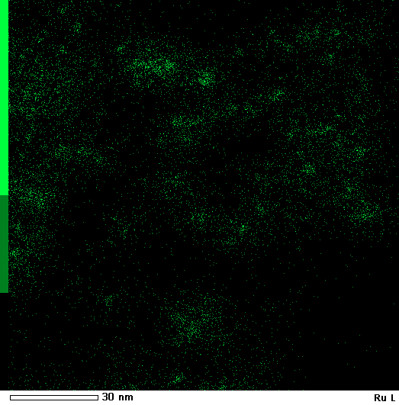 | 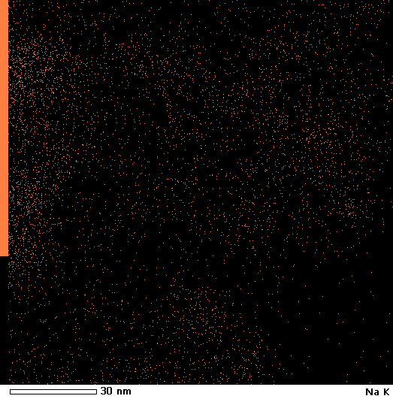
c | 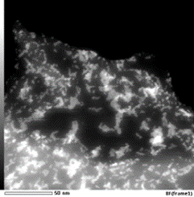 | 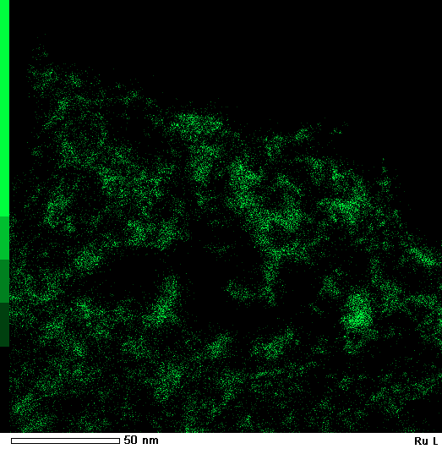 | 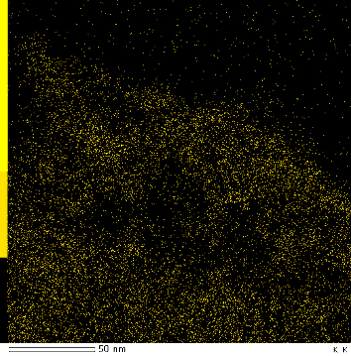
d | 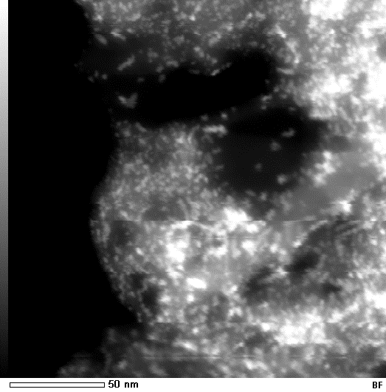    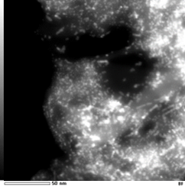 | 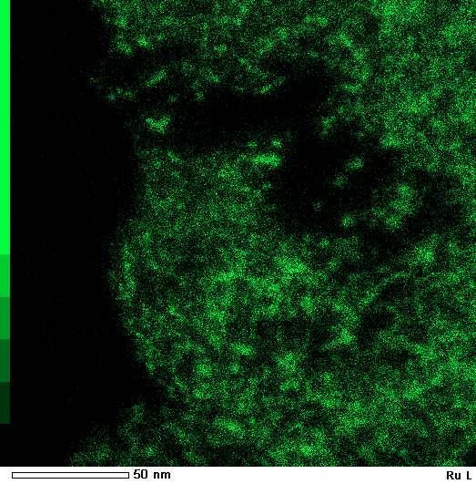 | 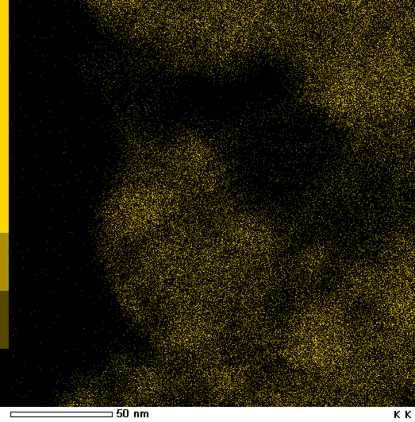
Figure S5. STEM images and EDS maps for (a) RuNa(1:3.7)/H, (b) RuNa(1:10)/H, (c) RuK(1:3.7)/H and (d) RuK(1:10)/H. Ru, Na and K are shown in green, orange and yellow, respectively.

XPS
The peak assignments used for XPS fitting are summarised below.

- Ru 3p fitting
Ru was analysed by ex situ XPS. Because Ru 3d overlaps the C 1s region near 284.6 eV, the Ru 3p3/2 region at 458-468 eV was used. Components at 461.2-461.6, 463.4-463.8 and 465.7-466.1 eV were assigned to Ru⁰, RuO₂ and hydrated RuO₂ or Ru oxyhydroxide, respectively [1,2].

- Na 1s fitting
The Na 1s spectra were fitted with components near 1071.6 and 1073.1 eV, assigned to carbonate/bicarbonate and oxide/hydroxide environments [3–6], respectively. A third component near 1075 eV appeared at high loading. This high-binding-energy component could not be assigned unambiguously and may reflect differential charging; it was therefore not used to identify a specific Na phase.

- K 2p fitting
The K 2p region contains the characteristic K 2p3/2-K 2p1/2 doublet. A K 2p3/2 component at 292.2 ± 0.1 eV was assigned to K₂CO₃ and KHCO₃ environments [7].

- O 1s fitting
The O 1s spectra were fitted using the following components:
- O1 (529-530.6 eV): lattice inorganic oxygen from Na oxide or carbonates[8], and conjugated carbonyl oxygen, including quinone- and pyrone-like groups [9,10];
- O2 (531.4±0.4 eV): C=O type oxygen (carbonylic oxygen in esters and anhydrides)[11,12]
- O3 (532.5 ± 0.4 eV): C–O type oxygen (hydroxylic groups, non-carbonyl – ether type – oxygen atoms in esters and anhydrides)
- O4 (534.2 ± 0.4 eV): oxygen in acidic carboxyl groups [11,12]
- O5 (535.3 ± 0.4 eV): assigned to chemisorbed water and/or weakly bound oxygen-containing species [12].
- A Na KLL Auger feature was also observed near 536 eV [13].

XPS References
[1] R. Chetty, W. Xia, S. Kundu, M. Bron, T. Reinecke, W. Schuhmann, M. Muhler, Effect of Reduction Temperature on the Preparation and Characterization of Pt−Ru Nanoparticles on Multiwalled Carbon Nanotubes, Langmuir 25 (2009) 3853–3860. https://doi.org/10.1021/la804039w.
[2] S. Armenise, L. Roldán, Y. Marco, A. Monzón, E. García-Bordejé, Elucidation of Catalyst Support Effect for NH3 Decomposition Using Ru Nanoparticles on Nitrogen-Functionalized Carbon Nanofiber Monoliths, J. Phys. Chem. C 116 (2012) 26385–26395. https://doi.org/10.1021/jp308985x.
[3] P.H. Citrin, High-Resolution X-Ray Photoemission from Sodium Metal and Its Hydroxide, Phys. Rev. B 8 (1973) 5545–5556. https://doi.org/10.1103/PhysRevB.8.5545.
[4] A. Barrie, F.J. Street, An Auger and X-ray photoelectron spectroscopic study of sodium metal and sodium oxide, Journal of Electron Spectroscopy and Related Phenomena 7 (1975) 1–31. https://doi.org/10.1016/0368-2048(75)80052-1.
[5] S.P. Kowalczyk, L. Ley, F.R. McFeely, R.A. Pollak, D.A. Shirley, X-Ray Photoemission from Sodium and Lithium, Physical Review. B. Solid State. 8 (1973) 3583–3585.
[6] R.V. Siriwardane, J.M. Cook, Interactions of SO2 with sodium deposited on CaO, Journal of Colloid and Interface Science 114 (1986) 525–535. https://doi.org/10.1016/0021-9797(86)90438-8.
[7] X. ‐L. Zhou, S.R. Coon, J.M. White, Potassium promoted decomposition of methyl bromide on Ag(111), J. Chem. Phys. 94 (1991) 1613–1625. https://doi.org/10.1063/1.459965.
[8] X. Feng, D.F. Cox, Synthesis of a planar, multicomponent catalytic surface of Na2CO3/MnO, Surface Science 707 (2021) 121807. https://doi.org/10.1016/j.susc.2021.121807.
[9] M.E. Schuster, M. Hävecker, R. Arrigo, R. Blume, M. Knauer, N.P. Ivleva, D.S. Su, R. Niessner, R. Schlögl, Surface Sensitive Study To Determine the Reactivity of Soot with the Focus on the European Emission Standards IV and VI, The Journal of Physical Chemistry A 115 (2011) 2568–2580. https://doi.org/10.1021/jp1088417.
[10] J.R. Pels, F. Kapteijn, J.A. Moulijn, Q. Zhu, K.M. Thomas, Evolution of nitrogen functionalities in carbonaceous materials during pyrolysis, Carbon 33 (1995) 1641–1653. https://doi.org/10.1016/0008-6223(95)00154-6.
[11] A.B. Dongil, B. Bachiller-Baeza, A. Guerrero-Ruiz, I. Rodríguez-Ramos, A. Martínez-Alonso, J.M.D. Tascón, Surface chemical modifications induced on high surface area graphite and carbon nanofibers using different oxidation and functionalization treatments, Journal of Colloid and Interface Science 355 (2011) 179–189. https://doi.org/10.1016/j.jcis.2010.11.066.
[12] M.R. Cuervo, E. Asedegbega-Nieto, E. Díaz, S. Ordóñez, A. Vega, A.B. Dongil, I. Rodríguez-Ramos, Modification of the adsorption properties of high surface area graphites by oxygen functional groups, Carbon 46 (2008) 2096–2106. https://doi.org/10.1016/j.carbon.2008.08.025.
[13] https://xpsdatabase.net/sodium-na-z11/, (n.d.).

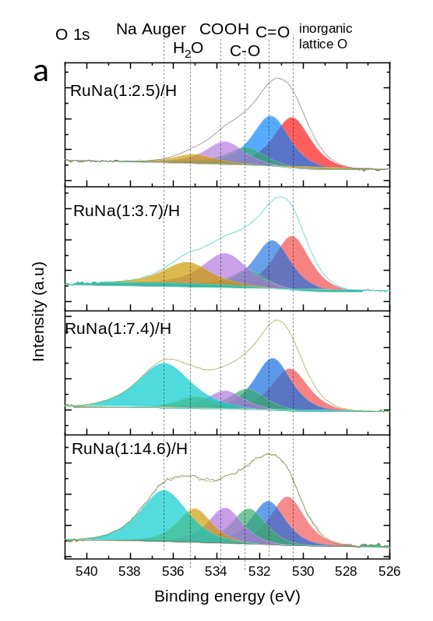 | 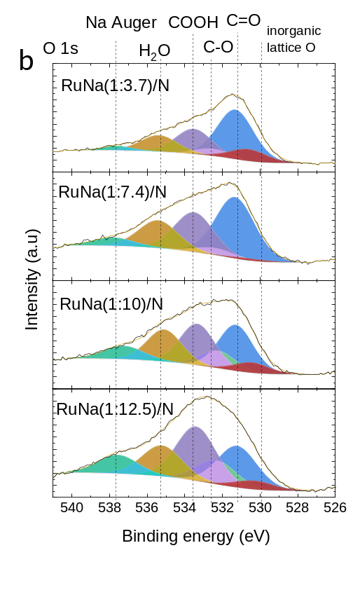
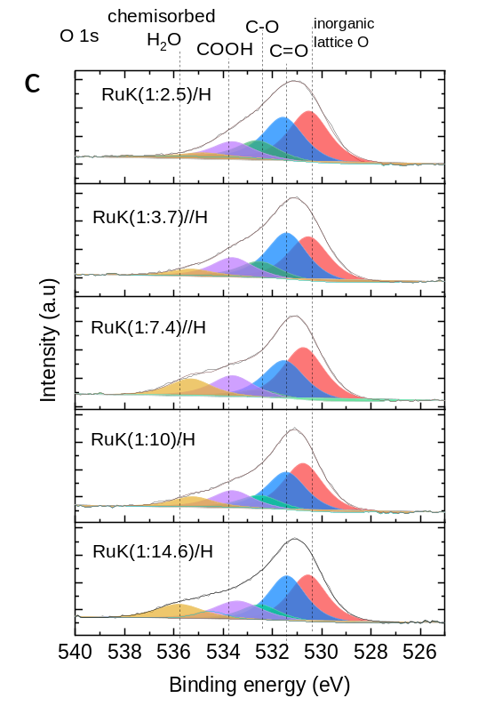 | 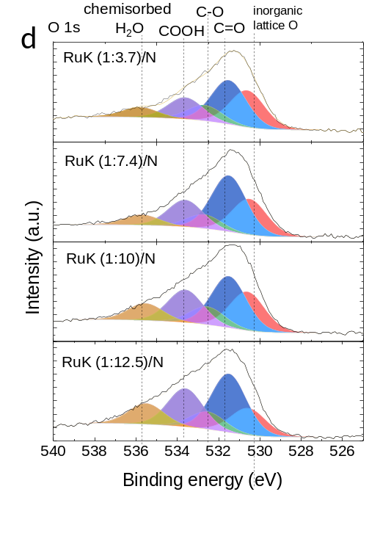
Figure S6. Fits of the O 1s XPS spectra of RuNa DFMs with different Na loadings on (a) HSAG and (b) AC Norit, and RuK DFMs with different K loadings on (c) HSAG and (d) AC Norit.

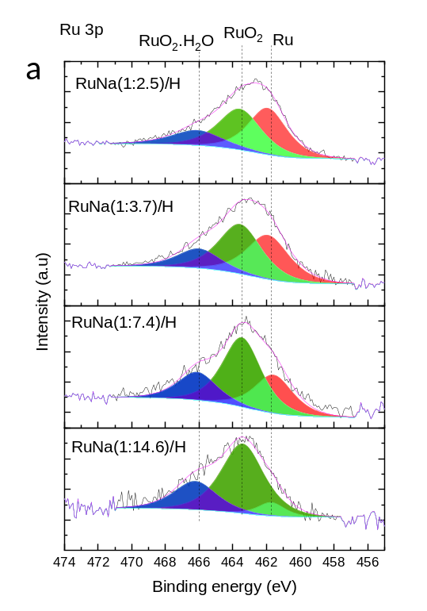 | 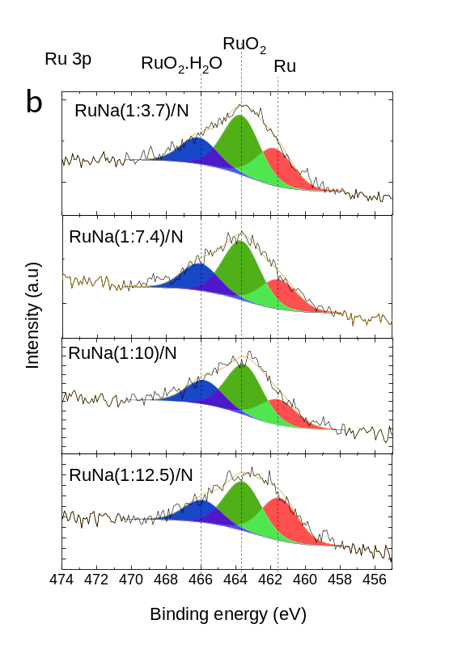
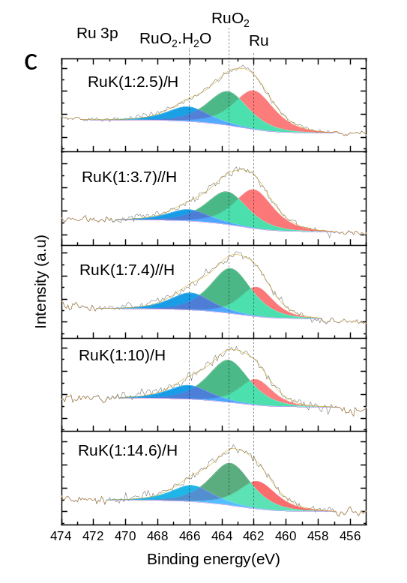 | 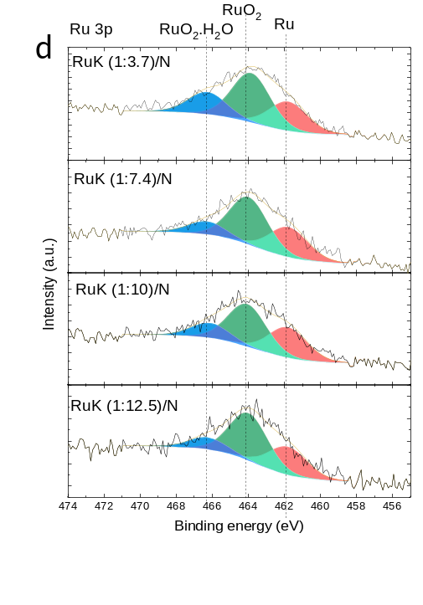
Figure S7. Fits of the Ru 3p XPS spectra of RuNa DFMs with different Na loadings on (a) HSAG and (b) AC Norit, and RuK DFMs with different K loadings on (c) HSAG and (d) AC Norit.
Table S2. CH₄ onset temperature, apparent initial CH₄ production rate and total CH₄ yield for RuK(1:2.5)/H and RuNa(1:2.5)/H at different regeneration temperatures.
Regeneration temperature | RuK(1:2.5)/H |  |  | RuNa(1:2.5)/H
 | CH₄ onset | Apparent  initial rate* | Total CH₄ yield | CH₄ onset | Apparent initial rate* | Total CH₄ yield
ºC | ºC | µmol g⁻¹ s⁻¹ | µmol g⁻¹ | ºC | µmol g⁻¹ s⁻¹ | µmol g⁻¹
200 | 171 | 0.03 | 61 | 157 | 0.13 | 100
250 | 172 | 0.30 | 165 | 173 | 0.21 | 111
300 | 171 | 0.40 | 193 | 173 | 0.22 | 159
* These values therefore reflect both reaction and release during a non-isothermal experiment and should not be interpreted as intrinsic kinetic constants.

Table S3. CH₄ onset and peak temperatures, apparent initial CH₄ production rate and total CH₄ yield for RuNa and RuK supported on HSAG.
DFM | CH₄ peak onset | CH₄ peak maximum | Initial CH₄ rate | Total CH₄ yield
 | ºC | ºC | µmol g⁻¹ s⁻¹ | µmol g⁻¹
RuNa(1:2.5)/H | 177 | 218-291 | 0.15 | 153
RuNa(1:3.7)/H | 199 | 250-291 | 0.17 | 128
RuNa(1:7.4)/H | 181 | 220-293 | 0.14 | 133
RuNa(1:10)/H | 191 | 241-294 | 0.15 | 107
RuNa(1:14.6)/H | 200 | 254-281 | 0.17 | 116
RuK(1:2.5)/H | 199 | 263 | 0.37 | 195
RuK(1:3.7)/H | 251 | 296 | 0.34 | 205
RuK(1:7.4)/H | 226 | 291 | 0.46 | 220
RuK(1:10)/H | 270 | 300 | 0.13 | 168
RuK(1:14.6)/H | 264 | 300 | 0.21 | 145

Table S4. CH₄ onset and peak temperatures, apparent initial CH₄ production rate and total CH₄ yield for RuNa and RuK supported on Norit AC.
DFM | CH₄ peak onset | CH₄ peak maximum | Initial CH₄ rate | Total CH₄ yield
 | ºC | ºC | µmol g⁻¹ s⁻¹ | µmol g⁻¹
RuNa(1:2.5)/N | 194 | 233 | 0.28 | 176
RuNa(1:3.7)/N | 160 | 202 | 0.33 | 275
RuNa(1:7.4)/N | 179 | 250 | 0.46 | 346
RuNa(1:10)/N | 160 | 219 | 0.50 | 382
RuNa(1:12.5)/N | 179 | 216 | 0.52 | 386
RuK(1:2.5)/N | 263 | 300 | 0.55 | 277
RuK(1:3.7)/N | 224 | 296 | 0.86 | 379
RuK(1:7.4)/N | 247 | 300 | 0.64 | 401
RuK(1:10)/N | 238 | 296 | 0.95 | 398
RuK(1:12.5)/N | 276 | 300 | 0.28 | 402

Table S5. Comparison of DFMs operated under isothermal direct-air-capture and conversion conditions.
Reference | DFM composition | Capture T | Regeneration T | CO₂ captured | CO₂ conversion | CH₄ selectivity | CO₂ slip during purge/heating
 |  | ºC | ºC | µmol*g⁻¹ | % | % | %
[28]  Jeong-Potter et al. | 0.5 wt% Ru+6.1 wt% Na₂O/γ-Al₂O₃ | 320 | 320 | 200 | 75 | 100 | 25
[43]  Tayyab et al. | LaCoO₃ perovskite derived material (Co/LCO) | 300 | 300 | 36 (dry) | <100 | 100 | 0
[43]  Tayyab et al. | LaCoO₃ perovskite derived material (Co/LCO) | 450 | 450 | 48.9 (dry) | n.r. | 0 (CO) | n.r
[29]  Tatsumichi et al. | 10 wt% Ni + 15 wt% La en Al₂O₃ | 350 | 350 | 129 | 97 | 99 | 3
[29]  Tatsumichi et al. | 10 wt% Ni + 4 wt% Ca en Al₂O₃ | 350 | 350 | 118 | 99 | 99 | 1
[29]  Tatsumichi et al. | 10 wt% Ni + 3 wt% Na en Al₂O₃ | 350 | 350 | 161 | 99 | 89 | 1

Table S6. Comparison of DFMs operated under isothermal direct-air-capture and conversion conditions.
Reference | DFM  composition | Capture T | Regeneration T | CO₂ captured |  | CO₂ conversion | CH₄ selectivity | CO₂ slip during purge/heating*
 |  | ºC | ºC | µmol*g-1 |  | % | % | %
[30]  McNeary et al. | Diaminosilane- 5 wt% Ru/TiO₂ | 50 | 200 | 62 |  | <5 | 100 | >95
[15]  Crawford et al. | 1 wt% Ru + ~20 wt% Na/ FAU zeolite | 50 | 300 | 281 |  | 100 | 100 | 0
[24]  Jeong-Potter et al. | 1 wt% Ru + 10 wt% Na₂O /γ-Al₂O₃ | 25 | 300 | 1300 (humid) |  | 79 | 100 | 21
[19]  Kosaka et al. | 10 wt% Ni + 15 wt% Na₂CO₃/γ-Al₂O₃ | 20-25 | 450 | 168 (at 0.9 MPa) |  | 97 | 98 | 0-2
[44]  Martínez-López et al. | 15 wt% MgO + 20 wt% NiO-CeO₂ on β-zeolite | 35 | 350 | 568 |  | 45 | 100 | 32
[34]  Karaçoban et al. | 1.7 wt% Ru + 10 wt% K₂CO₃ on CNF | 30 | 225 | 410  (humid) |  | 56 | 87 | 44
[45]  Lin et al. | 0.25 wt% Ru + 10 wt% Na₂CO₃ on Al₂O₃ | 40 | 300 | 811  (humid) |  | 37 | - | 49
[35]  Karaçoban et al. | 1.6 wt% Ru + 10 wt% K₂CO₃ on CNF | 30 | 250 | 310 |  | 58 | - | 42
[46]  Zhang et al. | 1.6 wt% Ru + 5 wt% Na₂CO₃ on Al₂O₃ | 25 | 350 | 87 |  | 21 | 21 | 79
[46]  Zhang et al. | 1.6 wt% Ru + 15 wt% Na₂CO₃ on Al₂O₃ | 25 | 350 | 432 |  | 64 | 66 | 36
[46]  Zhang et al. | 1.6 wt% Ru + 25 wt% Na₂CO₃ on Al₂O₃ | 25 | 350 | 570 |  | 81 | 89 | 19
[46]  Zhang et al. | 1.6 wt% Ru + 25 wt% Na₂CO₃ on Al₂O₃ | 25 | 350 | 2055  (humid) |  | 64 | 65 | 36
[46]  Zhang et al. | 1.6 wt% Ru + 35 wt% Na₂CO₃ on Al₂O₃ | 25 | 350 | 582 |  | 90 | 99 | 10
[31]  Moral-Pombo et al. | 4 wt% Ru + 5.4 wt% Ba on HSGA | 40 | 300 | 110  (humid) |  | 100 | 100 | 0
[31]  Moral-Pombo et al. | 4 wt% Ru + 10 wt% Cs on HSGA | 40 | 300 | 440  (humid) |  | 93 | 100 | 7
[32]  García-Bordejé et al. | 3 wt% Ru + 6.8 wt% NaNO₃ on Al₂O₃ | 40 | 300 | 740  (humid) | 96 |  | 100 | 4
[32]  García-Bordejé et al. | 3 wt% Ru + 11.6 wt% KNO₃ on Al₂O₃ | 40 | 300 | 440  (humid) | 75 |  | 100 | 25
[47]  Wu et al. | Ni_{0.7}Ce_{0.3}O_{x} (molar ratio) | 25 | 230 | 1050  (humid) | 84 |  | 100 | 16
[26]  Lin et al. | 0.25 wt% Ru + 6.1 wt% Na₂O + γ-Al₂O₃ on monolith | 25 | 280 | 800 (humid) | 50 |  | 100 | 50
[25]  Abdallah et al. | 1 wt% Ru + 10 wt% Na₂O + γ-Al₂O₃ on monolith | 0 | 300 | 368 (humid) | 42 |  | 100 | 58
[25]  Abdallah et al. | 1 wt% Ru + 10 wt% Na₂O + γ-Al₂O₃ on monolith | 25 | 300 | 1030 (humid) | 56 |  | 100 | 44
[25]  Abdallah et al. | 1 wt% Ru + 10 wt% Na₂O + γ-Al₂O₃ on monolith | 40 | 300 | 745 (humid) | 52 |  | 100 | 48
[48]  Feng et al. | 10 wt% NiCa | 25 | 450 | 8960 | 96 |  | 100 | 4
[48]  Feng et al. | 10 wt% NiCa₉Mg | 25 | 450 | 8370 | 96 |  | 100 | 4
[48]  Feng et al. | 10 wt% NiCa₉Ce | 25 | 450 | 7930 | 95 |  | 100 | 5
[48]  Feng et al. | 10 wt% NiCa₉Zr | 25 | 450 | 7420 | 97 |  | 100 | 3
[49]  Lee et al. | 5 wt% Ru + 40 wt% K₂CO₃ on K-β″ Alumina | 30 | 300 | 209 (humid) | 69 |  | 99 | 31
[27]  Kim et al. | 10 wt% Ni + 30 wt% K₂CO₃ on Al₂O₃ | 30 | 320 | 2150 (humid) | 32 |  | 87 | 65
This work | 3 wt% Ru+6.8 wt% Na on AC | 40 | 300 | 380  (humid) | 98.6 |  | 100 | 1.4
* When CO₂ slip was not reported, it was estimated from the reported CO₂ conversion by assuming that unconverted carbon was released as CO₂.

