Supplementary File 2: Statistical Parameterisation and Correlation Analysis

Variable | ABM Weight | P Value | Standard Error | Relationship | Significant
Urban_area | -2.63 | 9.9E-33 | 0.22 | Negative (Reduces Cases) | Yes
Population | -2.54 | 3.0E-32 | 0.21 | Negative (Reduces Cases) | Yes
Indigenous_agents | -2.41 | 6.9E-29 | 0.22 | Negative (Reduces Cases) | Yes
Flooded_GrassSwamp | -1.91 | 1.7E-14 | 0.25 | Negative (Reduces Cases) | Yes
Endemic_agents | -1.77 | 2.8E-30 | 0.16 | Negative (Reduces Cases) | Yes
Deforestation_Second | -1.19 | 3.0E-05 | 0.29 | Negative (Reduces Cases) | Yes
TT_AGENTS | -1.08 | 3.8E-08 | 0.20 | Negative (Reduces Cases) | Yes
prcp_mm_lag2 | -1.04 | 5.6E-06 | 0.23 | Negative (Reduces Cases) | Yes
prcp_mm_lag1 | -1.01 | 9.3E-06 | 0.23 | Negative (Reduces Cases) | Yes
prcp_mm | -0.76 | 8.0E-04 | 0.23 | Negative (Reduces Cases) | Yes
Deforestation_TT | -0.50 | 4.4E-02 | 0.25 | Negative (Reduces Cases) | Yes
Deforestation_Primary | -0.20 | 3.8E-01 | 0.23 | Negative (Reduces Cases) | No
Comunitarie_agents | 0.16 | 5.7E-01 | 0.28 | Positive (Increases Cases) | No
Forest_tt | 0.20 | 3.9E-01 | 0.23 | Positive (Increases Cases) | No
temp_C_lag2 | 0.52 | 3.6E-02 | 0.25 | Positive (Increases Cases) | Yes
temp_C | 0.54 | 3.0E-02 | 0.25 | Positive (Increases Cases) | Yes
temp_C_lag1 | 0.70 | 4.3E-03 | 0.25 | Positive (Increases Cases) | Yes
Flooded_Forest | 1.19 | 6.4E-07 | 0.24 | Positive (Increases Cases) | Yes
LULC_Water | 1.20 | 5.6E-11 | 0.18 | Positive (Increases Cases) | Yes
Farming | 2.04 | 6.9E-23 | 0.21 | Positive (Increases Cases) | Yes
Table S1. Complete Generalized Linear Model (GLM) outputs for spatial parameterisation.
Note: This table expands upon Table 2 from the main manuscript, detailing the complete list of Negative Binomial coefficients, p-values, standard errors, and relational significance for all variables tested prior to ABM-GIS incorporation.

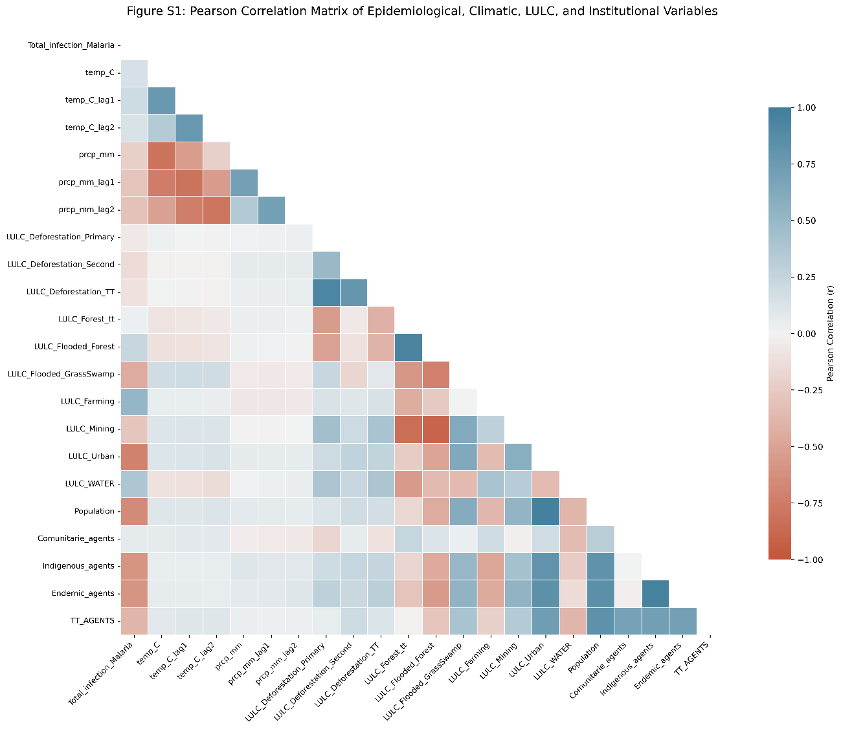
Figure S1. Pearson correlation matrix between epidemiological, climatic, landscape (LULC), and institutional variables for the cross-border Oiapoque basin. The correlation indices evaluate collinearity and historical associations across the 262-month time series prior to ABM-GIS parameterisation.

Table S2. Simulated epidemiological outcomes under optimistic and pessimistic clinical efficacy profiles during the seasonal transmission peak.
Scenario | Climate & Institutional Description | Efficacy Profile | Mean Total Cases | Standard Deviation
6 | High Temp, Low Precip (Current HA) | Pessimistic | 202.7 | 14.7
7 | High Temp, Low Precip (+20% HA) | Pessimistic | 197.4 | 11.6
8 | High Temp, Low Precip (Current HA) | Optimistic | 199.2 | 11.5
9 | High Temp, Low Precip (+20% HA) | Optimistic | 206.4 | 14.7
Note: HA: Health Agents. The sensitivity analysis modifies the clinical mitigation multipliers embedded in the ABM-GIS. The "Pessimistic" profile simulates reduced clinical blocking capacity (e.g., lower adherence to treatment or delayed diagnostics), whereas the "Optimistic" profile simulates near-perfect clinical containment upon contact. The results demonstrate that despite extreme variations in assumed clinical efficacy, the macroscopic disease burden remains tightly constrained within the model's stochastic variance (anchored around ~200 cases), confirming that spatial friction and pendular mobility outpace clinical intervention.

