LucaCell: a sequence-centric foundation model for cross-species single-cell analysis
Yan Sun ^{1,2,3†}, Yong He ^{2,4†*}, Minsi Ren ^{2,5}, Yanhui Wang ⁶, Penghao Xu ⁷, Yong Hou ^{1,3}, Yu Kang ⁴, Tingjun Hou ⁴, Jieping Ye ², Huanming Yang ^{3*}, Zheng Wang ^{2*}

- College of Life Sciences, University of Chinese Academy of Sciences, Beijing, China
- Token Foundry, Alibaba Token Hub, Alibaba Group, Hangzhou, China
- BGI Research, Shenzhen, China
- College of Pharmaceutical Sciences, Zhejiang University, Hangzhou, China
- Department of Artificial Intelligence, School of Engineering, Westlake University, Hangzhou, China
- College of Ocean and Earth Sciences and State Key Laboratory of Marine Environmental Science, Xiamen University, Xiamen, China
- ZJU-Veminsyn Bio-AI joint Research & Development Center, College of Agriculture and Biotechnology, Zhejiang University, Hangzhou, China
† These authors contributed equally.
* Correspondence to Yong He (sanyuan.hy@alibaba-inc.com), Huanming Yang (yanghm@genomics.cn), and Zheng Wang (wz388779@alibaba-inc.com).

Supplementary Materials

Supplementary Figures
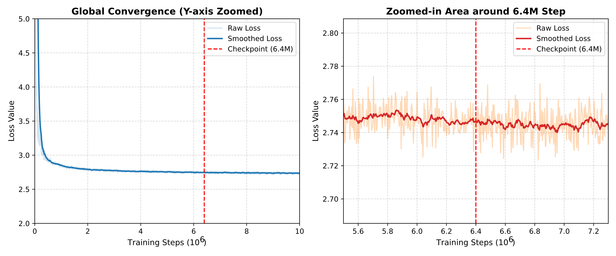
Figure S1. Pre-training loss trajectory of LucaCell. Global self-supervised pre-training loss trajectory across 10 million steps (left), with a zoomed-in view around the 6.4 million (M) step mark (right). The red dashed line indicates the 6.4M-step checkpoint selected for downstream tasks and fine-tuning initialization.

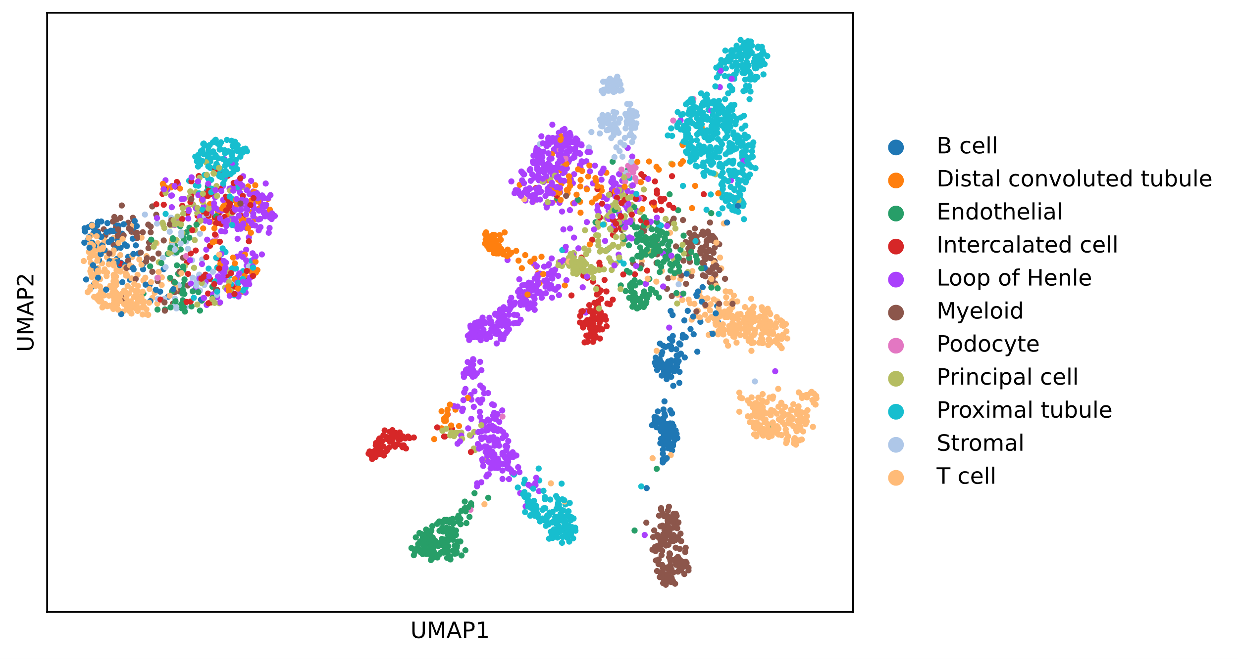
Figure S2. Joint latent space of cross-species and cross-modal cell representations. UMAP visualization of LucaCell-derived embeddings colored by cell type across human, mouse, and lemur datasets and across RNA-seq and ATAC-seq modalities.

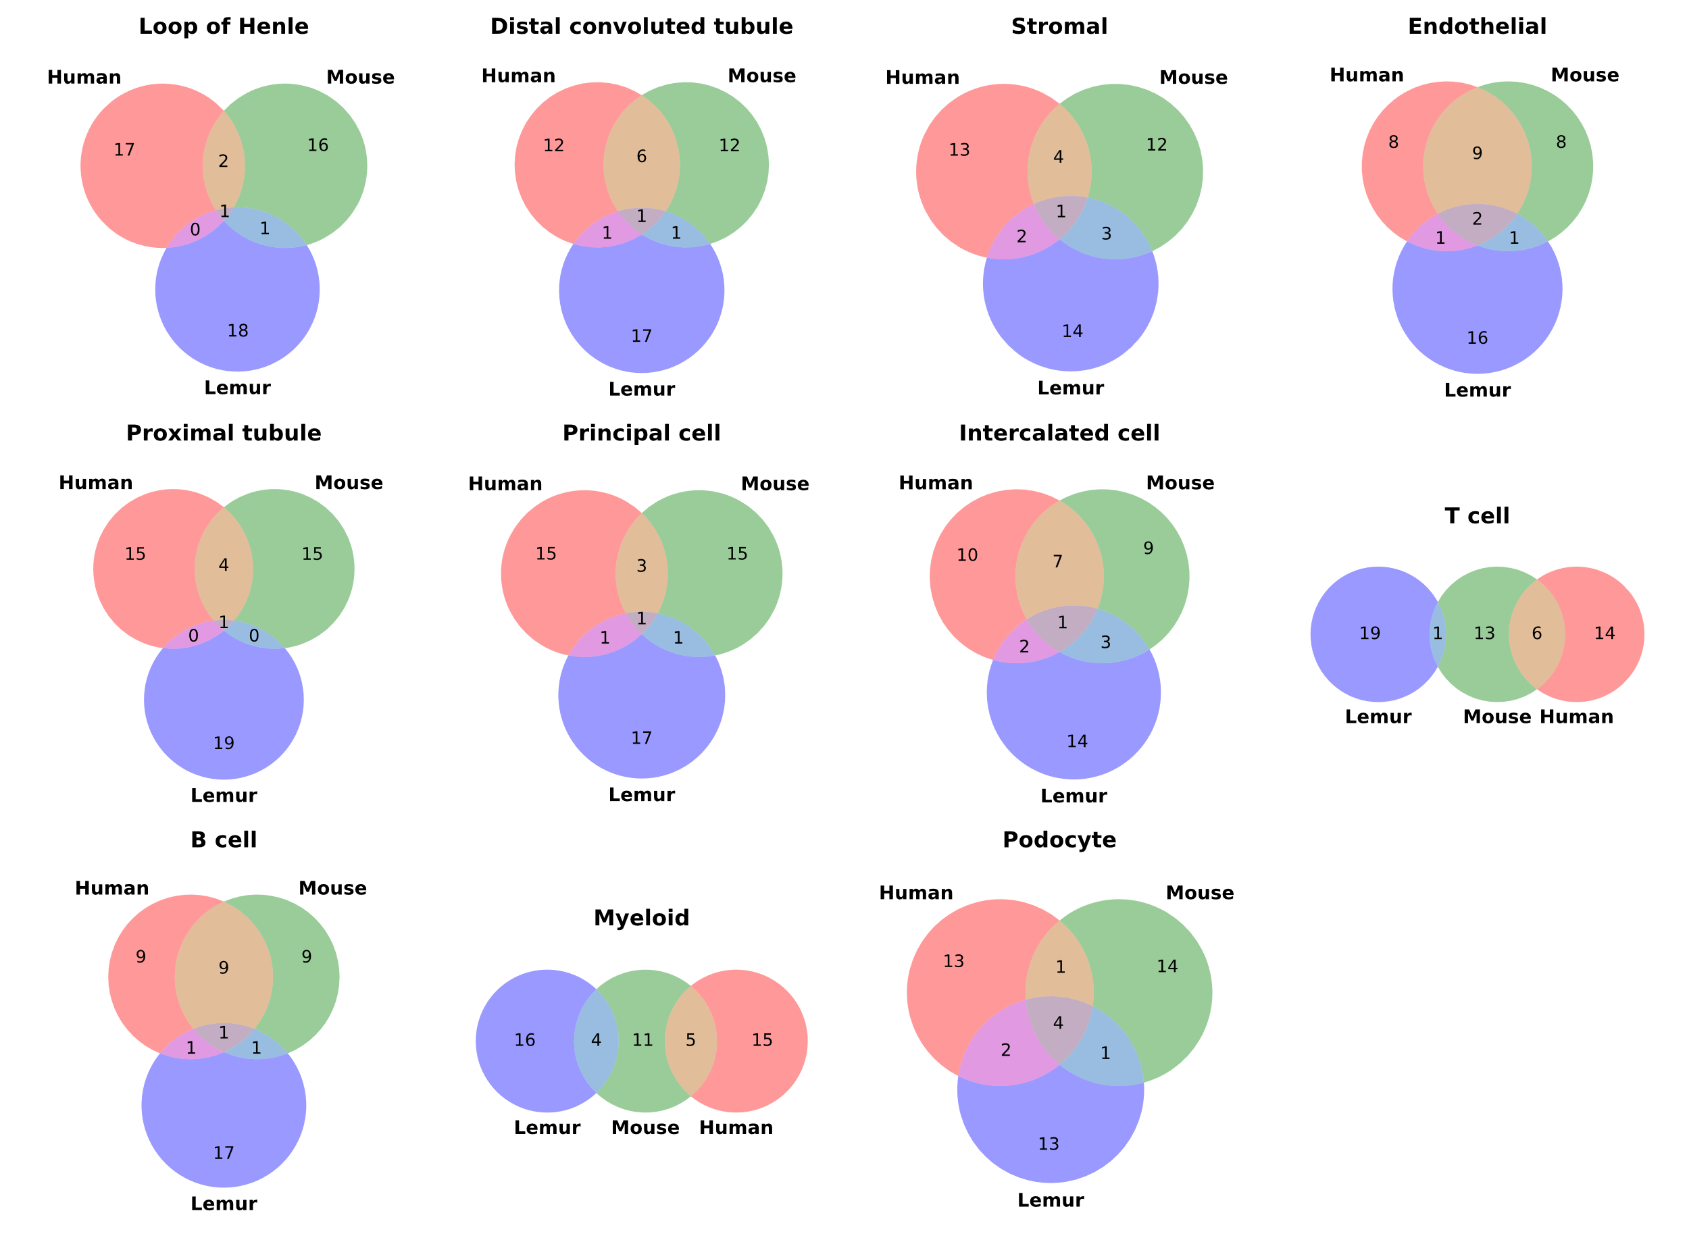
Figure S3. Marker-gene overlap across species. Overlap of cell type-specific marker genes identified independently in human, mouse, and lemur, shown separately for each cell type.

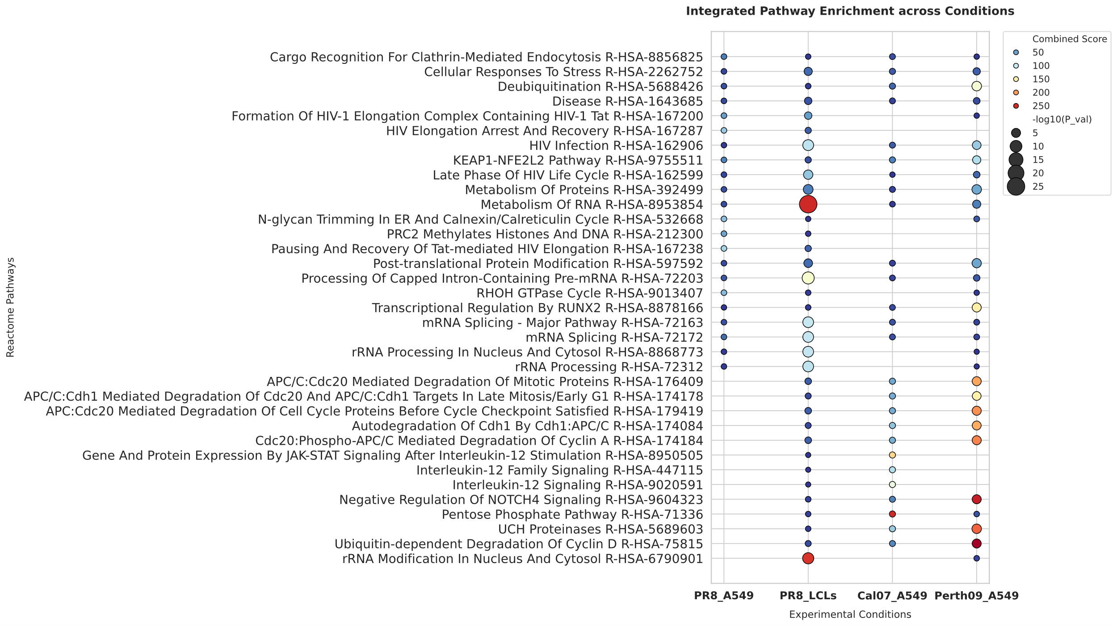
Figure S4. Reactome pathway enrichment for shared downregulated genes. Top 10 enriched Reactome pathways identified from the overlap of downregulated DEGs across the four virus-cell line combinations.

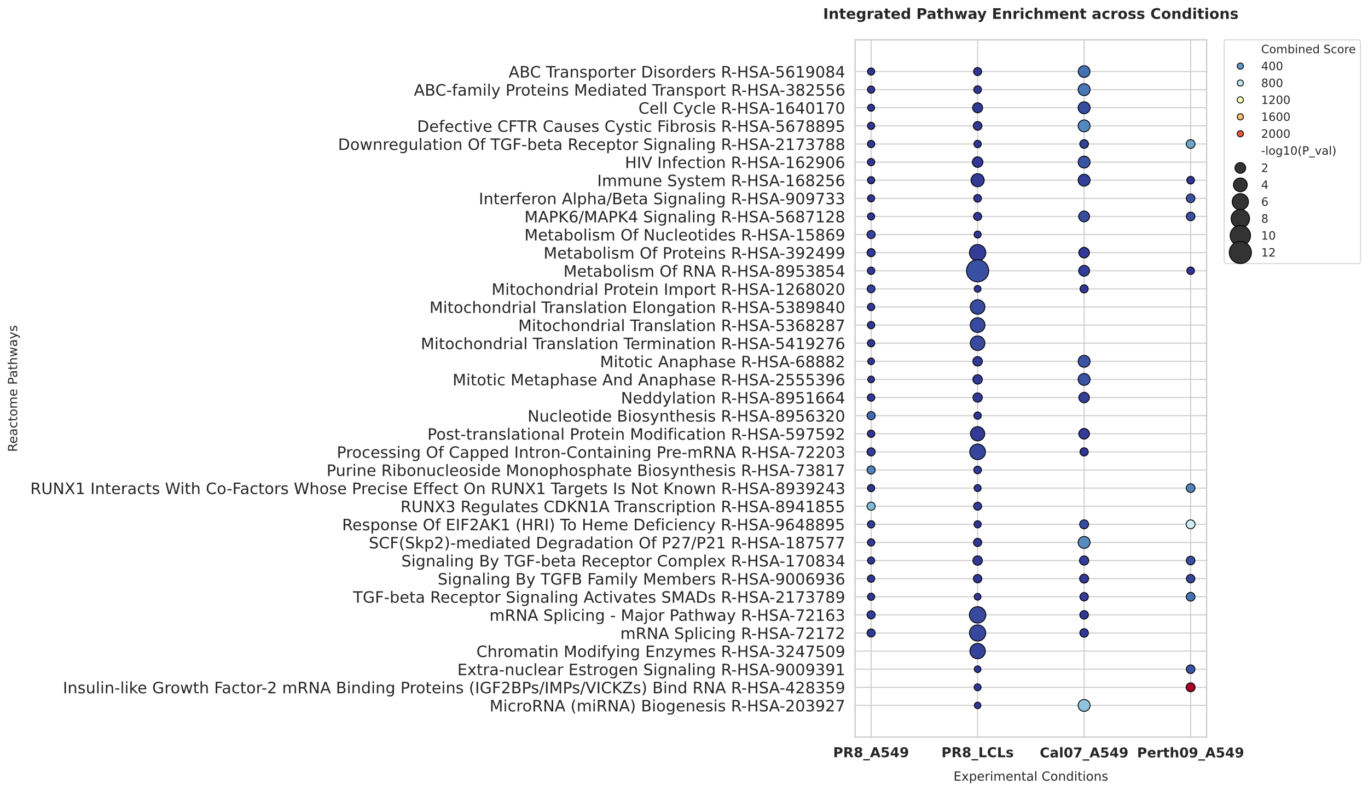
Figure S5. Reactome pathway enrichment for genes downregulated only in predicted infection-like cells. Top 10 enriched Reactome pathways identified from genes downregulated exclusively in predicted infection-like mock cells across the four virus-cell line combinations.

Supplementary Tables
Table S1. Comparison among single-cell foundation models
Model | Gene representation | Expression representation | Cross-species transfer | Non-coding region inclusion | Nucleotide-level mutation sensitivity | RNA-seq read-level input
Geneformer [1] | Gene ID/Name | Ranked expression | ✗ | ✗ | ✗ | ✗
scFoundation [2] | Gene ID/Name | Continuous expression | ✗ | ✗ | ✗ | ✗
scGPT [3] | Gene ID/Name | Binned expression | ✗ | ✗ | ✗ | ✗
CellFM [4] | Gene ID/Name | Continuous expression | ✗ | ✗ | ✗ | ✗
TranscriptFormer [5] | Protein sequence-derived embedding | Raw counts | ✓ | ✗ | ✗ | ✗
UCE [6] | Protein sequence-derived embedding | Count-weighted sampling | ✓ | ✗ | ✗ | ✗
LucaCell | mRNA sequence-derived embedding | Binned expression | ✓ | ✓ | ✓ | ✓

Table S2. Datasets used for downstream analyses
Task | Dataset | Source | Accession
Cross-species cell type prediction | Human kidney scRNA-seq and scATAC-seq [7] | GEO [8] | GSE254185
Cross-species cell type prediction | Lemur kidney scRNA-seq [9] | CELLxGENE [10] | cellxgene.cziscience.com/collections/a137437b-d284-4a27-b1e9-36958a8f92c1
Cross-species cell type prediction | Mouse kidney scRNA-seq [11] | CELLxGENE | cellxgene.cziscience.com/collections/9c9d04c4-8899-417f-bb6f-6107dcadf14f
Alignment-free microbe embedding | Human gut smRNA-seq [12] | Genome Sequence Archive [13] | PRJCA017256
Alignment-free microbe embedding | Bacterial culture smRNA-seq [14] | Genome Sequence Archive | CRA011274
Gene perturbation prediction | Adamson [15] | GEO | GSE90546
SNP-associated gene expressions | OneK1K [16] | GEO | GSE196830
Viral load prediction | PR8_A549 [17] | GEO | GSE122031
Viral load prediction | Cal07_ A549 and Perth09_ A549 [18] | GEO | GSE143167
Viral load prediction | PR8_LCLs [19] | GEO | GSE205796
Viral load prediction | Russell [20] | / | datadryad.org/dataset/doi:10.5061/dryad.qp0t3
None of the datasets used for downstream tasks were included in the pre-training corpus.

Table S3. Task-specific hyperparameters for downstream tasks
Tasks | Maximum epochs | Peak learning rate | Batch size | Warmup steps | Loss type | Best metric
Cross-species cell type prediction | 80 | 2×10⁻⁴ | 16 | 1,000 | Cross entropy | Macro-F1
Alignment-free microbe embedding | 100 | 2×10⁻⁴ | 16 | 1,000 | Cross entropy | Macro-F1
Gene perturbation prediction | 200 | 1×10⁻⁴ | 16 | 1,000 | Global MSE | Pearson correlation
SNP-associated gene expressions | 300 | 1×10⁻⁴ | 16 | 1,000 | Global MSE | Pearson correlation
Viral load prediction | 500 | 1×10⁻⁵ | 16 | 1,000 | Global MSE | Pearson correlation
‘Maximum epochs’ were task-specific to account for differences in training difficulty and convergence speed, ‘Peak learning rates’ were tuned according to target granularity, ‘Loss Type’ denotes the training objective used during model building, and ‘Best metric’ denotes the validation metric used to select the best checkpoint at the epoch level for performance reporting on test dataset and inference. For all comparative experiments, the models were trained and evaluated using identical hyperparameter settings and random seeds, and all downstream tasks were conducted on a single NVIDIA A100 GPU. No task-specific hyperparameter tuning was performed for the comparative experiments, ensuring a fair comparison. Unless otherwise noted, all downstream tasks used the hyperparameters summarized here.

Reference
1. Theodoris CV, Xiao L, Chopra A, Chaffin MD, Al Sayed ZR, Hill MC, et al. Transfer learning enables predictions in network biology. Nature. 2023;618:616–24. https://doi.org/10.1038/s41586-023-06139-9
2. Hao M, Gong J, Zeng X, Liu C, Guo Y, Cheng X, et al. Large-scale foundation model on single-cell transcriptomics. Nat Methods. 2024;21:1481–91. https://doi.org/10.1038/s41592-024-02305-7
3. Cui H, Wang C, Maan H, Pang K, Luo F, Duan N, et al. scGPT: toward building a foundation model for single-cell multi-omics using generative AI. Nat Methods. 2024;21:1470–80. https://doi.org/10.1038/s41592-024-02201-0
4. Zeng Y, Xie J, Shangguan N, Wei Z, Li W, Su Y, et al. CellFM: a large-scale foundation model pre-trained on transcriptomics of 100 million human cells. Nat Commun. 2025;16:4679. https://doi.org/10.1038/s41467-025-59926-5
5. Pearce JD, Simmonds SE, Mahmoudabadi G, Krishnan L, Palla G, Istrate A-M, et al. TranscriptFormer: A generative cell atlas across 1.5 billion years of evolution. Science. American Association for the Advancement of Science; 2026;393:aec8514. https://doi.org/10.1126/science.aec8514
6. Rosen Y, Roohani Y, Agrawal A, Samotorčan L, Quake SR, Leskovec J, et al. Universal cell embedding provides a foundation model for cell biology. Nature. 2026;656:183–91. https://doi.org/10.1038/s41586-026-10689-z
7. Reck M, Baird DP, Veizades S, Sutherland C, Bell RMB, Hur H, et al. Multiomic analysis of human kidney disease identifies a tractable inflammatory and pro-fibrotic tubular cell phenotype. Nat Commun. 2025;16:4745. https://doi.org/10.1038/s41467-025-59997-4
8. Edgar R, Domrachev M, Lash AE. Gene Expression Omnibus: NCBI gene expression and hybridization array data repository. Nucleic Acids Res. 2002;30:207–10. https://doi.org/10.1093/nar/30.1.207
9. de Morree A, De Vlaminck I, Shapiro L, Razafindrakoto A, Ravelonjanahary HN, Wright P, et al. A molecular cell atlas of mouse lemur, an emerging model primate. Nature. 2025;644:173–84. https://doi.org/10.1038/s41586-025-09113-9
10. CZI Cell Science Program, Abdulla S, Aevermann B, Assis P, Badajoz S, Bell SM, et al. CZ CELLxGENE Discover: a single-cell data platform for scalable exploration, analysis and modeling of aggregated data. Nucleic Acids Res. 2025;53:D886–900. https://doi.org/10.1093/nar/gkae1142
11. Lake BB, Melo Ferreira R, Hansen J, Menon R, Basta J, Thiessen Philbrook H, et al. Cellular and Spatial Drivers of Unresolved Injury and Functional Decline in the Human Kidney. bioRxiv. 2025;2025.09.26.678707. https://doi.org/10.1101/2025.09.26.678707
12. Shen Y, Qian Q, Ding L, Qu W, Zhang T, Song M, et al. High-throughput single-microbe RNA sequencing reveals adaptive state heterogeneity and host-phage activity associations in human gut microbiome. Protein Cell. 2025;16:211–26. https://doi.org/10.1093/procel/pwae027
13. Wang Y, Song F, Zhu J, Zhang S, Yang Y, Chen T, et al. GSA: Genome Sequence Archive*. Genomics Proteomics Bioinformatics. 2017;15:14–8. https://doi.org/10.1016/j.gpb.2017.01.001
14. Xu Z, Wang Y, Sheng K, Rosenthal R, Liu N, Hua X, et al. Droplet-based high-throughput single microbe RNA sequencing by smRandom-seq. Nat Commun. 2023;14:5130. https://doi.org/10.1038/s41467-023-40137-9
15. Adamson B, Norman TM, Jost M, Cho MY, Nuñez JK, Chen Y, et al. A Multiplexed Single-Cell CRISPR Screening Platform Enables Systematic Dissection of the Unfolded Protein Response. Cell. Elsevier; 2016;167:1867-1882.e21. https://doi.org/10.1016/j.cell.2016.11.048
16. Yazar S, Alquicira-Hernandez J, Wing K, Senabouth A, Gordon MG, Andersen S, et al. Single-cell eQTL mapping identifies cell type–specific genetic control of autoimmune disease. Science. American Association for the Advancement of Science; 2022;376:eabf3041. https://doi.org/10.1126/science.abf3041
17. Ramos Irene, Smith Gregory, Ruf-Zamojski Frederique, Martínez-Romero Carles, Fribourg Miguel, Carbajal Edwin A., et al. Innate Immune Response to Influenza Virus at Single-Cell Resolution in Human Epithelial Cells Revealed Paracrine Induction of Interferon Lambda 1. J Virol. American Society for Microbiology; 2019;93:10.1128/jvi.00559-19. https://doi.org/10.1128/jvi.00559-19
18. Sun J, Vera JC, Drnevich J, Lin YT, Ke R, Brooke CB. Single cell heterogeneity in influenza A virus gene expression shapes the innate antiviral response to infection. PLOS Pathog. Public Library of Science; 2020;16:e1008671. https://doi.org/10.1371/journal.ppat.1008671
19. Schott BH, Wang L, Zhu X, Harding AT, Ko ER, Bourgeois JS, et al. Single-cell genome-wide association reveals that a nonsynonymous variant in ERAP1 confers increased susceptibility to influenza virus. Cell Genomics [Internet]. Elsevier; 2022 [cited 2026 May 29];2. https://doi.org/10.1016/j.xgen.2022.100207
20. Russell AB, Trapnell C, Bloom JD. Extreme heterogeneity of influenza virus infection in single cells. Chakraborty AK, editor. eLife. eLife Sciences Publications, Ltd; 2018;7:e32303. https://doi.org/10.7554/eLife.32303

