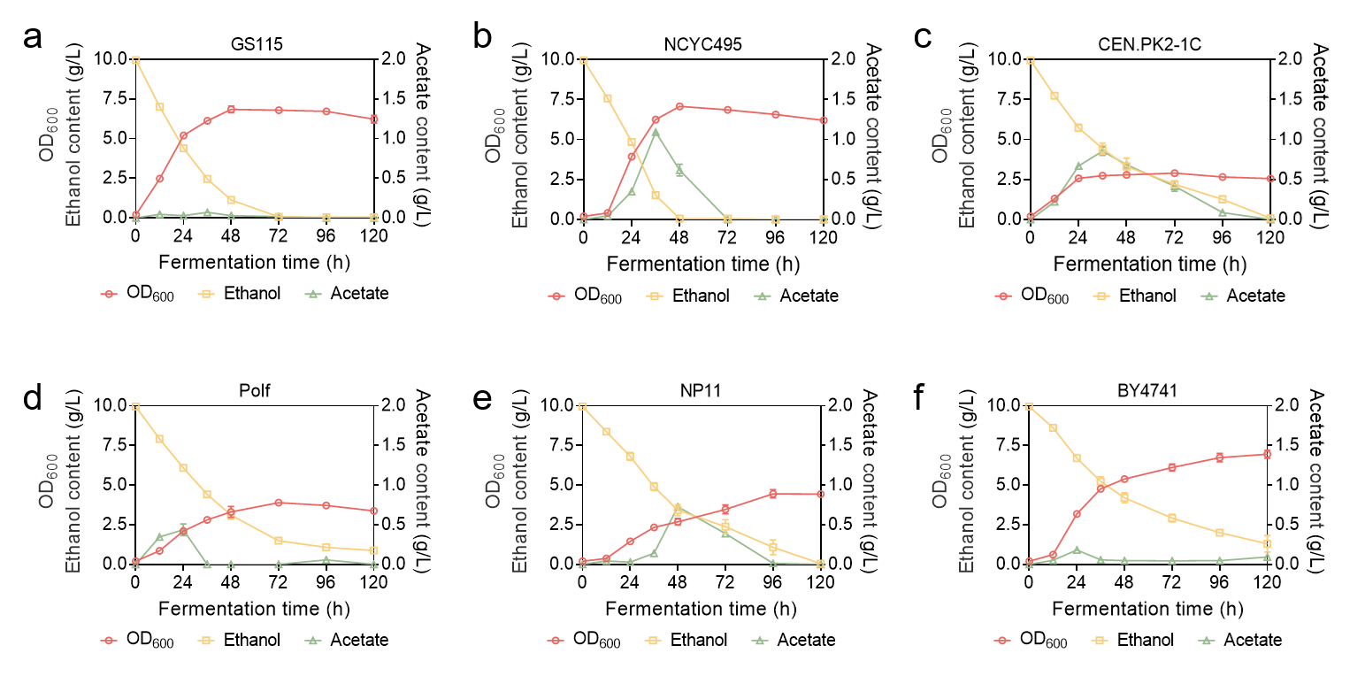
Extended Data Fig. 1 | Fermentation kinetics and ethanol utilization profiles of six representative yeast strains under 10 g/L ethanol cultivation.
a, Time-course fermentation profile of K.phaffii GS115 showing cell growth (OD600, red circles), ethanol consumption (g/L, yellow squares), and extracellular acetate accumulation (g/L, green triangles) over 120 h. b, Time-course profile of O. polymorpha NCYC495. c, Time-course profile of S. cerevisiae CEN.PK2-1C. d, Time-course profile of Y. lipolytica PO1f. e, Time-course profile of R. toruloides NP11. f, Time-course profile of S. cerevisiae BY4741. All strains were cultured in synthetic medium containing 10 g/L ethanol as the sole carbon source. Data are presented as mean ±s.d. (n=3 independent biological replicates).

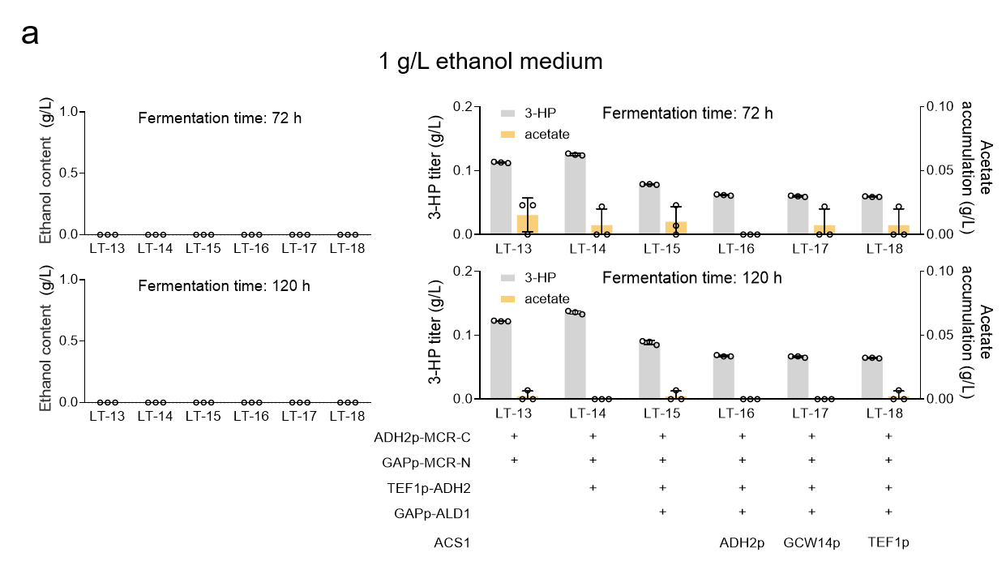

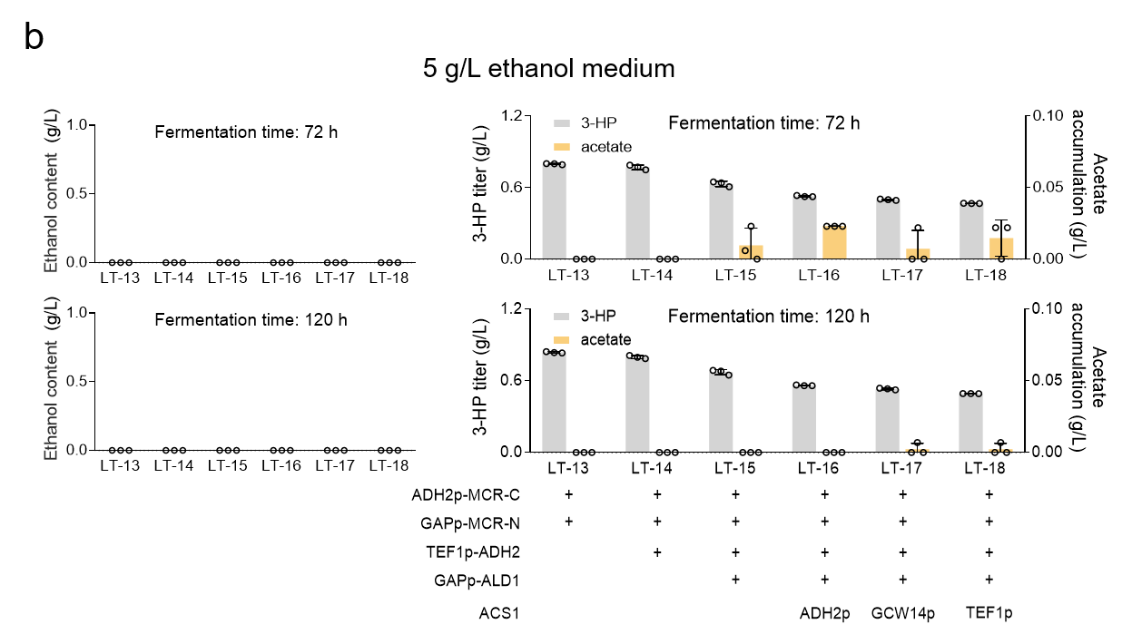

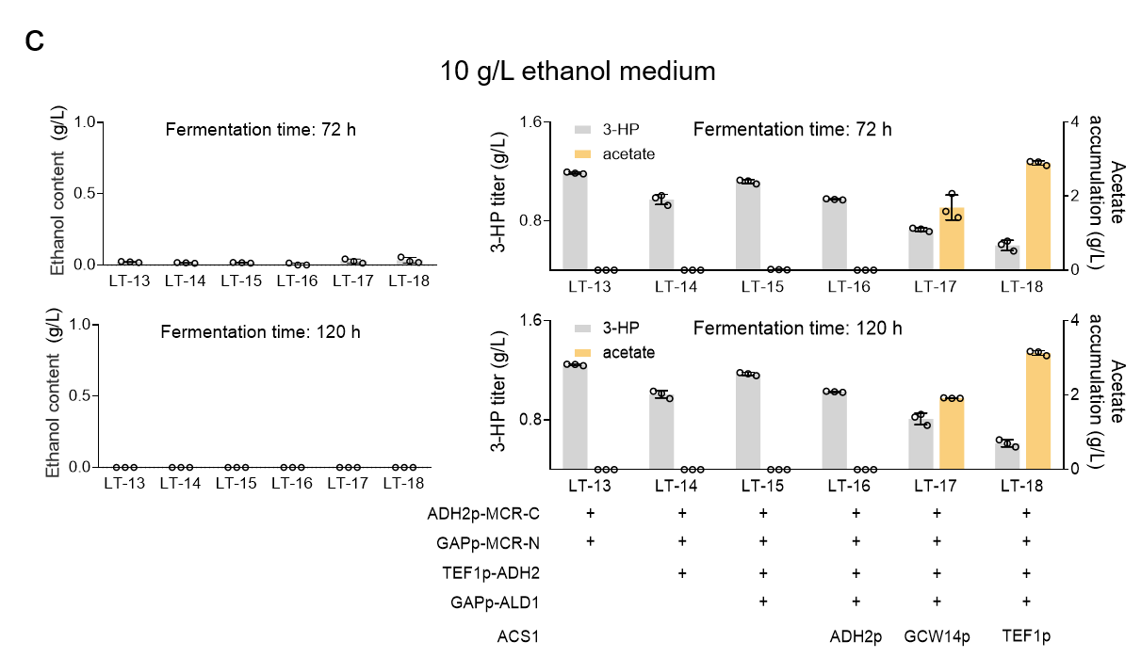
Extended Data Fig. 2 | Characterization of ethanol assimilation and 3-HP production across engineered strains under lower substrate loadings.
a, Fermentation profiles of engineered strains (LT-13 to LT-18) in media containing 1 g/L ethanol. Residual ethanol content (left panels), 3-HP titers (right panels, grey bars), and acetate accumulation (right panels, yellow bars) were determined at 72 h and 120 h of cultivation, respectively. Genotypic modifications of the respective strains—including the expression modules of MCR-C, MCR-N, ADH2, ALD1, and ACS1 under distinct promoters—are indicated at the bottom. b, Same as in a, but with 5 g/L ethanol medium. c, Same as in a, but with 10 g/L ethanol medium. Data are presented as mean ± s.d. (n = 3 independent biological replicates).
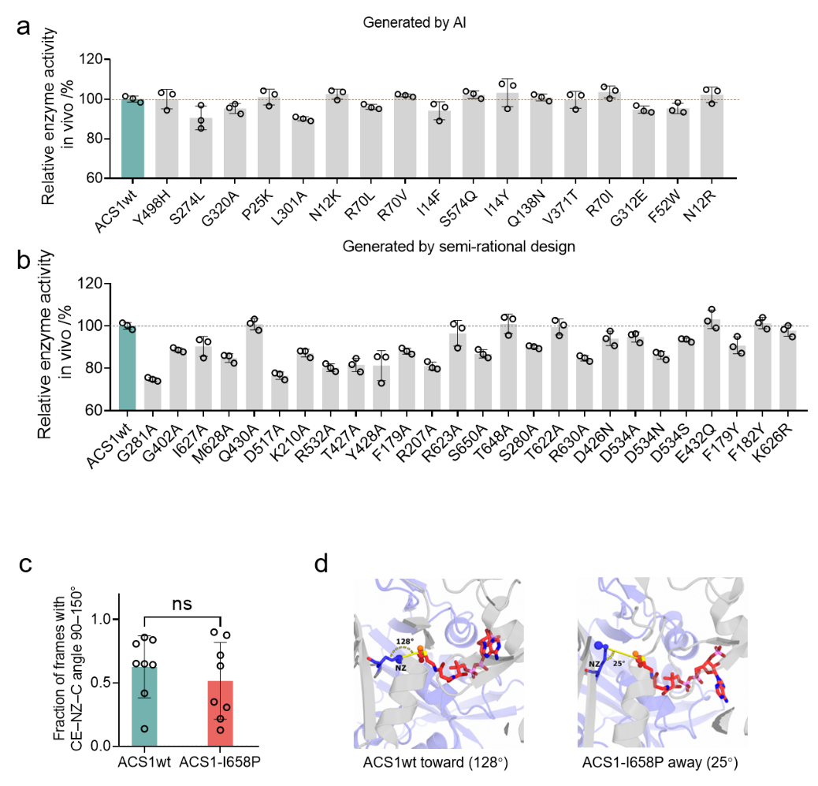
Extended Data Fig. 3 | Engineering of endogenous K. phaffii GS115 ACS1 and characterization of variants.
a, Relative activities of 17 ACS1 variants selected by Saprot-based protein language model prediction, determined from 3-HP production after cultivation in medium containing 20 g/L ethanol for 120 h. b, Relative activities of 26 ACS1 variants selected by semi-rational design, determined from 3-HP production after cultivation in medium containing 20 g/L ethanol for 120 h. Data are presented as mean ±s.d. (n=3 independent biological replicates). c, Fraction of MD simulation frames with a CE–NZ–C angle of 90–150°, defined as the “toward ACO” orientation. Points represent independent MD replicas; bars show the mean and error bars indicate s.d.; ns, not significant. d, Representative MD snapshots of ACS1wt in a toward-ACO orientation (128°) and ACS1-I658P in an away-from-ACO orientation (25°). The ACS domain is shown in gray, the GNAT domain in light purple, docked acetyl-CoA (ACO) in red sticks and K626 in blue sticks. The K626 NZ atom is the terminal nitrogen of the lysine side chain and represents the nucleophilic amine that attacks the acetyl carbonyl carbon of ACO. Yellow dashed arcs indicate the CE–NZ–C angle. The CE–NZ–C angle is defined by the K626 C atom (CE), the terminal N atom of the K626 lysine side chain (NZ), and the acetyl carbonyl carbon of ACO (C).

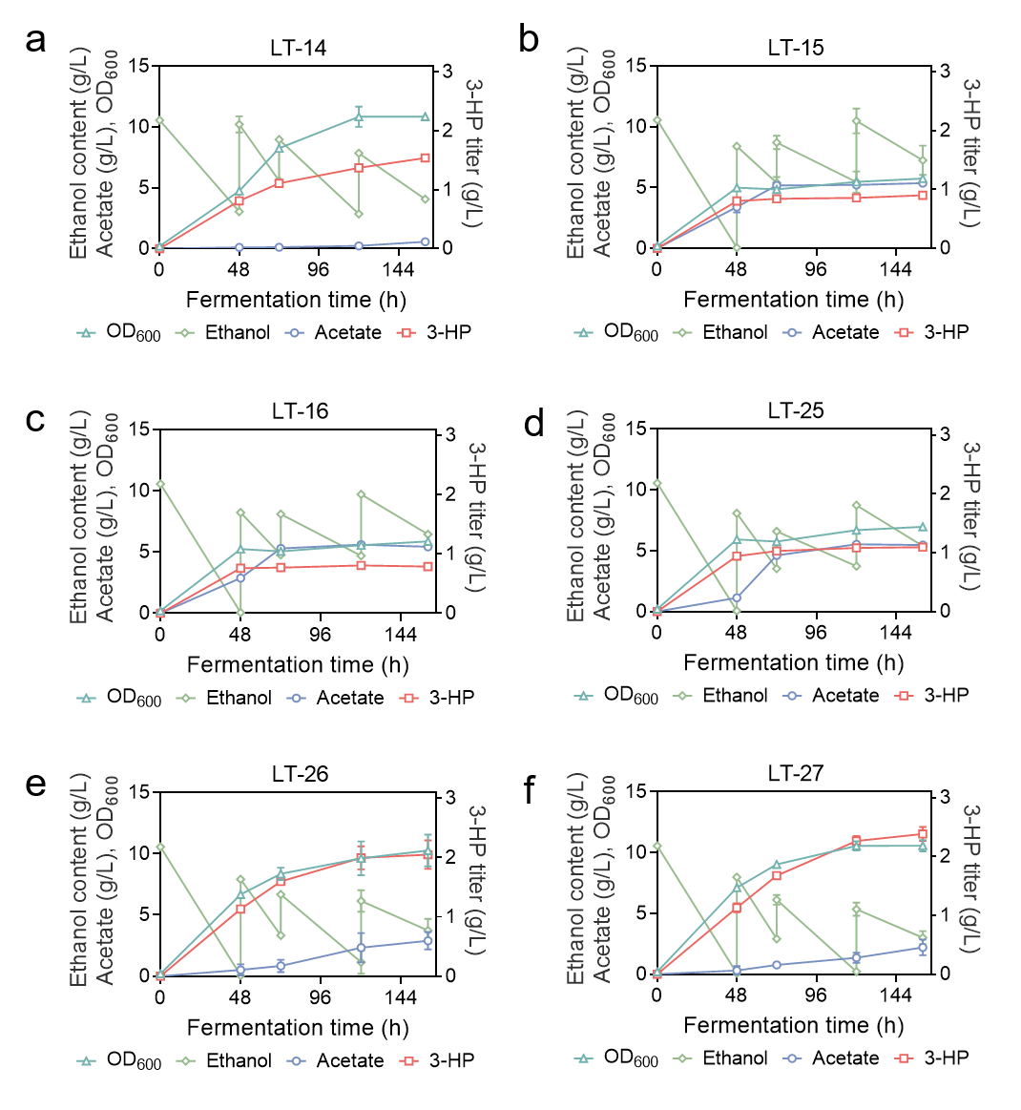
Extended Data Fig. 4 | Time-course profiles of six engineered strains during 160 h of fed-batch shake-flask cultivations.
a, Time-course profiles of cell growth (OD₆₀₀, cyan triangles), residual ethanol content (green diamonds), acetate accumulation (blue circles), and 3-HP titer (red squares) for strain LT-14 during 160 h of fed-batch cultivation in shake flasks. The initial ethanol concentration was set at 10 g/L. Intermittent pulse feeding of pure ethanol (0.2–0.5 mL) paired with an equal volume of 2.5xYNB solution was initiated at 48 h and maintained every 24–48 h. b, Same as in a, time-course profile of strain LT-15. c, Same as in a, time-course profile of strain LT-16. d, Same as in a, time-course profile of strain LT-25. e, Same as in a, time-course profile of strain LT-26. f, Same as in a, time-course profile of strain LT-27. Data are presented as mean ± s.d. (n = 3 independent biological replicates).
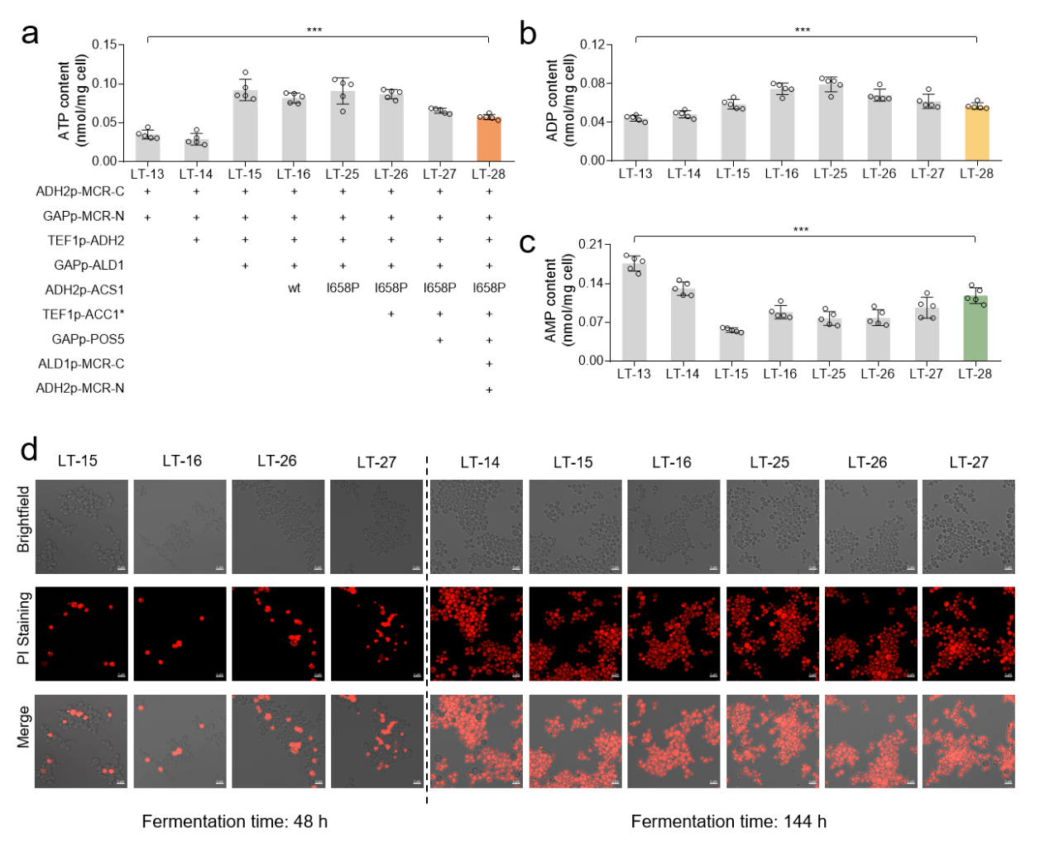
Extended Data Fig. 5 | Intracellular adenylate levels and cell membrane integrity of eight engineered strains during 160 h of fed-batch shake-flask cultivations.
a, Intracellular ATP content in eight engineered strains (LT-13 to LT-28). Genotypic modifications of each strain—including the progressive integration of MCR-C, MCR-N, ADH2, ALD1, ACS1 (wild-type or I658P mutant), ACC1*, and POS5 expression modules under specified promoters—are indicated at the bottom. b, Intracellular ADP content in the eight engineered strains. c, Intracellular AMP content in the eight engineered strains. Data in a-c are presented as mean ± s.d. (n = 5 independent biological replicates). Statistical significance was determined using one-way ANOVA with Tukey’s post-hoc test (***P < 0.001). d, PI staining depicting membrane integrity of engineered strains at 48 h and 144 h during 160 h fed-batch shake-flask cultivations. Brightfield images (top), PI fluorescence staining images (middle), and merged overlays (bottom) are shown. Scale bars, 5 μm. Representative images are from n=5 independent experiments with similar results.

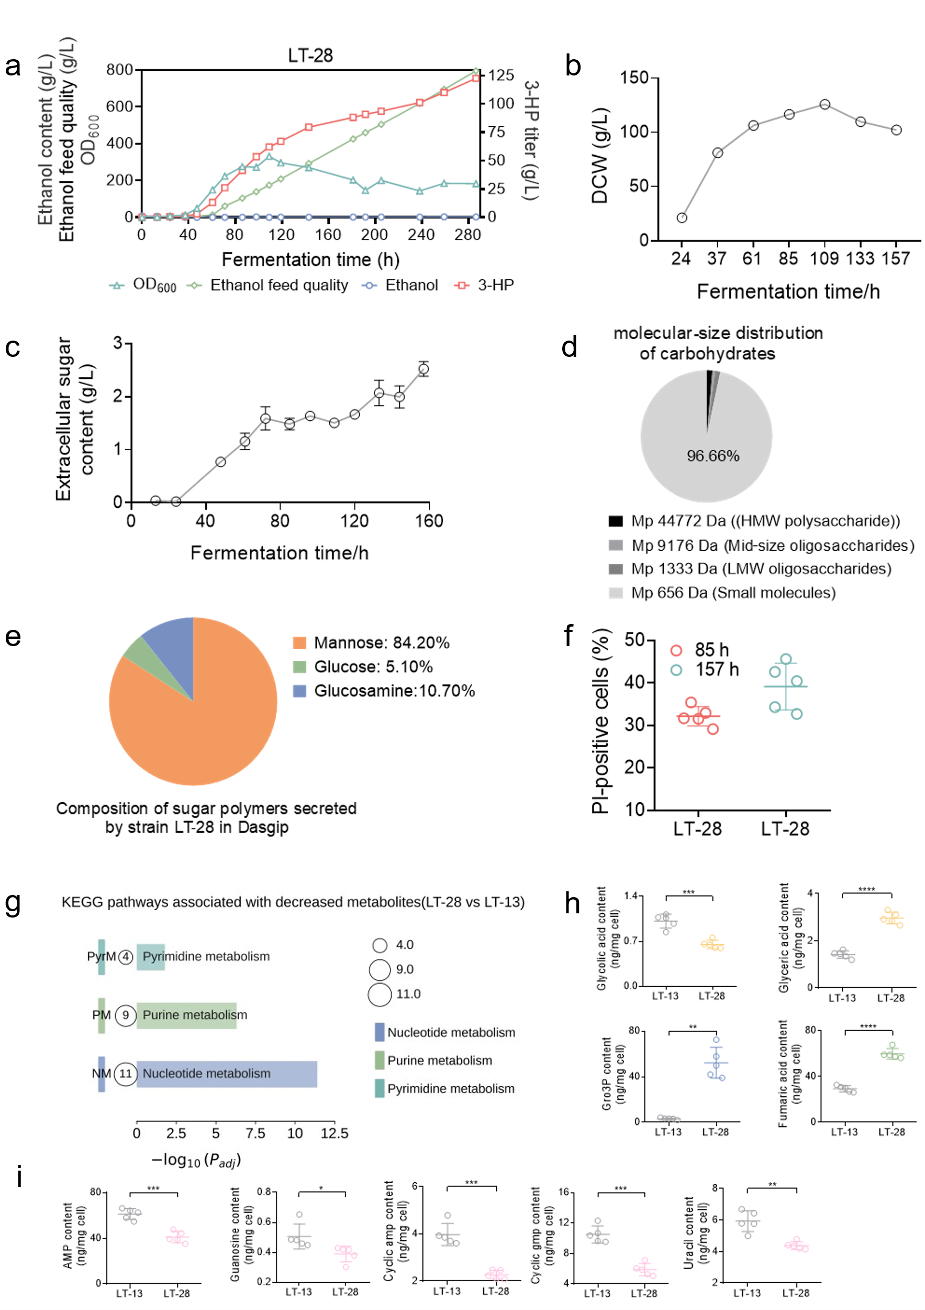
Extended Data Fig. 6 | Scale-up performance of strain LT-28 in a bioreactor and comparative intracellular metabolomic profiling.
a, Initial fed-batch fermentation profile of strain LT-28 in a Dasgip bioreactor. Cultivation was performed with an initial OD₆₀₀ of 0.810 in 8 g/L YNE medium, with pH controlled at 5.6 and ethanol feeding triggered by DO levels > 40%. b–f, Characterization of extracellular carbohydrate secretion and cell viability of strain LT-28 during bioreactor cultivation corresponding to the fermentation trial shown in Fig. 6a. b, DCW profile. c, Extracellular total sugar content determined by the anthrone-sulfuric acid assay. Data are presented as mean ± s.d. (n= 3 biological replicates). d, Molecular-size distribution of extracellular carbohydrates analyzed by HPGPC. Values represent peak area percentages. e, Molar percentage composition of monosaccharides in secreted oligosaccharides and polysaccharides determined by HPAEC-PAD. f, Proportions of propidium iodide (PI)-positive cells sampled at 85 h and 157 h. Center line indicates mean (n = 5 biological replicates). g, KEGG pathway enrichment analysis (-log₁₀P. adj) of differential intracellular metabolites between strain LT-28 and control strain LT-13. Selected pathways contain representative metabolites that decreased in LT-28 (including AMP, guanosine, cAMP, cGMP, and uracil). Bubble size represents the total number of differential metabolites mapped to each pathway. h, i, Comparative levels of representative upregulated (h) and downregulated (i) intracellular metabolites between strains LT-13 and LT-28. Data are presented as mean ± s.d. (n = 5 biological replicates). Statistical significance was calculated using two‑tailed unpaired t‑test with Welch’s correction. (*P < 0.05, **P < 0.01, ***P < 0.001, ****P < 0.0001).

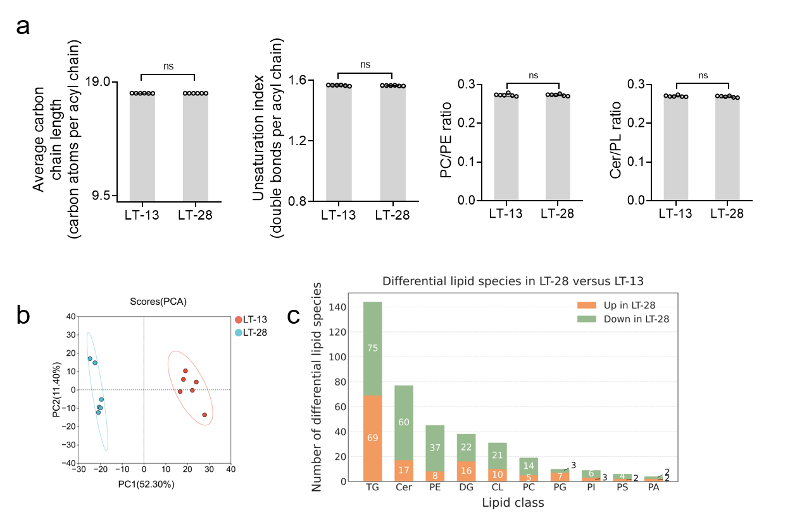
Extended Data Fig. 7 | Lipidomic profiling of LT-13 and LT-28 during growth on ethanol.
a, Comparison of global lipid structural indices between LT-13 and LT-28, including average acyl-chain length (ACL), unsaturation index (UI), phosphatidylcholine-to-phosphatidylethanolamine ratio (PC/PE) and ceramide-to-phospholipid ratio (Cer/PL). ACL and UI were calculated as abundance-weighted averages of phospholipid species, with ACL expressed as the number of carbon atoms per acyl chain and UI as the number of double bonds per acyl chain. PC/PE and Cer/PL were calculated from the summed normalized abundances of the corresponding lipid classes. Data are shown as individual biological replicates (n = 6) with bars representing the mean. Statistical significance was assessed using two-sided Welch’s t-tests; ns, not significant. b, PCA of the lipidomic profiles in positive-ion mode of LT-13 and LT-28. Each point represents an independent biological replicate (n = 6). The percentages indicate the variance explained by the first two principal components. Ellipses indicate 95% confidence intervals. c, Distribution of differential lipid species between LT-28 and LT-13 across major lipid classes. Bars show the numbers of lipid species that were increased or decreased in LT-28 relative to LT-13. TG, triglyceride; Cer, ceramide; PE, phosphatidylethanolamine; DG, diglyceride; CL, cardiolipin; PC, phosphatidylcholine; PG, phosphatidylglycerol; PI, phosphatidylinositol; PS, phosphatidylserine; PA, phosphatidic acid.
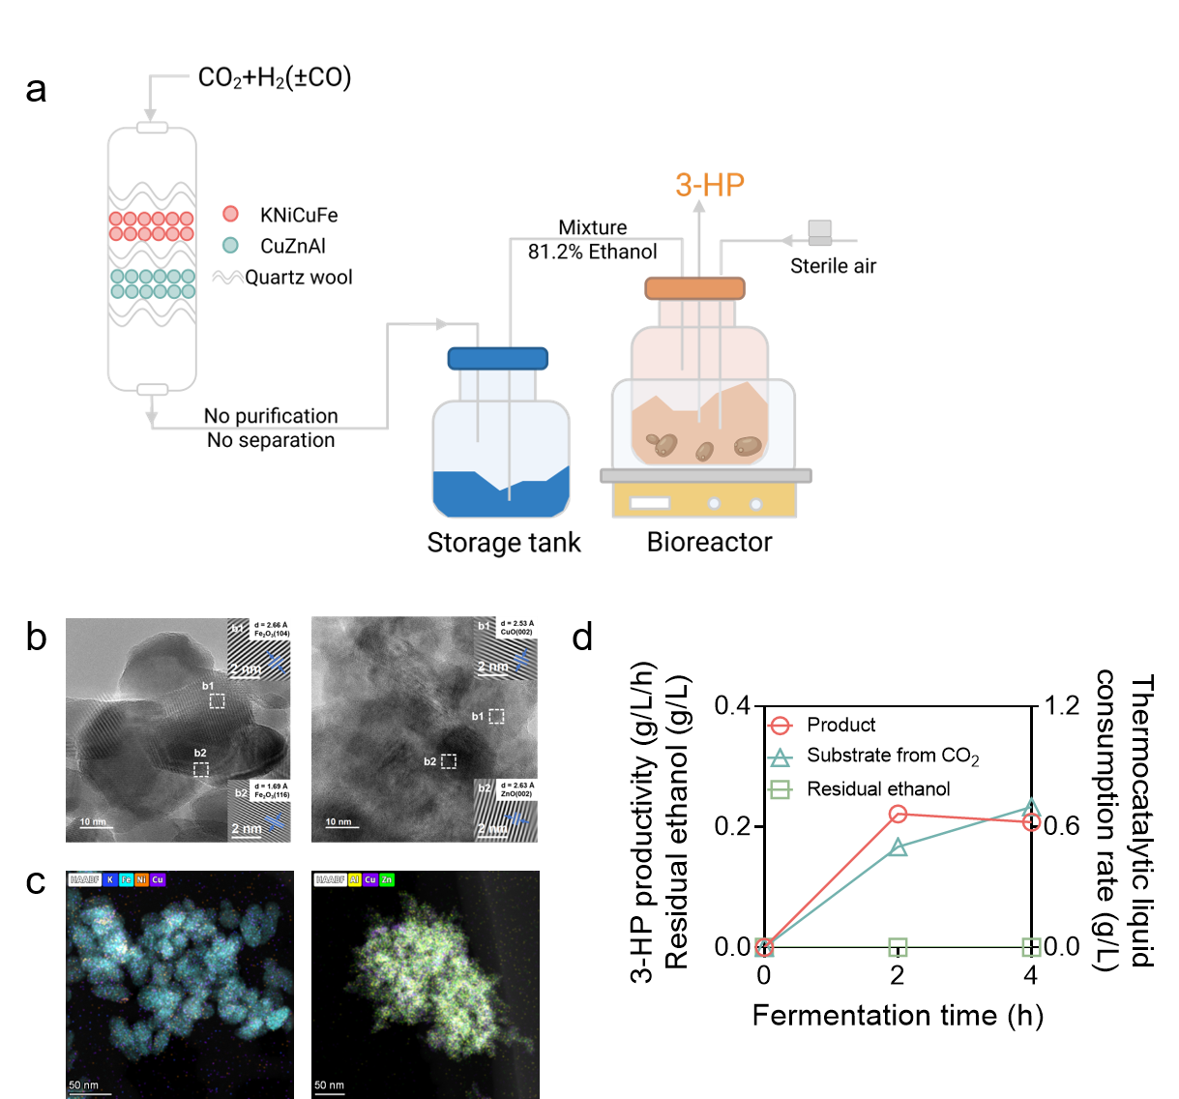
Extended Data Fig. 8 | Coupled thermocatalytic-biological conversion of CO₂ to 3-HP by engineered strain LT-28.
a, Schematic of the integrated CO₂-to-3-HP system. CO₂/H₂ (±CO) passes through a dual-bed thermocatalytic reactor to generate ethanol-rich liquid products, which are directly delivered to the LT-28 bioreactor for 3-HP synthesis without purification. b, HRTEM micrographs of the KNiCuFe (left) and CuZnAl (right) catalysts. Insets b1 and b2 display lattice-resolved crystalline features. c, Elemental mapping showing elemental distribution of KNiCuFe (left) and CuZnAl (right) catalyst particles. d, Time-dependent profiles of 3-HP productivity, substrate consumption rate and residual ethanol concentration during the coupled bioconversion.

