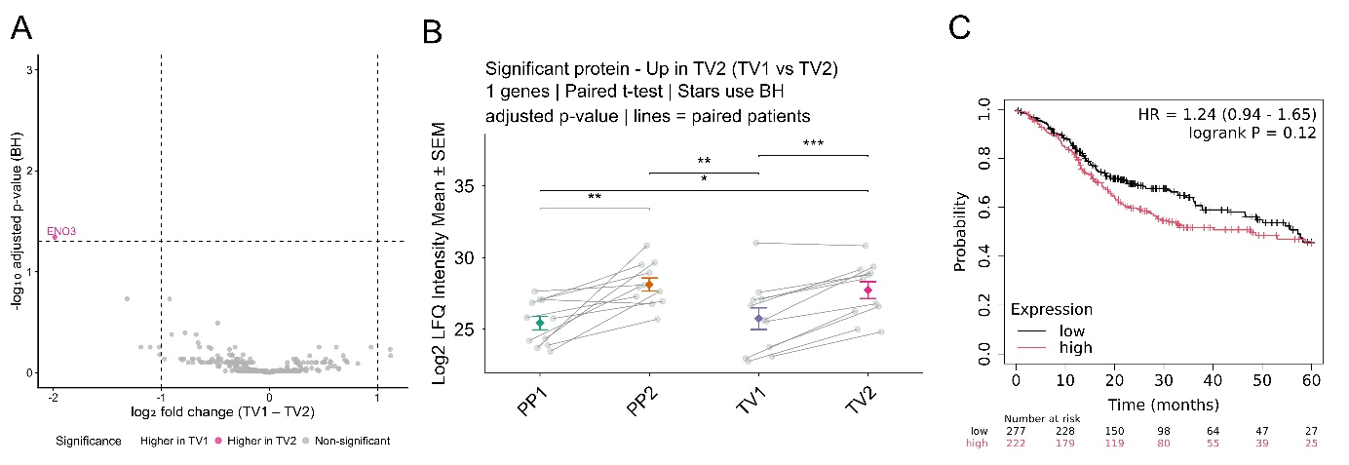

Supplemental Fig. 1. Proteomic profiling of tumor venous plasma EVs before and after tumor resection. (A) Volcano plot of tumor venous plasma EVs before (TV1) versus after (TV2) resection (n = 11); one protein, ENO3, elevated in TV2 (adjusted p < 0.05, fold change > 2). (B) Log2 LFQ intensity of ENO3 in PP1, PP2, TV1, and TV2; each dot represents one patient, mean ± SEM. Paired t-test, BH-adjusted: *p < 0.05, **p < 0.01, ***p < 0.001, ****p < 0.0001. (C) Kaplan–Meier 5-year overall survival of HNSCC patients stratified by nine-protein signature expression (KMplot.com, Pan-cancer RNA-seq, n = 499; best cutoff).

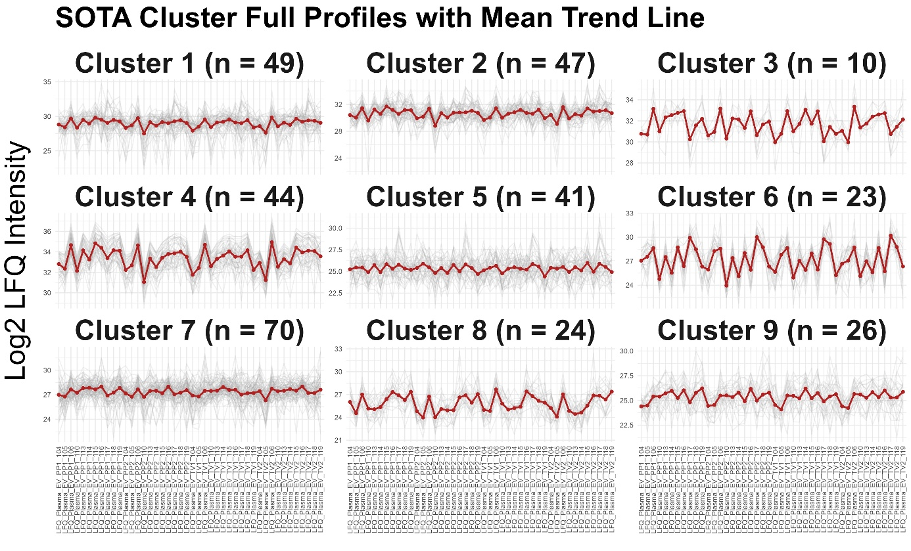
Supplementary Fig. 2. SOTA clustering of EV protein profiles. Unsupervised SOTA clustering yielded nine co-varying clusters. Grey lines show individual proteins; red lines show cluster means. Protein counts per cluster are shown in panel headers.

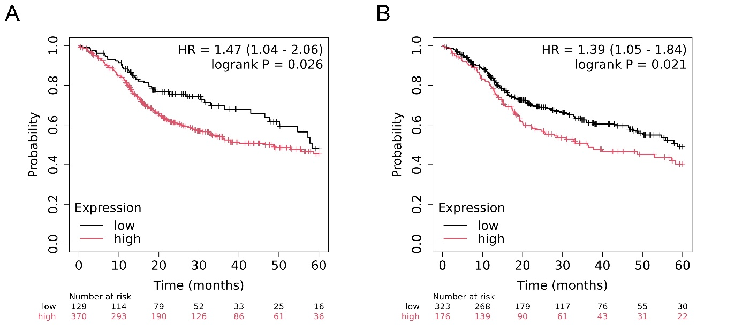

Supplemental Fig. 2. Unsupervised SOTA clustering reveals a survival-associated EV protein signature (A) Kaplan–Meier 5-year overall survival curves for HNSCC patients stratified by average expression of the 24-protein signature identified in Cluster 8 (KMplot.com, Pan-cancer RNA-seq, n = 499; auto-selected best cutoff). (B) Kaplan–Meier 5-year overall survival curves for HNSCC patients stratified by average expression of the two-protein signature co-identified in Cluster 8 and the pairwise differential protein sets (KMplot.com, Pan-cancer RNA-seq, n = 499; auto-selected best cutoff).

