Appendix
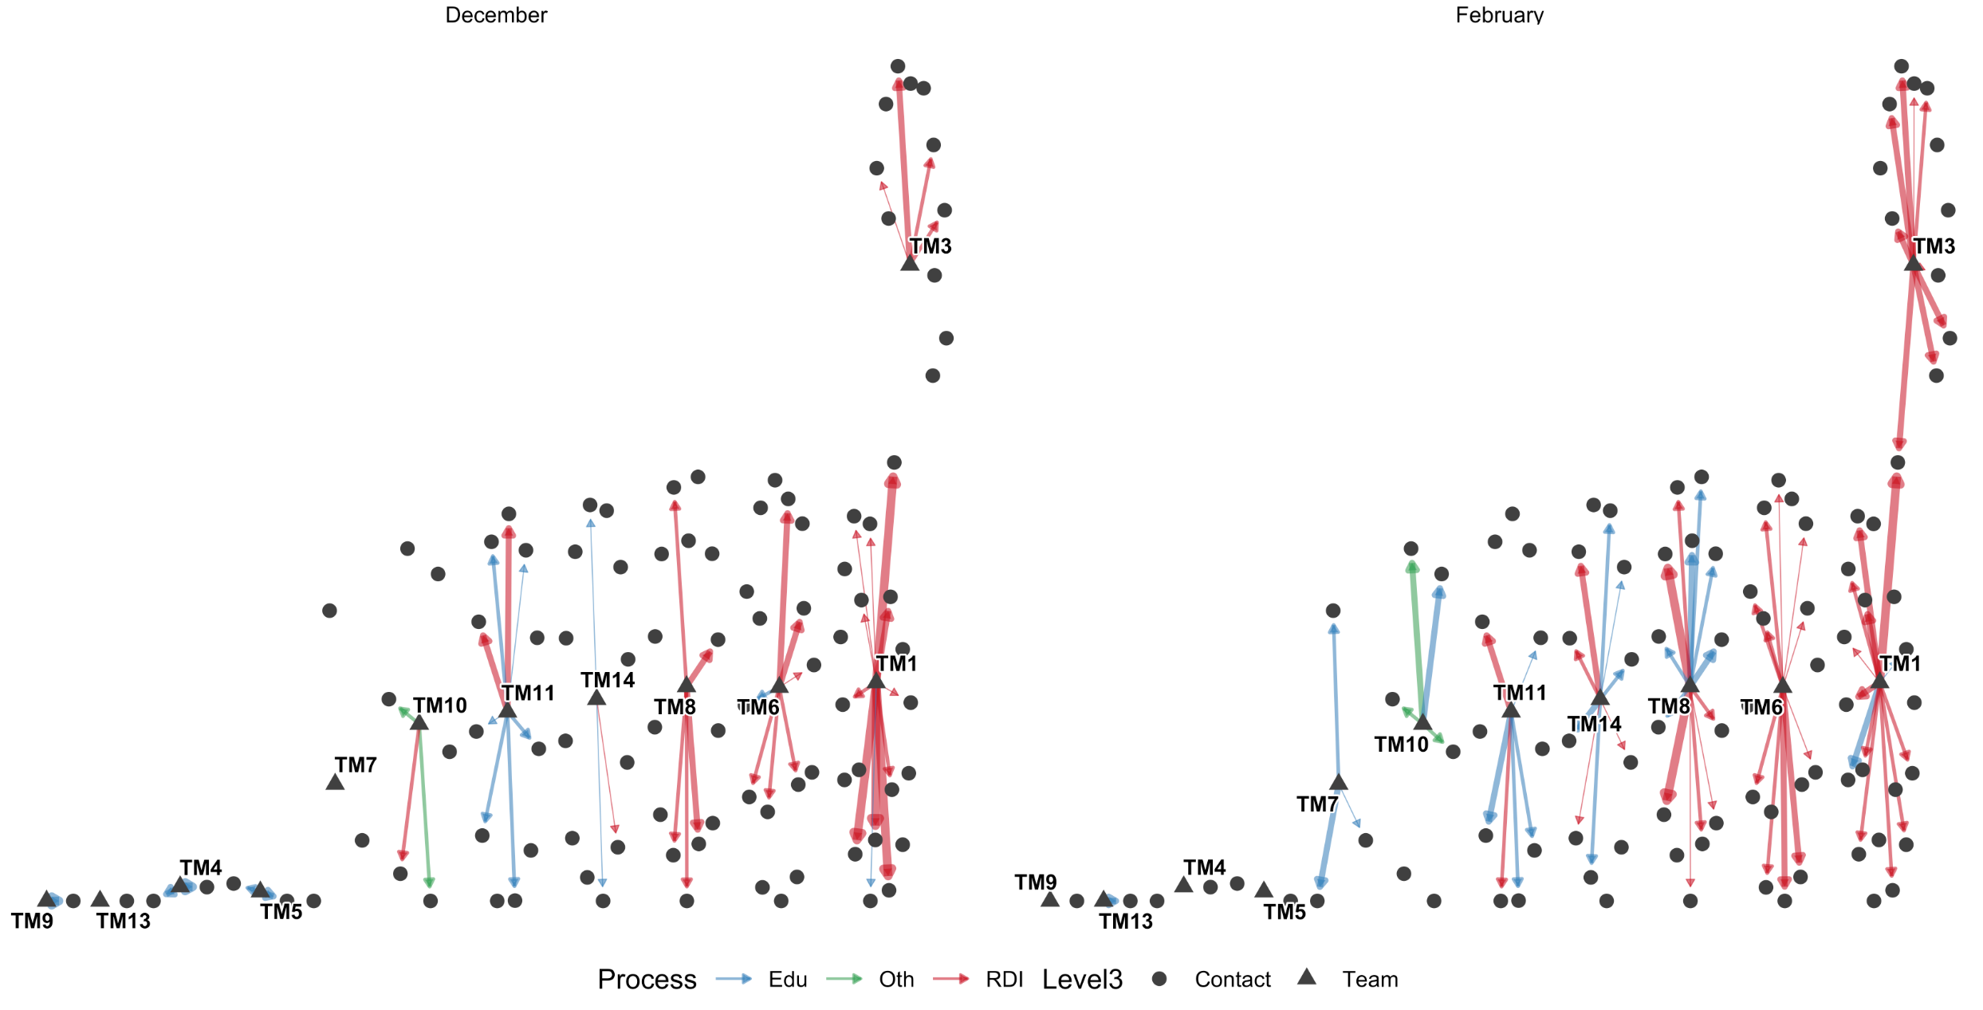
Fig. A1 External outreach subnetwork, December and February. Directed ties from members to contacts outside the institution, coloured by process type, with width proportional to interaction intensity. Members with no external tie in a window are plotted as isolates, so the concentration of boundary spanning is visible
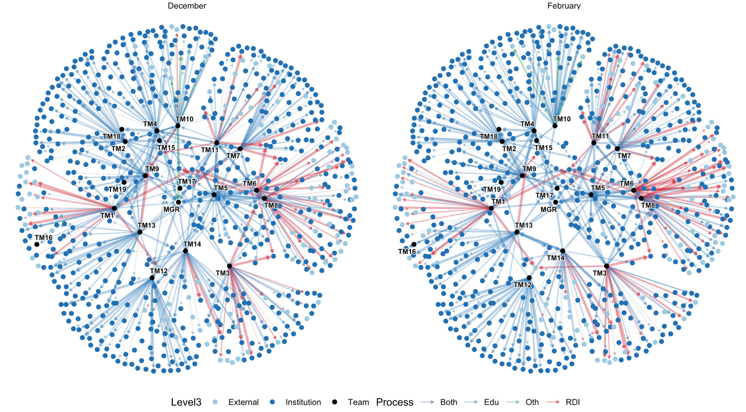
Fig. A2 Full interaction network across all three organizational levels, December and February, faceted by window. Nodes coloured by organizational level, edges by process type. Presented in the appendix rather than in the main text because, with 932 ties across three levels and four process types, it supports no claim that is not made more precisely by Tables 1 to 3

