Supplementary Table S1. Measurement-level characteristics stratified by concurrent CVP (88 observations from 29 patients).
Variable | All (N=88) | CVP≤12 (n=69) | CVP>12 (n=19) | P
Age (years)* | 56.0 [50.0, 60.0] | 56.0 [50.0, 60.0] | 57.0 [53.0, 66.0] | 0.319
Male sex, n (%)* | 51 (58.0) | 33 (47.8) | 18 (94.7) | <0.001
Height (cm)* | 161.0 [153.0, 168.0] | 160.0 [152.0, 167.0] | 170.0 [161.0, 174.5] | <0.001
Weight (kg)* | 60.0 [56.0, 68.0] | 56.0 [54.0, 63.0] | 75.0 [63.0, 90.0] | <0.001
BMI (kg/m²)* | 23.8 [21.8, 24.6] | 23.4 [21.6, 24.6] | 28.9 [23.5, 29.1] | <0.001
CPB time (min)* | 194.0 [158.0, 232.5] | 194.0 [158.0, 234.0] | 194.0 [142.5, 194.5] | 0.376
Cross-clamp (min)* | 141.0 [99.8, 169.0] | 142.0 [105.0, 178.0] | 135.0 [92.0, 139.0] | 0.161
APACHE II* | 17.0 [16.0, 19.0] | 17.0 [16.0, 18.0] | 18.0 [17.0, 20.5] | 0.018
ReDS (%) | 28.0 [25.0, 33.5] | 28.0 [25.0, 32.0] | 30.0 [25.0, 38.0] | 0.291
EVLW (mL) | 509 [427, 710] | 500 [418, 708] | 569 [465, 738] | 0.414
ELWI (mL/kg) | 9.5 [7.0, 13.0] | 9.0 [7.0, 13.0] | 11.0 [8.0, 12.5] | 0.460
PVPI | 1.6 [1.4, 2.5] | 1.6 [1.3, 2.5] | 1.8 [1.6, 2.4] | 0.333
ITBV (mL) | 1590 [1317, 1808] | 1590 [1317, 1776] | 1581 [1247, 1984] | 0.812
ITBVI (mL/m²) | 962 [837, 1088] | 956 [854, 1080] | 986 [804, 1147] | 0.648
GEDI (mL/m²) | 770 [670, 871] | 765 [662, 849] | 784 [714, 1077] | 0.111
PCCI (L/min/m²) | 2.5±0.8 | 2.5±0.8 | 2.6±0.7 | 0.883
dPmax (mmHg/s) | 1075 [783, 1342] | 1075 [826, 1322] | 964 [657, 1470] | 0.619
ELWI >12, n (%) | 23 (26.1) | 18 (26.1) | 5 (26.3) | —
*Demographic and operative variables are repeated across measurement days from the same patient; P values are descriptive and do not account for clustering. Continuous variables: median [IQR] or mean±SD.
The number of pairs contributed by each patient is shown in Supplementary Figure S2 (median 3; range 1–10).

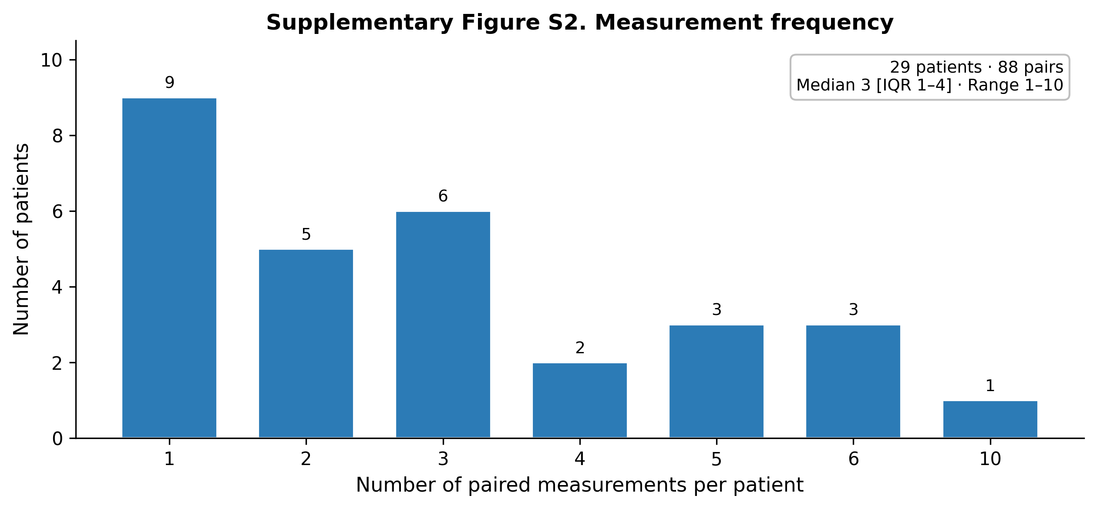
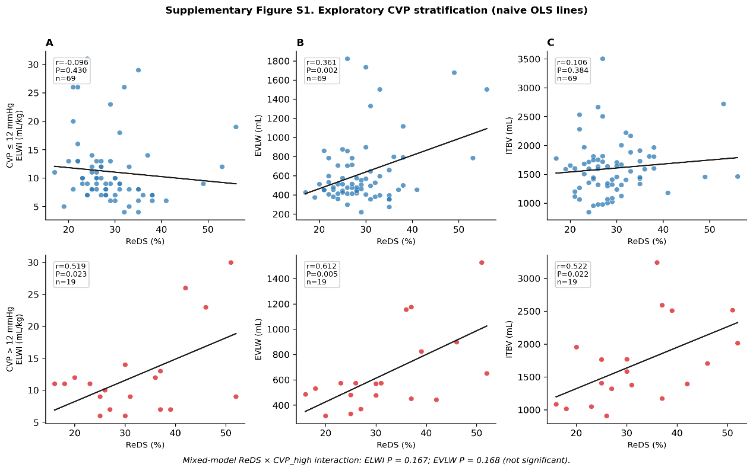
Supplementary Figure S1. Number of paired measurements per patient. Distribution of once-daily ReDS–PiCCO pairs contributed by each of the 29 patients until PiCCO removal (median 3; range 1–10; total 88 pairs).
Supplementary Figure S2. Exploratory stratification by concurrent CVP. Measurement-level scatter plots of ReDS versus (A) ELWI, (B) EVLW, and (C) intrathoracic blood volume (ITBV), separated by CVP ≤ 12 mmHg (top row; n = 69) and CVP > 12 mmHg (bottom row; n = 19). Ordinary least-squares lines are shown for visualization only and do not account for within-patient clustering. In mixed-effects models with a ReDS × CVP_high interaction, the interaction terms were not significant for ELWI (P = 0.167) or EVLW (P = 0.168).

Table S3. Exploratory ROC metrics of ReDS for ELWI > 12 mL/kg (measurement level).
Stratum | n (events) | AUC (approx. 95% CI) | Interpretation | Cut-off proposed?
Overall | 88 (23) | 0.492 (0.35–0.64) | Non-informative | No
CVP ≤ 12 mmHg | 69 (18) | 0.368 (0.21–0.54) | Non-informative | No
CVP > 12 mmHg (exploratory) | 19 (5) | 0.843 (0.61–1.00) | Hypothesis-generating only | No
AUCs are measurement-level and not cluster-adjusted. The high-CVP subset has only 5 events; no diagnostic threshold is recommended for clinical use.

Figure S3
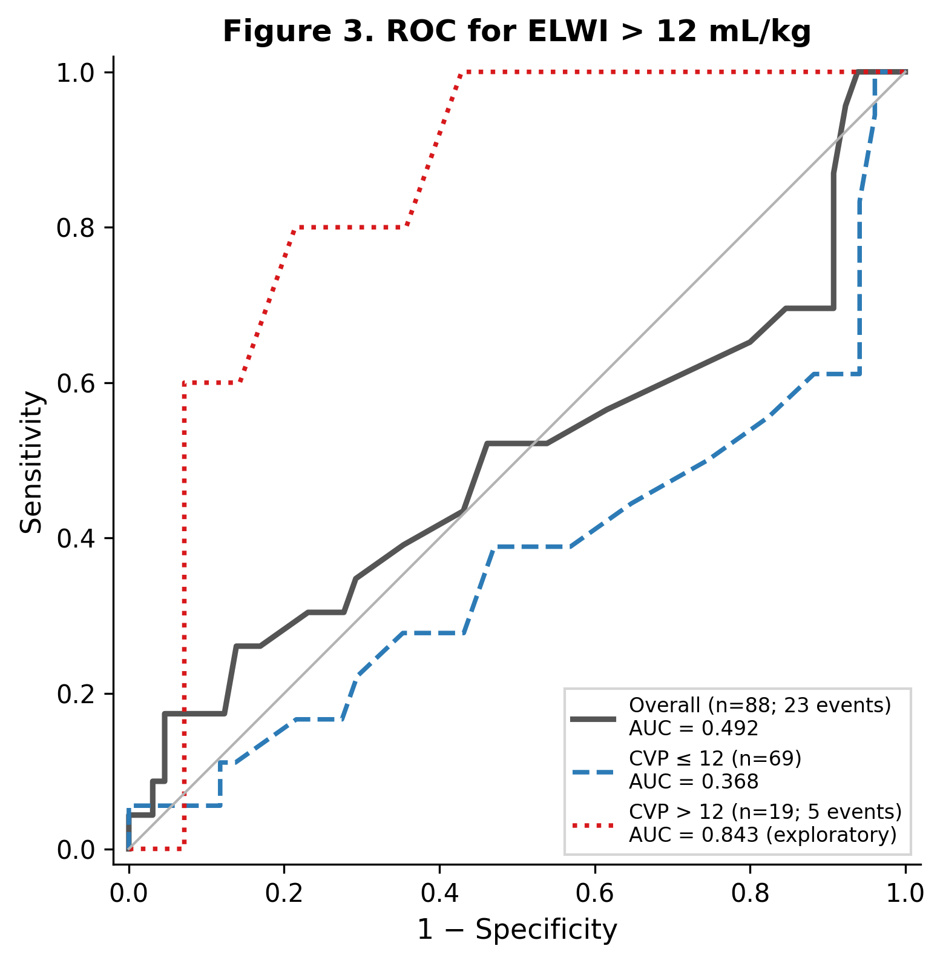
Figure s3. Receiver-operating characteristic curves for ELWI > 12 mL/kg. Discrimination of elevated extravascular lung water index by ReDS at the measurement level. Solid grey line: all measurements (n = 88; 23 events; AUC = 0.492). Dashed blue line: measurements with central venous pressure (CVP) ≤ 12 mmHg (AUC = 0.368). Dotted red line: measurements with CVP > 12 mmHg (n = 19; 5 events; apparent AUC = 0.843; exploratory only). Curves are not adjusted for within-patient clustering; no diagnostic cut-off is recommended.

