Supplementary File to:

Interface energetics and cavity architecture underlying cage stability in six-subunit manganese catalase

Amrita^{1,2}, Srijita Acharya¹, Soumyananda Chakraborti^{3*}, Sucharita Dey^{1*}

¹Department of Bioscience and Bioengineering, Indian Institute of Technology Jodhpur, NH 62, Nagaur Road, Karwar 342030, Rajasthan, India.
²Current address: Department of Life Sciences, Kristu Jayanti University, K.Narayanapura, Bengaluru-560077, Karnataka, India
³Department of Biological Sciences, Birla Institute of Technology & Science, Pilani, Hyderabad Campus, Jawahar Nagar, Kapra Mandal, Dist.-Medchal-500 078, Telangana, India
*Corresponding Authors: soumyananda.chakraborti@hyderabad.bits-pilani.ac.in (SC), sdey@iitj.ac.in (SD)
#Lead Contact: sdey@iitj.ac.in; Tel: +91 291 280 1218

Supplementary Table 1: Dataset, source organism, and quality of the Manganese catalase structures used in the study

Manganese catalase abbreviation used | MnCatalase Type | PDB ID | Organism | Resolution/Quality
Lactobacillus (LactoB) | Mesophilic | 1jku | Lactobacillus plantarum | 1.84 Å
Anabaena | Mesophilic | 6j42 | Nostoc sp. PCC7120 | 2.49 Å
Thermophilic (Thermo) | Thermophilic | 2v8t | Thermus thermophilus HB27 | 0.98 Å
Thermophilic  (Thermo) | Thermophilic | 2cwl | Thermus thermophilus HB8 | 1.65 Å
Geobacillus (GeoB) | Extremophile | AFª | Geobacillus thermopakistaniensis | ipTM^{b}=0.96, pTM^{c}=0.96
Archaea | Extremophile | AFª | Pyrobaculum calidifontis | ipTM^{b}=0.96, pTM^{c}=0.97
ªAlphafold (AF) modelled structures. ^{b}ipTM: interface predicted Template Modelling score. It is a confidence metric that estimates how accurately AlphaFold predicts the relative positioning between the chains in the modelled complex. ^{c}pTM: predicted Template Modelling score; it evaluates the overall fold of the entire model, whereas ipTM specifically focuses on the chain-chain interfaces.

Supplementary Table 2: Comparison of sequence-based physicochemical properties of a single subunit from Manganese catalase and Ferritin structures (taken from earlier study)

 | Mesophilic MnCatalase | Thermophilic MnCatalase | C-ferritinª | B-ferritinª | Bo-ferritinª | Dps proteinsª
Assembly | 6-mer | 6-mer | 24-mer | 24-mer | 24-mer | 12-mer
Number | 31 | 39 | 18 | 10 | 13 | 30
MW | 29846±294 | 33211±371 | 20739±1562 | 20145±1601 | 18925±1080 | 18947±1832
% Non-polar residues | 48.75 | 59 | 45 | 47 | 47 | 48
% Polar residue | 51.25 | 41 | 55 | 53 | 53 | 52
GRAVY | -0.63 | -0.24 | -0.61 | -0.38 | -0.45 | -0.27
Isoelectric Point | 5.03±0.12 | 5.5±0.16 | 5.32±0.36 | 4.99±0.42 | 4.84±0.20 | 5.09±0.44
Top 3 AA | GLY, GLU, LEU | LEU, ALA , GLY | LEU, GLU ,ALA | LEU, GLU, ALA | LEU, GLU, ALA | LEU, ALA ,GLU
Instability Index | 33.6(stable) | 41(stable) | 37.5(stable) | 39.2(stable) | 39.9(stable) | 34.5(stable)

<MW>: Molecular weight in Daltons
GRAVY: The Grand Average of Hydropathy calculated as the sum of hydropathy values of all the amino acids, divided by the number of residues in the sequence¹.
ªAbbreviations denote the ferritin subfamilies such as eukaryotic classical ferritin (C-ferritin), bacterial ferritin (B-ferritin), bacterioferritin (Bo-ferritin) and Dps proteins (Dps) that were analysed in the earlier study^{1,2}.

Supplementary Table 3: Secondary Structure characteristics of Manganese catalase and Ferritin monomers

 | LactobacillusMnCatalase | Thermophilic MnCatalase | C-ferritin | B-ferritin | Bo-ferritin | Dps proteins
Helix fraction | 0.52 | 0.52 | 0.73 | 0.77 | 0.78 | 0.74
Turn+Bend+Coil fraction | 0.44 | 0.42 | 0.27 | 0.23 | 0.22 | 0.21
β-Sheet fraction | 0.04 | 0.06 | 0.00 | 0.00 | 0.00 | 0.05

* Helix fraction, Turn fraction, and β-Sheet fraction data are obtained from the DSSP tool ³ using PDB structures of the proteins.

Supplementary Table 4: Physico-chemical properties of Manganese catalase and C-ferritin interfaces

 | Interface  type | Mesophilic MnCatalase(2) | Thermophilic MnCatalase(2) | Interface type | Dps proteins(30) | C-ferritin(18)
 | IntL | 7767.8±58.5 | 2450.1±15.2 | IntA | 2646 ± 467 | 2867 ± 330
<Buried surface Area (A²)>, BSA | IntLX | 3575.4±45.9 | 7763.9±106.9 | IntB | 1136± 408 | 1495 ± 511
 | IntN | 2148.8±56.9 | 2061.2±19 | IntC | 1001 ± 358 | 1118 ± 125
 | IntL | 793.7±6.4 | 240.8±1.3 | IntA | 261.1 ± 46.9 | 300.1 ± 36.9
<Number of Interface atoms> | IntLX | 359.8±3.9 | 766.7±5.8 | IntB | 120.6 ± 40.9 | 152 ± 47.7
 | IntN | 215.4±5.2 | 212.1±4.6 | IntC | 105.4 ± 35.4 | 110.9 ± 11.5
 | IntL | 199.9±1.9 | 66±1 | IntA | 71.3 ± 10.6 | 71.2 ± 8.9
<Number of Interface residues> | IntLX | 91±1.2 | 200.7±1.6 | IntB | 31.8 ± 11.2 | 40.2 ± 13.2
 | IntN | 67.1±2.1 | 59.9±0.9 | IntC | 27.3 ± 8.5 | 27.3 ± 8.5
 | IntL | 0.44 | 0.46 | IntA | 0.40 | 0.32
<f _{non-polar}> | IntLX | 0.61 | 0.43 | IntB | 0.34 | 0.29
 | IntN | 0.38 | 0.33 | IntC | 0.44 | 0.35
 | IntL | 24.6±0.2 | 22±0.1 | IntA | 23.0 ± 1.8 | 21.7 ± 1.7
<Local Atomic Density>Ld | IntLX | 25.3±0.1 | 31±0.3 | IntB | 16.7 ± 2.8 | 18.3 ± 1.5
 | IntN | 14.7±0.4 | 22.7±0.3 | IntC | 18.2 ± 3.0 | 17.2 ± 0.9
 | IntL | 39.2±19.9 | 5.5±1.5 | IntA | 12.6 ± 5.6 | 19.0 ± 6.4
<Number of H-bonds> | IntLX | 17.2±0.7 | 54.5±0.5 | IntB | 5.0 ± 3.7 | 5.6 ± 2.0
 | IntN | 10.5±5.0 | 10.3±0.4 | IntC | 3.1 ± 2.1 | 6.9 ± 1.8
 | IntL | -257.8±86.9 | -72.95±0.65 | IntA | -80±21.9 | -89.1±15.8
<ΔG> (Rosetta energy unit) | IntLX | -92.95±6.65 | -281.55±3.15 | IntB | -24.6±14 | -35.4±13
 | IntN | -43.6±22.7 | -65.85±1.05 | IntC | -25.6±12.2 | -29.1±5.3
 | IntL | 0.76±0.01 | 0.74±0 | IntA | 0.70±0.06 | 0.70±0.04
<Sc> | IntLX | 0.64±0.01 | 0.72±0 | IntB | 0.64±0.06 | 0.67±0.04
 | IntN | 0.65±0.02 | 0.75±0.01 | IntC | 0.72±0.08 | 0.76±0.06
 | IntL | -793 | -950.4 | IntA | -566.6 | -719.8
<Elec> (kcal/mol) | IntLX | -724.2 | -1106.5 | IntB | -539.3 | -667.3
 | IntN | -693.6 | -970.3 | IntC | -520.5 | -662.9
 | IntL | -2975.1, 459.5 | -3582.8, 986.9 | IntA | -1932.8,  535.4 | -2162.6, 405.3
<van der Waals energy> attr, rep (kcal/mol) | IntLX | -2780, 559 | -3828.5, 851.6 | IntB | -1885.5, 664.3 | -2110.8, 433.4
 | IntN | -2721.3, 734.1 | -3594.3, 1015.1 | IntC | -1883.3, 759.6 | -2110, 447

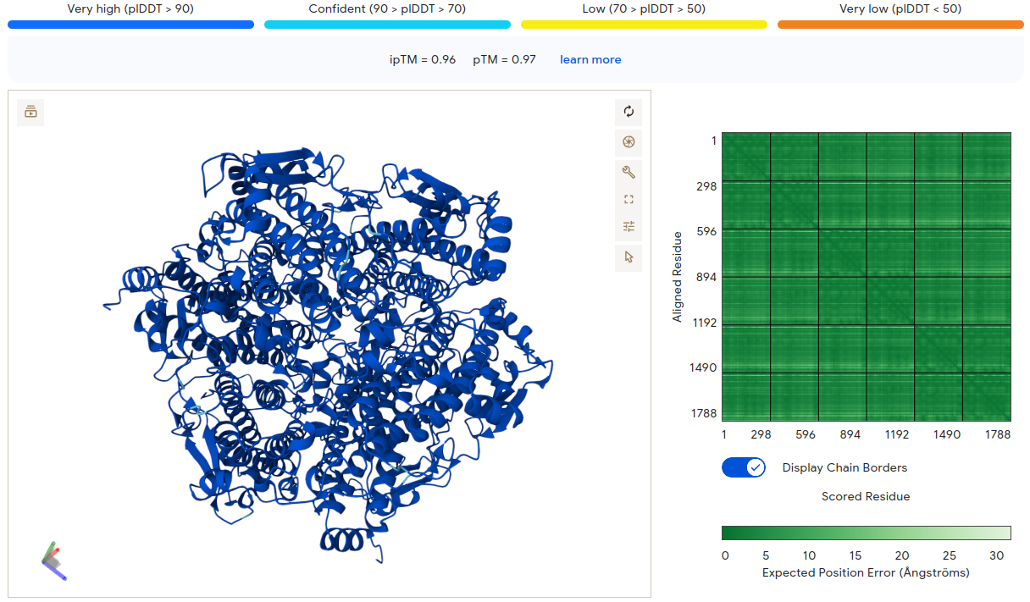

Figure S1: Archaea (Pyrobaculum calidifontis) Alphafold structure confidence level (ipTM=0.96,pTM=0.97

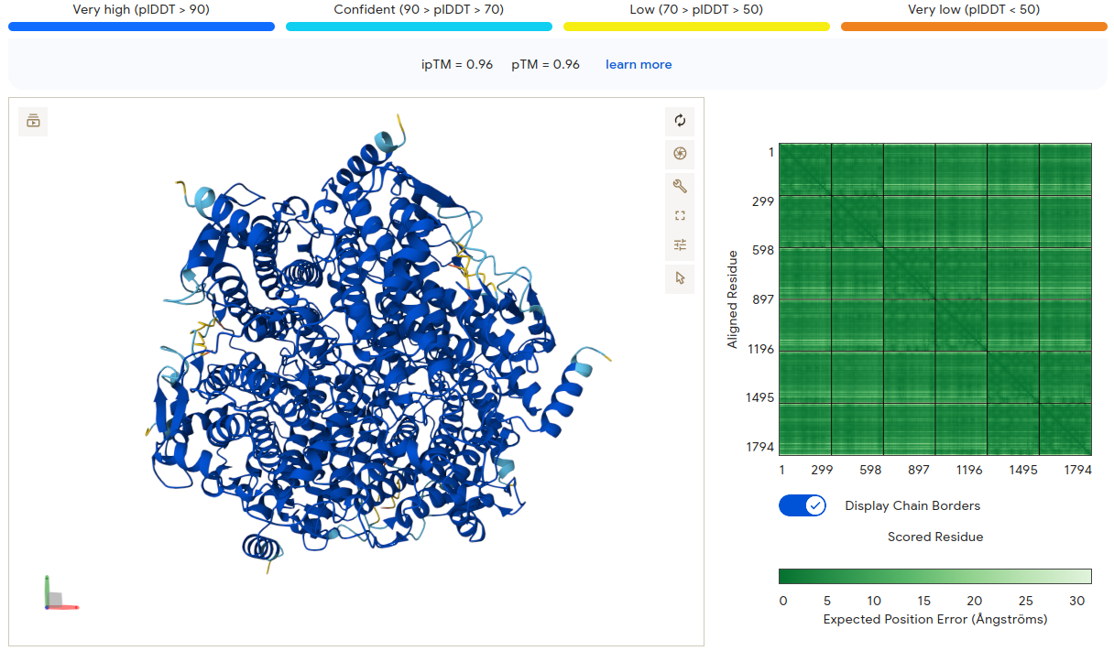
Figure S2: GeoB (Geobacillus thermopakistaniensis) Alphafold structure confidence level (ipTM=0.96,pTM=0.96)

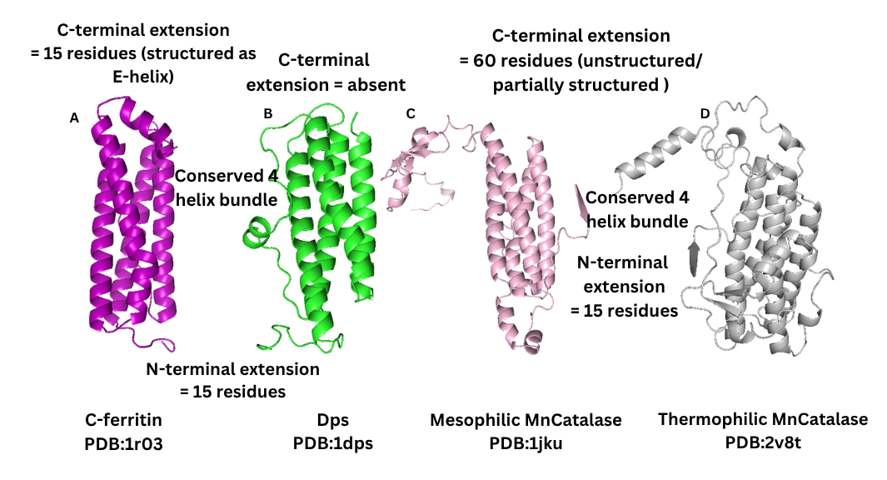

Figure S3: Structural comparison of Manganese catalase monomer with that of C-ferritin and Dps monomer
Cartoon depiction of the monomer of A. C-ferritin (PDB:1r03) in purple, B. Dps (PDB:1dps) in green, C. Mesophilic MnCatalase (PDB:1jku) in pink and D. Thermophilic MnCatalase (PDB:2v8t) in grey

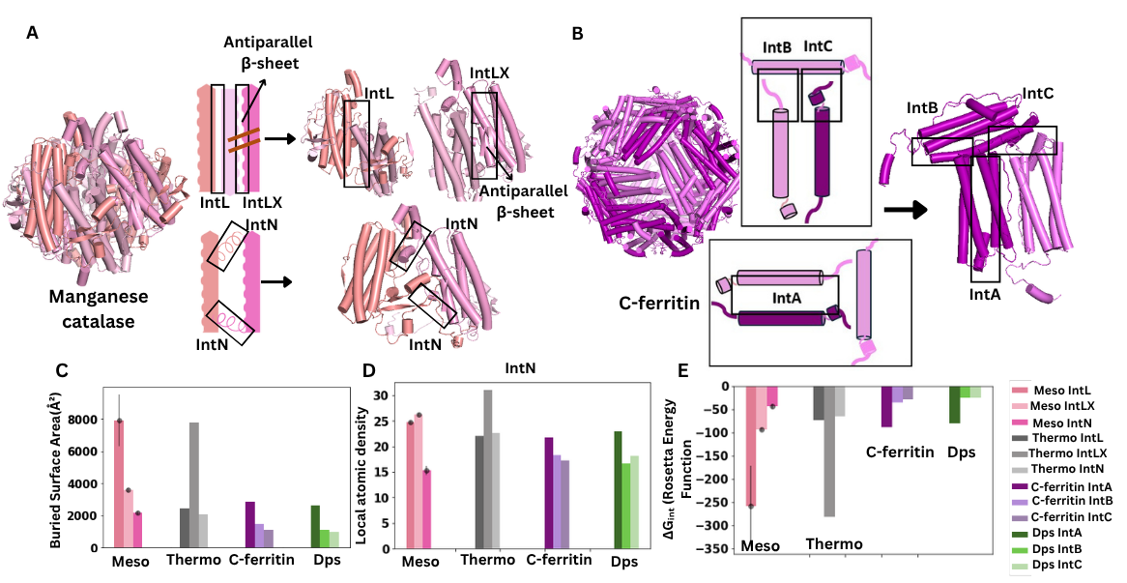
Figure S4: Structural depiction of manganese catalase and C-ferritin interfaces and its geometrical properties
Cylindrical cartoon depiction of the cage and interfaces of A. Manganese catalase with IntL as lateral interface without antiparallel β sheet, Int LX as lateral interface with antiparallel β sheet and IntN as angular interface, B. C-ferritin with IntA as interface generated between antiparallel subunits, Int B as perpendicular interface with N-terminus extension and IntC as perpendicular interface with C-terminus extension. C. Buried Surface Area (BSA) and D. Local atomic density for the 3 interfaces of Mesophilic (Meso) and Thermophilic (Thermo) Manganese catalase (IntL, IntLX and IntN) and for the 3 interfaces of C-ferritin and Dps proteins (IntA, IntB and IntC). (Local Atomic Density is the mean number of interface atoms located within 12Å of a given interface atom )⁴ E. ΔG analysis for the 3 interfaces of Mesophilic (Meso) and Thermophilic (Thermo) Manganese catalase (IntL, IntLX and IntN) and for the 3 interfaces of C-ferritin and Dps proteins (IntA, IntB and IntC) using Rosetta tool. In all the barplots, Mesophilic MnCatalase interfaces data is shown in the shades of pink, Thermophilic MnCatalase interfaces data is shown in the shades of grey, C-ferritin interfaces data is shown in the shades of purple and Dps interfaces data is shown in the shades of green

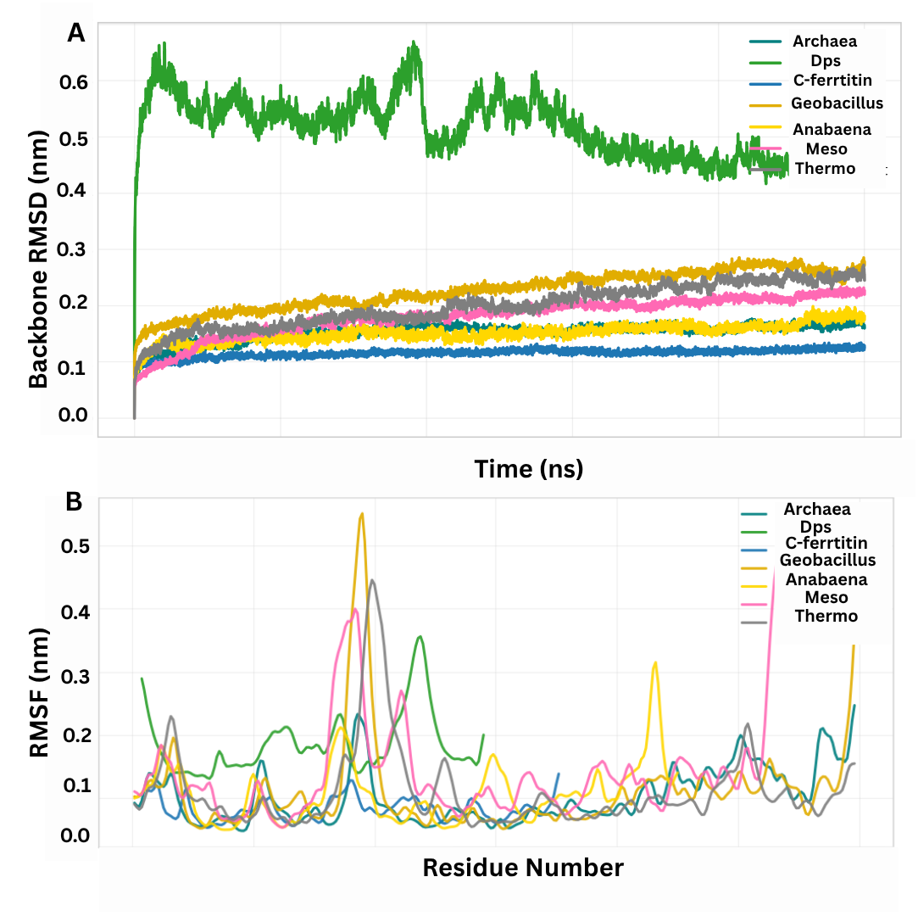
Figure S5: Dynamic analysis of manganese catalase structure with that of Dps and C-ferritin. Line graph of A. Backbone Root Mean Square Deviation (RMSD) in nm for 100ns, B. Root Mean Square Fluctuation (RMSF) for the residues

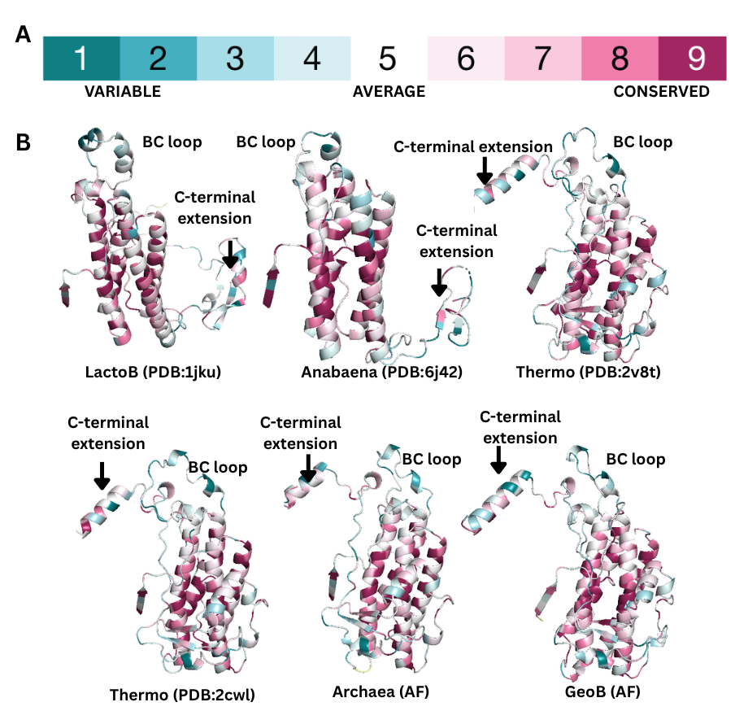
Figure S6: Manganese catalase structures with conservation scores obtained from ConSurf
A. Depiction of ConSurf Conservation Scale B. Manganese catalase monomer structures LactoB (PDB:1jku), Anabaena (PDB: 6j42), Thermo (PDB: 2v8t, 2cwl) and Archaea and GeoB (Alphafold structures) showing different regions with different conservation scores.

References

1. Wilkins, M.R., Gasteiger, E., Bairoch, A., Sanchez, J.C., Williams, K.L., Appel, R.D., and Hochstrasser, D.F. (1999). Protein identification and analysis tools in the ExPASy server. Methods Mol Biol 112, 531–552.
2. Amrita, Chakraborti, S., and Dey, S. (2025). Physicochemical features of subunit interfaces and their role in self-assembly across the ferritin superfamily. Structure 33, 401–415.e2.
3. Kabsch, W., and Sander, C. (1983). Dictionary of protein secondary structure: pattern recognition of hydrogen-bonded and geometrical features. Biopolymers 22, 2577–2637.
4. Bahadur, R.P., Chakrabarti, P., Rodier, F., and Janin, J. (2004). A dissection of specific and non-specific protein-protein interfaces. J Mol Biol 336, 943–955.

