Supplementary Information

Employing the dynamics of the electrochemical interface at aqueous zinc-ion battery cathode
Nigel Becknell¹, Pietro P. Lopes¹, Toru Hatsukade¹, Xiuquan Zhou¹, Yuzi Liu², Brandon Fisher², Duck Young Chung¹, Mercouri G. Kanatzidis^{1,3}, Nenad M. Markovic¹, Sanja Tepavcevic^{1,}* & Vojislav R. Stamenkovic^{1,†,}*
¹Materials Science Division, Argonne National Laboratory, Lemont, IL 60439, USA.
²Center for Nanoscale Materials, Argonne National Laboratory, Lemont, IL 60439, USA.
³Department of Chemistry, Northwestern University, Evanston, IL 60208, USA.

†Current address: The Henry Samueli School of Engineering, University of California, Irvine, Irvine, CA 92697, USA.

*corresponding author

Supplementary Figures and Tables:
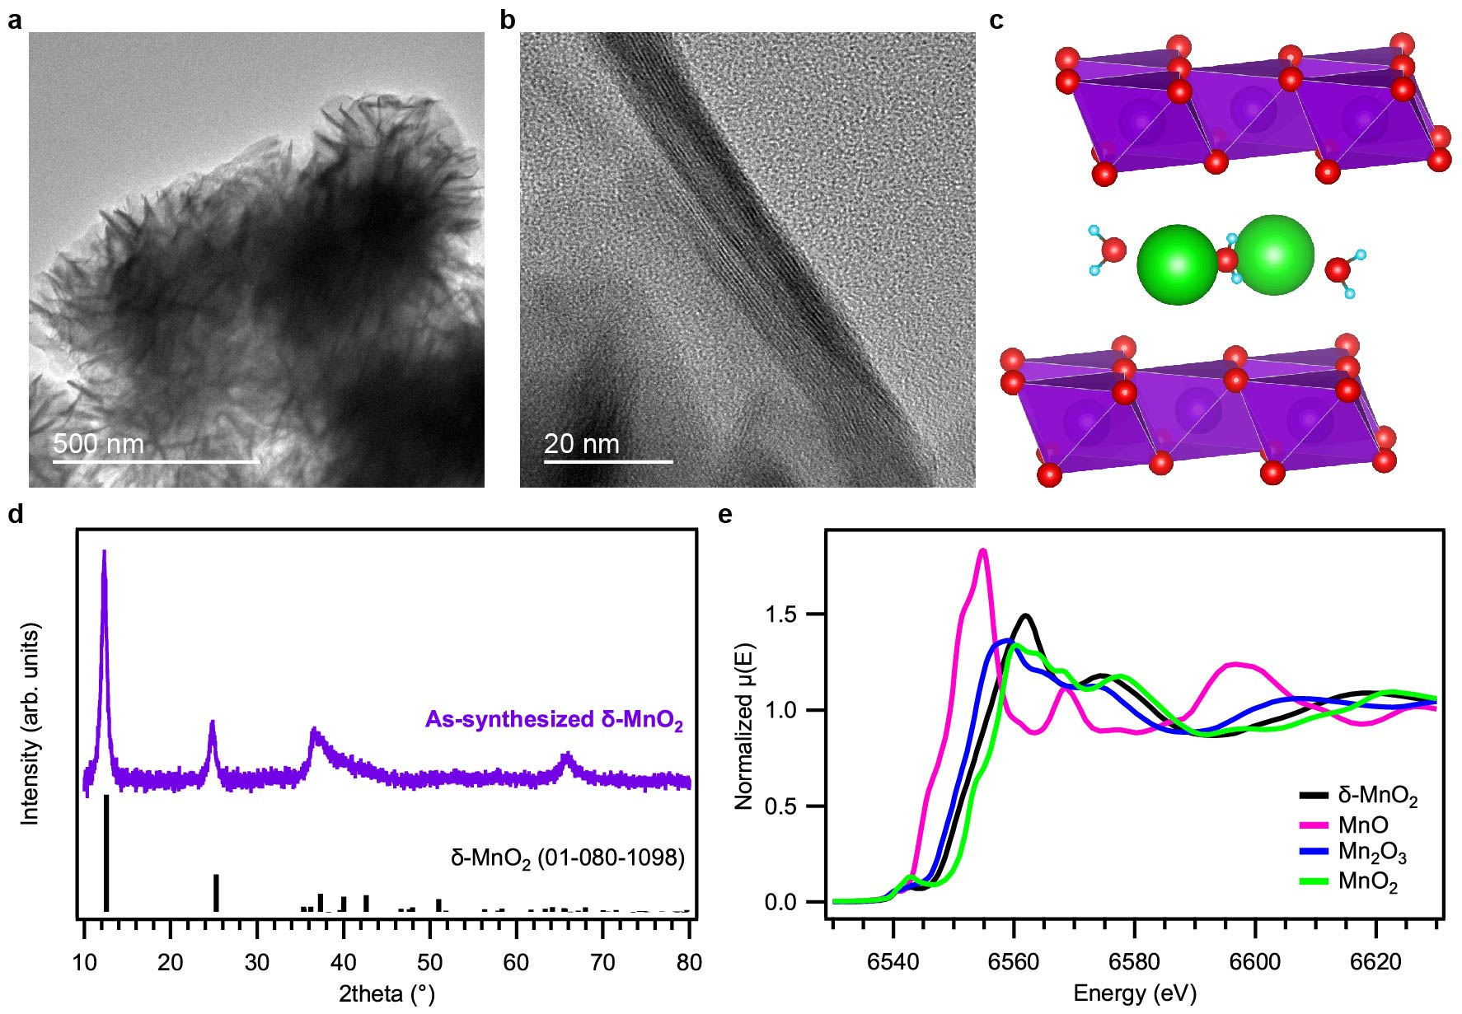

Supplementary Figure 1. Characterization of as-synthesized δ-MnO₂. a TEM and b HRTEM images of δ-MnO₂ sheets interconnected in clusters. c Schematic of δ-MnO₂ structure. Mn-purple, O-red, H-blue, K-green. d XRD of δ-MnO₂. e XANES of δ-MnO₂ compared to standards.

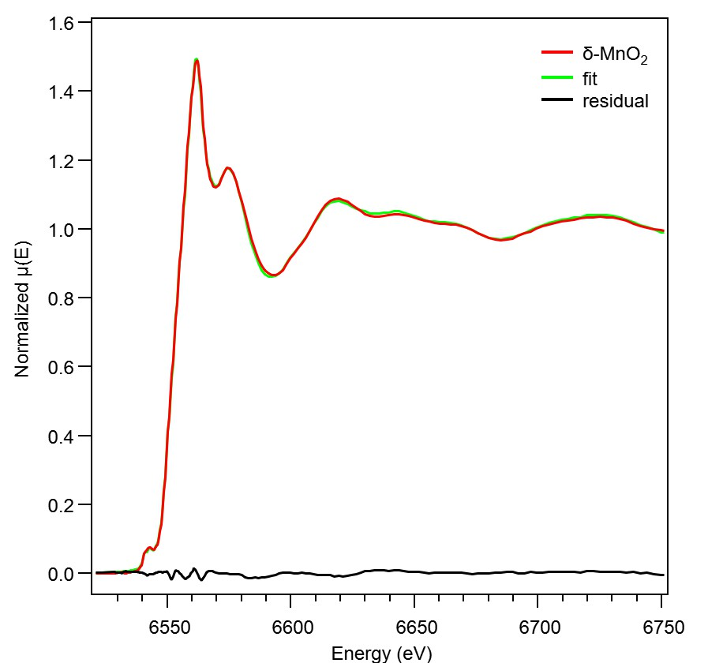

Supplementary Figure 2. LCF to normalized XANES of as-prepared δ-MnO₂ using Combo method. Fitting parameters are shown in Supplementary Table 1 for the fit between 6521 to 6751 eV. The fit indicates an average Mn oxidation state of 3.65.

Supplementary Table 1. Fitting parameters for LCF to as-prepared δ-MnO₂ using the Combo method.
Mn Standards |  | δ-MnO₂
Mn (IV) | Pyrolusite | -
Mn (IV) | Ramsdellite | 0.185
Mn (IV) | Ca₂Mn₃O₈ | 0.073
Mn (IV) | KBi | 0.432
Mn (III) | Groutite | -
Mn (III) | Feitknechtite | 0.162
Mn (III) | Manganite | -
Mn (III) | Mn₂O₃ | -
Mn (III) | MnPO₄ | 0.101
Mn (II) | Hureaulite | -
Mn (II) | Fungi | -
Mn (II) | Rhodocrosite | 0.026
Mn (II) | Manganosite | -
Mn (II) | Pyroxmangite | -
Mn (II) | Tephroite | -
Mn (II) | MnSO₄(aq) | 0.022
Mn (II) | MnSO₄(s) | -
 | Sum | 1.001
 | R-factor | 0.00019
 | Reduced χ² | 0.000043

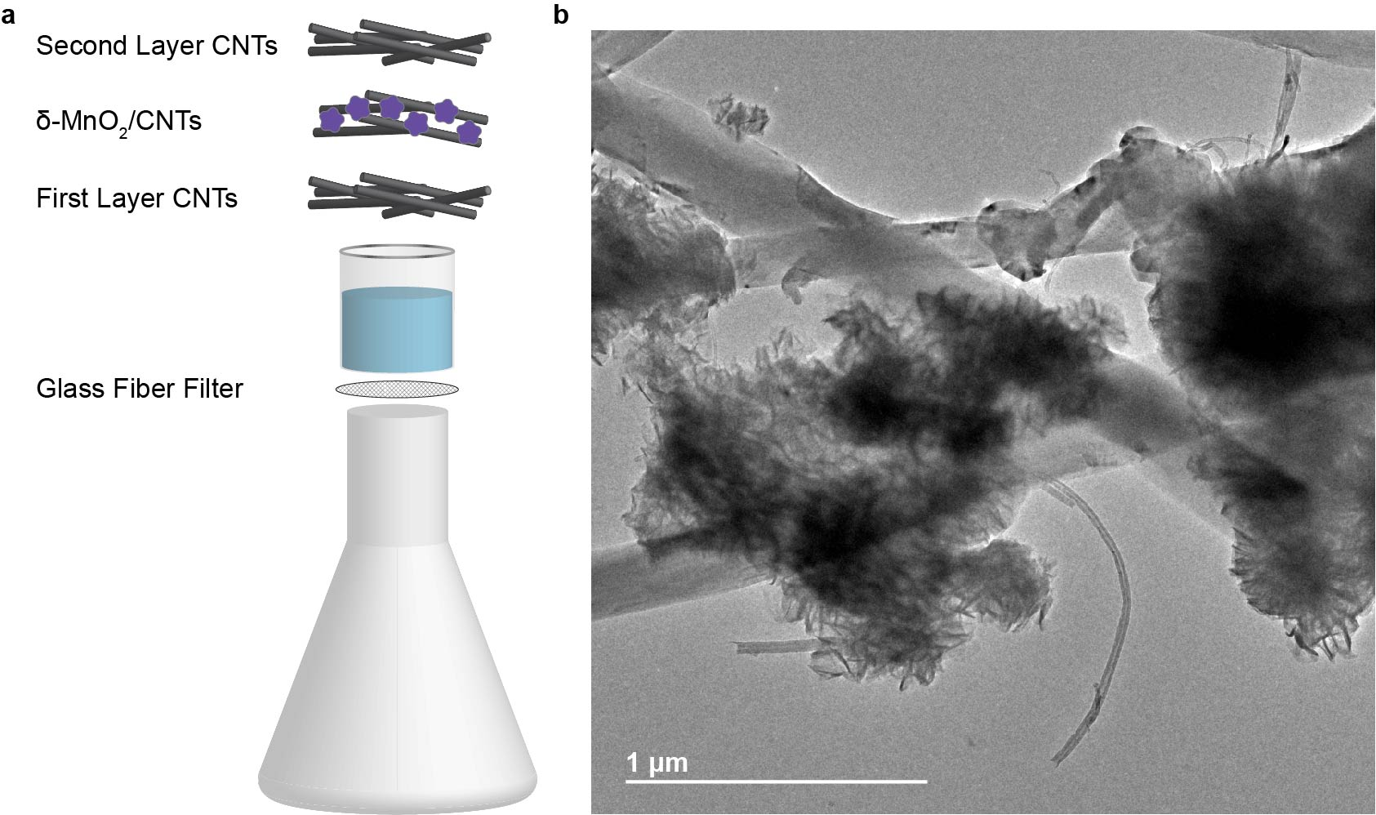
Supplementary Figure 3. Electrode preparation for coin cell testing. a Filtration of δ-MnO₂ and CNTs onto a glass fiber filter created the δ-MnO₂ /CNT composite electrode. b TEM image of δ-MnO₂/CNT composite.
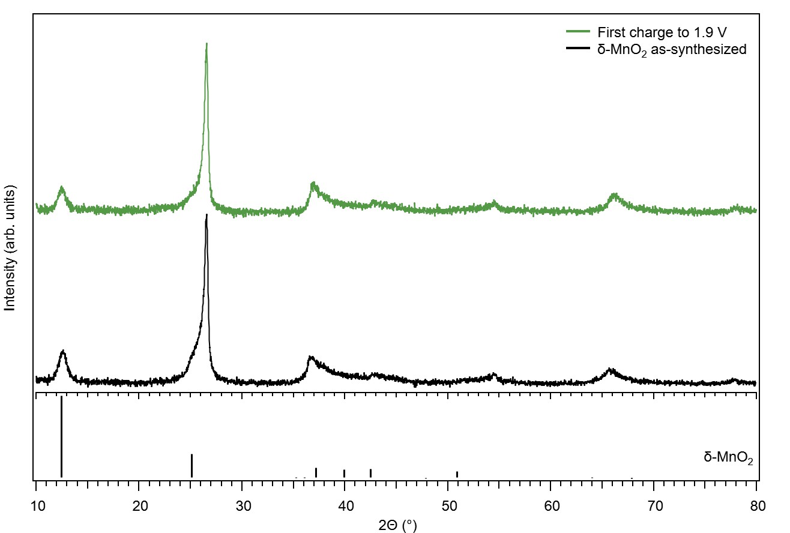

Supplementary Figure 4. Similarity in structure after initial charging of δ-MnO₂. Comparison of XRD for as-synthesized δ-MnO₂ and after the first charge to 1.9 V in 0.5 M ZnSO₄/0.5 M MnSO₄.
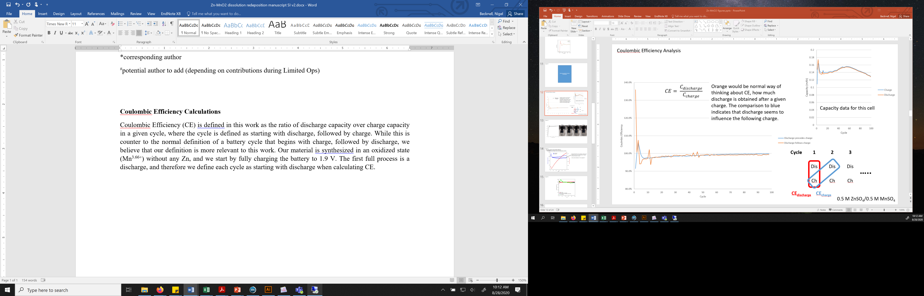
Supplementary Figure 5. Explanation of how Coulombic efficiency is calculated in this work. In this work, the cycle is defined as starting with discharge (circled in red), while the standard definition is typically a cycle starting with charge (circled in blue).

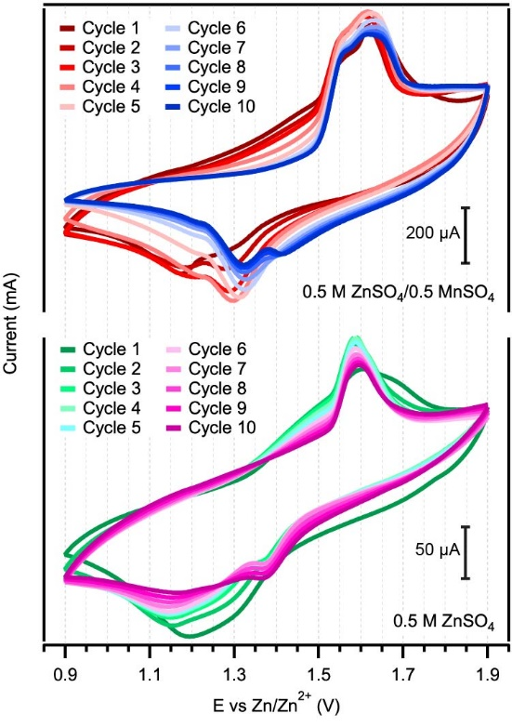
Supplementary Figure 6. Comparison of CV with and without Mn in electrolyte. CV of δ-MnO₂ in either Zn²⁺_{(aq)}-Mn²⁺_{(aq)} or Zn²⁺_{(aq)}-only electrolyte at 0.5 mV/s between cycles 1 to 10.

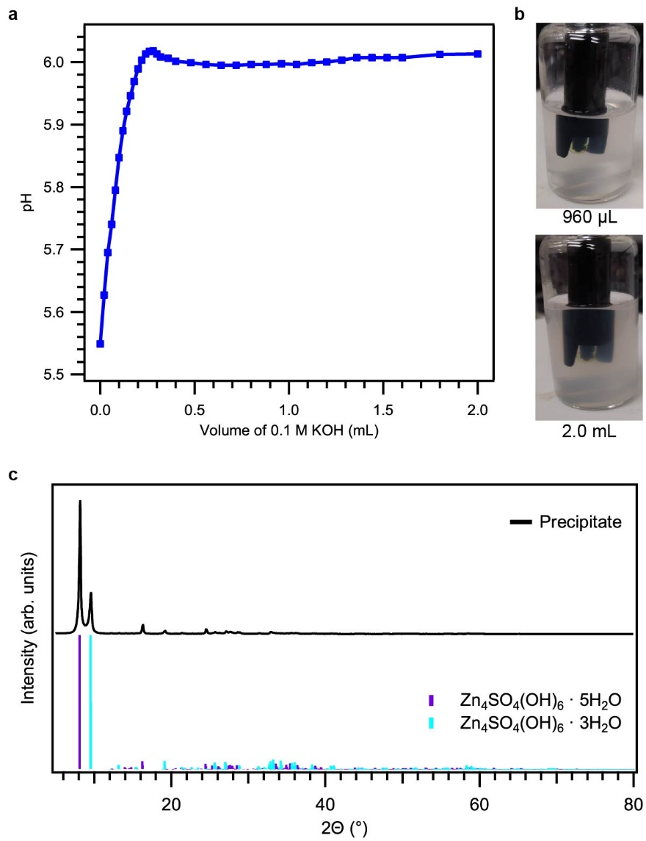
Supplementary Figure 7. Raising pH of 0.5 M ZnSO₄/0.5 M MnSO₄ electrolyte by adding 0.1 M KOH. a Change in pH with cumulative addition of 0.1 M KOH. b Images of solution becoming cloudy with addition of 960 µL (top) or 2.0 mL (bottom) 0.1 M KOH that precipitates white ZHS. c XRD pattern of precipitate after 2.0 mL of 0.1 M KOH addition to the electrolyte showing the presence of ZHS with their simulated diffraction peaks.
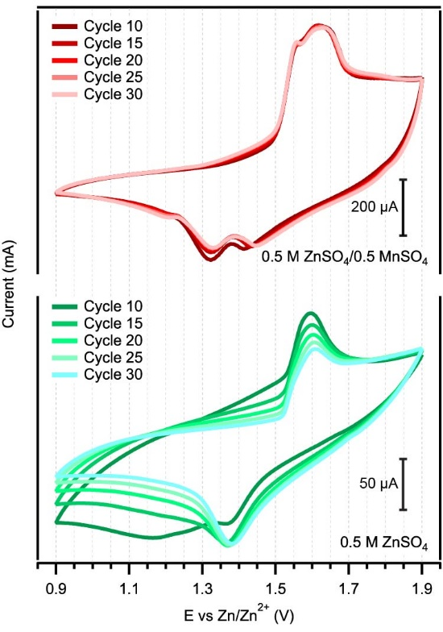
Supplementary Figure 8. Comparison of CV with and without Mn in electrolyte. CV of δ-MnO₂ in either Zn²⁺_{(aq)}-Mn²⁺_{(aq)} or Zn²⁺_{(aq)}-only electrolyte at 0.5 mV/s between cycles 10 to 30.

Supplementary Table 2. Zn:Mn ratio in electrode (cycled in 0.5 M ZnSO₄/0.5 M MnSO₄) after rinsing with deionized water as determined by ICP-MS.
 | Zn:Mn ratio (ICP-MS)
100 cycles, charge | 0.49
100 cycles, discharge | 0.61

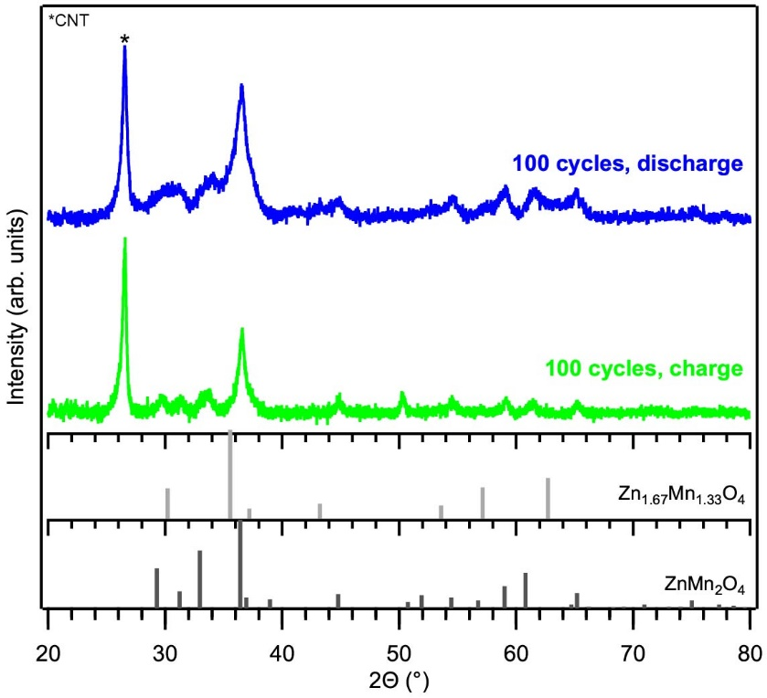
Supplementary Figure 9. Determination of phase in charged and discharged state. XRD of the δ-MnO₂/CNT electrode after cycling 100 times in 0.5 M ZnSO₄/0.5 M MnSO₄ in the charged and discharged state.

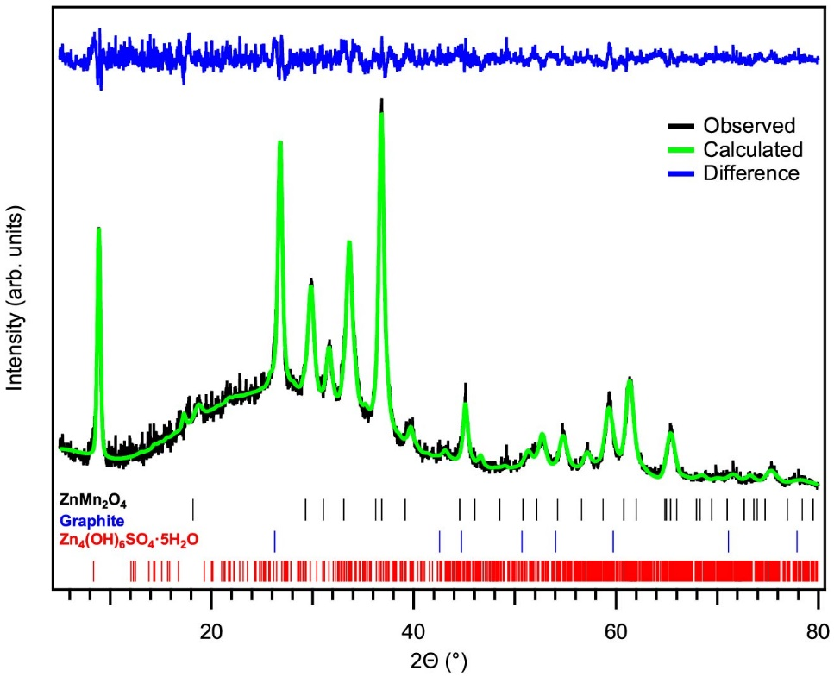
Supplementary Figure 10. Long-term cycling of δ-MnO₂ in Zn-only electrolyte. Rietveld refinement of powder XRD pattern for electrode cycled 100 times in 0.5 M ZnSO₄, ending on discharge. The refinement demonstrates an excellent fit to the data using tetragonal ZnMn₂O₄, graphite (for the CNT support), and ZHS·5H₂O. The weight profile R_{wp} = 6.3%, and the ZnMn₂O₄ phase was fitted using a tetragonal space group of I4₁/amd with a = 5.7489(10) Å and c = 9.1961(18) Å.
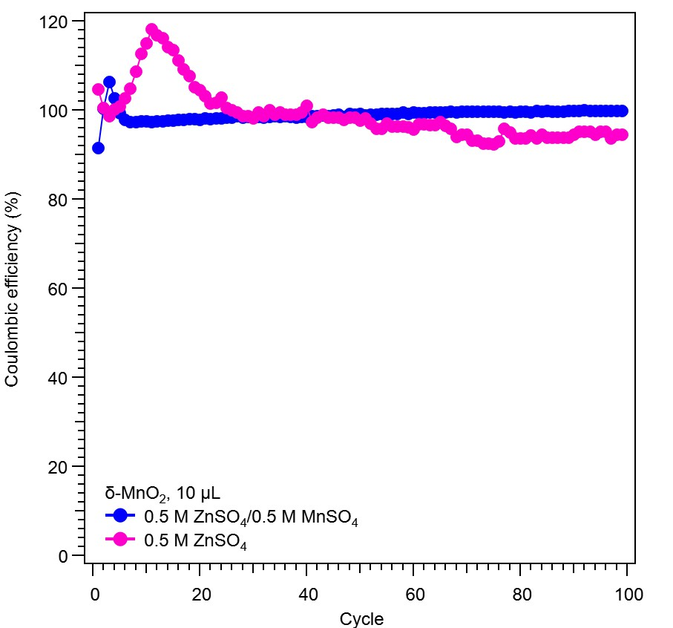
Supplementary Figure 11. Comparison of CE with and without Mn in electrolyte. CE of δ-MnO₂/CNT electrode in Zn²⁺_{(aq)}-Mn²⁺_{(aq)} or Zn²⁺_{(aq)}-only electrolyte over 100 cycles.

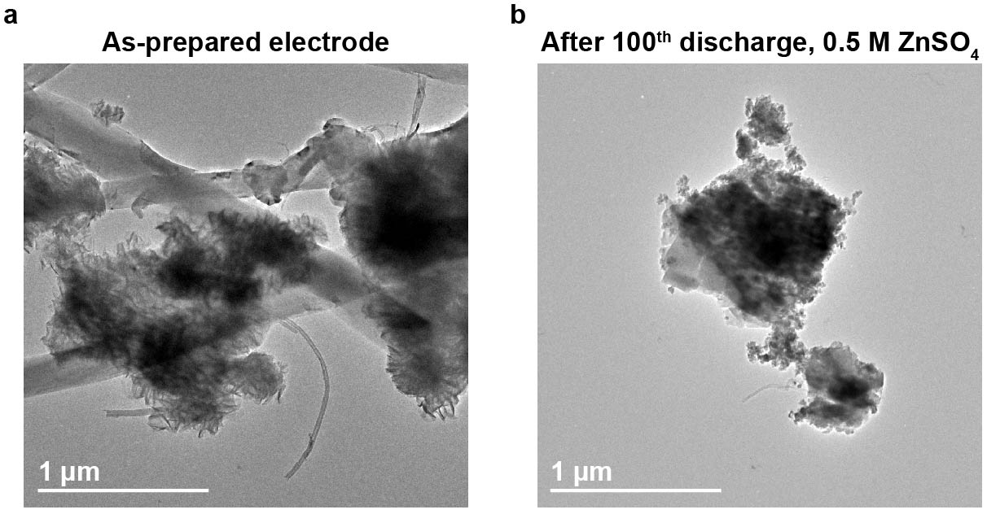
Supplementary Figure 12. Structural degradation in Zn-only electrolyte. TEM images of a the as-prepared δ-MnO₂/CNT electrode and b the cycled electrode after the 100th discharge in 0.5 M ZnSO₄.

Supplementary Note 1. Explanation of Coulombic efficiency definition in this work.
CE is defined in this work as the ratio of discharge capacity over charge capacity in a given cycle, where the cycle is defined as starting with discharge, followed by charge. In Supplementary Figure 5, this is labeled as CE_{discharge} in red, while the conventional definition of CE is labeled as CE_{charge} in blue. While this is counter to the normal definition of a battery cycle that begins with charge, followed by discharge, this definition is more relevant to the purpose of this work. The δ-MnO₂ is synthesized in an oxidized state (Mn^{3.65+}) without any Zn, and the coin cell is further conditioned by fully charging to 1.9 V. The first full process is a discharge, and therefore each cycle is defined as starting with discharge when calculating CE.

