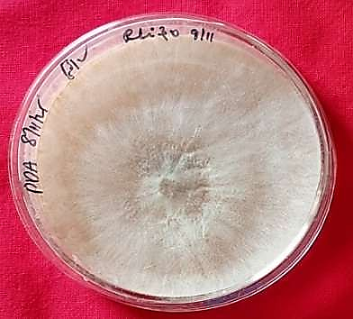
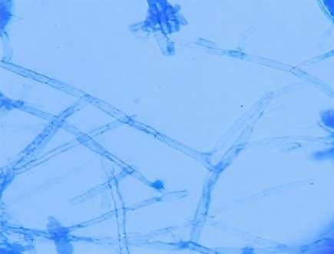
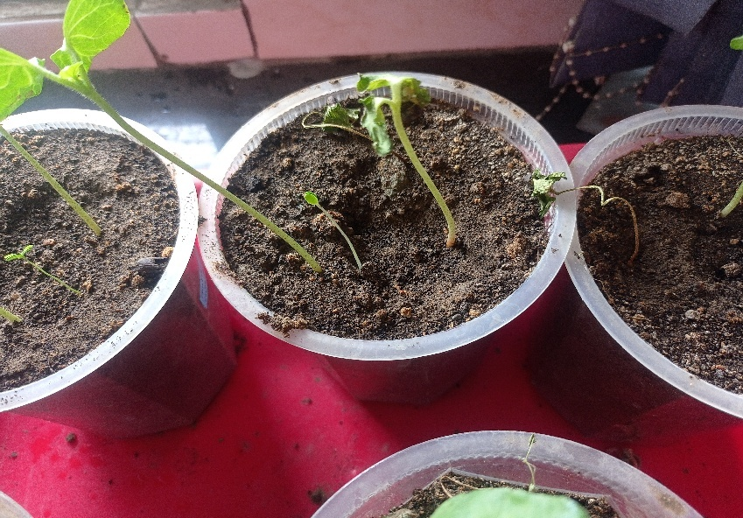
S1
Cultural, microscopic, and pathogenic characteristics of Rhizoctonia solani in cotton. (A) Colony morphology on PDA; (B) characteristic right-angled hyphal branching; and (C) disease symptoms induced by R. solani in cotton seedlings.
a
b
c

S2

Effect of selective fungal endophyte treatments on cotton seed germination.
Values expressed are mean of three replications

