Supplementary Information
Monte Carlo simulation and breast cancer transcriptomic benchmarking characterize reliability limits of high-dimensional biomedical feature selection
Hao Ma¹, Jiaxin Yin¹˒²*
¹ Jinzhou Medical University, Jinzhou, China
² Department of Radiology, The First Affiliated Hospital of Dalian Medical University, Dalian, China
*Correspondence: Jiaxin Yin, yinjx@jzmu.edu.cn
Hao Ma: mah@stu.jzmu.edu.cn; ORCID 0009-0007-0574-8519
Jiaxin Yin: ORCID 0009-0007-0413-2608

S1 Study stages and experiment identities
The supporting results cover broad screening, local sample-size analyses, dedicated cMCP tuning confirmation, four-cell synthetic confirmation, the original 200-gene breast cancer benchmarks, the GSE96058 high-dimensional and signal experiments, and alternative synthetic mechanisms. Supplementary Data preserves the original analysis filenames and task identifiers. Screening results are distinct from independent confirmation; the primary confirmation proportions do not pool their denominators.
Broad screening evaluated 624 configurations and nine procedures with 30 pairs per configuration. Initial sample-size screening in settings A and B used n=50, 100, 150, 250, 400, 600, 800 and 1,000. Refinement added 270 pairs at previously screened levels and 300 at new levels. Setting A refinement used n=250, 325 and 400. Setting B refinement covered n=400, 600 and 800, followed by n=500, 700 and 1,000. Supplementary Fig. S1 uses new pairs only. The files retain initial_K, new_K and total_K with their respective success counts.
The first method-confirmation batch in setting C, the tuning screen and dedicated tuning confirmation are separate experiments. Initial cMCP confirmation gave 226/300 successes; dedicated tuning confirmation gave 233/300 for the minimum-deviance rule and 286/300 for the one-standard-error rule. The corresponding minimum-deviance result in independent four-cell setting V1 was 230/300. These counts belong to different random repetitions and are not interchangeable. Main Fig. 2 uses the dedicated C tuning batch and the separate V1 to V4 confirmation cells.

S2 Joint endpoint and diagnostic categories
For true support S and selected set A, TPR=|A∩S|/|S| and FDP=|A∖S|/max(1,|A|). For the paired sets A and B, Jaccard=|A∩B|/|A∪B|, with Jaccard=1 for two empty sets. Success requires both TPRs ≥0.80, both FDPs ≤0.10 and Jaccard ≥0.75. All K repetitions contribute to the reliability denominator, including computational failures and non-estimable results.
Classification first separates computational/non-estimable results, then checks Jaccard. Results below the Jaccard threshold are unstable. Among stable results, two empty sets are stable empty; any nonempty result with an FDP violation is stable nonempty false selection. Remaining stable nonempty results with inadequate recall are stable nonempty omission. The remainder are reliable. Because unstable results can also violate accuracy requirements, component counts overlap and must not be added to obtain the total number of failures.
If a selected set contains k variables and the true support has size s, the recall and FDP requirements imply ceiling(0.80s) ≤ k ≤ floor(s/0.90). This necessary output-size condition is not sufficient for successful recovery. In broad screening, mRMR's fixed output violated this range in 544/624 configurations. The cluster-representative upper bound was below the minimum recall requirement in 166/624 configurations.
Of 165,611 normally completed broad-screening method-pair results, 50,509 were stable but inaccurate: 49,268 stable empty and 1,241 stable nonempty. The latter included 46 with recall failure only, 1,183 with FDP failure only and 12 with both. Under the mutually exclusive scheme, those 12 are assigned to stable nonempty false selection. Broad screening also recorded 2,839 non-estimable results and 30 computational failures, retained in the total of 168,480 results.

S3 Synthetic generators and selection implementations

S3.1 Original module generator and local settings
The original generator creates a module of g variables for each signal and assigns the module's first variable a nonzero coefficient. Remaining candidates are background noise. Within-module correlation is rho. A shared component of weight 0.10 in the module latent variables produces correlation rho×0.10 between variables in different signal modules. Both sides share support positions but independently draw coefficient signs. The sample linear predictor is scaled to the configured signal parameter and the intercept is calibrated to the target event proportion. The signal labels in this historical generator are not the same calibration procedure as the explicit oracle-AUC reference calibration in later experiments.
Setting A used p=200, s=10, g=3, rho=0, event proportion 0.50 and signal parameter 4. Setting B used p=213, s=12, g=10, rho=0.516398773802212, event proportion 0.27739016754732 and signal parameter 7. Setting C used n=1,000, p=200, s=40, g=3, rho=0, event proportion 0.50 and signal parameter 4. Four-cell confirmation V1 to V4 used (n,rho)=(1,000,0), (500,0), (1,000,0.60) and (500,0.60), with the remaining C parameters unchanged.
The original generator retried a single-class outcome using the next seed. An existing audit of 390 pairs identified four low-event-proportion pairs whose two sides coincided under that procedure; not every historical broad-screening seed was reconstructed. Later independent confirmation used a revised generator that attempted generation once and retained single-class or non-estimable outcomes in the denominator. The original results serve as broad diagnosis, while the independent confirmations support the primary reliability and tuning estimates.

S3.2 Input handling and fitting
Input checks require finite numerical predictors, binary outcomes, at least eight observations and at least two features. Earlier experiments standardize each full data side and remove zero-variance columns. Class-stratified cross-validation targets three folds, reduces folds when class counts require it and records failure if the training-side minimum class count remains below two. Methods sharing a pair preserve their randomization identities; both cMCP rules are extracted from the same validation path.
LASSO and Elastic Net use 50 penalty values and binomial deviance; Elastic Net has alpha=0.5. Nongrouped MCP uses ncvreg's binomial MCP implementation with minimum validation error. Univariate screening uses a point-biserial correlation t approximation with n−2 degrees of freedom, followed by BH correction at 0.10. mRMR uses the classic mRMRe implementation with min(p,max(5,floor(sqrt(p)))) selected features. Full frozen implementations are retained in formal_methods.R and the experiment-specific programs.
Grouping uses average-linkage clustering with distance 1−|cor(X)| and max(2,min(p,floor(sqrt(p)))) groups. Group LASSO uses grpreg's grLasso penalty and cMCP uses its cMCP penalty. One-standard-error tuning selects the largest lambda with mean validation deviance at most the minimum mean deviance plus its standard error. This ensures no smaller penalty than the minimum-deviance rule, but does not require nested selections along a nonconvex path. CPSS constructs 20 complementary half-sample pairs, standardizes and fits one-standard-error LASSO in each half, and retains variables with selection frequency ≥0.80 across the 40 fits.

S3.3 Alternative data-generating mechanisms
The AR(1) mechanism generates mean-zero, unit-variance Gaussian predictors with covariance 0.60 raised to the distance between indices. Signals occupy the first ten adjacent positions. The latent-factor design uses three independent factors, assigns features cyclically to loading 0.70 and gives independent residuals scale sqrt(1−0.70²). Every fourth feature receives a batch displacement of ±0.35, followed by scaling by sqrt(1+0.35²). Batch does not directly enter the outcome equation. Ten signal indices are obtained by rounding an equally spaced sequence from 1 to 1,000.
The module mechanism uses ten three-variable signal modules with within-module correlation 0.60 and a common latent component of 0.10. Each module's first variable is a signal; the remaining 970 variables are independent noise. Each mechanism uses a 20,000-row reference covariate sample to calibrate AUC 0.75 or 0.95 and event proportion 0.30. Coefficient signs alternate over support order. After calibration, effect multipliers and intercepts remain fixed across all confirmation repetitions, without rescaling in individual samples.
The calibration parameters are in external_dgp_calibration.csv. Twelve cells with 30 screening pairs and four methods yield 1,440 method-pair results. The frozen rule assigns 300 new pairs if either cMCP screening reliability is ≥0.20, otherwise 60. The three n=1,000, AUC=0.95 cells received 300 pairs; the remaining nine received 60. Independent confirmation yielded 5,760 method-pair results. Manifests identify all seeds and repetitions.

S4 Empirical expression data and artificial outcomes

S4.1 Data inclusion and target definition
The source GSE96058 study contained 3,273 breast cancer samples and technical-replicate information. The present harmonized expression output contains 3,189 samples with matched identifiers and defined ER records; technical-replicate columns do not add independent patients. GSE7390 contributes 198 samples. The analysis uses the expression output of the harmonization script, which applies clinical matching and ER eligibility. Candidate filtering, support definition and outcome generation follow this step.
Each artificial outcome model connects a known nonzero gene support to the empirical covariates through a fixed logistic linear predictor. Binary outcomes are drawn independently by row from its probabilities. A true signal means a nonzero coefficient in this artificial generator. Measured ER, overall survival, relapse-free survival and distant-metastasis-free survival are not fitting or evaluation outcomes in these experiments.

S4.2 Original 200-gene GSE96058 experiment
Seed 2026092231 partitions samples into 637 reference and 2,552 sampling-pool observations. Reference-set variance orders candidate genes, with identifiers breaking ties, and the top 200 are retained. Two disjoint 40-gene supports represent high or low mean absolute correlation. Coefficient signs alternate after sorting identifiers. Scaling, supports, effect multipliers and intercepts are frozen from the reference set.
The high-correlation effect multiplier is approximately 0.675385 and intercept 0.135360; the low-correlation values are 0.726869 and 0.081555. Reference targets are oracle AUC 0.95 and event proportion 0.50. In the sampling pool, the corresponding AUCs are approximately 0.945737 and 0.957511 and event proportions 0.505023 and 0.507419. Exact values are retained in gse96058_plasmode_calibration.csv.
The four cells are XH500, XH1000, XL500 and XL1000, with H/L denoting support type. Screening and confirmation use separate seeds and 30 versus 300 pairs. Confirmation generated 4,800 method-pair results without computational failures or non-estimable outcomes. Sampling is with replacement; an original patient may occur multiple times within a side or on both sides. The mean fraction of distinct source patients was approximately 0.909 for 500 draws and 0.827 for 1,000 draws. Conditional resampling independence does not add new independent patients to the source cohort.

S4.3 GSE7390
Seed 2026092341 partitions the 198 samples into 39 reference and 159 sampling-pool observations. Harmonization yields 12,343 unique genes. Only 43 candidates overlap the GSE96058 200-gene set, and eight and six genes overlap its high- and low-correlation supports. Accordingly, GSE7390 constructs its own candidate set and supports using the same rules. Ten-signal supports use the first ten identifier-sorted members of the corresponding 40-gene supports.
Cells H10N050, H10N100, H10N150, L10N050, L10N100 and L10N150 combine support type with n=50, 100 and 150; H40N150 and L40N150 use 40 signals. Each support is separately calibrated to reference AUC 0.95 and event proportion 0.50. Sampling-pool AUCs for high-10, low-10, high-40 and low-40 are approximately 0.947, 0.966, 0.946 and 0.945; event proportions are approximately 0.530, 0.482, 0.630 and 0.423.
The prespecified screening branch assigns 300 confirmation pairs if either cMCP rule has reliability between 0.20 and 0.80; otherwise it assigns 60. All eight cells received 60, producing 1,920 method-pair results and no joint successes. Two original data pairs at n=50 involved a cMCP side-fitting failure, affecting four method tasks across both tuning rules; they remain in the denominators. No non-estimable results were recorded. Continuous summaries retain their original valid-side or valid-pair denominators, while success always uses the full K.
At s=10 and n=150, one-standard-error cMCP had mean TPR approximately 0.079 and 0.170 for high- and low-correlation supports, compared with 0.121 and 0.312 for minimum-deviance tuning. Group LASSO had mean TPR approximately 0.892 and 0.937 but mean FDP approximately 0.899 and 0.936. These component summaries show why both sparse low-recall and large high-FDP sets can fail the same joint target.

S4.4 High-dimensional GSE96058 benchmark
Deterministic hashing divides the 2,552 evaluation patients into two disjoint pools of 1,276. Each repetition samples n=500 or 1,000 without replacement within each pool. Matched 2,000-gene and full-gene conditions share patients, artificial outcomes and three-fold assignments. The formal task manifest contains 1,200 shared sampling identities, 3,600 dimension-specific data pairs and 14,400 method results.
Reference-set variance, with identifier tie-breaking, determines the top-2,000 (P2K) and all-positive-variance (FULL, 22,092 genes) spaces. Both high- and low-correlation 20-gene supports come from P2K and require at least 50 distinct reference expression values. This covariate-only eligibility amendment preceded new outcome generation: the initial low-correlation support had insufficient dispersion for the alternating equal-effect model to reach reference AUC 0.95. Selection outcomes were not used to revise the support.
P2K and FULL groups are built in the reference set using distance 1−|r| and average linkage, giving 44 and 148 groups. The P2K grouping SHA-256 is e4609f1b73e4a6ddb4d22e319aeb0af85599fc7265ff83dca51eb69e03bca283; FULL is d0018563ebe826d2d0e5b24d30f99a886be726f31c555be0c8546e96379f76c6. The exact FULL compressed distance contains 244,017,186 elements and is computed with block products. Small-matrix equivalence checks matched direct distance construction.
cMCP uses gamma=3, tau=1/3 and a 100-point full-side master path. Each training fold removes its own zero-variance columns and estimates its own scaling. If fitting terminates a training path early, only the common master-path prefix with finite predictions in all three folds is used for tuning. Elastic Net uses alpha=0.5, binomial deviance and 50 penalties. Both methods share patient-level outcome-stratified folds and refit on the entire side after tuning. The formal environment records R 4.6.1, grpreg 3.6.0, glmnet 5.0, matrixStats 1.5.0, data.table 1.18.6.1, digest 0.6.39 and ps 1.9.3; plots use ggplot2 4.0.3.
Four signal experiments use P2K, n=1,000 and AUC 0.85, crossing support type with equal or heterogeneous magnitudes. Heterogeneous magnitudes decrease geometrically by identifier order with a 4:1 range, root-mean-square normalization and alternating signs. AUC 0.85 equal-effect conditions share patients and Bernoulli uniform variates with matching AUC 0.95 conditions; heterogeneous conditions are paired with the equal-effect conditions. Frozen protocol amendments, input and group locks, and task manifests accompany the reproduction archive.

S5 Interval construction and threshold sensitivity
For x successes in K pairs, exact intervals are two-sided Clopper to Pearson bounds, with lower bound zero at x=0 and upper bound one at x=K. Single-cell intervals use error rate 0.05. A family of m cells uses 0.05/m per interval: m=4 for four-cell synthetic and 200-gene GSE96058 experiments, eight for GSE7390 and 12 for alternative mechanisms, each within one method. These are not simultaneous intervals across every method and experiment.
For the paired contrast, p+ is one-standard-error-only success probability and p− minimum-deviance-only success probability. Each discordance probability has an exact interval with error rate 0.05/(2m), and the difference interval is [L+−U−, U+−L−]. Combining the marginal bounds is conservative. The exact description applies to the component binomial bounds, not to an assertion of exact nominal coverage for their difference.
For 0/60, the single-cell upper bound is 0.0596295, the eight-cell upper bound 0.0916620 and the 12-cell upper bound 0.0977796. For the alternative module, n=300 and AUC=0.95, minimum-deviance cMCP achieved 6/60, with a single-cell upper bound approximately 0.205 and a 12-cell bound approximately 0.258. Zero successes in 300 pairs also retains a positive upper bound.
For dedicated C confirmation at 286/300, the Wilson interval is approximately 0.923203 to 0.972001 and the exact interval 0.922940 to 0.974255. Main Fig. 2 uses exact intervals. For B at n=1,000, the new-pair result 229/270 has Wilson lower bound approximately 0.8005, exact lower bound 0.7997 and three-extension-level corrected lower bound 0.7886. This near-threshold uncertainty is retained without inferring a universal minimum sample size.
High-dimensional reliability intervals form eight-cell families within each rule. Contrast families comprise eight cMCP tuning, 24 Elastic Net baseline and 16 FULL-minus-P2K comparisons. The signal module has four cMCP tuning contrasts and 16 signal-strength or heterogeneity contrasts. Threshold sensitivity crosses minimum TPR 0.70/0.80/0.90, maximum FDP 0.05/0.10/0.20 and minimum Jaccard 0.50/0.75/0.90. The eight main cells form 216 tuning contrasts; endpoints are reconstructed from saved selections. The exploratory 200-gene analysis uses saved component metrics and 108 contrasts, with 216 rule-specific reliability rows. Its large-sample high- and low-correlation cells have 25 and 21 positive point differences; 19 and ten corrected intervals remain positive. No corrected interval favors minimum-deviance tuning in that 200-gene analysis.

S6 Complete confirmation tables
Tables S1 to S4 present four-cell synthetic, 200-gene GSE96058, GSE7390 and alternative-mechanism confirmation. Table S5 gives paired contrasts and Table S6 gives module results. Tables S7 to S9 report high-dimensional main results, signal results and tuning contrasts. Table S10 summarizes the exploratory 200-gene threshold analysis. Numerical cells are preserved from the original finalized tables; expanded machine-readable results accompany Supplementary Data.
Table S1. Independent synthetic confirmation.
Cell | Method | Successes/K | Exact 95% CI | 4-cell CI
V1 | cMCP 1se | 286/300 | 0.923 to 0.974 | 0.914 to 0.978
V1 | cMCP min | 230/300 | 0.715 to 0.813 | 0.700 to 0.825
V1 | Group LASSO | 0/300 | 0.000 to 0.012 | 0.000 to 0.017
V1 | MCP | 14/300 | 0.026 to 0.077 | 0.022 to 0.086
V2 | cMCP 1se | 0/300 | 0.000 to 0.012 | 0.000 to 0.017
V2 | cMCP min | 0/300 | 0.000 to 0.012 | 0.000 to 0.017
V2 | Group LASSO | 0/300 | 0.000 to 0.012 | 0.000 to 0.017
V2 | MCP | 4/300 | 0.004 to 0.034 | 0.002 to 0.040
V3 | cMCP 1se | 288/300 | 0.931 to 0.979 | 0.922 to 0.983
V3 | cMCP min | 281/300 | 0.903 to 0.961 | 0.893 to 0.967
V3 | Group LASSO | 0/300 | 0.000 to 0.012 | 0.000 to 0.017
V3 | MCP | 78/300 | 0.211 to 0.314 | 0.199 to 0.328
V4 | cMCP 1se | 0/300 | 0.000 to 0.012 | 0.000 to 0.017
V4 | cMCP min | 0/300 | 0.000 to 0.012 | 0.000 to 0.017
V4 | Group LASSO | 0/300 | 0.000 to 0.012 | 0.000 to 0.017
V4 | MCP | 0/300 | 0.000 to 0.012 | 0.000 to 0.017

Table S2. GSE96058 breast cancer plasmode confirmation.
Cell | Method | Successes/K | Exact 95% CI | 4-cell CI
XH1000 | cMCP 1se | 291/300 | 0.944 to 0.986 | 0.936 to 0.989
XH1000 | cMCP min | 251/300 | 0.790 to 0.877 | 0.777 to 0.886
XH1000 | Group LASSO | 0/300 | 0.000 to 0.012 | 0.000 to 0.017
XH1000 | MCP | 22/300 | 0.047 to 0.109 | 0.041 to 0.119
XH500 | cMCP 1se | 0/300 | 0.000 to 0.012 | 0.000 to 0.017
XH500 | cMCP min | 0/300 | 0.000 to 0.012 | 0.000 to 0.017
XH500 | Group LASSO | 0/300 | 0.000 to 0.012 | 0.000 to 0.017
XH500 | MCP | 0/300 | 0.000 to 0.012 | 0.000 to 0.017
XL1000 | cMCP 1se | 287/300 | 0.927 to 0.977 | 0.918 to 0.981
XL1000 | cMCP min | 245/300 | 0.768 to 0.859 | 0.755 to 0.869
XL1000 | Group LASSO | 0/300 | 0.000 to 0.012 | 0.000 to 0.017
XL1000 | MCP | 49/300 | 0.123 to 0.210 | 0.114 to 0.223
XL500 | cMCP 1se | 0/300 | 0.000 to 0.012 | 0.000 to 0.017
XL500 | cMCP min | 0/300 | 0.000 to 0.012 | 0.000 to 0.017
XL500 | Group LASSO | 0/300 | 0.000 to 0.012 | 0.000 to 0.017
XL500 | MCP | 1/300 | 0.000 to 0.018 | 0.000 to 0.024

Table S3. GSE7390 breast cancer plasmode confirmation.
Cell | Method | Successes/K | Exact 95% CI | 8-cell CI
H10N050 | cMCP 1se | 0/60 | 0.000 to 0.060 | 0.000 to 0.092
H10N050 | cMCP min | 0/60 | 0.000 to 0.060 | 0.000 to 0.092
H10N050 | Group LASSO | 0/60 | 0.000 to 0.060 | 0.000 to 0.092
H10N050 | MCP | 0/60 | 0.000 to 0.060 | 0.000 to 0.092
H10N100 | cMCP 1se | 0/60 | 0.000 to 0.060 | 0.000 to 0.092
H10N100 | cMCP min | 0/60 | 0.000 to 0.060 | 0.000 to 0.092
H10N100 | Group LASSO | 0/60 | 0.000 to 0.060 | 0.000 to 0.092
H10N100 | MCP | 0/60 | 0.000 to 0.060 | 0.000 to 0.092
H10N150 | cMCP 1se | 0/60 | 0.000 to 0.060 | 0.000 to 0.092
H10N150 | cMCP min | 0/60 | 0.000 to 0.060 | 0.000 to 0.092
H10N150 | Group LASSO | 0/60 | 0.000 to 0.060 | 0.000 to 0.092
H10N150 | MCP | 0/60 | 0.000 to 0.060 | 0.000 to 0.092
H40N150 | cMCP 1se | 0/60 | 0.000 to 0.060 | 0.000 to 0.092
H40N150 | cMCP min | 0/60 | 0.000 to 0.060 | 0.000 to 0.092
H40N150 | Group LASSO | 0/60 | 0.000 to 0.060 | 0.000 to 0.092
H40N150 | MCP | 0/60 | 0.000 to 0.060 | 0.000 to 0.092
L10N050 | cMCP 1se | 0/60 | 0.000 to 0.060 | 0.000 to 0.092
L10N050 | cMCP min | 0/60 | 0.000 to 0.060 | 0.000 to 0.092
L10N050 | Group LASSO | 0/60 | 0.000 to 0.060 | 0.000 to 0.092
L10N050 | MCP | 0/60 | 0.000 to 0.060 | 0.000 to 0.092
L10N100 | cMCP 1se | 0/60 | 0.000 to 0.060 | 0.000 to 0.092
L10N100 | cMCP min | 0/60 | 0.000 to 0.060 | 0.000 to 0.092
L10N100 | Group LASSO | 0/60 | 0.000 to 0.060 | 0.000 to 0.092
L10N100 | MCP | 0/60 | 0.000 to 0.060 | 0.000 to 0.092
L10N150 | cMCP 1se | 0/60 | 0.000 to 0.060 | 0.000 to 0.092
L10N150 | cMCP min | 0/60 | 0.000 to 0.060 | 0.000 to 0.092
L10N150 | Group LASSO | 0/60 | 0.000 to 0.060 | 0.000 to 0.092
L10N150 | MCP | 0/60 | 0.000 to 0.060 | 0.000 to 0.092
L40N150 | cMCP 1se | 0/60 | 0.000 to 0.060 | 0.000 to 0.092
L40N150 | cMCP min | 0/60 | 0.000 to 0.060 | 0.000 to 0.092
L40N150 | Group LASSO | 0/60 | 0.000 to 0.060 | 0.000 to 0.092
L40N150 | MCP | 0/60 | 0.000 to 0.060 | 0.000 to 0.092

Table S4. Complete external DGP confirmation.
Cell | Method | Successes/K | Exact 95% CI | 12-cell CI
AR1N0300A75 | Group LASSO | 0/60 | 0.000 to 0.060 | 0.000 to 0.098
AR1N0300A75 | cMCP min | 0/60 | 0.000 to 0.060 | 0.000 to 0.098
AR1N0300A75 | cMCP 1se | 0/60 | 0.000 to 0.060 | 0.000 to 0.098
AR1N0300A75 | MCP | 0/60 | 0.000 to 0.060 | 0.000 to 0.098
AR1N0300A95 | Group LASSO | 0/60 | 0.000 to 0.060 | 0.000 to 0.098
AR1N0300A95 | cMCP min | 0/60 | 0.000 to 0.060 | 0.000 to 0.098
AR1N0300A95 | cMCP 1se | 0/60 | 0.000 to 0.060 | 0.000 to 0.098
AR1N0300A95 | MCP | 0/60 | 0.000 to 0.060 | 0.000 to 0.098
AR1N1000A75 | Group LASSO | 0/60 | 0.000 to 0.060 | 0.000 to 0.098
AR1N1000A75 | cMCP min | 0/60 | 0.000 to 0.060 | 0.000 to 0.098
AR1N1000A75 | cMCP 1se | 0/60 | 0.000 to 0.060 | 0.000 to 0.098
AR1N1000A75 | MCP | 0/60 | 0.000 to 0.060 | 0.000 to 0.098
AR1N1000A95 | Group LASSO | 0/300 | 0.000 to 0.012 | 0.000 to 0.020
AR1N1000A95 | cMCP min | 286/300 | 0.923 to 0.974 | 0.907 to 0.981
AR1N1000A95 | cMCP 1se | 248/300 | 0.779 to 0.868 | 0.756 to 0.884
AR1N1000A95 | MCP | 252/300 | 0.794 to 0.880 | 0.771 to 0.895
LATN0300A75 | Group LASSO | 0/60 | 0.000 to 0.060 | 0.000 to 0.098
LATN0300A75 | cMCP min | 0/60 | 0.000 to 0.060 | 0.000 to 0.098
LATN0300A75 | cMCP 1se | 0/60 | 0.000 to 0.060 | 0.000 to 0.098
LATN0300A75 | MCP | 0/60 | 0.000 to 0.060 | 0.000 to 0.098
LATN0300A95 | Group LASSO | 0/60 | 0.000 to 0.060 | 0.000 to 0.098
LATN0300A95 | cMCP min | 1/60 | 0.000 to 0.089 | 0.000 to 0.132
LATN0300A95 | cMCP 1se | 0/60 | 0.000 to 0.060 | 0.000 to 0.098
LATN0300A95 | MCP | 4/60 | 0.018 to 0.162 | 0.009 to 0.212
LATN1000A75 | Group LASSO | 0/60 | 0.000 to 0.060 | 0.000 to 0.098
LATN1000A75 | cMCP min | 0/60 | 0.000 to 0.060 | 0.000 to 0.098
LATN1000A75 | cMCP 1se | 0/60 | 0.000 to 0.060 | 0.000 to 0.098
LATN1000A75 | MCP | 0/60 | 0.000 to 0.060 | 0.000 to 0.098
LATN1000A95 | Group LASSO | 0/300 | 0.000 to 0.012 | 0.000 to 0.020
LATN1000A95 | cMCP min | 300/300 | 0.988 to 1.000 | 0.980 to 1.000
LATN1000A95 | cMCP 1se | 300/300 | 0.988 to 1.000 | 0.980 to 1.000
LATN1000A95 | MCP | 236/300 | 0.736 to 0.832 | 0.712 to 0.850
MODN0300A75 | Group LASSO | 0/60 | 0.000 to 0.060 | 0.000 to 0.098
MODN0300A75 | cMCP min | 0/60 | 0.000 to 0.060 | 0.000 to 0.098
MODN0300A75 | cMCP 1se | 0/60 | 0.000 to 0.060 | 0.000 to 0.098
MODN0300A75 | MCP | 0/60 | 0.000 to 0.060 | 0.000 to 0.098
MODN0300A95 | Group LASSO | 0/60 | 0.000 to 0.060 | 0.000 to 0.098
MODN0300A95 | cMCP min | 6/60 | 0.038 to 0.205 | 0.022 to 0.258
MODN0300A95 | cMCP 1se | 1/60 | 0.000 to 0.089 | 0.000 to 0.132
MODN0300A95 | MCP | 0/60 | 0.000 to 0.060 | 0.000 to 0.098
MODN1000A75 | Group LASSO | 0/60 | 0.000 to 0.060 | 0.000 to 0.098
MODN1000A75 | cMCP min | 0/60 | 0.000 to 0.060 | 0.000 to 0.098
MODN1000A75 | cMCP 1se | 0/60 | 0.000 to 0.060 | 0.000 to 0.098
MODN1000A75 | MCP | 0/60 | 0.000 to 0.060 | 0.000 to 0.098
MODN1000A95 | Group LASSO | 0/300 | 0.000 to 0.012 | 0.000 to 0.020
MODN1000A95 | cMCP min | 297/300 | 0.971 to 0.998 | 0.960 to 0.999
MODN1000A95 | cMCP 1se | 300/300 | 0.988 to 1.000 | 0.980 to 1.000
MODN1000A95 | MCP | 135/300 | 0.393 to 0.508 | 0.368 to 0.534

Table S5. All paired tuning contrasts in independent multi-cell confirmation.
Cell | K | 1se-only / min-only | Difference (pp) | Family CI (pp) | Family size
V1 | 300 | 56 / 0 | 18.7 | 11.0 to 25.5 | 4
V2 | 300 | 0 / 0 | 0.0 | -1.9 to 1.9 | 4
V3 | 300 | 14 / 7 | 2.3 | -3.9 to 8.4 | 4
V4 | 300 | 0 / 0 | 0.0 | -1.9 to 1.9 | 4
XH1000 | 300 | 40 / 0 | 13.3 | 6.6 to 19.5 | 4
XH500 | 300 | 0 / 0 | 0.0 | -1.9 to 1.9 | 4
XL1000 | 300 | 43 / 1 | 14.0 | 6.7 to 20.7 | 4
XL500 | 300 | 0 / 0 | 0.0 | -1.9 to 1.9 | 4
H10N050 | 60 | 0 / 0 | 0.0 | -10.2 to 10.2 | 8
H10N100 | 60 | 0 / 0 | 0.0 | -10.2 to 10.2 | 8
H10N150 | 60 | 0 / 0 | 0.0 | -10.2 to 10.2 | 8
L10N050 | 60 | 0 / 0 | 0.0 | -10.2 to 10.2 | 8
L10N100 | 60 | 0 / 0 | 0.0 | -10.2 to 10.2 | 8
L10N150 | 60 | 0 / 0 | 0.0 | -10.2 to 10.2 | 8
H40N150 | 60 | 0 / 0 | 0.0 | -10.2 to 10.2 | 8
L40N150 | 60 | 0 / 0 | 0.0 | -10.2 to 10.2 | 8
AR1N0300A75 | 60 | 0 / 0 | 0.0 | -10.8 to 10.8 | 12
AR1N0300A95 | 60 | 0 / 0 | 0.0 | -10.8 to 10.8 | 12
AR1N1000A75 | 60 | 0 / 0 | 0.0 | -10.8 to 10.8 | 12
AR1N1000A95 | 300 | 6 / 44 | -12.7 | -21.5 to -3.2 | 12
LATN0300A75 | 60 | 0 / 0 | 0.0 | -10.8 to 10.8 | 12
LATN0300A95 | 60 | 0 / 1 | -1.7 | -14.3 to 10.8 | 12
LATN1000A75 | 60 | 0 / 0 | 0.0 | -10.8 to 10.8 | 12
LATN1000A95 | 300 | 0 / 0 | 0.0 | -2.3 to 2.3 | 12
MODN0300A75 | 60 | 0 / 0 | 0.0 | -10.8 to 10.8 | 12
MODN0300A95 | 60 | 0 / 5 | -8.3 | -24.8 to 9.5 | 12
MODN1000A75 | 60 | 0 / 0 | 0.0 | -10.8 to 10.8 | 12
MODN1000A95 | 300 | 3 / 0 | 1.0 | -2.2 to 4.3 | 12

Table S6. Variable- and module-level recovery in the external module mechanism.
Cell | Method | K | Variable successes | Module successes | Mean module FDP
MODN0300A75 | cMCP 1se | 60 | 0 | 0 | 0.008
MODN0300A75 | cMCP min | 60 | 0 | 0 | 0.145
MODN0300A75 | Group LASSO | 60 | 0 | 0 | 0.429
MODN0300A75 | MCP | 60 | 0 | 0 | 0.264
MODN0300A95 | cMCP 1se | 60 | 1 | 2 | 0.011
MODN0300A95 | cMCP min | 60 | 6 | 10 | 0.014
MODN0300A95 | Group LASSO | 60 | 0 | 0 | 0.924
MODN0300A95 | MCP | 60 | 0 | 0 | 0.356
MODN1000A75 | cMCP 1se | 60 | 0 | 1 | 0.024
MODN1000A75 | cMCP min | 60 | 0 | 0 | 0.277
MODN1000A75 | Group LASSO | 60 | 0 | 0 | 0.849
MODN1000A75 | MCP | 60 | 0 | 0 | 0.402
MODN1000A95 | cMCP 1se | 300 | 300 | 300 | 0.000
MODN1000A95 | cMCP min | 300 | 297 | 297 | 0.004
MODN1000A95 | Group LASSO | 300 | 0 | 0 | 0.979
MODN1000A95 | MCP | 300 | 135 | 135 | 0.103

Table S7. Joint reliability in the high-dimensional GSE96058 confirmation.
Setting | Method | Successes/K | Rate (%) | 95% CI (%) | 8-cell CI (%) | Mean TPR | Mean FDP | Mean Jaccard | Mean selected
FULL, H support, n=500 | cMCP 1se | 0/300 | 0.0 | 0.0 to 1.2 | 0.0 to 1.9 | 0.024 | 0.543 | 0.197 | 1.07
FULL, H support, n=500 | cMCP min | 0/300 | 0.0 | 0.0 to 1.2 | 0.0 to 1.9 | 0.026 | 0.692 | 0.089 | 1.93
FULL, H support, n=500 | Elastic Net 1se | 0/300 | 0.0 | 0.0 to 1.2 | 0.0 to 1.9 | 0.143 | 0.954 | 0.090 | 67.55
FULL, H support, n=500 | Elastic Net min | 0/300 | 0.0 | 0.0 to 1.2 | 0.0 to 1.9 | 0.132 | 0.978 | 0.037 | 130.28
FULL, H support, n=1000 | cMCP 1se | 0/300 | 0.0 | 0.0 to 1.2 | 0.0 to 1.9 | 0.041 | 0.554 | 0.186 | 2.05
FULL, H support, n=1000 | cMCP min | 0/300 | 0.0 | 0.0 to 1.2 | 0.0 to 1.9 | 0.046 | 0.765 | 0.084 | 4.52
FULL, H support, n=1000 | Elastic Net 1se | 0/300 | 0.0 | 0.0 to 1.2 | 0.0 to 1.9 | 0.202 | 0.950 | 0.113 | 83.81
FULL, H support, n=1000 | Elastic Net min | 0/300 | 0.0 | 0.0 to 1.2 | 0.0 to 1.9 | 0.219 | 0.970 | 0.052 | 151.53
FULL, L support, n=500 | cMCP 1se | 0/300 | 0.0 | 0.0 to 1.2 | 0.0 to 1.9 | 0.570 | 0.148 | 0.335 | 13.60
FULL, L support, n=500 | cMCP min | 0/300 | 0.0 | 0.0 to 1.2 | 0.0 to 1.9 | 0.719 | 0.197 | 0.430 | 18.15
FULL, L support, n=500 | Elastic Net 1se | 0/300 | 0.0 | 0.0 to 1.2 | 0.0 to 1.9 | 0.883 | 0.688 | 0.144 | 66.89
FULL, L support, n=500 | Elastic Net min | 0/300 | 0.0 | 0.0 to 1.2 | 0.0 to 1.9 | 0.963 | 0.847 | 0.081 | 137.46
FULL, L support, n=1000 | cMCP 1se | 297/300 | 99.0 | 97.1 to 99.8 | 96.2 to 99.9 | 0.981 | 0.003 | 0.959 | 19.67
FULL, L support, n=1000 | cMCP min | 296/300 | 98.7 | 96.6 to 99.6 | 95.7 to 99.8 | 0.988 | 0.008 | 0.962 | 19.92
FULL, L support, n=1000 | Elastic Net 1se | 0/300 | 0.0 | 0.0 to 1.2 | 0.0 to 1.9 | 1.000 | 0.831 | 0.092 | 132.90
FULL, L support, n=1000 | Elastic Net min | 0/300 | 0.0 | 0.0 to 1.2 | 0.0 to 1.9 | 1.000 | 0.916 | 0.054 | 249.78
P2K, H support, n=500 | cMCP 1se | 0/300 | 0.0 | 0.0 to 1.2 | 0.0 to 1.9 | 0.030 | 0.504 | 0.209 | 1.22
P2K, H support, n=500 | cMCP min | 0/300 | 0.0 | 0.0 to 1.2 | 0.0 to 1.9 | 0.042 | 0.618 | 0.110 | 2.41
P2K, H support, n=500 | Elastic Net 1se | 0/300 | 0.0 | 0.0 to 1.2 | 0.0 to 1.9 | 0.229 | 0.883 | 0.205 | 41.85
P2K, H support, n=500 | Elastic Net min | 0/300 | 0.0 | 0.0 to 1.2 | 0.0 to 1.9 | 0.256 | 0.932 | 0.107 | 80.07
P2K, H support, n=1000 | cMCP 1se | 0/300 | 0.0 | 0.0 to 1.2 | 0.0 to 1.9 | 0.061 | 0.465 | 0.227 | 2.44
P2K, H support, n=1000 | cMCP min | 0/300 | 0.0 | 0.0 to 1.2 | 0.0 to 1.9 | 0.082 | 0.683 | 0.127 | 5.80
P2K, H support, n=1000 | Elastic Net 1se | 0/300 | 0.0 | 0.0 to 1.2 | 0.0 to 1.9 | 0.295 | 0.892 | 0.213 | 56.56
P2K, H support, n=1000 | Elastic Net min | 0/300 | 0.0 | 0.0 to 1.2 | 0.0 to 1.9 | 0.411 | 0.922 | 0.122 | 107.57
P2K, L support, n=500 | cMCP 1se | 29/300 | 9.7 | 6.6 to 13.6 | 5.6 to 15.2 | 0.701 | 0.017 | 0.558 | 14.29
P2K, L support, n=500 | cMCP min | 93/300 | 31.0 | 25.8 to 36.6 | 23.9 to 38.8 | 0.810 | 0.026 | 0.676 | 16.66
P2K, L support, n=500 | Elastic Net 1se | 0/300 | 0.0 | 0.0 to 1.2 | 0.0 to 1.9 | 0.989 | 0.709 | 0.177 | 74.65
P2K, L support, n=500 | Elastic Net min | 0/300 | 0.0 | 0.0 to 1.2 | 0.0 to 1.9 | 0.997 | 0.836 | 0.125 | 126.97
P2K, L support, n=1000 | cMCP 1se | 299/300 | 99.7 | 98.2 to 100.0 | 97.4 to 100.0 | 0.979 | 0.001 | 0.960 | 19.59
P2K, L support, n=1000 | cMCP min | 297/300 | 99.0 | 97.1 to 99.8 | 96.2 to 99.9 | 0.993 | 0.007 | 0.972 | 20.01
P2K, L support, n=1000 | Elastic Net 1se | 0/300 | 0.0 | 0.0 to 1.2 | 0.0 to 1.9 | 1.000 | 0.780 | 0.146 | 98.14
P2K, L support, n=1000 | Elastic Net min | 0/300 | 0.0 | 0.0 to 1.2 | 0.0 to 1.9 | 1.000 | 0.877 | 0.120 | 168.11

Table S8. Joint reliability in the prespecified signal-realism module.
Setting | Method | Successes/K | Rate (%) | 95% CI (%) | 4-cell CI (%) | Mean TPR | Mean FDP | Mean Jaccard
H support, AUC 0.85, equal effects | cMCP 1se | 0/300 | 0.0 | 0.0 to 1.2 | 0.0 to 1.7 | 0.038 | 0.487 | 0.185
H support, AUC 0.85, equal effects | cMCP min | 0/300 | 0.0 | 0.0 to 1.2 | 0.0 to 1.7 | 0.059 | 0.775 | 0.062
H support, AUC 0.85, equal effects | Elastic Net 1se | 0/300 | 0.0 | 0.0 to 1.2 | 0.0 to 1.7 | 0.202 | 0.861 | 0.220
H support, AUC 0.85, equal effects | Elastic Net min | 0/300 | 0.0 | 0.0 to 1.2 | 0.0 to 1.7 | 0.229 | 0.914 | 0.114
H support, AUC 0.85, heterogeneous effects | cMCP 1se | 0/300 | 0.0 | 0.0 to 1.2 | 0.0 to 1.7 | 0.050 | 0.536 | 0.219
H support, AUC 0.85, heterogeneous effects | cMCP min | 0/300 | 0.0 | 0.0 to 1.2 | 0.0 to 1.7 | 0.073 | 0.701 | 0.085
H support, AUC 0.85, heterogeneous effects | Elastic Net 1se | 0/300 | 0.0 | 0.0 to 1.2 | 0.0 to 1.7 | 0.245 | 0.870 | 0.181
H support, AUC 0.85, heterogeneous effects | Elastic Net min | 0/300 | 0.0 | 0.0 to 1.2 | 0.0 to 1.7 | 0.267 | 0.914 | 0.108
L support, AUC 0.85, equal effects | cMCP 1se | 75/300 | 25.0 | 20.2 to 30.3 | 19.0 to 31.8 | 0.914 | 0.089 | 0.712
L support, AUC 0.85, equal effects | cMCP min | 2/300 | 0.7 | 0.1 to 2.4 | 0.0 to 3.0 | 0.973 | 0.261 | 0.558
L support, AUC 0.85, equal effects | Elastic Net 1se | 0/300 | 0.0 | 0.0 to 1.2 | 0.0 to 1.7 | 0.991 | 0.642 | 0.219
L support, AUC 0.85, equal effects | Elastic Net min | 0/300 | 0.0 | 0.0 to 1.2 | 0.0 to 1.7 | 0.998 | 0.787 | 0.143
L support, AUC 0.85, heterogeneous effects | cMCP 1se | 1/300 | 0.3 | 0.0 to 1.8 | 0.0 to 2.4 | 0.597 | 0.049 | 0.604
L support, AUC 0.85, heterogeneous effects | cMCP min | 0/300 | 0.0 | 0.0 to 1.2 | 0.0 to 1.7 | 0.749 | 0.235 | 0.464
L support, AUC 0.85, heterogeneous effects | Elastic Net 1se | 0/300 | 0.0 | 0.0 to 1.2 | 0.0 to 1.7 | 0.858 | 0.614 | 0.206
L support, AUC 0.85, heterogeneous effects | Elastic Net min | 0/300 | 0.0 | 0.0 to 1.2 | 0.0 to 1.7 | 0.917 | 0.781 | 0.134

Table S9. Paired cMCP contrasts in the high-dimensional GSE96058 confirmation.
Setting | 1SE-only/min-only | Difference (pp) | 95% CI (pp) | 8-comparison CI (pp)
FULL, H support, n=1000 | 0/0 | 0.0 | -1.5 to 1.5 | -2.1 to 2.1
FULL, H support, n=500 | 0/0 | 0.0 | -1.5 to 1.5 | -2.1 to 2.1
FULL, L support, n=1000 | 1/0 | 0.3 | -1.4 to 2.1 | -2.1 to 2.9
FULL, L support, n=500 | 0/0 | 0.0 | -1.5 to 1.5 | -2.1 to 2.1
P2K, H support, n=1000 | 0/0 | 0.0 | -1.5 to 1.5 | -2.1 to 2.1
P2K, H support, n=500 | 0/0 | 0.0 | -1.5 to 1.5 | -2.1 to 2.1
P2K, L support, n=1000 | 2/0 | 0.7 | -1.4 to 2.7 | -2.1 to 3.5
P2K, L support, n=500 | 3/67 | -21.3 | -28.1 to -13.9 | -30.1 to -11.6
Note. Tables S7 to S9 were generated from 3,600 completed data-pair files. All 14,400 method results were complete; no fitting failure was recorded. FULL and P2K denote 22,092 and 2,000 candidate genes, respectively. H and L denote high- and low-correlation artificial supports.

Table S10. Threshold sensitivity in the four 200-gene GSE96058 confirmation cells.
Cell | Support | n per side | Difference range (pp) | Negative / zero / positive | 108-comparison CI below / above 0
XH500 | High-correlation | 500 | 0.0 to 0.0 | 0 / 27 / 0 | 0 / 0
XH1000 | High-correlation | 1,000 | -1.7 to 31.7 | 2 / 0 / 25 | 0 / 19
XL500 | Low-correlation | 500 | -0.3 to 0.0 | 3 / 24 / 0 | 0 / 0
XL1000 | Low-correlation | 1,000 | -4.3 to 17.3 | 6 / 0 / 21 | 0 / 10
Note. Differences are cMCP 1se minus cMCP min. The 108-comparison family comprises 27 threshold combinations in each of four cells. The analysis was reconstructed from saved per-repeat TPR, FDP, and Jaccard values without refitting. Full rates and paired contrasts are supplied as CSV files.

S7 Secondary results and diagnostic interpretation
The early method-remediation and cMCP stress experiments were used to identify confirmation conditions. Their results remain in remediation_method_summary.csv, cmcp_stress_method_summary.csv and cmcp_lambda_screen_method_summary.csv. Dedicated method and tuning confirmations have separate manifests and summaries. Screening files do not contribute to the main confirmation denominators.
In the AR(1) strong-signal, large-sample cell, an additional comparison of nongrouped MCP with minimum-deviance cMCP gave 252 versus 286 successes. There were 11 MCP-only and 45 cMCP-only successes. The difference was −11.3 percentage points, with conservative 95% interval approximately −18.6 to −3.8 and 12-cell interval −21.1 to −1.0 points. This comparison was added after the primary confirmation and is secondary.
Of 52 one-standard-error cMCP failures in that cell, 51 were unstable and one was stable false selection; 51 pairs also violated the recall requirement. Of 48 nongrouped MCP failures, 26 were stable false selection and 22 unstable. Its component-failure counts were one for recall, 46 for FDP and 22 for Jaccard. Because these overlap, their sum is not a total failure count.
Module-level success under strong signal and n=1,000 remained 297/300 and 300/300 for the two cMCP rules. At n=300 and the same signal strength, allowing module substitutes increased successes from 6/60 to 10/60 for minimum-deviance cMCP and from 1/60 to 2/60 for the one-standard-error rule. The weak-signal n=1,000 one-standard-error result changed from zero feature-level successes to one module-level success in 60 pairs. Group LASSO in the strong-signal, large-sample cell recovered all ten true modules on average but selected approximately 607.5 modules, giving mean module FDP approximately 0.979 and no module joint success. Complete module summaries retain hit counts, set sizes and all component measures.

S8 Execution audit and reproduction materials
In the original analysis audit, all 5,760 alternative-mechanism method results were reconstructed from left and right selected sets, with no discrepancy in TPR, FDP, Jaccard or joint success. The shared-data, shared-cMCP-path and seed checks passed. Four-cell synthetic and 200-gene GSE96058 confirmation each produced 4,800 method-pair results. Recorded computational and non-estimable statuses remain in the source summaries.
The high-dimensional analysis includes 3,600 formal pair files and 14,400 method results, comprising 9,600 main and 4,800 signal-experiment results. Fitting failures, patient-isolation violations and shared-patient/outcome/fold identity failures were zero. Main and 27-threshold endpoints were reconstructed from formal selected sets. A further 189 superseded implementation-check files were quarantined and excluded. The recorded maximum worker working set was 2.819 GiB and summed task wall time was 13.30 hours. Execution audit, per-file SHA-256 inventory and the full 14,400-row method table are included in the supporting materials.
The original manuscript audit recomputed intervals for 112 confirmation method cells, checked 28 paired contrasts and reconciled the 48 alternative-mechanism category totals with K. The present submission package preserves these source audits and provides its own checks of copied numerical tables and high-dimensional endpoint counts. Reproduction materials are organized into preparation/generation scripts, manifests, fitting entry points and analysis summaries. They retain the original experiment identities. The code archive provides a path guide for running the historical scripts in a new environment; raw patient expression matrices remain obtainable from the cited data sources rather than being republished in the manuscript package.
The completed-study scope excludes the historical proposal for 177,630 further broad-screening precision tasks, additional targeted AR(1) runs, METABRIC analyses and observed clinical-outcome experiments. Those proposed activities contribute no results to this article. Historical protocol files are retained for provenance and must be distinguished from completed execution records.

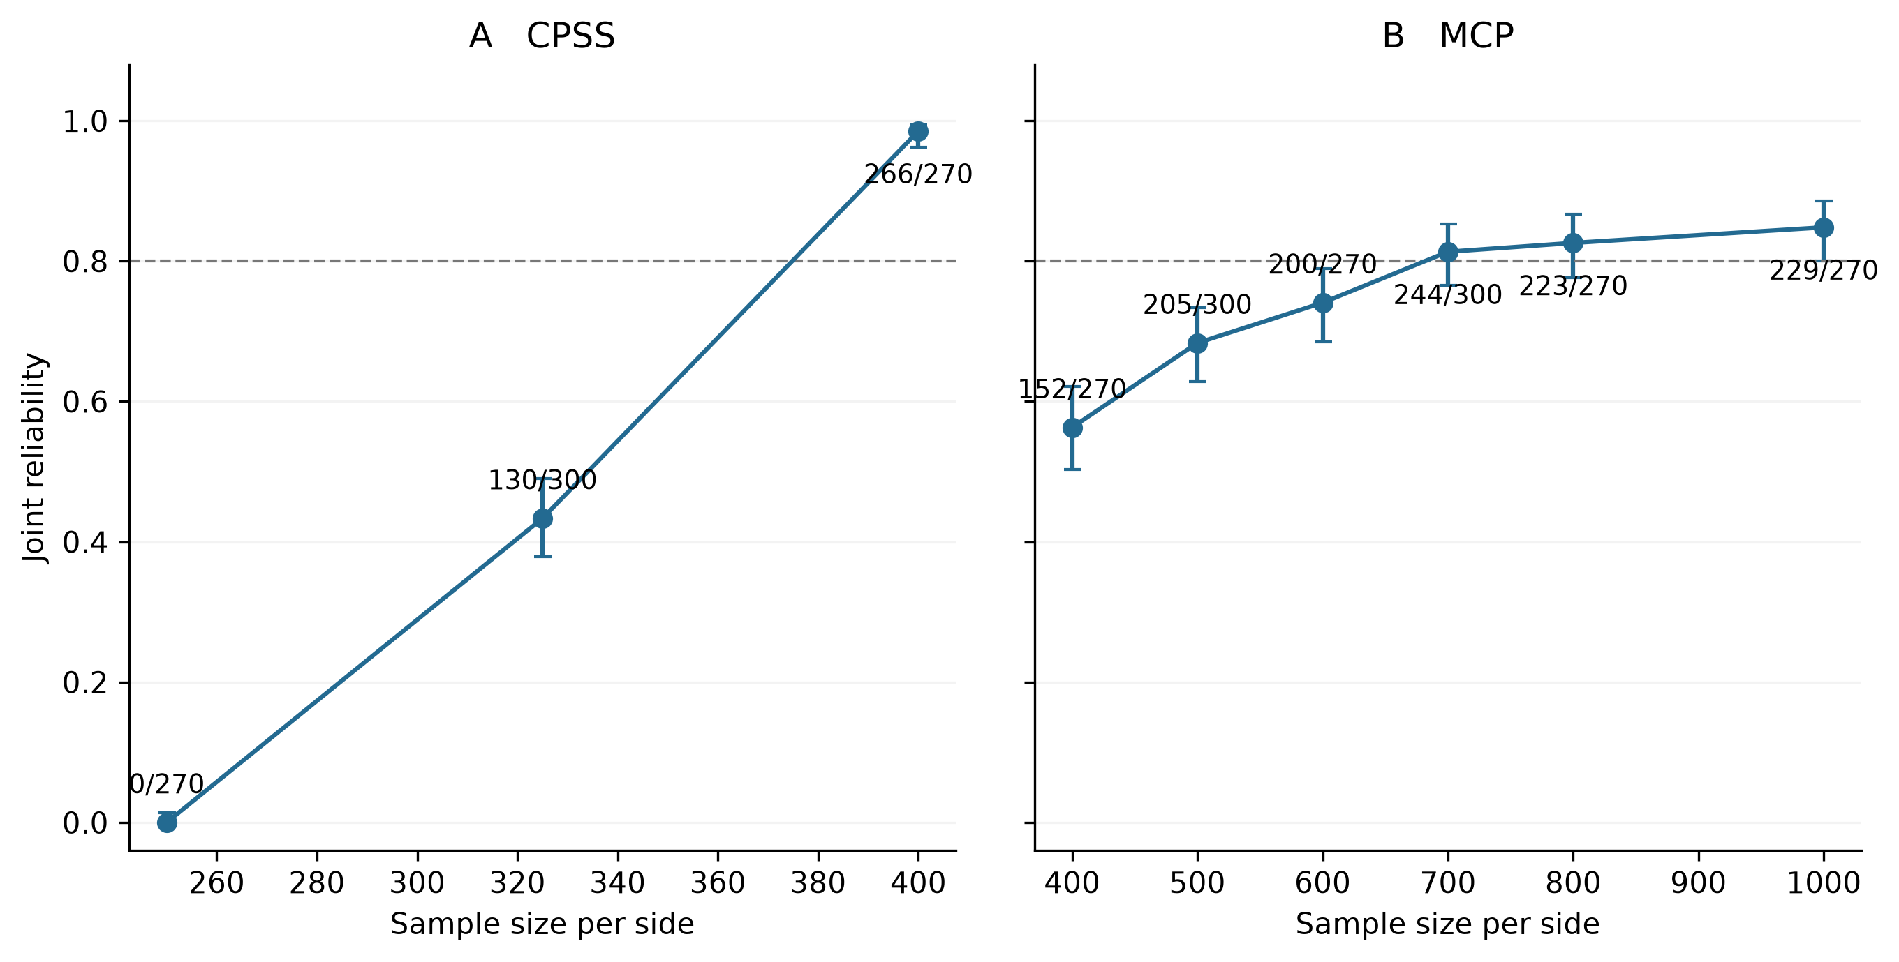
Figure S1. Local sample-size patterns. Points and Wilson 95% intervals use newly generated pairs only. Labels give successes/new pairs. The dashed line denotes reliability 0.80. Sample sizes were selected following diagnostic screening; pooled summaries remain in Supplementary Data.

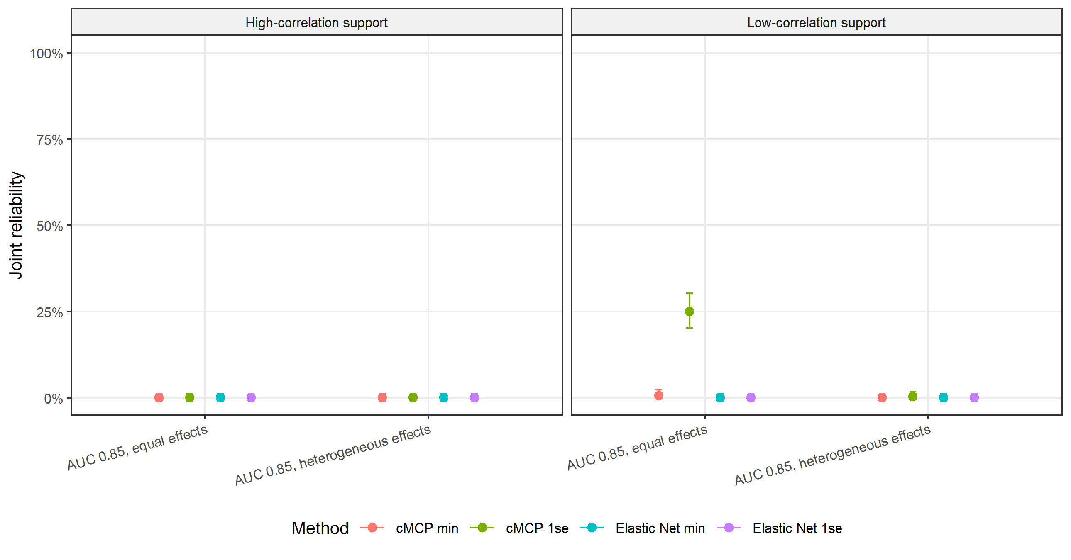
Figure S2. Signal strength and heterogeneity in the 2,000-gene benchmark. The signal module uses 1,000 patients per side, 300 pairs per setting and target oracle AUC 0.85. Equal and heterogeneous effects are compared within high- and low-correlation supports. Heterogeneous magnitudes span a 4:1 range. Strong-signal comparisons use the corresponding main-experiment conditions.

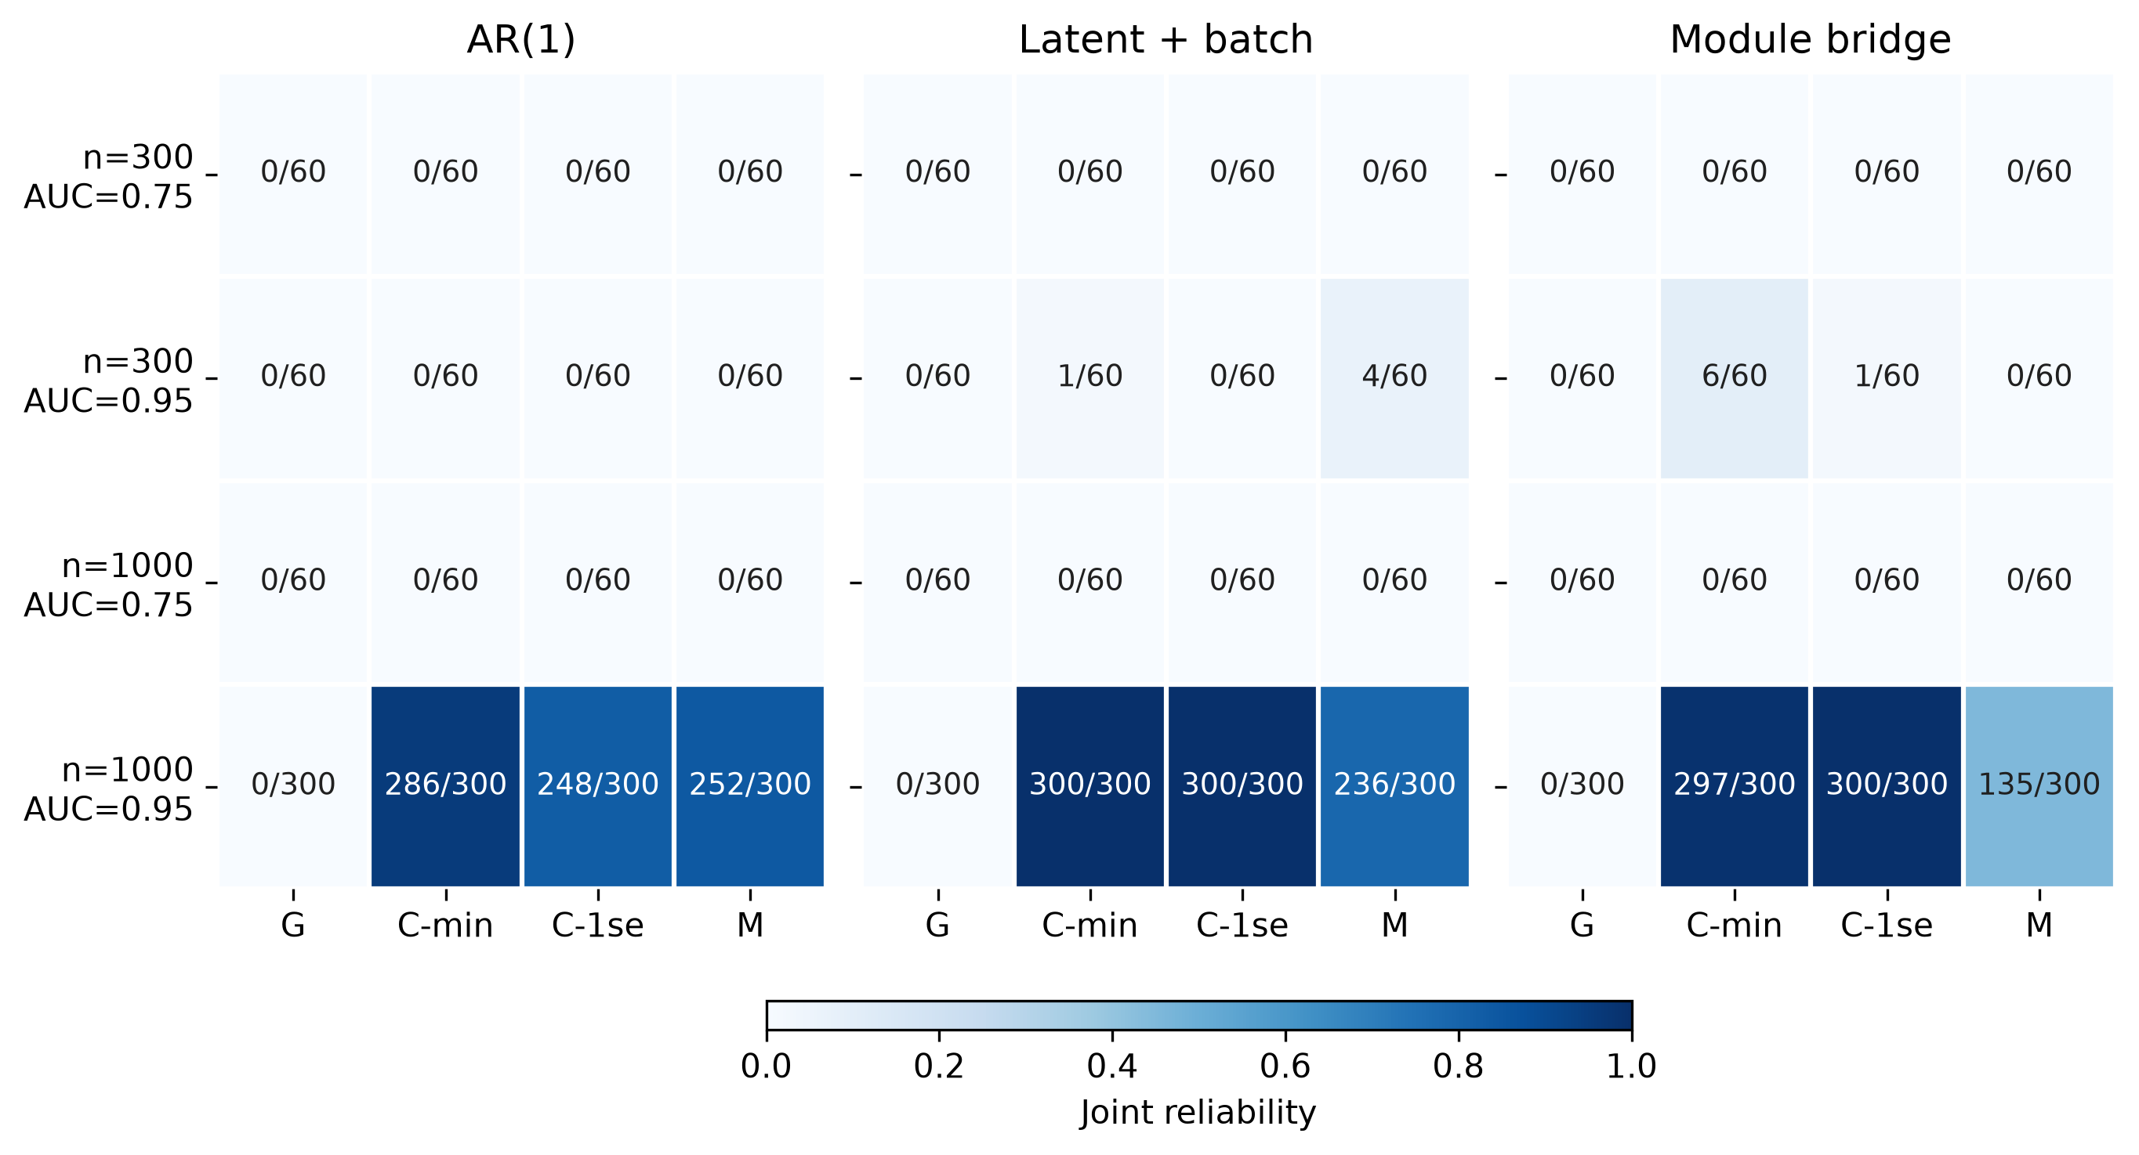
Figure S3. Reliability across 12 alternative mechanisms. Cells report successes/K. Each mechanism combines n=300 or 1,000 with target oracle AUC 0.75 or 0.95. The three n=1,000, AUC=0.95 settings use K=300; others use K=60. G denotes Group LASSO, C-min and C-1se cMCP rules, and M nongrouped MCP. Color encodes proportions, not statistical significance.

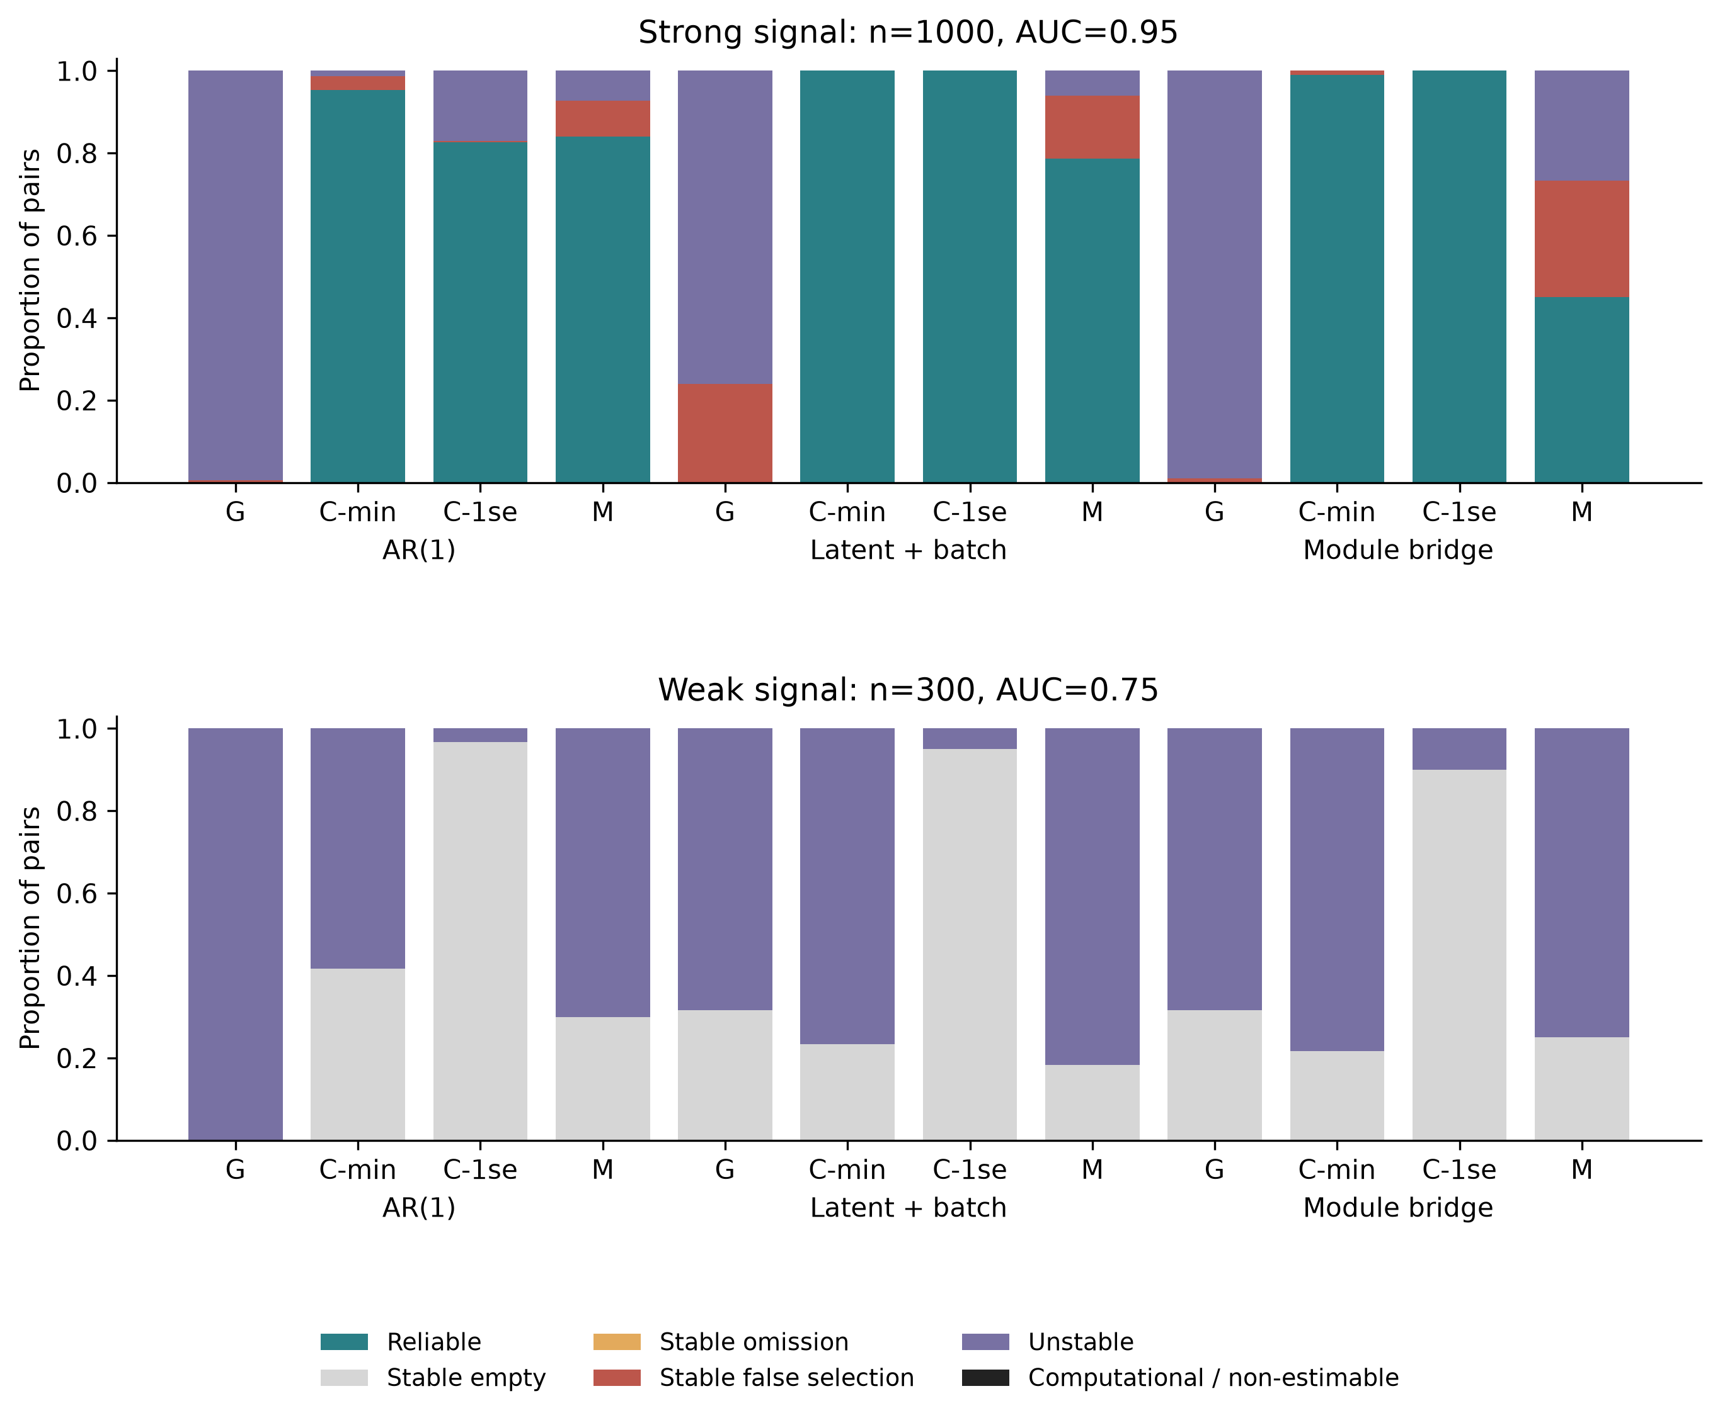
Figure S4. Failure categories in alternative mechanisms. Top panels show n=1,000, AUC=0.95; bottom panels n=300, AUC=0.75. Categories are mutually exclusive. Instability takes precedence over nonempty accuracy failures; unstable pairs can also fail recall or FDP. No computational or non-estimable outcomes occurred in these confirmations.

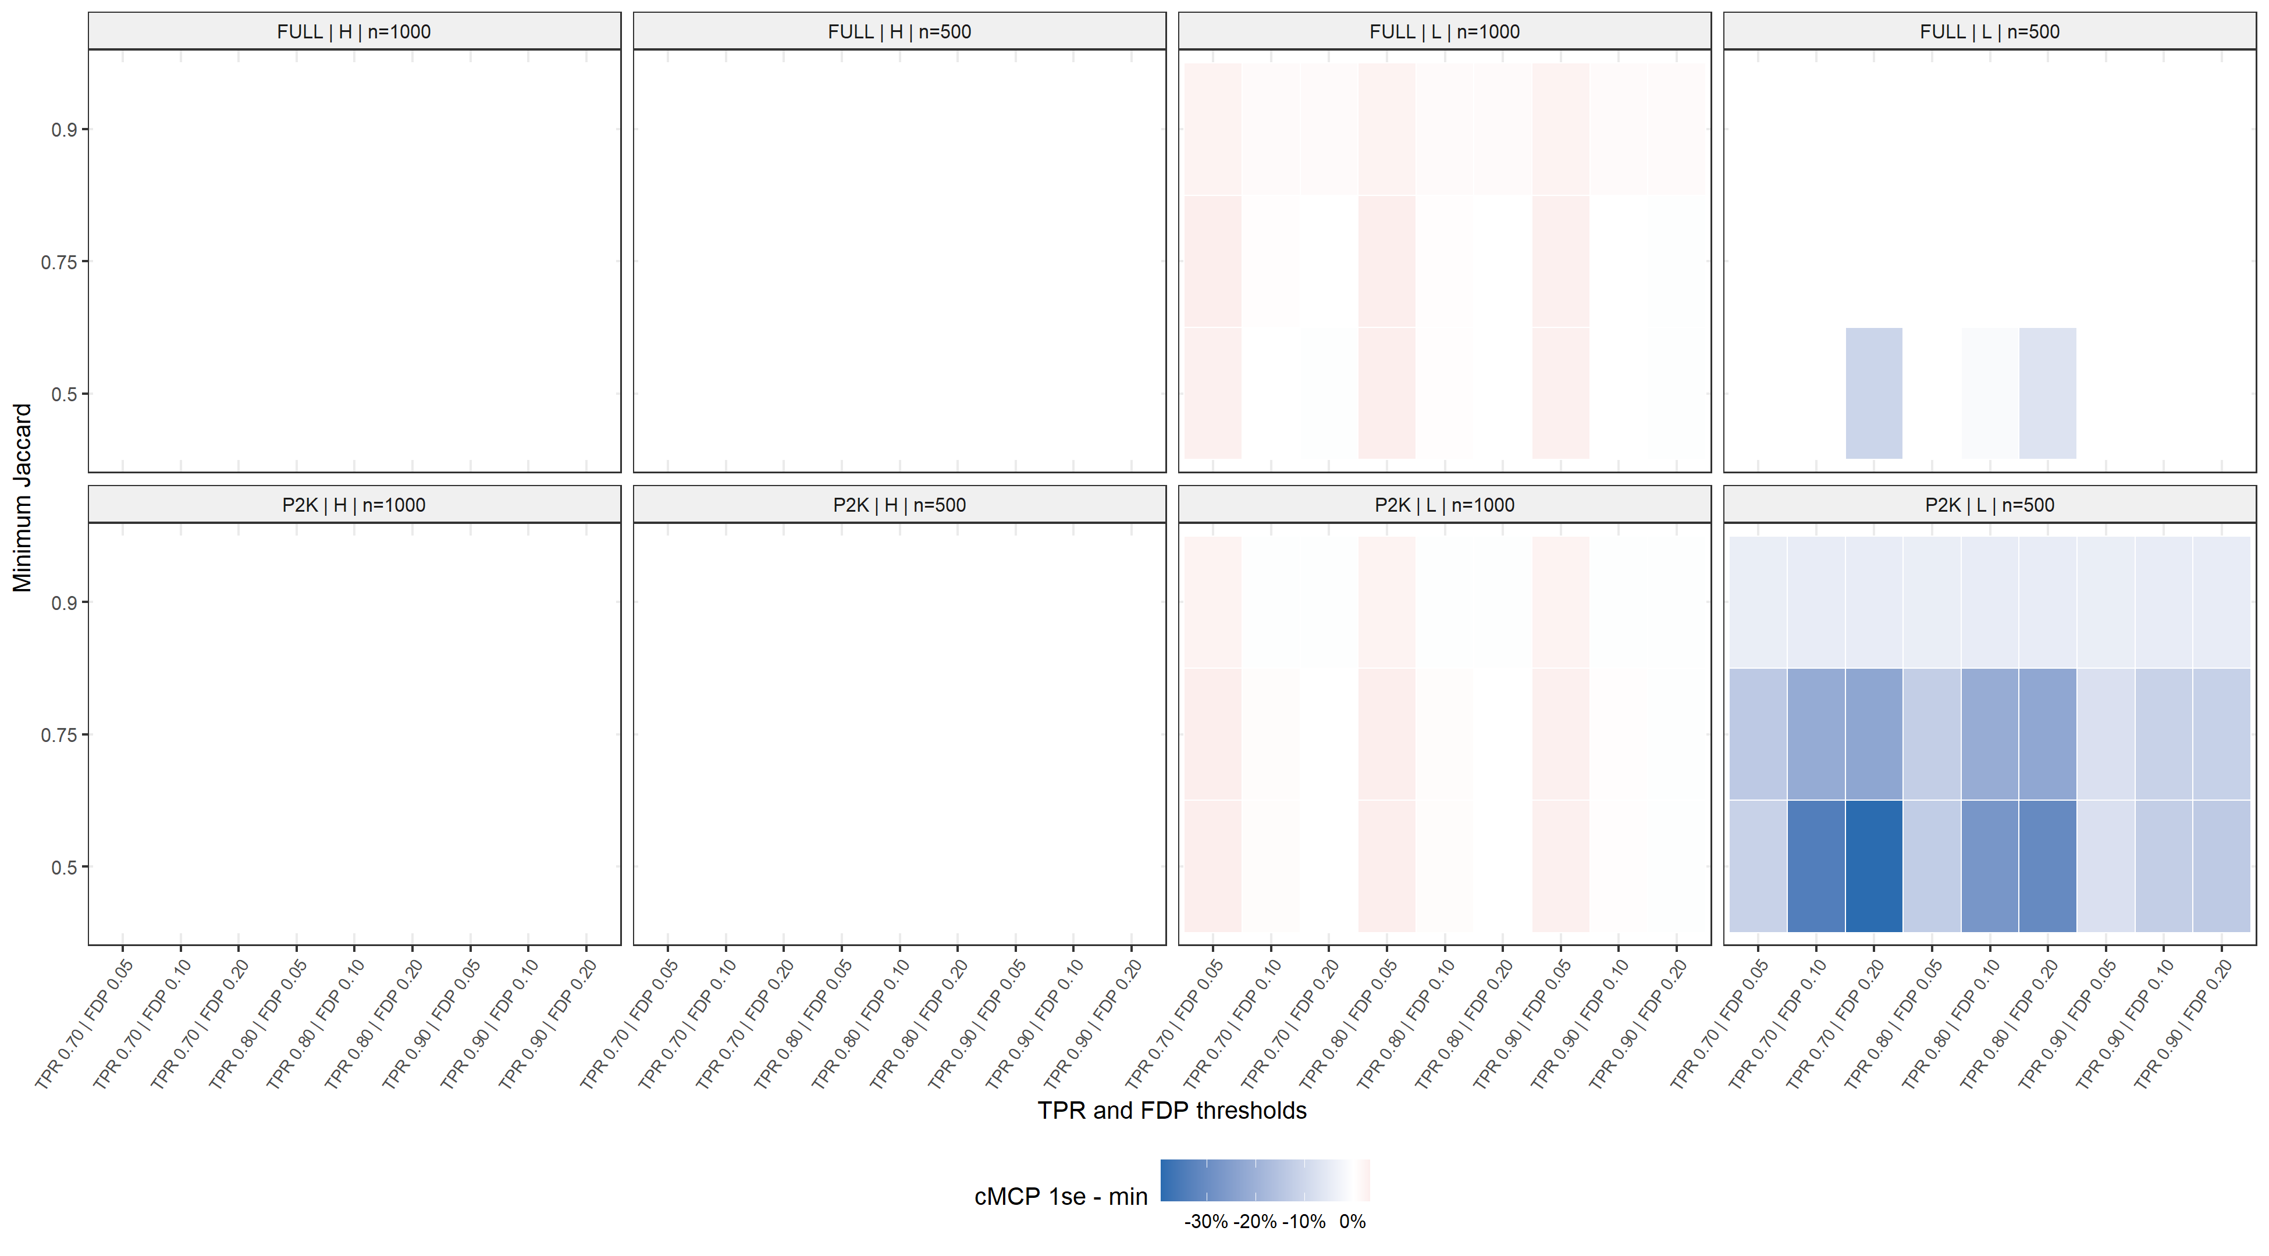
Figure S5. High-dimensional threshold sensitivity. Each main setting is evaluated under 27 combinations of minimum TPR, maximum FDP and minimum Jaccard. Contrasts are cMCP one-standard-error minus minimum-deviance reliability. Simultaneous intervals use the family of 216 comparisons; full values are in Supplementary Data.

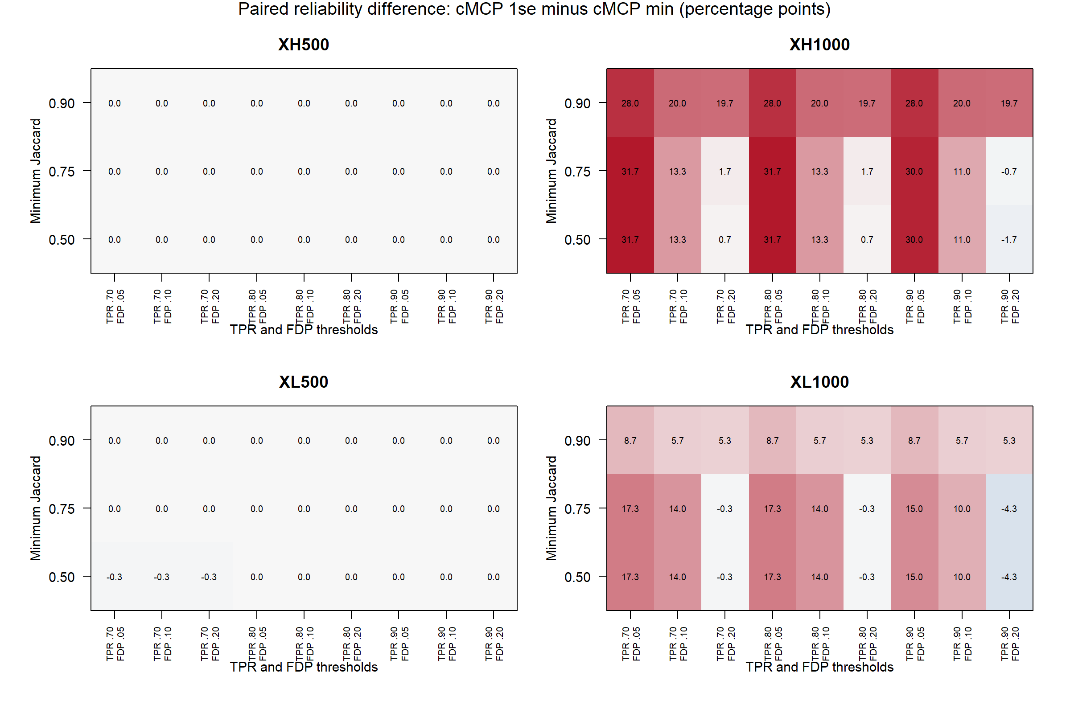
Figure S6. Exploratory threshold sensitivity in the 200-gene GSE96058 experiment. Contrasts are cMCP one-standard-error minus minimum-deviance reliability across 27 threshold combinations. Positive values favor stronger penalization. H/L denote support correlation; 500/1,000 denote bootstrap draws per side. Table S10 summarizes intervals corrected across 108 contrasts.

