SUPPLEMENTARY INFORMATION
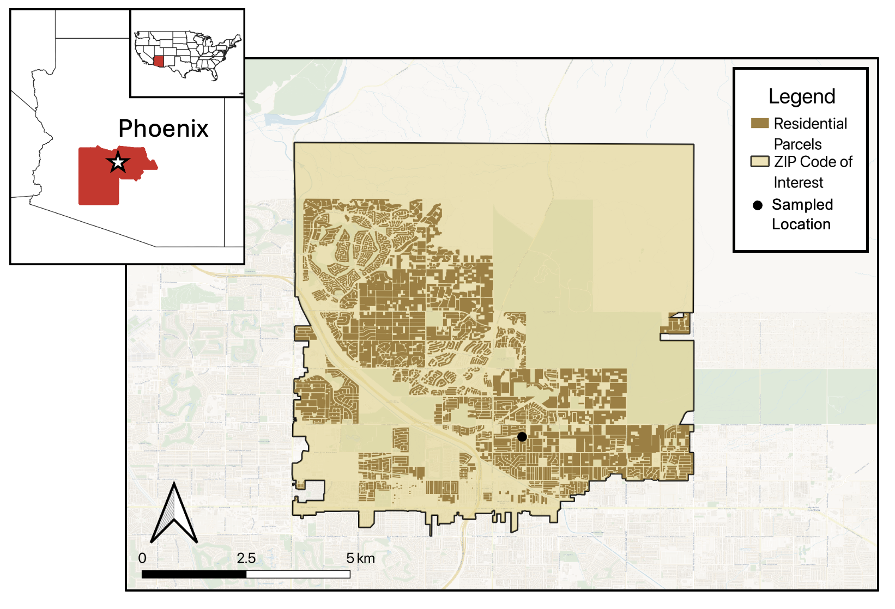
Fig. S1 An example of a zip code of interest (ZOI) showing residential parcels and a sampled backyard tortoise location within Maricopa County, Arizona, USA. Residential environmental variables were summarized at the zip code level

