A Density Functional Theory Study on the Water Aggregation Behaviour of Fatty-Acid based Anionic Surface Active Ionic Liquids
Suresh Sampathkumarª and Vijayakumar Subramaniam^{b,*}
ªDepartment of Physics, Bharathiar University, Coimbatore – 641 046.
^{b}Department of Medical Physics, Bharathiar University, Coimbatore – 641 046.
Corresponding Author: svijayakumar@buc.edu.in

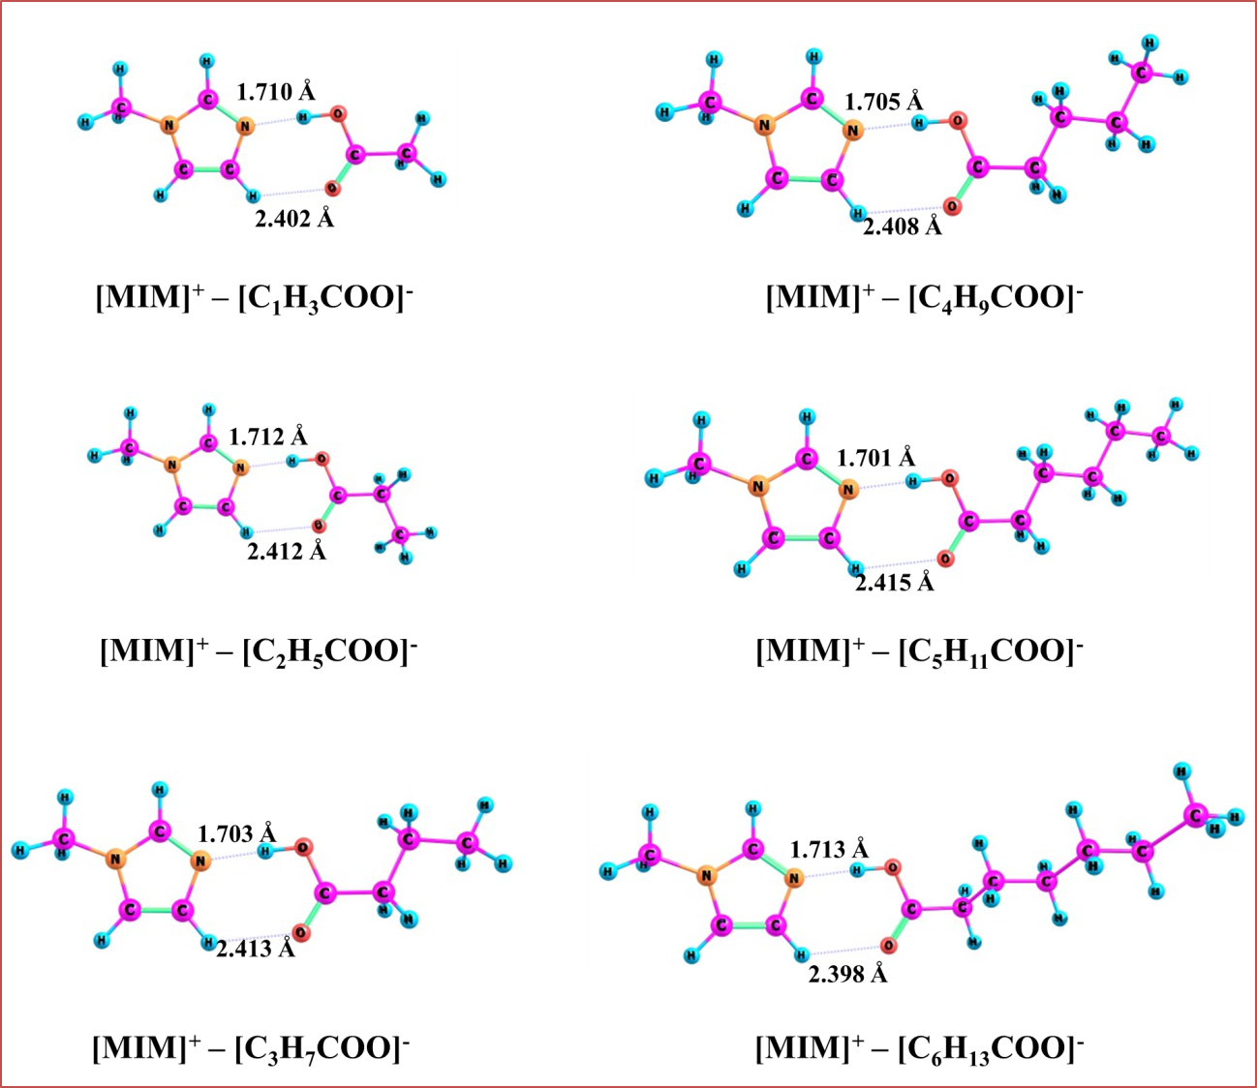
Figure S1. The optimized structures of Ion-pairs [MIM]⁺–[C_{m}H_{n}COO]⁻ (m=1-6; n=3-13) at M06-2X/6-311++G** level of theory (Site-2).
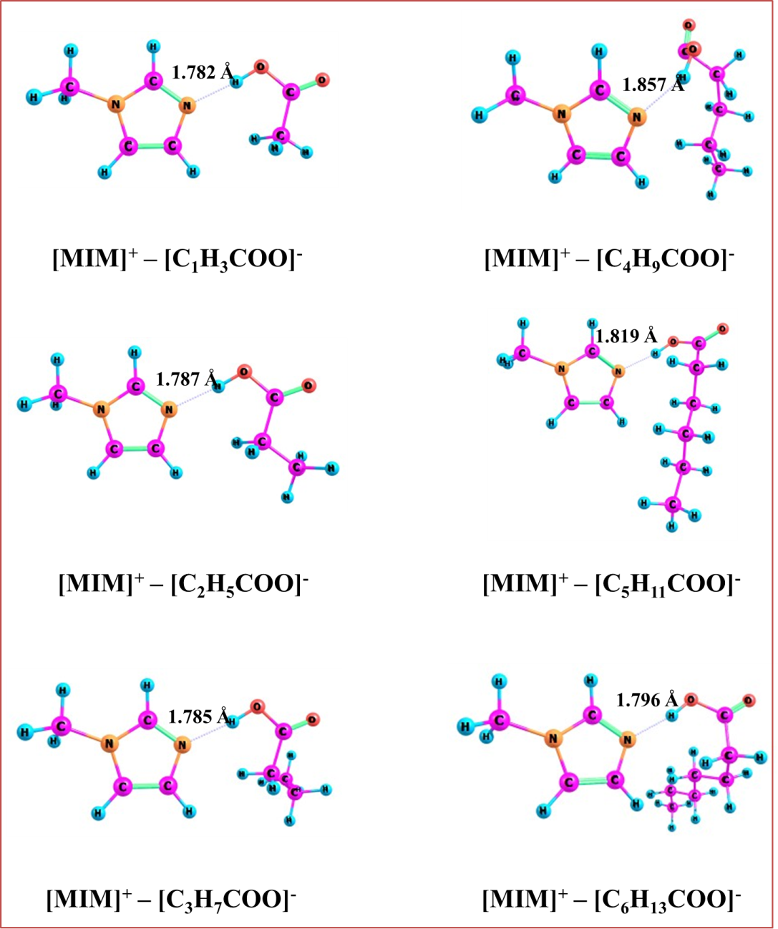
Figure S2. The optimized structures of Ion-pairs [MIM]⁺–[C_{m}H_{n}COO]⁻ (m=1-6; n=3-13) at M06-2X/6-311++G** level of theory (Site-3).

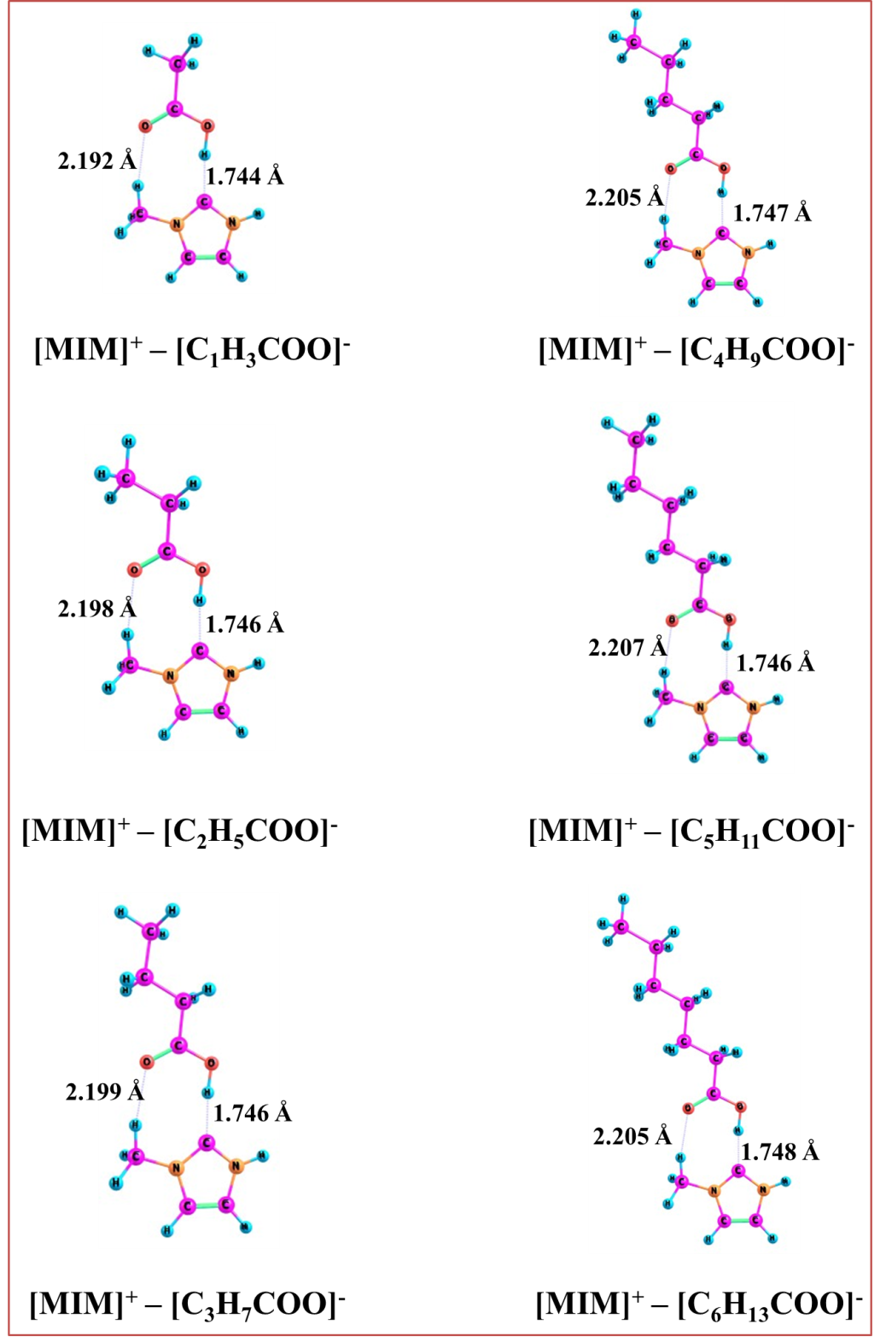
Figure S3. The optimized structures of Ion-pairs [MIM]⁺–[C_{m}H_{n}COO]⁻ (m=1-6; n=3-13) at M06-2X/6-311++G** level of theory (Site-4).

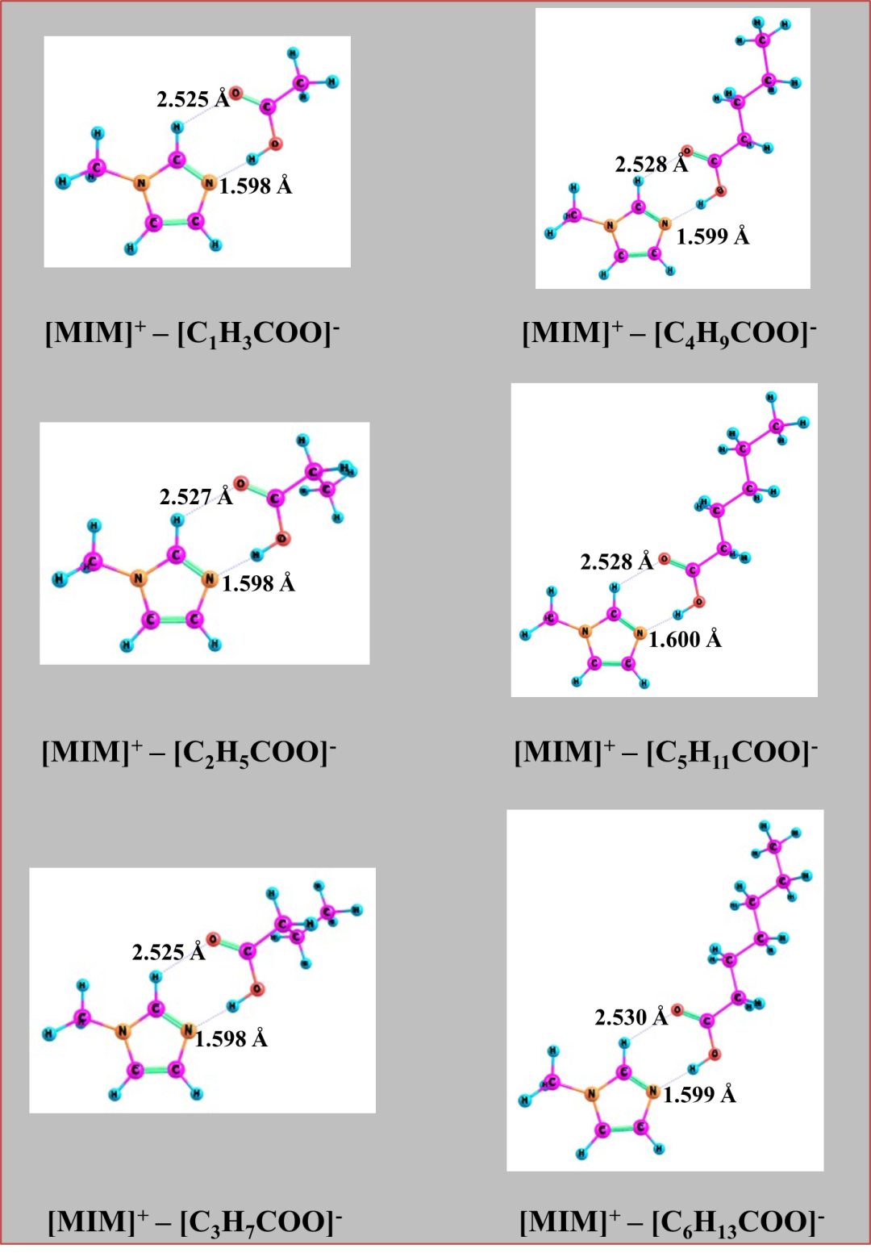
Figure S4. The optimized structures of Ion-pairs [MIM]⁺–[C_{m}H_{n}COO]⁻ (m=1-6; n=3-13) in water phase at M06-2X/6-311++G** level of theory.

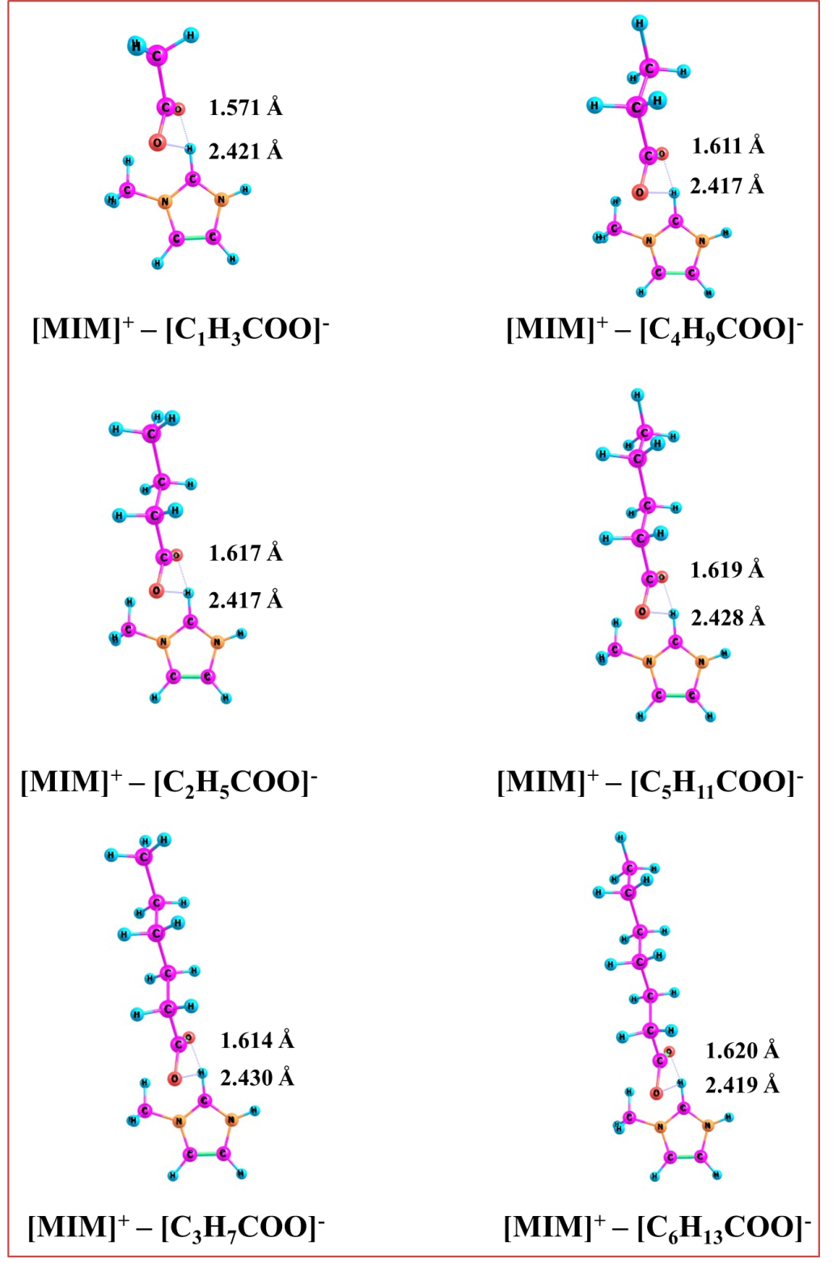
Figure S5. The optimized structures of Ion-pairs [MIM]⁺–[C_{m}H_{n}COO]⁻ (m=1-6; n=3-13) without proton transfer at M06-2X/6-311++G** level of theory.

Table S1. The relative energies for the [MIM]⁺–[C_{m}H_{n}COO]⁻ (m=1-6; n=3-13) ILs compare to their ground state geometry (in kcal/mol) calculated at M06-2X/6-311++G** level of theory.
ILs | With Proton transfer |  |  |  |  | Without proton  transfer
ILs | Site-1 | Site-2 | Site-3 | Site-4 | Water phase | Without proton  transfer
[MIM]⁺–[C₁H₃COO]– | 0.00 | 1.41 | 6.66 | 23.05 | -7.15 | 28.56
[MIM]⁺–[C₂H₅COO]– | 0.00 | 0.24 | 5.39 | 22.23 | -7.03 | 26.47
[MIM]⁺–[C₃H₇COO]– | 0.00 | 1.49 | 5.55 | 22.26 | -6.69 | 26.10
[MIM]⁺–[C₄H₉COO]– | 0.00 | 3.29 | 6.66 | 23.46 | -6.81 | 27.65
[MIM]⁺–[C₅H₁₁COO]– | 0.00 | 3.38 | 6.79 | 23.56 | -6.53 | 28.82
[MIM]⁺–[C₆H1₃COO]– | 0.00 | 2.33 | 7.14 | 23.17 | -6.53 | 27.33

