Supplementary Information
Supplementary I
Persistent HPV16 E7 Expression Establishes a Preconditioned Epithelial State and Reveals Enhanced Female Transcriptional Responsiveness During Oral Carcinogenesis
PV Kalani Hettiarachchi, Joshua Miao, RLPR Liyanage, Avi-Hai Hovav, Arutha Kulasinghe, Ian Frazer, Kelvin Tuong, Debottam Sinha, Janin Chandra*
*Correspondence to: j.chandra@uq.edu.au (J.C)
This file contains Supplementary Figures S1–S8, Supplementary Tables 1–3, and associated legends supporting the histopathological, immunophenotypic and transcriptomic analyses presented in the main manuscript.

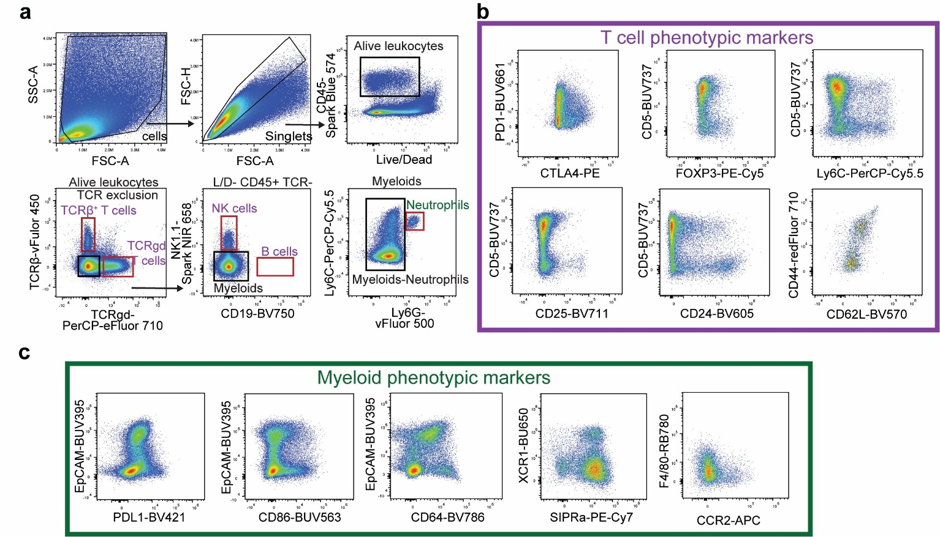

Supplementary Figure S1. Gating strategy and phenotypic marker identification of immune populations within the tongue epithelium. (a) Representative gating strategy used for identification of major immune populations from tongue epithelial single-cell suspensions. Following exclusion of debris, doublets and dead cells, live CD45⁺ leukocytes were identified and subdivided into TCRβ⁺ and TCRγδ⁺ T cells, NK cells, B cells and myeloid cells. Neutrophils were identified within the myeloid compartment based on Ly6G and Ly6C expression. (b-c) Representative marker-expression plots used for phenotypic characterisation of T cell and myeloid populations. T cell populations were assessed for expression of PD1, CTLA4, FOXP3, Ly6C, CD24, CD62L and CD25, while myeloid populations were assessed for EpCAM, PD-L1, CD86 and CD64 expression. Population frequencies reported throughout the study were quantified using the corresponding manual hierarchical gating strategies.

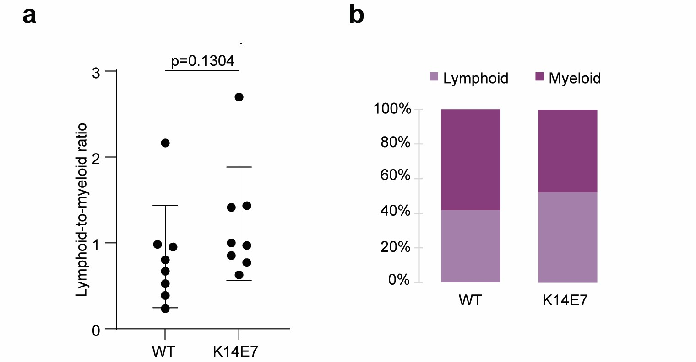

Supplementary Figure S2. Broad lymphoid and myeloid compartment balance is preserved within K14E7 tongue epithelium. (a) Lymphoid-to-myeloid ratio was calculated using parent lymphoid populations (TCRβ⁺, TCRγδ⁺, NK, and NKT-like cells) and non-lymphoid myeloid populations within the CD45⁺ compartment. K14E7 mice demonstrated a modest increase in the relative lymphoid contribution compared with WT controls; however, the overall lymphoid-to-myeloid ratio was not significantly altered (Mann–Whitney p = 0.1304). (b) Stacked proportional plots similarly demonstrated preservation of the overall balance between lymphoid and myeloid compartments across genotypes. Together, these findings indicate that baseline immune remodelling within K14E7 epithelium is not explained by broad compartmental redistribution between lymphoid and myeloid populations. Data are presented as individual mice with mean ± SD.

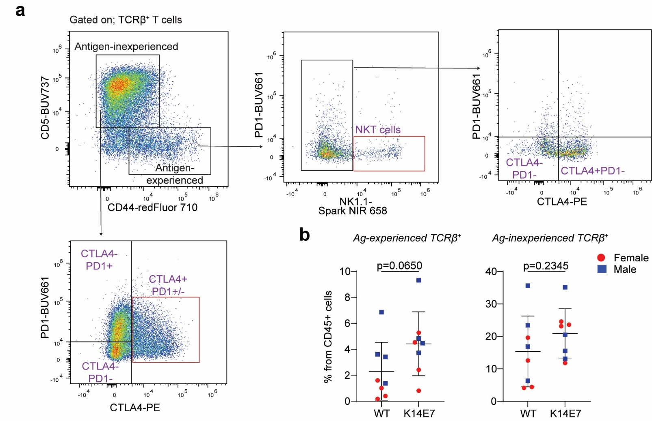

Supplementary Figure S3. Gating and quantification of antigen-inexperienced and antigen-experienced TCRβ⁺ cells in WT and K14E7 tongue epithelium.
(a) Representative gating strategy used to identify antigen-inexperienced (CD5⁺CD44⁻) and antigen-experienced (CD5⁻CD44⁺) TCRβ⁺ cells. Antigen-inexperienced cells were further subdivided according to CTLA4 and PD1 expression. Within the antigen-experienced compartment, NK1.1⁺ NKT-like cells were identified and excluded prior to analysis of CTLA4 and PD1 expression in conventional NK1.1⁻ antigen-experienced T cells. (b) Frequencies of antigen-experienced and antigen-inexperienced TCRβ⁺ cells within the CD45⁺ compartment in WT and K14E7 tongue epithelium (Mann–Whitney; antigen-experienced, p = 0.0650; antigen-inexperienced, p = 0.2345). Bars show mean ± SD; each point represents an individual mouse.

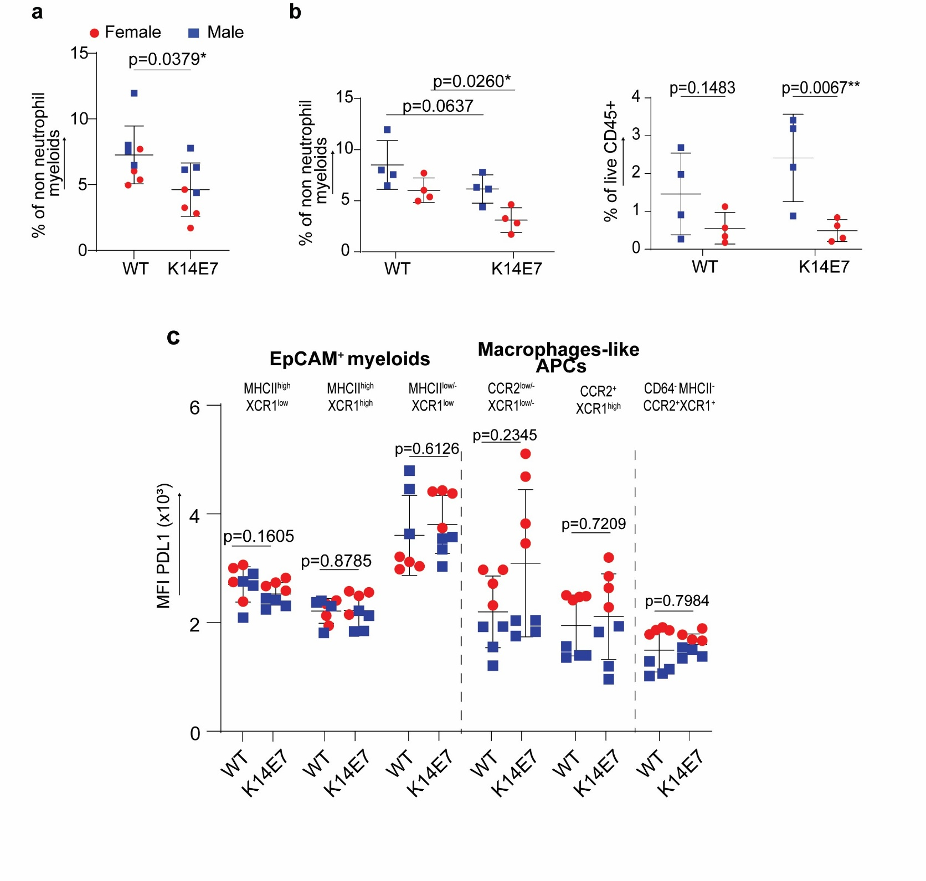

Supplementary Figure S4. Additional myeloid population and PD-L1 phenotyping in WT and K14E7 tongue epithelium. (a) Frequency of CD64-MHCII-CCR2⁺XCR1⁺ myeloid cells expressed as a percentage of non-neutrophil myeloid cells in WT and K14E7 epithelium. (b) Sex-stratified quantification of CD64⁻MHCII⁻CCR2⁺XCR1⁺ myeloid cells. (c) Neutrophil frequency expressed as a percentage of live CD45⁺ cells, shown by genotype and sex. (d) PD-L1 expression (MFI) across the indicated EpCAM⁺ myeloid and macrophage-like populations. Data are presented as mean ± SD, with individual points representing biologically independent animals. Pooled genotype comparisons were performed using two-sided Mann–Whitney U tests. Sex- and genotype-specific comparisons were analysed by two-way ANOVA followed by uncorrected Fisher’s LSD tests for secondary pairwise comparisons. Exact P values are shown in the figure.

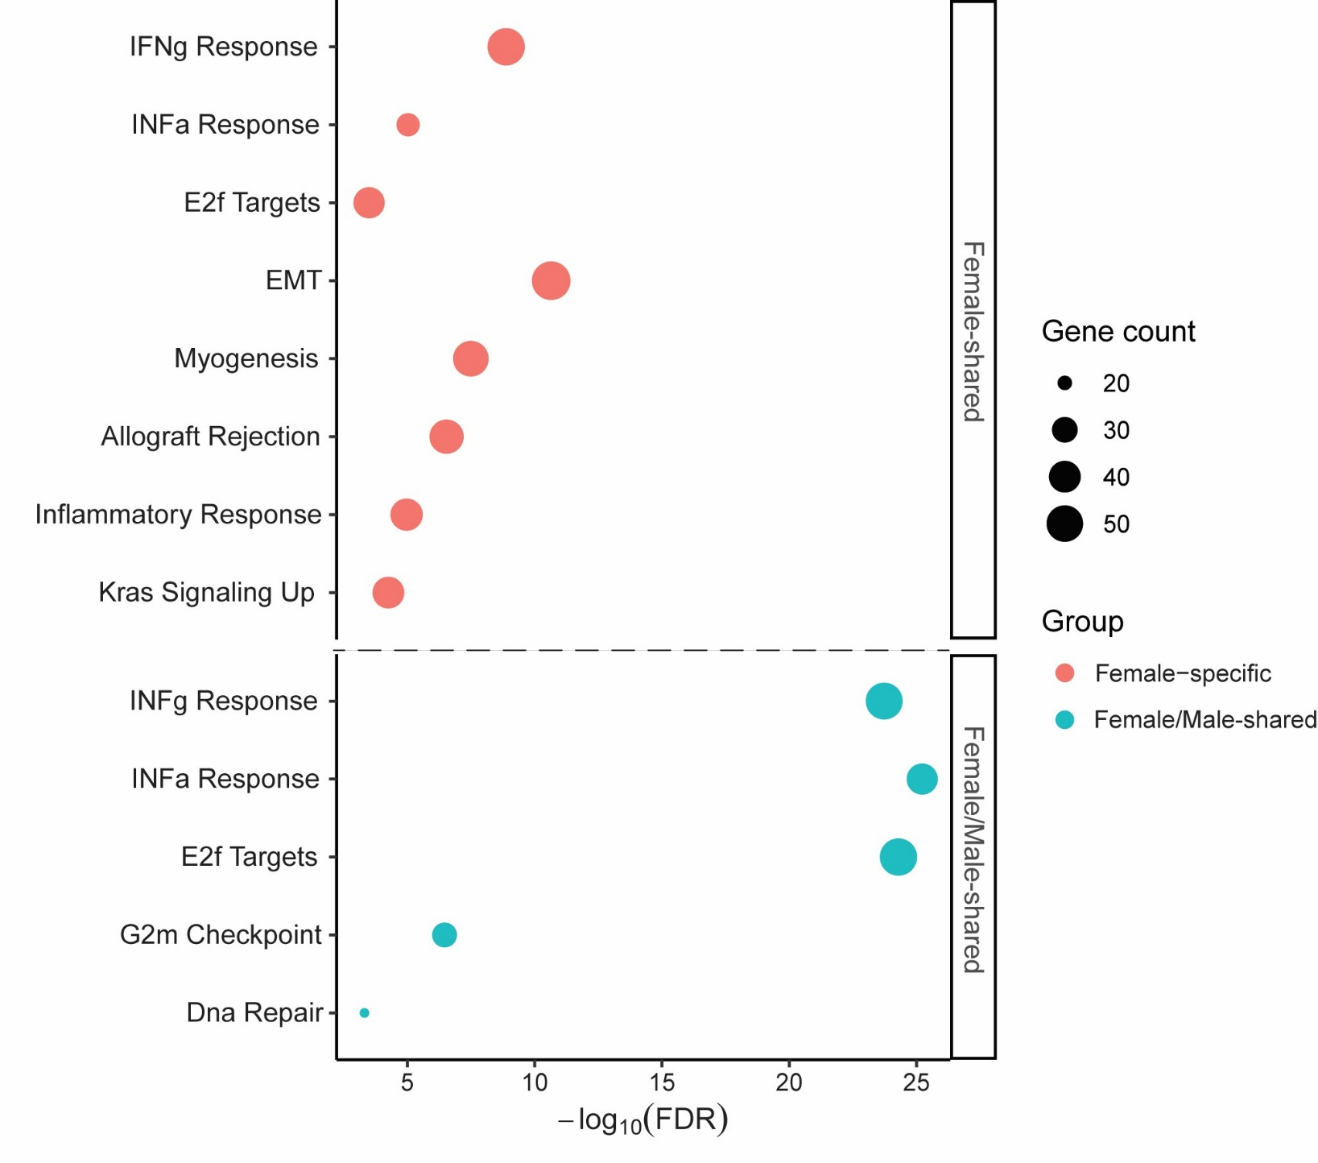

Supplementary Figure S5. Hallmark over-representation analysis (ORA) of sex-partitioned DEGs from K14E7 versus WT epithelium. Hallmark ORA was performed on DEGs identified from K14E7-versus-WT comparisons conducted independently in female and male mice. DEGs were partitioned into those detected only in females, shared between the female and male comparisons, and detected only in males. Pathways significantly enriched following Benjamini–Hochberg correction (FDR < 0.05) are shown. Bubble size represents the number of DEGs contributing to each Hallmark pathway, and the x-axis indicates pathway significance as −log10(FDR). No Hallmark pathways were significantly enriched among DEGs detected only in males.

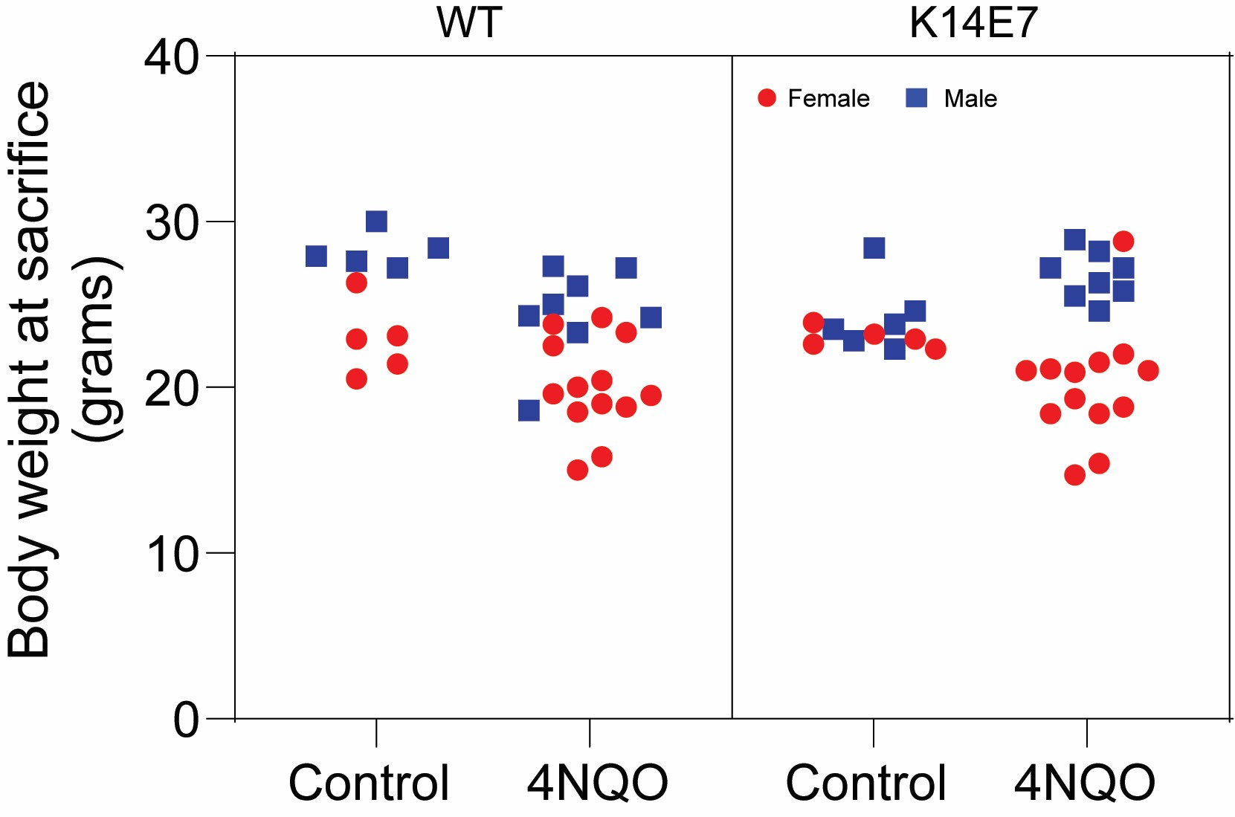

Supplementary Figure S6: Body weights were analysed by three-way ANOVA using a mixed-effects model. Significant main and interaction effects were observed; however, Šídák-adjusted multiple comparisons did not identify significant differences between control and 4NQO treated groups within genotype-sex strata. These data indicate no overt genotype- or sex-specific systemic toxicity under the applied 4NQO regimen.

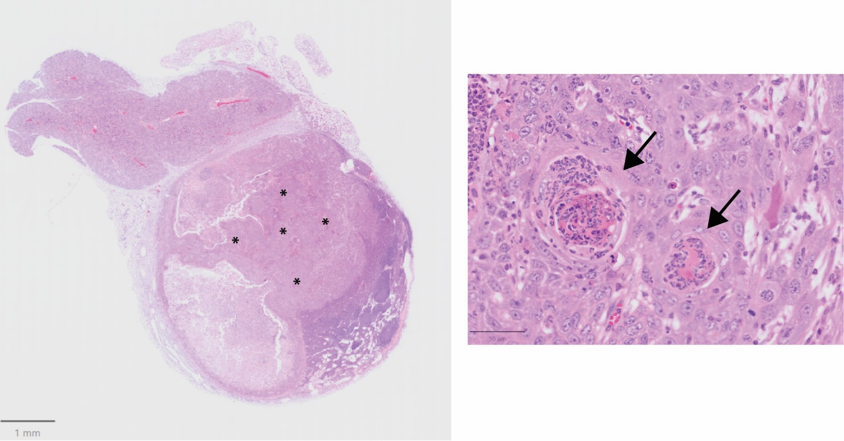

Supplementary Figure S7: Metastatic squamous cell carcinoma identified in a K14E7 mouse following 4NQO exposure. Representative haematoxylin and eosin (H&E)-stained sections showing a regional lymph node metastasis identified in a K14E7 mouse following 4NQO-induced oral carcinogenesis. Left, low-magnification overview of the lymph node showing extensive replacement by metastatic squamous cell carcinoma (asterisks). Right, higher-magnification view showing nests of atypical squamous epithelial cells with keratinisation (arrows) and associated stromal response. Scale bars, 1 mm (left) and 50 μm (right).

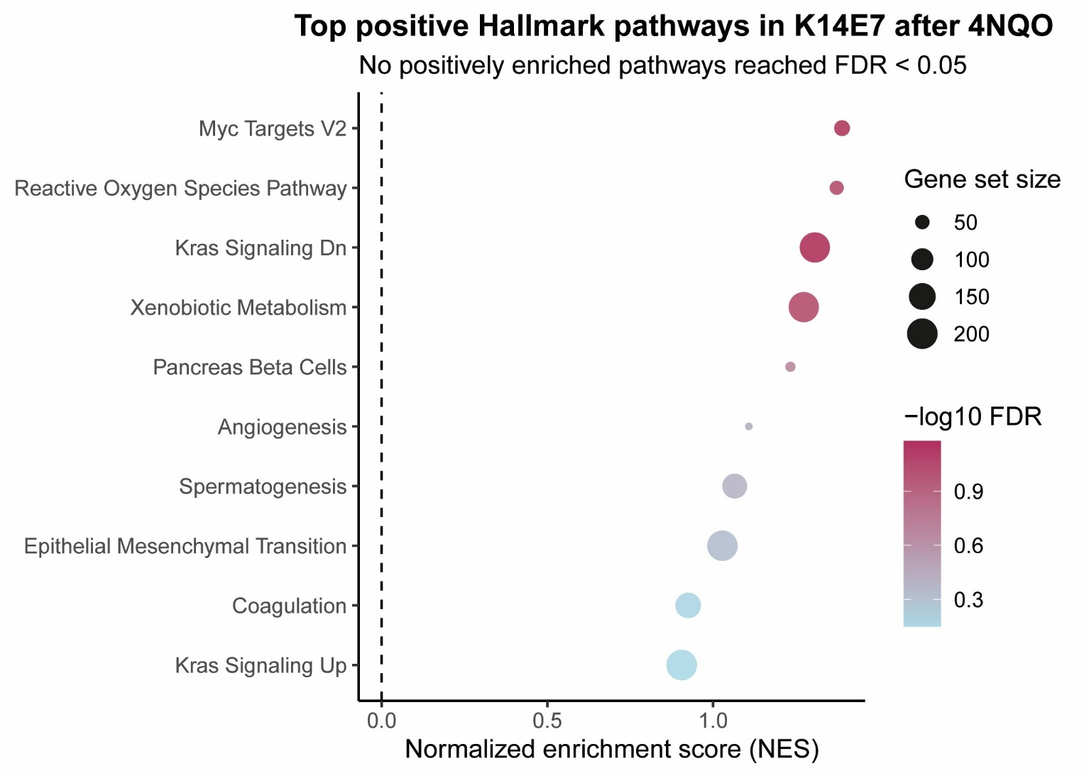
[Grab your reader’s attention with a great quote from the document or use this space to emphasize a key point. To place this text box anywhere on the page, just drag it.]

Supplementary Figure S8. Positive Hallmark pathways following 4NQO treatment in K14E7 epithelium. The ten highest positively enriched Hallmark pathways following 4NQO exposure in K14E7 epithelium are shown. None reached statistical significance after multiple-testing correction (all FDR > 0.05).

Genotype | Sex | Total N | Disease related events (n) | Censored (n) | Reason for censoring
WT | Male | 8 | 5 | 3 | Reached experimental endpoint
WT | Female | 13 | 10 | 3 | Reached experimental endpoint
K14E7 | Male | 8 | 4 | 4 | Reached experimental endpoint
K14E7 | Female | 14 | 11 | 3 | Ethical endpoint: Thymic enlargement–  associated respiratory distress
Supplementary Table 1: Summary survival outcomes following 4NQO exposure. Summary of tumour-related survival outcomes stratified by genotype and sex. Disease-related events indicate euthanasia due to tumour burden.

Censored animals did not experience a disease-related endpoint and were removed alive due to the pre-specified ethical maximum study duration or non–tumour-related morbidity. Total N reflects pooled age-matched cohorts.

Supplementary Table 2: Distribution of Disease Severity Index (DSI) categories across experimental groups. Percentage distribution of animals within each Disease Severity Index (DSI) category after 16 weeks of 4NQO treatment. DSI categories were defined as mild (scores 1–2), moderate (3–4), and severe (5–6) based on macroscopic clinical scoring.
Severity index | K14E7_Male (n=8, %) | K14E7_Female  (n=13, %) | WT_Male  (n=8, %) | WT_Female (n=13, %)
Mild Disease (1-2) | 12.5 | 30.8 | 12.5 | 0
Moderate Disease (3-4) | 12.5 | 15.4 | 25 | 15.4
Severe Disease (5-6) | 75 | 53.8 | 62.5 | 84.6

Values indicate the percentage of animals within each group.

Supplementary Table 3. Twenty-nine-colour spectral flow cytometry antibody panel used for immunophenotyping of murine tongue epithelium. Details are provided for each antibody, including target antigen, fluorochrome, clone, supplier, catalogue number and staining concentration.
No. | Antigen | Fluorochrome | Clone | Supplier | Catalogue no | Final dilution
1 | CD317 (PDCA1) | Spark UV 387 | 927 | BioLegend | 127044 | 1/200
2 | CD326 (EpCAM) | BUV395 | G8.8 | BD Bioscience | 740281 | 1/400
3 | CD4 | BUV496 | RM4-5 | Invitrogen | 364-0042-82 | 1/200
4 | CD86 | BUV563 | PO3 | BD Bioscience | 741285 | 1/400
5 | CD279 (PD1) | BUV661 | 29F.1A12 | BD Bioscience | 568603 | 1/100
6 | CD5 | BUV737 | 53-7.3 | BD Bioscience | 612809 | 1/800
7 | CD274 (PDL1) | BV421 | 10F.9G2 | BioLegend | 124315 | 1/800
8 | TCRβ | vFluor 450 | H57-597 | Cytek Biosciences | 75-5961-U100 | 1/100
9 | Ly6G | vFluor 500 | 1A8 | Cytek Biosciences | 85-1276-U100 | 1/200
10 | CD62L | BV570 | MEL-14 | BioLegend | 104433 | 1/100
11 | CD24 | BV605 | M1/69 | BioLegend | 101827 | 1/100
12 | XCR1 | BV650 | ZET | BioLegend | 148220 | 1/200
13 | CD25 | BV711 | PC61.5 | Invitrogen | 407-0251-82 | 1/200
14 | CD19 | BV750 | 6D5 | BioLegend | 115561 | 1/200
15 | CD64 | BV786 | X54-5/7.1 | BD Bioscience | 741024 | 1/100
16 | CD45 | Spark Blue 574 | 30-F11 | BioLegend | 103184 | 1/100
17 | CD8a | PerCP | 53-6.7 | Cytek Biosciences | 67-0081-U100 | 1/100
18 | Ly6C | PerCP-Cy5.5 | HK1.4 | Invitrogen | 45-5932-82 | 1/200
19 | TCRγδ | PerCP-eFluor 710 | eBioGL3 | Invitrogen | 46-5711-82 | 1/200
20 | F4/80 | RB780 | T45-2342 | BD Bioscience | 569224 | 1/100
21 | CD152 (CTLA-4) | PE | UC10-4F10-11 | Cytek Biosciences | 50-1522-U100 | 1/400

No. | Antigen | Fluorochrome | Clone | Supplier | Catalogue no | Final dilution
22 | Foxp3 | PE-Cy5 | 3G3 | Cytek Biosciences | 55-5773-U100 | 1/400
23 | CD172a (SIRPA) | PE-Cy7 | P84 | BioLegend | 144008 | 1/200
24 | CD11c | PE/Fire 810 | QA18A72 | BioLegend | 161106 | 1/1600
25 | CD192 (CCR2) | APC | QA18A56 | BioLegend | 160104 | 1/100
26 | NK-1.1 | Spark NIR 685 | S17016D | BioLegend | 156530 | 1/200
27 | CD44 | redFluor 710 | IM7 | Cytek Biosciences | 80-0441-U100 | 1/800
28 | MHCII | APC-Cy7 | M5/114.15.2 | Cytek Biosciences | 25-5321-U100 | 1/800
29 | Viability | Zombie NIR | N/A | BioLegend | 423106 | 1/1000

