Supplementary Table S1. Detection results for Rhizoctonia theobromae across sampled cassava plants and tissues

Plant Code | 6 months |  | 9 months
Plant Code | 28S¹ | COX1¹ | 28S¹ |  |  | COX1³
Plant Code | Leaf (Midrib/Petiole) | Leaf (Midrib/Petiole) | Leaf (Midrib/Petiole) | Stem | Root | COX1³
A | 1/1 | 1/1 | — | 4/4 | 1/1 | 5/5
B | 3/5 | 5/5 | 5/5 | 9/9 | 1/1 | 15/15
C | 6/10 | 10/10 | 1/2 | 7/7 | 0/2 | 11/11
D | 5/5 | 5/5 | 3/3 | 9/9 | — | 12/12
E | 5/5² | 5/6 | — | 2/2 | 1/1 | 3/3
F | 5/5 | 5/5 | 2/2 | 4/4 | 1/1 | 7/7
G | 5/5² | 5/6 | 3/3 | 7/7 | 1/1 | 11/11
H | 5/6² | 6/7 | 1/1 | 6/6 | 1/1 | 8/8
I | 4/4² | 4/5 | 2/2 | 7/7 | 1/1 | 10/10
J | 4/4 | 4/4 | — | 4/4 | 1/1 | 5/5
K | 4/4² | 4/6 | 2/2 | 7/7 | 1/1 | 10/10
L | 7/7 | 7/7 | 0/1 | 8/8 | 0/1 | 10/10
M | 6/6 | 6/6 | 1/4 | 5/9 | 1/1 | 14/14
N | 6/6² | 6/7 | 1/1 | 8/9 | 1/1 | 11/11
O | 1/1² | 1/2 | 1/1 | 4/4 | 1/1 | 6/6
P | 4/4 | 4/4 | 0/2 | 7/7 | 1/1 | 10/10
Q | 5/5 | 5/5 | — | 1/1 | — | 1/1
Total | 76/83  (91.6%) | 83/91 (91.2%) | 22/29 (75.9%) | 99/104 (95.2%) | 13/16 (81.3%) | 149/149 (100%)
¹Detection data are presented as positive/total samples tested.
²Some samples were positive for R. theobromae 28S but negative for the cassava COX1 assay.
³Combined result in all tissue types per plant code

Supplementary Table S2. In silico evaluation of the R. theobromae (syn. Ceratobasidium theobromae) TaqMan probe sequence against representative fungal sequences.

Organism | Accession No. | Location | Host | Primer-Probe Match
Ceratobasidium theobromae | HQ424241.1 | Indonesia | Theobroma cacao | +
Ceratobasidium theobromae | KU319575.1 | Indonesia | Theobroma cacao | +
Ceratobasidium theobromae | KU319576.1 | Indonesia | Theobroma cacao | +
Ceratobasidium theobromae | OR673502.1 | Philippines | Manihot esculenta | +
Ceratobasidium theobromae | PP296691.1 | Philippines | Manihot esculenta | +
Ceratobasidium theobromae | PQ559890.1 | Philippines | Manihot esculenta | +
Ceratobasidium theobromae | PQ559892.1 | Philippines | Manihot esculenta | +
Ceratobasidium theobromae | PQ559894.1 | Philippines | Manihot esculenta | +
Ceratobasidium theobromae | PQ559896.1 | Philippines | Manihot esculenta | +
Ceratobasidium sp. | OQ361384.1 | USA | Cercis canadensis | +
 | PP662685.1 | USA | Cornus florida | +
Ceratobasidium sp. AG-I | OL686895.1 |  |  | -
Rhizoctonia sp. | MW836108.1 |  | Brassica napus | -
Ceratobasidium sp. AG-V | KM505159.1 | China | Zingiber officinale | -
Ceratobasidium cereale | OQ397532.1 | South Korea | oat | -
Ceratobasidium cereale | OQ397533.1 | South Korea | oat | -
Ceratobasidium cereale | OQ397534.1 | South Korea | oat | -
Ceratobasidium ramicola | HQ424243.1 | Indonesia | Theobroma cacao | -
Ceratobasidium sp. CBS 129339 | KC336073.1 | Germany |  | -
Ceratobasidium sp. FO 38200 | ON543146.1 | China | Cypripedium guttatum | -
Rhizoctonia solani | MK260664.1 | India |  | -
Rhizoctonia solani | MN078809.1 | India | Vigna unguiculata | -
Rhizoctonia solani | OP550086.1 | Iraq | Soil (Cantaloupe) | -
Rhizoctonia solani | OQ345812.1 | India | Lablab purpureus | -
Sistotrema raduloides | KF218969.1 | Finland |  | -
Termitomyces microcarpus | MN160315.1 | Thailand |  | -
Thanatephorus cucumeris | OP896215.1 |  |  | -
Bergerella atrofusca | MN902070.1 | Austria | Physcia aipolia | -
Botryobasidium obtusisporum | DQ898729.1 |  |  | -
Candelabrochaete septocystidia | EU118609.1 | Sweden |  | -
Ceraceomyces microsporus | AF090876.1 |  |  | -
Ceratorhiza hydrophila | MT381951.1 | Ecuador | Pistia stratiotes | -
Ceriporia sordescens | KX752606.1 | USA |  | -
Laxitextum bicolor | AF310102.1 | Russia |  | -
Phlebia sp. FBCC296 | LN611130.1 |  |  | -

Supplementary Table S3. Sequences and characteristics of primers and probe used in this study

Target | Name | Sequences (5′- 3′)ª | Tm (°C) | %GC | Position (bp) | Amplicon size (bp) | Reference
Large subunit rDNA (28S rDNA) | Cth28S-F | TACGGGCCAGCATGGATTTT | 60.0 | 50.0 | 351-370^{b} | 101 | This study
Large subunit rDNA (28S rDNA) | Cth28S-R | CTCGATCCCAATCGACGTGT | 59.9 | 55.0 | 432-451^{b} | 101 | This study
Large subunit rDNA (28S rDNA) | Cth28S-P | [FAM]-ACCGGCGGAAAAGGGCTTGG-[TAMRA] | 65.8 | 65.8 | 372-391^{b} | 101 | This study
Cytochrome oxidase I (COX1) | COX-F | CGTCGCATTCCAGATTATCCA | 58.2 | 47.6 | 459,855- 459,875^{c} | 79 | (Weller et al., 2000)
Cytochrome oxidase I (COX1) | COX-R | CAACTACGGATATATAAGRRCCRRAACTG | 58.8-64.7 | 40.0 | 459,905-459,934^{c} | 79 | (Weller et al., 2000)
Cytochrome oxidase I (COX1) | COX-P | [FAM]-AGGGCATTCCATCCAGCGTAAGCA-[TAMRA] | 66.6 | 54.2 | 459,878-459,901^{c} | 79 | (Weller et al., 2000)
ªFAM 6-carboxyfluorescein, TAMRA, a registered trademark of IDT
^{b}Position of the primer or probe considering the GenBank accession no. PP296691.1 as a reference sequence.
^{c}Position of the primer or probe considering the GenBank accession no. NC_045136. Manihot esculenta complete mitochondrial genome

Supplementary Table S4. In-silico specificity assessment of the R. theobromae primer pair using Primer-BLAST

Species / taxon | Accession number(s) | Forward mismatches | Reverse  mismatches | Total mismatches | Predicted amplicon (bp)
Ceratobasidium theobromae | PV639453.1, PV639452.1, PQ559901.1, PQ559900.1, PQ559898.1, PQ559897.1, PQ559896.1, PQ559893.1, PQ559892.1, PQ559891.1, OR673508.1, OR673506.1, OR673504.1, OR673503.1, OR673502.1, KU319578.1, KU319577.1, KU319576.1, KU319575.1 | 0 | 0 | 0 | 101
Thanatephorus theobromae  (synonymous name) | HQ424242.1, HQ424241.1 | 0 | 0 | 0 | 101
Ceratobasidium sp. | PQ587527.1–PQ587520.1, PP662685.1–PP662681.1, PP350698.1, OQ361384.1, PV580885.1, PV580884.1, PV580883.1, PV580797.1, AY293171.1 | 0–1 | 0–1 | 0–2 | 101
Ceratobasidium cornigerum | AY152405.1 | 1 | 1 | 2 | 101
Rhizoctonia quercus | PV121927.1, MH867202.1 | 0 | 1 | 1 | 101
Dentiscutata heterogama | LR731339.1, LR730678.1 | 0–1 | 1–2 | 2 | 101–102
Diversispora epigaea | LR731083.1, LR730592.1 | 1 | 1 | 2 | 100–101
Acaulospora kentinensis | LR730690.1 | 1 | 1 | 2 | 101
Skeletocutis albocremea | PQ324949.1, PQ324948.1 | 1–2 | 1–2 | 3 | 101
Botryobasidium spp. | PQ285266.1, OR470954.1, OR470950.1, OR470948.1, OR460928.1, etc. | 2–3 | 1–2 | 4–5 | ~101
Amauroderma spp. | PX687938.1, PX687937.1, MW546338.1, MW546336.1, MW546328.1, etc. | 2–3 | 2 | 4–5 | 101
Antrodia spp. | JQ700281.1, JQ700272.1, KC585132.1, MH867991.1, etc. | 2 | 2 | 4 | 101
Fomitopsis spp. | KT995146.1, MG787642.1, MG787645.1, PZ517314.1, PX652839.1, etc. | 2 | 2 | 4 | 101
Lopharia spp. | OR822096.1, MK993636.1, PV839363.1, PQ363274.1, PQ197852.1, etc. | 2–3 | 2 | 4–5 | 101
Skeletocutis spp. | PZ122160.1, PP474334.1, MF685360.1, MF924723.1, PQ324952.1, PQ324916.1, MN905062.1, etc. | 2 | 2 | 4 | 101
Tyromyces spp. | PX658065.1, ON366756.1, KY948893.1, MH867567.1, etc. | 2 | 2 | 4 | 101
Polyporus spp. | PX091339.1, PV436639.1, MT483608.1, KX900099.1, MH867079.1, etc. | 3 | 2 | 5 | 101–103
Daedaleopsis spp. | OQ408440.1, OQ408429.1, OQ408437.1, etc. | 3 | 2 | 5 | 101–103
Lentinus spp. | OM802486.1, PQ248544.1, FJ755219.1, etc. | 3 | 2 | 5 | 101–103
Alloexidiopsis spp. | MZ352939.1, OM801932.1, etc. | 3 | 2 | 5 | 99
Pyrofomes juniperinus | KY940264.1 | 3 | 3 | 6 | 101

Supplementary Table S5. BLASTn analysis of the R. theobromae TaqMan probe sequence

Species / taxon | Accession number(s)* | Query coverage (%) | N matches  (% similarity) | E-value
Ceratobasidium theobromae (target) | PQ559901.1, PQ559900.1, PQ559898.1, PQ559897.1, PQ559896.1, PQ559893.1, PQ559892.1, PQ559891.1; OR673508.1, OR673506.1, OR673504.1–OR673502.1; KU319578.1–KU319575.1; PV639453.1–PV639452.1 | 100 | 20/20 (100%) | 7.1
Ceratobasidium sp. | PQ587527.1–PQ587520.1; PP662685.1–PP662681.1; PP350698.1; OQ361384.1 | 100 | 20/20 (100%) | 7.1
Thanatephorus theobromae  (synonymous name) | HQ424242.1–HQ424241.1 | 100 | 20/20 (100%) | 7.1
Other fungi  Trichoderma reesei | CP040226.1, CP040212.1, CP040191.1, CP016236.1, XM_006961490.1, CP021308.1, CP021294.1, CP089844.1, CP089828.1 | 95 | 19/20 (95%) | 28
Russula faginea; Arachnomyces sp. | OZ200924.1, OZ200920.1, OZ200914.1; OX453235.1 | 90–95 | 18–19/20 (90–95%) | 28–111
Other bacteria  Roseibium album; Paenibacillus sp.; Varunaivibrio sulfuroxidans; Gordonia spp.; Mesobacillus sp.; Mesorhizobium sp.; Pseudomonas sp.; Geobacter benzoatilyticus; Desulfobacter sp.; other bacterial taxa | OZ247583.1; CP150274.1; CP119676.1; CP046257.1, CP093238.1; CP126080.1; CP083956.1; AP021905.1; CP071382.1; CP054838.1; OZ247430.1, OZ243956.1, OZ242300.1 | 90–95 | 18–19/20 (90–95%) | 28–111
Other plants  Acaena ovalifolia; Cheirolophus tagananensis | OZ078299.1–OZ078274.1; OZ199082.1 | 90 | 18/20 (90%) | 111
Other animals  Entelurus aequoreus; Nerophis ophidion; Rhogogaster chlorosoma; Plebejus idas; Macrothele cretica; Procloeon bifidum; Athalia spp.; Ctena decussata; Stagnicola palustris; Microtus agrestis; Aethecerus discolor; Dolabella auricularia; Doratura stylata; Rymosia fasciata; Arvicola amphibius; Meganola albula | XM_062070525.1; XM_061879145.1; OX101801.1; OZ320388.1–OZ320334.1; OZ207549.2; OZ259033.1; OZ021698.1, OZ010627.1; OZ022504.1; OZ501502.1; OZ496540.1–OZ496516.1; OZ469831.1; OZ465646.1; OZ455257.1; OZ413697.1; LR862394.1; OW388147.1 | 90–95 | 18–19/20 (90–95%) | 28–111
Uncultured/environmental  Uncultured Elusimicrobiota, Pirellulales, Alphaproteobacteria, Hahellaceae, Pseudomonadota, Desulfobacteraceae, and Acidobacteriaceae bacteria; Verrucomicrobiia, Bryobacterales, Methylacidiphilales, and Hyphomicrobiales bacteria | OZ305600.1; OZ307488.1; OZ305051.1; OZ304626.1; OZ304378.1; OZ490594.1, OZ489601.1; OZ490365.1; OZ489811.1; OZ508629.1, OZ508299.1; OZ508139.1; OZ505822.1; OZ503724.1; OZ502262.1 | 90 | 18/20 (90%) | 111

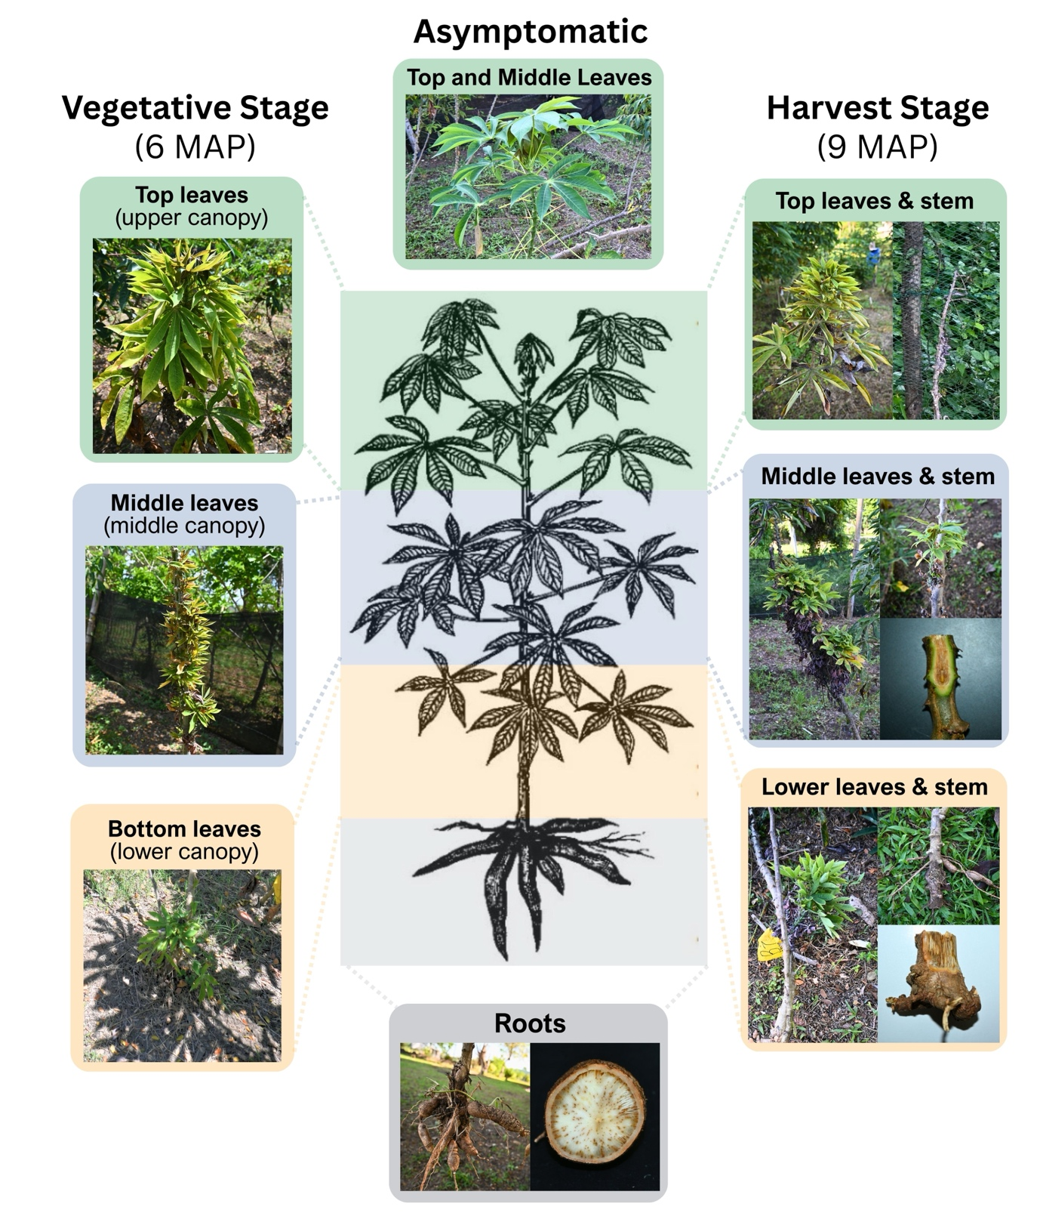

Supplementary Figure S1. Representative symptomatic and asymptomatic cassava plants sampled at 6 and 9 months after planting. Symptomatic plants exhibited excessive branching, shortened internodes, reduced leaf size, and witches’ broom symptoms. Samples were collected from available upper, middle, and lower canopy positions, stem sections, and roots.

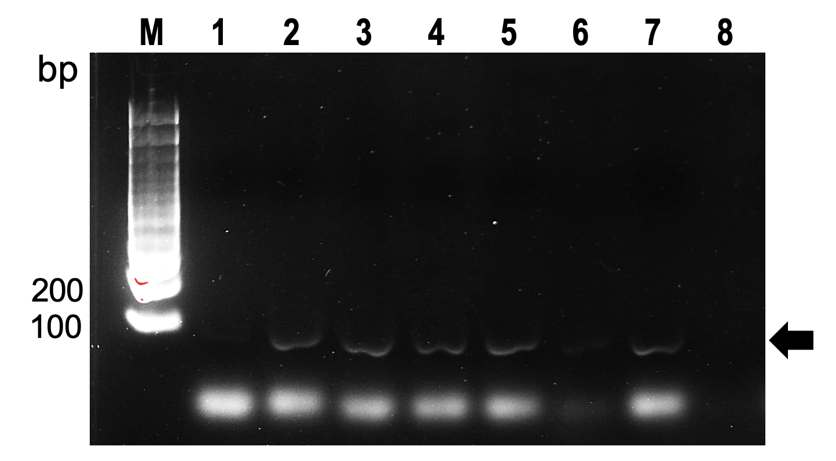

Supplementary Figure S2. Gel electrophoreses image of PCR products obtain from real-time PCR run targeting the R. theobromae 28S rDNA region. Lane M, 100-bp DNA ladder; lanes 1–5 and 7, representative PCR products from DNA of C. theobromae-infected and symptomatic cassava, respectively; lanes 6 and 8, healthy cassava and no-template control, respectively. A single amplification product of approximately 101 bp, corresponding to the expected target fragment, was observed in the positive samples (black arrow), whereas no product of the expected size was observed in the healthy cassava and no-template control.

