Electronic Supplementary Material – Online Resource 1
Article title: A Direction-Aware Meta-Analytic Framework for Aggregating Transcriptomic Evidence of Spaceflight Responses Across Species
Journal: Microgravity Science and Technology
Authors: Sulthan Rafi Abyan Hidayat, Diah Ayu NurFadilah, Isna Arofatun Nikmah, Rizky Dwi Satrio, Muhammad Rasyad Lubis, Muhammad Rizky Ramadhan, Dian Yoel Panusunan Pasaribu, Ekelia Tian Permana Sitepu
Corresponding author: Sulthan Rafi Abyan Hidayat, Department of Biology, Faculty of Military Mathematics and Natural Sciences, Indonesia Defense University, Bogor, Indonesia; sulthanrafiabyanhidayat@gmail.com
Supplementary Table S1 reports a historical sensitivity analysis of the superseded v5 filter-then-test pipeline (Methods 2.3), referenced in Discussion 4.3 as a record of that earlier procedure’s threshold-sensitivity rather than a property of the present directional Fisher method: the number of genes passing the directional-concordance filter and the number statistically significant (FDR < 0.05) at the 70% threshold used throughout the main text, for each of the seven core taxonomic groups, and matching the corresponding Table 1 values exactly. Corresponding figures at 60% and 80% thresholds, and the Jaccard overlap between the 60% and 70% significant-gene sets, were generated in an earlier sensitivity-analysis run but could not be reproduced from the archived pipeline outputs to match these verified 70%-threshold figures; rather than report unverified numbers, these columns are omitted from Table S1 (see note below the table). The full gene-level output underlying the verified 70% threshold is provided in the data released on Zenodo (Methods 2.5).
Table S1. Concordance-threshold sensitivity analysis (historical v5 filter-then-test procedure): genes passing filter and significant genes at the verified 70% threshold, by species; 60% and 80% threshold columns are omitted (see note below).
Species | Pass60%¹ | Pass70% | Pass80%¹ | Sig60%¹ | Sig70% | Sig80%¹ | Jaccard60% vs 70%¹
Mus musculus | — | 5,401 | — | — | 581 | — | —
Homo sapiens | — | 15,024 | — | — | 6,604 | — | —
Rattus norvegicus | — | 6,968 | — | — | 290 | — | —
Arabidopsis thaliana | — | 7,541 | — | — | 5,648 | — | —
Drosophila melanogaster | — | 6,965 | — | — | 6,047 | — | —
Caenorhabditis elegans | — | 5,603 | — | — | 4,479 | — | —
Bacillus subtilis | — | 2,717 | — | — | 1,801 | — | —
¹Columns shown as —: see note below. Pass = genes passing the directional-concordance filter at that threshold (Methods 2.3); Sig = genes significant at Fisher FDR < 0.05 among those passing. Jaccard 60% vs 70% = size of the intersection divided by the size of the union of the full significant-gene sets at the two thresholds (0 = no overlap, 1 = identical sets). For Rattus norvegicus and Bacillus subtilis (two contributing datasets each), all three thresholds are mathematically equivalent (Discussion 4.3). Mus musculus (77 datasets) shows the lowest Jaccard overlap of any species, consistent with the dataset-count-dependent sensitivity discussed in Discussion 4.3. Pass70%/Sig70% values in this table match the primary-analysis values reported in Table 1 and used throughout the main text (total Pass70% = 50,219; total Sig70% = 25,450 across the seven species; Results 3.2), including for Arabidopsis thaliana (7,541 / 5,648). The Pass60%, Pass80%, Sig60%, Sig80% and Jaccard60%-vs-70% values from an earlier sensitivity-analysis run at the 60% and 80% thresholds could not be reproduced from the archived pipeline outputs to match the verified 70%-threshold figures above (attempts to regenerate them under two plausible definitions of the v5 majority-direction rule gave totals differing from the archived Sig70%/Pass70% totals by up to several hundred genes per species), and are therefore omitted from this table (shown as —) rather than reported as unverified numbers; only the fully verified Pass70%/Sig70% columns are retained.
Table S2. Ortholog cutoff-sensitivity analysis (gene-level hit pairs per species pair, by cutoff).
Table S2 reports the ortholog cutoff-sensitivity analysis summarised in Results 3.3: the number of gene-level ortholog hit pairs (g:Orth query plus top-N reciprocal check, Methods 2.3) recovered for each of the ten unordered species-pair combinations at four gene-list cutoffs (100, 200, 300 and 500 genes per species). The 300-gene column matches Table 2 in the main text exactly.
Species pair | Top 100 | Top 200 | Top 300 | Top 500
Caenorhabditis elegans ↔ Drosophila melanogaster | 0 | 2 | 2 | 12
Caenorhabditis elegans ↔ Homo sapiens | 0 | 2 | 6 | 22
Caenorhabditis elegans ↔ Mus musculus | 0 | 6 | 8 | 12
Caenorhabditis elegans ↔ Rattus norvegicus | 0 | 2 | 4 | 16
Drosophila melanogaster ↔ Homo sapiens | 0 | 0 | 9 | 17
Drosophila melanogaster ↔ Mus musculus | 2 | 5 | 9 | 23
Drosophila melanogaster ↔ Rattus norvegicus | 2 | 4 | 8 | 22
Homo sapiens ↔ Mus musculus | 2 | 6 | 8 | 20
Homo sapiens ↔ Rattus norvegicus | 2 | 6 | 16 | 46
Mus musculus ↔ Rattus norvegicus | 2 | 6 | 14 | 28
Values are the number of gene-level ortholog hit pairs (Table 2, Methods 2.3) summed across both directional queries for each unordered species pair; only the mammalian pairs (Mus musculus, Homo sapiens, Rattus norvegicus) reach BH-FDR significance at the 300-gene cutoff (Results 3.3), and this pattern of mammalian pairs reaching significance earliest, and remaining significant at every larger cutoff, holds across the full 100-500 gene range tested here.
A dataset-per-mission breakdown is not included as a supplementary table in this version of the manuscript. Mission-level metadata (originating spaceflight mission, cohort, and animal or plant line identifiers) was targeted during initial dataset curation (Methods 2.1) but was not consistently or reliably retrievable in structured form across the 121 curated datasets at the time of this analysis, for the same reason noted as a limitation in Discussion 4.3 regarding unmatched sample dependencies. Per-dataset accession numbers (OSD identifiers) for all 121 datasets are available in the released data (Zenodo, Methods 2.5), and readers wishing to cross-reference individual datasets against OSDR's own mission metadata can do so directly via those accession numbers.
Figure S1 presents the cross-species pathway category overlap network summarising the thematic enrichment pattern reported in Table 5 and Discussion 4.1, moved here from the main text to conserve space.
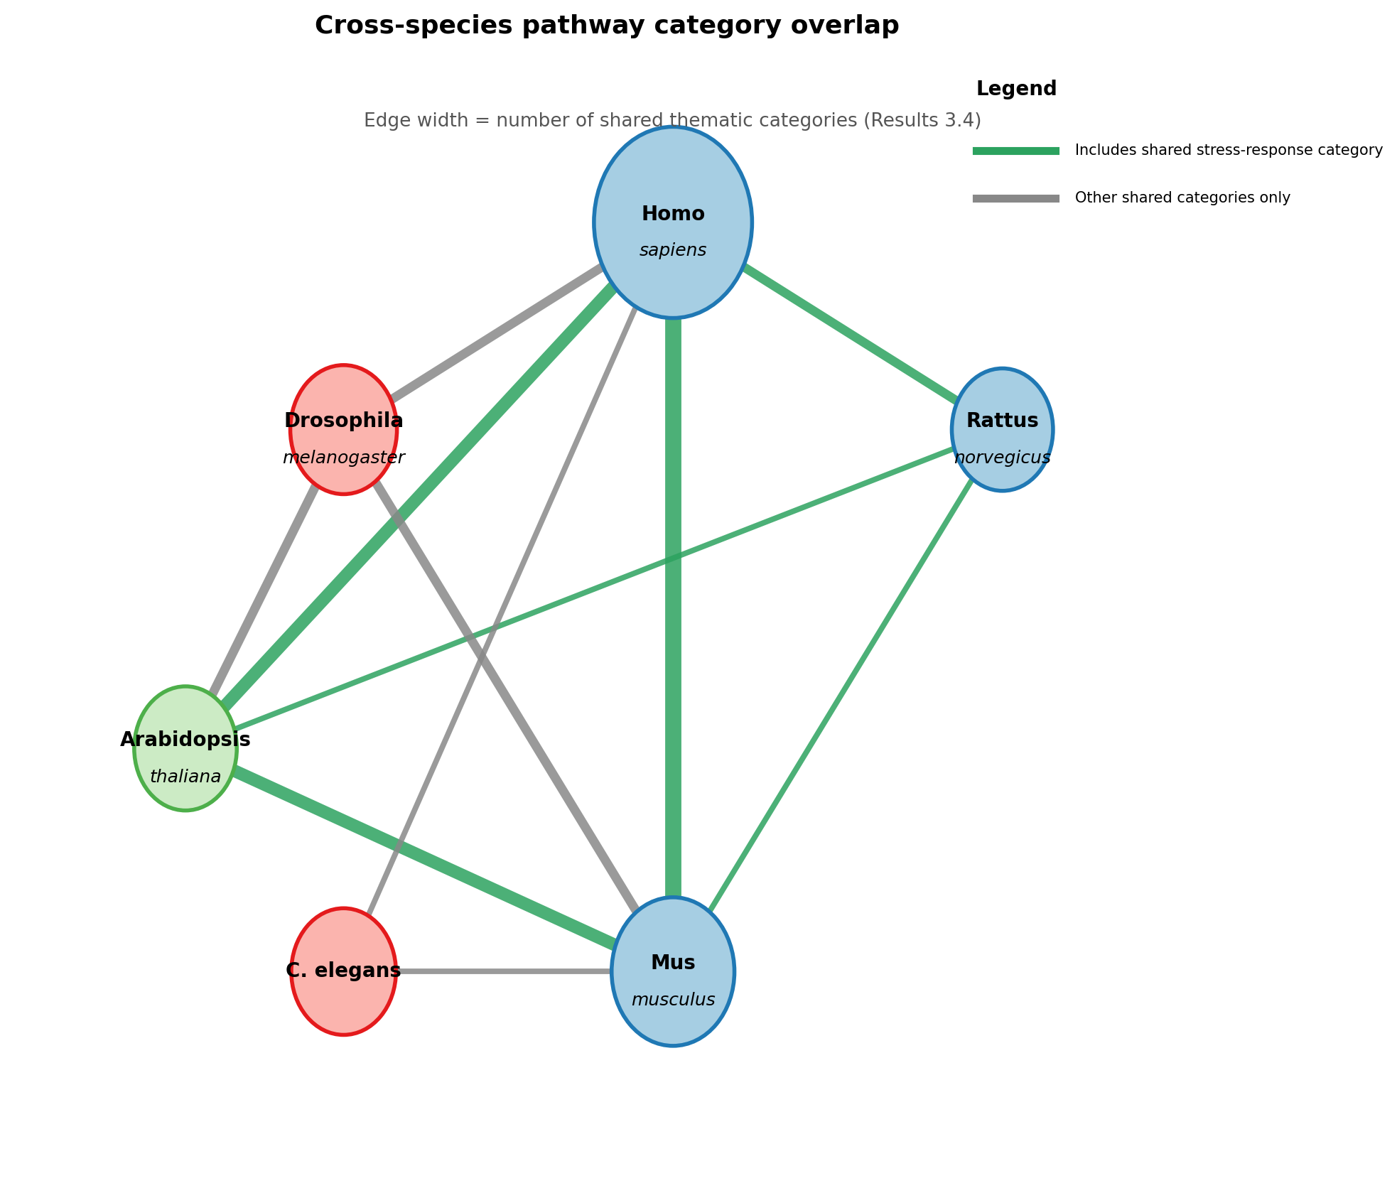
Figure S1. Cross-species pathway category overlap network. The 867 enriched terms recovered across six species (Results 3.4, 3.5), of which 500 or all available significant genes per species were used depending on cutoff applicability (Methods 2.4), were grouped into thematic categories by keyword matching on term names; terms that matched a thematic category (275 of 867, 32 per cent) are shown here, while unmatched generic terms are excluded from this network as too non-specific to convey shared biology. Edge width indicates the number of shared thematic categories between each species pair; edges are coloured green where the shared categories include the general stress-response group underlying the cross-kingdom finding reported in Discussion 4.1; because this grouping is thematic and keyword-based rather than a validated ontology mapping, a green edge indicates that both species have at least one enriched term matching this broad thematic category, not that the two species share the same specific gene set or pathway mechanism. Node radius is scaled to the square root of each species' total enriched-term count. Bacillus subtilis is excluded, as g:Profiler enrichment was not supported for this species (Results 3.4). This categorisation is thematic and exploratory rather than a validated ontology mapping, and is intended to visually summarise the pattern already reported in Table 5 rather than to introduce a new statistical result.

