Supplemental Information
for
Chemical cues induce gamete release during coral spawning

Natasha Bartels¹*, Jean-Baptiste Raina¹, Zoe J. Crane², Nicole J. Dilernia¹, David J. Hughes², Hannah Kish¹, Lonidas Koukoumaftsis², Laura M. La Motta¹, Caitlin A. Lawson³, Axel Olander¹, Malcolm Possell⁴, Stephen Woodcock⁵, David J. Suggett^{1,6}, Jennifer L. Matthews¹*
¹ Climate Change Cluster, Faculty of Science, University of Technology Sydney, Ultimo, New South Wales, Australia
² National Sea Simulator, Australian Institute of Marine Science, Townsville, QLD 4810
³ Heron Island Research Station, Faculty of Science, University of Queensland, Gladstone, 4680, Australia
⁴ School of Life and Environmental Sciences, University of Sydney, Sydney, New South Wales, Australia
⁵ School of Mathematical and Physical Sciences, University of Technology Sydney, Ultimo, NSW 2007 Australia
⁶ KAUST Coral Restoration Initiative (KRRI) and Division of Biological and Environmental Science and Engineering (BESE), King Abdullah University of Science and Technology, Thuwal, Saudi Arabia
*Correspondence: Jennifer.Matthews@uts.edu.au, Natasha.Bartels@alumni.uts.edu.au
N.B., 0000-0002-0904-8866; J.-B.R, 0000-0002-7508-0004; Z.J.C., 0009-0001-3035-3144, N.J.D., 0000-0002-0872-7402; D.J.H., 0000-0003-3778-7460; H.K., 0009-0002-1238-2918; L.K., 0009-0007-8088-1862; L.M.L., 0000-0002-4075-4646; C.A.L., 0000-0003-1060-8485; A.O., 0000-0001-5490-365X; M.P., 0000-0001-5376-8433; D.J.S., 0000-0001-5326-2520; J.L.M., 0000-0002-2766-8671

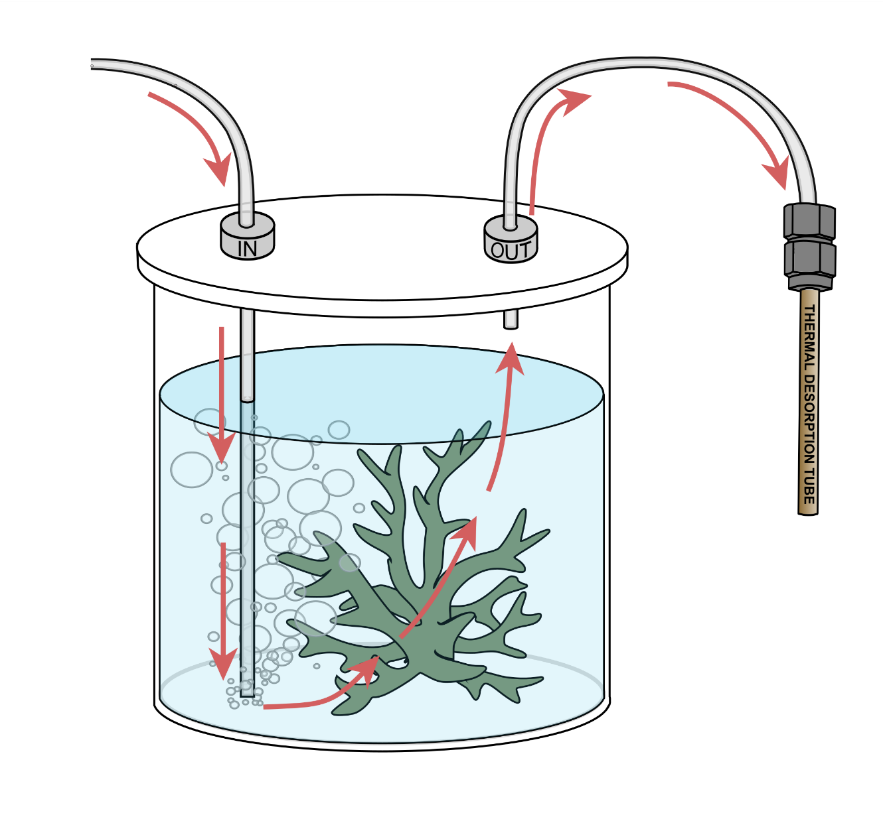
Figure S1. Chambers used to sample volatile metabolites from coral colonies. Arrows indicate the direction of airflow, with the outlet collected onto thermal desorption tubes.

