Supplementary material — Contents
• S1. Variables recorded in the centralised electronic case-report form (eCRF)
• S2. Degree of control. Definition and construct
• S3. Operational variables and missing data
• S4. General characteristics of the sample (n=1,307)
• S5. Documented diagnosis by phenotype
• S6. Inhaled treatments prescribed by phenotype
• S7. Vaccination coverage, overall and by phenotype
• S8. Unsupervised phenotyping (data-driven clustering). Exploratory analysis

S1. Variables recorded in the centralised electronic case-report form (eCRF)
Digitised version of the eCRF hosted on the Research Electronic Data Capture (REDCap) platform of the Institute of Health Sciences of Castilla y León (ICSCYL).
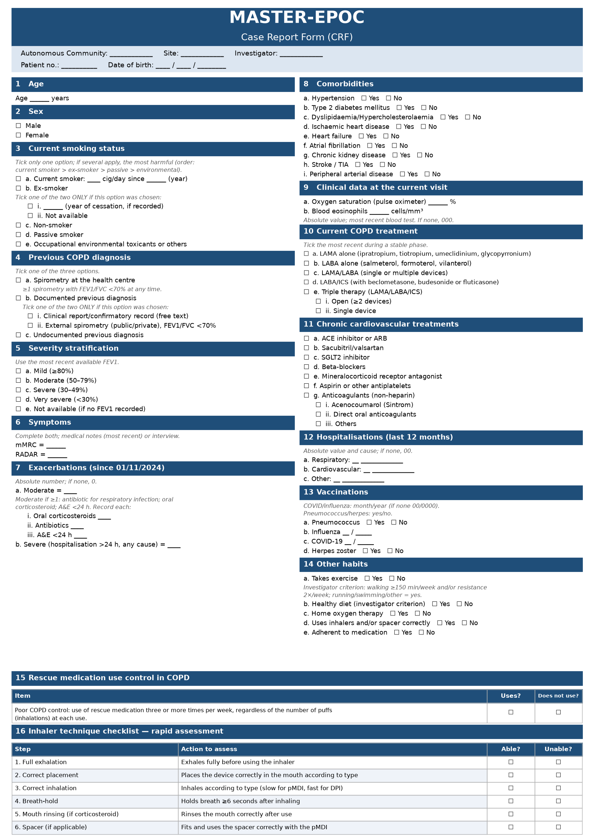
S2. Degree of control by the RADAR scale. Definition and construct
Definition of clinical control
The degree of clinical control is assessed quantitatively according to the GesEPOC control criteria. A predefined score is assigned to each of the following four domains:
• use of rescue medication ≥3 times/week (3 points)
• ≥1 moderate or severe exacerbation (2 points)
• dyspnoea mMRC ≥2 (2 points)
• self-reported physical activity <30 minutes/day (1 point).
The four domains are summed arithmetically (range 0–8). A score of 0–1 is considered good control, 2–3 moderate control, and ≥4 poor control—a threshold validated against adverse events (1). The clinical-control construct has been validated as a predictor of exacerbations in cohorts (2–3).
1. Soler-Cataluña JJ, Villagrasa M, Catalán P, et al. Risk validation of a new quantitative score for clinical control of COPD: The RADAR score. Arch Bronconeumol. 2026;62(1):28-34. PMID: 40592678.
2. Barrecheguren M, Kostikas K, Mezzi K, Shen S, Alcazar B, Soler-Cataluña JJ, et al. COPD clinical control as a predictor of future exacerbations: concept validation in the SPARK study population. Thorax. 2020;75(4):351-353. PMID: 32041741.
3. Miravitlles M, Sliwinski P, Rhee CK, Costello RW, Carter V, Tan JHY, et al. Predictive value of control of COPD for risk of exacerbations: An international, prospective study. Respirology. 2020;25(11):1136-1143. PMID: 32249487.

S3. Operational variables and missing data
Table S3-1. Distribution of eosinophils in the sample (n=1,257 with valid data)
Group | N_eos | <100 | 100-199 | 200-299 | ≥300 | Median (IQR)
Full sample | 1,257 | 255 (20.3%) | 397 (31.6%) | 291 (23.1%) | 314 (25.0%) | 180 (100–298)
Table S3-2. Distribution of eosinophils in exacerbators with vs without established cardiovascular disease
Group | N_eos | <100 | 100-199 | 200-299 | ≥300 | Median (IQR)
Exacerbator WITHOUT CVD | 207 | 47 (22.7%) | 73 (35.3%) | 42 (20.3%) | 45 (21.7%) | 158 (100–280)
Exacerbator WITH CVD | 183 | 42 (23.0%) | 56 (30.6%) | 45 (24.6%) | 40 (21.9%) | 170 (100–270)
No differences: distribution across ranges χ² p=0.694; median (Mann–Whitney) p=0.888.
Table S3-3. Missing values imputed as zero
Missing data for cardiovascular entities, risk factors and exacerbations, imputed as zero before deriving the exacerbator profile and risk stratification; prevalences are conservative floors.
Variable | Missing imputed as 0 | % of 1.307
Ischaemic heart disease | 11 | 0.8
Heart failure | 10 | 0.8
Atrial fibrillation | 10 | 0.8
Stroke/TIA | 11 | 0.8
Peripheral arterial disease | 10 | 0.8
Hypertension | 10 | 0.8
Dyslipidaemia (hypercholesterolaemia) | 12 | 0.9
Diabetes | 10 | 0.8
Smoking | 4 | 0.3
Chronic kidney disease | 14 | 1.1
Moderate exacerbations | 12 | 0.9
Severe exacerbations | 19 | 1.5
Missing values imputed as zero, by variable (N=1,307).

S4. General characteristics of the sample (n=1,307)
Table S4. General characteristics of the sample (N=1,307). Continuous variables: median (Q1–Q3); categorical: n (%) with 95% CI (Wilson) over valid cases.
Variable | Value | Valid n
Demographics
Age, years — median (IQR) | 72.6 (66.0–79.4) | 1289
Male sex | 857 (65.7%) [IC95% 63.1–68.3] | 1304
Smoking status
Current smoker | 390 (30.7%) [IC95% 28.2–33.3] | 1270
Ex-smoker | 772 (60.8%) [IC95% 58.1–63.4] | 1270
Never smoker | 108 (8.5%) [IC95% 7.1–10.2] | 1270
Functional variables
mMRC — median (IQR) | 1.0 (1.0–2.0) | 1299
mMRC ≥2 | 593 (45.7%) [IC95% 43.0–48.4] | 1299
RADAR — median (IQR) | 2.0 (0.0–3.0) | 1296
RADAR <2 (good control) | 610 (47.1%) [IC95% 44.3–49.8] | 1296
RADAR ≥4 (poor control) | 309 (23.8%) [IC95% 21.6–26.2] | 1296
Functional severity (FEV1)
Mild (GOLD 1) | 245 (20.5%) [IC95% 18.3–22.8] | 1197
Moderate (GOLD 2) | 703 (58.7%) [IC95% 56.0–61.5] | 1197
Severe (GOLD 3) | 204 (17.0%) [IC95% 15.0–19.3] | 1197
Very severe (GOLD 4) | 45 (3.8%) [IC95% 2.8–5.0] | 1197
Severe/very severe (GOLD 3–4) | 249 (20.8%) [IC95% 18.6–23.2] | 1,197
GOLD 2023 stratification (A/B/E)
GOLD A (low symptom, low risk) | 573 (44.5%) [IC95% 41.8–47.2] | 1288
GOLD B (more symptom, low risk) | 309 (24.0%) [IC95% 21.7–26.4] | 1288
GOLD E (exacerbator) | 406 (31.5%) [IC95% 29.0–34.1] | 1288
Eosinophils (cells/µL)
Eosinophils — median (IQR) | 180 (100–298) | 1,257
Eos <100 | 255 (20.3%) [IC95% 18.1–22.6] | 1,257
Eos 100-199 | 397 (31.6%) [IC95% 29.0–34.2] | 1,257
Eos 200-299 | 291 (23.1%) [IC95% 20.9–25.5] | 1,257
Eos ≥300 | 314 (25.0%) [IC95% 22.7–27.5] | 1,257
Cardiovascular comorbidities and risk factors
Ischaemic heart disease | 162 (12.5%) [IC95% 10.8–14.4] | 1297
Heart failure | 213 (16.4%) [IC95% 14.5–18.5] | 1298
Atrial fibrillation | 168 (12.9%) [IC95% 11.2–14.9] | 1298
Stroke/TIA | 90 (6.9%) [IC95% 5.7–8.5] | 1297
Peripheral arterial disease | 99 (7.6%) [IC95% 6.3–9.2] | 1298
Hypertension | 843 (64.9%) [IC95% 62.3–67.5] | 1298
Dyslipidaemia | 860 (66.4%) [IC95% 63.7–68.9] | 1296
Diabetes | 431 (33.2%) [IC95% 30.7–35.8] | 1298
Chronic kidney disease | 184 (14.2%) [IC95% 12.4–16.2] | 1294
Established CVD (≥1 of 5) | 481 (36.8%) [IC95% 34.2–39.4] | 1,307
Hospitalisations (12 months)
Total hospitalisations — median (IQR) | 0 (0–1), rango 0–6 | 1288
≥1 hospitalisation (any cause) | 344 (26.7%) [IC95% 24.4–29.2] | 1288
≥1 respiratory hospitalisation | 220 (17.0%) [IC95% 15.1–19.2] | 1292
≥1 cardiovascular hospitalisation | 63 (4.9%) [IC95% 3.8–6.2] | 1293
≥1 other-cause hospitalisation | 125 (9.7%) [IC95% 8.2–11.4] | 1288
Inhaled bronchodilator treatment
No treatment | 0 (0.0%) [IC95% -0.0–0.3] | 1296
LAMA | 118 (9.1%) [IC95% 7.7–10.8] | 1296
LABA | 29 (2.2%) [IC95% 1.6–3.2] | 1296
LABA+LAMA | 345 (26.6%) [IC95% 24.3–29.1] | 1296
LABA+ICS | 135 (10.4%) [IC95% 8.9–12.2] | 1296
Triple | 573 (44.2%) [IC95% 41.5–46.9] | 1296
Concomitant cardiovascular treatment
IECA/ARA-II | 673 (52.0%) [IC95% 49.3–54.8] | 1293
Beta-blockers | 268 (20.7%) [IC95% 18.6–23.0] | 1293
Acetylsalicylic acid | 257 (19.9%) [IC95% 17.8–22.2] | 1292
Anticoagulants | 207 (16.0%) [IC95% 14.1–18.1] | 1293
iSGLT2 | 297 (23.0%) [IC95% 20.8–25.4] | 1292
Sacubitrilo/valsartán | 75 (5.8%) [IC95% 4.7–7.2] | 1292
Vaccinations
Influenza | 1081 (83.7%) [IC95% 81.6–85.6] | 1291
Pneumococcal | 970 (75.0%) [IC95% 72.5–77.2] | 1294
COVID-19 | 1110 (85.8%) [IC95% 83.8–87.6] | 1293
Herpes zoster | 417 (32.3%) [IC95% 29.8–34.8] | 1293

S5. Documented diagnosis by phenotype
Overall documented diagnosis was 88.4%, with no differences between phenotypes (χ², p=0.32). Overall percentages are the weighted mean of the phenotype rows. Spirometric confirmation at the centre itself (32.9% overall) did differ by phenotype (χ², p<0.001), being lower in exacerbators (23.8%) than in non-exacerbators (37.0%).
Table S5-1. Documented diagnosis by phenotype. p=0.32 (χ²)
Phenotype | n | Correct  diagnosis
Exacerbator – established CVD | 189 | 164 (87%)
Exacerbator – high CVR | 194 | 179 (92%)
Exacerbator – low/moderate CVR | 24 | 19 (79%)
Non-exacerbator – established CVD | 291 | 259 (89%)
Non-exacerbator – high CVR | 528 | 462 (88%)
Non-exacerbator – low/moderate CVR | 72 | 64 (89%)
OVERALL | 1,298 | 1,147 (88.4%)
Table S5-2. Spirometry at the centre itself by phenotype. p<0.001 (χ²)
Phenotype | n | Spirometry  at the centre
Exacerbator – established CVD | 189 | 39 (21%)
Exacerbator – high CVR | 194 | 56 (29%)
Exacerbator – low/moderate CVR | 24 | 2 (8%)
Non-exacerbator – established CVD | 291 | 94 (32%)
Non-exacerbator – high CVR | 528 | 215 (41%)
Non-exacerbator – low/moderate CVR | 72 | 21 (29%)
OVERALL | 1,298 | 427 (32.9%)

S6. Inhaled treatments prescribed by phenotype
Significant differences were found in the inhaled-treatment pattern between phenotypes (overall χ² across the six phenotypes, p<0.001). Triple therapy differed between phenotypes (χ², p<0.001): highest in exacerbator·CVD (68.8%) and lowest in non-exacerbator·low/moderate risk (26.8%). Descriptive contrast: the pattern follows the gradient of severity and exacerbation, not an eosinophil-based indication.
Phenotype | No treatment | LAMA | LABA | LABA+LAMA | LABA+ICS | Triple
Exacerbator – established CVD | 2% (3) | 5% (9) | 3% (5) | 17% (33) | 5% (9) | 69% (130)
Exacerbator – high CVR | 3% (6) | 5% (10) | 2% (3) | 19% (37) | 9% (18) | 62% (121)
Exacerbator – low/moderate CVR | 0% (0) | 8% (2) | 0% (0) | 17% (4) | 8% (2) | 67% (16)
Non-exacerbator – established CVD | 8% (24) | 11% (31) | 1% (3) | 29% (84) | 9% (27) | 42% (122)
Non-exacerbator – high CVR | 10% (53) | 11% (58) | 3% (15) | 31% (164) | 13% (71) | 31% (165)
Non-exacerbator – low/moderate CVR | 14% (10) | 11% (8) | 4% (3) | 32% (23) | 11% (8) | 27% (19)
Values are % (n) within each phenotype.

S7. Vaccination coverage, overall and by phenotype
Overall vaccination coverage is shown in S4. Coverage by phenotype is presented here, overall and for each vaccine. For each vaccine the crude OR and the age-adjusted OR are given, taking the non-exacerbator / high cardiovascular-risk phenotype as reference (95% CI; statistical significance). The crude difference in influenza and pneumococcal vaccination disappears after adjustment for age; for COVID-19 and herpes zoster there are no differences.
Table S7-1. Overall vaccination coverage by phenotype
Phenotype | N | Influenza | Pneumococcal | COVID-19 | Herpes zoster
Exacerbator – established CVD | 189 | 168 (90%) | 157 (84%) | 164 (88%) | 56 (30%)
Exacerbator – high CVR | 195 | 167 (86%) | 159 (82%) | 166 (85%) | 70 (36%)
Exacerbator – low/moderate CVR | 24 | 21 (91%) | 16 (70%) | 19 (83%) | 6 (26%)
Non-exacerbator – established CVD | 292 | 251 (86%) | 226 (77%) | 260 (89%) | 95 (33%)
Non-exacerbator – high CVR | 532 | 427 (81%) | 371 (70%) | 443 (84%) | 170 (32%)
Non-exacerbator – low/moderate CVR | 76 | 47 (67%) | 41 (59%) | 58 (83%) | 20 (29%)
Table S7-2. Influenza vaccine: crude and age-adjusted OR by phenotype
Phenotype | n (%) | Crude OR (95% CI) | Crude p | Age-adjusted OR (95% CI) | Adjusted p
Exacerbator – established CVD | 168/186 (90%) | 2.16 (1.27–3.69) | 0.005 | 1.21 (0.69–2.12) | 0.505
Exacerbator – high CVR | 167/194 (86%) | 1.43 (0.90–2.28) | 0.126 | 1.22 (0.75–1.97) | 0.418
Exacerbator – low/moderate CVR | 21/23 (91%) | 2.43 (0.56–10.55) | 0.234 | 3.64 (0.81–16.35) | 0.091
Non-exacerbator – established CVD | 251/292 (86%) | 1.42 (0.96–2.11) | 0.083 | 0.92 (0.60–1.41) | 0.717
Non-exacerbator – high CVR | 427/526 (81%) | 1 (ref) | — | 1 (ref) | —
Non-exacerbator – low/moderate CVR | 47/70 (67%) | 0.47 (0.27–0.82) | 0.007 | 0.64 (0.36–1.16) | 0.143

Table S7-3. Pneumococcal vaccine: crude and age-adjusted OR by phenotype
Phenotype | n (%) | Crude OR (95% CI) | Crude p | Age-adjusted OR (95% CI) | Adjusted p
Exacerbator – established CVD | 157/187 (84%) | 2.20 (1.43–3.39) | <0.001 | 1.44 (0.91–2.26) | 0.118
Exacerbator – high CVR | 159/195 (82%) | 1.86 (1.24–2.79) | 0.003 | 1.71 (1.12–2.61) | 0.012
Exacerbator – low/moderate CVR | 16/23 (70%) | 0.96 (0.39–2.38) | 0.932 | 1.22 (0.48–3.12) | 0.682
Non-exacerbator – established CVD | 226/292 (77%) | 1.44 (1.03–2.01) | 0.031 | 1.02 (0.72–1.44) | 0.930
Non-exacerbator – high CVR | 371/527 (70%) | 1 (ref) | — | 1 (ref) | —
Non-exacerbator – low/moderate CVR | 41/70 (59%) | 0.59 (0.36–0.99) | 0.046 | 0.74 (0.43–1.27) | 0.278
Table S7-4. COVID-19 vaccine: crude and age-adjusted OR by phenotype
Phenotype | n (%) | Crude OR (95% CI) | Crude p | Age-adjusted OR (95% CI) | Adjusted p
Exacerbator – established CVD | 164/187 (88%) | 1.35 (0.82–2.22) | 0.232 | 0.96 (0.57–1.61) | 0.886
Exacerbator – high CVR | 166/195 (85%) | 1.09 (0.69–1.72) | 0.726 | 0.95 (0.60–1.52) | 0.834
Exacerbator – low/moderate CVR | 19/23 (83%) | 0.90 (0.30–2.71) | 0.853 | 1.02 (0.33–3.13) | 0.970
Non-exacerbator – established CVD | 260/291 (89%) | 1.59 (1.02–2.47) | 0.039 | 1.21 (0.77–1.91) | 0.408
Non-exacerbator – high CVR | 443/527 (84%) | 1 (ref) | — | 1 (ref) | —
Non-exacerbator – low/moderate CVR | 58/70 (83%) | 0.92 (0.47–1.78) | 0.797 | 1.07 (0.54–2.12) | 0.845
Table S7-5. Herpes zoster vaccine: crude and age-adjusted OR by phenotype
Phenotype | n (%) | Crude OR (95% CI) | Crude p | Age-adjusted OR (95% CI) | Adjusted p
Exacerbator – established CVD | 56/186 (30%) | 0.90 (0.63–1.30) | 0.588 | 0.76 (0.52–1.11) | 0.162
Exacerbator – high CVR | 70/195 (36%) | 1.18 (0.83–1.66) | 0.357 | 1.13 (0.80–1.60) | 0.495
Exacerbator – low/moderate CVR | 6/23 (26%) | 0.74 (0.29–1.91) | 0.536 | 0.81 (0.31–2.10) | 0.663
Non-exacerbator – established CVD | 95/292 (33%) | 1.01 (0.75–1.37) | 0.936 | 0.88 (0.64–1.21) | 0.442
Non-exacerbator – high CVR | 170/527 (32%) | 1 (ref) | — | 1 (ref) | —
Non-exacerbator – low/moderate CVR | 20/70 (29%) | 0.84 (0.48–1.46) | 0.534 | 0.93 (0.53–1.63) | 0.803
Table S7-6. Summary of vaccination-coverage contrasts by phenotype: crude vs age-adjusted p
Vaccine | Crude p (χ²) | Age-adjusted p (LRT)
Influenza | <0.001 | 0.152
Pneumococcal | <0.001 | 0.050
COVID-19 | 0.342 | 0.958
Herpes zoster | 0.788 | 0.588

S8. Unsupervised phenotyping (data-driven clustering). Exploratory analysis
Methodology
Eleven phenotypic variables were selected: 4 numerical (age, mMRC, RADAR, eosinophils) and 7 categorical/binary (sex, exacerbator profile, established cardiovascular disease, severe/very severe FEV1, smoking —ever vs never smoker—, correct inhaler technique and respiratory hospitalisation). Smoking was coded according to the project's verified dictionary (1=current smoker, 2=ex-smoker, 3=never smoker): “ever smoker” = smoking∈{1,2}. The analysis was restricted to complete cases (n=901). When combining numerical and categorical variables the Euclidean distance is not valid: the Gower distance (cluster::daisy) was used, which internally standardises each numerical variable to its [0,1] range—preventing the variable of greatest magnitude from dominating—and treats categorical variables by matching, giving comparable weight to all. All steps involving randomness (PAM, UMAP, bootstrap) use a fixed seed (set.seed 2026).
Supplementary Figure S8-1. Internal validation: mean silhouette by number of clusters
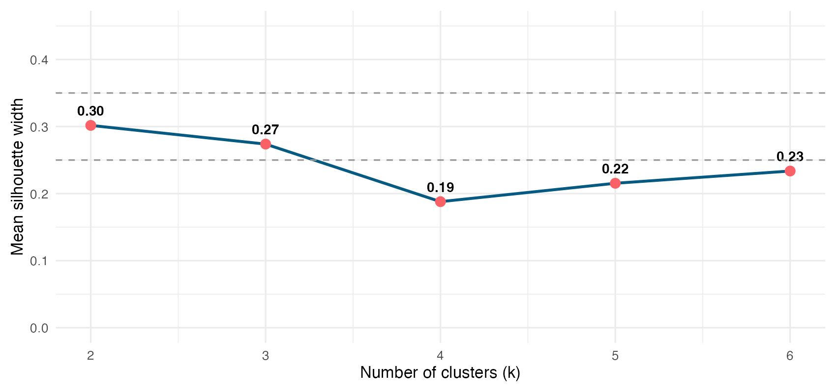
Silhouette values are modest across the whole range (0.19–0.30; all <0.35). The best-silhouette partition is k=2 (Ward, 0.30). Under the Kaufman & Rousseeuw criterion (silhouette <0.25 = no substantial structure; 0.25–0.50 = weak structure), these values indicate that the phenotypes do not form sharp natural islands: the structure is more a continuum of severity and cardiovascular burden than discrete groups. k=4 was chosen (not the best-silhouette k=2) for clinical interpretability—allowing the exacerbation and cardiovascular-burden axes to be separated—explicitly assuming this is an interpretative decision and not a statistical optimum.

Supplementary Figure S8-2. MDS projection of the Gower distance, coloured by cluster (k=4)
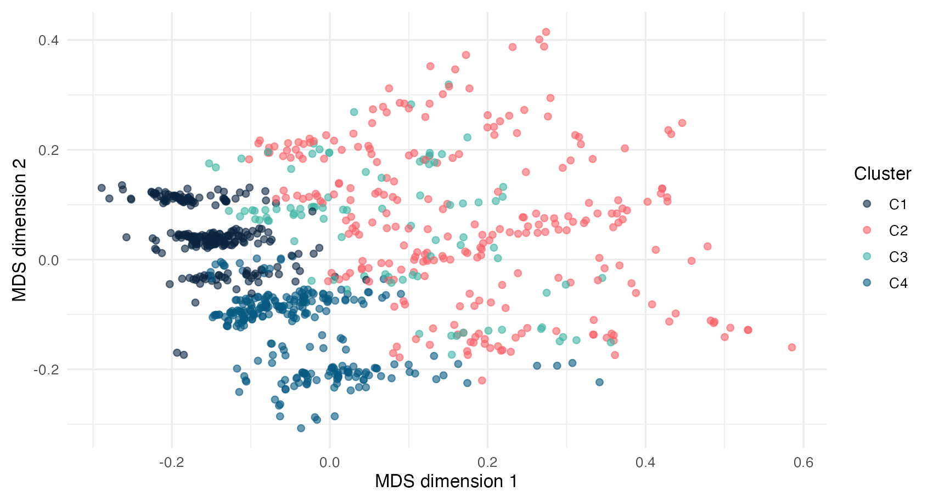
The overlap between colours is consistent with a continuous structure. The projection preserves local neighbourhood but not global distances, so it is interpreted qualitatively. The point clouds overlap and fragment along technical variables rather than clean clinical boundaries, consistent with the low silhouette. Despite the continuous structure, the k=4 cut yields clinically interpretable groups.

