Supplemental Figures and Tables
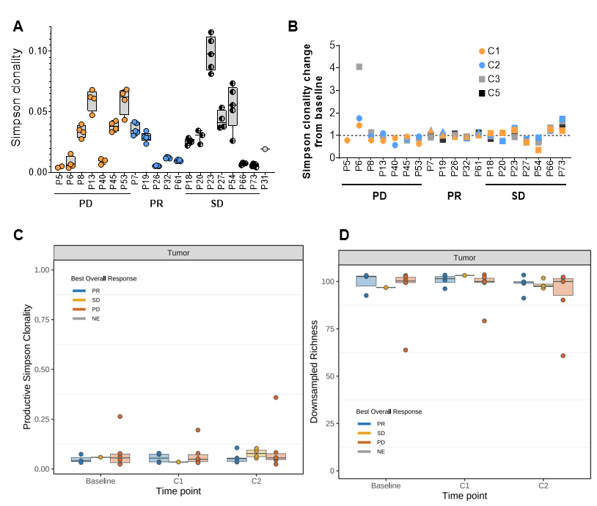
Figure S1. Longitudinal blood and tumor TCR repertoire dynamics.
(A) Longitudinal changes in blood Simpson clonality across all treatment points combined per each sample, stratified by response (PR, partial response; SD, stable disease; PD, progressive disease), shown as range. (B) Relative Simpson clonality change across treatment as a ratio between the timepoints, the C0 value for each sample was assigned a value of 1.0. C1, C2, C3, C5 – treatment cycles. (C) Longitudinal changes in tumor productive Simpson clonality across treatment timepoints, stratified by best response. (D) Longitudinal changes in tumor TCR richness across treatment timepoints, stratified by best response.

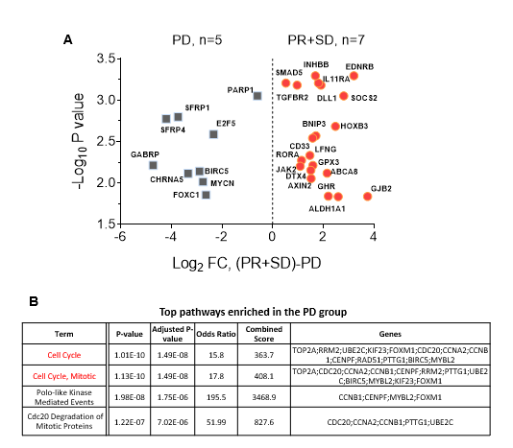
Figure S2. Baseline transcriptional differences between tumors from PD and PR+SD groups. (A) Volcano plot of differential gene expression in baseline tumor biopsies from patients with progressive disease (PD, n = 5) and those with partial response or stable disease (PR+SD, n = 7), based on NanoString nCounter Breast Cancer 360 data analyzed. Differential expression is shown as log2 fold change versus two-sided test p value; only genes meeting the prespecified significance threshold are displayed, and the top ranked genes are highlighted. (B) Tabular summary of selected pathways enriched in baseline tumor biopsies from PD versus PR+SD groups, including pathway scores and representative contributing genes identified from the differential expression analysis.

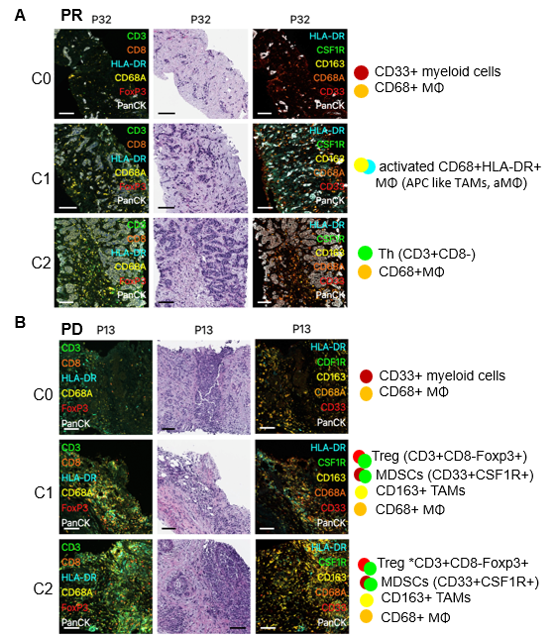
Figure S3. Representative qMIF images of intra-tumoral immune cell phenotyping in longitudinal tumor sections collected at baseline (C0) and on-treatment (C1, C2) demonstrating phenotypes in PR (A) and PD (B).

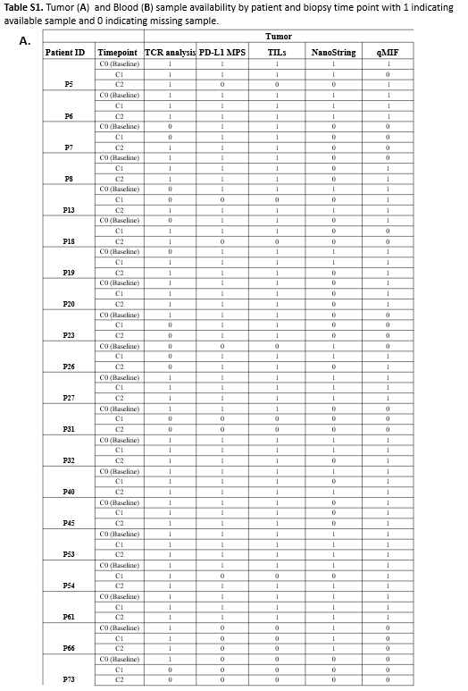

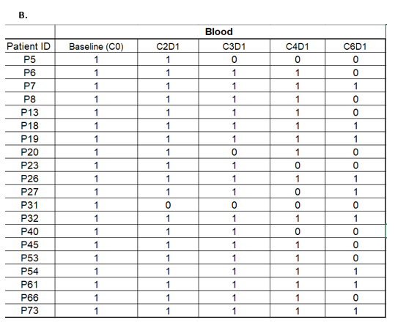

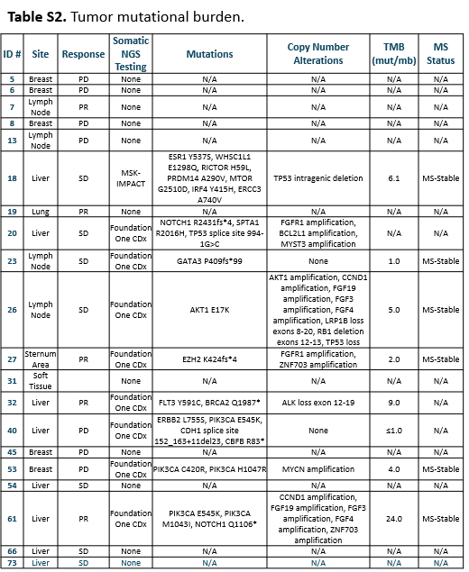

Table S3: Clinical and tumor characteristics of responders (n=5)
ID | Age (years) | Metastatic Tumor Receptor Markers and Histopathology | Tumor burden and metastatic sites | PFS (mo) | OS (mo) | Dead/ alive | Serial PD-L1 | Serial TIL | Genomics (TMB and mutations) | Prior Lines of cytotoxic therapy in MBC | Prior Lines of hormone therapy in MBC | Prior CDK4/6 inhibitor | Immune related AEs
7 | 75 | ER>90%/ PR>90%, IDC | Baseline target lesion sum 4.2cm Lung, Liver, Lymph Node | 9.1 | 38.1 | DOD | Baseline Bx:0 Post-C1 Bx: 0 Post-C2 Bx:0 | Baseline Bx: 11-20% Post-C1 Bx: 11-20% Post-C2 Bx: 1-10% | n/a | 1 capecitabine | 2 | Yes (palbociclib) | grade3 diarrhea
19 | 43 | ER100%/ PR40%, IDC | Baseline target lesion sum 1.8cm Lung | 13.8 | 47.6 | AWD | Baseline Bx:0 Post-C1 Bx: 0 Post-C2 Bx:0 | Baseline Bx: 1-10% Post-C1 Bx: 1-10% Post-C2 Bx: 1-10% | n/a | 0 | 1 | No | grade3 diarrhea
27 | 60 | ER 76-100%/PR 0, IDC | Baseline target lesion sum 1.0cm Lung and Sternum | 5.8 | 14.4 | DOD | Baseline Bx:2 Post-C1 Bx:3 Post-C2 Bx:10 | Baseline Bx: 1-10% Post-C1 Bx: >20% Post-C2 Bx: >20% | n/a | 2 gemcitabine capecitabine | 2 | Yes (palbociclib) | grade3 hypo-thyroid
32 | 57 | ER 99%/PR 10%, DCIS (prior to metastatic) | Baseline target lesion sum 9.0cm Liver and Lymph node | 8.2 | 43.9 | DOD | Baseline Bx:0 Post-C1 Bx: 0 Post-C2 Bx:0 | Baseline Bx: >20% Post-C1 Bx: >20% Post-C2 Bx: >20% | 9 mutations in FLT3, ALK, BRCA2 | 0 | 3 | yes (palbociclib and ribociclib) | none
61 | 43 | ER 76-100%/PR 0, IDC | Baseline target lesion sum 20.7cm Liver | 15.4 | 20.7 | AWD | Baseline Bx:0 Post-C1 Bx: 1 Post-C2 Bx:90 | Baseline Bx: 11-20% Post-C1 Bx: >20% Post-C2 Bx: >20% | 24 | 0 | 1 | yes (palbociclib) | none

