Supplementary materials

Appendix 1. Overview of climate and construction -related measurement scales.

13. Opinions concerning climate change
"In my opinion…
A. …human activities are causing climate change."
B. …climate change is exaggerated by the media, and it is not a big issue."
C. …climate change is a real and serious issue."
D. …recent extreme weather disasters are caused by climate change."
E. …climate change depends on natural variations, and it is not caused by humans."
14. Opinions about construction, climate, and the environment*
"In my opinion…
A. …wood as a construction material stores carbon and thus can help reduce net emissions of global warming gases."
C. …building with wood is more climate friendly than concrete or steel."
D. …building with wood destroys important habitats for rare and endangered species."
E. …building with wood contributes significantly to higher greenhouse gas emissions."
F. …building materials – whether steel, wood, or concrete – do not impact the climate."
G. …building materials – whether wood, steel, or concrete – can impact the habitat of endangered species."
15. Opinions concerning construction and extreme weather events
"In my opinion…
A. …extreme weather has already increased the maintenance costs of wood in exteriors (e.g., facades)."
B. …extreme weather conditions have not decreased the technical durability of wood in exteriors (e.g., facades)."
C. …extreme weather conditions will curb the appeal of using wood in building exteriors."
D. …extreme weather conditions will increase the appeal of using wood as a load-bearing material in construction."
E. …carbon stored in wooden building materials will significantly increase the attractiveness of using wood in construction."
F. …carbon stored in wooden building materials will significantly increase the attractiveness of using wood in the construction of public service buildings (e.g., schools)."
G. …carbon stored in wooden building materials will not significantly increase the attractiveness of using wood in the construction of residential housing."
H. …wooden building materials used indoors are aesthetically less appealing to me than other materials."
I. …wooden building materials used outdoors are aesthetically more appealing to me than other materials."
*Variable 14B excluded from the analysis due to differences in question setting between countries.

Appendix 2. Multicollinearity results (GVIF).

2A. GVIF table for Finnish data.
 | GVIF | Df | GVIF^(1/(2*Df))
Age groups | 1.087501 | 2 | 1.021192
Gender | 1.097170 | 1 | 1.047459
Education | 1.073192 | 1 | 1.035950
Residential location | 1.110759 | 2 | 1.026609
Q13C CC is real & serious | 1.059707 | 1 | 1.029421
Pref. home load-bearing material | 1.124724 | 3 | 1.019783
Forest sector relation | 1.083702 | 1 | 1.041010
Familiarity with wooden buildings | 1.113982 | 1 | 1.055453

2B. GVIF for Swedish data.
 | GVIF | Df | GVIF^(1/(2*Df))
Age groups | 1.068678 | 2 | 1.016744
Gender | 1.083243 | 1 | 1.040789
Education | 1.050466 | 1 | 1.024923
Residential location | 1.095504 | 2 | 1.023066
Q13C CC is real & serious | 1.036017 | 1 | 1.017849
Pref. home load-bearing material | 1.196949 | 3 | 1.030416
Forest sector relation | 1.105109 | 1 | 1.051241
Familiarity with wooden buildings | 1.133698 | 1 | 1.064752

Appendix 3. Regression diagnostics
3A. Results for ‘FIN – pos’ model (left) and ‘FIN – neg’ model (right).
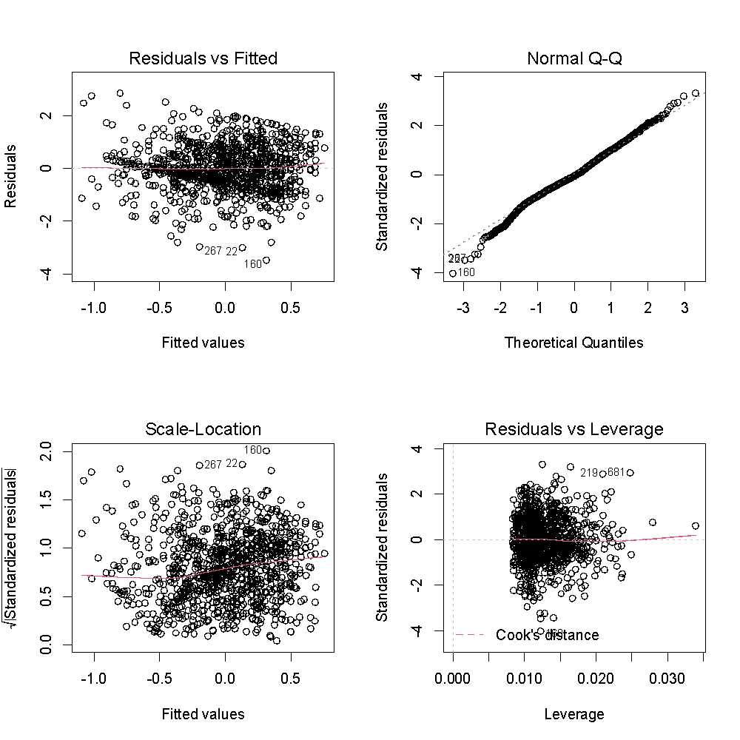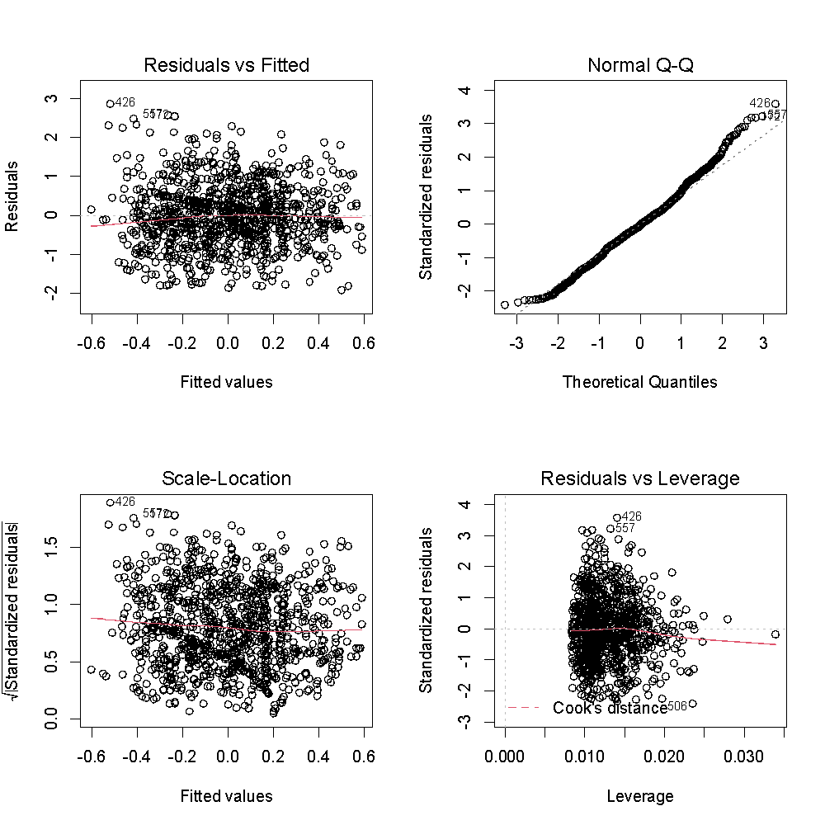

3B. Results for ‘SWE – pos’ model (left) and ‘SWE – neg’ model (right).
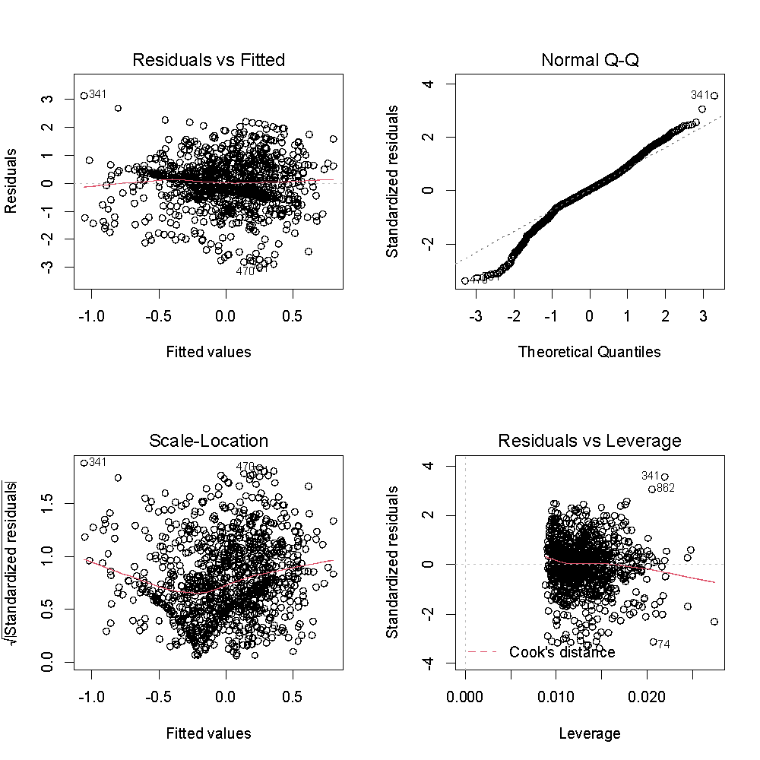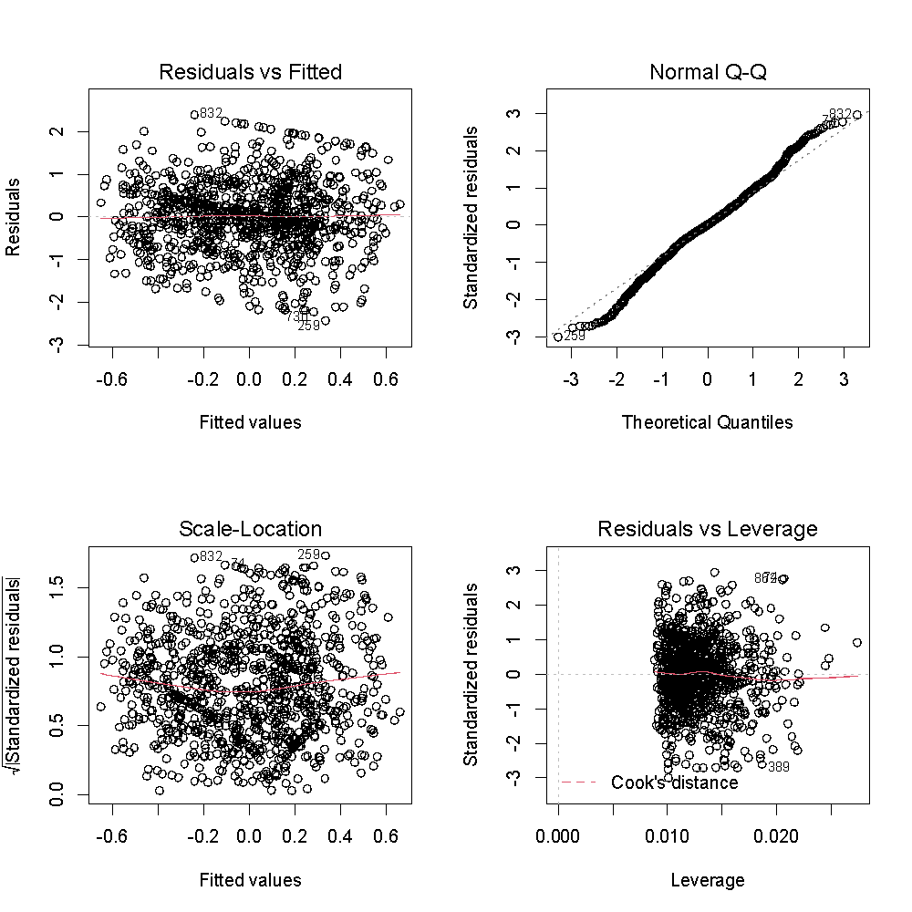

Appendix 4. R code for final factor analysis solution and linear regression models.
#Importing data for Finland
data_fin <- read.csv("NOFOBE_FIN_all.csv", header=TRUE, sep=";")
library(psych)
data_fin <- na.omit(data_fin) #deleting all empty cells created by excel
describe(data_fin)
#Removing "prefer not to answer" responses (2) from gender variable
data_fin$gender <- replace(data_fin$gender, data_fin$gender=="Prefer not to answer" , NA)
table(data_fin$gender)
data_fin <- na.omit(data_fin)

#Importing data for Sweden
data_swe <- read.csv("NOFOBE_SWE_data_all.csv", header=TRUE, sep=";")
data_swe <- na.omit(data_swe) #deleting all empty cells created by excel
describe(data_swe)

#Finland: Factor analysis for question 15
extreme_weather_events_fin <- data.frame(data_fin$Q15_EW_increased_wood_maintenance_costs, data_fin$Q15_EW_not_decreased_wood_technical_durability, data_fin$Q15_EW_will_curb_building_wood_use, data_fin$Q15_EW_increase_load_bearing_construction_material_wood_use, data_fin$Q15_C_WB_increase_construction_wood_use_attractiveness, data_fin$Q15_C_WB_increase_public_building_wood_use_attractiveness, data_fin$Q15_C_WB_not_increase_residential_housing_wood_use_attractiveness, data_fin$Q15_WB_materials_indoors_less_appealing, data_fin$Q15_WB_materials_outdoors_more_appealing)
extreme_weather_perceptions_fin <- fa(extreme_weather_events_fin[c(-1,-2)], nfactors=2,rotate="varimax", fm="ml")
print(extreme_weather_perceptions_fin)
print(extreme_weather_perceptions_fin$loadings, cutoff=0.4)
extreme_weather_perceptions_fin_ML1 <- data.frame(data_fin$Q15_EW_increase_load_bearing_construction_material_wood_use, data_fin$Q15_C_WB_increase_construction_wood_use_attractiveness, data_fin$Q15_C_WB_increase_public_building_wood_use_attractiveness, data_fin$Q15_WB_materials_outdoors_more_appealing) #For 2 factors
extreme_weather_perceptions_fin_ML2 <- data.frame(data_fin$Q15_EW_will_curb_building_wood_use, data_fin$Q15_C_WB_not_increase_residential_housing_wood_use_attractiveness, data_fin$Q15_WB_materials_indoors_less_appealing) #For 2 factors
library(ltm) #for cronbach alpha
cronbach.alpha(extreme_weather_perceptions_fin_ML1) #0.79
cronbach.alpha(extreme_weather_perceptions_fin_ML2) #0.685

library(data.table)
data_fin <- cbind(data_fin,extreme_weather_perceptions_fin$scores)
setnames(data_fin, "ML1", "factor_positive")
setnames(data_fin, "ML2", "factor_negative")

#Sweden: Factor analysis for question 15
extreme_weather_events_swe <- data.frame(data_swe$Q15_EW_increased_wood_maintenance_costs, data_swe$Q15_EW_not_decreased_wood_technical_durability, data_swe$Q15_EW_will_curb_building_wood_use, data_swe$Q15_EW_increase_load_bearing_construction_material_wood_use, data_swe$Q15_C_WB_increase_construction_wood_use_attractiveness, data_swe$Q15_C_WB_increase_public_building_wood_use_attractiveness, data_swe$Q15_C_WB_not_increase_residential_housing_wood_use_attractiveness, data_swe$Q15_WB_materials_indoors_less_appealing, data_swe$Q15_WB_materials_outdoors_more_appealing)
extreme_weather_perceptions_swe <- fa(extreme_weather_events_swe [c(-1,-2)], nfactors=2,rotate="varimax", fm="ml")
print(extreme_weather_perceptions_swe)
print(extreme_weather_perceptions_swe$loadings, cutoff=0.4)
extreme_weather_perceptions_swe_ML1 <- data.frame(data_swe$Q15_EW_increase_load_bearing_construction_material_wood_use, data_swe$Q15_C_WB_increase_construction_wood_use_attractiveness, data_swe$Q15_C_WB_increase_public_building_wood_use_attractiveness, data_swe$Q15_WB_materials_outdoors_more_appealing)
extreme_weather_perceptions_swe_ML2 <- data.frame(data_swe$Q15_EW_will_curb_building_wood_use, data_swe$Q15_C_WB_not_increase_residential_housing_wood_use_attractiveness, data_swe$Q15_WB_materials_indoors_less_appealing)
cronbach.alpha(extreme_weather_perceptions_swe_ML1) #0.821
cronbach.alpha(extreme_weather_perceptions_swe_ML2) #0.693

data_swe <- cbind(data_swe,extreme_weather_perceptions_swe$scores)
setnames(data_swe, "ML1", "factor_positive")
setnames(data_swe, "ML2", "factor_negative")

#Finland: Converting data
library(dplyr)
#Forest sector relation
data_fin$forest_relation <- case_when(data_fin$Q24_had_work_forest_sector==1 ~ 1, data_fin$Q24_owned_forest ==1 ~ 1,data_fin$Q24_had_work_forest_sector==0 ~ 0, data_fin$Q24_owned_forest==0 ~ 0)
table(data_fin$forest_relation)
#Residential location
data_fin$living_env[data_fin$current_living_environment =="capital_region_metropolitan_area"]="large_city"
data_fin$living_env[data_fin$current_living_environment == "large_city"]="large_city"
data_fin$living_env[data_fin$current_living_environment =="small_medium_city"]="small_medium_city"
data_fin$living_env[data_fin$current_living_environment =="village"]="countryside"
data_fin$living_env[data_fin$current_living_environment =="countryside"]="countryside"
#Familiarity with wooden buildings
data_fin$familiarity_with_wooden_buildings[data_fin$Q18_MSWB_never_heard==0]=1
data_fin$familiarity_with_wooden_buildings[data_fin$Q18_MSWB_never_heard==1]=0
table(data_fin$familiarity_with_wooden_buildings)
#Education level
data_fin$edu[data_fin$education_level =="primary_education"]="lower_education"
data_fin$edu[data_fin$education_level =="secondary_education"]="lower_education"
data_fin$edu[data_fin$education_level =="university_bachelor"]="higher_education"
data_fin$edu[data_fin$education_level =="university_master"]="higher_education"
data_fin$edu[data_fin$education_level =="university_doctoral"]="higher_education"
table(data_fin$edu)
#Age groups
data_fin$age_groups[data_fin$age_recode =="18-22"]="18-35"
data_fin$age_groups[data_fin$age_recode =="23-35"]="18-35"
data_fin$age_groups[data_fin$age_recode =="36-55"]="36-55"
data_fin$age_groups[data_fin$age_recode =="56-99"]="56-99"
table(data_fin$age_groups)

#Sweden: Converting data
#Forest sector relation
data_swe$forest_relation <- case_when(data_swe$Q24_had_work_forest_sector==1 ~ 1, data_swe$Q24_owned_forest ==1 ~ 1,data_swe$Q24_had_work_forest_sector==0 ~ 0, data_swe$Q24_owned_forest==0 ~ 0)
table(data_swe$forest_relation)
#Residential location
data_swe$living_env[data_swe$current_living_environment =="capital_region_metropolitan_area"]="large_city"
data_swe$living_env[data_swe$current_living_environment == "large_city"]="large_city"
data_swe$living_env[data_swe$current_living_environment =="small_medium_city"]="small_medium_city"
data_swe$living_env[data_swe$current_living_environment =="village"]="countryside"
data_swe$living_env[data_swe$current_living_environment =="countryside"]="countryside"
#Familiarity with wooden buildings
data_swe$familiarity_with_wooden_buildings[data_swe$Q18_MSWB_never_heard==0]=1
data_swe$familiarity_with_wooden_buildings[data_swe$Q18_MSWB_never_heard==1]=0
table(data_swe$familiarity_with_wooden_buildings)
#Education level
data_swe$edu[data_swe$education_level =="primary_education"]="lower_education"
data_swe$edu[data_swe$education_level =="secondary_education"]="lower_education"
data_swe$edu[data_swe$education_level =="university_bachelor"]="higher_education"
data_swe$edu[data_swe$education_level =="university_master"]="higher_education"
data_swe$edu[data_swe$education_level =="university_doctoral"]="higher_education"
table(data_swe$edu)
#Age groups
data_swe$age_groups[data_swe$age_recode =="18-22"]="18-35"
data_swe$age_groups[data_swe$age_recode =="23-35"]="18-35"
data_swe$age_groups[data_swe$age_recode =="36-55"]="36-55"
data_swe$age_groups[data_swe$age_recode =="56-99"]="56-99"
table(data_swe$age_groups)

#Finland: Recoding the reference levels
data_fin$Q10_prefrred_home_structural_material <- factor(data_fin$Q10_prefrred_home_structural_material, levels=c("primarily_wood", "other_than_wood", "wood_with_other_materials", "do_not_know")) #primarily wood as the reference level

#Sweden: Recoding the reference levels
data_swe$Q10_prefrred_home_structural_material <- factor(data_swe$Q10_prefrred_home_structural_material, levels=c("primarily_wood", "other_than_wood", "wood_with_other_materials", "do_not_know")) #primarily wood as the reference level

#Linear models
lm_model_pos_fin <- lm(factor_positive ~ age_groups + gender + edu + living_env + Q13_CC_real_serious + Q10_prefrred_home_structural_material + forest_relation + familiarity_with_wooden_buildings , data=data_fin)
summary(lm_model_pos_fin)
lm_model_neg_fin <- lm(factor_negative ~ age_groups + gender + edu + living_env + Q13_CC_real_serious + Q10_prefrred_home_structural_material + forest_relation + familiarity_with_wooden_buildings, data=data_fin)
summary(lm_model_neg_fin)

lm_model_pos_swe <- lm(factor_positive ~ age_groups + gender + edu + living_env + Q13_CC_real_serious + Q10_prefrred_home_structural_material + forest_relation + familiarity_with_wooden_buildings , data=data_swe)
summary(lm_model_pos_swe)
lm_model_neg_swe <- lm(factor_negative ~ age_groups + gender + edu + living_env + Q13_CC_real_serious + Q10_prefrred_home_structural_material + forest_relation + familiarity_with_wooden_buildings, data=data_swe)
summary(lm_model_neg_swe)

library(texreg)
htmlreg(list(lm_model_pos_fin, lm_model_neg_fin, lm_model_pos_swe, lm_model_neg_swe),stars= c(0.001,0.01,0.05),file="linear_models_fin-swe_final.doc", custom.model.names=c("FIN - pos", "FIN - neg", "SWE - pos", "SWE - neg" ), single.row=T)

#Regression diagnostics
par(mfrow=c(2,2))
plot(lm_model_pos_fin)

par(mfrow=c(2,2))
plot(lm_model_neg_fin)

par(mfrow=c(2,2))
plot(lm_model_pos_swe)

par(mfrow=c(2,2))
plot(lm_model_neg_swe)

#Multicollinearity
car::vif(lm_model_pos_fin)
car::vif(lm_model_pos_swe)

#Bonferonni p-value for most extreme observations
library(car)
outlierTest(lm_model_pos_fin)
outlierTest(lm_model_neg_fin)
outlierTest(lm_model_pos_swe)
outlierTest(lm_model_neg_swe)

