Supplementary Material for
Spatially variable barley root microbiomes do not imply weak host genetic control at field scale
Authors:
Menghui Dong¹, Katarzyna Retzer², Heinrich Grausgruber³, Aditya Sanjay Malwe⁴, Miguel Sanchez Garcia⁵, Andrea Visioni⁵, Karl Ludwig Körber¹, Anna Elisabeth Backhaus⁵, Kerstin Rönsch ⁶, Markus Schmitt⁶, Christopher James Barnes^{1,4}†, Mette Vestergård¹†, Mogens Nicolaisen¹†
Affiliations
¹ Department of Agroecology, Aarhus University, 4200 Slagelse, Denmark
² Department of Ecosystem Management, Climate and Biodiversity, Institute of Forest Ecology, University of Natural Resources and Life Sciences (BOKU), 1190 Vienna, Austria
³ Department of Agricultural Sciences, Institute of Crop Breeding and Genomics, University of Natural Resources and Life Sciences (BOKU), 3430 Tulln an der Donau, Austria
⁴ Center for Evolutionary Hologenomics, Globe Institute, University of Copenhagen, 1353 Copenhagen K, Copenhagen, Denmark
⁵ Biodiversity and Crop Improvement, International Center for Agricultural Research in the Dry Areas (ICARDA), 10112 Rabat, Morocco
⁶ Eurofins Genomics Food/Environment/White Biotech Products & Services GmbH, 85560 Ebersberg, Germany
Corresponding author
† These authors jointly supervised this work.
Correspondence: mn@agro.au.dk (Mogens Nicolaisen); mvestergard@agro.au.dk (Mette Vestergård); c.barnes@sund.ku.dk (Christopher James Barnes)

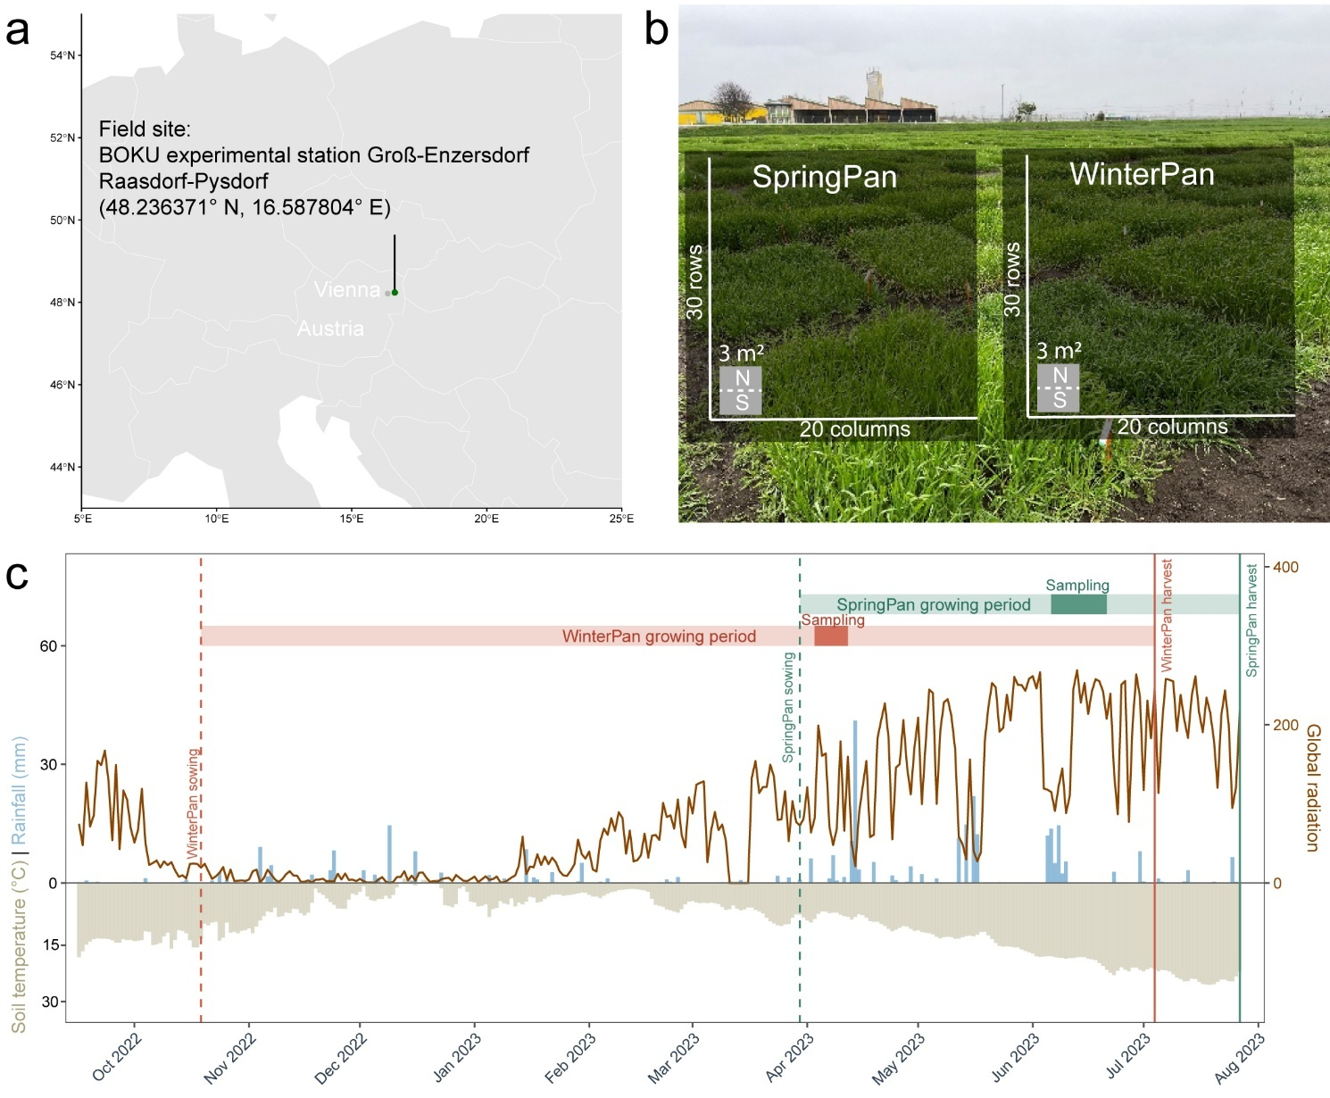
Fig.S1 Design of the field experiment. a) field location b) plot layout c) weather conditions across the growing season
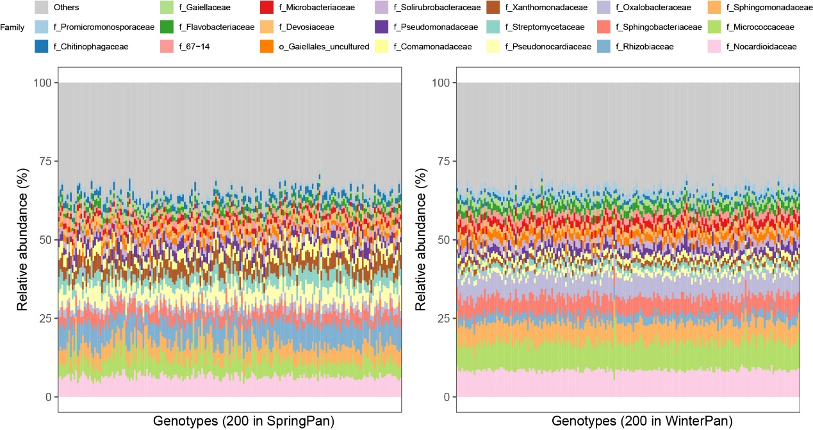
Fig.S2 Bacterial taxonomic community composition at family level in Spring and Winter panels. The relative abundance of top 15 abundant families from each panel are shown in the figure.

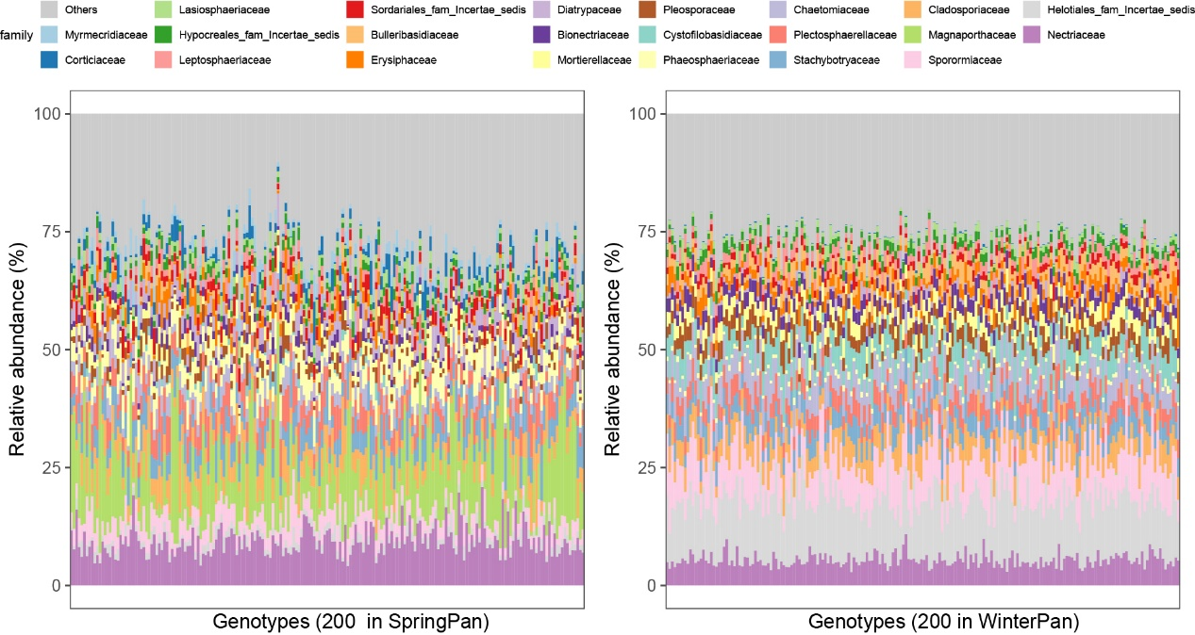
Fig. S3 Fungal taxonomic community composition at family level in Spring and Winter panels. The relative abundance of top 15 abundant families from each panel are shown in the figure.
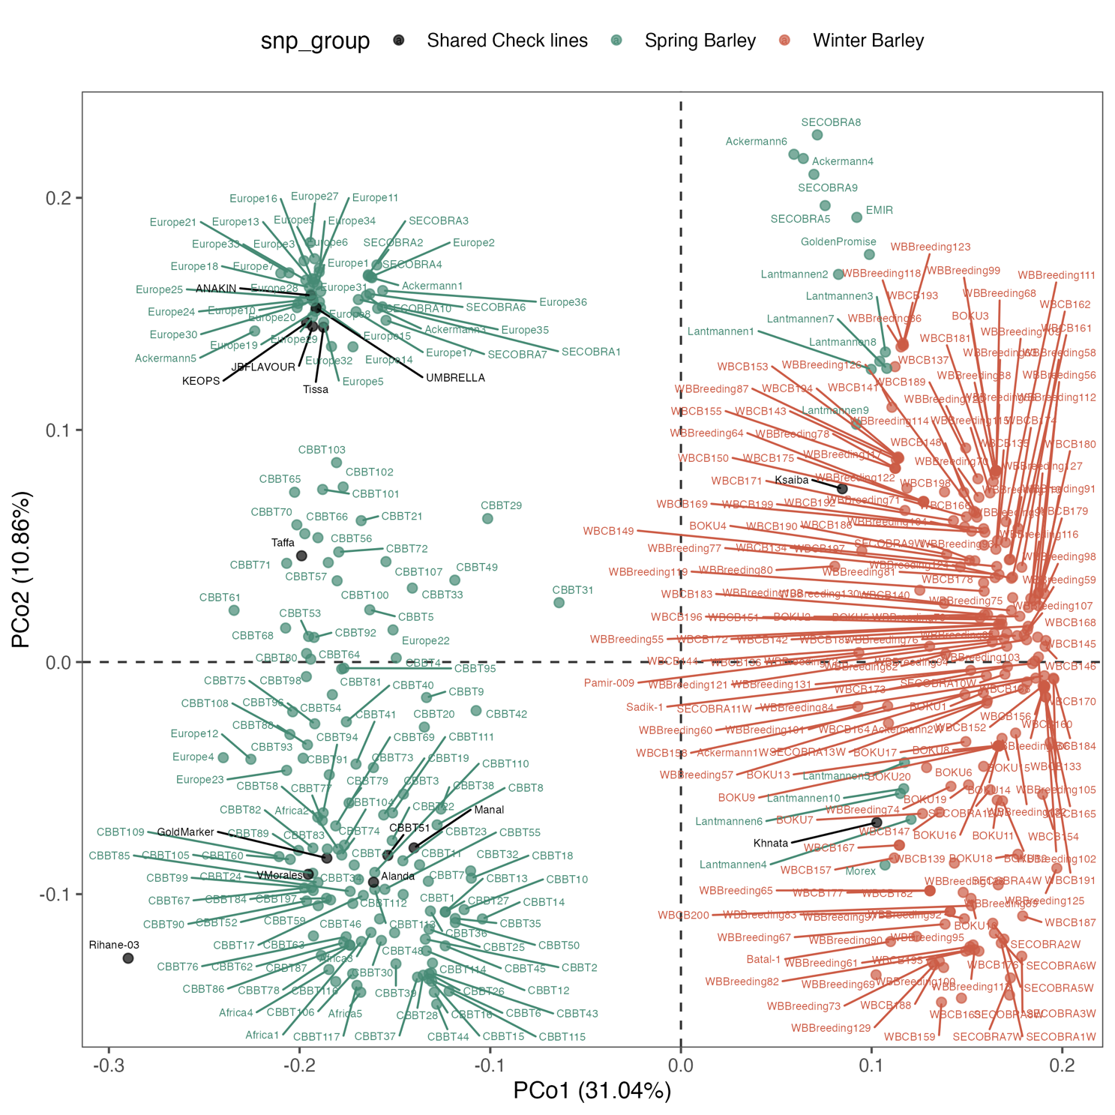
Fig.S4. Principal coordinate analysis (PCoA) of barley genotypes based on Provesti’s genetic distance using SNP data.

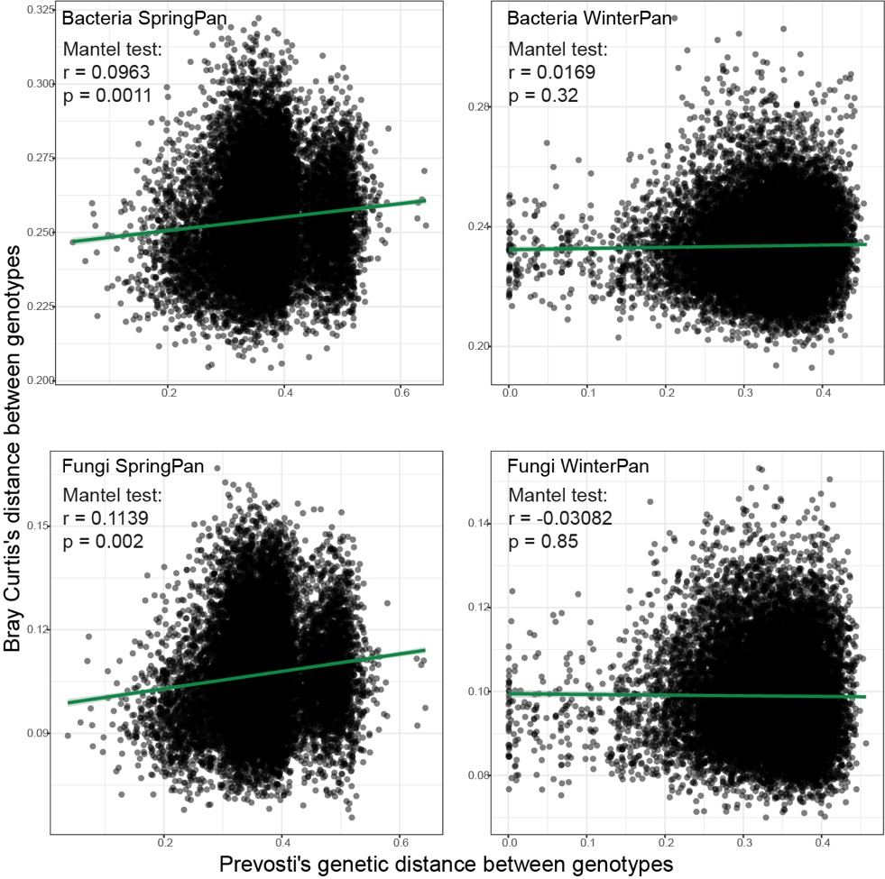
Fig.S5. Mantel correlations between host genetic distance and microbiome composition at the genotype level. Pairwise Prevosti’s genetic distances between barley genotypes were correlated with Bray-Curtis dissimilarities in microbial community composition for bacterial and fungal communities in SpringPan and WinterPan. Each point represents one pairwise genotype comparison, and green lines indicate the fitted linear trend. Mantel tests were performed using vegan::mantel, with spearman correlation and using 9999 permutations. Significant positive correlations were detected in SpringPan for both bacteria and fungi, whereas no significant relationships were observed in WinterPan.

Table S1 PERMANOVA on effect of subplot location (North or South) on microbial communities
Organism | Trial | R² | Pr(>F)
Bacteria | SpringPan | 0.00132 | <0.001
Bacteria | WinterPan | 0.00142 | 0.003
Fungi | SpringPan | 0.00174 | <0.001
Fungi | WinterPan | 0.00712 | <0.001
PERMANOVA was performed based on Bray-Curtis dissimilarities with 999 permutations. To account for plot-level spatial structure, permutations were constrained within plots using the strata argument (strata = Plot). Constraining permutations by plot ensured that north and south subplots within the same plot were not treated as independent samples

Table S2 Plot layout and plots sampled for soil property determination. Blue cells were plots that were sampled for soil chemistry analysis, numbers in the cells are plot-ID used in the experiment. The spring and winter panels used the same layout.
581 | 582 | 583 | 584 | 585 | 586 | 587 | 588 | 589 | 590 | 591 | 592 | 593 | 594 | 595 | 596 | 597 | 598 | 599 | 600
580 | 579 | 578 | 577 | 576 | 575 | 574 | 573 | 572 | 571 | 570 | 569 | 568 | 567 | 566 | 565 | 564 | 563 | 562 | 561
541 | 542 | 543 | 544 | 545 | 546 | 547 | 548 | 549 | 550 | 551 | 552 | 553 | 554 | 555 | 556 | 557 | 558 | 559 | 560
540 | 539 | 538 | 537 | 536 | 535 | 534 | 533 | 532 | 531 | 530 | 529 | 528 | 527 | 526 | 525 | 524 | 523 | 522 | 521
501 | 502 | 503 | 504 | 505 | 506 | 507 | 508 | 509 | 510 | 511 | 512 | 513 | 514 | 515 | 516 | 517 | 518 | 519 | 520
500 | 499 | 498 | 497 | 496 | 495 | 494 | 493 | 492 | 491 | 490 | 489 | 488 | 487 | 486 | 485 | 484 | 483 | 482 | 481
461 | 462 | 463 | 464 | 465 | 466 | 467 | 468 | 469 | 470 | 471 | 472 | 473 | 474 | 475 | 476 | 477 | 478 | 479 | 480
460 | 459 | 458 | 457 | 456 | 455 | 454 | 453 | 452 | 451 | 450 | 449 | 448 | 447 | 446 | 445 | 444 | 443 | 442 | 441
421 | 422 | 423 | 424 | 425 | 426 | 427 | 428 | 429 | 430 | 431 | 432 | 433 | 434 | 435 | 436 | 437 | 438 | 439 | 440
420 | 419 | 418 | 417 | 416 | 415 | 414 | 413 | 412 | 411 | 410 | 409 | 408 | 407 | 406 | 405 | 404 | 403 | 402 | 401
381 | 382 | 383 | 384 | 385 | 386 | 387 | 388 | 389 | 390 | 391 | 392 | 393 | 394 | 395 | 396 | 397 | 398 | 399 | 400
380 | 379 | 378 | 377 | 376 | 375 | 374 | 373 | 372 | 371 | 370 | 369 | 368 | 367 | 366 | 365 | 364 | 363 | 362 | 361
341 | 342 | 343 | 344 | 345 | 346 | 347 | 348 | 349 | 350 | 351 | 352 | 353 | 354 | 355 | 356 | 357 | 358 | 359 | 360
340 | 339 | 338 | 337 | 336 | 335 | 334 | 333 | 332 | 331 | 330 | 329 | 328 | 327 | 326 | 325 | 324 | 323 | 322 | 321
301 | 302 | 303 | 304 | 305 | 306 | 307 | 308 | 309 | 310 | 311 | 312 | 313 | 314 | 315 | 316 | 317 | 318 | 319 | 320
300 | 299 | 298 | 297 | 296 | 295 | 294 | 293 | 292 | 291 | 290 | 289 | 288 | 287 | 286 | 285 | 284 | 283 | 282 | 281
261 | 262 | 263 | 264 | 265 | 266 | 267 | 268 | 269 | 270 | 271 | 272 | 273 | 274 | 275 | 276 | 277 | 278 | 279 | 280
260 | 259 | 258 | 257 | 256 | 255 | 254 | 253 | 252 | 251 | 250 | 249 | 248 | 247 | 246 | 245 | 244 | 243 | 242 | 241
221 | 222 | 223 | 224 | 225 | 226 | 227 | 228 | 229 | 230 | 231 | 232 | 233 | 234 | 235 | 236 | 237 | 238 | 239 | 240
220 | 219 | 218 | 217 | 216 | 215 | 214 | 213 | 212 | 211 | 210 | 209 | 208 | 207 | 206 | 205 | 204 | 203 | 202 | 201
181 | 182 | 183 | 184 | 185 | 186 | 187 | 188 | 189 | 190 | 191 | 192 | 193 | 194 | 195 | 196 | 197 | 198 | 199 | 200
180 | 179 | 178 | 177 | 176 | 175 | 174 | 173 | 172 | 171 | 170 | 169 | 168 | 167 | 166 | 165 | 164 | 163 | 162 | 161
141 | 142 | 143 | 144 | 145 | 146 | 147 | 148 | 149 | 150 | 151 | 152 | 153 | 154 | 155 | 156 | 157 | 158 | 159 | 160
140 | 139 | 138 | 137 | 136 | 135 | 134 | 133 | 132 | 131 | 130 | 129 | 128 | 127 | 126 | 125 | 124 | 123 | 122 | 121
101 | 102 | 103 | 104 | 105 | 106 | 107 | 108 | 109 | 110 | 111 | 112 | 113 | 114 | 115 | 116 | 117 | 118 | 119 | 120
100 | 99 | 98 | 97 | 96 | 95 | 94 | 93 | 92 | 91 | 90 | 89 | 88 | 87 | 86 | 85 | 84 | 83 | 82 | 81
61 | 62 | 63 | 64 | 65 | 66 | 67 | 68 | 69 | 70 | 71 | 72 | 73 | 74 | 75 | 76 | 77 | 78 | 79 | 80
60 | 59 | 58 | 57 | 56 | 55 | 54 | 53 | 52 | 51 | 50 | 49 | 48 | 47 | 46 | 45 | 44 | 43 | 42 | 41
21 | 22 | 23 | 24 | 25 | 26 | 27 | 28 | 29 | 30 | 31 | 32 | 33 | 34 | 35 | 36 | 37 | 38 | 39 | 40
20 | 19 | 18 | 17 | 16 | 15 | 14 | 13 | 12 | 11 | 10 | 9 | 8 | 7 | 6 | 5 | 4 | 3 | 2 | 1

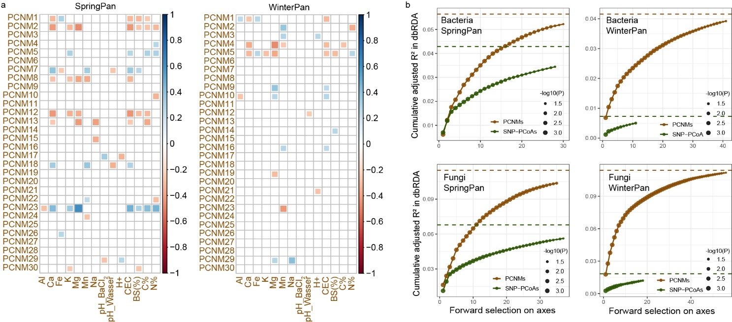
Fig.S6 a) Spearman correlation between Principal Coordinates of Neighbourhood Matrix (PCNM) axis and soil properties across the 60 selected plots. b) Cumulative explained variation (adjusted R²) of SNP-PCoA axes and spatial PCNM axes selected by forward selection in distance-based redundancy analysis (dbRDA). Dashed lines indicate the total adjusted R² of the dbRDA models when all SNP-PCoA axes or all spatial PCNM axes were included. During forward selection, additional axes were not retained once the cumulative adjusted R² exceeded these values, thereby avoiding model overfitting.
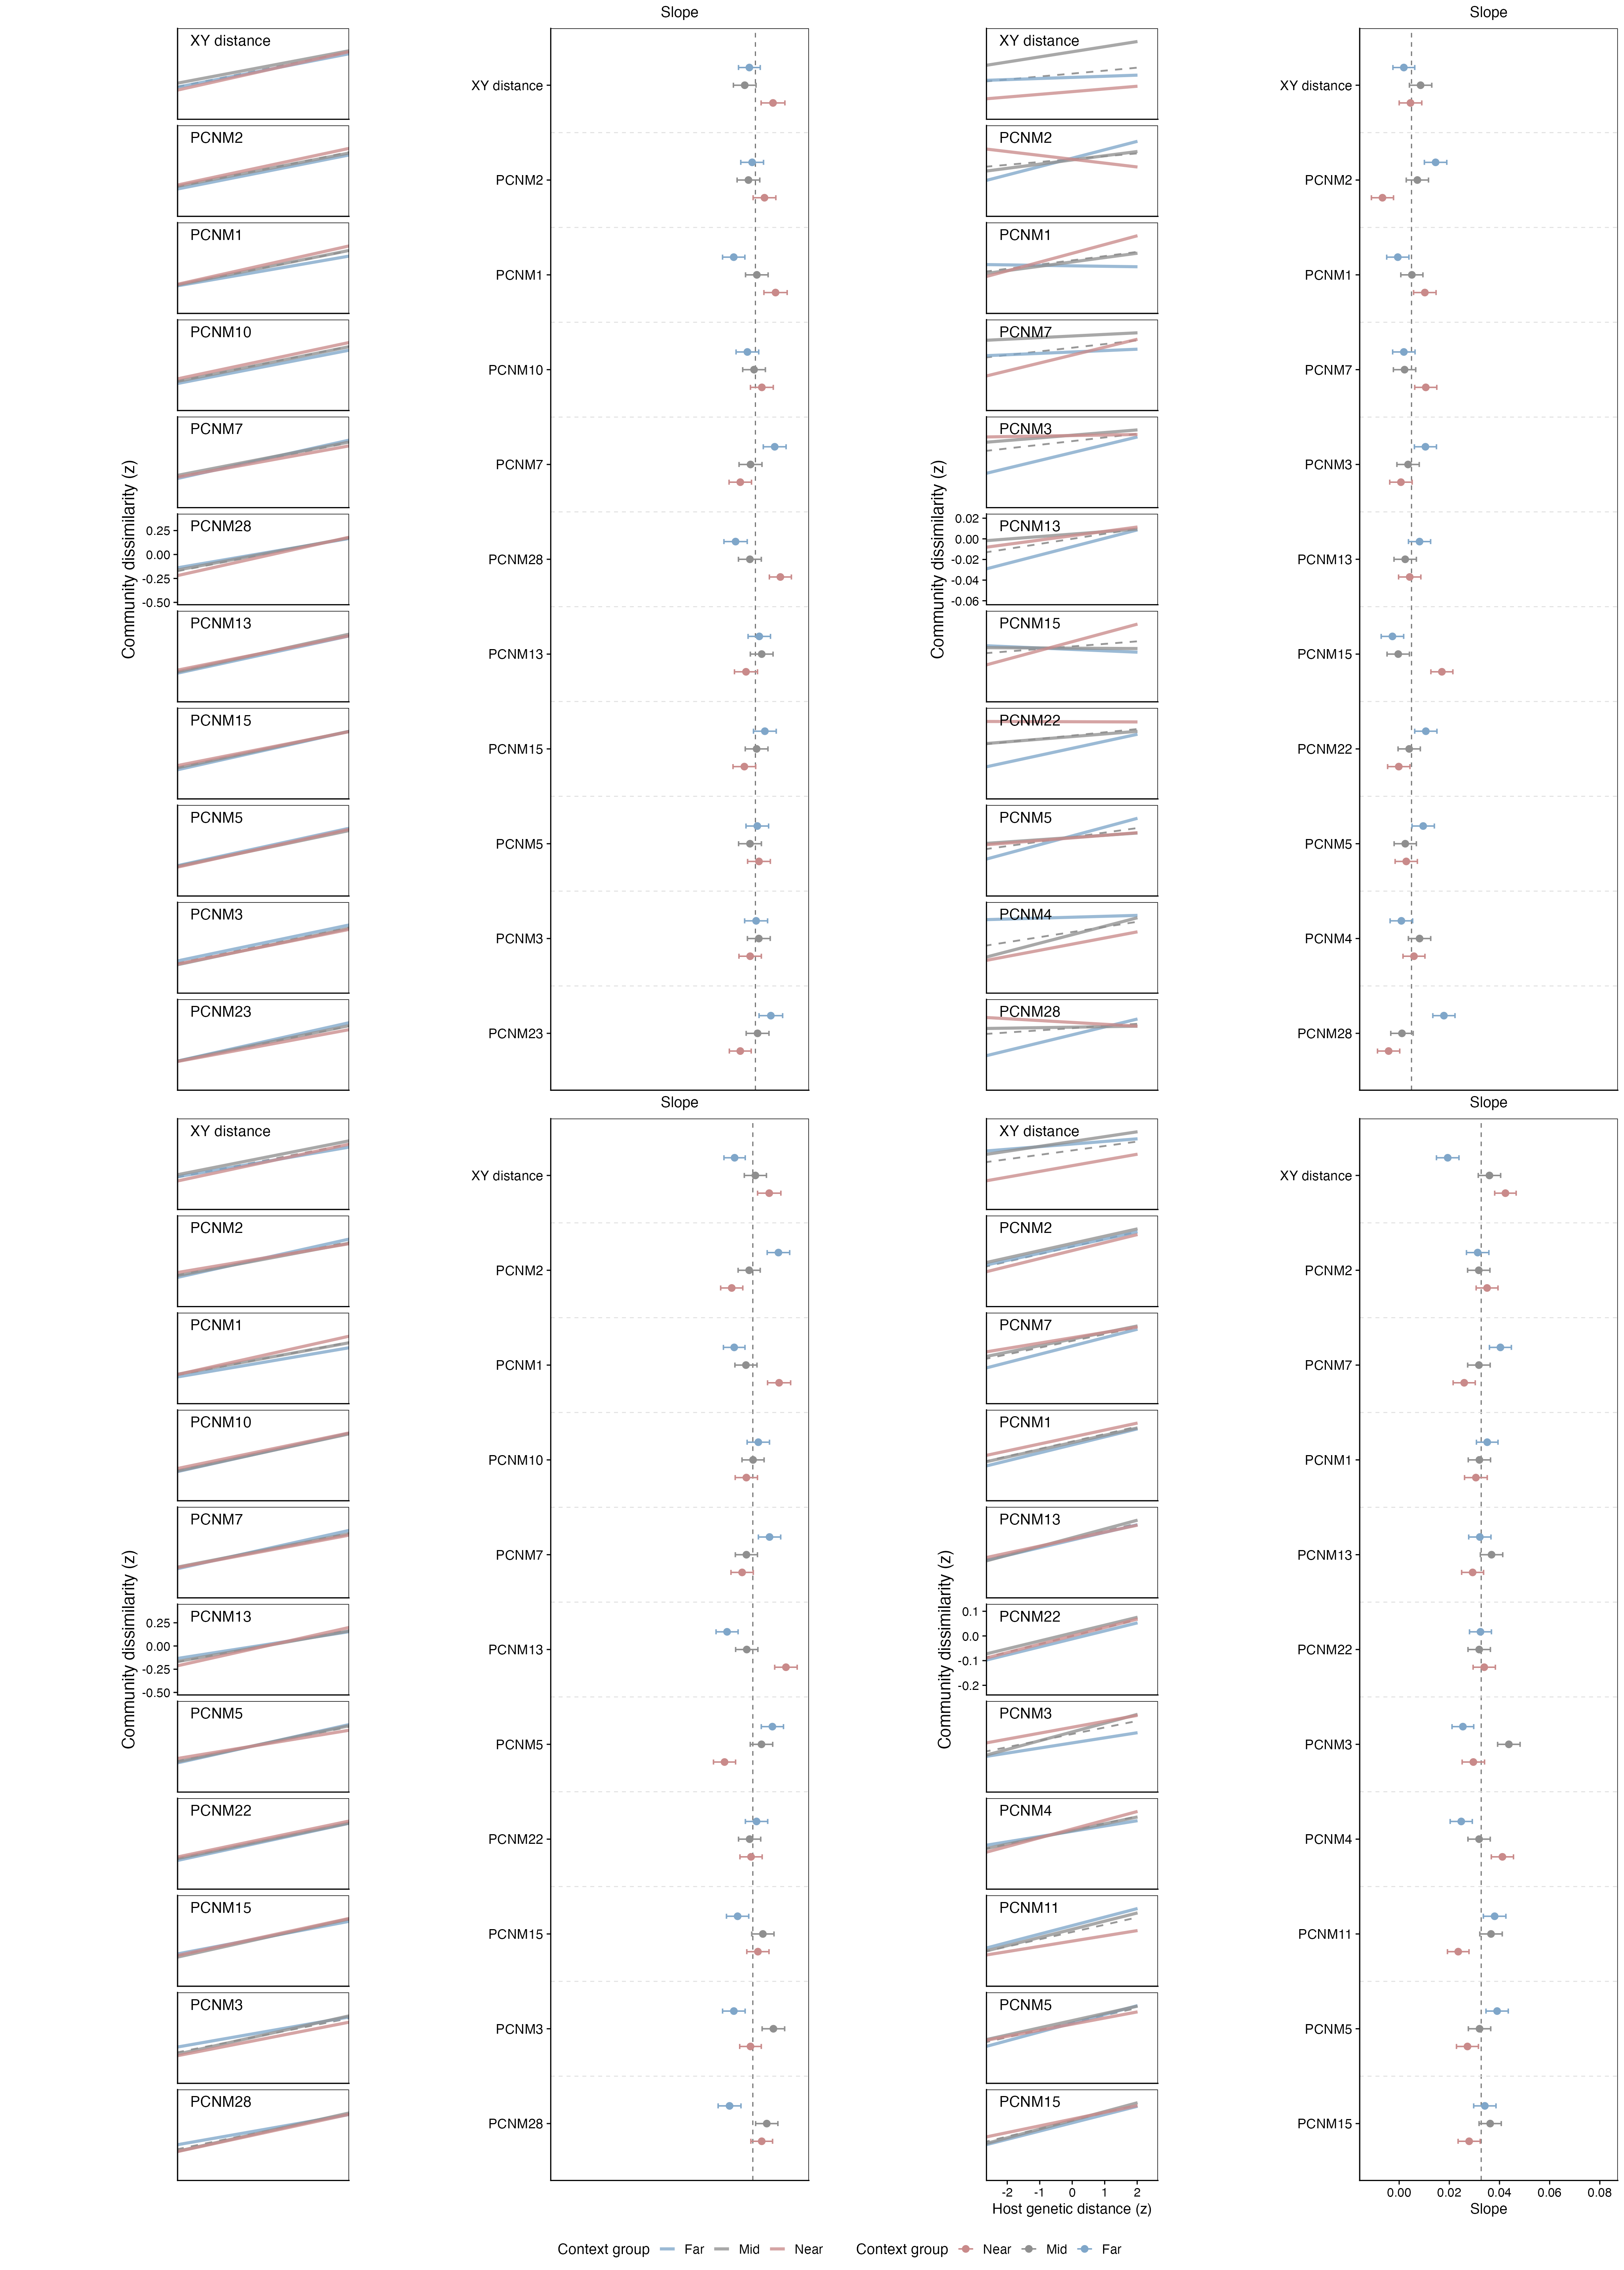
Fig.S7 Spatial-context dependence of host genetic effects across geographic and PCNM-defined gradients. For each organism-panel combination, pairwise microbial community dissimilarity was regressed against host genetic distance within three spatial-context groups defined by tertiles (Near, Mid, and Far) for raw geographic distance (XY distance) and for each of the top 10 PCNM axes. Left panels show group-specific regressions after z-score standardization of both host genetic distance and community dissimilarity; coloured lines indicate the three spatial-context groups and the dashed black line indicates the overall regression across all sample pairs. Right panels summarize the corresponding group-specific slopes with 95% confidence intervals, with dashed vertical lines indicating the overall slope for the corresponding organism-panel combination. PCNMs are ordered by forward-selection rank within each panel.
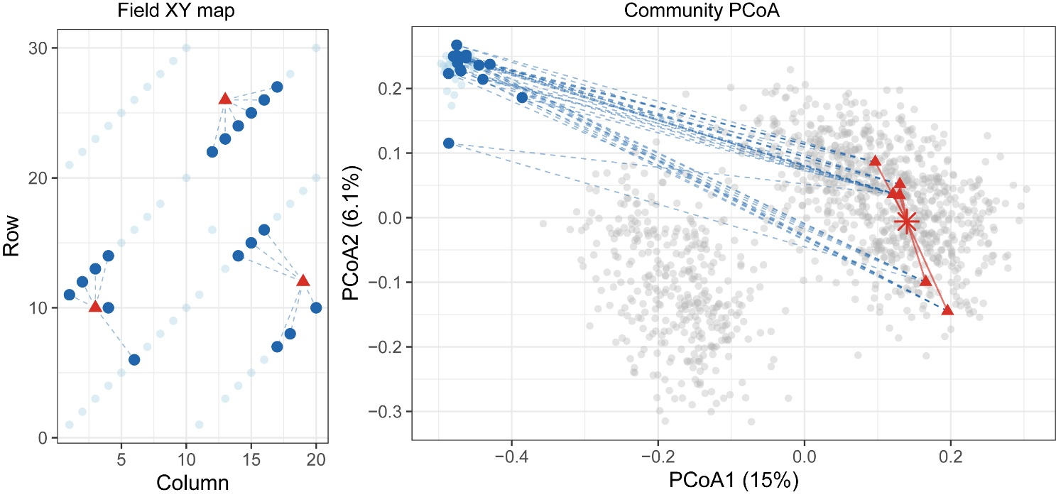
Fig.S8 Representative example illustrating how host selection strength and within genotype divergence was quantified. A representative barley genotype (ALANDA) from the SpringPan bacterial dataset is shown. Left, the field positions of root samples from the highlighted genotype (red triangles) and bulk-soil samples are displayed. Blue dashed lines connect each root sample to its six geographically nearest bulk-soil samples (dark-blue points), which were used to calculate local host selection strength. Right, the same samples are projected in microbial community ordination space. Grey points represent root microbiomes from other genotypes, dark-blue points represent the linked local bulk-soil communities, and red triangles represent root microbiomes of the highlighted genotype. Blue dashed lines show root-to-local-bulk community distances, whereas red lines connect the highlighted root samples to their genotype centroid (red star), illustrating within-genotype community dispersion.
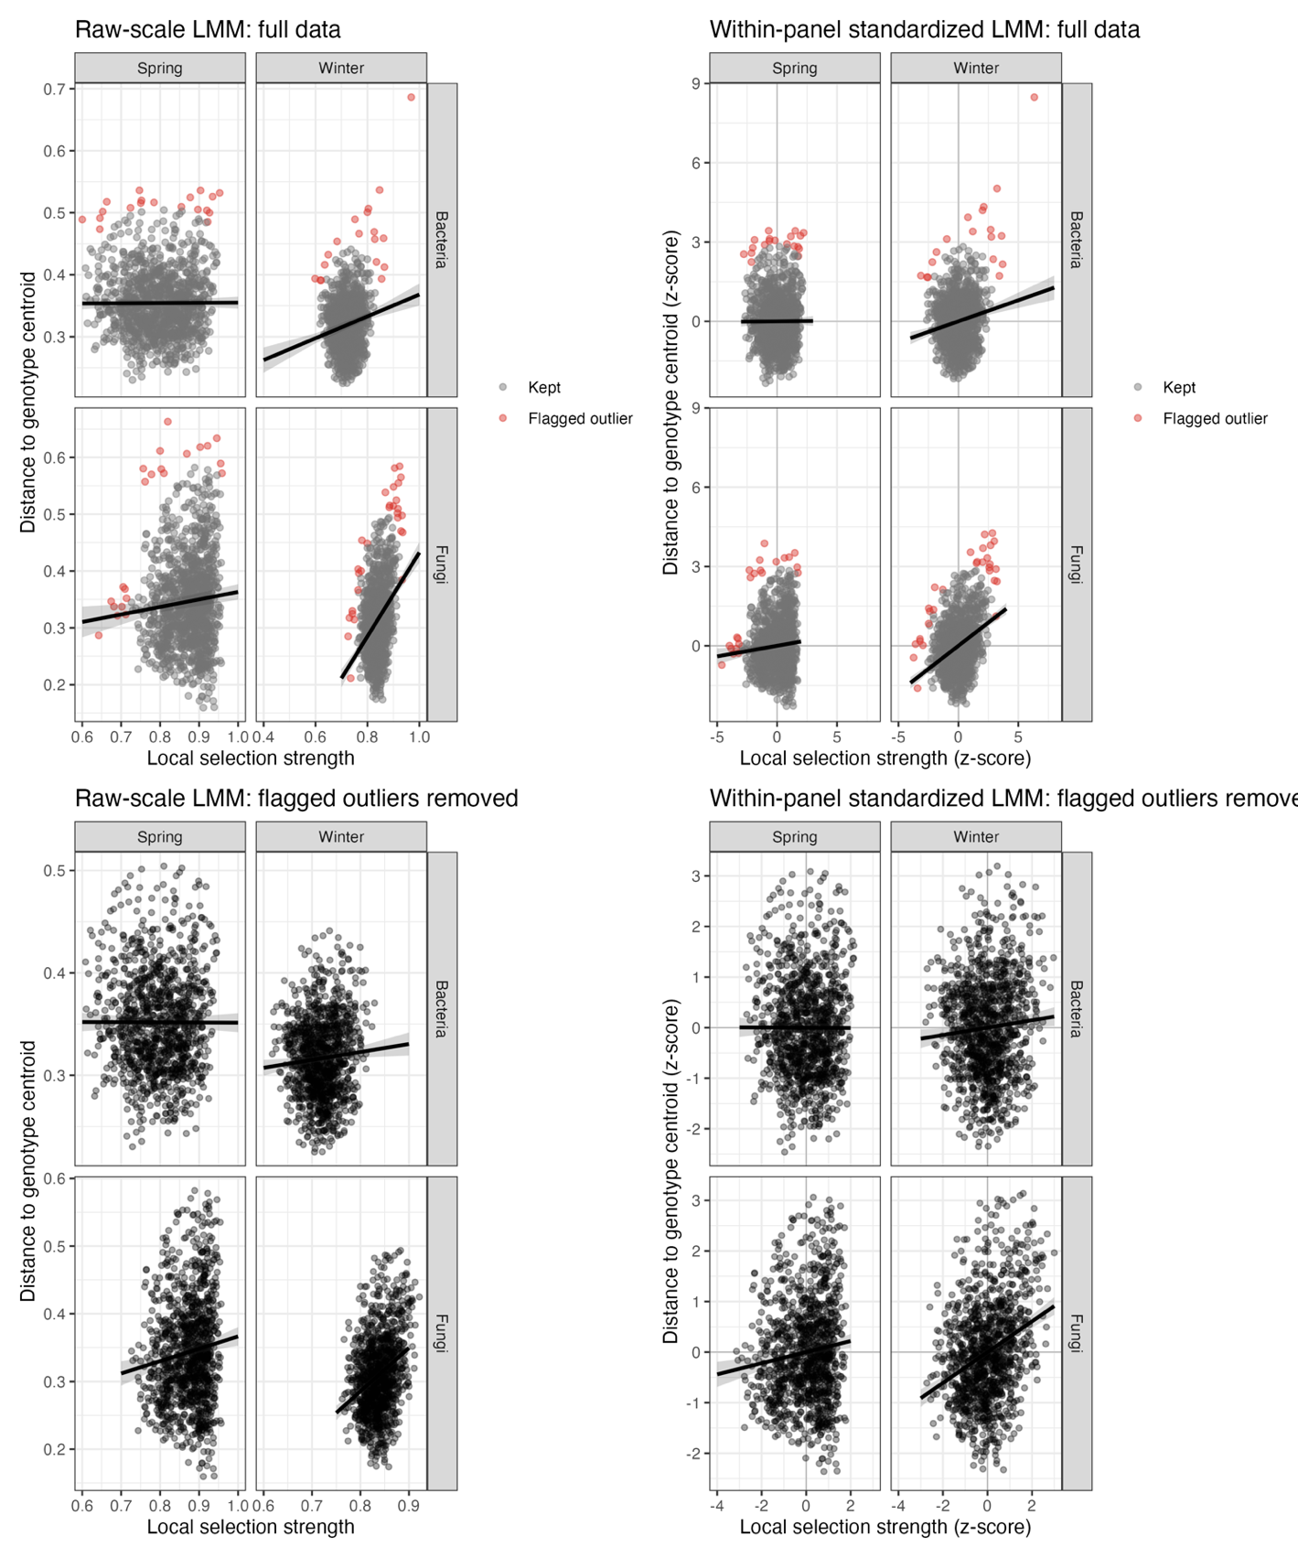
Fig.S9. Sensitivity of host selection–dispersion regressions to z-score standardization and outlier removal. Outliers were defined within each community-by-trial panel as observations exceeding the 99% chi-square cutoff of the bivariate Mahalanobis distance based on host selection strength and distance to genotype centroid.
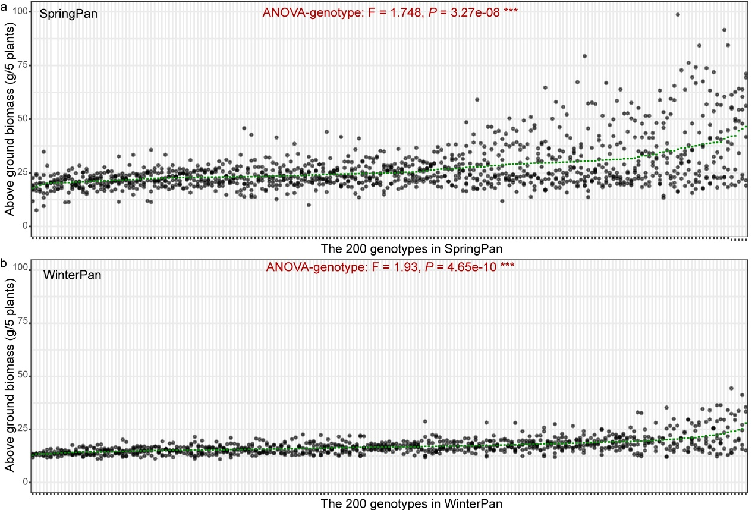
Fig.S10 Barley above ground biomass in SpringPan (a) and WinterPan (b). The black dots represent individual biomass of each replicate, while the green lines indicate the mean biomass per genotype.

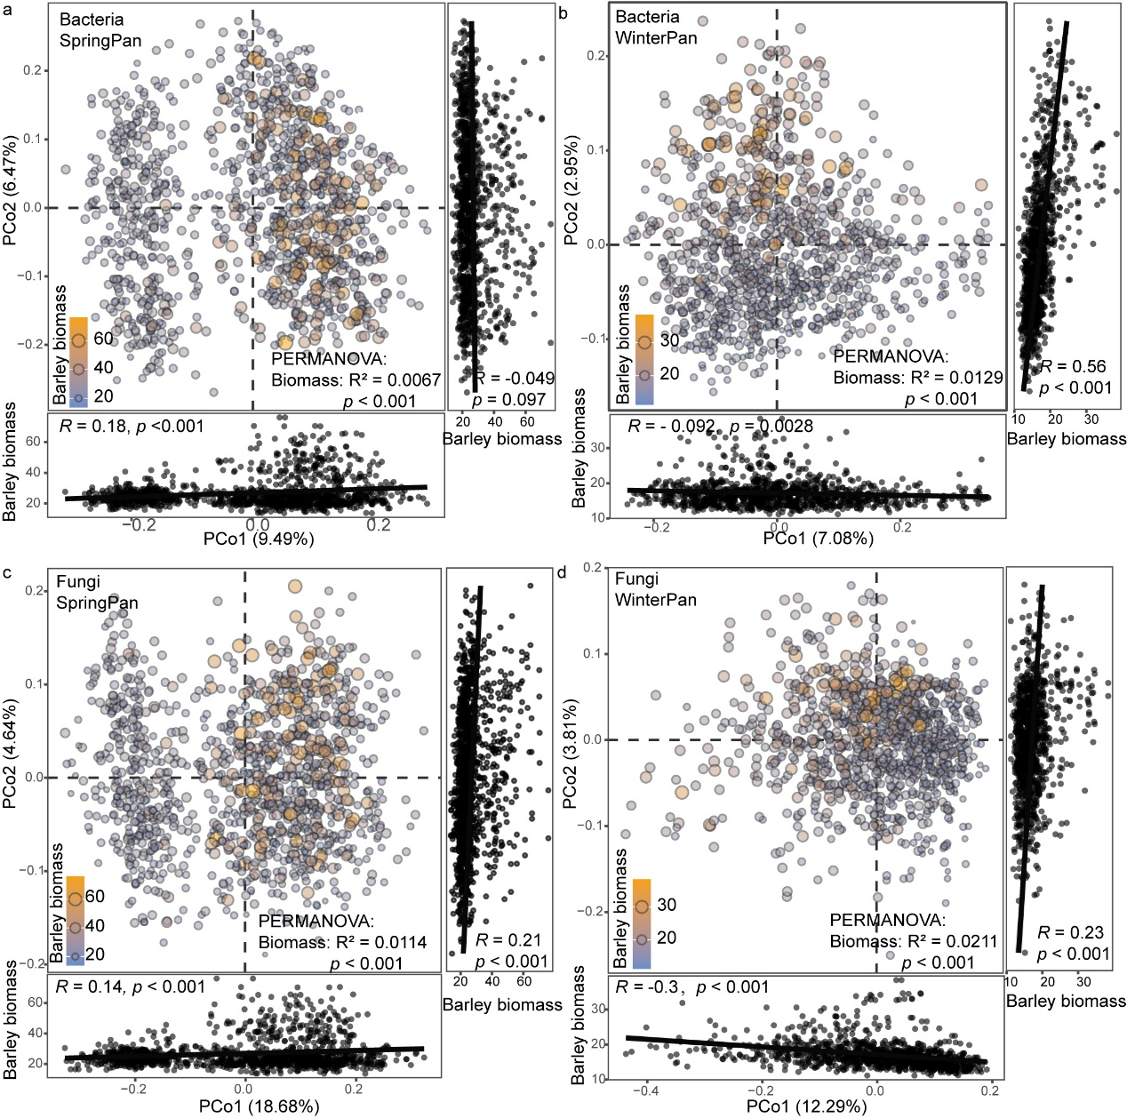
Fig. S11 Correlation between barley biomass and bacterial and fungal community composition in spring (a, c) and winter (b, d) panels. PCoA and PERMANOVA were performed based on Bray-Curtis dissimilarities. Correlations between PCoA axes and biomass were conducted using Spearman’s correlation test. Point size and color were illustrated corresponding to biomass values per five plants.

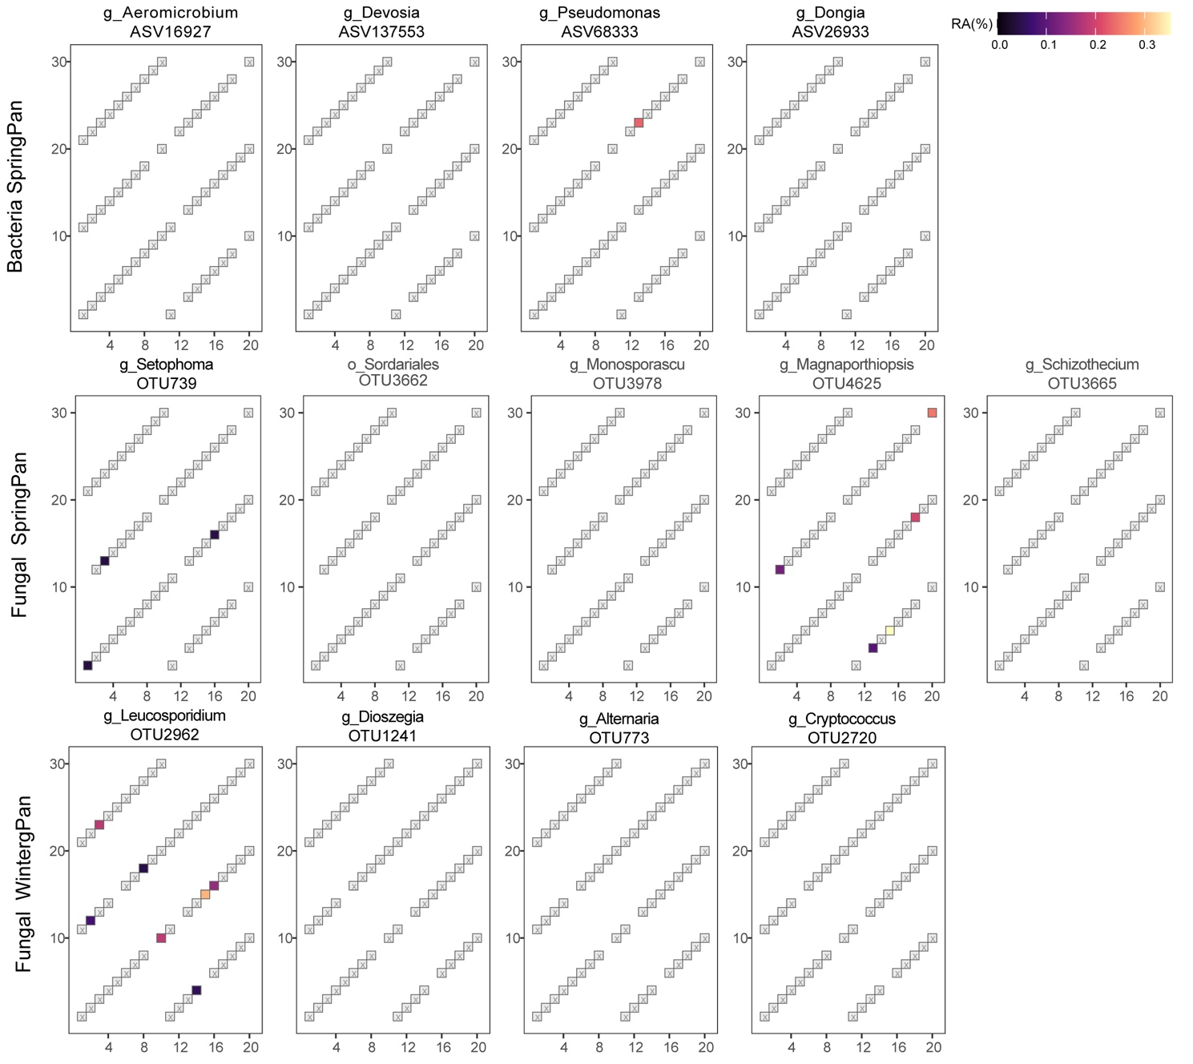
Fig. S12. Spatial distribution of the SNP-associated positive biomarkers in bulk soil across the 60 selected plot
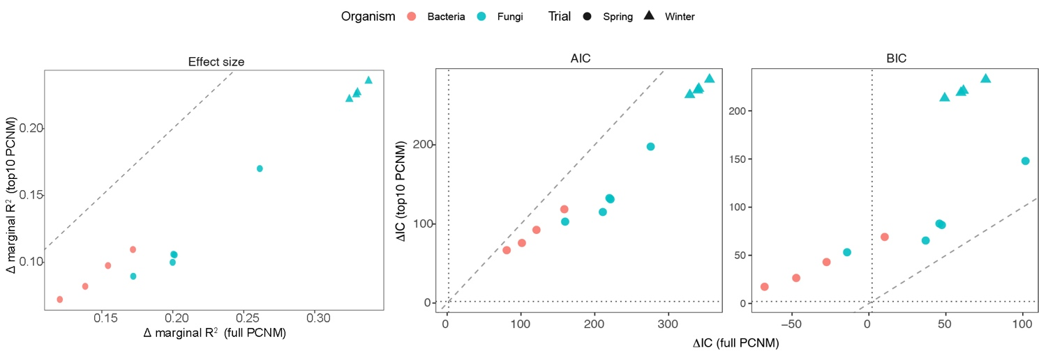
Figure S13 Comparison of full- and reduced-PCNM models for spatial effects on host genetic-associated positive biomarkers. Each point represents one SNP-associated positive biomarker. Spatial effects were evaluated using linear mixed-effects models fitted to rclr-transformed biomarker abundance, with genotype included as a random intercept. Spatial structure was represented by principal coordinates of neighbour matrices (PCNMs) selected separately for each organism-panel combination by forward selection in dbRDA. Three model comparisons are shown: differences in marginal R² between spatial models and the genotype-only null model (Δ marginal R²), differences in Akaike information criterion (ΔAIC), and differences in Bayesian information criterion (ΔBIC). In the left panel, Δ marginal R² of the full-PCNM model is plotted against that of the reduced top10-PCNM model. In the middle and right panels, ΔAIC and ΔBIC are shown for the full-PCNM and top10-PCNM models relative to the genotype-only null model; positive values indicate improvement over the null model. Dashed diagonal lines indicate equality between model versions. The reduced model included the first 10 forward-selected PCNM axes for the corresponding organism-panel combination, whereas the full model included all forward-selected PCNM axes. Points are coloured by organism and shaped by trial.

