Trojan bacteria cross blood-brain barrier for glioblastoma photothermal immunotherapy

Rong Sun,‡ Mingzhu Liu,‡ Jianping Lu, Binbin Chu, Yunmin Yang, Bin Song, Houyu Wang* & Yao He*

Suzhou Key Laboratory of Nanotechnology and Biomedicine, Institute of Functional Nano & Soft Materials & Collaborative Innovation Center of Suzhou Nano Science and Technology (NANO-CIC), Soochow University, Suzhou 215123, China

*Corresponding authors. Email: houyuwang@suda.edu.cn; yaohe@suda.edu.cn

‡These authors contributed equally to this work.

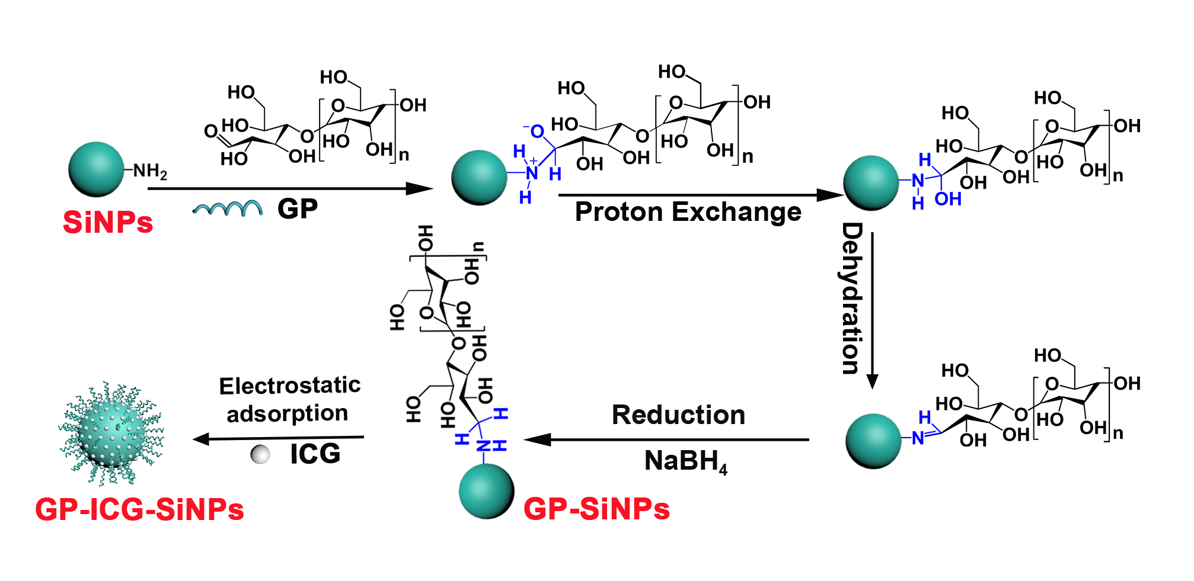
Supplementary Fig. 1. Schematic diagram of the synthesis of nanoagents GP-ICG-SiNPs. The GP molecules (e.g, poly[4-O-(α-D-glucopyranosyl)-D-glucopyranose]) are firstly conjugated to the SiNPs surface based on the Schiff base reaction between the aldehyde groups of GP and the amino groups terminated SiNPs. After that, the ICG molecules are loaded on GP-SiNPs through electrostatic adsorption.

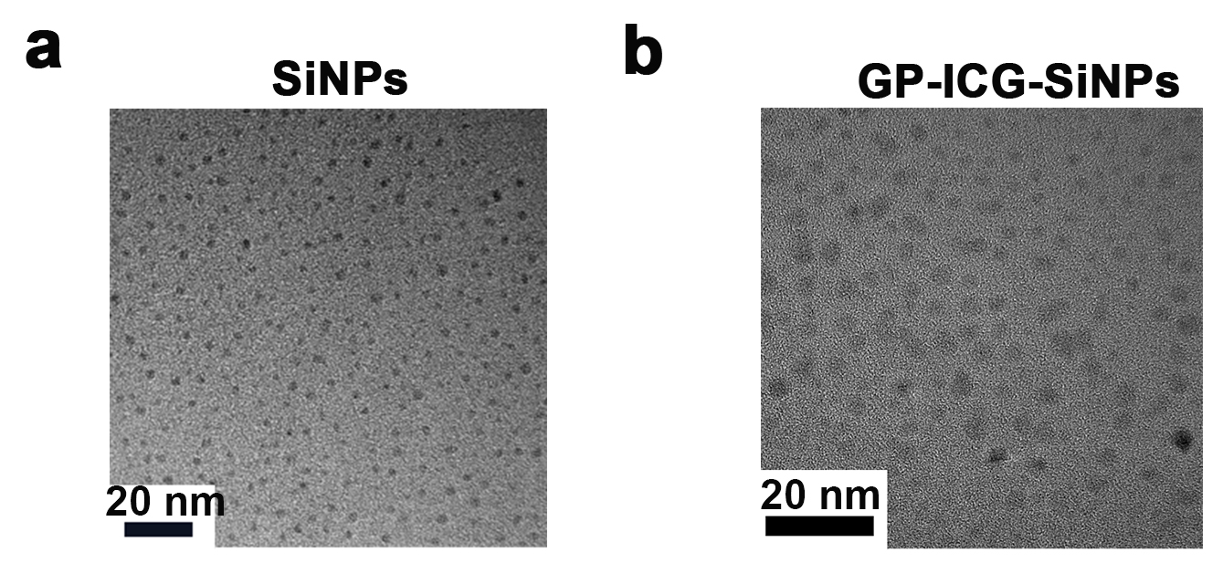

Supplementary Fig. 2. TEM images of the nanoagents. a, TEM image of SiNPs. b, TEM image of GP-ICG-SiNPs. Scale bars: 20 nm. GP-ICG-SiNPs appear as spherical particles with a narrow size distribution of ~3.2 nm, which is slightly larger than that of bare SiNPs (e.g., ~2.7 nm).

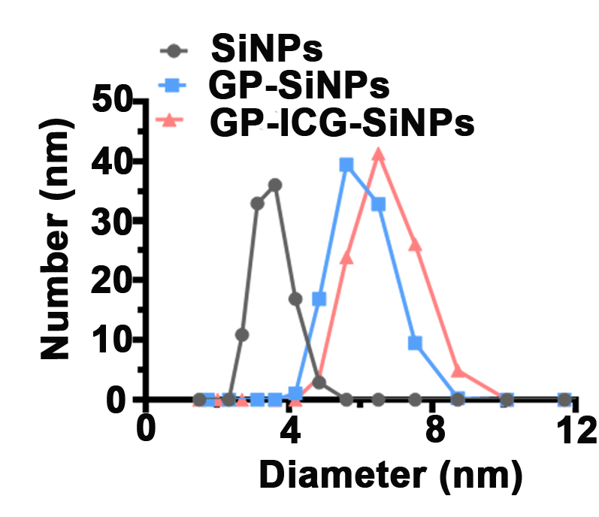
Supplementary Fig. 3. The DLS data of SiNPs, GP-SiNPs and GP-ICG-SiNPs. The hydrodynamic diameter of GP-ICG-SiNPs is ~5.6 nm, also larger than the hydrodynamic diameter of bare SiNPs (~3.0 nm).

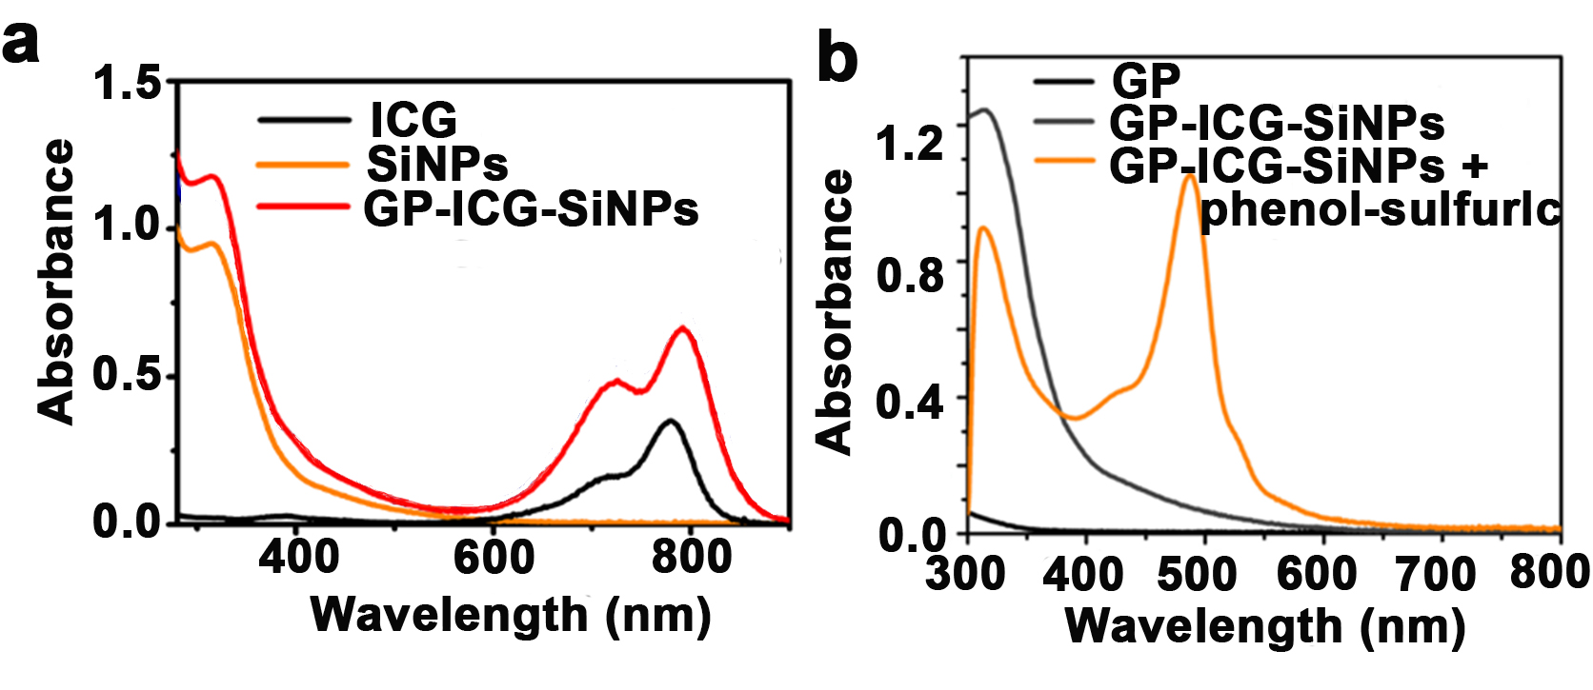
Supplementary Fig. 4. UV-vis absorbance of nanoagents. a, The UV-vis absorbance of ICG, SiNPs and GP-ICG-SiNPs. b, The UV-vis absorbance of GP, GP-ICG-SiNPs, and GP-ICG-SiNPs treated with the phenol-sulfuric acid.

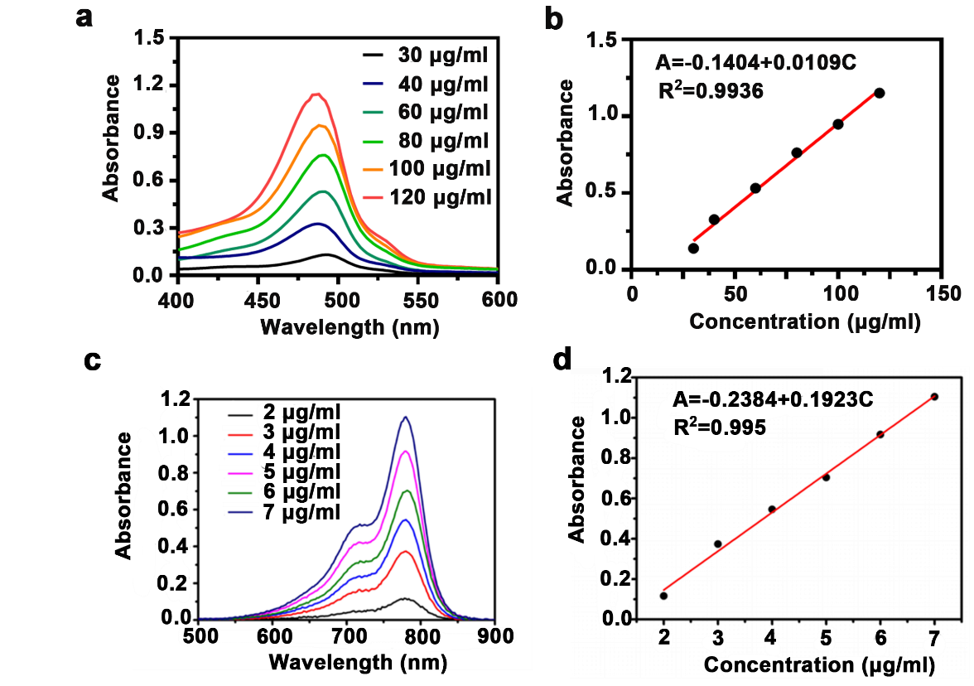
Supplementary Fig. 5. Quantification of GP and ICG. UV-vis absorption spectra of GP with various concentrations ranged from 30 to 120 μg/mL treated by the same amount of phenol-sulfuric acid (a) and corresponding calibration curve (b). UV-vis absorption spectra of ICG with various concentrations ranged from 0 to 10 μg/mL (c) and corresponding calibration curve (d).

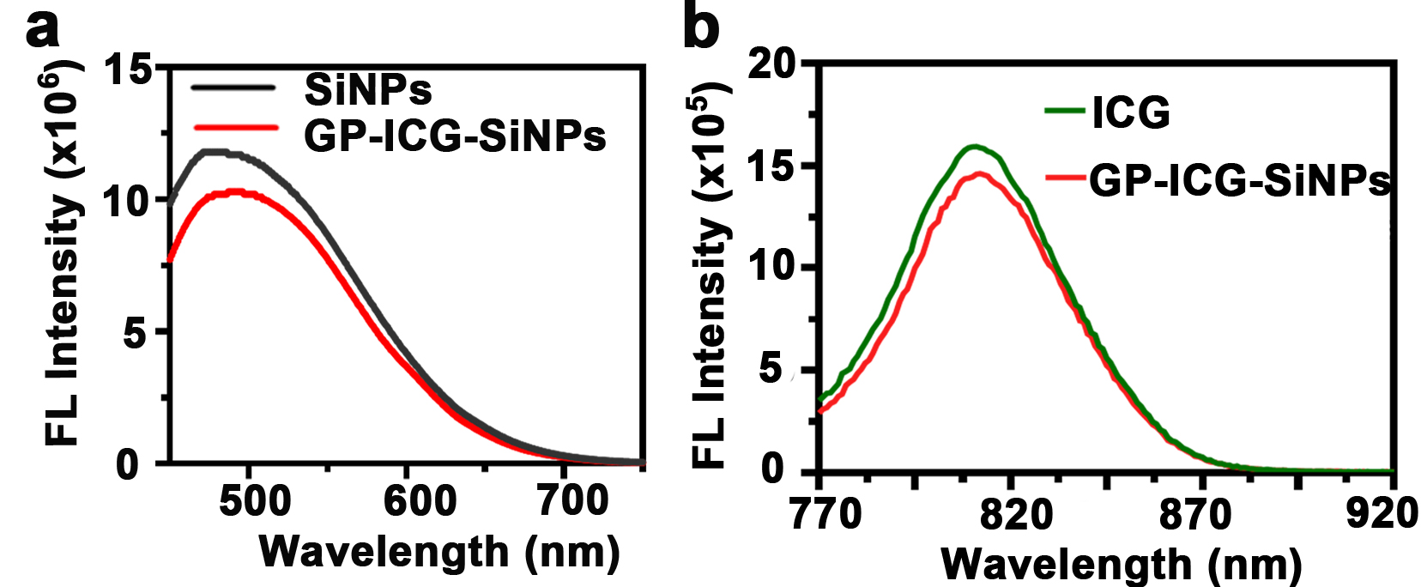
Supplementary Fig. 6. The PL spectra of SiNPs, ICG and GP-ICG-SiNPs. a, The PL spectra of SiNPs and GP-ICG-SiNPs under the excitation of 405 nm. b, The PL spectra of ICG and GP-ICG-SiNPs under the excitation of 780 nm.

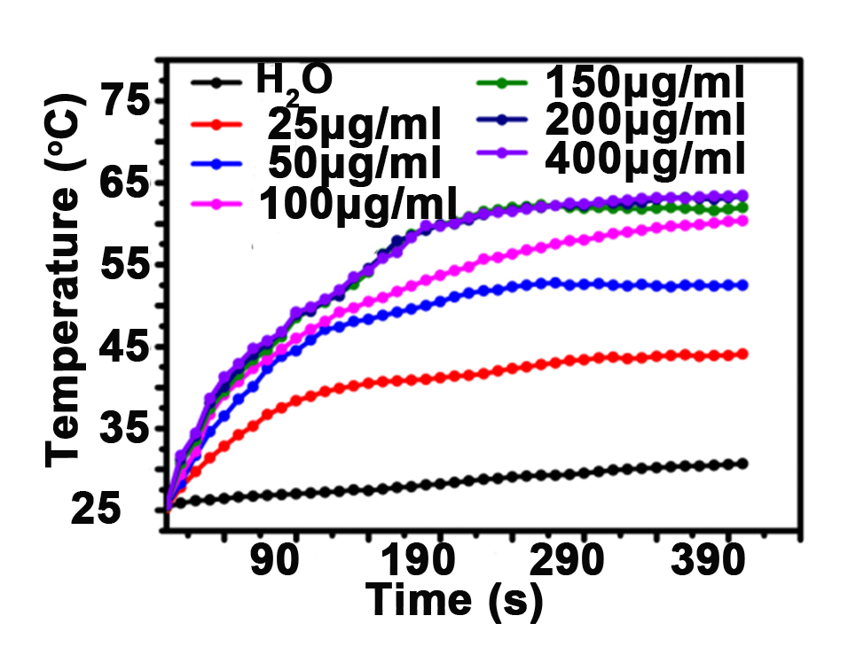
Supplementary Fig. 7. Photothermal heating curves of GP-ICG-SiNPs containing various ICG concentrations under the NIR laser (808 nm, 1 W/cm²) irradiation. The temperature of GP-ICG-SiNPs solutions can be enhanced by 30 °C during 300-sec 808-nm laser exposure when the loading concentration of ICG is or more than 150 μg/mL.

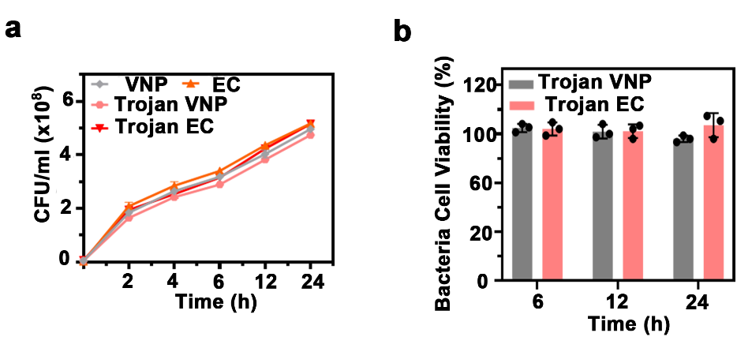
Supplementary Fig. 8. The effects of the internalized nanoagents on the growth and activity of host bacteria. a, The growth curves of bacteria (VNP and EC) and Trojan bacteria (Trojan VNP and Trojan EC) during 24-h culturing. b, The bacteria cell viability of bacteria (VNP and EC) and Trojan bacteria (Trojan VNP and Trojan EC) during 24-h culturing. All error bars represent the standard deviation determined from three independent assays. All data are presented as means ± SD.

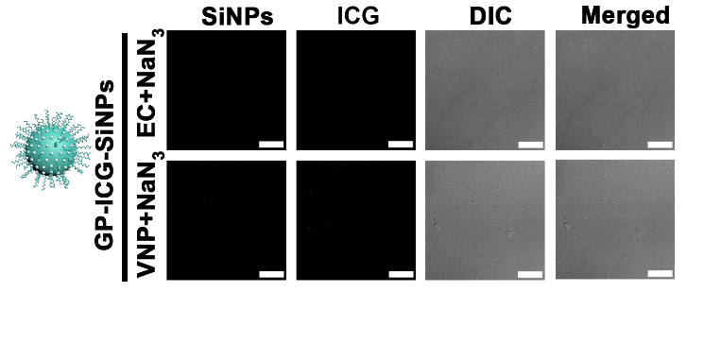
Supplementary Fig. 9. Fluorescent confocal images of EC and VNP treated with NaN₃ and then incubated with 10 mg/mL GP-ICG-SiNPs for 2 h at 37 ºC. After incubation, the treated bacteria were rinsed with PBS buffer for several times. The bacterial cell concentration is ~1.0 ×10⁷ CFU. Scale bars: 20 μm.

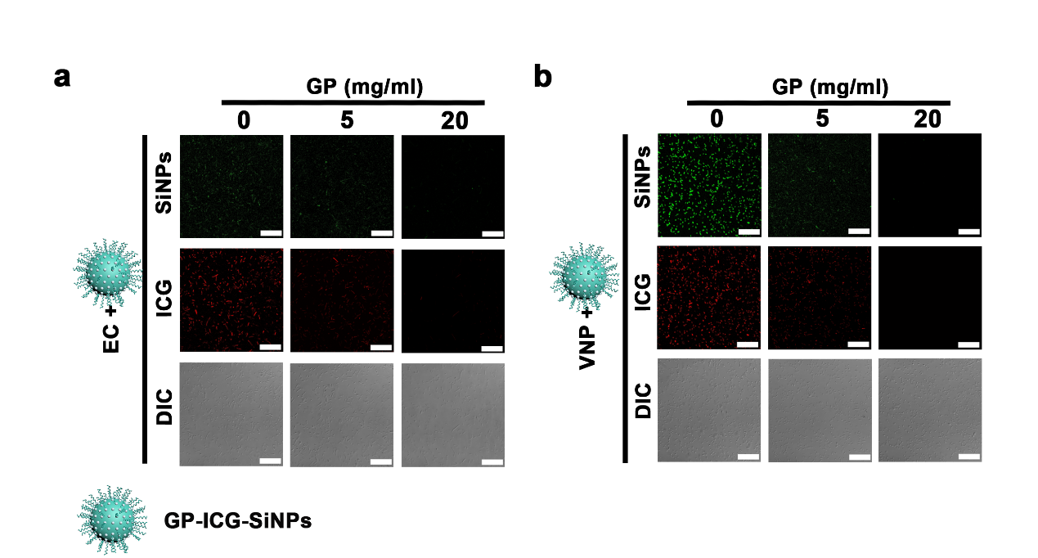
Supplementary Fig. 10. Fluorescent confocal images of nanoagents-treated with bacteria after treatments of free GP molecules with various concentrations. a, Confocal fluorescence images of EC treated with GP at 0, 5, and 20 mg/ml and incubated with 10 mg/mL GP-ICG-SiNPs for 2 h at 37 ºC. Scale bars: 20 μm. b, Confocal fluorescence images of VNP treated with GP at 0, 5, and 20 mg/ml and incubated with 10 mg/mL GP-ICG-SiNPs for 2 h at 37 ºC. Scale bars: 20 μm.

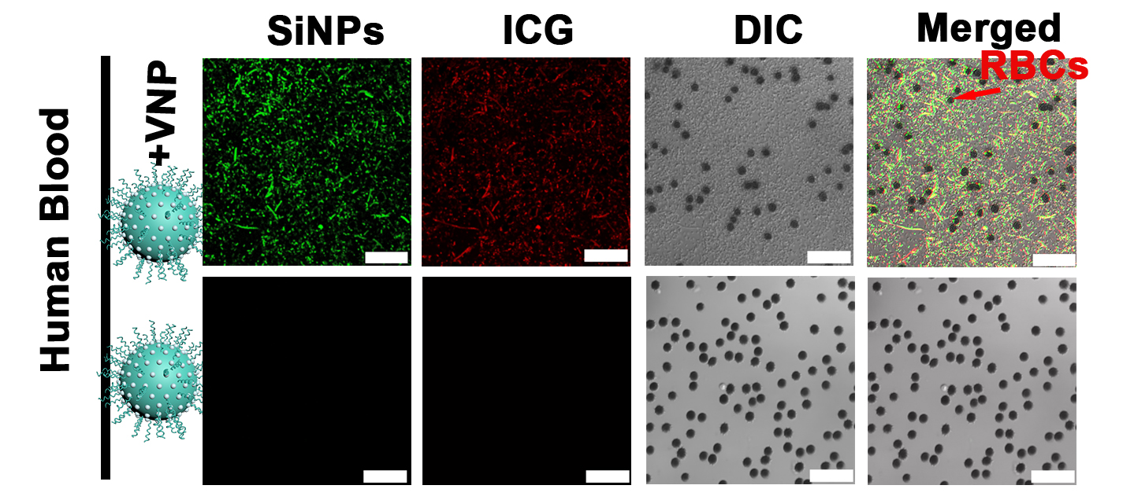
Supplementary Fig. 11. CLSM images of the mixture of human blood and VNP after incubation with GP-ICG-SiNPs. Arrows indicate red blood cells (RBCs). Scale bar: 25 μm. The VNP were incubated with the synthesized nanoagents ([SiNPs] = 12 mg/mL, [ICG] = 600 μg/mL) at 37 ºC for 2 h. After incubation, the treated bacteria were rinsed with PBS buffer for several times. The bacterial cell concentration is ~1.0 ×10⁷ CFU.

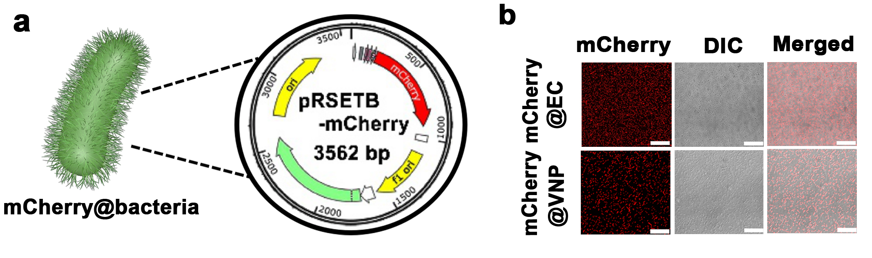
Supplementary Fig. 12. The construction of bacteria transformants. a, A scheme illustrating the plasmid of pRSETB-mCherry. b, Confocal fluorescence images of constructed mCherry@EC and mCherry@VNP expressing mCherry protein. Scale bars: 25 μm. The confocal images show the red fluorescence signals of mCherry (λ_{ex} = 543 nm, λ_{em} = 580-650 nm) from the EC or VNP, suggesting the successful construction of bacteria transformants.

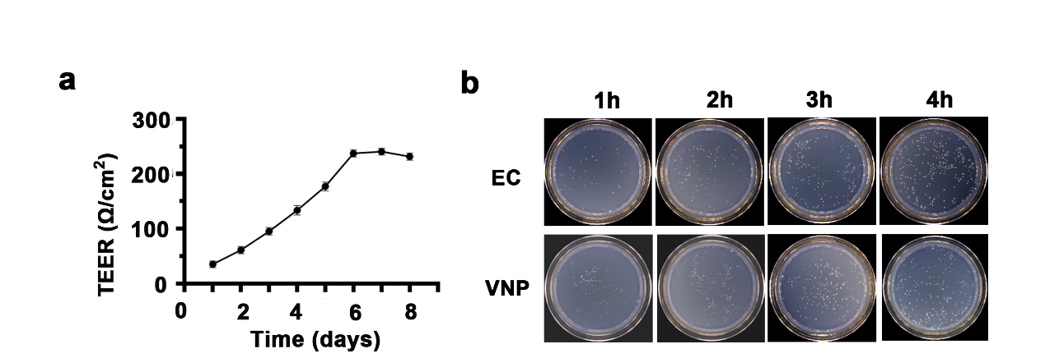
Supplementary Fig. 13. Evaluation of the constructed HBMEC model. a, Change in the TEER value of the HBMEC cell monolayer during culture. When the TEER value is 150-300 Ω/cm², the constructed HBMEC cell monolayer can be used to study BBB penetration. b, The colony growth of the medium taken from the lower chamber of the transwell on the LB plate at 1h, 2h, 3h, 4 h.

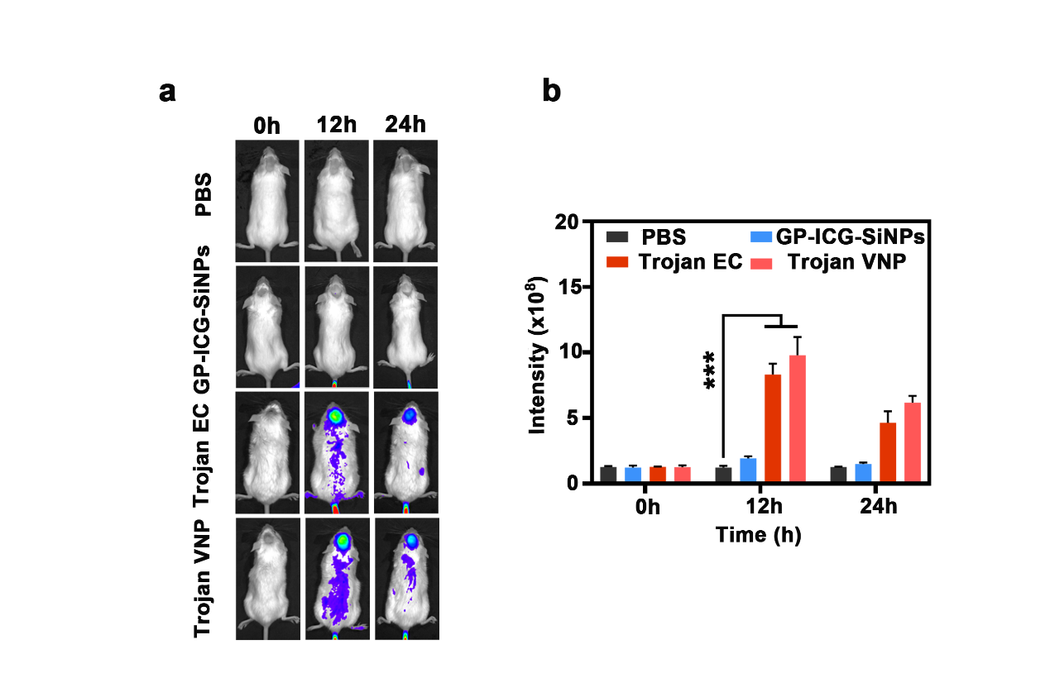
Supplementary Fig. 14. In vivo fluorescence imaging of in situ tumor-bearing mice. a, In vivo real-time fluorescence imaging of tumor-bearing mice at different time points under different drug treatments. b, Fluorescence quantitative analysis of GBM was performed at different time points. All error bars represent the standard deviation determined from three independent assays. All data are presented as means ± SD. Statistical significance was calculated via one-way analysis of variance (ANOVA) with a Tukey post-hoc test.

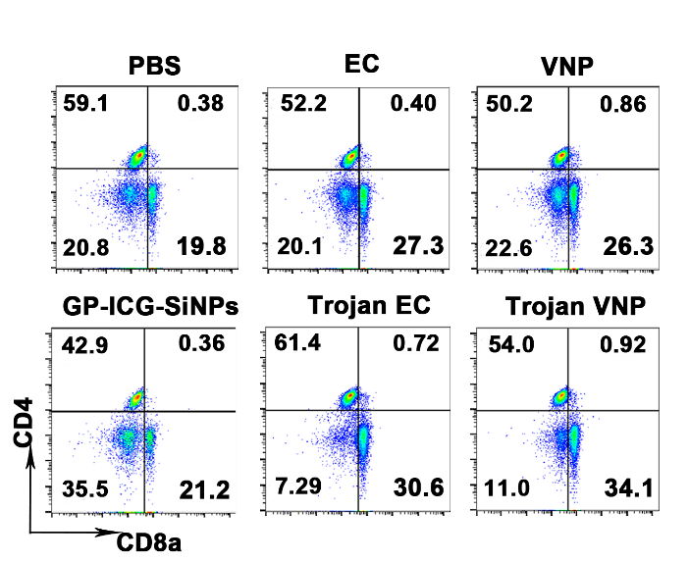
Supplementary Fig. 15. Representative flow cytometry plots illustrated CD3⁺ CD8a⁺ T cells in splenocytes.

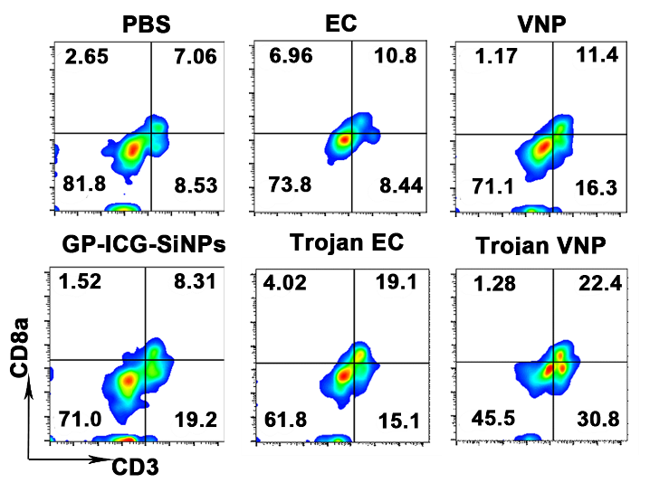
Supplementary Fig. 16. Representative flow cytometry plots illustrated CD3⁺ CD8a⁺ T cells in GBM tumour.

