Supplementary Figure 1. Quality control metrics and data filtering for single-cell RNA sequencing (scRNA-seq).
a) Violin plots displaying the distribution of the number of detected genes (left) and total unique molecular identifier (UMI) counts (right) per cell across all BHD and control samples. These metrics indicate consistent sequencing depth across groups and facilitated the exclusion of empty droplets and potential doublets.
b) Violin plot illustrating the percentage of mitochondrial gene expression per cell. Cells exhibiting an excessively high mitochondrial percentage, which typically represent dead, dying, or physically ruptured cells, were stringently filtered out during the quality control process.
c) Scatter plots demonstrating the positive correlation between total UMI counts and the number of detected genes. The robust correlation profile confirms high-quality library preparation and efficient cellular capture.

Supplementary Figure 2. Evaluation of batch-effect correction on the integrated scRNA-seq datasets.
(Left) Uniform Manifold Approximation and Projection (UMAP) of the merged single-cell data prior to batch-effect correction. Colors represent individual sample origins. (Right) UMAP projection of the integrated data following batch-effect correction. The post-correction UMAP demonstrates reduced batch-associated variation and improved integration across datasets, with clustering patterns appearing less influenced by technical or sample-specific effects.

Supplementary Figure 3. Quantitative analysis of cellular composition changes in BHD syndrome.
a）Stacked bar chart displaying the comparison of major cell population proportions in each sample between BHD lungs and healthy controls.
b）Stacked bar chart displaying the comparison of major epithelial population proportions in each sample between BHD lungs and healthy controls.
c) Box plots displaying the altered proportions of diverse cell subpopulations in control versus BHD lungs. Statistical significance was assessed by the Kruskal-Wallis test, with exact p-values displayed. Significant compositional shifts (* p < 0.05) were observed in specific lineages, including an enrichment of T_NK_ILC and DC populations, alongside a depletion of Neutrophil and Endothelial cells in the BHD group.

Supplementary Figure 4. Enrichment analysis of downregulated pathways in the BHD group.
Bubble plot displaying the top 20 pathways enriched by downregulated genes in BHD patients relative to controls. The y-axis displays the pathway names, while the x-axis shows the Rich factor. Bubble size is proportional to the number of associated downregulated genes (Num.Gene). The color scale from red to blue reflects the statistical significance of the enrichment. Notably, structural maintenance pathways, including "Adherens junction" and "Tight junction," alongside essential "Metabolic pathways," were prominently downregulated, corroborating the loss of epithelial mechanical integrity and cellular identity in BHD syndrome.

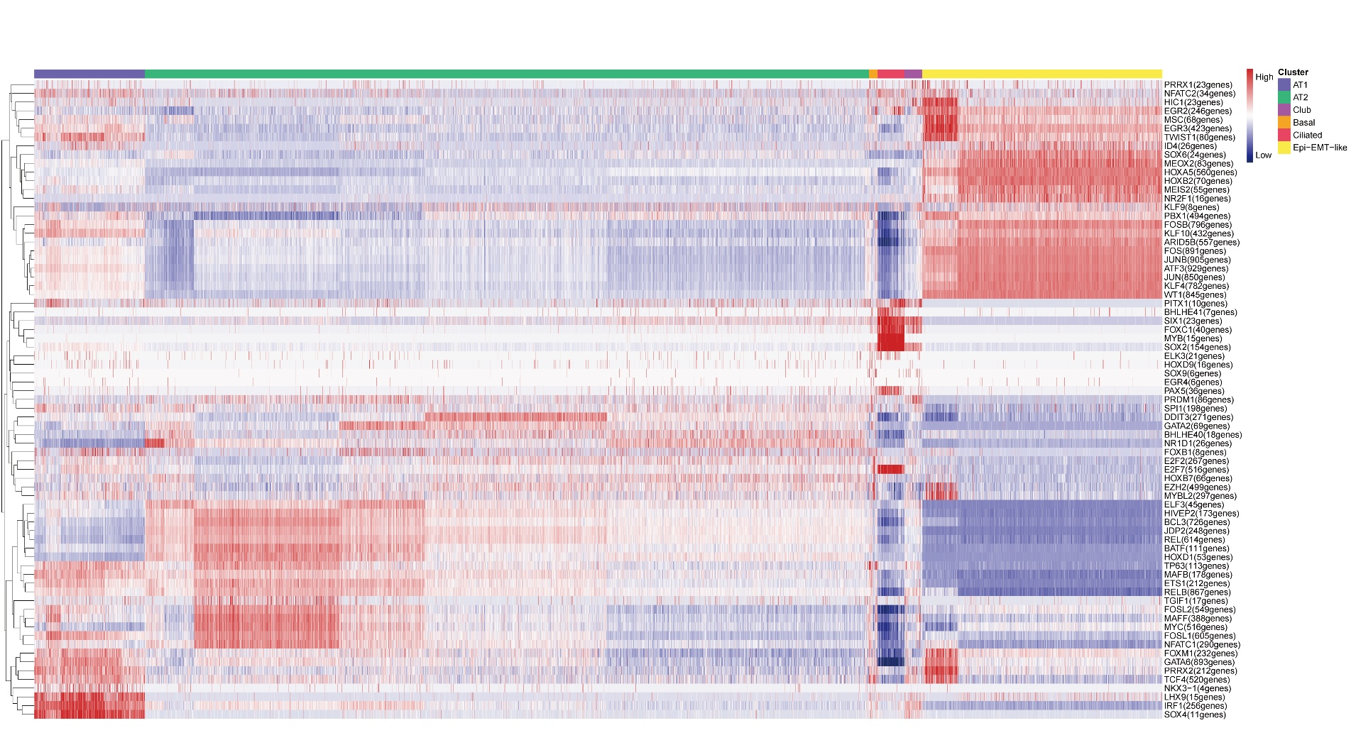
Supplementary Figure 5. Comprehensive SCENIC analysis of transcription factor regulon activity in epithelial cell populations.
Heatmap showing AUCell-based activity scores of transcription factor regulons across epithelial subpopulations in BHD and healthy lung tissues. Rows represent transcription factor regulons, and columns represent epithelial cell populations. Color intensity indicates the relative activity of each regulon across cell populations, with higher AUCell scores indicating greater regulon activity.

Supplementary Table 1. Novel FLCN variants of 85 BHD families
ACMG Classification | FLCN Germline Variant  (NM_144997.7) | Amino Acid Change | Location | Variant Type
Likely pathogenic | c.221delC | p.(Pro74fs) | Exon4 | Framshift
Likely pathogenic | c.395_396+ldel |  | Exon5 | Splice
Likely pathogenic | c.1489_1490insCC | p.(Val497fs) | Exon13 | Framshift
Likely pathogenic | c.83del | p.(Pro28Hisfs27) | Exon4 | Framshift
Likely pathogenic | c.676_683dup | p.(Phe229Serfs16) | Exon7 | Framshift
Likely pathogenic | c.106G>T | p.(E36*) | Exon4 | Nonsense
Likely pathogenic | c.1301-2A>T |  | Intron11 | Splice
Likely pathogenic | c.1415del | p.(Pro472Leufs2) | Exon12 | Framshift
Likely pathogenic | c.447del | p.(Phe150Leufs*27) | Exon6 | Framshift
Likely pathogenic | c.779+1del |  | Intron7 | Splice
Likely pathogenic | c.779+1G>A |  | Intron7 | Splice
Likely pathogenic | c.659dup | p.(Arg221GlufsTer27) | Exon7 | Framshift
Likely pathogenic | c.1125_1126del | p.(lle375Metfs14) | Exon10 | Framshift
Likely pathogenic | c.97del | p.(Asp33Metfs22) | Exon4 | Framshift
Likely pathogenic | c.979del | p.(Ala327Glnfs26) | Exon9 | Framshift
Likely pathogenic | c.661_662del | p.(Arg221AspfsTer26) | Exon7 | Framshift
Likely pathogenic | chr17:17116968_17131467 |  |  | Large Deletion
Pathogenic | c.1177-1G>A |  | Intron10 | Splice
Pathogenic | c.880G>T | p.(Glu294Ter) | Exon9 | Nonsense
Pathogenic | c.959_968del | p.(Arg320fs) | Exon9 | Framshift
Pathogenic | c.273del | p.(His92ThrfsTer38) | Exon5 | Framshift
Pathogenic | c.1298C>G | p.(Ser433Ter) | Exon11 | Nonsense
Pathogenic | c.199del | p.(Ala67ProfsTer63) | Exon4 | Framshift
Pathogenic | c.577del | p.(Val193SerfsTer30) | Exon6 | Framshift
Pathogenic | chr17:17116968_17131467 |  |  | Large Deletion
Variant of uncertain significance | c.1669del | p.(L557*) | Exon14 | Nonsense

