Supplementary file
Table S1. Structure, IC₅₀, and docking score of dataset
Compound ID |  | Structure | IC50 | Docking Score
1 |  | 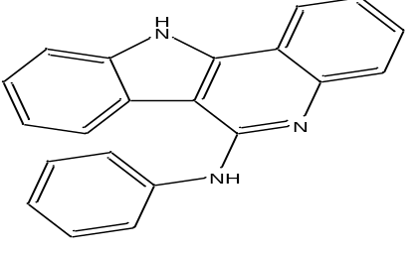 | 8.37 | -7.865
2 |  | 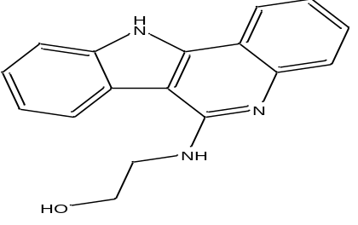 | 0.44 | -7.647
3 |  | 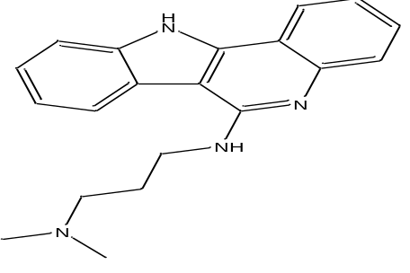 | 0.41 | -6.684
4 |  | 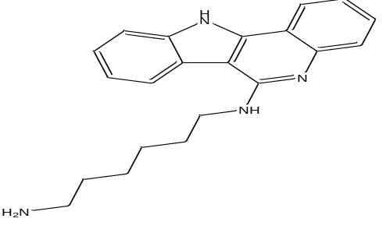 | 0.71 | -7.963
5 |  | 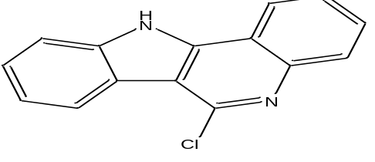 | 9.14 | -6.678
6 |  | 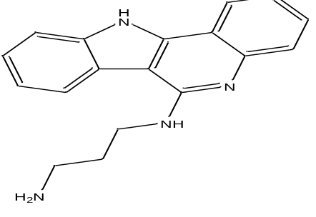 | 0.12 | -8.457
7 |  | 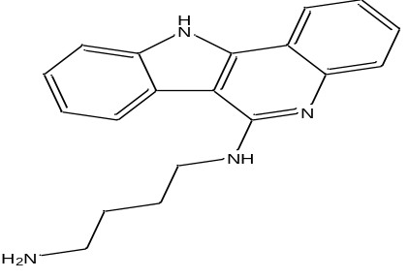 | 0.7 | -9.008
8 |  | 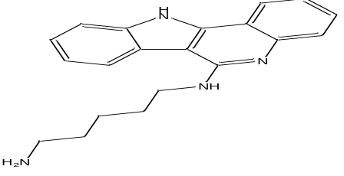 | 0.61 | -8.19
9 |  | 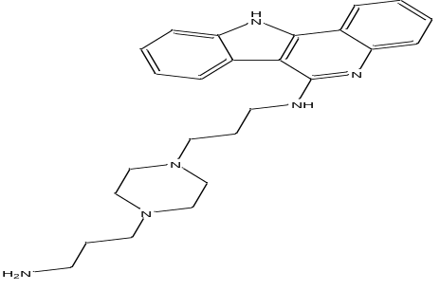 | 0.39 | -8.419
10 |  | 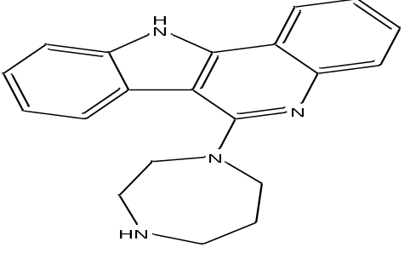 | 0.85 | -7.04
11 |  | 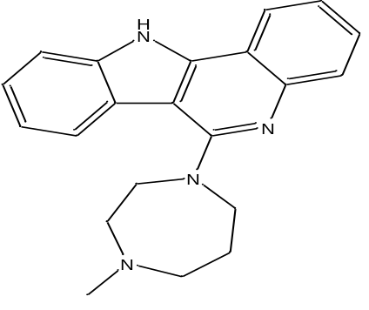 | 0.74 | -6.804
12 |  | 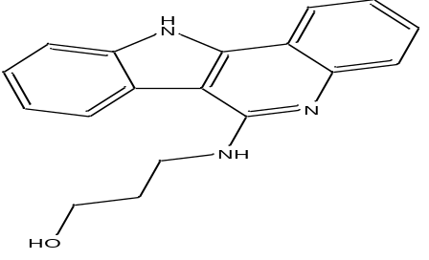 | 0.38 | -9.145
13 |  | 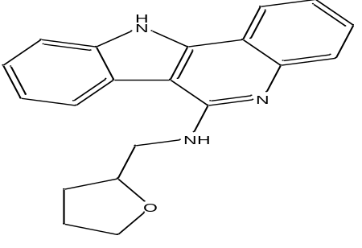 | 0.75 | -6.936
14 |  | 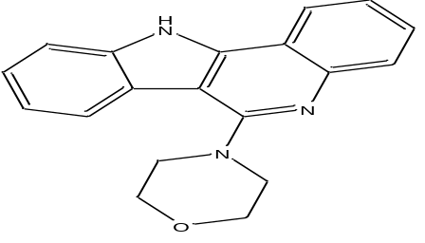 | 9.43 | -8.423
15 |  | 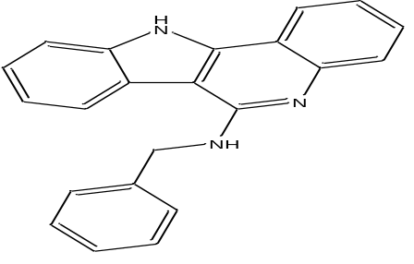 | 0.77 | -7.964
16 |  | 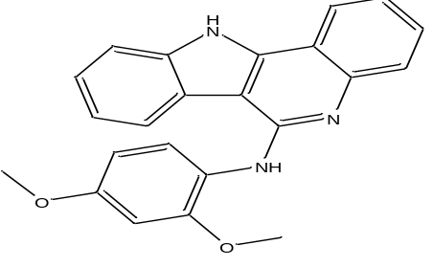 | 7.28 | -6.686
17 |  | 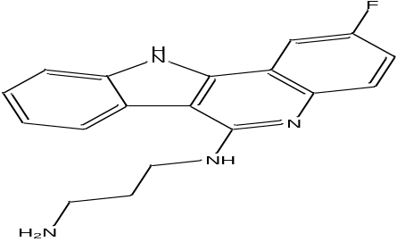 | 0.59 | -8.547
18 |  | 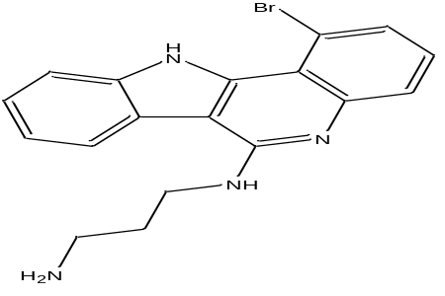 | 0.6 | -7.623
19 |  | 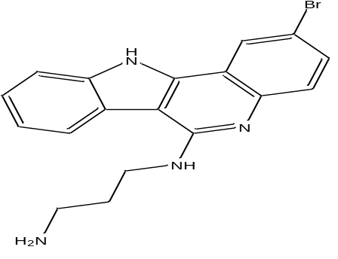 | 0.65 | -8.471
20 |  | 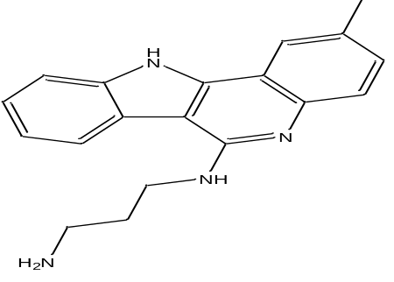 | 0.14 | -8.598
21 |  | 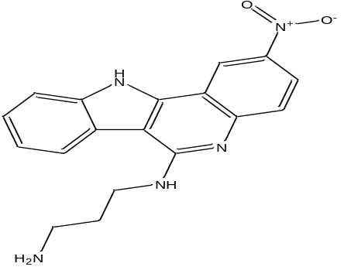 | 0.15 | -8.3
22 |  | 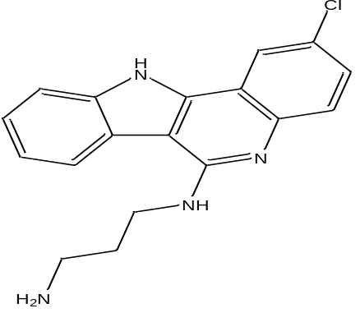 | 0.56 | -8.655
23 |  | 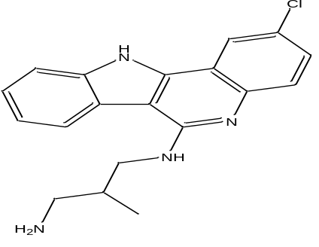 | 0.62 | -8.371
24 |  | 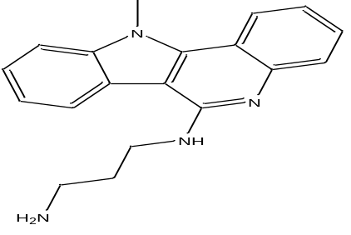 | 0.11 | -7.361
25 |  | 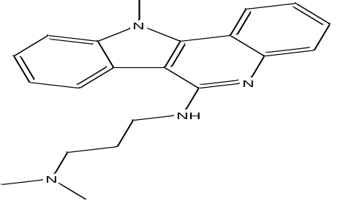 | 0.14 | -7.057
26 |  | 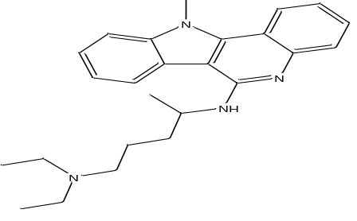 | 0.07 | -6.404
27 |  | 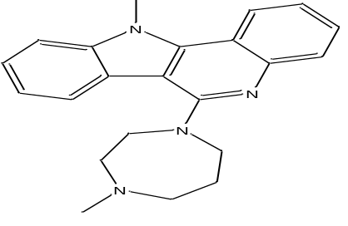 | 0.96 | -6.447
28 |  | 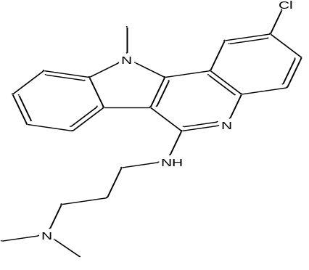 | 0.08 | -6.656
29 |  | 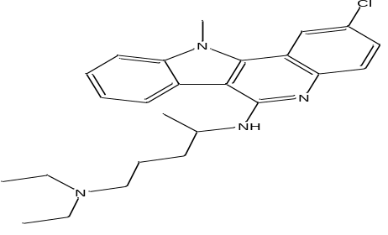 | 0.57 | -6.709
30 |  | 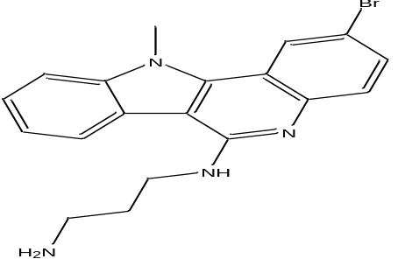 | 0.43 | -7.875
31 |  | 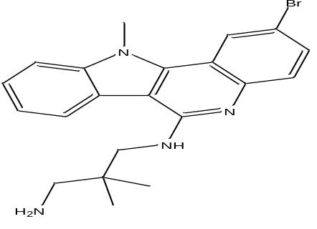 | 0.5 | -7.757
32 |  | 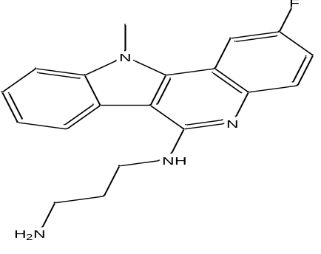 | 0.17 | -7.693
33 |  | 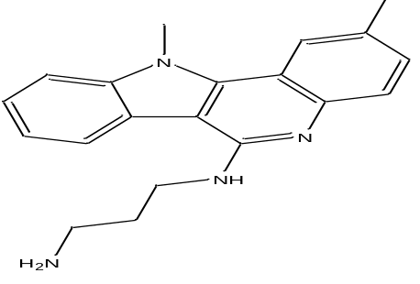 | 0.09 | -7.729
34 |  | 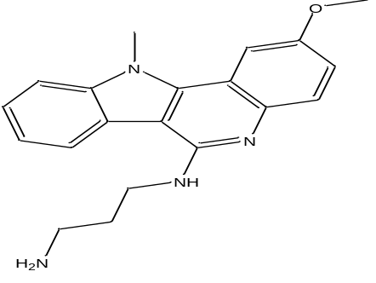 | 0.1 | -8.055
35 | 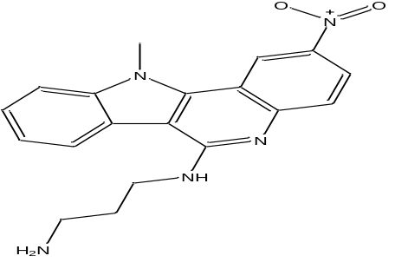 |  | 0.05 | -7.164

Table S2. MLR Y-randomization model parameter
MODEL TYPE | R | R² | Q²(LOO)
Original | 0.912844 | 0.833284 | 0.77985
Random 1 | 0.24041 | 0.057797 | -0.32654
Random 2 | 0.422732 | 0.178702 | -0.13036
Random 3 | 0.175835 | 0.030918 | -0.45018
Random 4 | 0.627812 | 0.394149 | 0.060681
Random 5 | 0.477564 | 0.228068 | -0.18473
Random 6 | 0.382543 | 0.146339 | -0.19469
Random 7 | 0.229374 | 0.052612 | -0.25793
Random 8 | 0.233907 | 0.054713 | -0.23804
Random 9 | 0.599287 | 0.359145 | 0.044604
Random 10 | 0.225268 | 0.050746 | -0.38643
Random Models Parameters
Average R | 0.337468
Average R² | 0.135037
Average Q²(LOO) | -0.2314
cRp² | 0.778348

Table.S3 Drug likeness predictions of the newly designed inhibitors best on Lipinski, veber, Egan and Goose
Compound ID | Lipinnski | Veber | Egan | Ghoose | Muegge
BBN1 | YES | YES | YES | NO | YES
BBN4 | YES | YES | YES | YES | YES
BBN6 | YES | YES | YES | YES | YES
Dabrafenib | NO | NO | NO | NO | YES

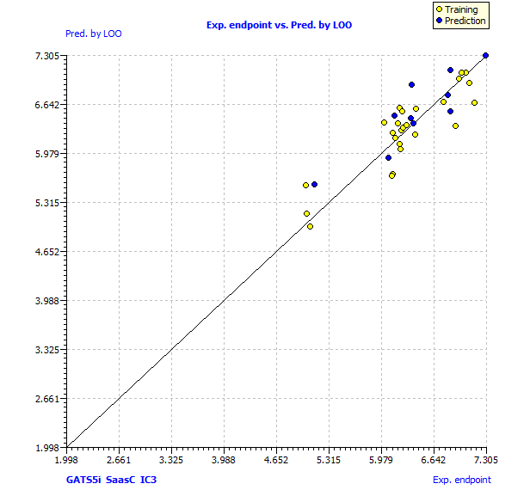
Figure 1. The LOO scatter plot (Experimented vs predicted by the model) for the best model

