Supplementary Information
Homotypic neutralizing responses exceed heterotypic responses to Rotarix in Bangladeshi infants

Supplementary Tables
Supplementary Table S1. Rotavirus antibody positivity and geometric mean titers by time point and secretor phenotype.
Time point | Antibody | Positivity overall n/N (%) | GMT total (95% CI) | GMT nonsecretors N=22 (95% CI) | GMT secretors N=75 (95% CI) | Secretor comparison P
6 weeks pre-dose 1 | IgA | 0/99 (0.0%) | NA | NA | NA | NA
6 weeks pre-dose 1 | IgG | 99/99 (100.0%) | 2,455 (1,940 to 3,106) | 2,257 (1,335 to 3,815) | 2,467 (1,874 to 3,247) | 0.759
6 weeks pre-dose 1 | G1P[8] NAb | 99/99 (100.0%) | 140 (121 to 162) | 117 (87 to 157) | 149 (125 to 177) | 0.157
6 weeks pre-dose 1 | G2P[4] NAb | 99/99 (100.0%) | 305 (256 to 362) | 212 (141 to 320) | 338 (279 to 411) | 0.042
22 weeks post-dose 2 | IgA | 46/99 (46.5%) | 19 (11 to 33) | 11 (4 to 31) | 21 (11 to 43) | 0.304
22 weeks post-dose 2 | IgG | 99/99 (100.0%) | 1,245 (1,028 to 1,507) | 877 (582 to 1,322) | 1,404 (1,129 to 1,746) | 0.044
22 weeks post-dose 2 | G1P[8] NAb | 99/99 (100.0%) | 105 (90 to 123) | 73 (57 to 92) | 118 (98 to 142) | 0.002
22 weeks post-dose 2 | G2P[4] NAb | 99/99 (100.0%) | 140 (121 to 162) | 88 (69 to 112) | 161 (136 to 191) | 9.62e-05

GMTs were calculated after log transformation. Secretor comparisons used Welch t-tests on log titers among infants with known secretor phenotype. IgA GMT at baseline was not summarized because all infants were IgA-seronegative by eligibility.
Supplementary Table S2. Sensitivity endpoint no more than one-dilution decline defined as fold-change ≥0.5.
Group | Rotavirus IgG | G1P[8] NAb | G2P[4] NAb | G1 minus G2 paired risk difference pp (95% CI) | G1/G2 paired RR (95% CI) | Exact McNemar P
Overall | 57/99 (57.6%) | 69/99 (69.7%) | 55/99 (55.6%) | 14.1 (2.9 to 25.4) | 1.25 (1.05 to 1.52) | 0.024
IgA nonresponders | 17/53 (32.1%) | 25/53 (47.2%) | 21/53 (39.6%) | 7.5 (-9.8 to 24.9) | 1.19 (0.79 to 1.82) | 0.523
IgA responders | 40/46 (87.0%) | 44/46 (95.7%) | 34/46 (73.9%) | 21.7 (8.2 to 35.2) | 1.29 (1.10 to 1.57) | 0.006

Supplementary Table S3. Stringent sensitivity endpoint four-fold rise defined as fold-change ≥4.
Group | G1P[8] NAb | G2P[4] NAb | G1 minus G2 paired risk difference pp (95% CI) | Exact McNemar P
Overall | 12/99 (12.1%) | 4/99 (4.0%) | 8.1 (2.7 to 13.5) | 0.008
IgA nonresponders | 0/53 (0.0%) | 0/53 (0.0%) | 0.0 (0.0 to 0.0) | 1.000
IgA responders | 12/46 (26.1%) | 4/46 (8.7%) | 17.4 (6.3 to 28.5) | 0.008

Supplementary Table S4. Paired G1P[8] and G2P[4] responder classification categories.
Endpoint | Group | Paired category | Count | Denominator | Percent
Maintenance/increase, fold-change ≥1 | Overall | G1+/G2+ | 22 | 99 | 22.2%
Maintenance/increase, fold-change ≥1 | Overall | G1+/G2- | 27 | 99 | 27.3%
Maintenance/increase, fold-change ≥1 | Overall | G1-/G2+ | 6 | 99 | 6.1%
Maintenance/increase, fold-change ≥1 | Overall | G1-/G2- | 44 | 99 | 44.4%
Maintenance/increase, fold-change ≥1 | IgA nonresponders | G1+/G2+ | 3 | 53 | 5.7%
Maintenance/increase, fold-change ≥1 | IgA nonresponders | G1+/G2- | 8 | 53 | 15.1%
Maintenance/increase, fold-change ≥1 | IgA nonresponders | G1-/G2+ | 5 | 53 | 9.4%
Maintenance/increase, fold-change ≥1 | IgA nonresponders | G1-/G2- | 37 | 53 | 69.8%
Maintenance/increase, fold-change ≥1 | IgA responders | G1+/G2+ | 19 | 46 | 41.3%
Maintenance/increase, fold-change ≥1 | IgA responders | G1+/G2- | 19 | 46 | 41.3%
Maintenance/increase, fold-change ≥1 | IgA responders | G1-/G2+ | 1 | 46 | 2.2%
Maintenance/increase, fold-change ≥1 | IgA responders | G1-/G2- | 7 | 46 | 15.2%
No more than one-dilution decline, fold-change ≥0.5 | Overall | G1+/G2+ | 45 | 99 | 45.5%
No more than one-dilution decline, fold-change ≥0.5 | Overall | G1+/G2- | 24 | 99 | 24.2%
No more than one-dilution decline, fold-change ≥0.5 | Overall | G1-/G2+ | 10 | 99 | 10.1%
No more than one-dilution decline, fold-change ≥0.5 | Overall | G1-/G2- | 20 | 99 | 20.2%
No more than one-dilution decline, fold-change ≥0.5 | IgA nonresponders | G1+/G2+ | 12 | 53 | 22.6%
No more than one-dilution decline, fold-change ≥0.5 | IgA nonresponders | G1+/G2- | 13 | 53 | 24.5%
No more than one-dilution decline, fold-change ≥0.5 | IgA nonresponders | G1-/G2+ | 9 | 53 | 17.0%
No more than one-dilution decline, fold-change ≥0.5 | IgA nonresponders | G1-/G2- | 19 | 53 | 35.8%
No more than one-dilution decline, fold-change ≥0.5 | IgA responders | G1+/G2+ | 33 | 46 | 71.7%
No more than one-dilution decline, fold-change ≥0.5 | IgA responders | G1+/G2- | 11 | 46 | 23.9%
No more than one-dilution decline, fold-change ≥0.5 | IgA responders | G1-/G2+ | 1 | 46 | 2.2%
No more than one-dilution decline, fold-change ≥0.5 | IgA responders | G1-/G2- | 1 | 46 | 2.2%
Four-fold rise, fold-change ≥4 | Overall | G1+/G2+ | 4 | 99 | 4.0%
Four-fold rise, fold-change ≥4 | Overall | G1+/G2- | 8 | 99 | 8.1%
Four-fold rise, fold-change ≥4 | Overall | G1-/G2+ | 0 | 99 | 0.0%
Four-fold rise, fold-change ≥4 | Overall | G1-/G2- | 87 | 99 | 87.9%
Four-fold rise, fold-change ≥4 | IgA nonresponders | G1+/G2+ | 0 | 53 | 0.0%
Four-fold rise, fold-change ≥4 | IgA nonresponders | G1+/G2- | 0 | 53 | 0.0%
Four-fold rise, fold-change ≥4 | IgA nonresponders | G1-/G2+ | 0 | 53 | 0.0%
Four-fold rise, fold-change ≥4 | IgA nonresponders | G1-/G2- | 53 | 53 | 100.0%
Four-fold rise, fold-change ≥4 | IgA responders | G1+/G2+ | 4 | 46 | 8.7%
Four-fold rise, fold-change ≥4 | IgA responders | G1+/G2- | 8 | 46 | 17.4%
Four-fold rise, fold-change ≥4 | IgA responders | G1-/G2+ | 0 | 46 | 0.0%
Four-fold rise, fold-change ≥4 | IgA responders | G1-/G2- | 34 | 46 | 73.9%

Supplementary Table S5. Full paired GEE models for strain, IgA response, and strain × IgA-response interaction.
Model | Term | Metric | Estimate (95% CI) | P value
Binary FC≥1 endpoint, additive GEE | Strain: G1P[8] vs G2P[4] among IgA nonresponders | Risk difference or difference-in-differences | 5.7 pp (-7.6 to 18.9) | 0.402
Binary FC≥1 endpoint, additive GEE | IgA responder vs nonresponder for G2P[4] | Risk difference or difference-in-differences | 28.4 pp (11.1 to 45.6) | 0.001
Binary FC≥1 endpoint, additive GEE | Strain × IgA response interaction | Risk difference or difference-in-differences | 33.5 pp (13.2 to 53.7) | 0.001
Binary FC≥1 endpoint, log-link GEE | Strain: G1P[8] vs G2P[4] among IgA nonresponders | Relative risk or ratio of RRs | 1.37 (0.65 to 2.92) | 0.407
Binary FC≥1 endpoint, log-link GEE | IgA responder vs nonresponder for G2P[4] | Relative risk or ratio of RRs | 2.88 (1.40 to 5.91) | 0.004
Binary FC≥1 endpoint, log-link GEE | Strain × IgA response interaction | Relative risk or ratio of RRs | 1.38 (0.61 to 3.13) | 0.438
Continuous log2 fold-change GEE | Strain: G1P[8] vs G2P[4] among IgA nonresponders | Geometric mean ratio or ratio of ratios | 1.23 (0.97 to 1.57) | 0.090
Continuous log2 fold-change GEE | IgA responder vs nonresponder for G2P[4] | Geometric mean ratio or ratio of ratios | 2.24 (1.57 to 3.18) | 7.55e-06
Continuous log2 fold-change GEE | Strain × IgA response interaction | Geometric mean ratio or ratio of ratios | 1.83 (1.24 to 2.71) | 0.002

Supplementary Table S6. Full modified Poisson models for NAb maintenance/increase defined as fold-change ≥1.
Outcome | Predictor | N | Adjusted RR (95% CI) | P value
G1P[8] NAb maintenance/increase | Baseline strain-specific NAb per 2-fold higher | 97 | 0.66 (0.54 to 0.80) | 2.91e-05
G1P[8] NAb maintenance/increase | Baseline rotavirus IgG per 2-fold higher | 97 | 0.90 (0.75 to 1.07) | 0.237
G1P[8] NAb maintenance/increase | IgA seroconversion at 22 weeks | 97 | 2.47 (1.26 to 4.82) | 0.008
G2P[4] NAb maintenance/increase | Baseline strain-specific NAb per 2-fold higher | 97 | 0.48 (0.38 to 0.60) | 8.37e-10
G2P[4] NAb maintenance/increase | Baseline rotavirus IgG per 2-fold higher | 97 | 1.06 (0.81 to 1.39) | 0.662
G2P[4] NAb maintenance/increase | IgA seroconversion at 22 weeks | 97 | 1.32 (0.52 to 3.33) | 0.560
Adjusted models included 97 infants with known secretor phenotype; two infants with indeterminate secretor status were excluded from models including secretor status
Supplementary Table S7. Spearman correlations with approximate 95% confidence intervals.
Panel | Comparison | N | Spearman ρ | 95% CI lower | 95% CI upper | P value
Figure 1a | Baseline IgG vs baseline G1P[8] NAb | 99 | 0.49 | 0.33 | 0.63 | 2.35e-07
Figure 1b | Baseline IgG vs baseline G2P[4] NAb | 99 | 0.54 | 0.39 | 0.67 | 6.98e-09
Supplementary Figure S1a | G1P[8] NAb fold-change vs 22-week IgA titer | 99 | 0.67 | 0.54 | 0.76 | 5.03e-14
Supplementary Figure S1c | G2P[4] NAb fold-change vs 22-week IgA titer | 99 | 0.40 | 0.22 | 0.55 | 3.81e-05
Supplementary Figure S2a | Baseline IgG vs 22-week IgA titer | 99 | -0.66 | -0.76 | -0.53 | 1.68e-13
Supplementary Figure S2b | Baseline G1P[8] NAb vs 22-week IgA titer | 99 | -0.39 | -0.55 | -0.21 | 5.43e-05
Supplementary Figure S2c | Baseline G2P[4] NAb vs 22-week IgA titer | 99 | -0.50 | -0.63 | -0.33 | 1.50e-07

Supplementary Figures
Supplementary Figure S1. Colorblind-safe pie charts of paired G1P[8] and G2P[4] NAb response patterns by IgA seroconversion status. a-b, Primary endpoint, maintenance/increase in antibody titer, defined as fold-change ≥1. c-d, Sensitivity endpoint, no more than one-dilution decline, defined as fold-change ≥0.5. Pie slices show counts, denominators, percentages, and paired response categories.
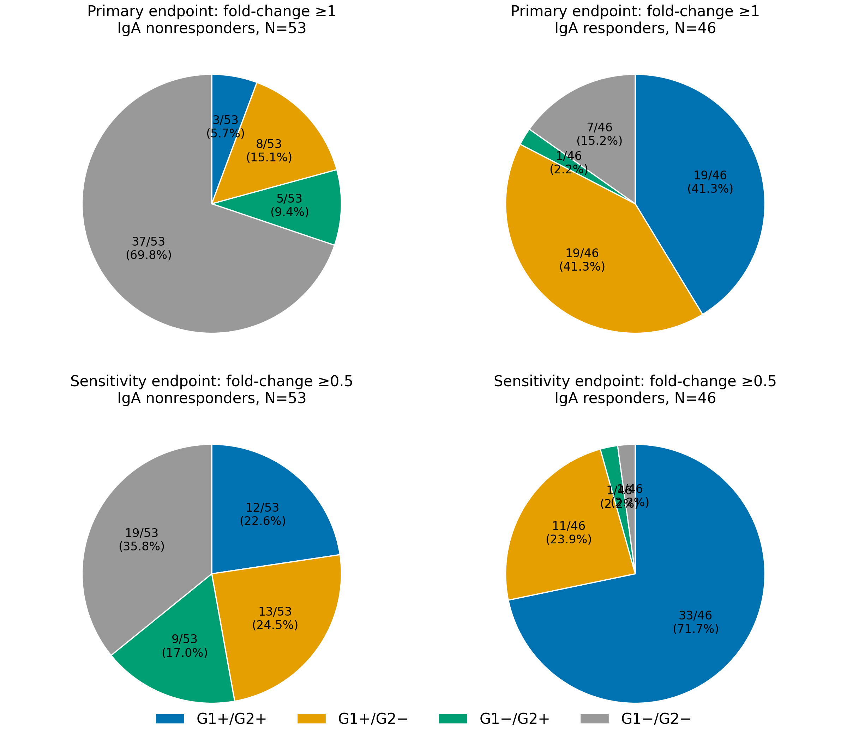

Supplementary Figure S2. Baseline antibody titers and 22-week IgA titer. Panels show baseline IgG, G1P[8] NAb, and G2P[4] NAb titers plotted against 22-week IgA titers. Each marker represents a unique x-y titer pair; marker area and shading are proportional to the number of infants with identical values. Solid trendlines and shaded bands show linear regression and 95% CI for the mean fitted in log2-transformed titer space. Red dotted lines indicate seropositivity cutoffs.
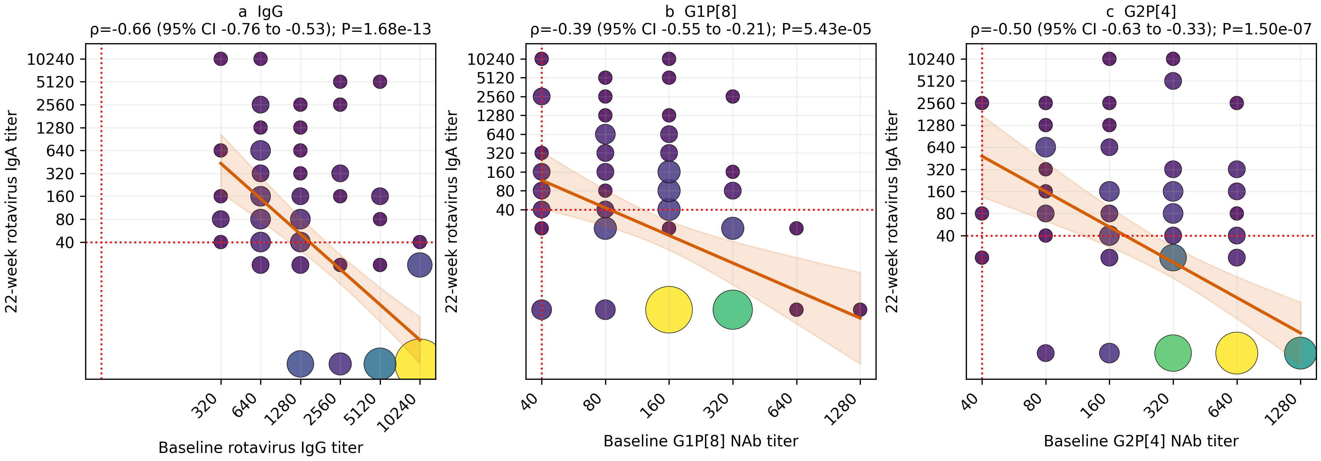

Supplementary Figure S3. Categorized baseline rotavirus IgG and strain-specific NAb titers. Baseline G1P[8] and G2P[4] NAb titers are shown according to baseline rotavirus IgG category. Points show individual infant titers; black markers and error bars show geometric mean titers with 95% CIs. This descriptive categorical analysis complements the continuous baseline IgG–NAb correlations shown in Figure 1. Baseline IgG categories were defined as low IgG, 160–1,280, and high IgG, 2,560–10,240. NAb, neutralizing antibody; GMT, geometric mean titer; CI, confidence interval.
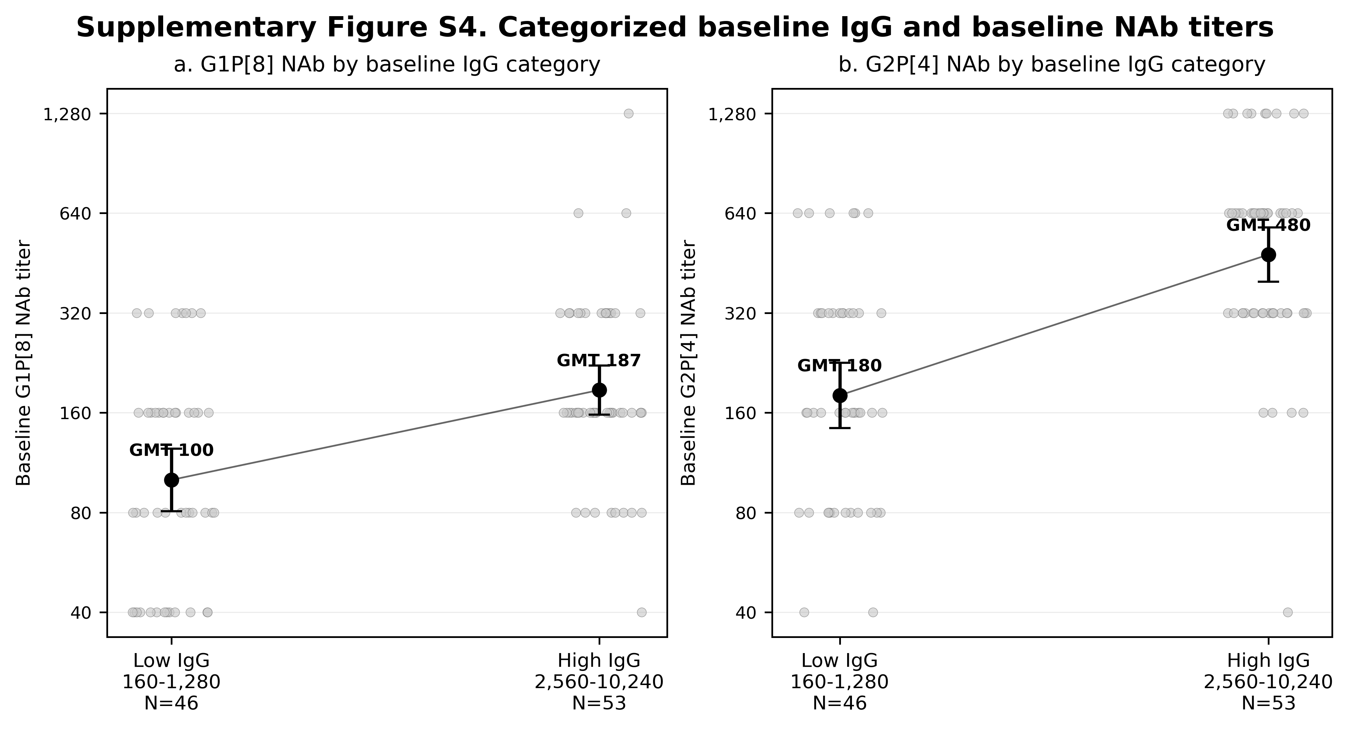

Supplementary Figure S4. CONSORT-style flow diagram for the neutralizing-antibody substudy. The diagram shows the Rotarix-arm source population, availability of paired testable sera, baseline IgA eligibility, selection of the NAb analytic cohort, and inclusion in secretor-adjusted models. The 573 to 549 reduction reflects 24 infants without paired testable serum samples; the 549 to 474 reduction reflects 75 infants who were rotavirus IgA-positive at 6 weeks.
