Supplementary information for

Modulating Growth Conditions and Microenvironment to Boost Antimicrobial Efficacy of Probiotics Against Pathogens

Oksana Gerulis¹, Liis Preem¹, Andrija Djuric⁴, Vincent Hickl^{3, 5, 6}, Marta Putrinš², Tanel Tenson², A. James Mason⁴, Qun Ren³, Karin Kogermann^{1*}

¹ University of Tartu, Institute of Pharmacy, Nooruse 1, 50411, Tartu, Estonia
² University of Tartu, Institute of Technology, Nooruse 1, 50411, Tartu, Estonia
³ Empa, Swiss Federal Laboratories for Materials Science and Technology, Laboratory for Biointerfaces, Lerchenfeldstrasse 5, 9014, St. Gallen, Switzerland
⁴ Institute of Pharmaceutical Science, School of Cancer & Pharmaceutical Sciences, King’s College London, Franklin-Wilkins Building, 150 Stamford Street, London, SE1 9NH, United Kingdom
⁵ Empa, Swiss Federal Laboratories for Materials Science and Technology, Laboratory for Biomimetic Membranes and Textiles, Lerchenfeldstrasse 5, 9014, St. Gallen, Switzerland
⁶ Empa, Swiss Federal Laboratories for Materials Science and Technology, Center for X-ray Analytics, Überlandstrasse 129, 8600, Dübendorf, Switzerland

*Corresponding author: Karin Kogermann, karin.kogermann@ut.ee

Relationship between pH and antimicrobial activity
The diameters of the pH change zones (yellow zones indicating acid production) and inhibition zones (areas lacking pathogen growth) were measured in millimeters using ImageJ program (Table S1).

Table S1 Relationship between pH and antimicrobial activity
Probiotic | Tris buffer concentration in top agar  (mM) | pH of the Tris buffer | Yellow zones | Inhibition zones
L. plantarum Fibro 1 | 100 | 7.5 | 42.10 ± 4.85 | 28.67 ± 0.46
L. plantarum Fibro 1 | 100 | 8.0 | 40.40 ± 4.31 | 23.20 ± 2.50
L. plantarum Fibro 1 | 100 | 8.8 | 40.20 ± 4.24 | 18.40 ± 5.66
L. plantarum Fibro 1 | 200 | 7.5 | 40.70 ± 6.68 | 26.23 ± 4.22
L. plantarum Fibro 1 | 200 | 8.0 | 26.30 ± 5.82 | 18.70 ± 1.10
L. plantarum Fibro 1 | 200 | 8.8 | 18.05 ± 2.47 | 13.45 ± 4.88
L. plantarum Fibro 1 | 300 | 7.5 | 35.97 ± 4.29 | 24.37 ± 5.50
L. plantarum Fibro 1 | 300 | 8.0 | 18.25 ± 6.29 | 14.25 ± 0.91
L. plantarum Fibro 1 | 300 | 8.8 | 18.70 ± 0.50 | 7.90 ± 0.14
L. rhamnosus Fibro 2 | 100 | 7.5 | 50.70 ± 14.86 | 35.77± 10.08
L. rhamnosus Fibro 2 | 100 | 8.0 | 36.70 ± 6.77 | 21.60 ± 0.82
L. rhamnosus Fibro 2 | 100 | 8.8 | 26.20 ± 6.66 | 15.83 ± 1.78
L. rhamnosus Fibro 2 | 200 | 7.5 | 40.10 ± 21.18 | 25.07 ± 8.60
L. rhamnosus Fibro 2 | 200 | 8.0 | 27.40 ± 6.36 | 17.77 ± 2.84
L. rhamnosus Fibro 2 | 200 | 8.8 | 18.13 ± 4.76 | 11.46 ± 1.25
L. rhamnosus Fibro 2 | 300 | 7.5 | 33.10 ± 1.32 | 22.5 ± 1.31
L. rhamnosus Fibro 2 | 300 | 8.0 | 21.70 ± 5.48 | 15.3 ± 1.22
L. rhamnosus Fibro 2 | 300 | 8.8 | 14.05 ± 5.18 | 12.9 ± 0.07

Evaluation of LAB growth in different growth media
To evaluate the optimal growth conditions for lactic acid bacteria (LABs), different growth media were tested and their initial and final pH were recorded (Table S2).
Table S2 Initial pH and final pH of different growth media before and after lactic acid bacteria (LAB) were grown
Bacteria | Media | Initial pH | Final pH
LP | M17 | 6.80 | 6.46
 | M17 pH 5.5 | 5.59 | 6.20
 | MRS | 6.59 | 3.87
LR | M17 | 6.80 | 6.45
 | M17 pH 5.5 | 5.59 | 6.17
 | MRS | 6.59 | 3.83
Key: LP – L. plantarum Fibro 1; LR- L. rhamnosus Fibro 2

Crystal violet (CV) staining
CV method. At the end of biofilm incubation, PDMS disks were processed by gently washing each disk as described above. Then, 900 µL of 0.5% (w/v) CV solution was added to fully cover the disk surface. After 15 min at room temperature, the staining solution was removed, and disks were washed three times with 500 µL of sterile 1× PBS, air-dried on sterile well plate lids, and recorded with images for analysis. To quantify biofilm biomass, the CV dye was eluted in 30% acetic acid followed by measurement of absorbance at 590 nm.
CV results. The CV staining assay results showed that both probiotic strains were able to adhere to the PDMS surface under the tested growth conditions, although their biofilm formation was lower than that of S. aureus. In the Mueller-Hinton medium, the OD₆₀₀ values for L. plantarum and L. rhamnosus were 0.48 and 0.29, respectively, compared with 1.60 for S. aureus. In the DMEM/F12+GLU medium at pH 5.5, the corresponding OD₆₀₀ values were 0.57, 0.73 and 1.75, respectively. These differences were statistically significant (p value of ≤0.0362). In contrast, no statistically significant differences were observed in the CV results between the biofilm inhibition and mature biofilm treatment conditions (Fig. S1).

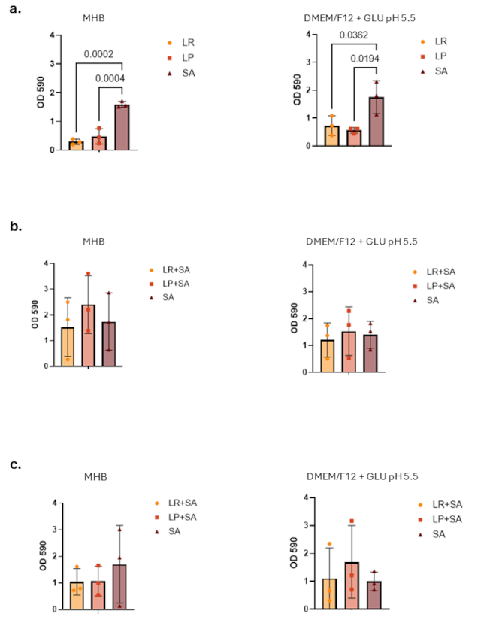
Fig. S1 a. Biofilm formation, b. inhibition of biofilm formation and c. treatment of pathogenic (S. aureus) biofilm by probiotic bacteria in MHB and DMEM/F12 + GLU pH 5.5 media. Key: LP - L. plantarum Fibro 1, LR - L. rhamnosus Fibro 2, SA - S. aureus DSM2569. Data are presented as mean ± SD of three biological replicates (N = 3). P values for statistically significant differences are indicated above the brackets

Impact of the growth media on probiotics’ antimicrobial activity
The effect of growth medium on the antimicrobial activity of probiotic strains was evaluated using the agar overlay assay (according to Hossain et al., 2022, with modifications) (Fig. S2). Three different media were tested as base agar: MRS, M17, and Mueller–Hinton agar (MHA).
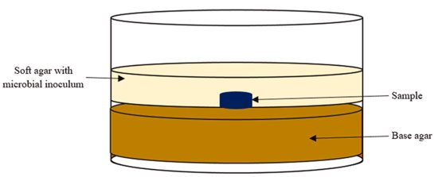
Fig. S2 The scheme of agar overlay assay

MRS agar supported both the growth of LAB and the formation of clear inhibition zones against E. coli DSM 1103. By contrast, probiotics were able to grow on M17 agar, but no inhibition zones were observed, indicating reduced antimicrobial activity under these conditions. No growth of probiotics was detected on MHA (Fig. S2A).
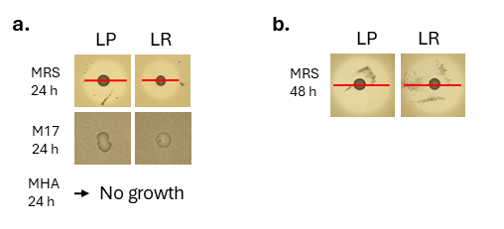
Fig. S3 a. Growth of probiotics and corresponding inhibition zones against E. coli DSM 1103 on different base media (MRS, M17, and MHA) following probiotic incubation for 24 h and b. 48 h prior to agar overlay. Key: MHA – Mueller Hinton agar, LP - L. plantarum Fibro 1, LR - L. rhamnosus Fibro 2, red line – the diameter of the inhibition zone

Incubation time impact on the antimicrobial activity of probiotics
To investigate the effect of incubation time prior to applying the top agar on the antimicrobial activity of LABs, the incubation of LABs on MRS agar base layer was conducted for 24 h and for 48 h at 37°C. The size of the inhibition zone was measured with ImageJ. Longer incubation resulted in larger inhibition zones, likely due to increased production and diffusion of bioactive antimicrobial compounds into the surrounding medium (Fig. S3B).

Antimicrobial activity of viable probiotics against pathogens at different growth conditions
Both probiotics had antimicrobial activity against different wound-associated pathogens (Fig. S4).
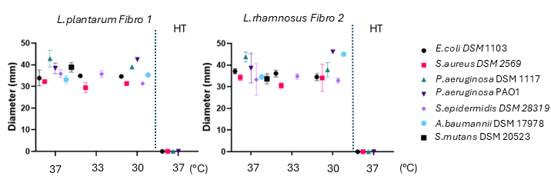
Fig. S4 The antimicrobial activity of probiotics against different wound-associated pathogens at various growth conditions. Data are presented as mean ± SD of the biological replicates (N ≥ 3). Key: HT- heat treated, LP - L. plantarum Fibro 1, LR - L. rhamnosus Fibro 2

L. rhamnosus Fibro 2 had higher overall antimicrobial activity. Both probiotic strains (L. plantarum Fibro 1 and L. rhamnosus Fibro 2) had greatest antimicrobial activity against P. aeruginosa DSM 1117 and P. aeruginosa PAO1. There was no statistical difference observed between various incubation temperatures of LABs. Heat-treated (HT) samples were used as controls and did not show any antimicrobial activity (Figs. S4 and S5).

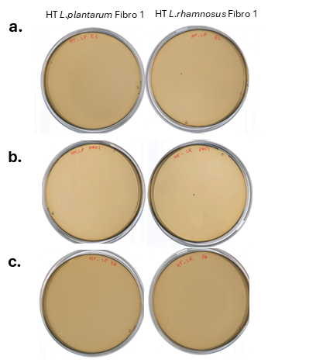
Fig. S5 The agar overlay results of heat-treated (HT) samples of L. plantarum Fibro 1 and L. rhamnosus Fibro 2 against a. E. coli DSM 1103, b. P. aeruginosa PAO1 and c. S. aureus DSM 2569. Key: HT – heat treated, LP - L. plantarum Fibro 1, LR - L. rhamnosus Fibro 2

Impact of prebiotic (inulin) additive in the base agar
The addition of 0.5% [w/v] inulin to the base agar did not improve the antimicrobial activity of probiotics against E. coli DSM 1103 and S. aureus DSM 2569 (Fig. S6).

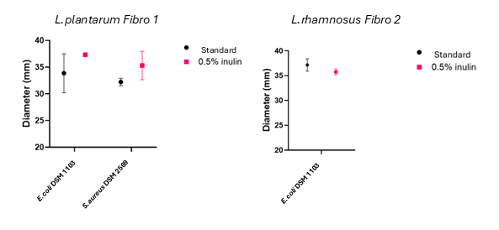
Fig. S6 The addition of the prebiotic – inulin 0.5% to the base agar did not influence the antimicrobial activity of probiotics against E. coli DSM 1103 and S. aureus DSM2569. Data are presented as mean ± SD of biological replicates (N ≥ 3)

Buffering capacity
The buffering capacity of HEPES was evaluated at concentrations of 100 mM and 200 mM. However, neither concentration was sufficient to prevent acidification of the medium. Even at 200 mM, the medium became acidic during the assay (Fig. S7).
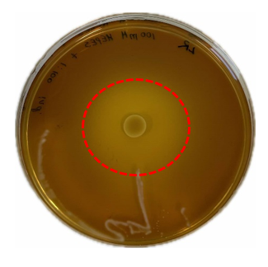
Fig. S7 Buffering capacity of HEPES (200 mM) in the agar overlay assay. MRS agar was used as the base layer, and the Mueller–Hinton broth top layer was supplemented with bromocresol purple at a 1:100 dilution. Key: the red dashed line represents the color change resulting from acid production

To evaluate the buffering capacity of the agar overlay model, Tris buffer at different concentrations (100 mM, 200 mM and 300 mM) with different pH values (7.5, 8.0 and 8.8) was used (Table S1).

Determination and quantification of the produced and consumed metabolites

To investigate the ability of free probiotics (planktonic) and fiber-encapsulated probiotics to produce metabolites and consume substrates, NMR was used. Both probiotic strains produced lactate while consuming glucose and acetate (Table S3). Statistically significant differences were observed in glucose and acetate consumption between the strains. In DMEM/F12 +GLU pH 5.5 L. rhamnosus consumed significantly more glucose than L. plantarum, while no statistically significant difference was detected in their lactate production. In MRS under aerobic conditions, L. plantarum consumed significantly more acetate than L. rhamnosus.

Table S3 Concentration of substrates and metabolites after free probiotics (planktonic) incubation in different growth media. Data are presented as mean ± SD of three biological replicates (N = 3)
Substrates and metabolites concentrations after the experiment in planktonic probiotic samples (mM) | Medium | L. plantarum | L. rhamnosus | p value
Glucose | MRS pH 5.5, AE | 9.78±1.76 | 8.62±1.70 | 0.9405
Glucose | MRS pH 5.5, AN | 4.60±1.66 | 4.73±1.92 | 0.9933
Glucose | DMEM/F12 + GLU pH 5.5 | 223.90±33.57 | 166.88±30.44 | 0.0034
Acetate | MRS pH 5.5, AE | 38.24±8.80 | 50.37±6.28 | 0.0465
Acetate | MRS pH 5.5, AN | 29.60±11.43 | 20.35±4.59 | 0.1165
Acetate | DMEM/F12 + GLU pH 5.5 | 1.00±0.19 | 0.96±0.29 | 0.9938
Lactate | MRS pH 5.5, AE | 181.08±20.20 | 196.64±10.02 | 0.5397
Lactate | MRS pH 5.5, AN | 178.56±61.24 | 186.21±33.13 | 0.7615
Lactate | DMEM/F12 + GLU pH 5.5 | 17.13±2.57 | 15.23±4.12 | 0.9396
Lactic acid * | MRS pH 5.5, AE | 116.16±70.77 | 80.59±16.43 | 0.1831
Lactic acid * | MRS pH 5.5, AN | 83.33±1.13 | 94.83±20.27 | 0.6561
Lactic acid * | DMEM/F12 + GLU pH 5.5 | 3.36±1.30 | 3.84±3.23 | 0.9849
Key: *- lactic acid was measured by spectrophotometric quantification assay, whereas glucose, lactate and acetate were measured by NMR

Statistically significant differences in lactate production were observed between the probiotic strains (Table S4). Under anaerobic conditions in MRS medium, fiber-incorporated L. rhamnosus produced significantly more lactate than L. plantarum. In contrast, glucose consumption did not differ significantly between the strains, whereas acetate consumption differed significantly under the same conditions. These findings indicate strain-specific differences in metabolic activity and suggest differences in carbon utilization pathways despite comparable glucose consumption.

Table S4 Concentration of substrates and metabolites after fiber-incorporated probiotic bacteria incubation in different growth media. Data are presented as mean ± SD of three biological replicates (N = 3)
Substrates and metabolites concentrations after the experiment in the samples with probiotic fiber mat (mM) | Medium | L. plantarum | L. rhamnosus | p value
Glucose | MRS pH 5.5, AE | 69.45 ± 26.51 | 82.87±10.14 | 0.1223
Glucose | MRS pH 5.5, AN | 81.38±2.93 | 52.30±8.33 | 0.0911
Glucose | DMEM/F12 + GLU pH 5.5 | 210.13±5.27 | 207.01±8.09 | 0.6020
Acetate | MRS pH 5.5, AE | 53.32±15.85 | 62.57±7.51 | 0.1844
Acetate | MRS pH 5.5, AN | 54.31±7.32 | 38.24±5.13 | 0.0308
Acetate | DMEM/F12 + GLU pH 5.5 | 2.35±0.48 | 1.65±0.49 | 0.9165
Lactate | MRS pH 5.5, AE | 7.59±3.26 | 11.69±5.83 | 0.1986
Lactate | MRS pH 5.5, AN | 15.34±7.67 | 74.79±21.11 | <0.0001
Lactate | DMEM/F12 + GLU pH 5.5 | 16.10±1.69 | 13.82±1.41 | 0.7763
Lactic acid * | MRS pH 5.5, AE | 32.78±29.53 | 26.90±26.73 | 0.7381
Lactic acid * | MRS pH 5.5, AN | 22.95±20.83 | 53.28±19.65 | 0.1438
Lactic acid * | DMEM/F12 + GLU pH 5.5 | 4.76±1.36 | 3.17±1.72 | 0.9354
Key: *- lactic acid was measured by spectrophotometric quantification assay, whereas glucose, lactate and acetate were measured by NMR

Antimicrobial activity of probiotics against planktonic pathogenic bacteria
To investigate the ability of LAB to inhibit the growth of planktonic pathogenic bacteria, the LAB strains were co-incubated with pathogens in mixed growth medium (MRS:MHB, 1:1) (as it supports the growth of both bacteria – LAB and pathogenic) and in DMEM/F12+GLU pH 5.5. The results demonstrated that the LAB strains strongly inhibited the proliferation of P. aeruginosa PAO1 and S. aureus in MRS:MHB. At the same time, LAB had no antimicrobial activity against S. aureus in DMEM/F12+GLU pH 5.5 medium (Fig. S8). Furthermore, HT probiotics demonstrated negligible or no antimicrobial activity. The pH of the MRS:MHB was decreased from 6.39 to 4.3 in the presence of LABs.
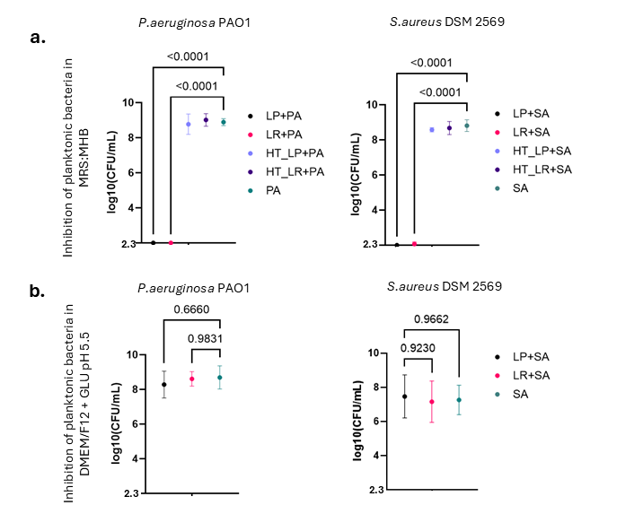
Fig. S8 a. The antimicrobial activity of probiotics against planktonic pathogenic bacteria in mixed media - MRS:MHB at ratio 1:1 and in b. DMEM/F12+GLU pH 5.5 medium at 37°C. Data are presented as mean ± SD of three biological replicates (N = 3). Values below the limit of detection (LOD = 2.3) were assigned a value of 2.3 for statistical analysis. Key: LP - L. plantarum Fibro 1, LR - L. rhamnosus Fibro 2, SA - S. aureus DSM2569

Supplementation of DMEM medium with glucose
In the in vitro biofilm assay was used DMEM F12 medium, that was supplemented with 2% glucose. Assay with pure DMEM F12 medium demonstrated that P.aeruginosa PAO1 degrades the gelatin-glucose (Gel-Glu) matrix. After 24 h of incubation at 37 °C, no Gel-Glu matrix remained, and the filter papers were stained green (Fig. S9).
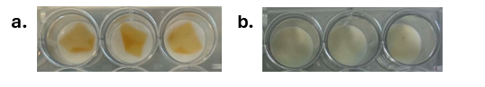
Fig. S9 In vitro biofilm model of P. aeruginosa PAO1: a. immediately after setup and b. after 24 h of incubation at 37 °C

Antibiofilm activity of probiotics in cell culture media
The effect of probiotics on pre-formed biofilm was examined in larger volume (500 µL of DMEM/F12+GLU pH 5.5 medium). This did not show significant antimicrobial activity (Fig. S10).

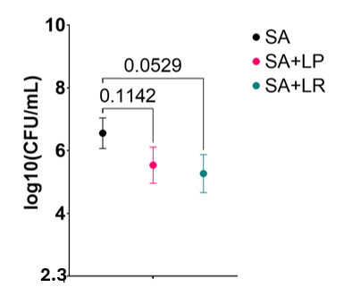
Fig. S10 Antibiofilm activity of probiotics against mature biofilm of S. aureus in larger volume of DMEM/F12+GLU pH 5.5 medium at 37°C. Data are presented as mean ± SD of three biological replicates (N = 3). Key: LP - L. plantarum Fibro 1, LR - L. rhamnosus Fibro 2, SA - S. aureus DSM2569, 2.3 log₁₀ is the LOD

