Supporting information
Azithromycin Salt/Cocrystal with Glycine and Acetamide for Superior Drug Performance: Experimental, Characterization and DFT Study
Noor Ul Islam^{a,b}, Habib Ullah*^{c}, Zakir Zaman Khan^{d}, Muhammad Zahoor*^{e}, Muhammad Naveed Umarª, Saeed Ur Rahman^{c}, …….^{f}*,
ªDepartment of Chemistry, University of Malakand, Chakdara Lower Dir, Khyber Pakhtunkhwa, Pakistan
^{b}Department of Chemistry, Government Degree Collage Lalqilla Dir Lower, Lalqilla 18350, Khyber Pakhtunkhwa, Pakistan
^{c}State Key Laboratory of Silicate Materials for Architectures, Wuhan University of Technology, Wuhan 430070, P.R. China
^{d}College of Resources and Environmental Engineering, Wuhan University of Science and Technology, Wuhan, 430081, China
^{e}Department of Biochemistry, University of Malakand, Chakdara Lower Dir Khyber Pakhtunkhwa, Pakistan

^{f}…………………………………………………………….

*Correspondence authors:
habib@whut.edu.cn (Habib Ullah)

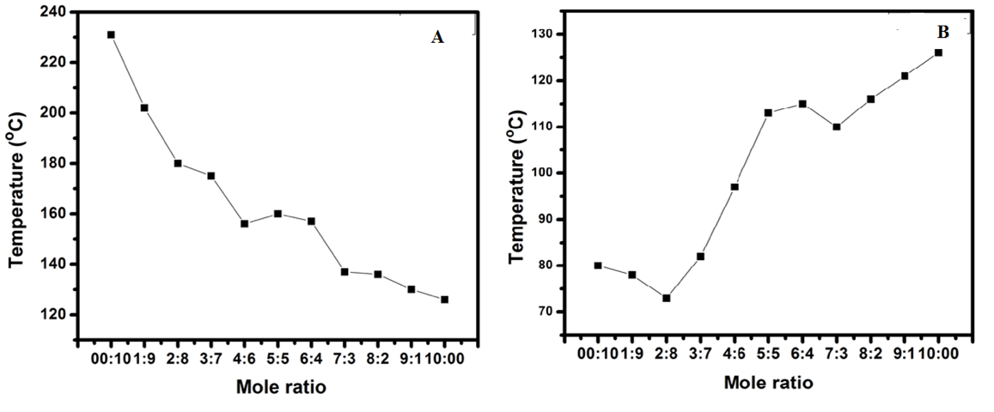

Figure S1: Binary phase diagram of AZT-Gly (A), and AZT-ACT (B) in different molar ratios.

Figure S2: FTIR spectrum of the as-received AZT-DH.

Figure S3: FTIR spectrum of the as-received Gly.

Figure S4: FTIR spectrum of the as-received ACT.

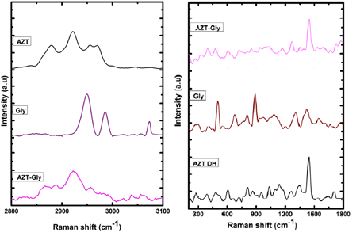
Figure S5: Raman spectra of AZT DH, Gly and AZT-Gly salt.

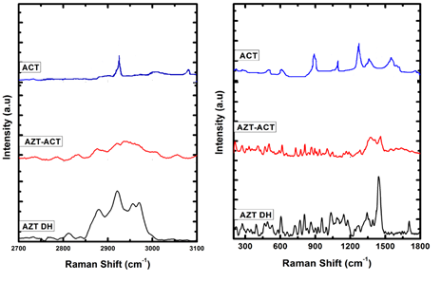

Figure S6: Raman spectra of AZT DH, ACT, and AZT-ACT cocrystal.

Figure S7: ¹³C CP-MAS SSNMR spectra of AZT-DH.

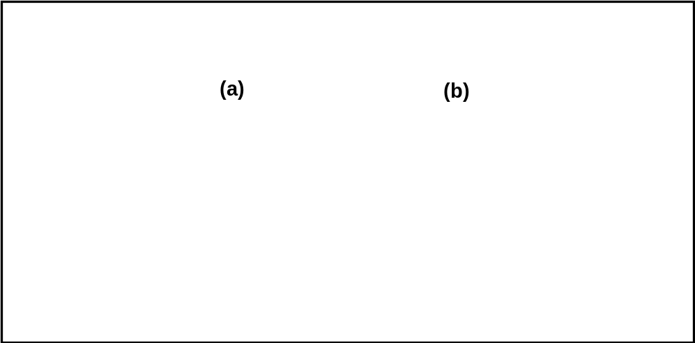

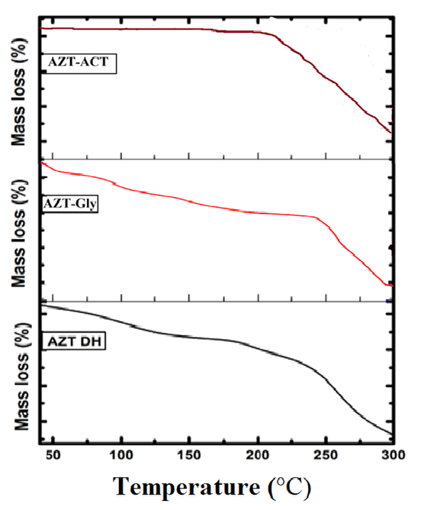
Figure S8: ¹³C CP-MAS SSNMR spectra of ACT and Gly.

Figure S9: TG thermograms of AZT DH, AZT-Gly salt, and AZT-ACT cocrystal.
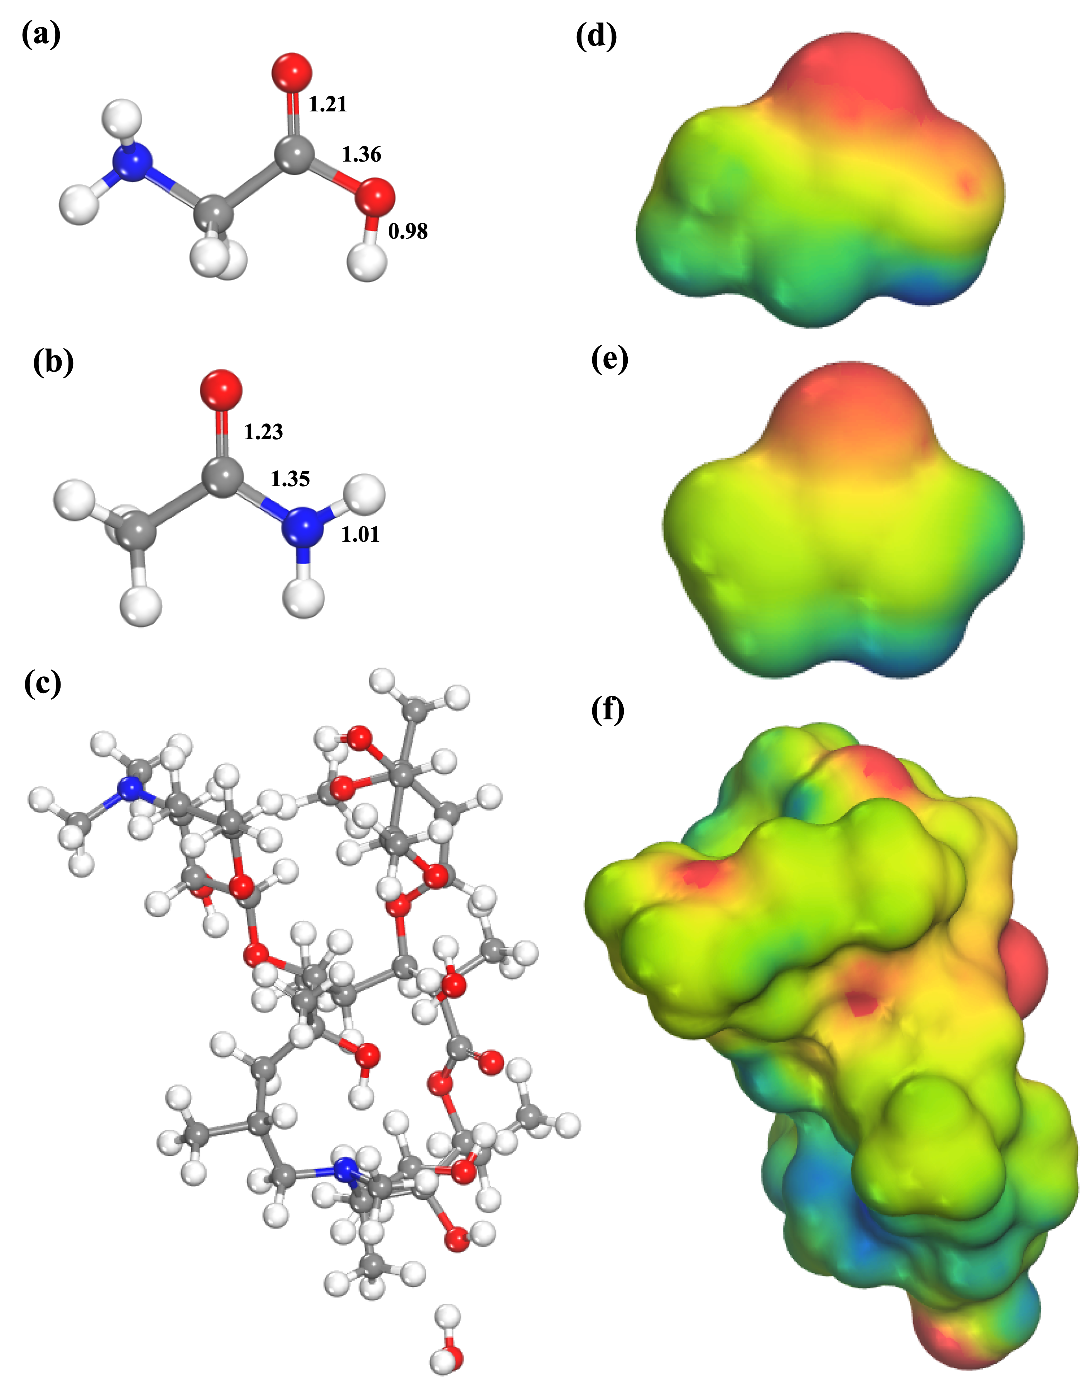
Figure S10. Optimized geometry of Gly (a), ACT (b), AZT (c), and their respective MEP maps (d, e, f)

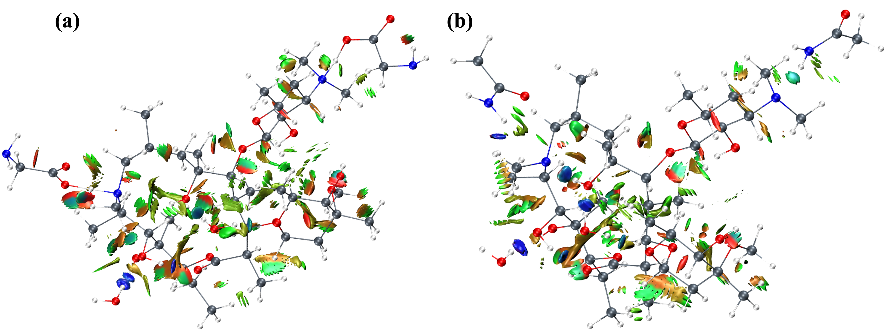

Figure S11. Reduced density gradient isosurfaces of AZT-Gly (a) and AZT-ACT (b) cocrystals.

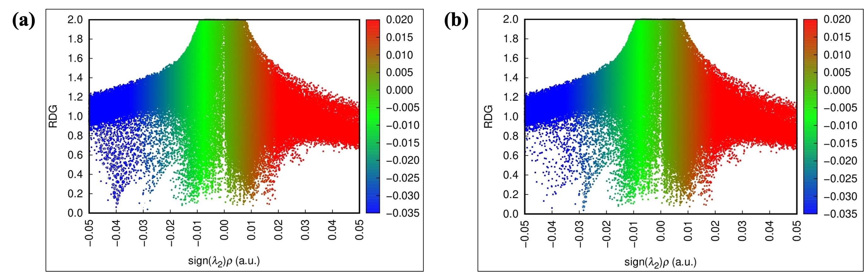

Figure S12. Non-covalent interactions scatter plots of AZT-Gly (a) and AZT-ACT (b) cocrystals.

Table S1: Melting point of raw materials and cocrystal.
Sample | Melting point (°C)
AZT DH | 124-126
Gly | 231-233
ACT | 80-81
AZT-Gly | 153-155
AZT-ACT | 132-134

