Supplementary Material for
Predicting Somatosensory Awareness from Intracranially informed Scalp EEG
by Alessandra Calcagno, Francesca Mannini et al.

ID | Sex | Age | Laterality | EZ | Pharmacology
S1 | M | 37 | R | Right fronto-central | CBZ: 800 mg/die; LCM: 300 mg/die
S2 | F | 31 | R | Not known | BRV: 200 mg/die; PER: 6 mg/die
S3 | F | 25 | R | Right central parietal operculum | LEV: 3000 mg/die; TPM: 300 mg/die
S4 | F | 39 | R | Left temporo-mesial | CBZ: 1000 mg/die; LEV: 2750 mg/die; CLB: 10 mg/die
S5 | F | 23 | R | Right central operculum | LCM: 200 mg/die
S6 | M | 44 | R | Left supramarginal/inferior parietal | LCM: 400 mg/die; TPM: 400 mg/die; BRV: 200 mg/die
S7 | M | 35 | R | Left temporo-mesial | LEV: 3000 mg/die; LCM: 400 mg/die; CBZ: 1400 mg/die

Supplementary Table S1. Demographic and clinical characteristics of the participants included in the simultaneous SEEG–EEG dataset.. EZ: Epileptogenic Zone; CBZ: Carbamazepine; PER: Perampanel; LEV: Levetiracetam; CLB: Clobazam; LCM: Lacosamide; BRV: Brivaracetam; TPM: Topiramate.

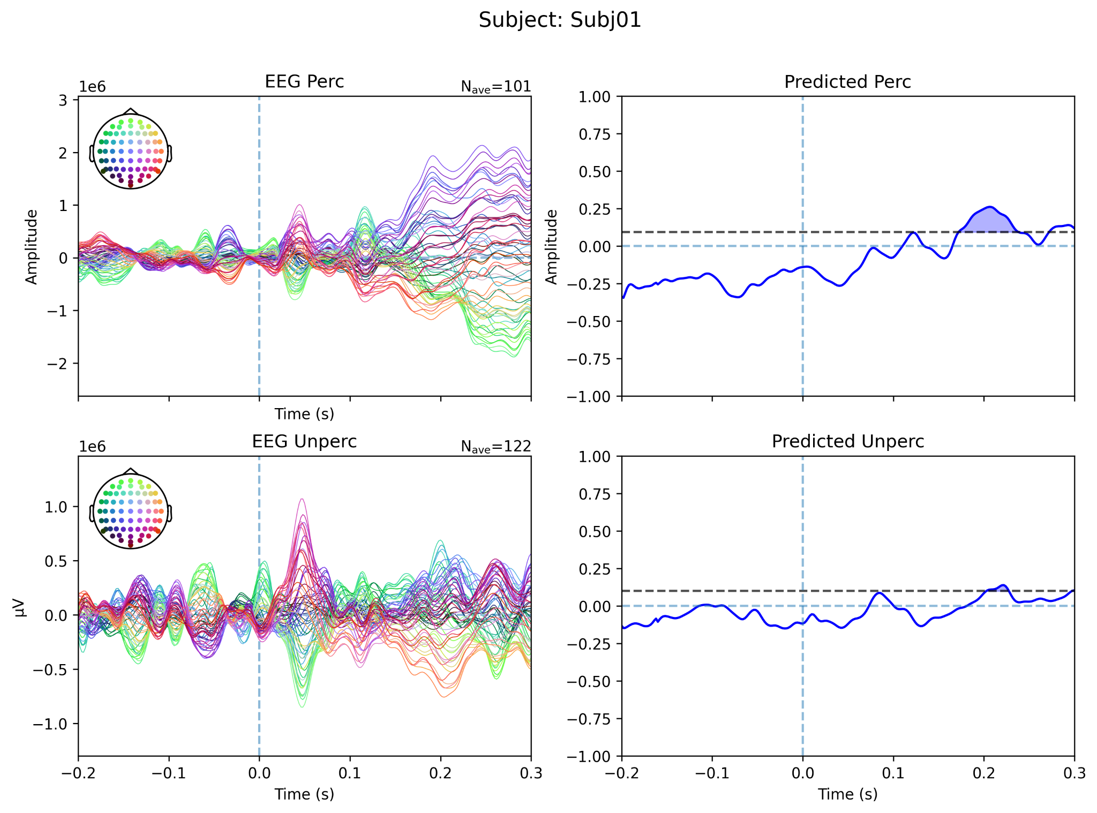 | 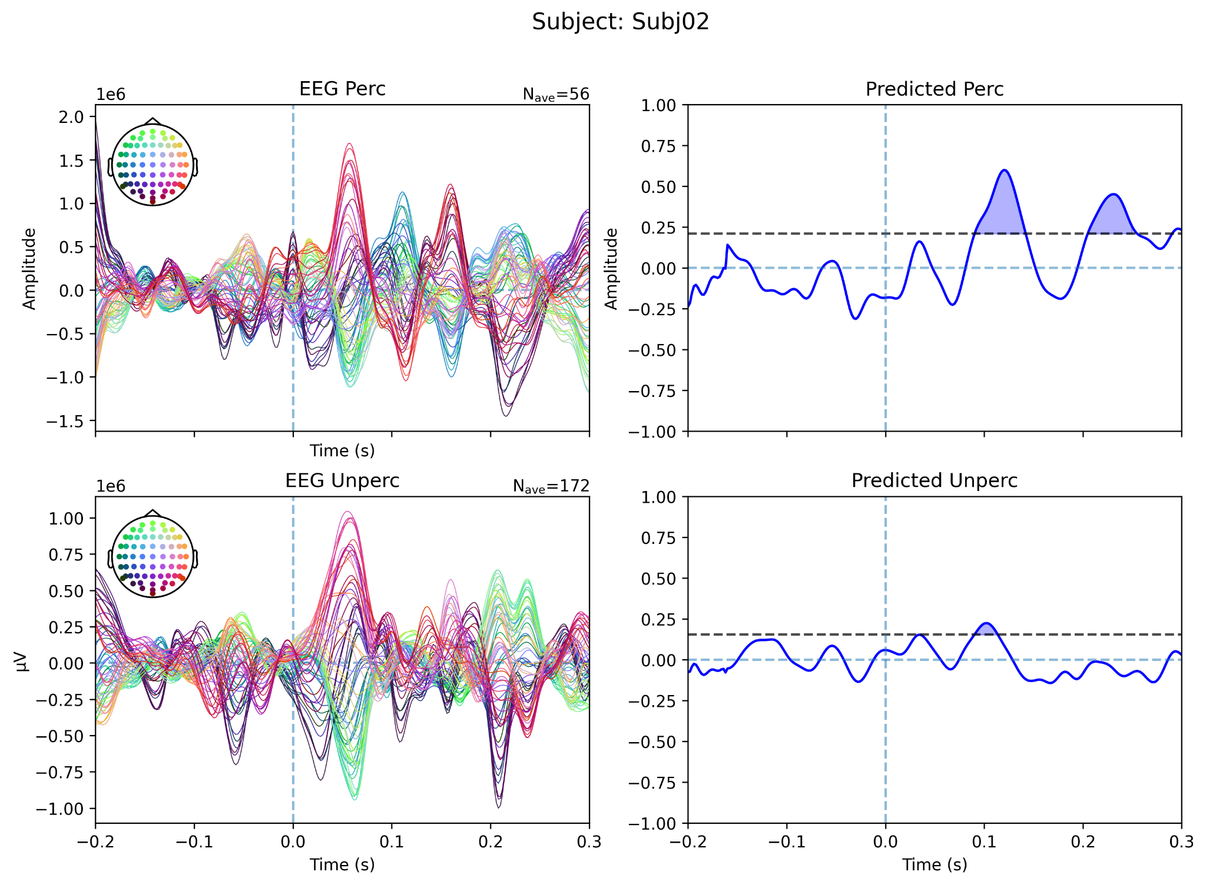
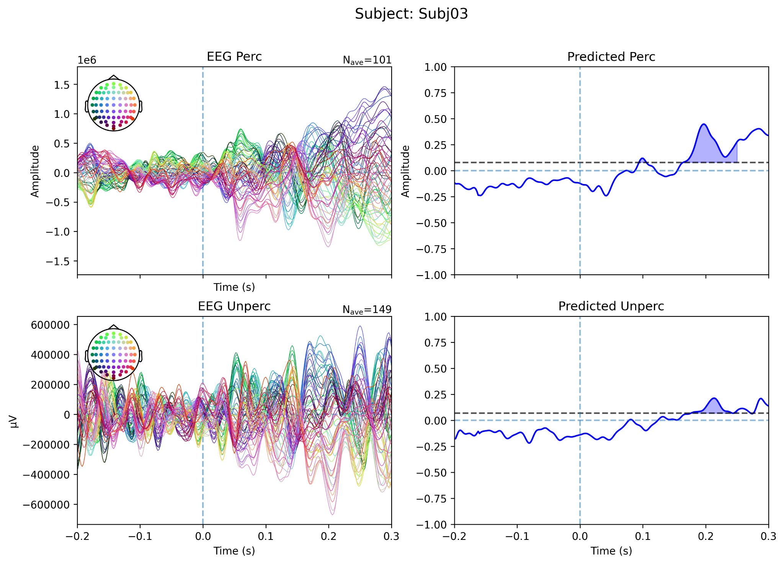 | 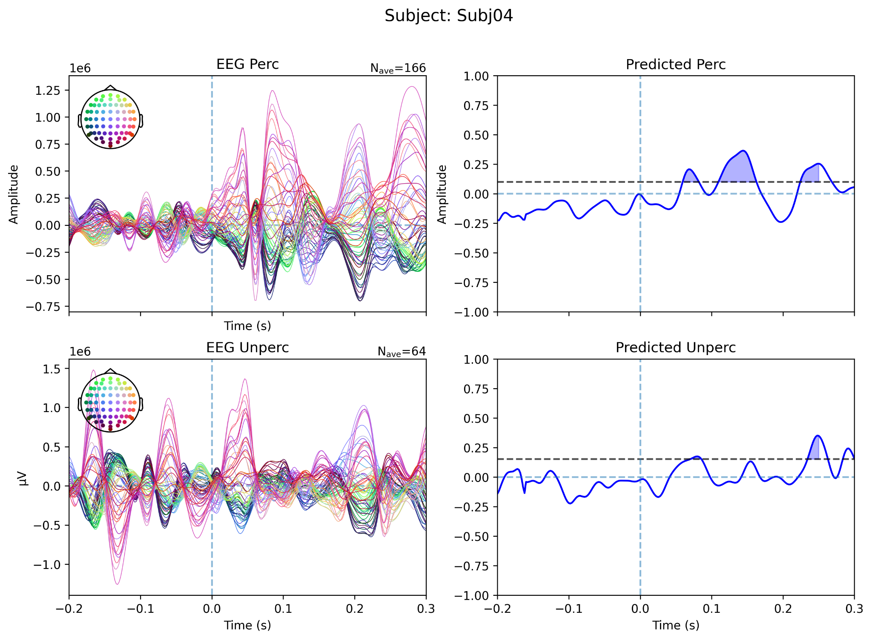
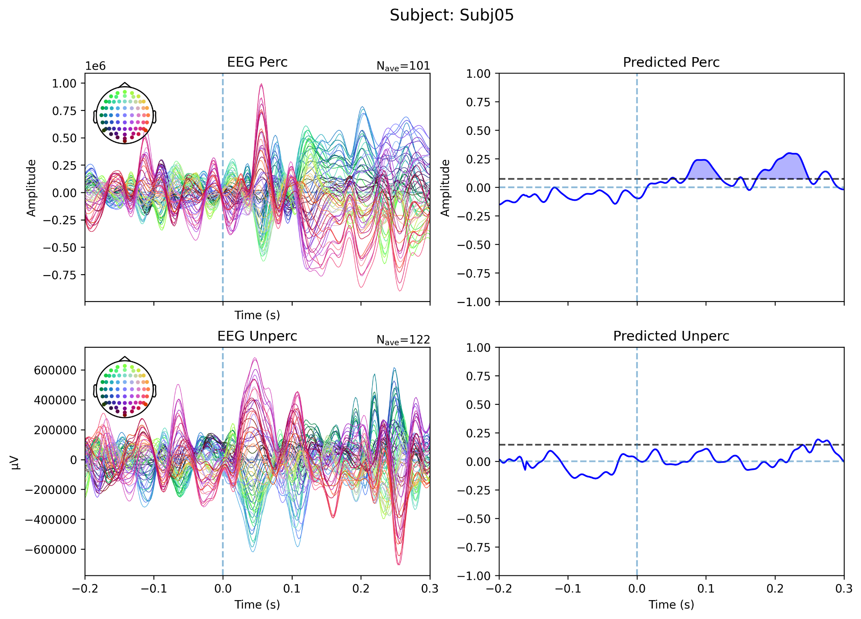 | 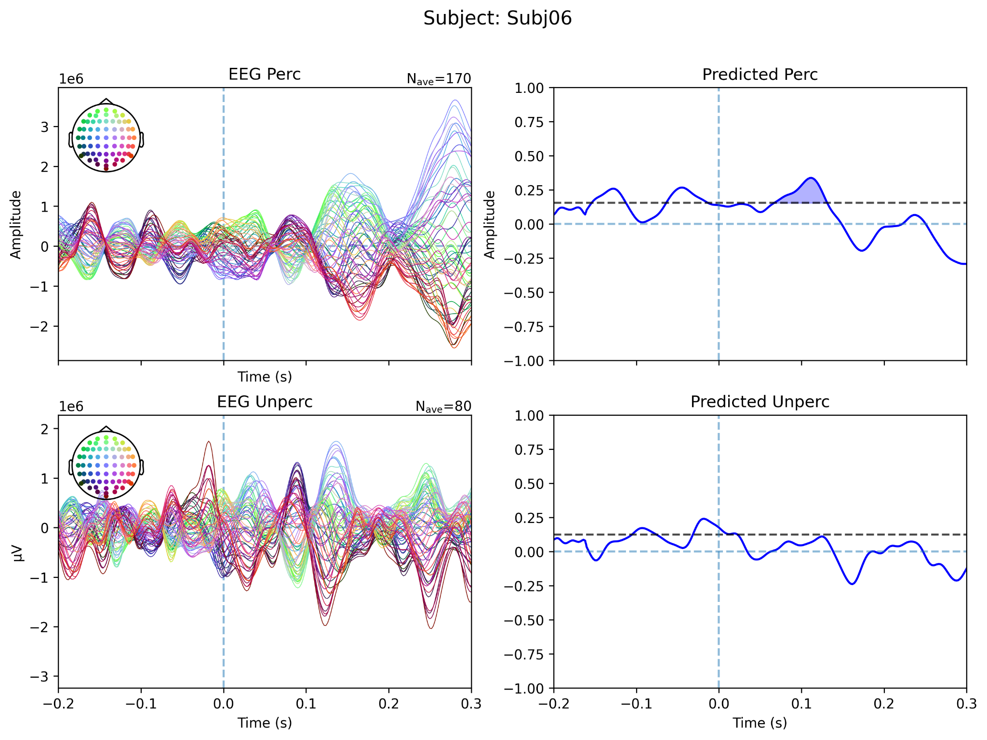
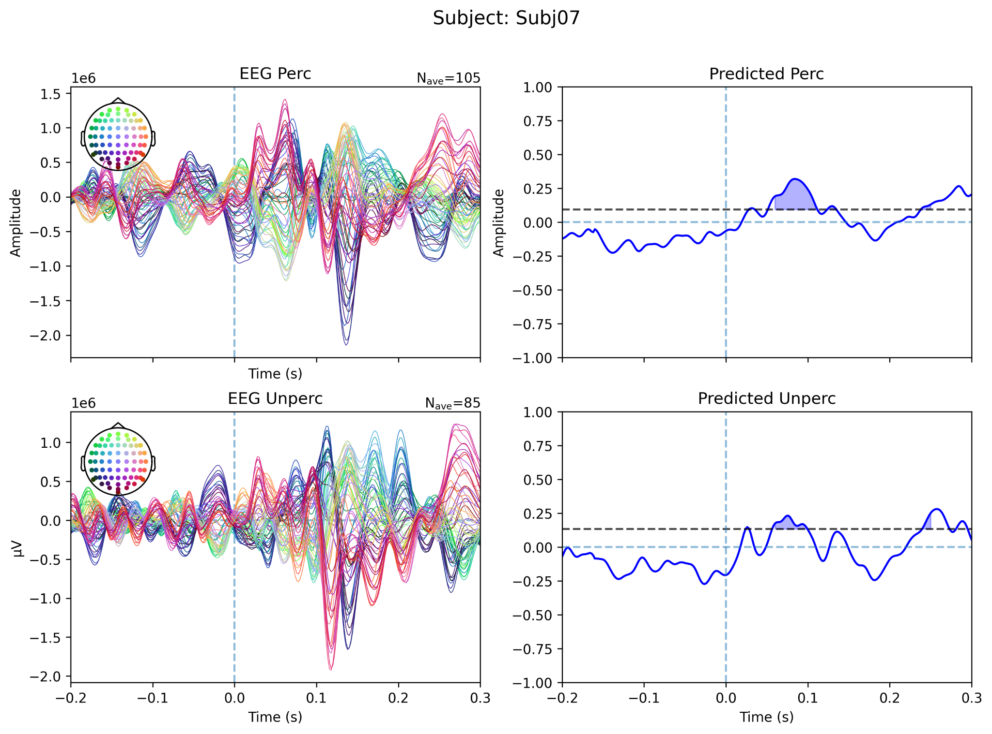 | 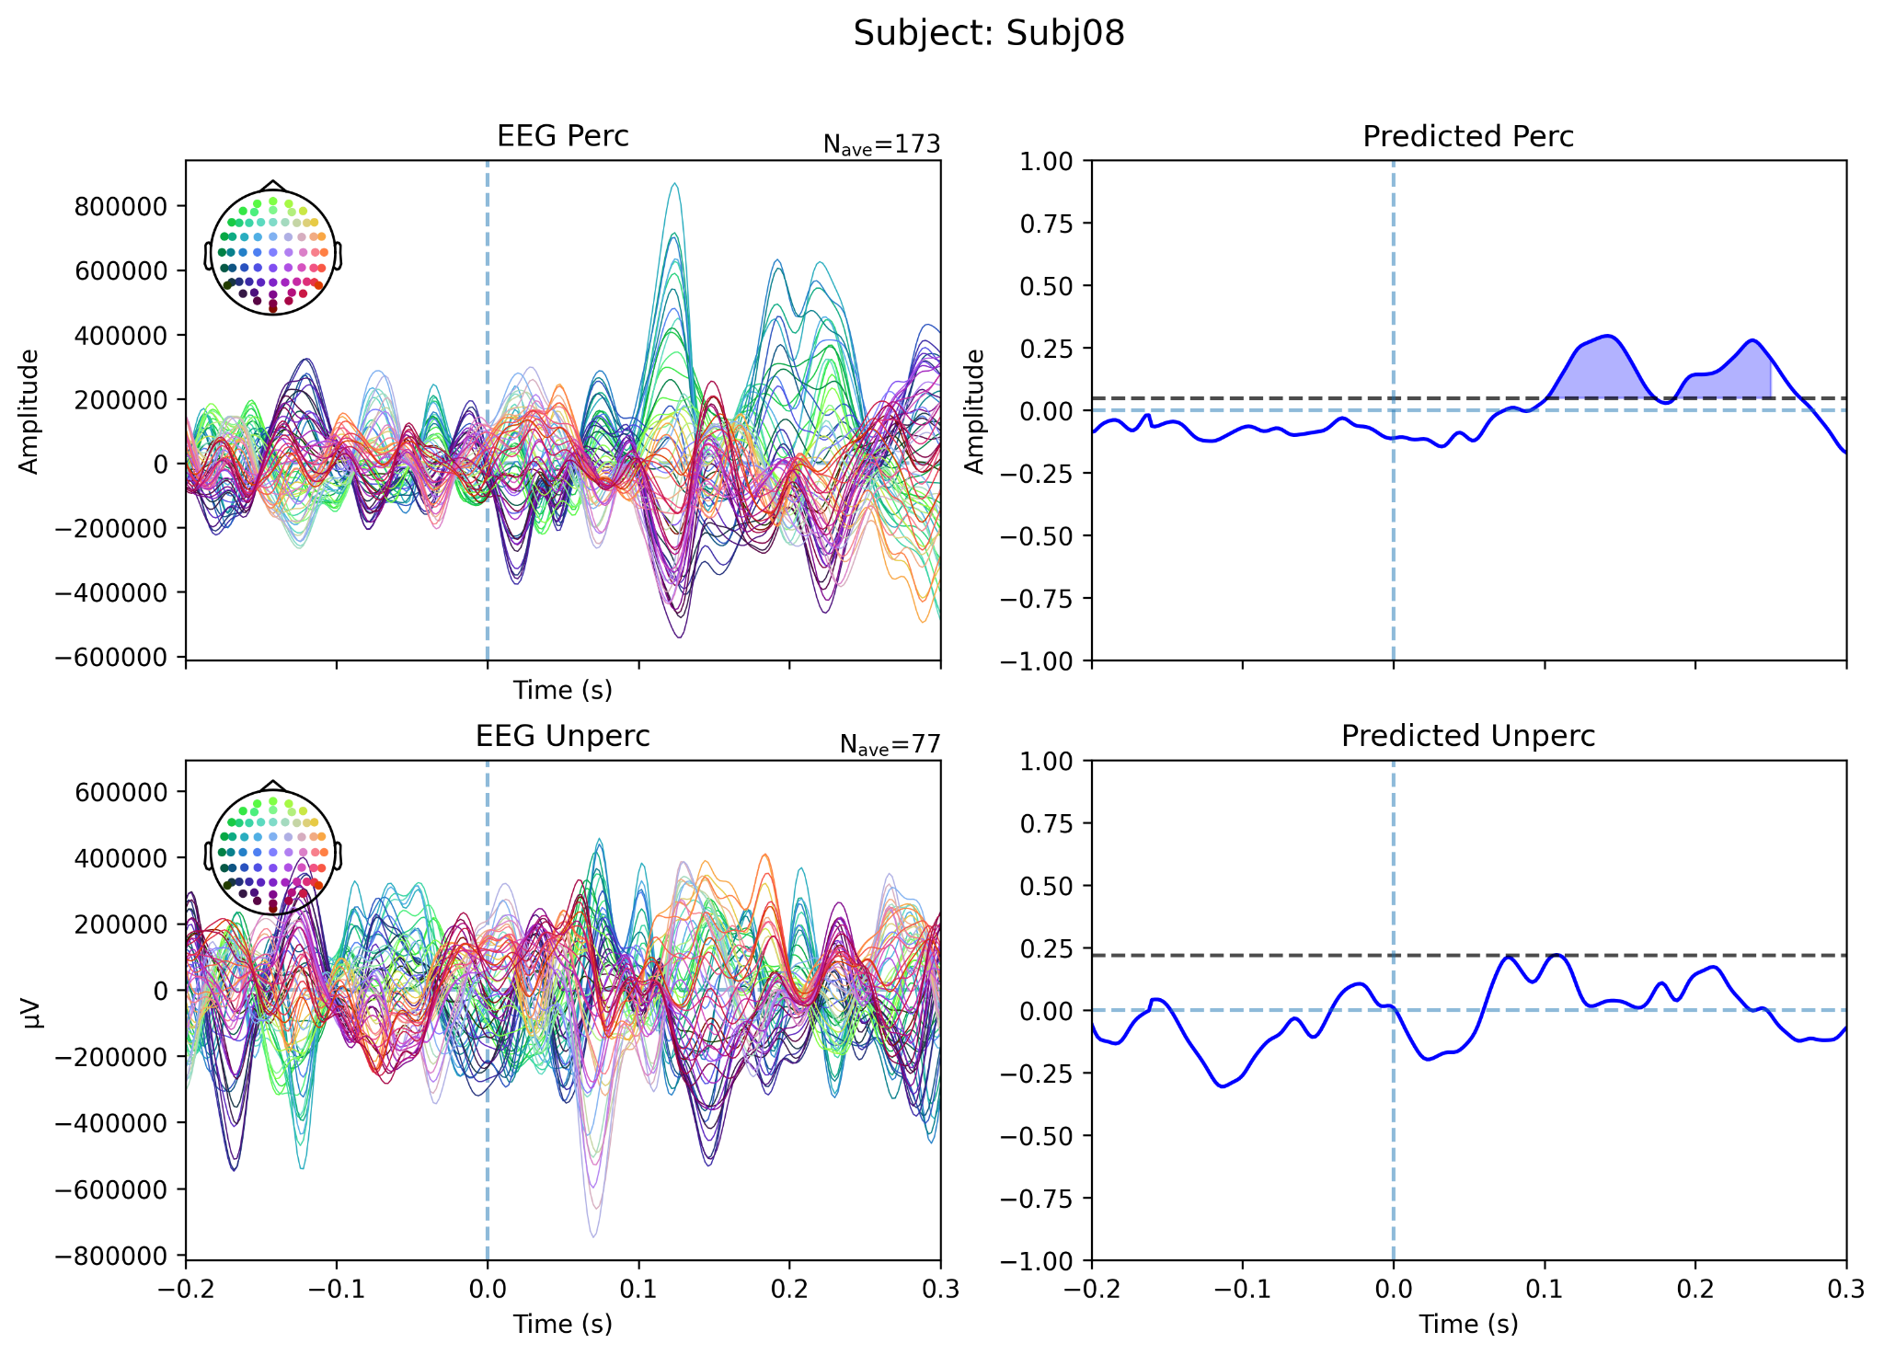
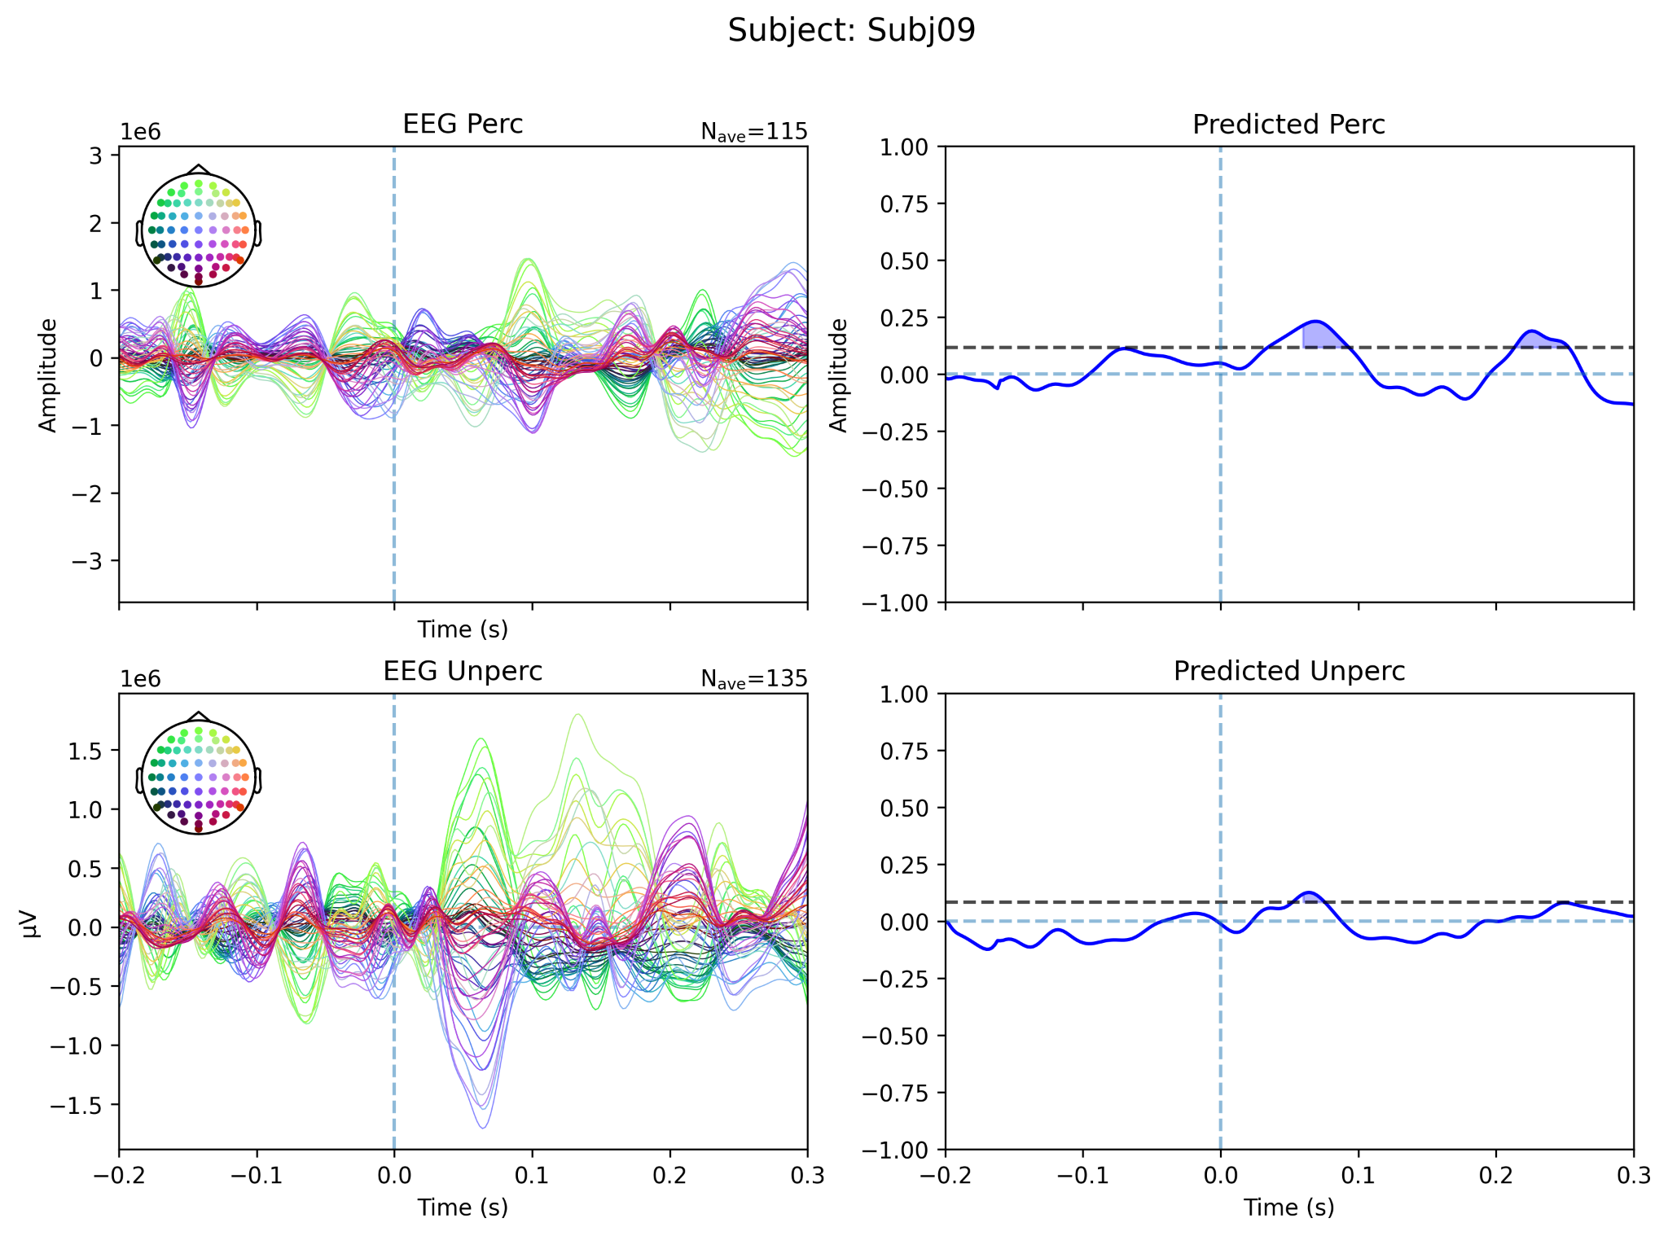 | 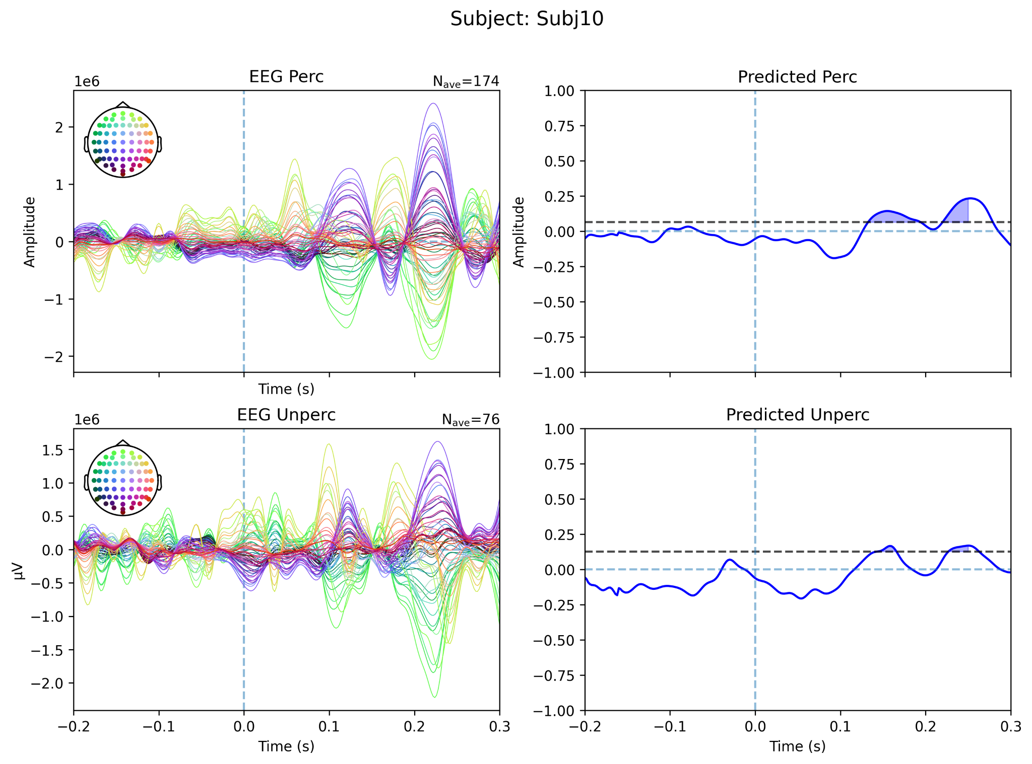
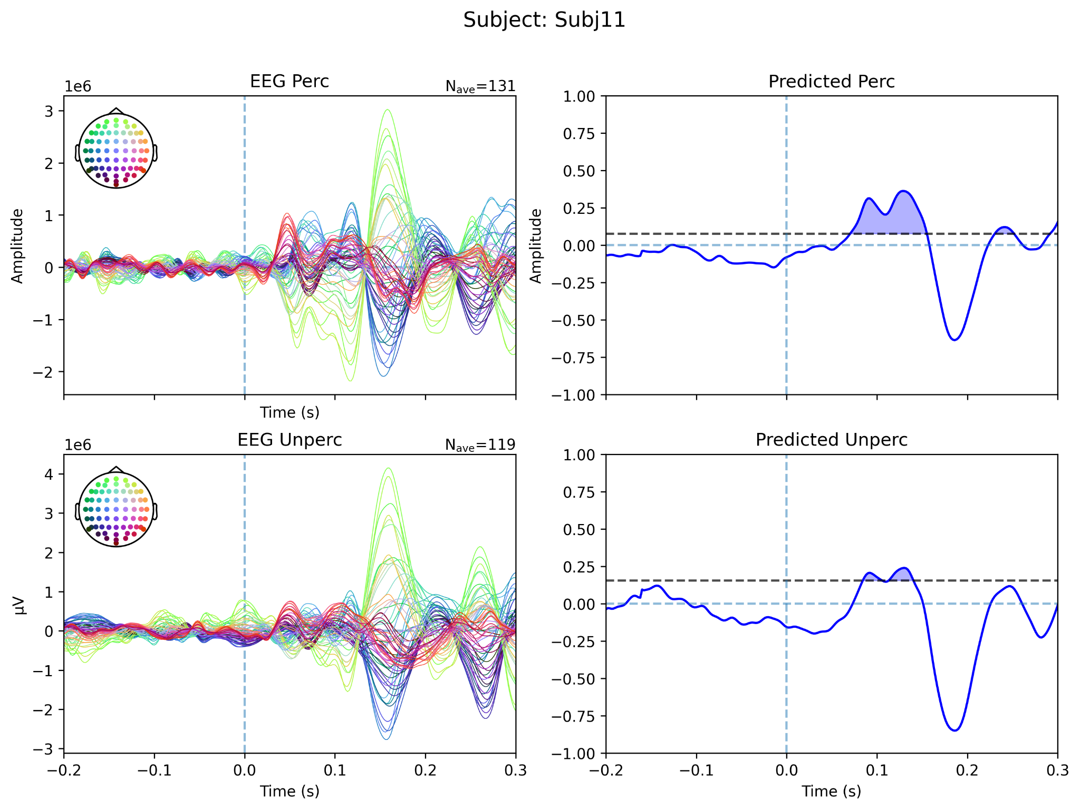 | 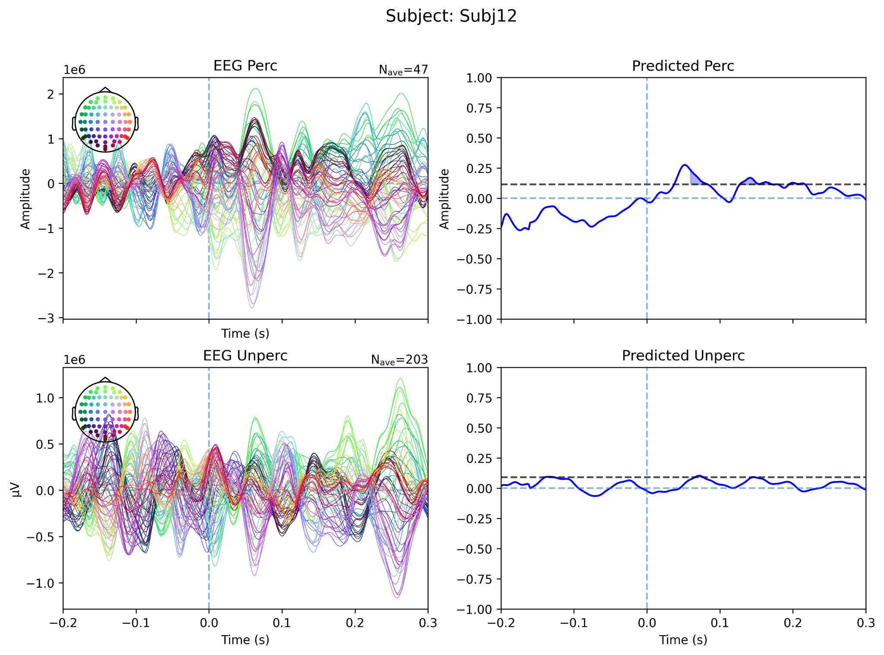
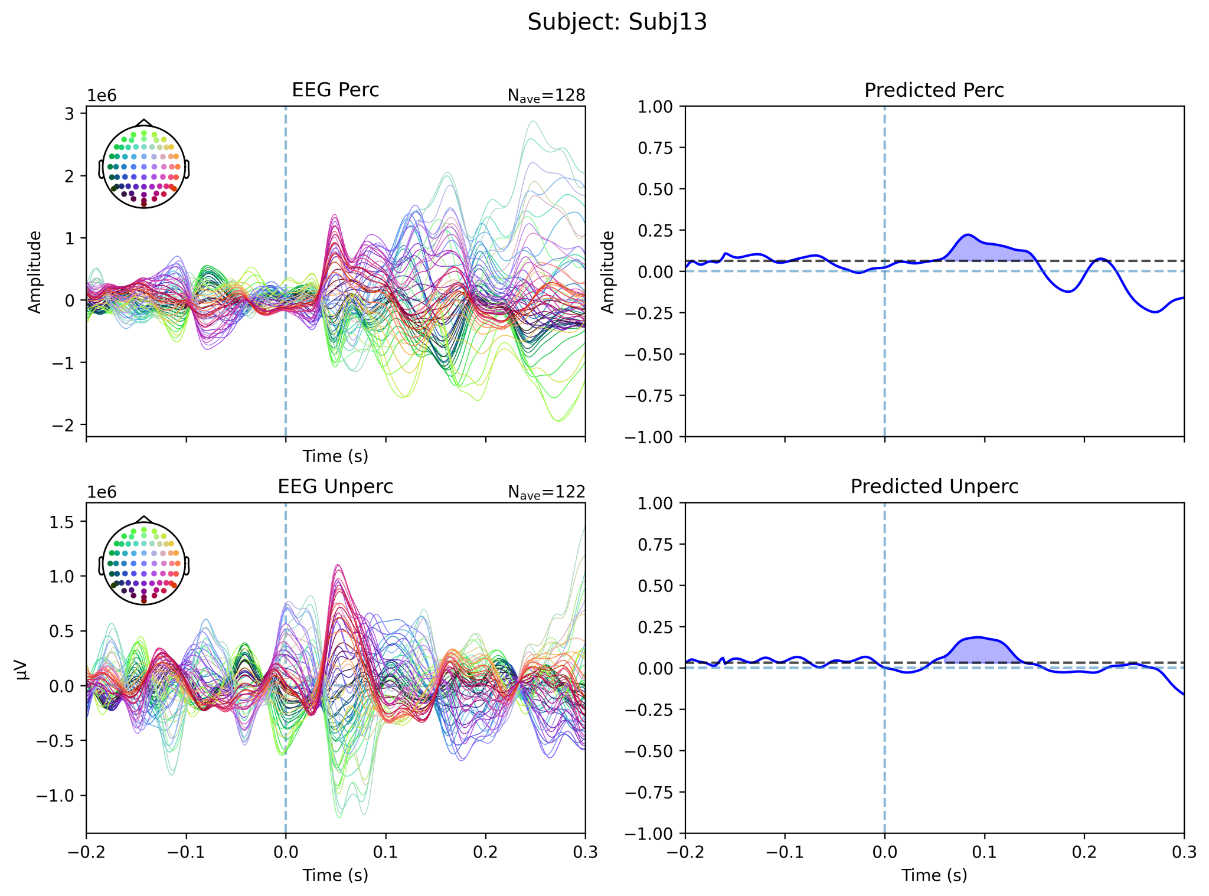 | 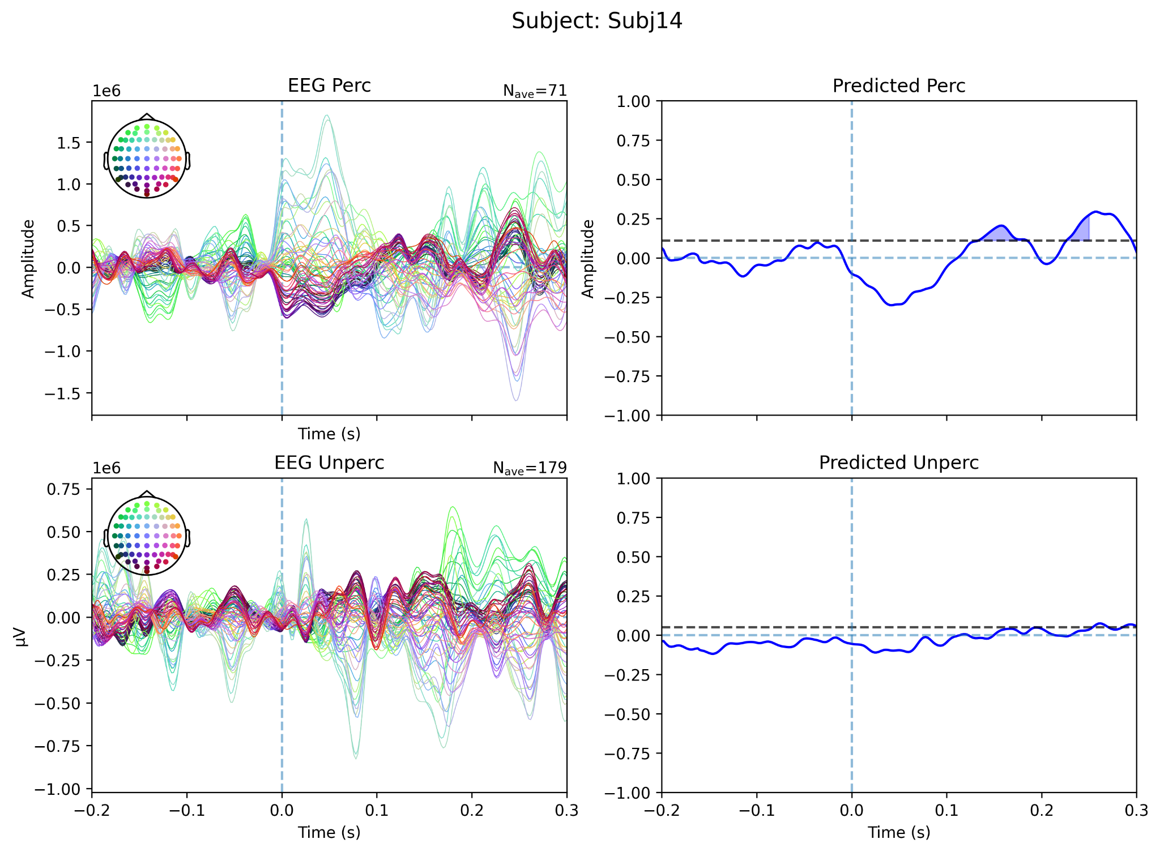
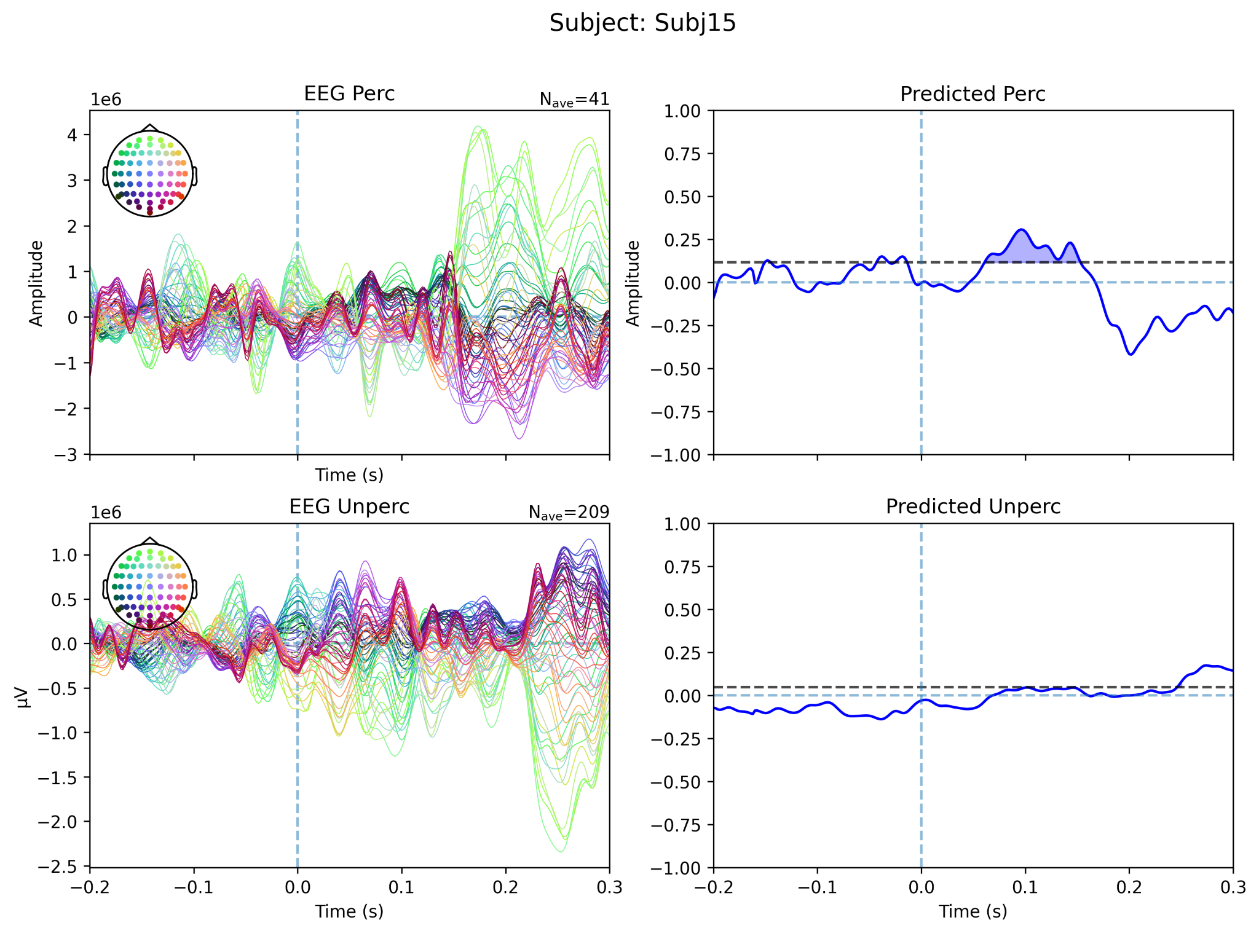 | 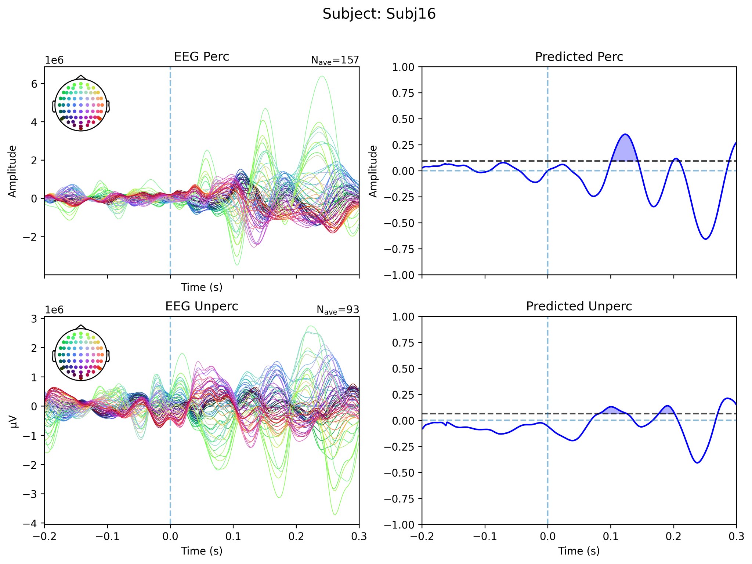

Supplementary Figure S1. Individual N140/SAN waveforms across participants from the somatosensory threshold-level dataset.

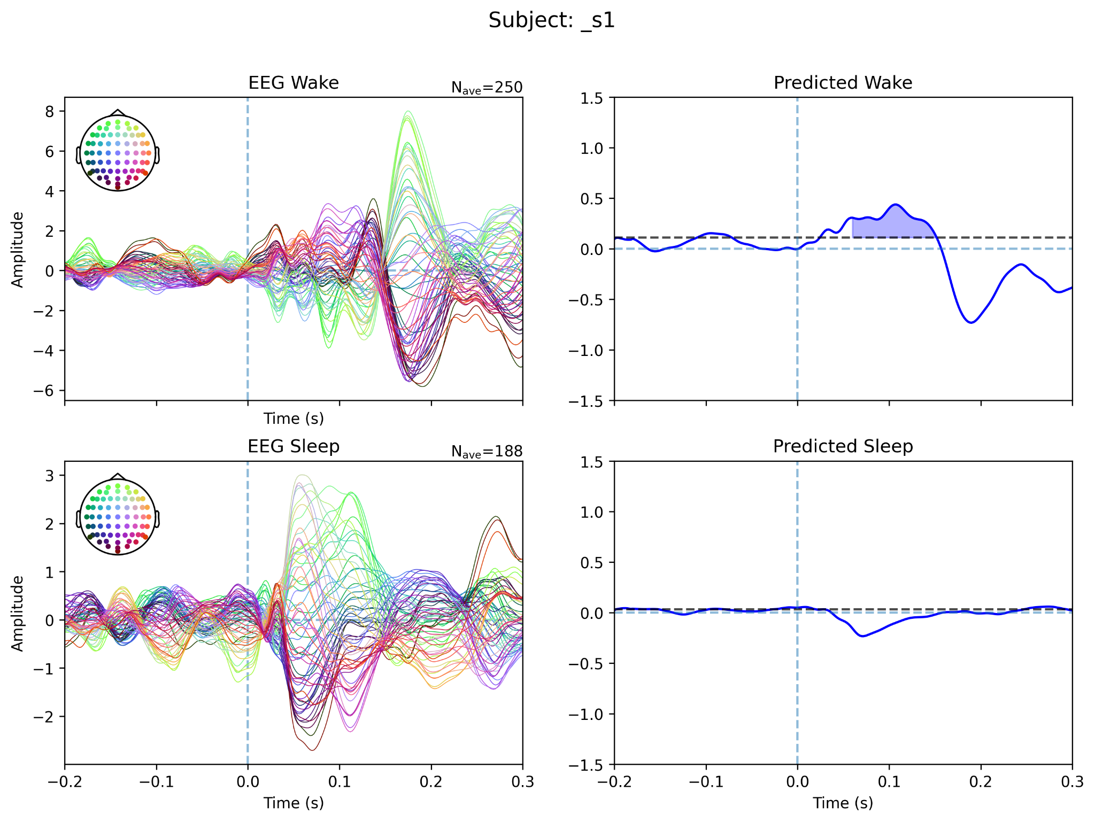 | 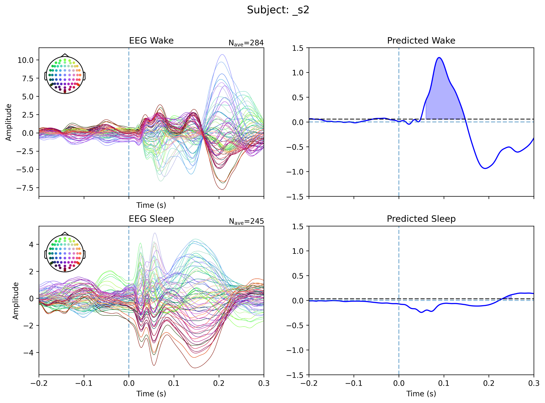
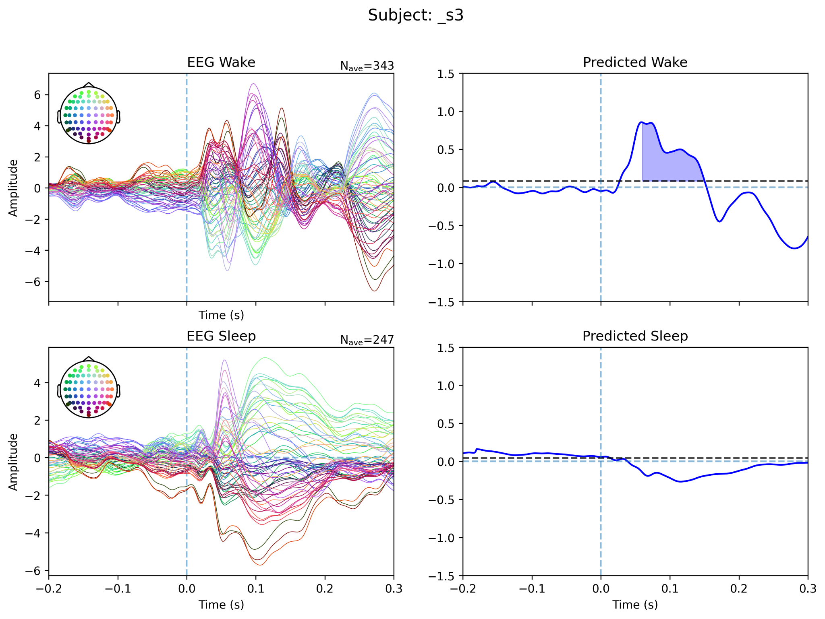 | 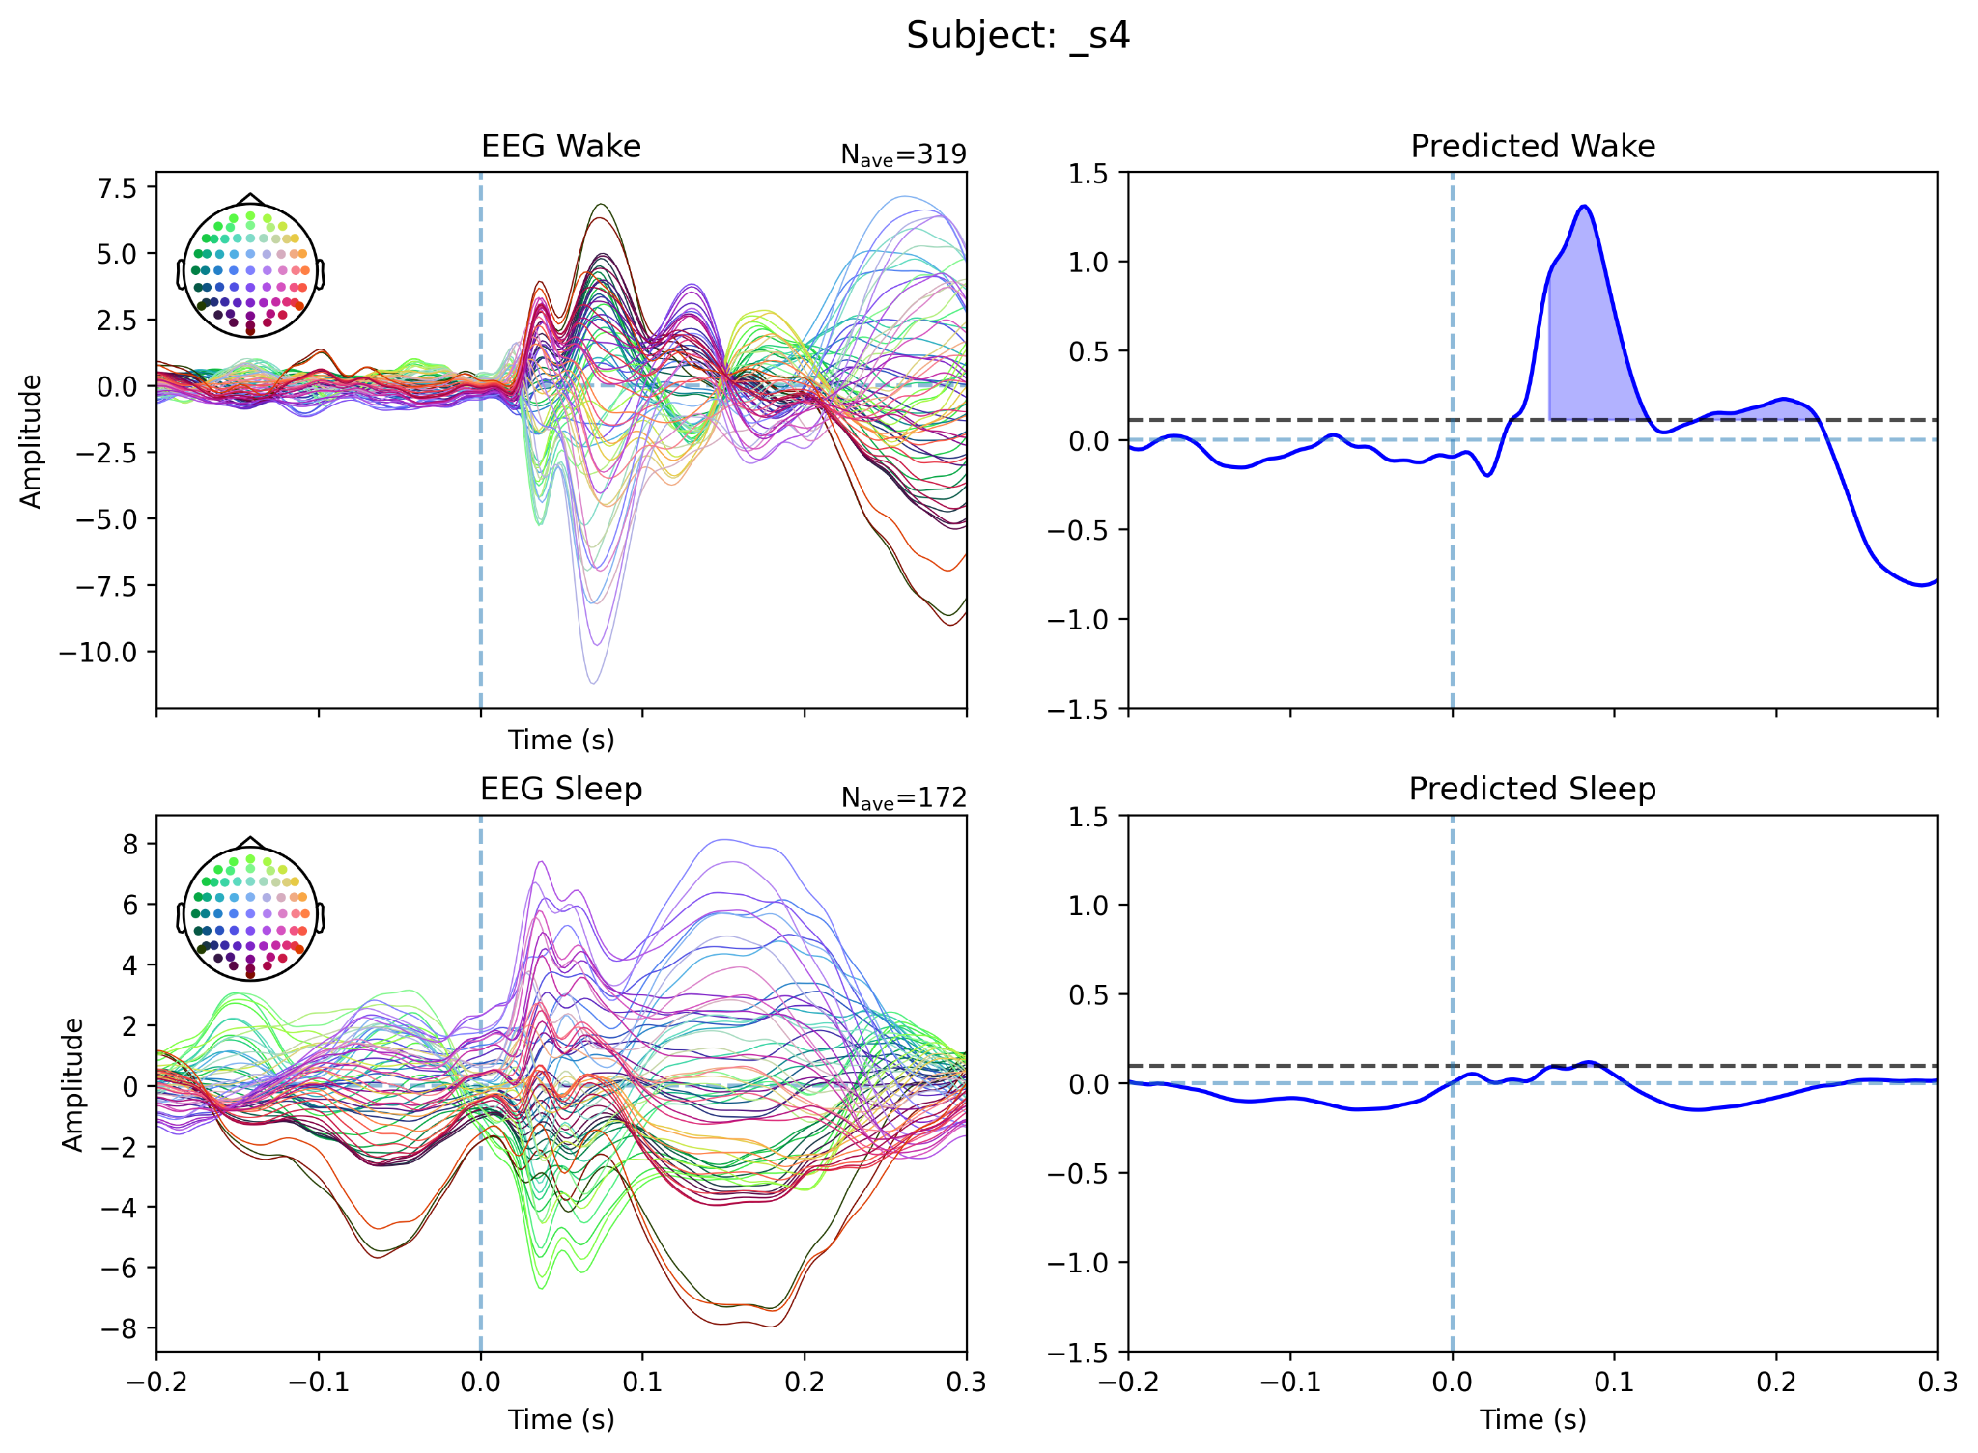
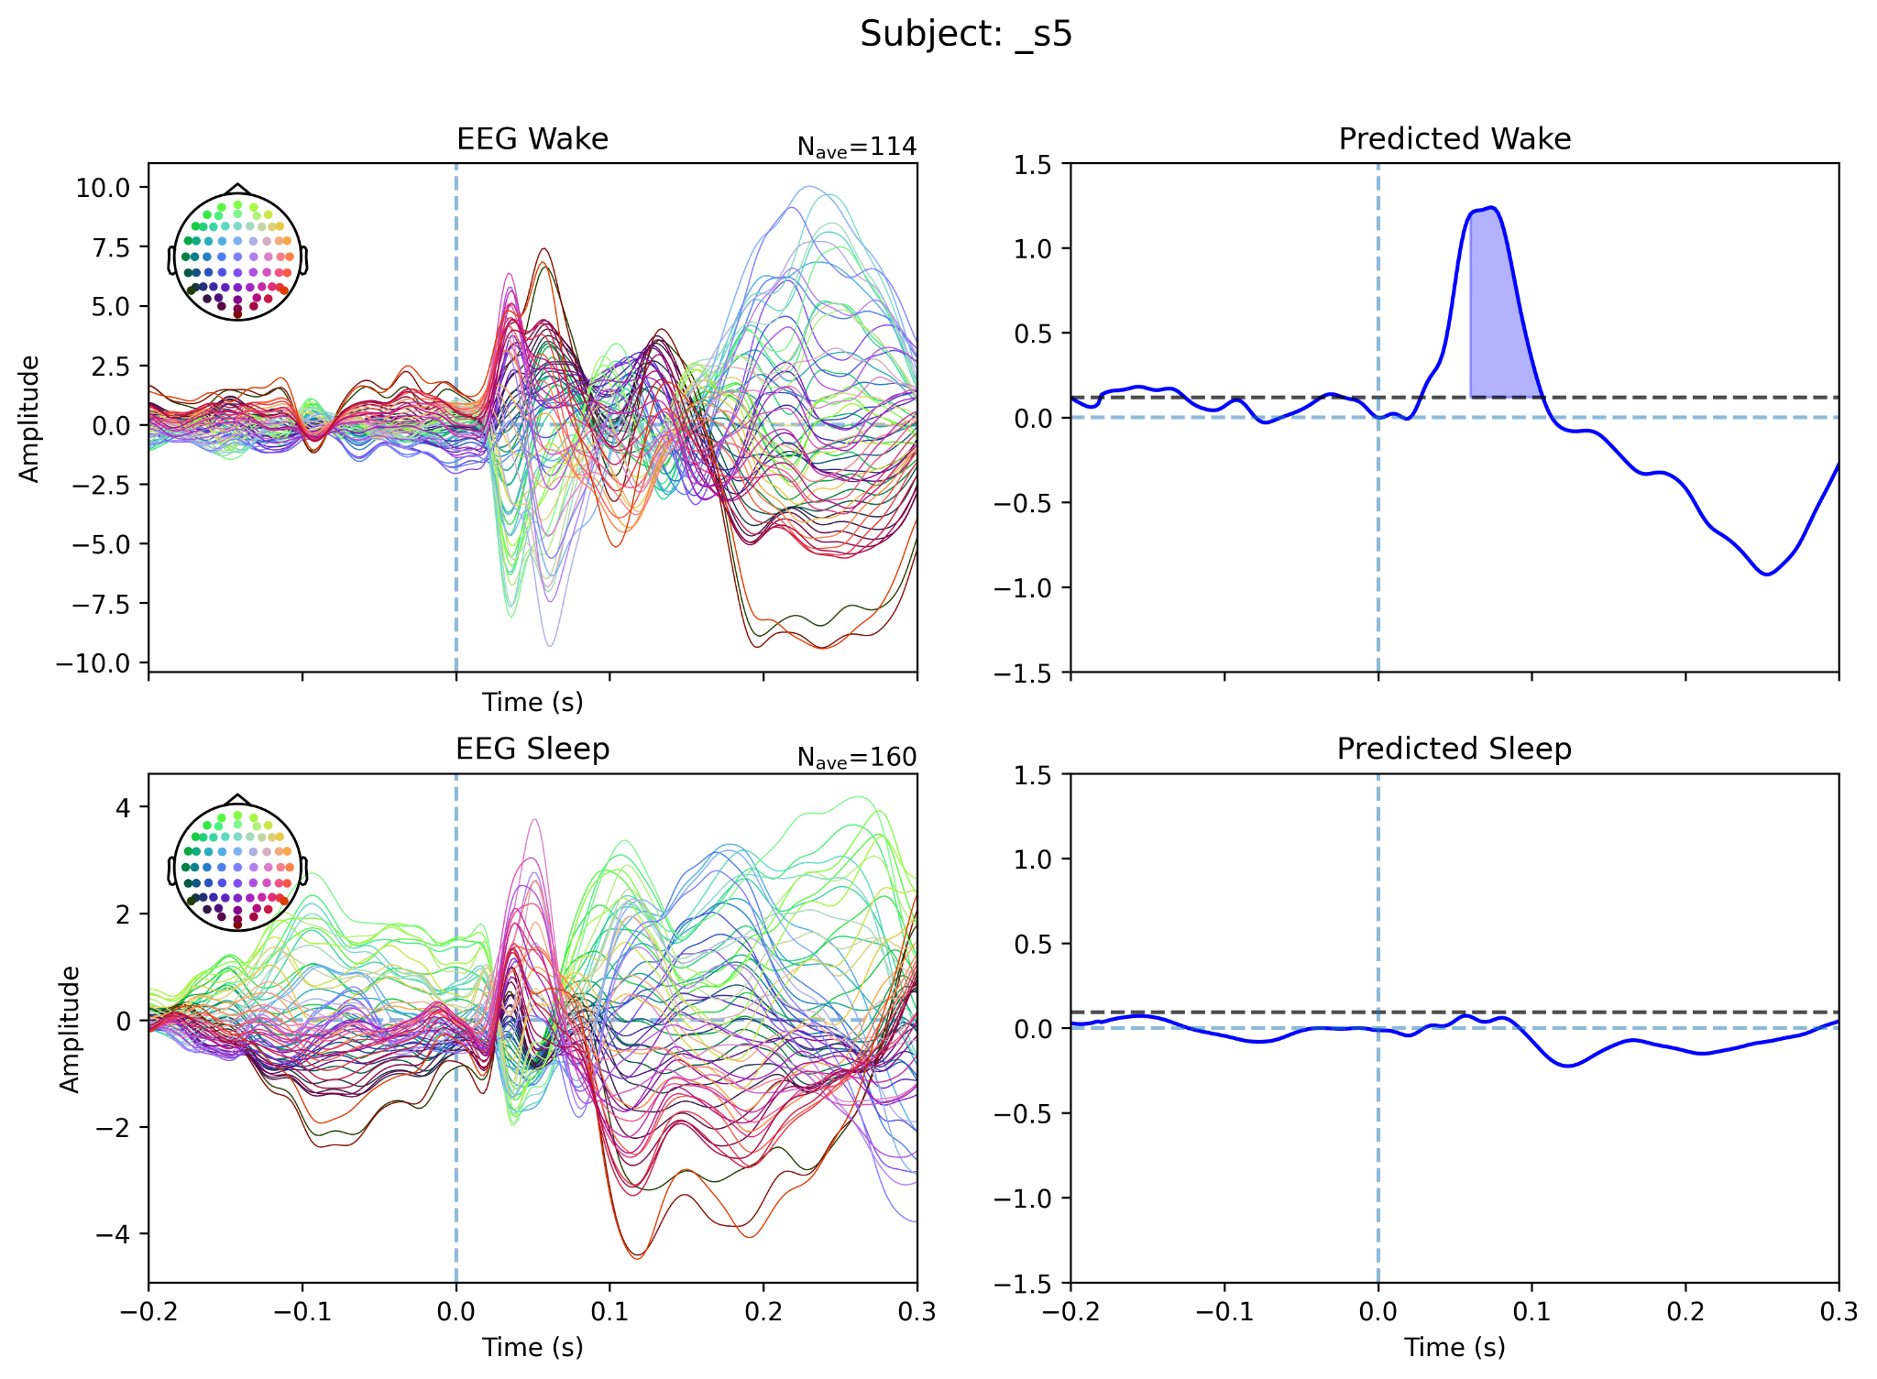 | 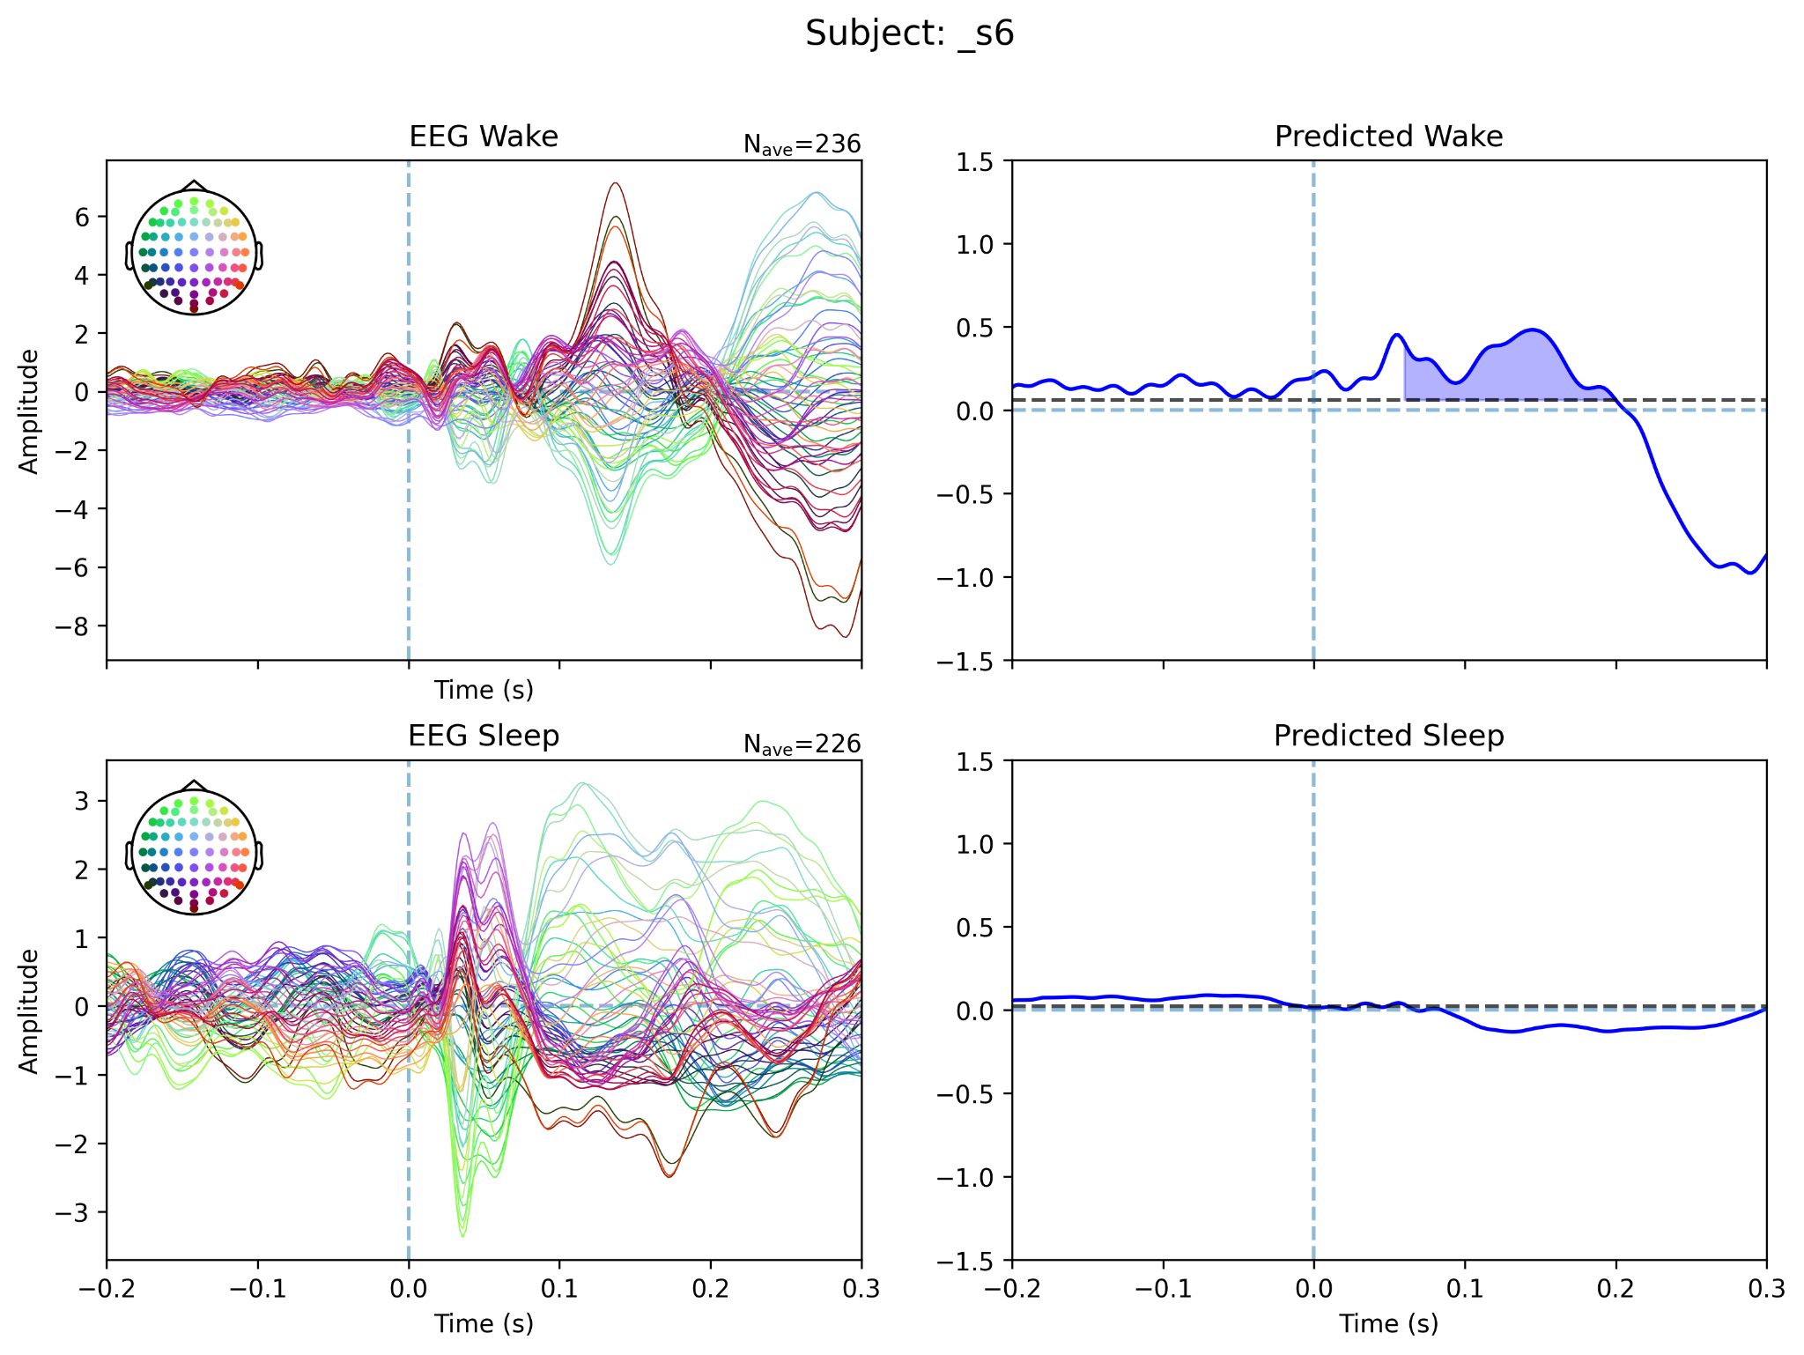
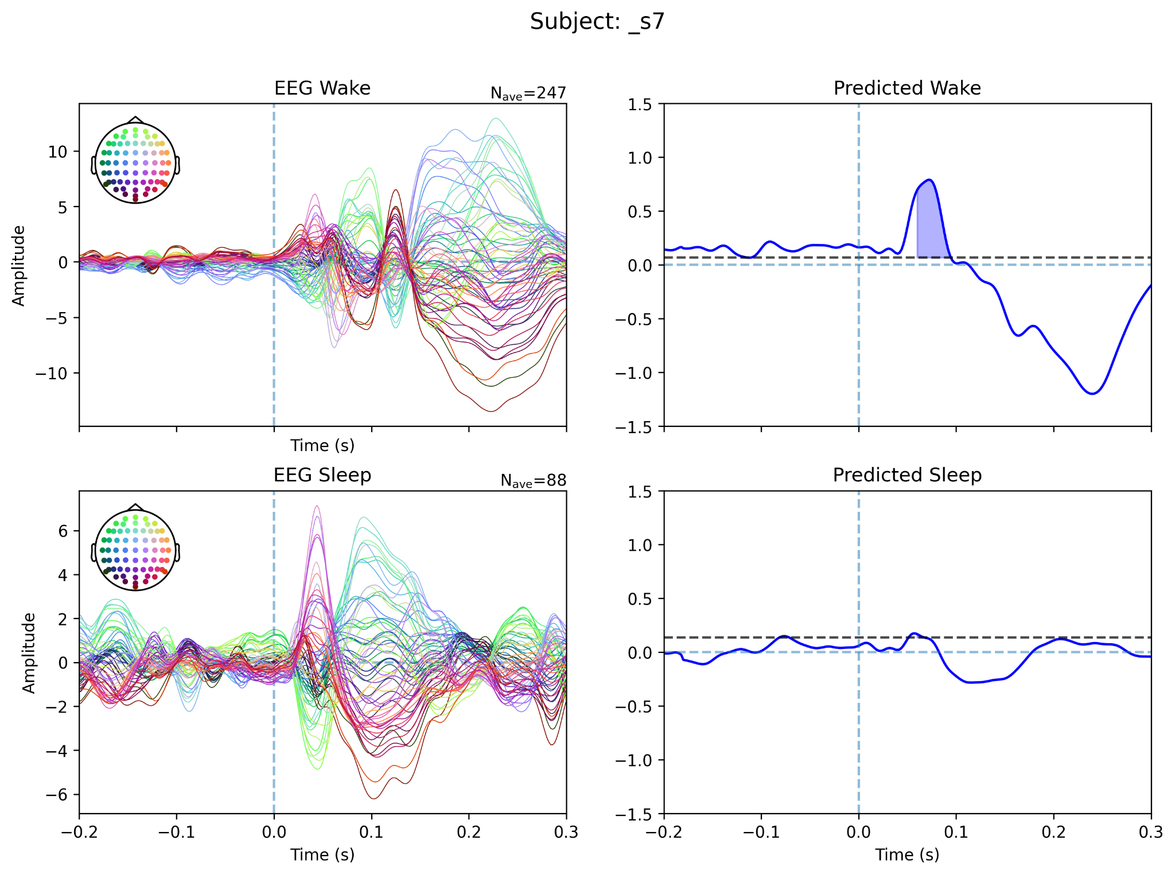 | 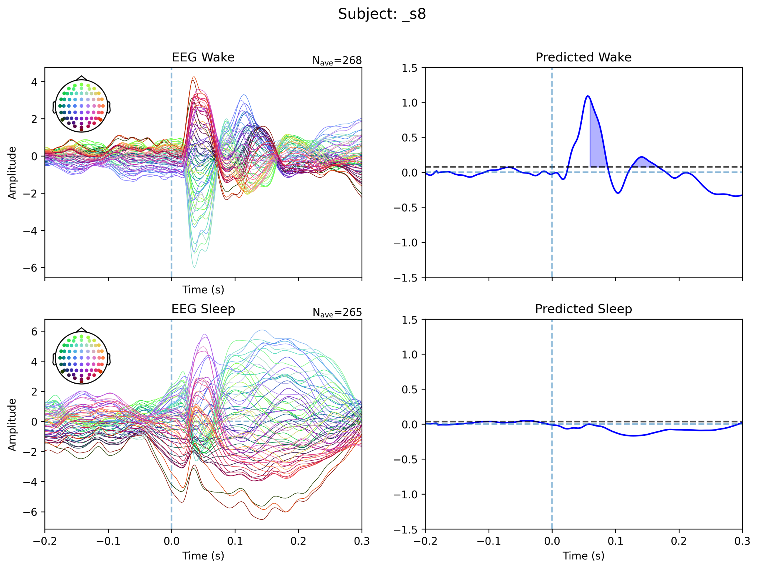

Supplementary Figure S2. Individual N140/SAN waveforms across participants from the wake vs sleep dataset.

