S1 Literature review
Viticulture and grapevine production account for a significant portion of the global crop production, representing 9% of perennial crop area (Zielonka et al., 2024) and fostering strong relationships between the economy, territories and culture where it is grown (Wolkovich et al., 2025). Italy alone accounts for 19.3% of global grapevine cultivation with 718,198 hectares (Orlandella et al., 2025), and has been producing wine for centuries (Laurent et al., 2025). The high commercial value of this product has led to increased research on improving environmental performance and maintaining product quality (Ruggeri et al., 2024). However, due to their cropping system, grapevines have a significant environmental impact, including the loss of soil carbon, through erosion and potentially harmful effects on biodiversity (Garcia et al., 2018; Zielonka et al., 2024). Field management coupled with sustainability schemes has therefore increased in recent years through national and international winegrowing certifications.
The International Organisation of Vine and Wine (OIV) was established in 1924 as one of the first institutions aiming at harmonising wine production protocols. Through the CST 1/2004 resolution, it introduced the principles and guidelines for sustainable viticulture, alongside the OIV-CST 518-2016 resolution. Focusing on Europe, the Common Agricultural Policy (CAP) promotes the adoption of obtaining Sustainability Certification for Wine throughout the System of National Integrated Quality Production (SQNPI) (Ceccacci et al., 2025). Besides that, almost every nation with significant wine production has a certification for sustainable winegrowing (Baiano, 2021; Moscovici & Reed, 2018). In order to achieve such certification, winegrowers must disclose their environmental impact. The lack of homogeneity creates a constellation of different frameworks worldwide that share common principles and methodologies (Montalvo-Falcón et al., 2023).
The most relevant of those is based on LCA and is made to assess the negative environmental impacts generated by the wine life cycle. Due to its standardised procedure (ISO 14025, 14040, 14067, 14046, etc.), LCA is an effective tool for assessing a range of different environmental impacts. In viticulture, it is becoming the reference methodology to support the environmental management of winegrowing, helping companies to detect environmental hotspots and identify which production activities and inputs can be improved to reduce environmental burdens (Orlandella et al., 2025; Trigo et al., 2024). For this reason, most certification schemes aligned with national and international standards, like the European Product Environmental Footprint (PEF), require an LCA application to ensure the quantification and monitoring of environmental performance indicators related to pollutant emissions and resource uses. In Italy, the wine production protocols outlining the rules to ensure authenticity and quality of wines encourage the adoption of an environmental certification scheme (Stanco & Lerro, 2020). The most common programs that foresee the release of a sustainability label based on LCA approaches are “Equalitas” and “V.I.V.A.” (Rugani and Lamastra, 2023).
Besides potentially detrimental impacts, a sustainable management of vineyards, like in many other agricultural activities, may help generate ecosystem services (ES) and positive externalities (Payen et al., 2021), such as increased soil carbon stock, biodiversity or rate of biowaste recycling. Those benefits can be traced and accounted with different approaches and tools, which however are not usually integrated with the LCA related certification schemes.
The benefit of exploiting ecological goods and services is unvaluable for human societies, as represented by the so-called Nature’s Contributions to People (NCP), a policy and research field emerging from the concept of ES Pinto et al. (2024). NCPs refer to the contributions of living nature to the quality of life of the people (Díaz et al., 2018). The integration of ES valuation into economic decision-making heralds a transformative approach. It beckons decision-makers to adopt holistic evaluation metrics, considering ecological impacts alongside economic metrics to forge development strategies that harmonize economic progress with ecological preservation (Jiang and Ding, 2025). Well-known examples in the forestry sector are two international certification programs allowing to quantify and monitor the increase in forest ES associated with expectedly sustainable management interventions, namely the ‘Forest Stewardship Council’, or FSC (Boubacar & Sissoko, 2025), and the ‘Programme for Endorsement of Forest Certification’, or PEFC (Bruzzese et al., 2025). Adopting an FSC and/or PEFC certification label is guarantee of traceability of ES flows and their management in case of buying and selling, for example through the implementation of a Payment for Ecosystem Services (PES) scheme.
The concept of PES, where a landowner or manager is paid on the basis of the ecosystem services his/her natural capital provides, is however not without controversy because the PES connected with VCMs (Value Stream Mapping) have been particularly contentious. As Folkersen (2018) concludes, only PES can mislead the main objective of sustainability assessment and NCP, which is to generate wealth and human well-being throughout environmental management strategies. This is because the instrumentalization of environmental value fails to take into account the diversity of human-nature relationships. This can lead to the marginalisation of local practices and knowledge, as well as increased conflict and inequity (Arias-Arévalo et al., 2025). A number of reasons feed the debate around the use of PES as separate from issues of ideology and economics. One aspect of discussion focuses on the monitoring, reporting and verification (MRV), the additionality and the permanence of projects (Miltenberger et al., 2021). Some authors recognise, however, that forest certification can help PES schemes overcoming their weak monitoring systems based on limited information about the actual delivery of the intended services to beneficiaries (Jaung et al., 2018). Not surprisingly, Savilaakso and Guariguata (2017) define the certification of forest ES as a “market-based mechanism that includes activities meant to guarantee that a given forest stand is explicitly managed in a way that maintains or enhances the provision of a specified ES”.
This paper aims to validate the hypothesis that the combined use of life cycle methods alongside established protocols for ES quantification and monitoring (based on FSC and/or PEFC schemes) can ensure reaching environmental sustainability in the agriculture sector by offering robust, traceable and unquestionable indicators and roadmaps to companies and farmers. In this regard, the recent Directive (EU) 2024/1760 of the European Parliament on corporate sustainability due diligence aims to encourage sustainable and responsible behaviour in companies’ operations by identifying and addressing potential and actual adverse impacts on human rights and the environment. This premise consistently aligns with the effort of the present research to implement integrated environmental cost and benefit analysis based on consideration of LCA as well as ES assessment and monitoring.
S2 Details on the development of the O-LCA model
S2.1 LCA principles and methodological criteria
When the objective of the environmental impact assessment is not product but corporate oriented, the organisation-LCA (O-LCA) is a valid tool to compile and evaluate the inputs, outputs and potential environmental impacts of the activities associated with the organisation, following a life cycle perspective. However, the O-LCA follows the four-phase approach proposed by the ISO 14040:2006 standard for product LCA, as described below.
On the Goal and Scope phase − The specific elements for organisational LCA are reporting organization, reporting flow, and system boundary. The system boundary determines the resource uses and emissions, and thus also impacts, categorised into direct (i.e., from sources that are owned or controlled by the reporting organization) and indirect (i.e., occur at sources owned or controlled by another organization, a supplier or the user/consumer, but are a consequence of the activities of the reporting organization).
On the life cycle inventory (LCI) phase − The inventory should consist of all resource use and emissions necessary for the activities involved in the provision of the reporting flow and considering the system boundary definition. Data collection can be performed with a bottom-up approach (at the product level), a top-down approach (at the organization or facility level) or a hybrid approach. In general, better quality and more specific data can be expected for activities inside the reporting organization. See also Section S2.2.
On the life cycle impact assessment (LCIA) phase − The impact assessment is aligned with the recommendations and requirements for product LCA, and the same impact categories and methods can be applied. The selection of impact categories should reflect a comprehensive set of environmental issues related to the system being studied. See also Section S2.3.
On the interpretation phase − Interpretation should indicate the consistency of the results according to all the aspects defined during the goal definition and scope phase. See also Section S2.3.
On the Functional Unit (UF) − The FU in LCA expresses the set of performances of a product system that are quantifiable with physical metrics (e.g., mass, volume, surface area, ...) and that can be used as a reference unit for the study, to which the value of inventory flows and all environmental impact indicators can be associated with. The UF basically defines what is “functional to the system” and will need to be studied. The entire LCA method is based on the UF concept, which is considered a “relative approach” because it is structured around a specific function. In other words, all calculations in LCA are assumed to be related to the UF selected for the study (e.g., the 75 cl bottle of wine distributed in the market and purchased by the consumer), since every input and output in the life cycle inventory analysis, as well as every environmental impact indicator, are (re)calculated with respect to the UF.
On the Characterization Factor (CF) − In LCA, the CF is a parameter derived from an impact characterization model that is applied to convert a life cycle inventory result into the common unit of the impact category indicator. According to the ISO 14044:2006, the ‘Characterization’ is a key step in the LCIA as it is used to calculate the magnitude of the contribution of each input and output, classified as an LCI result, to their respective environmental footprint impact categories by aggregating the contributions within each category. This requires a linear multiplication of the inventory data with pre-calculated characterization factors for each reference item and impact category involved in the calculation. For example, with regard to the Climate Change impact category, which reflects the Carbon Footprint, the reference element is CO₂ emitted to air and the unit of measurement of the impact indicator is the mass of carbon dioxide equivalent. In other words, in the characterization of Carbon Footprint, all GHGs released to the air as a result of anthropogenic activities and contributing to climate change, such as emissions of CO₂, CH₄, N₂O, etc., are accounted for with a single common indicator (in this case, referred to as the Carbon Footprint). For each GHG (LCI model output), a specific characterization factor has been developed to reflect its impact to the climate change and relative importance with respect to CO₂. For the carbon footprint, the characterization factors are expressed as global warming potentials (GWPs) over a variable time horizon, typically 100 years (GWP₁₀₀), and are measured in kg CO₂-eq. per kg of emission (e.g., the GWP of methane is 28 kg CO₂-eq./kg CH₄; the GWP of nitrous oxide is 265 kg CO₂-eq./kg N₂O; etc.; of course, the GWP of CO₂ = 1). The same calculation principle applies to each substance (in input or output) and corresponding impact category indicator against which the substance can generate an environmental effect.

Table S1 Impact category indicators selected for this study#. Further details on the evaluation of the Water Footprint are provided in Table S1.2.
Environmental impact category | Impact characterisation indicator |  | Unit | Supplementary information
Carbon Footprint |  | Radiative forcing as Global Warming Potential (GWP) | kg CO₂ eq. | GWP evaluates all inputs or outputs that result in greenhouse gas (climate-altering) emissions. The impact caused by the carbon footprint is represented by rising global average temperatures and abrupt regional climate changes.
Ozone depletion |  | Stratospheric ozone depletion potential (ODP) | g CFC-11 eq. | The ODP measures the destructive effect on ozone by chlorocarbons with a 100-year time horizon. CFC 11 or R-11 has the highest potential among chlorocarbons due to the presence of three chlorine atoms in its molecule.
Photochemical ozone formation |  | Photochemical ozone creation potential (POCP) | g NMVOC eq. | POCP is artificially caused by the photochemical oxidation of gases emitted by some vehicles, particularly carbon monoxide and volatile organic compounds (VOCs). When sunlight hits VOCs, they form airborne particles and ground-level ozone, commonly called smog. It is measured in units of Non-Methane VOCs (NMVOC).
Fine particulate matter formation |  | Particulate matter formation potential (PMFP) | g PM_{2.5} eq. | Fine particulate matter with a diameter of less than 2.5 μm (PM_{2.5}) represents a complex mixture of organic and inorganic substances that causes human health issues by reaching the upper respiratory tract and lungs when inhaled. PM_{2.5} secondary aerosols are formed in the air mainly from emissions of sulphur dioxide (SO₂), ammonia (NH₃) and nitrogen oxides (NO_{x}).
Acidification |  | Acidification potential (AP) | g SO₂ eq. | Atmospheric deposition of inorganic substances, such as sulfates, nitrates and phosphates, causes a change in soil acidity. For almost all plant species, there is an optimal, well-defined level of acidity. Acidification-related damage is considered to occur if the deviation from this optimal level for that particular species is significant.
Freshwater eutrophication |  | Eutrophication potential (EP) | g PO₄³⁻ eq. | The potential for eutrophication leads to increased growth of aquatic plants attributable to nutrients such as nitrogen and phosphorus released into water and soils as a result of excessive fertilization.
Human toxicity |  | Comparative toxic unit for humans (CTUh) | CTUh | Toxicity to humans is an impact category that represents the adverse effects on human health caused by the intake of toxic substances. This intake may occur by inhalation of air, ingestion of food/water, and dermal penetration. The effect might be non-carcinogenic or carcinogenic if the impact derives from particulate/smog caused by emissions of inorganic substances or ionizing radiation.
Freshwater ecotoxicity |  | Comparative toxic unit for ecosystems (CTUe) | CTUe | Ecotoxicity is the result of a multiplicity of toxicological mechanisms caused by the release of pollutants into water, which harm individual species and/or change the structure and function of biota, with a direct effect on aquatic ecosystem health; the CTUe expresses the fraction of potentially affected species (PAF), integrated over time and volume of the freshwater compartment, per unit mass of the emitted chemical. In practice: PAF × m³ × day per kg emitted = CTUe per kg emitted.
Water use |  | Water consumption potential (WCP) | L | This indicator represents a kind of “water footprint” in that it measures all the water consumed along the life cycle activities, which undergoes evaporation processes and is incorporated into products, transferred to other watersheds, or that reaches the sea.
Water scarcity |  | Water deprivation potential for users (WSF) | m³ eq. | This indicator quantifies the potential of water deprivation for humans or ecosystems. It is based on an estimate of the ratio of water demand to availability and measures the volume of available water that remains, per unit area in a given watershed and relative to the world average, once the demand for water by humans and the aquatic ecosystem has been satisfied.
Fossil resource use |  | Abiotic resource depletion, fossil fuels (ADP-fossil) | MJ | ODP characterization factors are calculated as abiotic resource depletion potentials quantified as kg of antimony equivalent per kg of extracted substance, or as MJ of energy carriers. The depletion model is based on the use/availability ratio. Full substitution among fossil energy carriers is assumed.
Minerals and metals resource use |  | Abiotic resource depletion (ADP-ultimate reserves) | g Sb eq.
Land use (agricultural) |  | Equivalent agricultural land occupation potential (ALOP) | m²a crop eq. | Conceptually, this approach assumes that a natural situation would have been present if no land use had occurred. Therefore, the living species richness of the current anthropogenic land use is compared with the natural reference, without taking into account any other anthropogenic land uses that may have occurred before the current one. Therefore, this impact category is based on the relative loss of species caused by a certain type of land use x, relative to the potential loss of species that may be directly associated with global-scale average annual agricultural production.

On the selected impact category and impact characterization indicators – As anticipated in the main paper, most of the impact listed in Table S1 were calculated by applying pre-calculated characterization factors related to the indicators recommended by the Environmental Footprint (EF) 3.1 method, in particular with regard to the indicators of GWP, ODP, POCP, CTUh, CTUe, WSI and the two ADPs. In contrast, the AP and EP indicators, and the PMFP, WCP and ALOP indicators were selected from the CML-IA baseline and ReCiPe 2016 v1.1 midpoint (H) LCIA methods, respectively. The use of different methods essentially relates to the need of applying specific indicators recommended for the calculation of the Water Footprint (WF) by the Equalitas standard, as discussed in Section S2.
More specifically, the decision to use impact characterisation factors from different (but complementary) LCIA methods and characterisation models was made in order to select the most suitable indicators for evaluating the life cycle of AriTer and its products, and to align with the Equalitas standard’s methodological criteria. For instance, the EF method is optimal for Environmental Product Declaration (EPD) studies and provides a wide range of indicators; however, its approach to assessing water use impacts is based on evaluating upstream resource stocks. In contrast, the ReCiPe method provides a more relevant indicator for monitoring water footprint: the ‘total net consumption’ of the resource, regardless of its availability upstream. Furthermore, Equalitas standard procedures for calculating WF require the use of an index of water scarcity, as detailed in Section S2. Other indicators of freshwater ecotoxicity, acidification and eutrophication must also be calculated, but these do not necessarily conform to the units of the EF method indicators (see SI 1 -Table 1 for details).
In general, the simultaneous application of two or more LCIA methods developed under different paradigms is not recommended in LCA. This is because indicators developed according to different assumptions and characterisation approaches may introduce an unnecessary level of uncertainty into the calculated value, which should be avoided. In any case, calculating indicators in isolation (as in the present study) does not generate any methodological inconsistencies, and makes the results even more relevant and useful for the company. The impact assessment stops at the “midpoint level” characterisation stage, without performing any arbitrary weighting or normalisation analysis, which could introduce a high degree of uncertainty into the overall impact assessment.
S2.2 Data collection and development of the inventory model
The process of collecting physical input and output data for each step of the life cycle was carried out by populating questionnaire table prepared in Excel format, supplemented with further communications and clarifications of the company during two technical interviews and by means of email exchanges. All information collected for this study refers to the production year 2022. Although complete and accurate from the beginning of the collection process, data were further revised and checked in light of the results obtained in a preliminary phase (between November 2023 and April 2024). This was done both to cover some data gaps and to adjust a few data collection incoherences, albeit of little relevance. Moreover, a general review to validate the inventory with marginal corrections was carried out using the company’s responses to a list of specific issues so as to optimize timing and use of resources. After this final validation process, there was in fact little change in the results, estimated to be under 3%.
Data collected were first processed and manipulated to be then included as input and output parameters within a representative model of the AriTer’s activities life cycle. In particular, data collected on farm were entered into datasets specifically created in OpenLCA (GreenDelta, 2023)to represent all life cycle production activities in the three phases: Upstream, Core, and Downstream (e.g., raw material extraction; transportation; glass production; viticulture; etc.). In turn, these datasets were connected to hundreds of other datasets upstream (through the foreground information entered as input) and downstream (through the data entered as output), allowing the creation of a complex network of “life cycles” linking several thousand process activities to each other. For example, the flow of electricity consumption in the winery amounted to around 70 MWh/year in total and was included in the “Winery Operations” dataset as primary data. This was connected in turn with a pre-defined supply chain model consisting of hundreds of processes containing input/output flows of typical activities (average technologies) of the electricity life cycle in Italy. In this way, for each indicator it was possible to estimate the ‘indirect’ impact of the AriTer’s production system (i.e., the impact that is not generated by emissions or resource uses in the farm’s agricultural area), thus distinguishing between direct impacts (over which the farm may have explicit control) and indirect impacts (over which the farm has implicit responsibility and sometimes no control).
As no specific data was available to estimate the impact associated with transporting input materials to the system (i.e. from suppliers to AriTer), a generic distance of 25 km was arbitrarily used. In terms of modelling the distribution of the final product to the market, however, the company provided more detailed estimates of the type of transport (sea and land) and destinations at national, European and intercontinental scales. The most representative processes were selected from the ecoinvent database based on the mode of transportation of the materials. It is believed that modelling this stage could provide the company with accurate and useful information on where the most critical environmental issues related to product transportation are concentrated, and how the distribution chain could be improved. For the end-of-life of packaging materials, information was only provided regarding the outputs of exhausted oils and secondary waste from the company (plastic, paper and cardboard of the products consumed by the company, wood from broken pallets, residual glass from the packaging processes, etc.). Those followed specific disposal routes for hazardous waste and/or recovery and recycling routes as indicated by specific waste classifications. While only hypothetical scenarios of municipal solid waste treatment, with different percentages of recycling, landfill and incineration in Europe, could be set up for the management of the waste from primary packaging (bottles, boxes, etc.).
As anticipated in the main paper, the model was constructed in compliance with the basic principles and criteria of ISO/TS 14072:2014, which is strictly dependent on the ISO 14040:2006 and ISO 14044:2006 standards regarding life cycle inventory (LCI) analysis. This implied compiling and quantifying the inputs and outputs of the processes and products of AriTer throughout their life cycle. The result of the LCI analysis is a catalogue of the flows of land use, raw materials and energy directly and indirectly used within the system boundaries of the organisation (defined at the initial model development stage), as well as pollutant emissions to air, water and soil. In addition to the aforementioned ISO standards, specific international Product Category Rules (PCR) were consulted to model and collect data related to the life cycle phases of the two main AriTer’s products (wine and evoo), thus providing an adequate technical-theoretical basis to support future environmental sustainability certification processes such as Equalitas.
S2.3 Model analysis and interpretation of the results
The LCI provides the starting point for the life cycle impact assessment (LCIA) phase in LCA. This aims to assess the magnitude and contextual relevance of the potential environmental impacts (e.g., Carbon Footprint) generated by the production system using the LCI results. In general, this methodological step associates inventory data with specific environmental impact category indicators. The result of an LCIA is the calculation of those environmental impacts, which can be achieved using LCIA methods provided by established literature and conforming to the guidelines of reference standards on which Equalitas and other schemes are based, such as the ISO 14046:2014 on water footprinting and the ISO 14064-1:2018 for the quantification and reporting of GHG emissions and removals at the organization level.
The LCIA method selected for this study, although with some variations with respect to the choice of indicators (See Section S1.1), is the Organisation Environmental Footprint (OEF). This method has been developed by the Joint Research Center (JRC) of the European Commission and is continuously evolving and being tested. It aims to offer a common way and shared approach for measuring environmental performance of companies in all economic sectors across Europe. By demonstrating its validity and relevance for LCA studies in the Italian agrifood sector, the Ministry of the Environment and Protection of Land and Sea (nowadays Ministry of the Environment and Energy Security), with the Decree No. 56 dated 21/03/18 the voluntary national scheme for the assessment and communication of the environmental footprint of products, called “Made Green in Italy”, has been made operational. This is part of the National programs for environmental footprint analysis and enterprise sustainability were the JRC-EC Environmental Footprint methods are a reference pillars.
The last step of the study is called “interpretation” and is the stage of the O-LCA in which both the LCI and LCIA results are reconsidered together. The interpretation stage should provide evidence of consistency of the results with the objective and prospective scope of the scenarios defined in the initial stages of the study, such that useful conclusions for the company and recommendations for improving environmental performance can be formulated. From this point of view, results from the O-LCA, particularly those related to the Carbon Footprint analysis, can be compared and balanced with the results from the assessment of carbon removals in forests and on agricultural soils. By associating the environmental footprint values with field surveys and an enhancement of the good agricultural practices already in use, it was possible to define a path of optimization for the management processes, in order to allow the farm reducing (through impact mitigation actions) the total load of its environmental footprint, as well as compensating (through insetting procedures) any residual and unavoidable impact. Results of the present O-LCA study will therefore be preparatory to the achievement of a carbon-neutral (or even carbon-positive) condition for the company. Regardless the climate neutrality certification scheme that might be adopted later, the condition of carbon neutral/positive can only be declared following the implementation of a carbon management plan, the basis of which were promoted in this paper.

S3 Application of the Equalitas procedure
S3.1 Calculation of the Carbon Footprint of AriTer’s wine
To assess the impact of AriTer’s wine supply chain, the analysis was aligned with the procedures for calculating the Carbon Footprint of organizations defined by the ISO 14064-1:2018, which is already recommended by the GHGs accounting protocol of the International Organization of Vine and Wine (OIV) and provided as a reference methodology by the application regulation of the Equalitas standard.
The ISO 14064-1 procedures detail principles and requirements for designing, developing, managing and reporting organization-level GHG inventories. The standard includes requirements for determining GHG emission and removal (of GHG from the atmosphere) boundaries, quantifying an organization’s GHG emissions and removals, and identifying specific company actions or activities aimed at improving GHG management. The document also includes requirements and guidance on inventory quality management, reporting, internal auditing and the organization’s responsibilities in verification activities. The ISO 14064-1 defines a carbon footprint profile as the sum of GHG emissions and carbon removals in the production system of an organisation, expressed in units of CO₂ equivalent mass (e.g., kg CO₂ eq.) and possibly based on O-LCA modelling using the climate change impact category (global warming potential, or global warming), as anticipated in Table S1.
The LCI model for the wine of Arillo in Terrabianca has been described above. For the definition of the reporting boundaries of the model, the approach recommended in the Annex I of the Equalitas standard’s implementation regulation released in 2021 was followed in order to allow comparisons of the results with literature data. This version of the Equalitas regulation foresaw the decomposition of the life cycle into three main phases linked in cascade: (i) viticulture and grape production activities (Farm / Azienda agricola), (ii) wine production activities (Winery / Cantina), and (iii) bottling and packaging of the final product (Bottler / Imbottigliatore). The link between each of these stages, as shown in Figure S1, is determined by specific transport processes.
Physical input and output data from each stage were collected and entered into the LCI model in compliance with the ISO 14064-1 procedures. Most of the foreground data were provided by the AriTer’s administration after the analysis of purchase invoices for farm products and services, as well as estimates and calculations made by the farm’s agronomists. All other data, especially the background data, were retrieved from the scientific literature and from specific databases created for conducting LCA studies (for more details, see the data collection in the main paper and at Section S1.2).

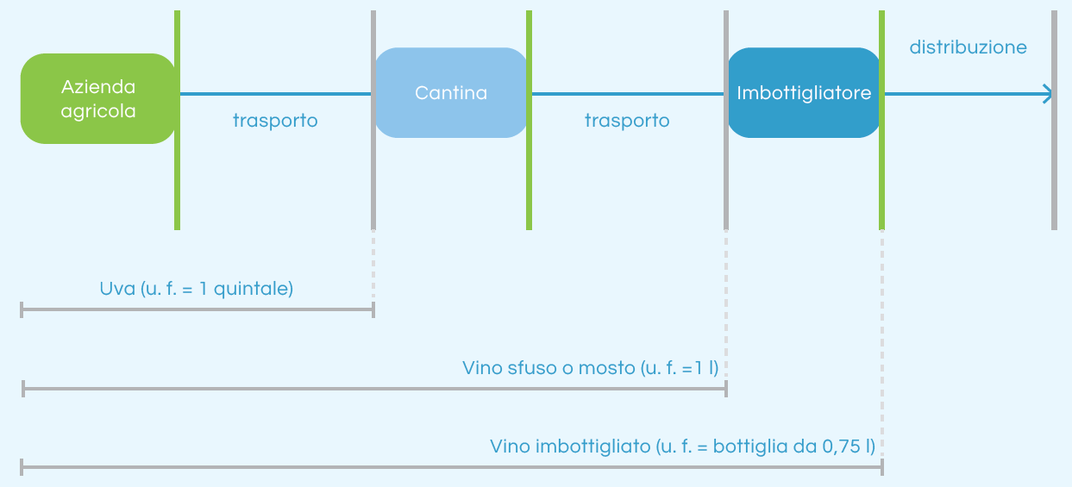
Figure S1 Key life cycle model stages recommended for the environmental footprint calculation of wine according to Equalitas; source: Figure 1.1 of Annex II, Equalitas Guidelines.

As additional elements beyond what is already defined in ISO 14064-1, the Annex I of Equalitas version released in 2021 required that:
- data used to quantify significant GHG emissions and removals refer to a 12-month period chosen within the last 24 months foreground data in this study refer to the 2022 grape collection and wine production year, and thus they were consistent for the achievement of the label by the beginning of 2025;
- all the direct and indirect GHG emissions and removals associated with the activities or facilities included in the reporting boundaries must be identified by the company all primary (consumption of energy, raw materials, fuels, fertilizers, glass, packaging materials, etc.) and secondary (emissions related to the use of chemicals, combustion of diesel fuel, etc.) data referred to the parcels owned by AriTer where grapes and wine are produced;
- concerning carbon removals, in the absence of other more specific studies it is possible to take as a reference a value of 0.7 kg CO₂/plant assuming a plant life of 30 years. In this regard, the standard provided a choice between one of two approaches: i) short carbon cycle emissions/removals are excluded (e.g., pruning, wine fermentation), or if measurements of plant carbon fluxes are available (e.g., via eddy covariance), all those emissions and removals are considered considering the absence of site-specific measurements on the vines and given the high uncertainty in defining the relationship between CO₂ uptake and release activities in the short carbon cycle, the study followed the first approach and considered neither removals nor emissions of GHGs of biogenic origin, assuming their difference to be zero. It is worth mentioning, however, that surveys and field sampling were conducted in this study to estimate with scientifically accepted approaches the stock (storage) of carbon currently present in the farm’s forests and agricultural soils. This activity made it possible to estimate the value of annual carbon uptake by the farm’s natural capital with high accuracy and representativeness;
- the cut-off should be 1% with reference to the elements under the control of the Organization in terms of LCI representativeness, the input flows attributable to the annual consumption of materials and energy (foreground data) were considered in their entirety. The only exception concerned the stock of infrastructure and machinery that have relatively long lifetimes (several years or decades), so-called “capital flows”. It is common practice in LCA to exclude inventory flows derived from these stocks, including those LCA guidelines and PCRs followed here, even if recent studies demonstrate that their contribution to environmental impacts might not be negligible. In terms of completeness and significance of the emissions inventory, however, all major GHGs that determined the Carbon Footprint with contribution greater than 1% (GHGs under the company’s control such as CO₂ generated from the combustion of diesel fuel and liquefied petroleum gas, LPG, or methane and nitrous oxide released in the field as a result of the use of natural manure) were accounted for.
S3.2 Calculation of the Water Footprint of AriTer’s wine
The same life cycle inventory model developed for the Carbon Footprint analysis was used to calculate the Water Footprint, except that:
- the reference standard was the ISO 14046:2014 (and no longer the ISO 14064-1), also recommended by the Equalitas standard, which specified principles, requirements and guidelines for assessing the WF of products, processes and organizations according to LCA principles;
- specific additional estimates were made to determine, at the foreground level, consumption and emissions of different categories of water that do not necessarily affect the Carbon Footprint calculation model. The WF is in fact determined by the sum of three water components of direct (in the foreground) and indirect (in the background) consumption, i.e., blue, green, and grey water, although neither the Equalitas guidelines nor the ISO 14046 standard expressly refer to this type of classification.
A number of additional elements to the ISO 14046 also applied for the calculation of the WF in the Equalitas procedures released in 2021, with further requirements when compared to the elements described above for the calculation of the Carbon Footprint, namely that:
- data retrieved for the calculation of the WF should refer to a 12-month period, chosen from within the last 24 months since this is the same inventory developed for the Carbon Footprint calculation, data referred to the year 2022;
- results should be presented in the form of an indicator profile (unless it is demonstrated that one or more impact categories on the water resource are not significant as required by the ISO 14046 standard) taking into consideration some specific impact categories extrapolated from the scientific literature as recommended in Annex II of the Equalitas procedures released in 2021, the indicators shown in Table S2 were calculated for each reported phase or activity. In addition, the sum of direct (related to the foreground system) and indirect (related to the background system) water consumptions was estimated, so as to provide an overall WF figure even though not required by the guidelines (see indicators shown in Table S1). The only impact category for which an alternative indicator to that recommended by the Equalitas standard was applied concerned the Water Scarcity Related Footprint (WSF). The most recent LCA literature with broad consensus in the scientific community (both according to OEF and PEF, and for estimating the water scarcity footprint according to the ISO 14046) recommends the use of AWARE; while indices based on the ratio of water withdrawal to water availability, such as the indicator developed by Pfister et al. in 2009, are no longer recommended.

Table S2 Impact category indicators used to describe the Water Footprint at each baseline life cycle stage or activity, as recommended in Table 2.1 of Annex II (Equalitas Guidelines). Note that the characterization factors used in the IMPACT2002+ method for aquatic acification and eutrophication are taken respectively from the CML-IA baseline and the EF methods mentioned earlier.
Indicator for calculating the Water Footprint | Reference LCIA methodology | Unit | Reference phase or activity
Water scarcity footprint | Pfister et al. (2009)  Boulay et al. (2018) | m³ eq. | Agricultural phase
Aquatic acification | IMPACT2002+  CML-IA baseline | kg SO₂ eq. | Packaging, fossil fuel consumption
Aquatic ecotoxicity | USEtox® 2.0 | CTUe | Fertilizers  (chemical and natural)
Human toxicity | USEtox® 2.0 | CTUh | Fertilizers  (chemical and natural)
Aquatic eutrophication | IMPACT2002+  EF v3.1 method | kg P eq. | Fertilizers  (chemical and natural)

- Among the different process units, at least the flows (elementary, of matter and/or energy) in input and output to the processes (including for outsourced activities) shown in Table 2.2 of Annex II of the Equalitas procedures (reported below) shall be considered all the relevant flows of the LCI were captured (with cut-off of 1%) and the Equalitas standard’s implementation regulation was strictly followed where possible, thus referring the data to the plots involved, the grapes processed from these plots, and the wine obtained from them and subsequently bottled. Only the data about evapotranspiration processes were not considered. This can be part of a follow-up research activity.

(source of the image: Annex II, Equalitas guidelines released in 2021)
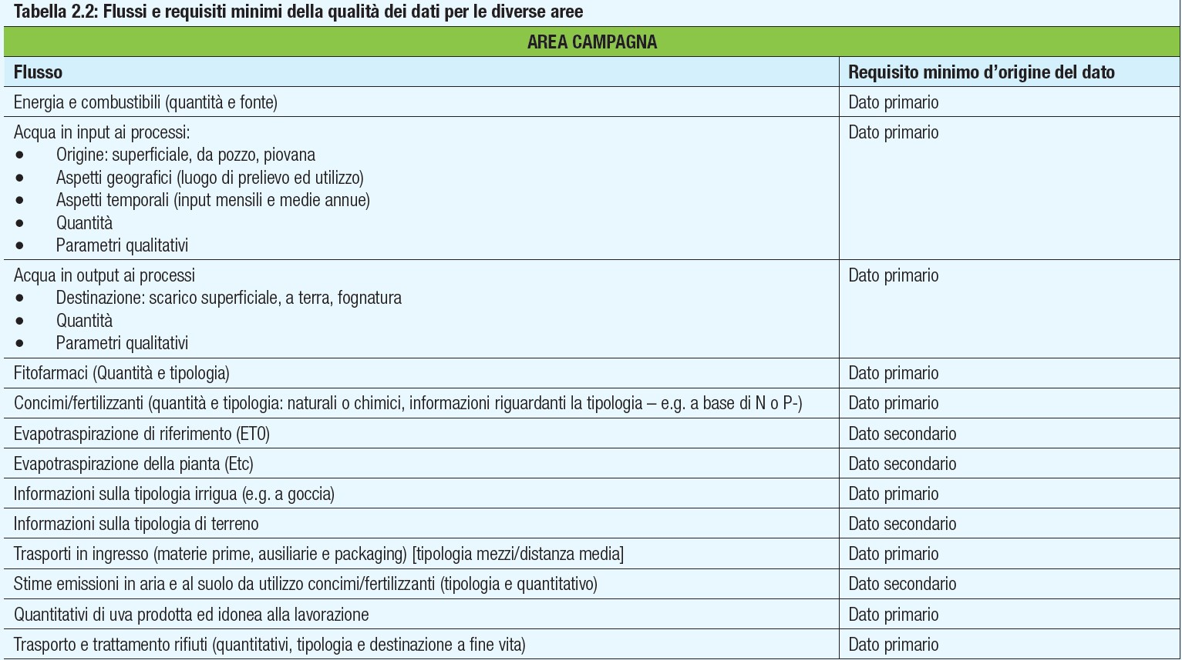
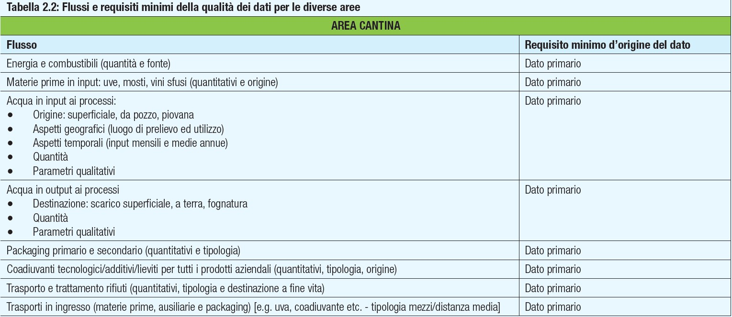

S3.3 Adjustment of the functional and reporting units to the Equalitas procedures
In accordance with the regulation of the Equalitas standard, the Carbon Footprint and Water Footprint values were referred to the three functional units (or reference flows) as shown in Table S3 (taken from Annex II of the Equalitas standard application regulation released in 2021). This allowed a preliminary comparison with LCA literature data and suggested how to position the environmental profile of Arillo in Terrabianca’s wines in the context of wine Footprint values in Italy.
Since multiple agricultural activities are conducted by AriTer, especially in Site C, the final AriTer’s Footprint values were calculated by applying at the inventory stage a set of causal allocation factors (ranging between 70% to 100% regarding the main products, that is grape and wine) to each input flow.

Table S3 AriTer Carbon and Water Footprint data reporting following the Equalitas procedures.
Area | Reference flow | Product index
Farm | Total quintals (q) of harvested grapes, made suitable for processing (and partly for sale) | 1 q of grapes harvested and made suitable for processing in the year under review
Winery | Total litres of produced bulk wine/must, made suitable for sale/bottling | 1 L of bulk wine/must processed and suitable for sale/bottling
Bottling / Conditioning | Total litres of wine bottled and ready for sale | 0.75 l of wine bottled and made ready for sale
S3.4 Equalitas indicators: Carbon and Water Footprint of the wine supply-chain
The environmental footprint indicators recommended by the Equalitas procedures, namely global warming potential for carbon footprint characterization, and five different Water Footprint indicators, namely water resource scarcity, acidification potential, eutrophication potential of water, toxicity for humans and for aquatic ecosystems, were estimated and compared with some literature results (Table S4). For this purpose, comparable data were collected from the sustainability report of some Italian wineries that have recently obtained the Equalitas standard.

Table S4 Calculation of carbon and water footprint indicators recommended by the Equalitas standard, and comparison with literature data retrieved from a few publicly available sustainability reports of other Equalitas certified companies.
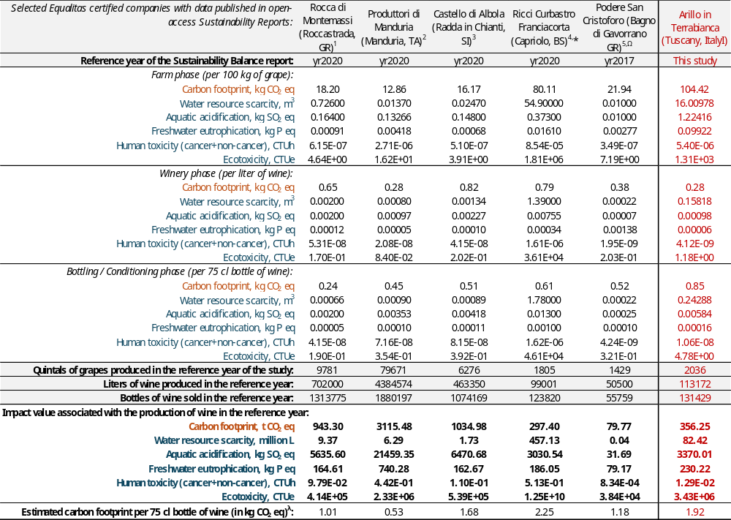
¹ https://www.zonin1821.com/app/uploads/2021/10/Bilancio-di-Sostenibilità-Rocca-Montemassi-2020-2021.04.15-Post-Audit.pdf; last access on August 2025
² https://www.produttoridimanduria.it/wp-; last access on August 2025content/uploads/2021/03/Bilancio%20di%20Sostenibilita%CC%80%20PdM%202020_web.pdf; last access on August 2025
³ https://www.zonin1821.com/app/uploads/2021/10/Bilancio-di-Sostenibilita%CC%80-Castello-di-Abola-2020-2021.04.15-Post-Audit.pdf; last access on August 2025
⁴ https://www.riccicurbastro.it/wp-content/uploads/2021/07/bilancio_sostenibilita_2020-ITA.pdf (link to web source possibly corrupted; document available upon request)
⁵ https://www.maremmaterradivini.com/wp-content/uploads/2018/09/Bilancio-Podere-San-Cristoforo-2018.02.15.pdf (link to web source possibly corrupted; document available upon request)
* The Sustainability Report for this company indicates carbon footprint data by stage in % only. Additional information on the average carbon footprint per bottle of wine was found on the company's website. The carbon footprint was estimated in absolute value by combining the two types of information.
^{Ω} Values for the Water Footprint indicators apparently available for the field phase only. The scores obtained for the other two phases were estimated from the % values available in the budget report.
^{λ} The carbon footprint per bottle of wine from Arillo in Terrabianca was calculated as a mean between the carbon footprint of the bottles from Site A and the carbon footprint of the bottles from Site C; accordingly, the contribution from Site B (Pienza) is excluded because only grape (and not bottles) are produced there.

While the indicators measured in all those studies were the same, it is unknown whether the calculation methodology and life cycle model built for the Equalitas analysis were perfectly comparable with the approach proposed in this study. In any case, comparison with literature data was useful to obtain an “order of magnitude” of the impact, and to identify possible critical issues and aspects that will need to be investigated further in the future.
For example, it can be observed that the total carbon footprint (from cradle to gate) associated with the 75 cl bottle of Arillo in Terrabianca’s wine, estimated at ~1.92 kg CO₂-eq., is aligned with the average carbon footprint (~1.53 kg CO₂-eq.) of the wines of the four companies that have a production size in the same order of magnitude (all companies except Produttori di Manduria), although at the stage level the figure is more varied.
Indeed, it turns out that Phase 1 (Farm) and Phase 3 (Bottling) have higher carbon footprints than the average (by more than 200 and 80 percent, respectively). This is mainly due to the low efficiency in resource usage (high consumptions in fossil fuels) resulting from the agricultural activities in Site C of Massa Marittima. With regard to the indicators of water footprint, however, the inverse scenario occurs, that is: Arillo in Terrabianca has typically lower impacts than the comparable literature averages. As reported in Table S5, the difference between Site A and Sites B and C in terms of environmental performance is apparent, with carbon footprint values in Phase 1 (Farm) by ~70% and ~80% lower, respectively.

Table S6 Calculation of carbon and water footprint indicators recommended by the Equalitas standard: detailed results by site of production for the wine of Arillo in Terrabianca.
Indicators by phase | Reporting unit | Site A | Site B | Site C | O-LCA model
Carbon Footprint |  | (kg CO₂-eq.)
Farm (phase 1) | 100 kg of grapes | 38.16 | 180.67 | 125.95 | 104.42
Winery (phase 2) | 1 L of bulk wine | 0.40 | n.d. | 0.19 | 0.28
Bottling / Conditioning (phase 3) | 0.75 l of bottled wine | 0.81 | n.d. | 0.87 | 0.85
Water Footprint – Water resource scarcity |  | (m³)
Farm (phase 1) | 100 kg of grapes | 10.26 | 24.72 | 17.30 | 16.01
Winery (phase 2) | 1 L of bulk wine | 0.22 | n.d. | 0.11 | 0.16
Bottling / Conditioning (phase 3) | 0.75 l of bottled wine | 0.22 | n.d. | 0.26 | 0.24
Water Footprint – Aquatic acidification |  | (kg SO₂-eq.)
Farm (phase 1) | 100 kg of grapes | 2.97E-01 | 3.03E+00 | 1.32E+00 | 1.22E+00
Winery (phase 2) | 1 L of bulk wine | 1.41E-03 | n.d. | 6.48E-04 | 9.78E-04
Bottling / Conditioning (phase 3) | 0.75 l of bottled wine | 5.73E-03 | n.d. | 5.89E-03 | 5.84E-03
Water Footprint – Freshwater eutrophication |  | (kg P-eq.)
Farm (phase 1) | 100 kg of grapes | 1.97E-02 | 2.99E-01 | 9.50E-02 | 9.92E-02
Winery (phase 2) | 1 L of bulk wine | 8.61E-05 | n.d. | 4.13E-05 | 6.08E-05
Bottling / Conditioning (phase 3) | 0.75 l of bottled wine | 1.58E-04 | n.d. | 1.64E-04 | 1.62E-04
Water Footprint – Human toxicity (cancer+non-cancer) |  | (CTUh)
Farm (phase 1) | 100 kg of grapes | 2.78E-06 | 5.65E-06 | 7.02E-06 | 5.40E-06
Winery (phase 2) | 1 L of bulk wine | 6.02E-09 | n.d. | 2.66E-09 | 4.12E-09
Bottling / Conditioning (phase 3) | 0.75 l of bottled wine | 9.90E-09 | n.d. | 1.10E-08 | 1.06E-08
Water Footprint – Ecotoxicity |  | (CTUe)
Farm (phase 1) | 100 kg of grapes | 7.32E+02 | 2.72E+03 | 1.29E+03 | 1.31E+03
Winery (phase 2) | 1 L of bulk wine | 1.41E+00 | n.d. | 1.00E+00 | 1.18E+00
Bottling / Conditioning (phase 3) | 0.75 l of bottled wine | 4.71E+00 | n.d. | 4.81E+00 | 4.78E+00
n.d. = not detectable
Greater environmental efficiency in Site A is also observed concerning the water footprint values in Phase 1, with indicator scores by ~73% and ~60% on average lower, respectively, than those from Site B and Site C. In contrast, the Phase 2 (Winery) in Site C is apparently more performant than Site A in terms of resource usage and, thus, environmental impact (Table S5).
Table S7 Rough estimation of the potential environmental impacts associated with the implementation of an artificial lake with 30,000 m³ of water capacity in Site C. Source of data: Asadollahfardi et al. (2023).
Items | Global warming  (t CO₂ eq.) | Toxicity to humans  (tons of 1,4-DB eq.) | Acidification  (kg SO₂ eq.) | Eutrophication  (kg PO₄⁻³ eq.)
Excavation for the reservoir, dam, and dike | 4.8 | 0.9 | 36.3 | 8.6
Portland cement of the reservoir floor and the weir body | 0.0 | 0.0 | 0.0 | 0.0
Polystyrene (geotextile) | 21.4 | 2.6 | 70.1 | 5.4
Polyethylene (geomembrane) | 24.1 | 1.2 | 81.7 | 6.8
Polystyrene (geogrid) | 0.2 | 0.0 | 0.7 | 0.1
Lean concrete | 9.9 | 1.7 | 25.3 | 7.3
Structural concrete | 52.0 | 7.2 | 121.4 | 38.2
Cement-sand mortar (masonry) | 13.4 | 2.0 | 34.6 | 9.5
Crushing Malone stones | 0.1 | 0.0 | 0.7 | 0.3
Reinforcement | 1.3 | 2.1 | 5.7 | 2.8
Skeleton (for the access bridges) | 1.0 | 4.0 | 5.0 | 3.3
Diesel (to destroy the roots and diesel spraying) | 0.0 | 0.0 | 0.5 | 0.1
Rubble placing | 0.3 | 0.2 | 2.1 | 0.6
Diesel fuel (for machinery) | 445.6 | 57.1 | 3403.3 | 781.9
Generator power consumption (for sewing sealing layers) | 0.3 | 0.0 | 3.1 | 0.7
Transportation | 34.5 | 13.2 | 152.3 | 35.0
Total, allocated by year (assumed lifetime = 80 years) | 6.1 | 0.9 | 39.4 | 9.0

Reference
Arias-Arévalo, P., Pacheco-Valdés, N., & García-Lozano, A. (2025). “With or without payment I conserve”: The fabric of intrinsic, instrumental and relational values in payments for ecosystem services. Journal of Environmental Management, 387, 125744. https://doi.org/10.1016/J.JENVMAN.2025.125744
Baiano, A. (2021). An Overview on Sustainability in the Wine Production Chain. Beverages 2021, Vol. 7, Page 15, 7(1), 15. https://doi.org/10.3390/BEVERAGES7010015
Bruzzese, S., Brun, F., Galati, A., Borsellino, V., Mirabella, C., Brunori, A., & Blanc, S. (2025). Examining the adoption of PEFC chain of custody certification in the Italian forest-based industry: An empirical study on motivations and impacts. Forest Policy and Economics, 170, 103385. https://doi.org/10.1016/J.FORPOL.2024.103385
Ceccacci, A., Camanzi, L., Rota, C., Fiorentini, R., & Malorgio, G. (2025). Enhancing wineries’ sustainability through territorial certifications: A case study in Emilia-Romagna, Italy. International Journal of Wine Business Research, 37(1), 87–112. https://doi.org/10.1108/IJWBR-03-2024-0009
Díaz, S., Pascual, U., Stenseke, M., Martín-López, B., Watson, R. T., Molnár, Z., … Shirayama, Y. (2018). An inclusive approach to assess nature’s contributions to people. Science, 359(6373), 270–272.
Folkersen, M. V. (2018). Ecosystem valuation: Changing discourse in a time of climate change. Ecosystem Services, 29, 1–12. https://doi.org/10.1016/J.ECOSER.2017.11.008
Garcia, L., Celette, F., Gary, C., Ripoche, A., Valdés-Gómez, H., & Metay, A. (2018). Management of service crops for the provision of ecosystem services in vineyards: A review. Agriculture, Ecosystems & Environment, 251, 158–170. https://doi.org/10.1016/J.AGEE.2017.09.030
Jaung, W., Bull, G. Q., Sumaila, U. R., Markum, & Putzel, L. (2018). Estimating water user demand for certification of forest watershed services. Journal of Environmental Management, 212, 469–478.
Jiang, Y., & Ding, X. (2025). Exploring the nexus between ecosystem services and economic sustainability: A stakeholder perspective. Corporate Social Responsibility and Environmental Management.
Laurent, B., Nicolas, B., Stéphane, M., Laure, P., Charlotte, C., … Nùria, R. (2025). Viticulture in Iron Age and Roman southeastern France: A reconstruction based on charcoal and seed-fruit data compared to archaeological evidence and wine yields modelling. Journal of Archaeological Science: Reports, 61. https://doi.org/10.1016/J.JASREP.2024.104952
Miltenberger, O., Jospe, C., & Pittman, J. (2021). The good is never perfect: Why the current flaws of voluntary carbon markets are services, not barriers to successful climate change action. Frontiers in Climate, 3, 686516. https://doi.org/10.3389/FCLIM.2021.686516
Moscovici, D., & Reed, A. (2018). Comparing wine sustainability certifications around the world: history, status and opportunity. Journal of Wine Research, 29(1), 1–25. https://doi.org/10.1080/09571264.2018.1433138;PAGE:STRING:ARTICLE/CHAPTER
Orlandella, I., Cicolin, M., Tuninetti, M., & Fiore, S. (2025). Environmental footprints of red wine production in Piedmont, Italy. Sustainability, 17(13), 5760. https://doi.org/10.3390/SU17135760
Payen, F. T., Sykes, A., Aitkenhead, M., Alexander, P., Moran, D., & MacLeod, M. (2021). Soil organic carbon sequestration rates in vineyard agroecosystems under different soil management practices: A meta-analysis. Journal of Cleaner Production, 290, 125736. https://doi.org/10.1016/J.JCLEPRO.2020.125736
Pinto, T., Machado, T., Nicolau, D., Oliveira, N. G., & Vaz, A. S. (2024). Accounting for nature contributions to people in corporate sustainability: The case of a waste management company in Portugal. Corporate Social Responsibility and Environmental Management, 31, 2619–2628.
Rugani, B., & Lamastra, L. (2023). A common framework for sustainability indicators in the wine sector: Dream or reality? Current Opinion in Environmental Science & Health, 31, 100408.
Ruggeri, G., Corsi, S., & Mazzocchi, C. (2024). A bibliometric analysis of wine economics and business research: Insights, trends, and future directions. International Journal of Wine Business Research, 36(1), 14–39. https://doi.org/10.1108/IJWBR-06-2023-0032
Savilaakso, S., and Guariguata, M. R. (2017). Challenges for developing Forest Stewardship Council certification for ecosystem services: How to enhance local adoption? Ecosystem Services, 28, 55-66.
Wolkovich, E. M., Rouleau-Desrochers, C., García de Cortázar-Atuari, I., Walker, M. A., & Lacombe, T. (2025). Building a more predictive model of terroir for the Anthropocene. Plants People Planet. https://doi.org/10.1002/PPP3.70055
Zielonka, N. B., Shutt, J. D., Butler, S. J., & Dicks, L. V. (2024). Management practices, and not surrounding habitats, drive bird and arthropod biodiversity within vineyards. Agriculture, Ecosystems & Environment, 367, 108982. https://doi.org/10.1016/J.AGEE.2024.108982

Hauschild et al., eds., 2018, Life Cycle Assessment - Theory and Practice. Springer International Publishing AG, Cham, Switzerland.
Broad scientific consensus nowadays exists on the causes that drive climate change at the global scale, which generates more or less tangible effects at regional scales through climate disruption and extreme weather events, desertification, rising sea levels, loss of biodiversity, and the spread of diseases. In this sense, climate change can be defined as the change in global temperature caused by increased greenhouse effect due to the release of specific greenhouse gases by human activities. It represents probably the most significant environmental impact generated by human production processes and also one of the most difficult to manage and address because of its wide scope and multitude of cascade effects. In LCA, the climate change impact characterization model uses emission factors developed by the United Nations Intergovernmental Panel on Climate Change, or IPCC. Those are expressed in terms of Global Warming Potential (GWP) over a time horizon of several years, the most common of which is 100 years (GWP₁₀₀).
https://eplca.jrc.ec.europa.eu/LCDN/developerEF.html (see additional information in Section 1.3); last access on August 2025
https://www.universiteitleiden.nl/en/research/research-output/science/cml-ia-characterisation-factors; last access on August 2025
https://www.rivm.nl/en/life-cycle-assessment-lca/recipe; last access on August 2025
https://www.openlca.org/download/; last access on August 2025
https://www.equalitas.it/en/; last access on August 2025
ISO 14064:2018-1, Greenhouse gases — Part 1: Specification with guidance at the organization level for quantification and reporting of greenhouse gas emissions and removals (https://www.iso.org/standard/66453.html; last access on August 2025).
OIV General principles for the communication related to the carbon footprint for enterprises/organisations and products in the grape vine and wine sector, https://www.oiv.int/node/2847 (last access on August 2025).
The IPCC 2021 AR6 indicator was used to calculate the Carbon Footprint in this study. This includes characterization factors updated to 2021 and collected from the latest IPCC Assessment Report (IPCC, 2021, Climate Change 2021 - The Physical Science Basis. Contribution of Working Group I to the Sixth Assessment Report of the Intergovernmental Panel on Climate Change [Masson-Delmotte et al. (eds.)], Cambridge University Press, Cambridge, United Kingdom and New York, NY, USA, 2391 pp., https://www.ipcc.ch/report/ar6/wg1/downloads/report/IPCC_AR6_WGI_FullReport.pdf; last access on August 2025).
EQUALITAS (2021). Regolamento applicativo dello standard sostenibilità della filiera vitivinicola: organizzazioni, prodotti, denominazioni di origine (SOPD); versione 4 dello standard. REG_SOPD_002_20210801.
In LCA, foreground (i.e., first-level) data are all those consumption and production data necessary to describe the system under study (e.g., amount of diesel consumed by the tractor; quantity of grapes produced, etc.). In contrast, background (i.e., second-level) data refer to the production inputs and outputs of the many upstream and downstream activities in the production chain (e.g., input and output data for the production of the diesel fuel consumed at the foreground level).
Font Vivanco, D. (2020). The role of services and capital in footprint modelling. The International Journal of Life Cycle Assessment, 25, 280-293; Jiang, M., Wang, R., Wood, R., Rasul, K., Zhu, B., & Hertwich, E. (2023). Material and carbon footprints of machinery capital. Environmental Science & Technology, 57(50), 21124-21135.
ISO 14046:2014, Environmental management — Water footprint — Principles, requirements and guidelines (https://www.iso.org/standard/43263.html; last access on August 2025).
In calculating the WF according to the traditional method promoted by the Water Footprint Network, it is possible to distinguish between three types of water consumption (https://waterfootprint.org/; last access on August 2025): (1) blue water, which is water withdrawn from surface and groundwater supplies intended for use in agricultural, domestic and industrial operations. It is the amount of freshwater that does not return downstream to the same point in the production process where it was withdrawn, or if returns there it does at different times; (2) green water, which is the volume of rainwater that does not contribute to surface runoff and refers mainly to evapo-transpired water for an agricultural use; (3) grey water, which represents the volume of polluted water, quantified as the volume of water needed to dilute pollutants to a level of quality above standards.
EQUALITAS (2021). Regolamento applicativo dello standard sostenibilità della filiera vitivinicola: organizzazioni, prodotti, denominazioni di origine (SOPD); versione 4 dello standard. REG_SOPD_002_20210801.
Boulay et al., 2018, The WULCA consensus characterization model for water scarcity footprints: assessing impacts of water consumption based on available water remaining (AWARE). Int. J. Life Cycle Assess., 23:368–378.
Pfister et al., 2009, Assessing the environmental impacts of freshwater consumption in LCA. Environ. Sci. Technol., 43, 4098–4104.
IMPACT2002+, User Guide, November 2012: https://www.scribd.com/document/159939753/IMPACT2002-UserGuide-for-vQ2-2; last access on August 2025.
USEtox is a scientific consensus model endorsed by UNEP’s Life Cycle Initiative for characterizing human and ecotoxicological impacts of chemicals. Main output is a database of characterization factors including fate, exposure, and effect parameters. Full documentation available here: https://usetox.org/sites/default/files/assets/USEtox_Documentation.pdf; last access on August 2025.
Asadollahfardi et al. (2023). Evaluation of environmental sustainability of the construction and operation phases of man‐made lakes; A case study: Chitgar Lake. Environmental Progress & Sustainable Energy 42, e14160.

